ASSIGNMENT 6
Design and Implementation of a
4-Bit Carry Lookahead Adder

NAME: DEBAYAN ROY; BTECH CSE (SEM III); ROLL: 11000125039
In a ripple carry adder, each full adder must wait for the carry from the previous stage, so the total delay grows with the number of bits. A carry lookahead adder (CLA) removes this waiting. Instead of passing the carry from stage to stage, it calculates every carry directly from the input bits A_{i}, B_{i} and the initial carry C₀, using extra "look-ahead" logic. All carries are therefore produced at nearly the same time, and the addition is much faster.
The method is based on two signals defined for every bit position i:
- Generate, G_{i} = A_{i}·B_{i}: the stage produces a carry by itself, whatever the incoming carry is.
- Propagate, P_{i} = A_{i} ⊕ B_{i}: the stage passes an incoming carry on to the next stage.

Carry equations
For a full adder, the carry-out of stage i can be written in terms of G_{i} and P_{i}:
C_{i+1} = G_{i} + P_{i}·C_{i}
Substituting the previous carry repeatedly removes the dependence on the intermediate carries, so every carry depends only on the G, P and C₀ values:
C₁ = G₀ + P₀C₀
C₂ = G₁ + P₁G₀ + P₁P₀C₀
C₃ = G₂ + P₂G₁ + P₂P₁G₀ + P₂P₁P₀C₀
C₄ = G₃ + P₃G₂ + P₃P₂G₁ + P₃P₂P₁G₀ + P₃P₂P₁P₀C₀
Each of these is a sum of AND terms, so it can be built with one level of AND gates followed by an OR gate. Because no carry depends on another carry, all four are calculated in parallel.

Sum equation
Once the carries are known, each sum bit needs only one XOR gate:
S_{i} = A_{i} ⊕ B_{i} ⊕ C_{i} = P_{i} ⊕ C_{i}
The final carry-out of the adder is C₄.

Block structure
The adder is built from three blocks:
- Propagate/generate block: four XOR gates give P₃–P₀ and four AND gates give G₃–G₀.
- Carry lookahead block: AND and OR gates implement the expressions for C₁ to C₄ directly from Pi, G and C₀.
- Sum block: four XOR gates combine each P_{i} with its carry C_{i} to give S₃–S₀.

5. Circuit Implementation
The circuit was built in a logic simulator as shown in Figure 1. The inputs A₃–A₀ and B₃–B₀ are at the top, with each bit pair feeding one AND gate (G_{i}) and one XOR gate (P_{i}). The carry lookahead logic sits in the middle of the circuit, and the carries C₁–C₄ are tagged in the diagram. The sum XOR gates and the output displays are at the bottom.

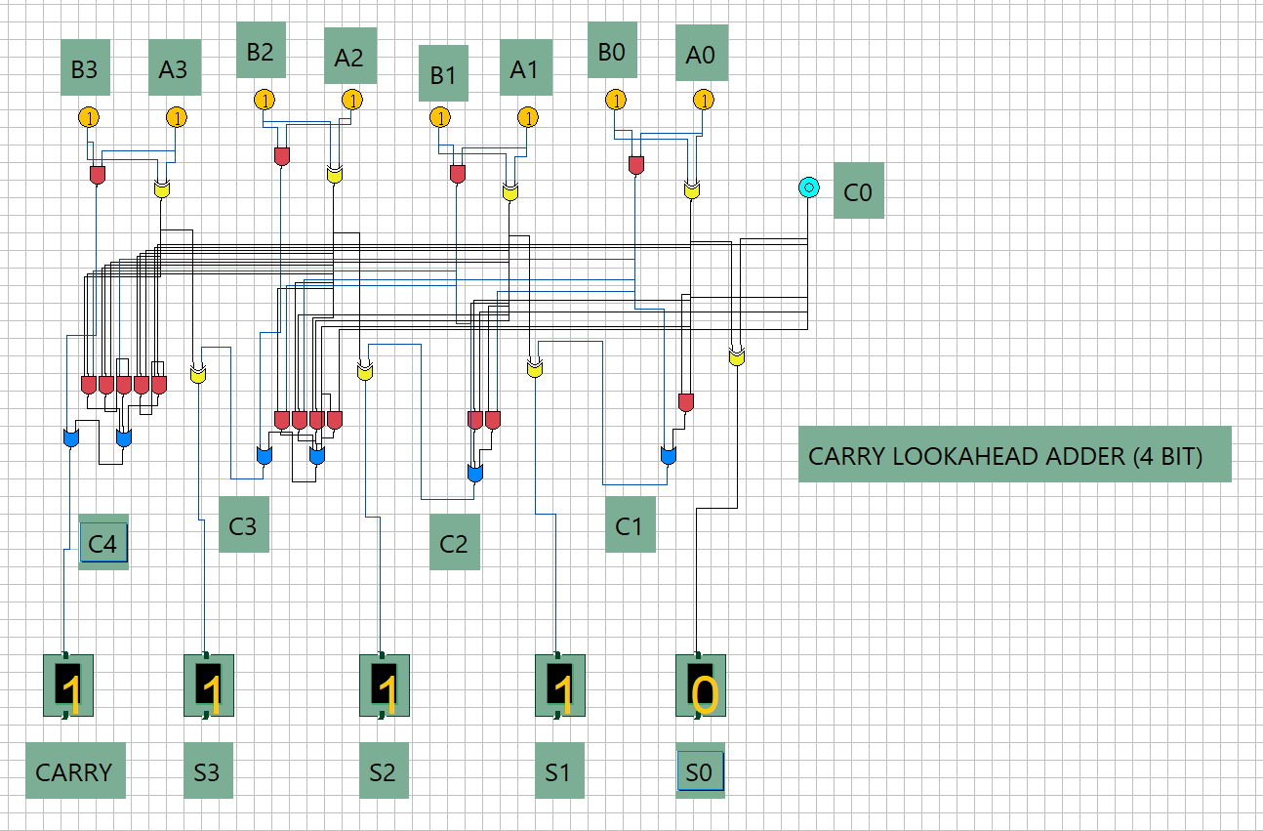
Figure 1: 4-bit carry lookahead adder (C₀ is the carry-in; the output marked CARRY is C₄)

