1.Initially loaded 120 records in the table ‘Product’ in MySQL database.
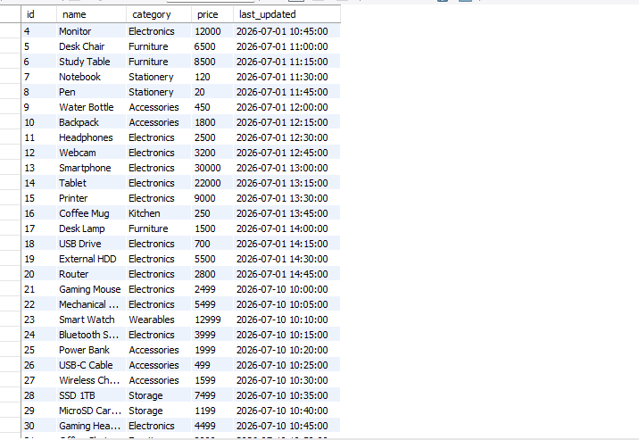

2. Record processed to producer successfully.
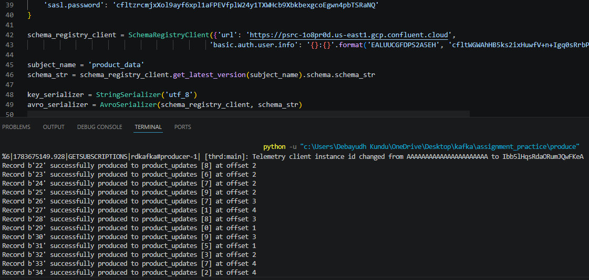

3.Consumers start consuming the records.
Consumer 1
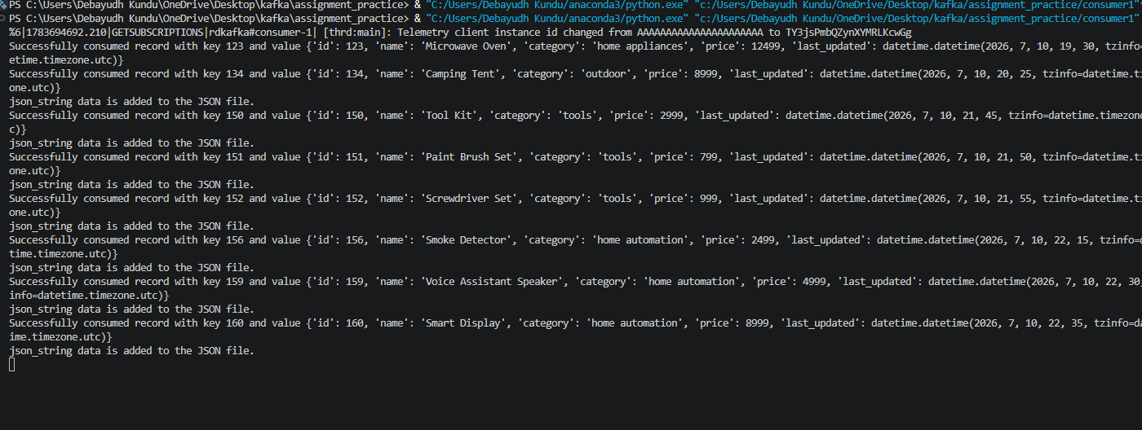

Consumer 2
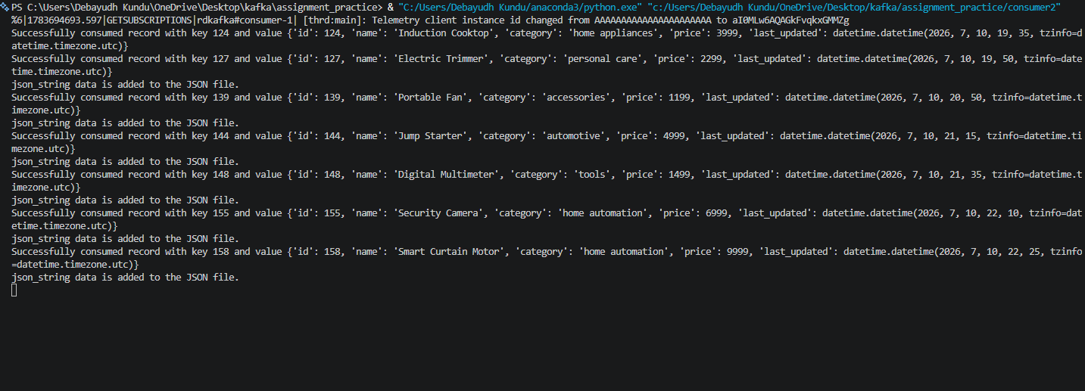

Consumer 3
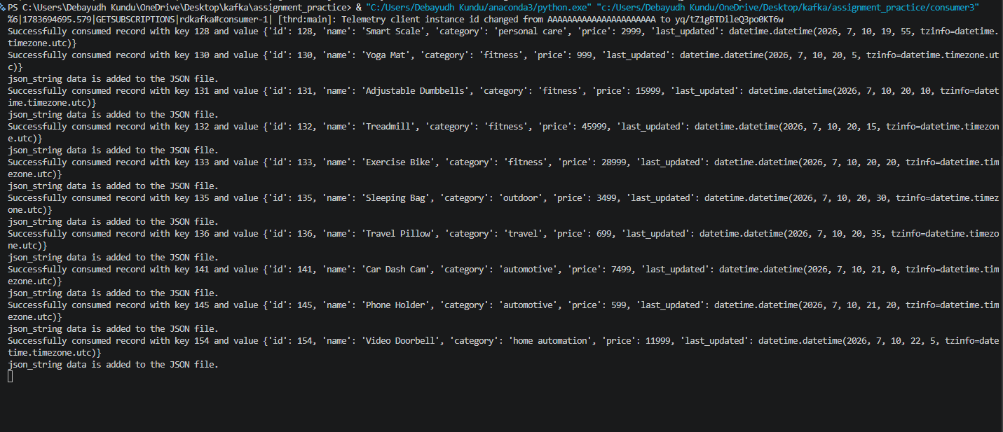

Consumer 4
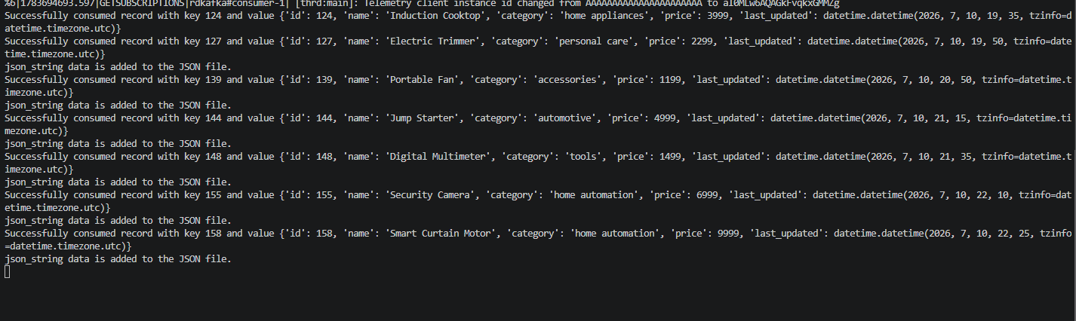
Consumer 5
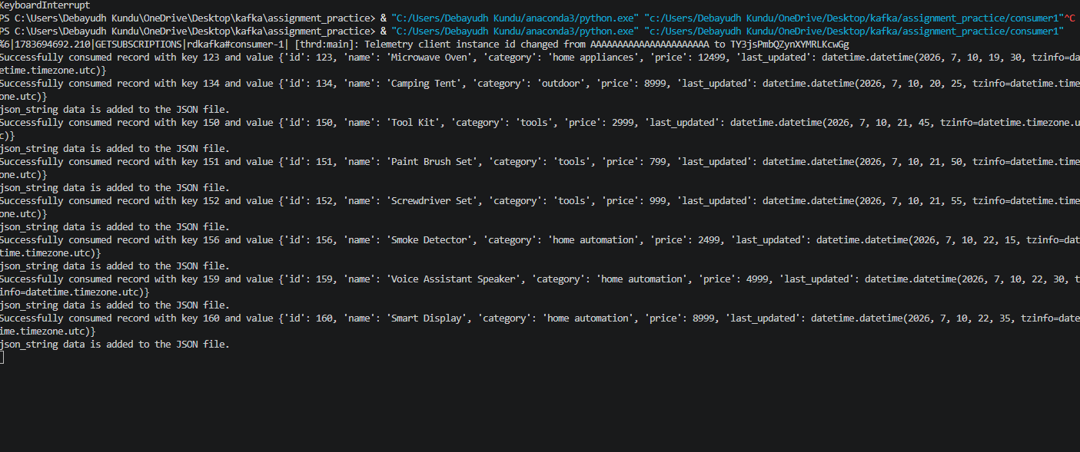

Ideally if there are 10 partition each consumer in a consumer group should consume 2 partition

