Debbie Brasier

Chris Seeger

LA 558

April 9, 2017

Tech Report: Waze vs. Google Maps

Waze is a technology product that uses social, community data to apply those traffic insights into its navigation app. Originally founded in 2006 by Ehud Shabtai as “FreeMap Israel”, the app was renamed to Waze in 2009. Because of its unique, community-driven approach, Waze caught the interest of many big tech firms in Silicon Valley, but eventually Google parent company Alphabet bought Waze for $1.1 billion on April 11, 2013. (Bort)

Since the Alphabet acquisition four years ago, Waze has continued to operate independently and competitively. (Chemi) Waze’s traffic and incident data is integrated into Google Maps, but while the two apps are similar, they are fairly different. While Google Maps is more of a traditional mapping software, Waze’s purpose is to help drivers “outsmart traffic” and save time while commuting on the roads. (Klosowski) While drivers have the app open, Waze passively, and anonymously, collects timestamps and location data to recommend the fastest route. Drivers can report real-time traffic conditions, search for the cheapest gas in the area, avoid tolls, and bypass speed cameras. Waze can also send your estimated arrival time to people you are planning to meet. With all of those useful features, Waze also integrates fun via some gamification techniques with different user levels from “Waze Baby” to “Waze Royalty”. ("Your Rank and Points.")

Both Google Maps and Waze have developer APIs available, but despite Google Maps using the Waze traffic data in its own apps, community developers cannot access Waze traffic data directly with an API. The Waze API is used primarily to integrate with other unrelated, smartphone apps. With a very small code snippet, a developer can automatically open the Waze app directed to a desired location, with no interaction cost to the user.

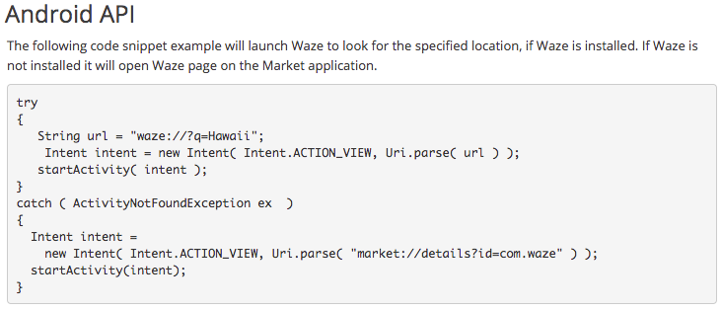

*Figure 1: Sample of Waze Android API code ("Free Community-based Mapping, Traffic & Navigation App.")*

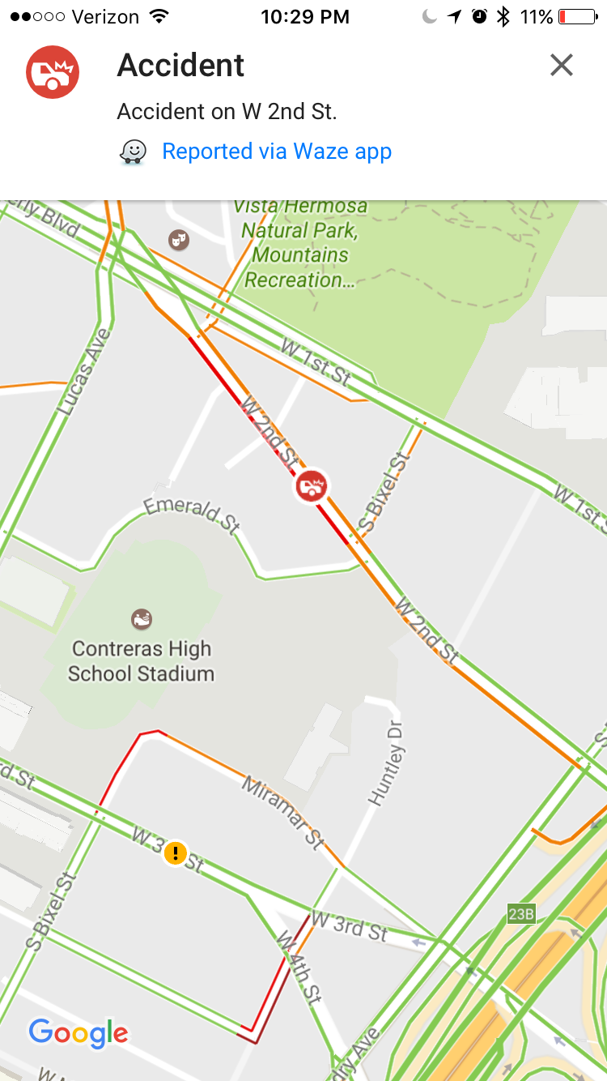Comparatively, Google Maps has a fully developed API with documentation and jsFiddles for developers to use. The traffic layer displays on the map as red, yellow, and green colorations of roadways. Unlike Waze, Google Maps navigation does not route drivers around traffic issues, and does not show specific traffic conditions, except for in the smartphone app. ("Traffic, Transit and Bicycling Layer.")

Works Cited

Bort, Julie. "Waze Cofounder Tells Us How His Company's $1 Billion Sale to Google Really Went down." Business Insider. Business Insider, 13 Aug. 2015. Web. 09 Apr. 2017.

Chemi, Eric. "Google Maps vs Waze vs Apple Maps: Who Wins?" CNBC. CNBC, 30 June 2016. Web. 09 Apr. 2017.

"Free Community-based Mapping, Traffic & Navigation App." Waze, n.d. Web. 09 Apr. 2017.

Klosowski, Thorin. "Turn-by-Turn Navigation Showdown: Google Maps vs. Waze." Lifehacker. Lifehacker.com, 28 Feb. 2016. Web. 09 Apr. 2017.

"Traffic, Transit and Bicycling Layer." Google Developers. Google, n.d. Web. 09 Apr. 2017.

Myers, Anthony. "How Waze Grew from Startup to Billion Dollar Google Acquisition #demo2013." CMSWire.com. CMSWire.com, 16 Oct. 2013. Web. 09 Apr. 2017.

"Your Rank and Points." Your Rank and Points - Waze. Waze, n.d. Web. 09 Apr. 2017.