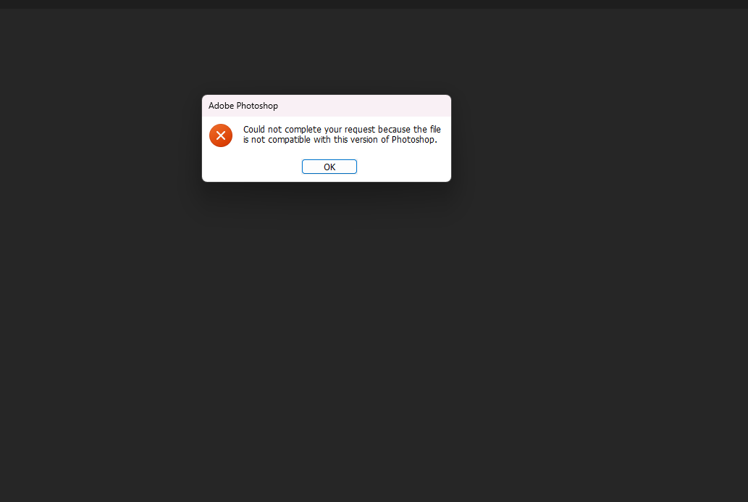
Jeremy for some reason this does not work could you save it to a Png format and send it again. Thank you

I still can’t open the file you sent for some reason . What version of photoshop did you use? So, I can download that.

