Screen shot of before conversion of data set to a table
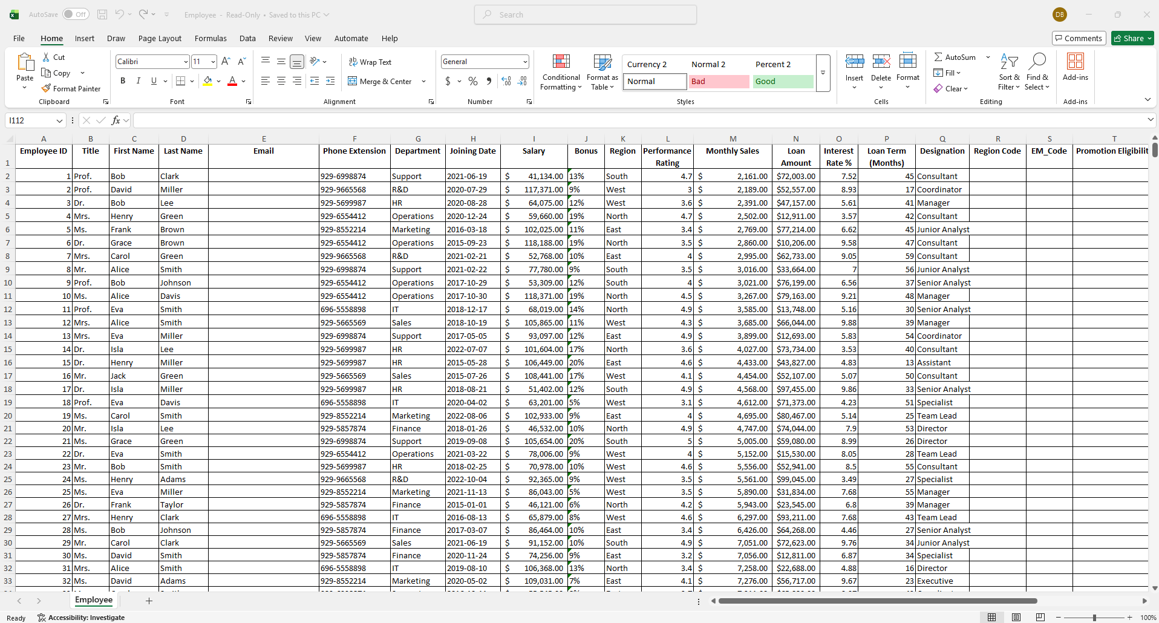

Screen shot after conversion of data set to a table and completion of the tasks.
