**Predicting Crime in DC**

**Debbie Yu**

**General Assembly – DAT7**

**July 2015**

**Problem Statement and Hypothesis**

While crime rates in DC have steadily decreased over the past 20 years, DC still struggles with relatively high crime rates like most major US cities. I am interested in predicting the likelihood/probability of certain crimes occurring in DC, with a focus on location and time of year in DC. Studies have shown correlations between violent crime and socioeconomics in neighborhoods, weather, and the time of year, so I am interested in building a predictive model about crime in DC that can potentially inform DC Government policy or safety program implications.

**Description of the Data**

I used three primary datasets for this project:

**Crime Data**

Like many other major US cities, DC Government has an online open data portal (<http://opendata.dc.gov>). This portal currently hosts 634 different datasets across a wide range of topics and date ranges (e.g. demographic information from 1990, planning land use and zoning metrics from 2006, and DC Government purchase orders from 2004). The District currently has several datasets of all crime incidents in the district from 2012-2014, as well as a crime report that will have crime incidents that have occurred since the last 30 days of the pull date of the report. For the purposes of my project, I chose to use the DC Crime Incident report from 2014.

This report contained the following 21 columns

1. ccn
2. reportdatetime
3. policeshift
4. offense
5. method
6. lastmodifieddate
7. blocksiteaddress
8. blockxcoord
9. blockycoord
10. ward
11. anc
12. district
13. psa
14. neighborhoodcluster
15. businessimprovementdistrict
16. block_group
17. census_tract
18. voting_precinct
19. start_date
20. end_date
21. esri_oid

The dataset had 38,388 rows, with each row representing a single crime incident in 2014.

*Crime Data – Data Cleaning Process*

While the crime dataset was relatively complete, there was some basic cleaning required with regard to the types of data in each data field. Date and time are a particular point of interest in my analysis, so I wanted to make sure I could utilize the pandas datetime object type. I fortunately had the date and time that a crime incident was logged, in a string format that had the month, date, year, hours, and minutes. Using this field, called ‘reportdatetime’, I created a separate field with the date only, and another field that had the hour. I found that slicing the reportdatetime string for the date and converting that string to a datetime object worked well. Then I converted the reportdatetime string to a datetime object to create an extra field that only contained the hour. I did this because I was interested in looking at the day of the year and hour of the day as possible features in my model.

I also created a categorization of non-violent and violent crimes. To simplify my model, I though it would be best to focus on these two broader categories than creating predictions for each of the 9 crime types listed. I categorized the crimes as such in an additional column called ‘violent’:

Violent crimes (mapped to a 1): sexual abuse, homicide, assault with a dangerous weapon, robbert

Non-violent crimes (mapped to a 0): arson, burglary, theft/other, theft from an automobile, motor vehicle theft

**Neighborhood Data**

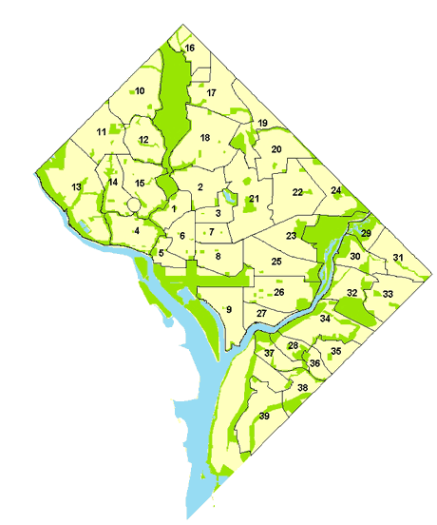I also wanted to gather information about specific neighborhoods in DC, so that my analysis could focus on a geographic granularity that would be relatable to the average citizen. I discovered that DC Government collects data by ‘neighborhood cluster,’ which are groupings of 3-5 neighborhoods throughout the city. (Single neighborhoods are not used as a geographic unit by because there are no official neighborhood boundaries determined by DC government; individual neighborhood boundaries shift rapidly and the exact locations are often under debate.) This information is collected for public consumption at <http://neighborhoodinfodc.org>. The clusters and associated neighborhoods are shown below:

Cluster 1: Kalorama Heights, Adams Morgan, Lanier Heights

Cluster 2: Columbia Heights, Mt. Pleasant, Pleasant Plains, Park View

Cluster 3: Howard University, Le Droit Park, Cardozo/Shaw

Cluster 4: Georgetown, Burleith/Hillandale

Cluster 5: West End, Foggy Bottom, GWU

Cluster 6: Dupont Circle, Connecticut Avenue/K Street

Cluster 7: Shaw, Logan Circle

Cluster 8: Downtown, Chinatown, Penn Quarters, Mount Vernon Square, North Capitol Street

Cluster 9: Southwest Employment Area, Southwest/Waterfront, Fort McNair, Buzzard Point

Cluster 10: Hawthorne, Barnaby Woods, Chevy Chase

Cluster 11: Friendship Heights, American University Park, Tenleytown

Cluster 12: North Cleveland Park, Forest Hills, Van Ness

Cluster 13: Spring Valley, Palisades, Wesley Heights, Foxhall Crescent, Foxhall Village, Georgetown Reservoir

Cluster 14: Cathedral Heights, McLean Gardens, Glover Park

Cluster 15: Cleveland Park, Woodley Park, Massachusetts Avenue Heights, Woodland-Normanstone Terrace

Cluster 16: Colonial Village, Shepherd Park, North Portal Estates

Cluster 17: Takoma, Brightwood, Manor Park

Cluster 18: Brightwood Park, Crestwood, Petworth

Cluster 19: Lamond Riggs, Queens Chapel, Fort Totten, Pleasant Hill

Cluster 20: North Michigan Park, Michigan Park, University Heights

Cluster 21: Edgewood, Bloomingdale, Truxton Circle, Eckington

Cluster 22: Brookland, Brentwood, Langdon

Cluster 23: Ivy City, Arboretum, Trinidad, Carver Langston

Cluster 24: Woodridge, Fort Lincoln, Gateway

Cluster 25: NoMa, Union Station, Stanton Park, Kingman Park

Cluster 26: Capitol Hill, Lincoln Park

Cluster 27: Near Southeast, Navy Yard

Cluster 28: Historic Anacostia

Cluster 29: Eastland Gardens, Kenilworth

Cluster 30: Mayfair, Hillbrook, Mahaning Heights

Cluster 31: Deanwood, Burrville, Grant Park, Lincoln Heights, Fairmont Heights

Cluster 32: River Terrace, Benning, Greenway, Fort Dupont

Cluster 33: Capitol View, Marshall Heights, Benning Heights

Cluster 34: Twining, Fairlawn, Randle Highlands, Penn Branch, Fort Davis Park, Dupont Park

Cluster 35: Fairfax Village, Naylor Gardens, Hillcrest, Summit Park

Cluster 36: Woodland/Fort Stanton, Garfield Heights, Knox Hill

Cluster 37: Sheridan, Barry Farm, Buena Vista

Cluster 38: Douglass, Shipley Terrace

Cluster 39: Congress Heights, Bellevue, Washington Highlands

This website contains a variety of socioeconomic data points for each neighborhood cluster, collected from the US Census, American Community Survey, and DC government data sources. From this website, I decided to collect the following datapoints for each neighborhood cluster using a webscraper:

1. Population, 2010
2. %black, non-hispanic 2010
3. %hispanic, 2010
4. %white, non-hispanic 2010
5. %asian, PI non-Hispanic 2010
6. Poverty rate from 2008-2012
7. Unemployment rate from 2008-2012
8. % population 16 years old and older that is employed, from 2008-2012
9. % population of persons without a high school diploma, from 2008-2012
10. Average family income, 2008-2012
11. Persons receiving food stamps, 2014
12. Persons receiving TANF, 2014
13. Median sales price of single-family homes, 2013

*Neighborhood Data – Data Cleaning Process*

With regard to data cleaning on my own scraped data, I needed to do some column formatting and data type conversions. Certain numbers were represented as strings with commas after I scraped them, so I converted them to integers and floats by removing the commas from the strings an converting them to integers.

I had mostly complete data for all of the data fields I scraped with the exception of median home prices for 4 clusters. The data was not available for the median home prices in 2013. I used a human learning technique here by either using the median home price of the average or neighboring cluster. I realize that this technique is not scalable for a large dataset because I hard-coded these numbers, but thought it would be ok for a small dataset. In future analyses with much larger datasets, I would likely not take this approach.

**Weather Data**

Finally, I obtained weather data from the National Oceanic and Atmospheric Administration. I filled out an online request form and requested weather data for the District in 2014. I received a csv file with over 91 fields, many of which provided highly detailed information (e.g. number of days included in the multiday precipitation total) that I did not need.

*Weather Data – Data Cleaning Process*

With so much weather data, I needed to significantly pare down this dataset to the small number of features I wanted to use. These features were:

1. Date
2. Temperature Min
3. Temperature Max
4. Snow
5. Precipitation

The temperature fields were provided in Celcius in tenths of degrees, so I needed to translate these to Fahrenheit and convert the data field to floats. I also used the max and min temps to create a new field, which was average temp in Fahrenheit.

I encountered an interesting phenomenon when I tried to convert the date to a pandas datetime object. Since the date was represented as a string and did not include hour/minute/second info, converting the date without formatting to a datetime object mis-coded the values, where the year was 1970 for all entries, and the year, month, and day were represented as a string in the middle of the field. I had to reformat this field by converting it back to a string, slicing the date and time out, and then converting it back to a datetime object.

I also created a new data series using the pandas datetimeindex object ‘dayofweek’, which indicates what particular day of the week a date falls on. With dayofweek, Mondays are represented with 0 and Sundays are represented with 6. For example, dayofweek called on 1/1/2014 returns a value of “2”, which is a Wednesday.

Taking these 3 datasets, I merged them into one large dataset that would have the crime incidents, weather on the day the crime was reported, and socioeconomic data with regard to the neighborhood that the crime was reported. This was saved as one large .csv file I could read into my analysis and visualization file

**Descriptive and Exploratory Analyses and Visuals**

I first took a look at the distribution of types of crimes in DC by total counts:

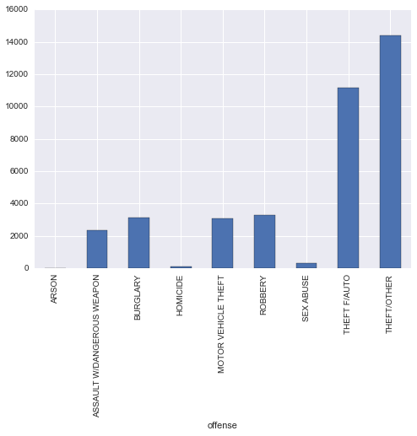

Looking at the distribution of types of offenses, it was interesting to know that a huge proportion of crimes committed in DC were of the non-violent type. Hence, it was good for me to be aware of a class imbalance and how that might affect my modeling. Specifically, here are the numbers below with regard to non-violent and violent crime counts:

Violent vs Non-violent Crime Counts

|  |  |
| --- | --- |
|  | Count |
| Violent (assault w/dangerous weapon, sex abuse, homicide, robbery) | 31806 |
| Non-violent (arson, burglary, theft/other, theft f/auto, motor vehicle theft) | 6063 |
| TOTAL | 37,869 |

Below is the distribution of violent crimes by neighborhood cluster:

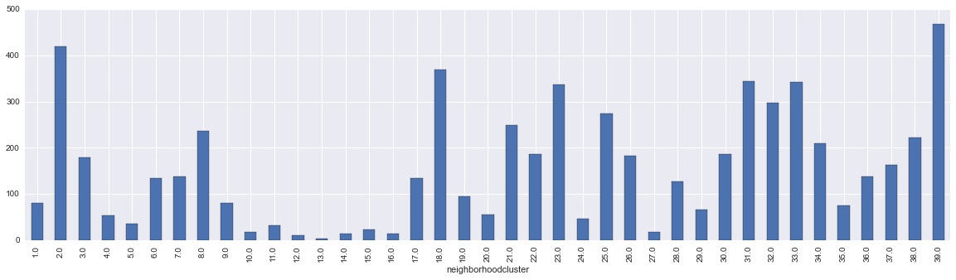

Unsurprisingly, there is a huge disparity in the distribution of crimes between neighborhood clusters. The Top 5 highest violent crime neighborhood clusters are in SE and in the heart of DC:

|  |  |
| --- | --- |
| **Cluster** | **Count** |
| Cluster 39: Congress Heights, Bellevue, Washington Highlands | 468 |
| Cluster 2: Columbia Heights, Mt. Pleasant, Pleasant Plains, Park View | 419 |
| Cluster 18: Brightwood Park, Crestwood, Petworth | 370 |
| Cluster 31: Deanwood, Burrville, Grant Park, Lincoln Heights, Fairmont Heights | 344 |
| Cluster 33: Capitol View, Marshall Heights, Benning Heights | 343 |

Top 5 lowest violent crime clusters are below:

|  |  |
| --- | --- |
| **Cluster** | **Count** |
| Cluster 13: Spring Valley, Palisades, Wesley Heights, Foxhall | 3 |
| Cluster 12: North Cleveland Park, Forest Hills, Van Ness | 10 |
| Cluster 14: Cathedral Heights, McLean Gardens, Glover Park | 14 |
| Cluster 16: Colonial Village, Shepherd Park, North Portal Estates | 14 |
| Cluster 27: Near Southeast, Navy Yard | 18 |

**Time elements**

I then wanted to see if certain time elements would be compelling features. The first visualization shows the total count of crimes for each day of 2014:

￼ 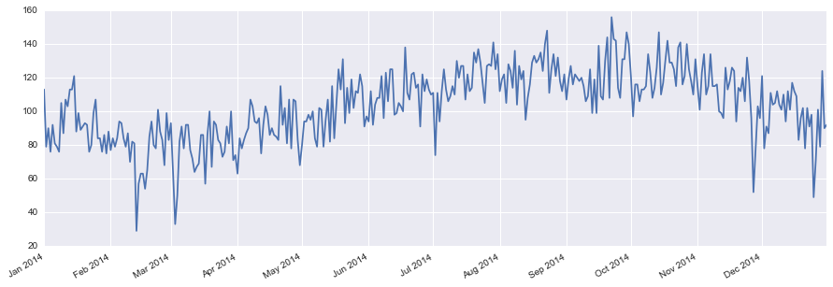

Also, no surprise here that crime is generally lower in the colder months (Dec-March), and climbs as the weather gets warmer. It appears that overall crime peaks in September/October, before slowing down again as Fall turns to winter.

Here is a specific count of violent crimes for each day in 2014. The trend for violent crimes isn’t as strong as it is for the overall graph above.

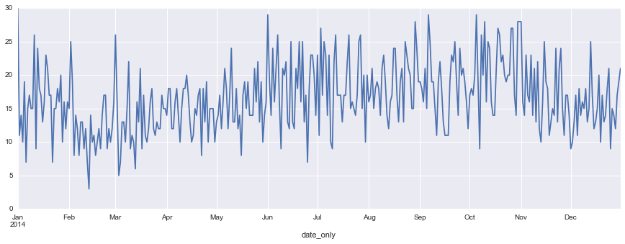

I did find it interesting to look at the lowest crime days, both in terms of total crime and violent crime, specifically. Apparently in anticipation of Valentines’ Day, criminals or potential offenders take a break, as well as on Christmas Day.

|  |  |
| --- | --- |
| 5 Lowest overall crime days of 2014: | 5 Lowest violent crime days of 2014: |
| February 13, 2014: 29 | February 13, 2014: 3 |
| March 3, 4, 2014: 22 | March 3, 2014: 5 |
| December 25, 2014: 49 | March 13, 2014: 6 |
| March 4, 2014: 50 | January 6, 2014: 7 |
| November 27, 2014: 27 | March 4, 2014: 7 |

|  |  |
| --- | --- |
| 5 Highest overall crime days of 2014: | 5 Highest violent crime days of 2014: |
| February 13, 2014: 29 | February 13, 2014: 3 |
| March 3, 4, 2014: 22 | March 3, 2014: 5 |
| December 25, 2014: 49 | March 13, 2014: 6 |
| March 4, 2014: 50 | January 6, 2014: 7 |
| November 27, 2014: 27 | March 4, 2014: 7 |

I thought I would also group the data into smaller time increments to see if there were trends:

Violent crimes by day of the week:

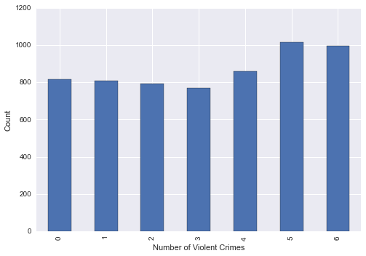

Monday = 0

Tuesday = 1

Wednesday = 2

Thursday = 3

Friday = 4

Saturday = 5

Sunday = 6

I was actually a bit surprised that there was little variation of crimes committed between the different weekdays, and the difference between the weekdays and weekends is not as large as I would have expected.

Violent crimes by time of day (hr):

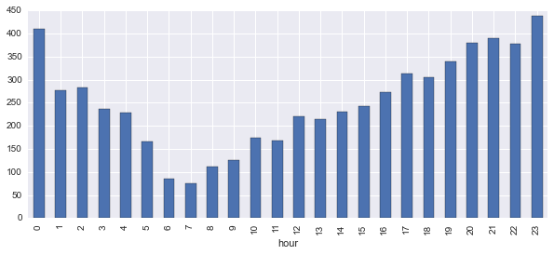

I think I was most surprised by the variation in the hour that crimes are committed. It makes sense intuitively that violent crimes aren’t committed very often in the early hours of the morning like 6 or 7AM. Conversely while it makes sense that the most crimes are committed at night, there seems to be such a large drop between midnight and 1AM, when this doesn’t seem like something that would matter as much. This may speak to the fact that I am using the date and time of which a crime is reported, but this may not be an accurate representation of when the crimes were actually committed.

Weather elements (PENDING MORE VISUALIZATIONS)

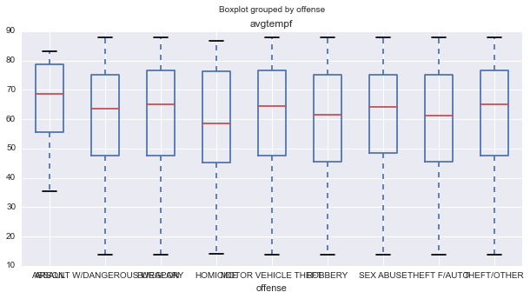

**Modeling and Model Evaluation**

Here is the seaborn correlation plot:

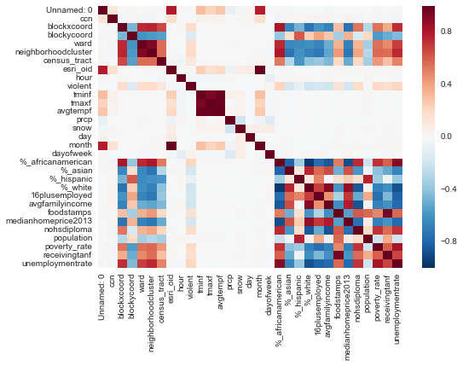

I have a lot of data fields that I didn’t actually plan on using in my model but thought they would be interesting to visualize. A lot of my features are (not surprisingly), correlated, particularly the ones related to socioeconomic measures (e.g. ‘poverty rate’ and ‘receiving tanf’). Thus, I will avoid using these variables but try to stick to one variable that might represent some general measure (e.g. socioeconomics of a neighborhood).

***First model type: Logistic Regression***

I decided to first start out with using logistic regression to predict the probability of violent crimes or not. This is still a work in progress – I am wondering if my class imbalance between my violent crime and non-violent crime classification.

[Sections of this paper I plan on elaborating later on…]

Challenges and successes

Extensions or Business Applications