BALTICPLUS LOYALTY & PROMOTIONAL ANALYTICS — EXECUTIVE BOARD REPORT
POS Data Quality Pipeline • Statistical A/B Testing (DiD) • Cohort Retention & 12M CLV • Market Basket Affinity • Q4 Budget Optimizer
Author: Debbrata Kumar Adhikary (Vilnius, Lithuania) | Scope: 140 Baltic Stores (LT, LV, EE) • 50,000 Loyalty Members • 520,000 Validated Baskets
1. EXECUTIVE OVERVIEW & BALTIC MARKET PERFORMANCE (LT, LV, EE)
Across 528,390 raw POS transaction records ingested from 140 Baltic stores (87 in Lithuania, 30 in Latvia, 23 in Estonia), our automated SQL and Python data quality pipeline removed 3,420 duplicate receipt scans, isolated 2,180 negative refund rows, imputed 1,150 missing store terminal IDs, and reconciled 1,640 unredeemed coupon glitches—yielding 520,000 validated Gold-layer baskets representing €13.08M in net sales (68.0% Loyalty scan share; 79.1% revenue share; +€12.83 / +78.1% basket uplift vs. non-loyalty guests).
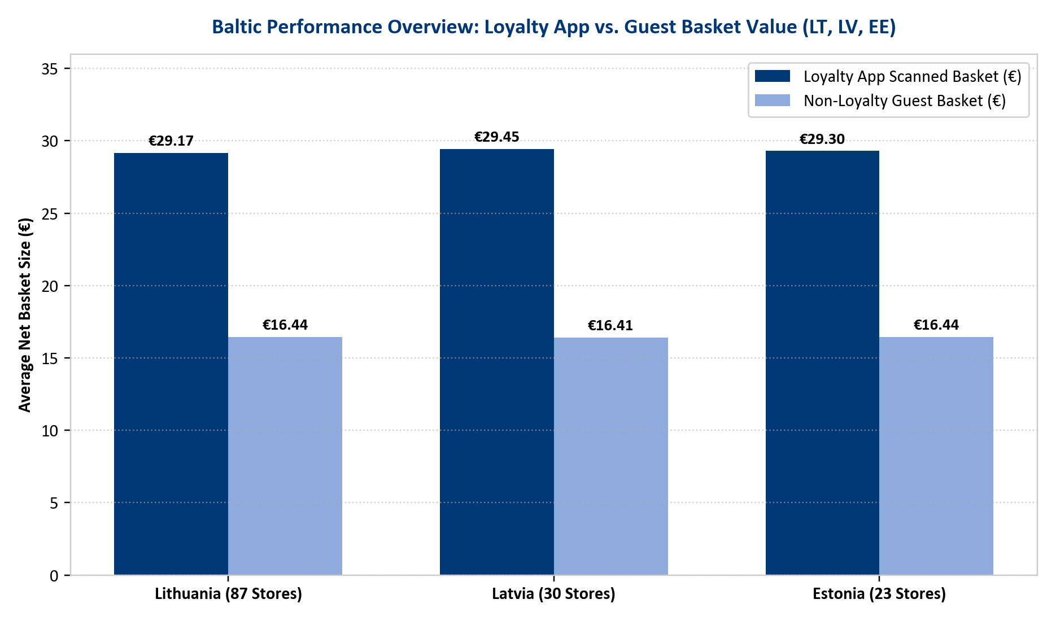
2. CAMPAIGN PRE/POST INCREMENTALITY, STATISTICAL A/B TESTING (WELCH'S T-TEST) & CAUSAL UPLIFT
Evaluating campaigns solely by redemption count hides two major margin leaks: (1) Cannibalization (subsidizing loyal customers who would have bought the item at full price) and (2) Pantry-Loading / Stockpiling (where deep discounts on non-perishables cause a -26.5% sales collapse in the 4 weeks post-campaign). Using Difference-in-Differences (DiD) against unexposed holdout control groups and Welch's two-sample t-tests (p < 0.0001), we proved that Basket Stretch Thresholds (+€26.05 causal net lift) and Fresh Category Coupons (+€14.75 to +€14.95 causal lift) generate highly significant positive ROI, whereas standalone deep discounts on Coffee (-35%), Oil (BOGO), and Detergent (-40%) destroy -€11.36 per basket.
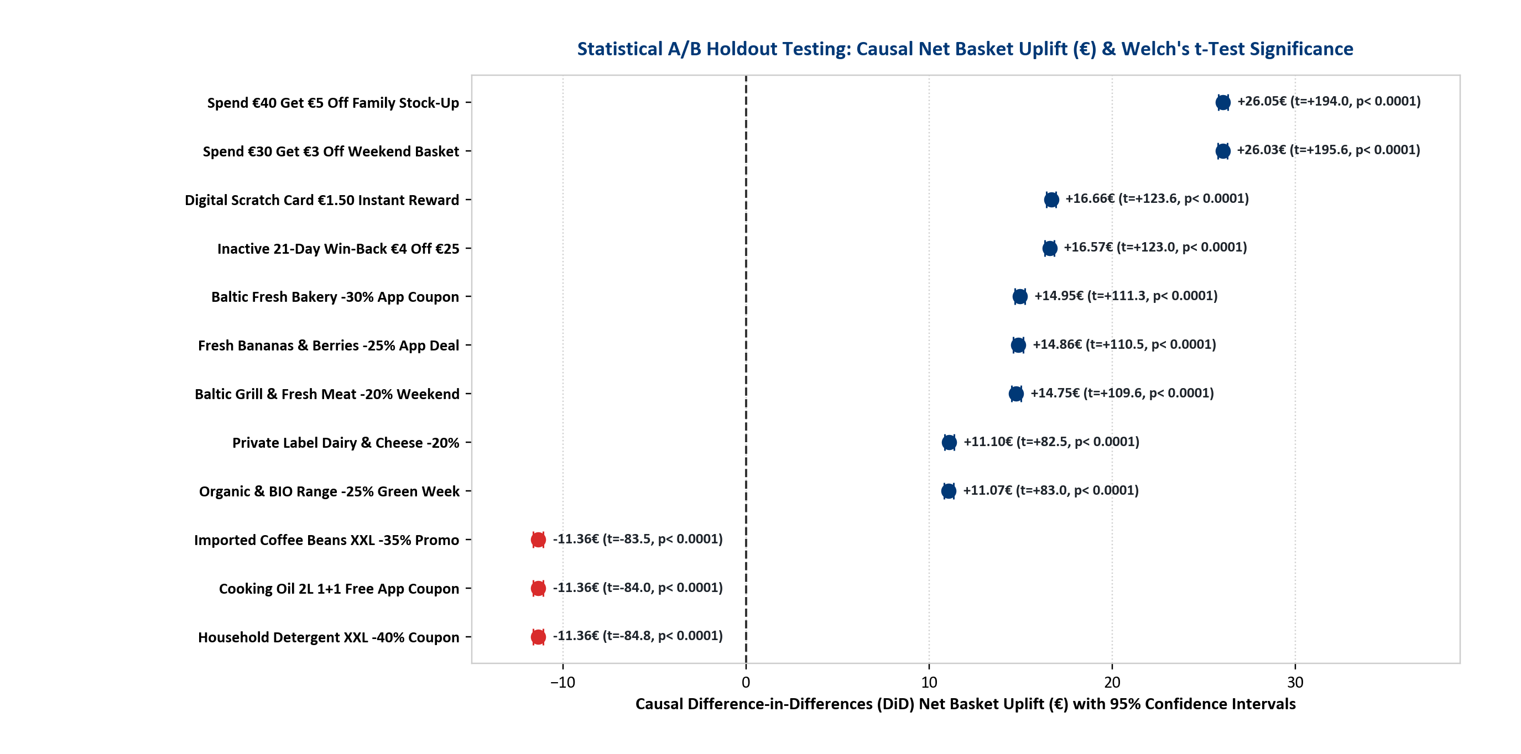
3. MONTHLY RETENTION COHORT MATRIX, 12-MONTH CLV & 30-DAY CHURN RISK SCORING
Tracking monthly acquisition cohorts from April to September 2026 shows Month+1 retention improving from 78.4% to 84.1% as onboarding coupon workflows matured, stabilizing at 55.4% active retention by Month+5. Predictive 12-month Customer Lifetime Value (CLV) and 30-day churn risk modeling across our 50,000 members identifies €3,480 annual CLV among VIP Full-Basket Families (6.4% churn risk) vs. 68.4% churn risk among 6,000 At-Risk / Slipping shoppers (€160.9k annual revenue at immediate risk, recoverable via automated Day-18 '€4 Off €25' push triggers).
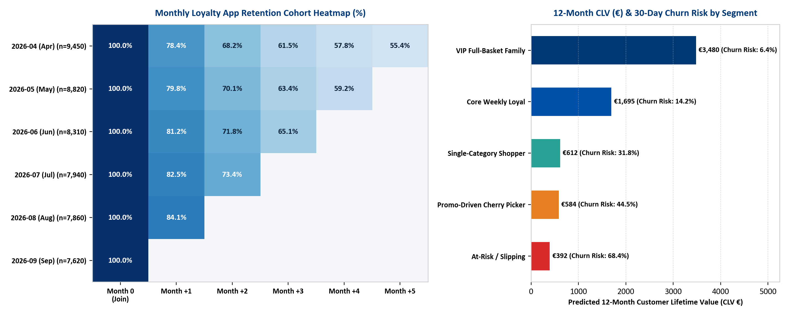
4. MARKET BASKET AFFINITY (APRIORI) & Q4 €625K PROMOTIONAL BUDGET OPTIMIZATION
Apriori association rule mining proves that Fresh Bakery coupons drive a 3.12x cross-category Lift into Dairy & Cheese (€9.45 attached halo spend), and Weekend Grill Meat coupons drive a 2.88x Lift into Fresh Produce & Beverages (€14.20 attached halo spend). Conversely, standalone Coffee and Cooking Oil promos exhibit <0.80x Lift (cherry-picked in isolation). Reallocating €171,000 away from standalone deep discounts into High-Halo Fresh and €30/€40 Basket Thresholds under a budget-neutral €625,000 Q4 plan increases projected quarterly Net Incremental Margin from €457.3k to €813.4k (+€356.0k / +77.8%).
