NYCU Pattern Recognition, Homework 4

**311553010, 陳姿羽**

**Part. 1, Coding (70%)**:

1. (5%) Implement K-fold data partitioning.

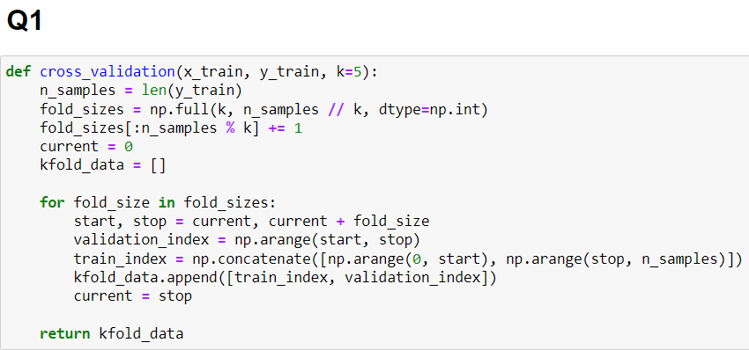

1. (10%) Set the kernel parameter to 'rbf' and do grid search on the hyperparameters **C** and **gamma** to find the best values through cross-validation. Print the best hyperparameters you found. Note that we suggest using K=5 for the cross-validation.

(best_c, best_gamma) is (1, 0.0001)

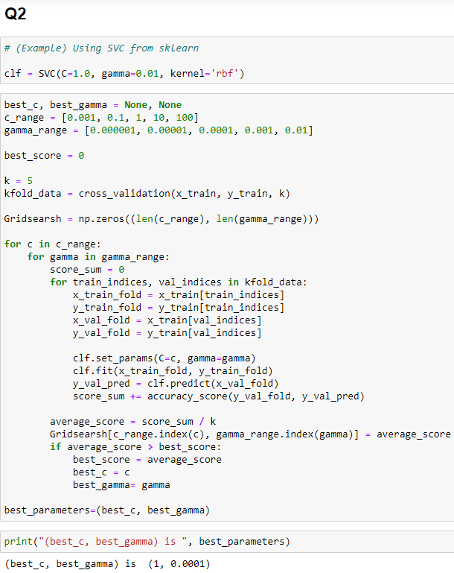

1. (10%) Plot the results of your SVM's grid search. Use "gamma" and "C" as the x and y axes, respectively, and represent the average validation score with color.  
   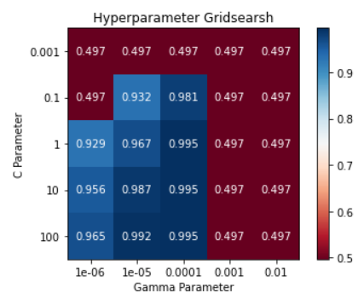
2. (5%) Train your SVM model using the best hyperparameters found in Q2 on the entire training dataset, then evaluate its performance on the test set. Print your testing accuracy.  
   Accuracy score: 0.995

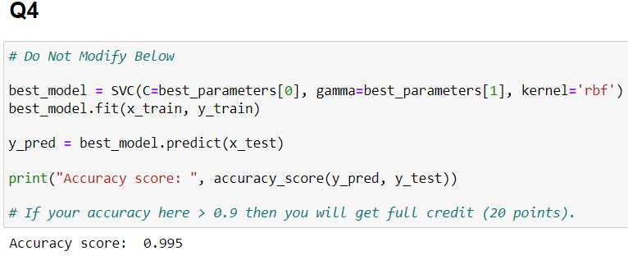

**Part. 2, Questions (30%):**

1. Show that the kernel matrix $K={\left[k\left(x_{n},x_{m}\right)\right]}_{nm}$ should be positive semidefinite is the necessary and sufficient condition for $k(x,x')$ to be a valid kernel.

According to Mercer's theorem, for a valid kernel matrix $K$, the dot product of any vector with $K$ must be greater than or equal to zero. Additionally, the kernel matrix $K$ must be positive semidefinite, which means that all of its eigenvalues are greater than or equal to zero. If the kernel matrix $K$ is not positive semidefinite, there may exist a vector $n$ such that $n∙K < 0$, which means that $K$ is not valid as a kernel function.

Therefore, the kernel matrix $K={\left[k\left(x_{n},x_{m}\right)\right]}_{nm}$ being positive semidefinite is the necessary and sufficient condition for $k(x,x')$ to be a valid kernel.

1. Given a valid kernel $k_{1}\left(x, x'\right)$, explain that $k\left(x, x'\right)= exp\left(k_{1}\left(x, x'\right)\right)$ is also a valid kernel. (Hint: Your answer may mention some terms like ____ series or ____ expansion.)

$K_{1}$ is a valid kernel, so it is also positive semidefinite. According to the eigenvalue decomposition theorem, any positive semidefinite can be represented by eigenvectors and eigenvalues. Thus, $K_{1}$ can be expressed as $K_{1} = λ v v^{T}$, where $λ$ is the eigenvalue and $v$ is the corresponding eigenvector.

After expanding $exp\left(k_{1}\left(x, x'\right)\right)$ using Taylor expansion, we substitute $k_{1}\left(x, x'\right)$ into the definition of the kernel matrix to obtain a new matrix *K*.

$$exp\left(k_{1}\left(x, x'\right)\right)= \sum_{m=0}^{∞}{\frac{k_{1}\left(x, x'\right)}{m!}}$$

Since $k_{1}\left(x, x'\right)$ is a real number, this Taylor expansion converges. The matrix *K* can be expressed as an infinite series sum.

$$K= \sum_{m=0}^{∞}{\frac{1}{m!}}K_{1}^{m}$$

Since $K_{1}$ is positive semidefinite, raising it to the power of *m*, $K_{1}^{m}$, also results in positive semidefinite. Consequently, *K* is positive semidefinite as well. Therefore, $exp\left(k_{1}\left(x, x'\right)\right)$ is a valid kernel.

1. Given a valid kernel $k_{1}\left(x, x'\right)$, prove that the following proposed functions are or are not valid kernels. If one is not a valid kernel, give an example of $k\left(x, x'\right)$ that the corresponding $K$ is not positive semidefinite and show its eigenvalues.
$k\left(x, x'\right)= k_{1}\left(x, x'\right)+x$

$k\left(x, x^{'}\right)= k_{1}\left(x, x^{'}\right)-1$

2. $k\left(x, x'\right)$ = ${k_{1}\left(x, x'\right)}^{2}+\exp\left({\left\|x\right\|}^{2}\right)*exp({\left\|x'\right\|}^{2})$
3. $k\left(x, x'\right)$ = ${k_{1}\left(x, x'\right)}^{2}+exp\left(k_{1}\left(x, x^{'}\right)\right)-1$
4. Consider the optimization problem

$minimize {(x-2)}^{2}$

$$subject to \left(x+4\right)\left(x-1\right)≤3$$

State the dual problem. (Full points by completing the following equations)

$L\left(x, λ\right)$*= ${(x-2)}^{2}+ λ(\left(x+4\right)\left(x-1\right)-3)$*

$∇_{x}L\left(x, λ\right)$ = $2(x-2)+ λ(2x+3)$

when $∇_{x}L\left(x, λ\right) =0$, $$(2\left(x-2\right)+ λ\left(2x+3\right)=0)$$

$x$*= $\frac{4-3λ}{2+2λ}$*

$L\left(x, λ\right)$ = $L\left( λ\right)$ = ${((\frac{4-3λ}{2+2λ})-2)}^{2}+ λ(\left((\frac{4-3λ}{2+2λ})+4\right)\left((\frac{4-3λ}{2+2λ})-1\right)-3)$