client.py

server.py

--------------------server.py----------------------

import socket

from threading import Thread

# Server's IP address

SERVER_HOST = "192.168.0.107"

SERVER_PORT = 8080  # port we want to use

separator_token = "<SEP>"  # we will use this to separate the client name & message

# Initialize list/set of all connected client's sockets

client_sockets = set()

# Create a TCP socket

s = socket.socket()

# Make the port as reusable port

s.setsockopt(socket.SOL_SOCKET, socket.SO_REUSEADDR, 1)

# Bind the socket to the address we specified

s.bind((SERVER_HOST, SERVER_PORT))

# Listen for upcoming connections

s.listen(5)

print(f"[*] Listening as {SERVER_HOST}:{SERVER_PORT}")

def listen_for_client(cs):

    """

    This function keeps listening for a message from `cs` socket.

    Whenever a message is received, broadcast it to all other connected clients.

    """

    while True:

        try:

            msg = cs.recv(1024).decode()

        except Exception as e:

            print(f"[!] Error: {e}")

            client_sockets.remove(cs)

        else:

            msg = msg.replace(separator_token, ": ")

            for client_socket in client_sockets:

                client_socket.send(msg.encode())

def accept_connections():

    while True:

        client_socket, client_address = s.accept()

        print(f"[+] {client_address} connected.")

        client_sockets.add(client_socket)

        t = Thread(target=listen_for_client, args=(client_socket,))

        t.daemon = True

        t.start()

if __name__ == "__main__":

    accept_connections()

--------------------client.py----------------------

import socket

from threading import Thread

# Server's IP address

SERVER_HOST = "192.168.0.107"

SERVER_PORT = 8080  # server's port

separator_token = "<SEP>"  # we will use this to separate the client name & message

# Initialize TCP client socket

s = socket.socket()

# Connect to the server

s.connect((SERVER_HOST, SERVER_PORT))

def listen_for_messages():

    while True:

        message = s.recv(1024).decode()

        print("\n" + message)

# Start listening for messages in a separate thread

Thread(target=listen_for_messages).start()

# Prompt the client for a name

name = input("Enter your name: ")

while True:

    # Input message we want to send to the server

    to_send = input("Enter a message: ")

    # A way to exit the program

    if to_send.lower() == 'q':

        break

    # Add the name and the separator token to the message

    to_send = f"{name}{separator_token}{to_send}"

    # Finally, send the message

    s.send(to_send.encode())

# Close the socket

s.close()

Output:

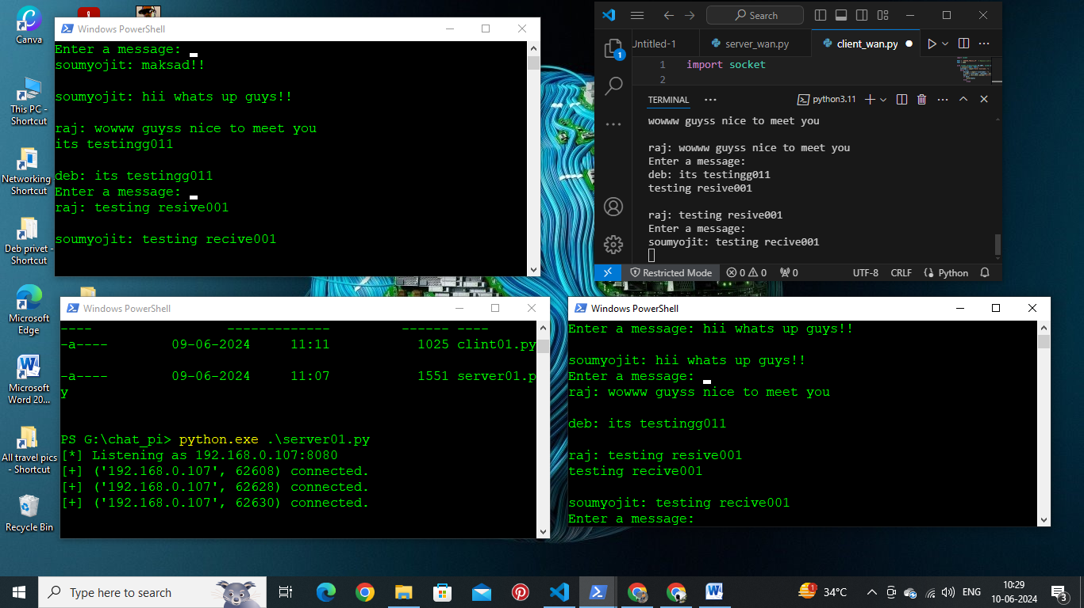

**Server:**

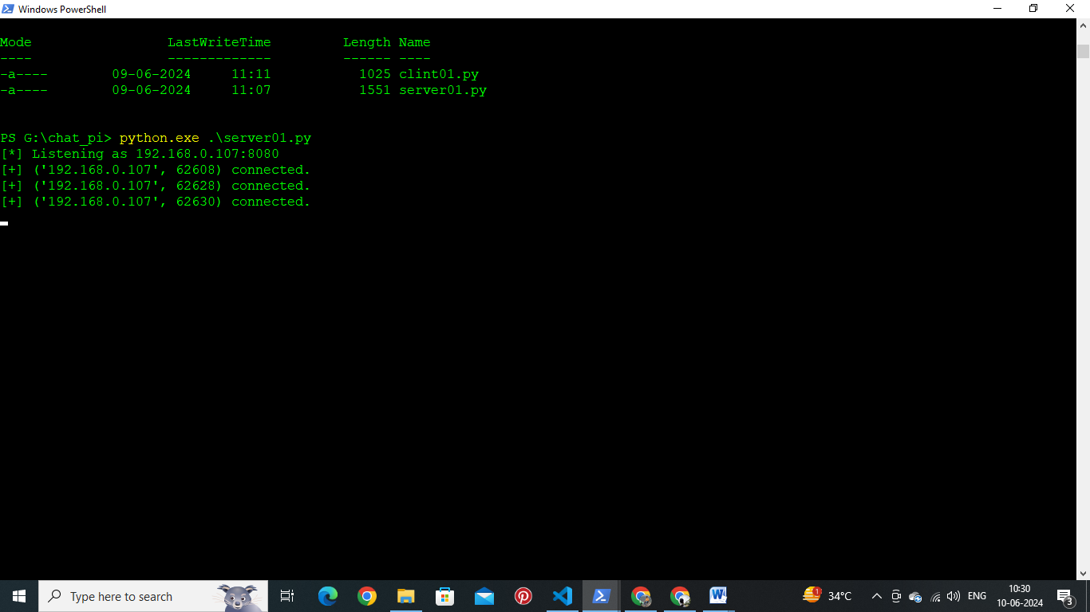

Client01:

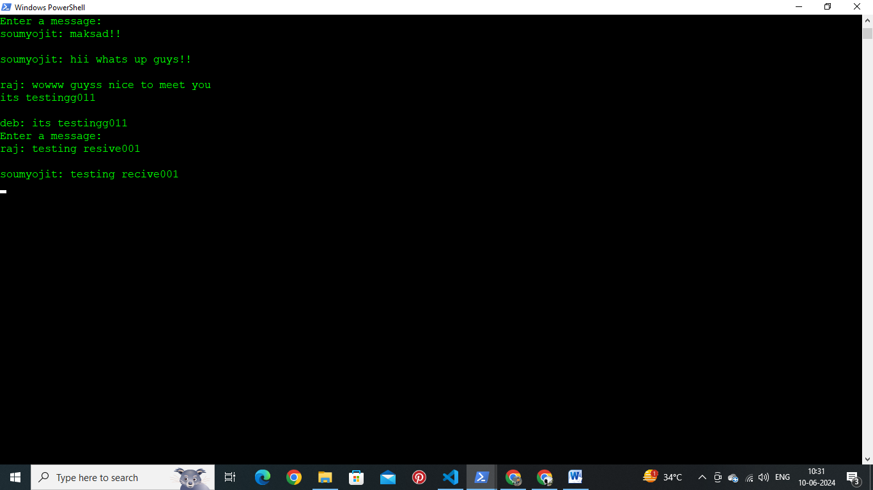

Client02:

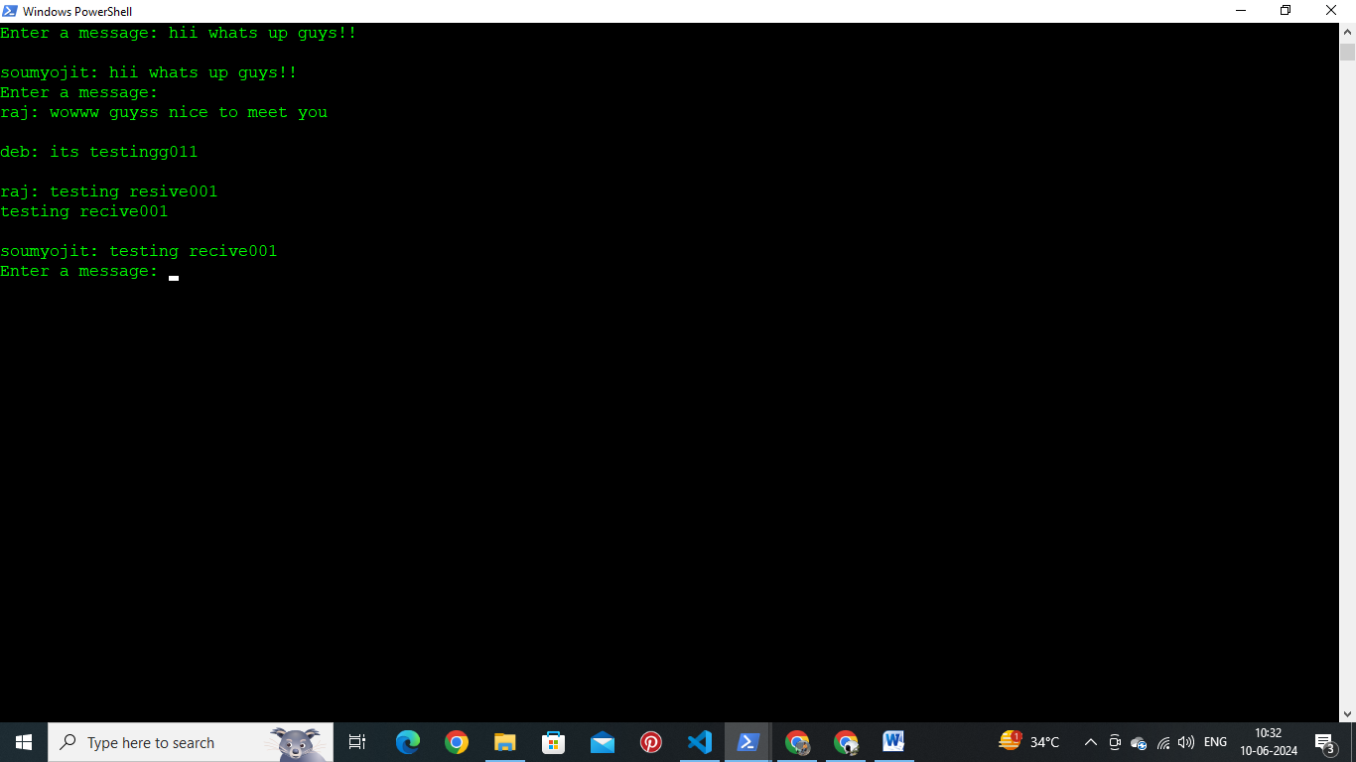

Client03:

