Debdas Ghosh

[deg107@pitt.edu](mailto:deg107@pitt.edu)

# Report

There are 20 classes to predict: aeroplane, bicycle, bird, boat, bottle, bus, car, cat, chair, cow, diningtable, dog, horse, motorbike, person, pottedplant, sheep, sofa, train, tvmonitor

Each class are distributed in train, test and validation sets.

Below is the code snippet to run the interactive module:

Accuracy of self-trained model (VGG-16 with SVM) is approximately 0.51



And below is the Confusion Matrix of that model:

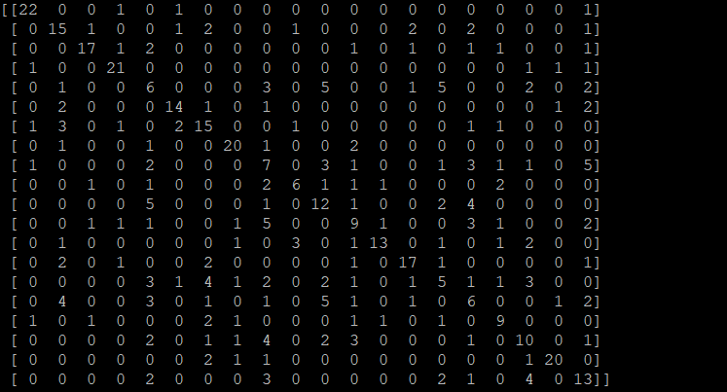

As can be seen this model correctly specifies all 20 classes with some exceptions. At the diagonal of the matrix there are high value numbers and rest are mostly zeros. The type of error the model makes is mainly False Positive, i.e. it’s predicting a different class than actual.

Accuracy of our First model based on VGG-16: 0.6576

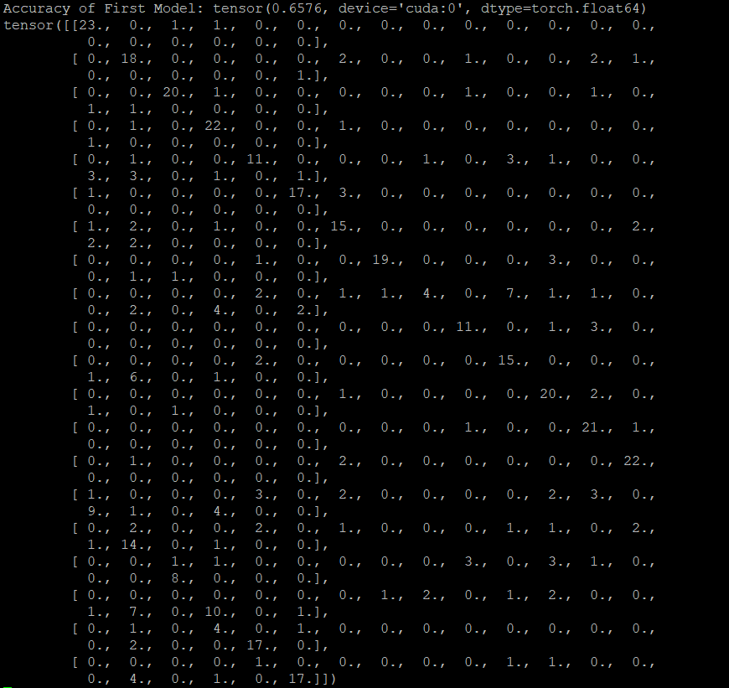

Predictions can be seen at the Confusion Matrix. It can be seen that there are more larger values in the diagonal axis than the last model’s confusion matrix.

After tuning some parameters accuracy achieved in Second Model: 0.7038



And below is the confusion matrix for it:

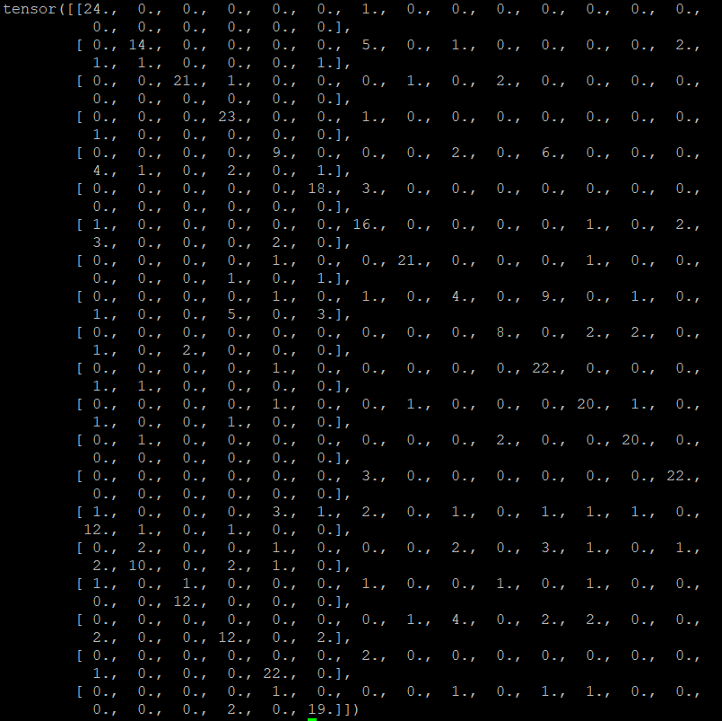

This increase in accuracy achieved by increasing the batch size to 16 (double to previous model) and decreasing the learning rate to 0.0001 (one-tenth of the previous model). I have used 50 epochs to train the model instead of 25 as it happened in the previous model. By increasing batch size, model gets more training data and with lower learning rate it converged to local minima more accurately and by running multiple times my model got to learn best features from those images.