CAPSTONE PRE-SUBMISSION DOCUMENT
AutoDrive ADAS Intelligence
Predicting Vehicle Safety Incidents & Quantifying Risk Using Telematics and ADAS Data an end-to-end Data Analytics & Machine Learning solution for fleet-safety and motor-insurance decisioning.
Domain: Automotive / Fleet & Insurance Analytics | Tech Stack: Jupyter Notebook | Language: Python | Methodology: Data Analytics & Machine Learning | Dataset: 50,500 × 40
Submitted By : Deepaa Belanii Candidate ID - 02IITM26LLM130 Group 9 Domain 11
1
Business Problem Understanding & Objective Formulation
Modern vehicles equipped with Advanced Driver-Assistance Systems (ADAS) continuously stream telematics — driving behaviour, vehicle-health diagnostics, ADAS alerts and environmental context. Fleet operators and motor insurers currently react to safety incidents after they occur, incurring high insurance claims, repair costs and vehicle downtime. There is no unified, data-driven mechanism to predict the likelihood of a safety incident before a trip and to explain which behavioural or mechanical factors drive that risk.
The provided dataset (AutoDrive_ADAS_Intelligence.csv) captures driver, vehicle, ADAS, trip and environmental attributes for 50,500 trips with a binary outcome safety_incident_flag (approximately 51% incident / 49% no-incident — a near-balanced target). The goal is to convert raw telematics into an actionable risk-intelligence and prevention system.
Objectives
- O1 — Predictive Modelling: classify safety_incident_flag per trip/vehicle from driver, ADAS, vehicle-health and environment features.
- O2 — Risk Scoring: produce a calibrated 0–100 safety-risk score per driver/vehicle for proactive ranking and intervention.
- O3 — Driver Factor Analysis: identify key behavioural, mechanical and environmental drivers via EDA and explainability (SHAP).
- O4 — Cost Insight: relate predicted risk to insurance_claim_amount, repair_cost and vehicle_downtime_days to estimate savings.
- O5 — Segmentation: cluster drivers/vehicles into risk personas for differentiated pricing and targeted training.
2
Challenges & Constraints
Data Challenges (observed in the dataset)
- Missing values — ~10,100 nulls, mainly driver_training_score (5,144) and battery_health_score (4,971).
- Inconsistent categories — vehicle_type contains messy variants (SUV / suv / SUVS).
- Duplicate rows — 500 exact duplicates to remove.
- Noise/ID columns — legacy_vehicle_reference, fleet_cluster_id, trip_batch_id, administrative_reference carry no predictive value.
Modelling & Project Constraints
- Weak single signals — top single-feature correlation is only ~0.25; a multivariate model is essential.
- Interpretability & fairness — explainable, non-discriminatory (driver_age) decisions required by insurers.
- Scope/Time — 12-week four-student capstone; offline Jupyter analysis (no live streaming deployment).
- Generalisation — guard against overfitting via cross-validation and a hold-out test set.
3 Background Study / Literature Review
- Telematics & UBI: driving-behaviour telematics improves claim prediction over demographic-only rating factors.
- ADAS & crash prevention: NHTSA/Euro-NCAP studies show crash reductions from forward-collision warning and automatic emergency braking — motivating ADAS-alert features.
- ML for incident prediction: tree ensembles (Random Forest, XGBoost, LightGBM) outperform linear baselines on tabular telematics.
- Explainable AI: SHAP (Lundberg & Lee, 2017) gives consistent feature attribution, now standard for transparent risk scoring.
- Calibration: Platt/isotonic calibration and threshold tuning turn model outputs into reliable business risk scores.
4 Proposed Methodology / Solution Approach
A supervised binary-classification pipeline executed end-to-end in Jupyter Notebook (Python) following the CRISP-DM cycle, complemented by unsupervised clustering for driver segmentation.
Phase | Activities & Techniques | Key Libraries
Data Cleaning | Drop 500 duplicates & ID/noise columns; standardise vehicle_type; impute training/battery scores (median/KNN); handle outliers. | pandas, numpy
EDA | Univariate/bivariate analysis, correlation heatmap, incident rates by vehicle type, manufacturer, weather & experience. | matplotlib, seaborn
Feature Engineering | Composite indices (total ADAS alerts, aggressive-driving score, vehicle-health index, exposure); encoding & scaling. | scikit-learn
Modelling | Baseline Logistic Regression → RF, XGBoost, LightGBM; stratified split; 5-fold CV; tuning (GridSearch/Optuna). | scikit-learn, xgboost, lightgbm
Evaluation | Accuracy, Precision, Recall, F1, ROC-AUC, PR-AUC, confusion matrix; calibration; business-threshold selection. | scikit-learn
Explainability | Global & local importance via SHAP; partial-dependence; fairness check on driver_age. | shap
Risk Score & Segmentation | Map probability to 0–100 score; K-Means risk personas; link to claim/repair/downtime costs. | scikit-learn
5
Workflow / Block Diagram
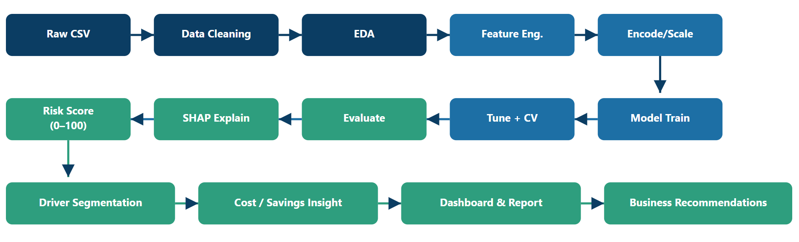

6 Proposed Timeline (12 Weeks)
Week | Milestone / Activity | Output
W1 | Problem finalisation, data understanding, metrics & plan | Pre-submission (this doc)
W2–3 | Data cleaning: duplicates, category fixes, imputation, drop noise | Clean dataset
W4 | Exploratory Data Analysis & visual insights | EDA notebook + charts
W5 | Feature engineering & encoding/scaling pipeline | Feature set
W6–7 | Baseline + ensemble models (LR, RF, XGBoost, LightGBM) | Trained models
W8 | Hyper-parameter tuning & cross-validation | Optimised model
W9 | Evaluation, calibration & risk-score (0–100) design | Metrics + risk scorer
W10 | Explainability (SHAP), fairness check, segmentation (K-Means) | Insight notebook
W11 | Cost/savings analysis & summary dashboard | Dashboard
W12 | Final report, presentation & documentation | Final capstone submission
7

Expected Deliverables & Outputs
- Cleaned dataset & reproducible preprocessing pipeline.
- Jupyter Notebooks — EDA, modelling, explainability (fully documented).
- Trained ML model predicting safety_incident_flag with target ROC-AUC >= 0.85.
- Safety-Risk Score (0–100) per driver/vehicle.
- Driver risk segments (personas) for pricing & training.
- SHAP / feature-importance report of incident drivers.
- Cost-impact analysis & estimated savings.
- Summary dashboard + final report & presentation with business recommendations.

