Optimal Equity Injection
for Banking Networks
Complete Study Guide & Implementation
Based on: Bayraktar, Guo, Tang, Zhang (2025)
Project: Risk Management on Financial Markets
March 2026

1. Executive Summary
This project addresses a fundamental question in systemic risk management: given a limited bailout budget, how should a central bank optimally distribute capital injections across failing banks over time to maximize the stability of the entire financial system?
We model a network of N homogeneous banks whose capital levels evolve randomly over T time periods. A regulator with a fixed budget c per period must decide, at each time step, how much to inject into each surviving bank. The goal is to maximize either the expected number of survivors (objective U) or the probability that all banks survive (objective V).
The mathematical framework uses stochastic optimal control with dynamic programming (Bellman equation). Since exact solutions are computationally infeasible (curse of dimensionality), we employ regression-based approximate dynamic programming with ridge regression, closely related to the Longstaff-Schwartz method for American option pricing.
We study two scenarios: (1) independent banks, and (2) interconnected banks with default cascades. A key finding is that the ‘socialistic policy’ (splitting budget equally among survivors) performs near-optimally.

2. Mathematical Formulation

2.1 The Banking Network
We consider N banks indexed by i = 1, ..., N operating in discrete time t = 0, 1, ..., T.
Bank capital: Each bank i has a capital level at time t:
A bank is solvent when its capital is positive, and defaults when it drops to zero or below:
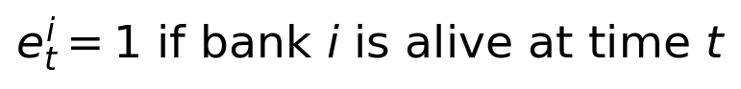
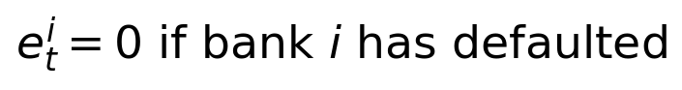

2.2 State Space
The full state of the system at time t is described by the pair of capital levels and survival indicators:
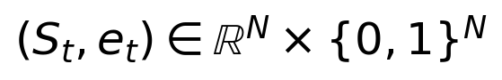
This is a hybrid space — part continuous (capital levels), part discrete (alive/dead indicators).

2.3 Dynamics and Shocks
Each period, bank i experiences a random shock (profit if positive, loss if negative). The regulator chooses injection amounts. Capital evolves according to:
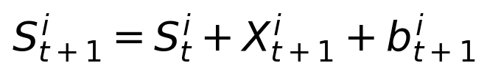
The survival status updates as:
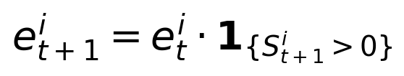
The regulator faces a budget constraint at each time step:
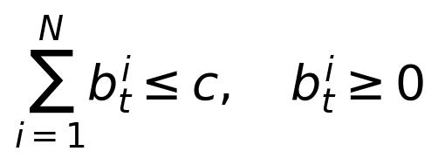
A key requirement is predictability — the regulator must decide before seeing the next shock:
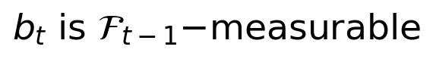

2.4 Two Cases
Case 1 (Independent banks): Banks are isolated. If one fails, others are unaffected. Capital dynamics follow the simple equation above.
Case 2 (Interconnected banks with default cascades): Banks hold interbank liabilities. When a bank defaults, every surviving bank suffers an immediate loss. The dynamics become:
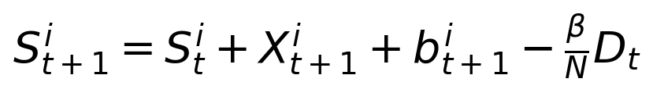
where D_t is the number of banks that default at time t. The cascade iterates: initial defaults cause losses that may push other banks below zero, causing further defaults, until a fixed point is reached.

2.5 Objective Functions
Objective U — Expected number of survivors:
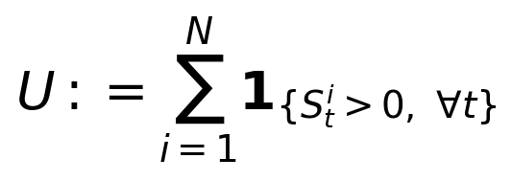
Objective V — Probability all survive:
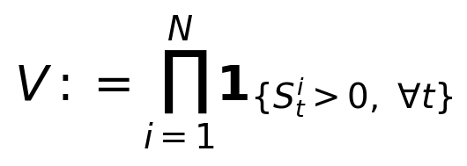
The difference: Objective U rewards saving any bank, while V only rewards keeping ALL banks alive. Under V, losing even one bank gives zero reward.

2.6 The Optimization Problem
We seek the optimal injection policy:
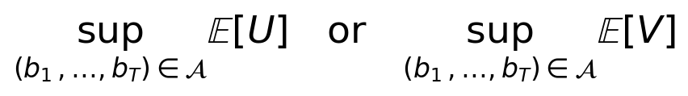

3. Dynamic Programming Principle

3.1 Value Function
The value function represents the maximum expected payoff achievable from time t onward:
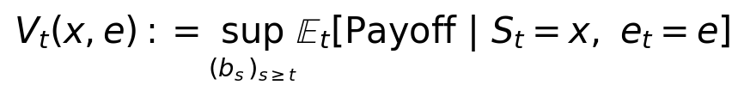
At the terminal time T:
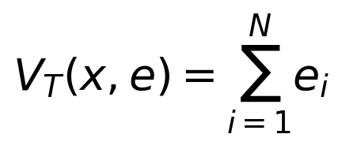
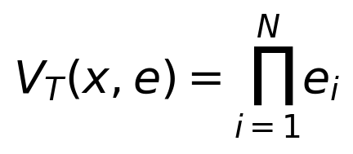

3.2 The Bellman Equation
The Bellman equation decomposes the optimization into one-step decisions:
with the dynamics:

3.3 Proof Sketch (Important for Oral!)
The proof uses three ingredients:
1. Tower property of conditional expectation:
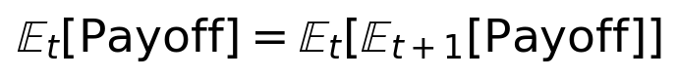
2. The supremum over all future controls decomposes:
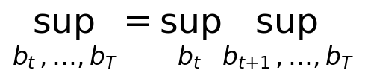
3. The inner supremum is exactly V_{t+1} by definition. Combining these gives:
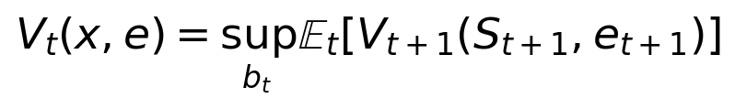
This is Bellman’s principle of optimality.

3.4 The Expectation in Detail
Given state (x, e) and action a, the expectation is a high-dimensional integral:
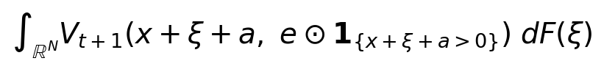
This integral is over R^N (high-dimensional), has indicator functions (non-smooth), requires knowing V_{t+1} everywhere, and may not have a closed form. Solution: Monte Carlo approximation!

4. Why We Cannot Solve This Exactly
The state space is uncountably infinite. To solve numerically via grid methods, we need:
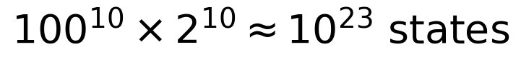
For N=10 banks with K=100 grid points per dimension, this requires roughly 10^23 states — more storage than exists on Earth. This is the curse of dimensionality. We need function approximation.

5. Function Approximation: The Key Idea

5.1 Linear Function Approximation
Instead of storing values at every state, we approximate the value function as a linear combination of feature functions:
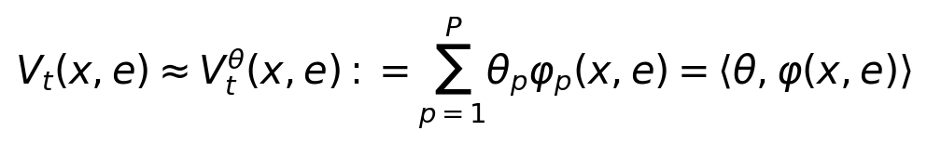
This reduces the problem from storing infinitely many values to storing only P parameters (the weights θ). The key insight is P << K^N.

5.2 Feature Functions
Good features should exploit symmetry (homogeneous banks are interchangeable) and capture different aspects of the state. Our features:
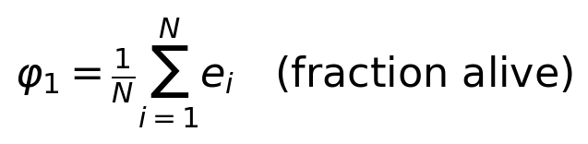
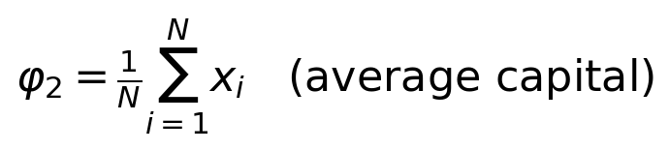
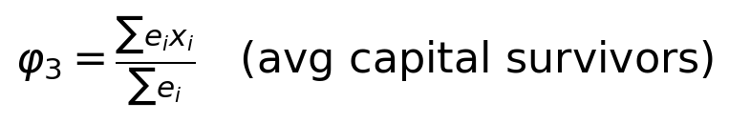
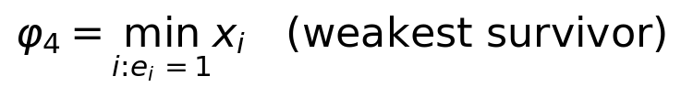
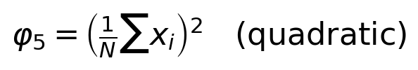
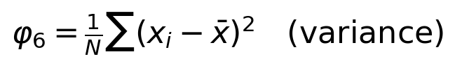

5.3 Why Linear Combinations?
Linear approximation leads to a convex optimization problem with a closed-form solution (quadratic program). And by the Stone-Weierstrass theorem, with enough features, linear combinations can approximate any continuous function arbitrarily well.

6. The Complete Algorithm

6.1 Step 0: Terminal Time
Sample N_train terminal states by simulating forward to time T using a rollout policy. For each state, compute the terminal payoff. Build feature matrix Φ and solve by ridge regression:
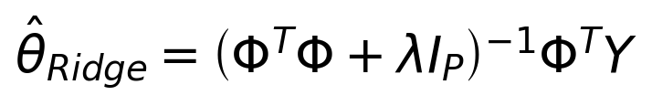

6.2 Backward Iteration (t = T-1, ..., 0)
Sub-step 1 (Generate training states): Simulate N_train trajectories from t=0 to time t using the rollout policy. Record the state reached at time t.
Sub-step 2 (Compute targets via Monte Carlo): For each training state, for each candidate action a, estimate the expected future value using M shock samples:
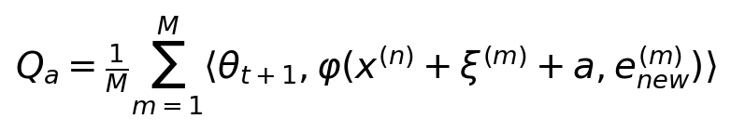
The target for each training state is the best achievable value:
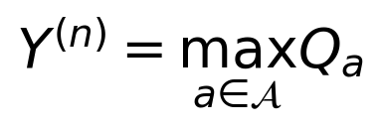
Sub-step 3 (Ridge regression): Build feature matrix Φ and target vector Y:
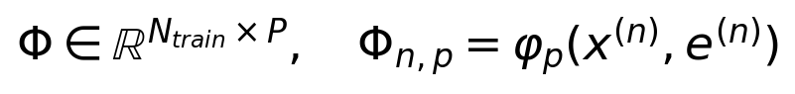
Solve:

Output: Weight vectors {θ_0, ..., θ_T} defining the approximate value function and optimal policy.

7. Ridge Regression

7.1 Why Not Just OLS?
OLS solves:
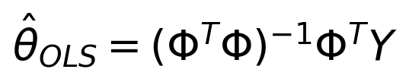
Two problems: (1) Overfitting when P is large relative to N_train. (2) Ill-conditioning when features are correlated, making ΦᵀΦ near-singular.

7.2 Ridge Regression
Ridge adds an L2 penalty:
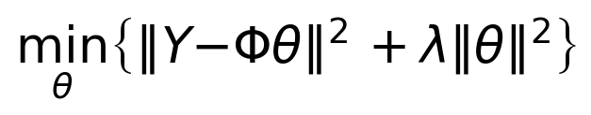
The closed-form solution is:


7.3 Proof of the Ridge Solution
Take the gradient and set to zero:
Rearranging:
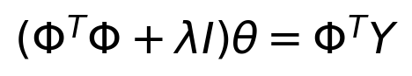

7.4 Properties
1. Always invertible:
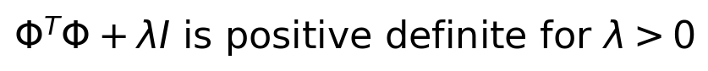
2. Shrinkage:
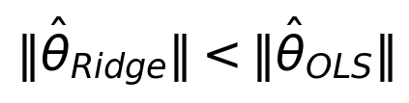
3. Bias-variance tradeoff:
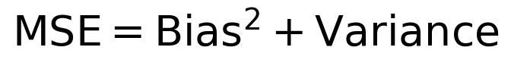
Increasing λ increases bias but decreases variance. The optimal λ minimizes total MSE.

7.5 SVD-Based Implementation
For numerical stability, compute via SVD:
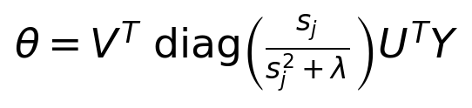
This avoids forming ΦᵀΦ directly. Rule of thumb for λ:
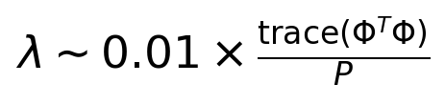

8. Default Cascades (Case 2)
In Case 2, banks are connected through interbank liabilities. When bank i defaults, every surviving bank suffers a loss of β/N.

8.1 Cascade Algorithm
The cascade is resolved iteratively: (1) Update capitals with shocks and injections. (2) Find newly defaulted banks. (3) Count new defaults D. If D=0, stop. (4) Each survivor loses βD/N. (5) Go to step 2. Repeats until no new defaults (fixed-point). At most N iterations needed.
This creates a fixed-point problem:
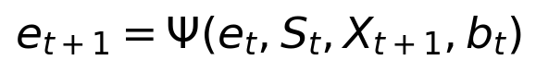

8.2 Key Insight
Cascades make the problem harder: one bank’s failure can bring down the whole system. This is why interconnected banking systems are fragile. The socialistic policy becomes even more important — keeping all banks above the default threshold prevents cascades from starting.

9. Numerical Results

9.1 Setup
Parameters: N=3 banks, T=5 time periods, budget c=1.0, initial capital S0=2.0, shocks ~ N(0,1), interbank liability β=1.5 (Case 2). Algorithm: N_train=200, M=80, ridge λ=0.01, P=11 features.

9.2 Case 1: Independent Banks
Policy | E[# Survivors] | Std Dev
No Intervention | 2.212 | 0.776
Inject Weakest | 2.820 | 0.409
Inject Strongest | 2.469 | 0.645
Socialistic (Equal Split) | 2.715 | 0.506
Optimal (Learned) | 2.821 | 0.415

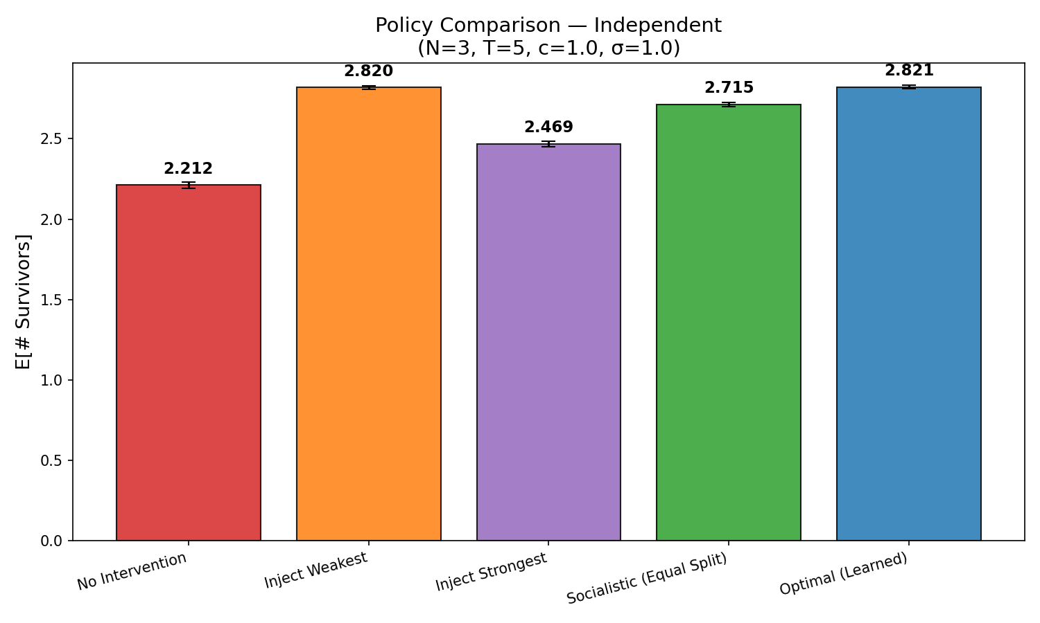
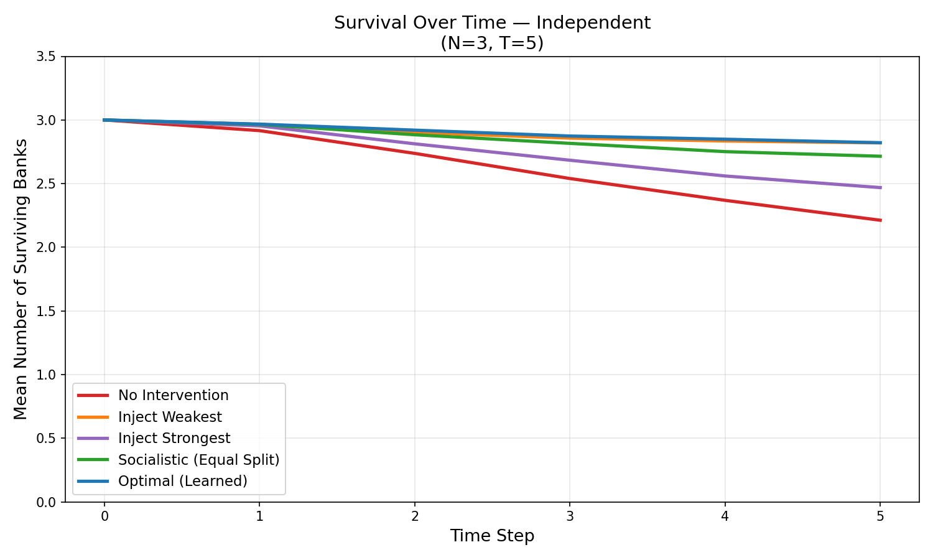
Key findings: Optimal and inject-weakest perform nearly identically (E[U]≈2.82), both significantly outperforming no intervention (2.21). Socialistic (2.72) is strong. Injecting the strongest (2.47) is clearly suboptimal.

9.3 Case 2: Interconnected Banks (Cascades)
Policy | E[# Survivors] | Std Dev
No Intervention | 2.059 | 0.895
Inject Weakest | 2.784 | 0.492
Inject Strongest | 2.396 | 0.689
Socialistic (Equal Split) | 2.700 | 0.534
Optimal (Learned) | 2.789 | 0.476

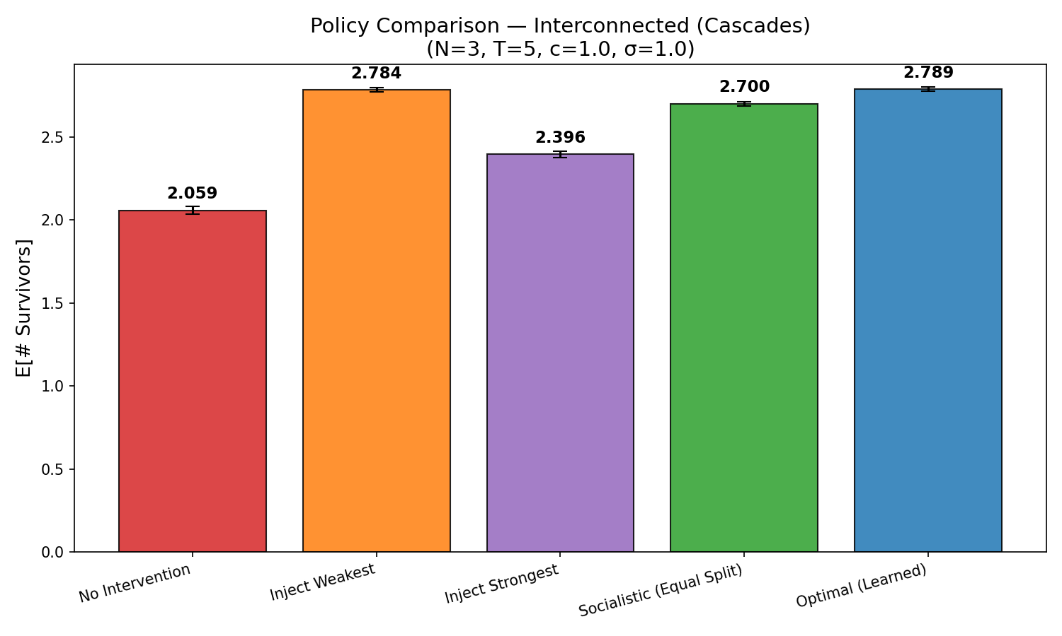
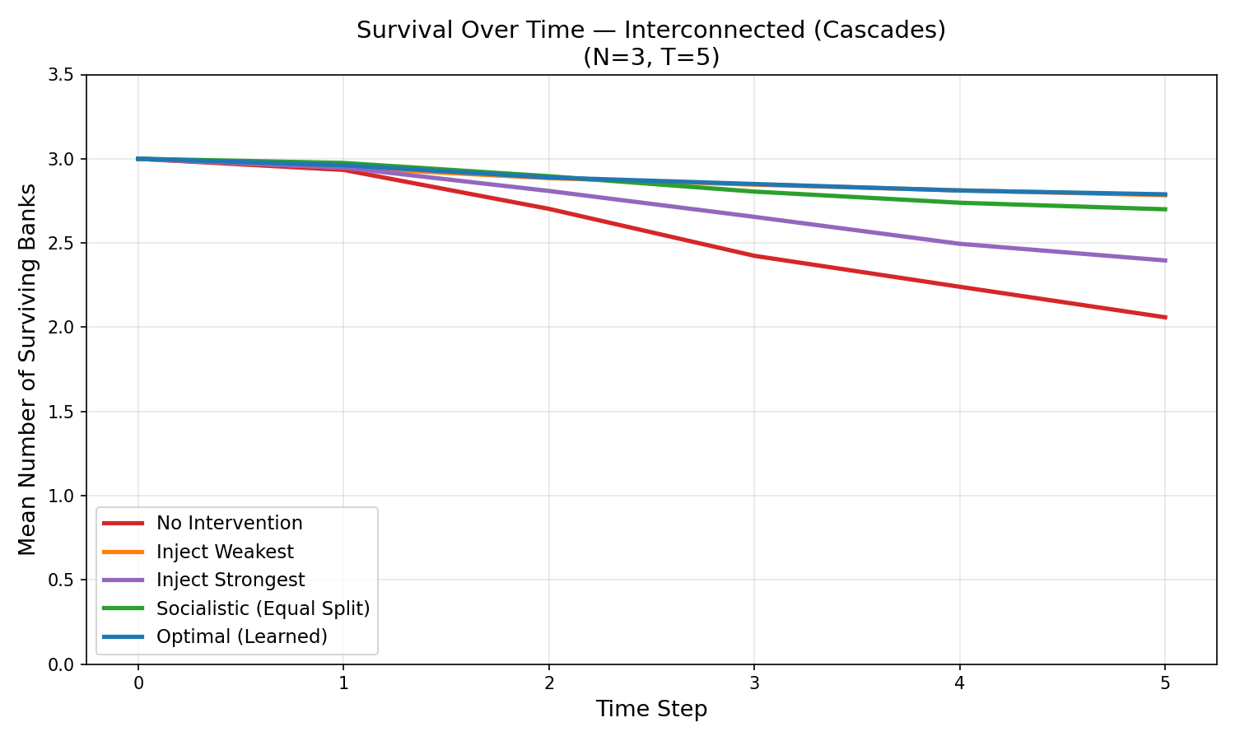
Default cascades reduce survival. No intervention drops to 2.06 (from 2.21). The gap between intervention and no intervention is larger, showing regulation is even more valuable with interconnected banks.

9.4 Cascade Effect and Budget Sensitivity
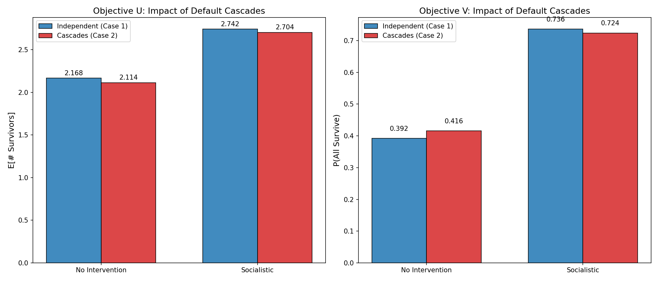
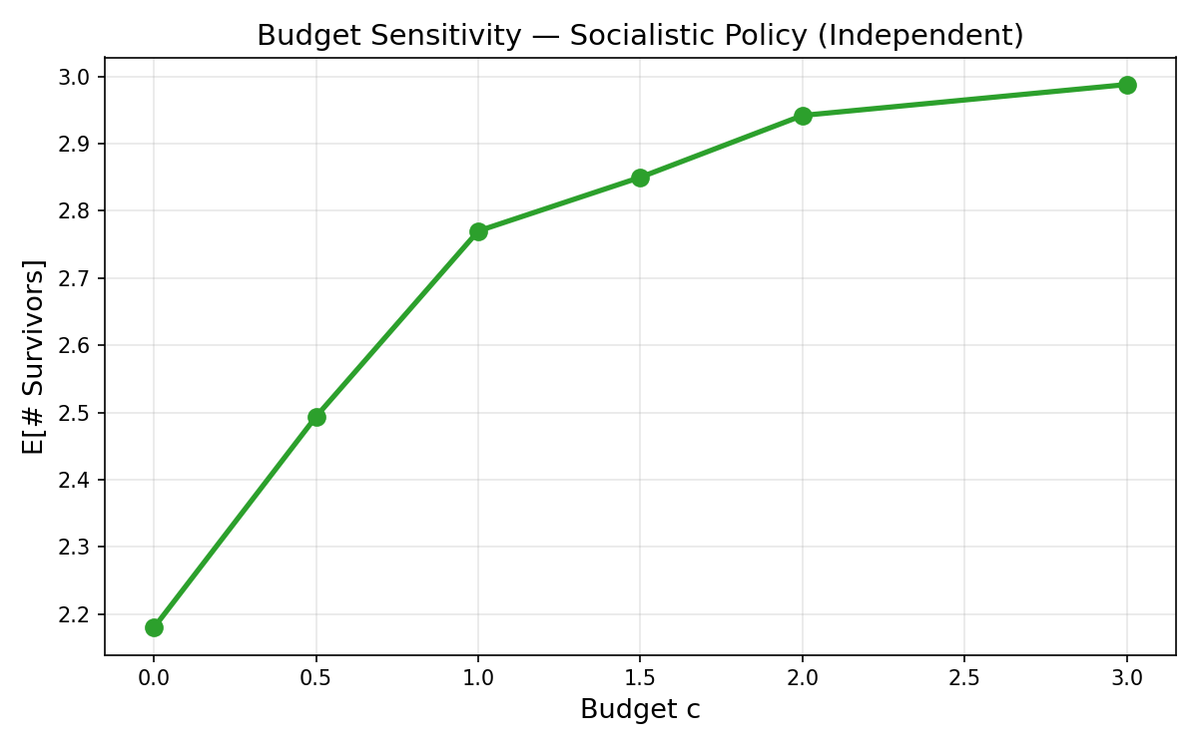
The cascade comparison shows interconnectedness consistently reduces survival. Budget sensitivity shows diminishing returns: the marginal benefit decreases, with the largest gains from the first units of budget.

10. The Socialistic Policy and Its Near-Optimality
A central result of Bayraktar et al. (2025) is that the ‘socialistic policy’ (equal split among survivors) is optimal or near-optimal, especially for objective V.

10.1 Intuition
For homogeneous banks with i.i.d. shocks, the value function is permutation-invariant. Since all banks are identical, there’s no reason to favor one over another. Equal splitting keeps all equally protected. For objective V, the weakest bank is the bottleneck, so keeping capitals equal is optimal. Jensen’s inequality also supports this: for concave objectives, equal allocation beats unequal ones.

10.2 Our Evidence
For objective U: socialistic achieves 2.72 vs optimal 2.82 (96% of optimal). For objective V: socialistic achieves P(all survive)=0.76 vs weakest-first at 0.83. The socialistic policy is extremely simple to implement yet achieves near-optimal results.

11. Error Analysis and Convergence
The approximate value function differs from the true value due to four error sources:
1. Approximation error (feature class):
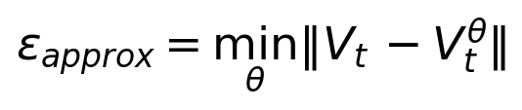
2. Statistical error (finite training set):
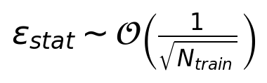
3. Monte Carlo error (finite samples):
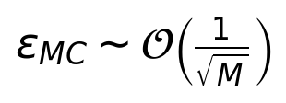
4. Action discretization error (finite action set).
Total error propagates backward through the Bellman recursion:
where γ < 1 is a contraction factor. Our R² values of 0.97-0.99 confirm excellent fit.

12. Connections to Other Methods

12.1 Longstaff-Schwartz Method
Our method is directly inspired by Longstaff-Schwartz (2001) for pricing American options. Both use backward induction with regression on basis functions. In American options, the decision is exercise vs. hold. Here, the decision is how to allocate the bailout budget. Both are instances of approximate dynamic programming with fitted value iteration.

12.2 Reinforcement Learning
In RL terminology: state = (S_t, e_t), action = b_t, reward = terminal payoff. Our method is Least Squares Temporal Difference (LSTD) learning. The key difference from general RL: we have a known model (can simulate transitions), allowing backward induction rather than online learning.

13. Likely Questions from the Professor
Q: Why dynamic programming and not direct optimization?
A: Sequential structure with uncertainty. Direct optimization would require solving over exponentially large contingent policies. DP decomposes into manageable one-step problems via the Bellman equation.
Q: Why ridge regression instead of OLS?
A: OLS overfits when P is large relative to N_train, and ΦᵀΦ may be ill-conditioned. Ridge ensures invertibility, reduces variance, improves generalization, at a small bias cost.
Q: What is the curse of dimensionality here?
A: State space R^N × {0,1}^N. Grid methods need K^N × 2^N states (exponential in N). For N=10 with K=100, that’s ~10^23 states. Function approximation stores only P parameters instead.
Q: Why are banks assumed homogeneous?
A: Homogeneity implies permutation invariance, drastically reducing complexity. The value function depends only on aggregates (average capital, number alive), justifying symmetric features.
Q: What makes the socialistic policy near-optimal?
A: For homogeneous banks, value function is symmetric. Equal injection maintains this symmetry. For objective V (all survive), the weakest bank is the bottleneck, so keeping all capitals equal is optimal. Jensen’s inequality supports this.
Q: How does the default cascade change the problem?
A: Creates positive feedback: one default triggers losses causing more defaults. Makes the problem non-local and creates a fixed-point cascade resolution. Makes socialistic policy more important since preventing any default prevents the cascade.
Q: What is the connection to Longstaff-Schwartz?
A: Both use backward induction + regression on basis functions. American options: exercise vs. hold. Here: budget allocation. Both are fitted value iteration.
Q: How do you choose the features?
A: Features should be: (1) symmetric (permutation invariant), (2) capture level, spread, extremes, (3) include nonlinear terms, (4) linearly independent. We use aggregate statistics respecting bank homogeneity.
Q: What are the sources of numerical error?
A: Four: approximation (features too restrictive), statistical (finite training, O(1/√N_train)), Monte Carlo (finite samples, O(1/√M)), and action discretization. Error propagates backward with contraction.
Q: Can this scale to N=100 or N=1000?
A: Yes, via the mean-field limit (N→∞): the system is characterized by the distribution of capitals rather than individual states. Our features are aggregates that don’t grow with N. Main bottleneck is action space.

14. Key Formulas Cheat Sheet
Capital dynamics:

Survival update:

Cascade dynamics:

Bellman equation:
Terminal conditions:


Function approximation:

Ridge regression:

Monte Carlo estimator:
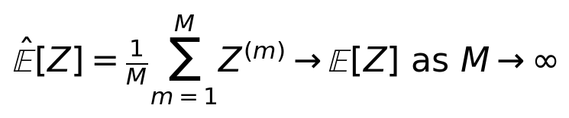
Error propagation:
Budget constraint:


