Classification

Dataset res.MCA

.

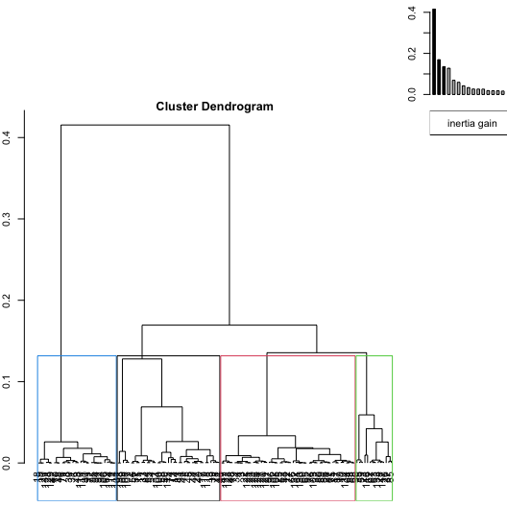

**Figure 1.1 - Hierarchical tree.**

The classification made on individuals reveals 4 clusters.

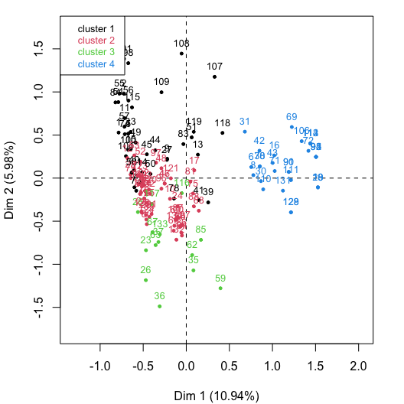

**Figure 1.2 - Ascending Hierarchical Classification of the individuals.**

The **cluster 1** is made of individuals such as *98*, *101*, *107* and *108*. This group is characterized by :

* high values for the variable *ESCOPETA*.

The **cluster 2** is made of individuals sharing :

* low values for the variable *ESCOPETA*.

The **cluster 3** is made of individuals such as *26*, *36* and *59*. This group is characterized by :

* high values for the variable *RIFLES*.

The **cluster 4** is made of individuals such as *18*, *19*, *20*, *92* and *93*. This group is characterized by :

* low values for the variable *ESCOPETA*.

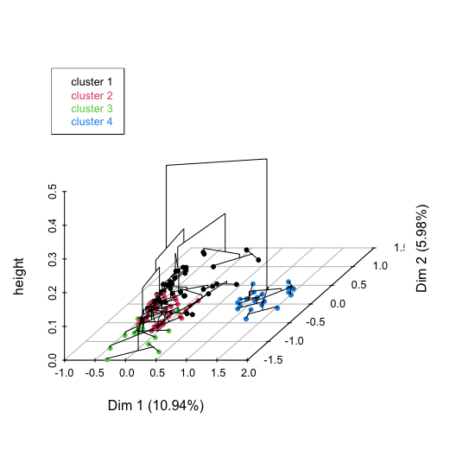

**Figure 1.3 - Hierarchical tree on the factorial map.**

The hierarchical tree can be drawn on the factorial map with the individuals colored according to their clusters.