Multiple Correspondence Analysis

Dataset Cazadores

This dataset contains 158 individuals and 89 variables.

### 1. Study of the outliers

The analysis of the graphs does not detect any outlier.

### 2. Inertia distribution

The inertia of the first dimensions shows if there are strong relationships between variables and suggests the number of dimensions that should be studied.

The first two dimensions of analyse express **10.55%** of the total dataset inertia ; that means that 10.55% of the individuals (or variables) cloud total variability is explained by the plane. This is a very small percentage and the first plane represents a small part of the data variability. This value is greater than the reference value that equals **6.33%**, the variability explained by this plane is thus significant (the reference value is the 0.95-quantile of the inertia percentages distribution obtained by simulating 1362 data tables of equivalent size on the basis of a uniform distribution).

From these observations, it is important to also interpret the dimensions greater or equal to the third one.

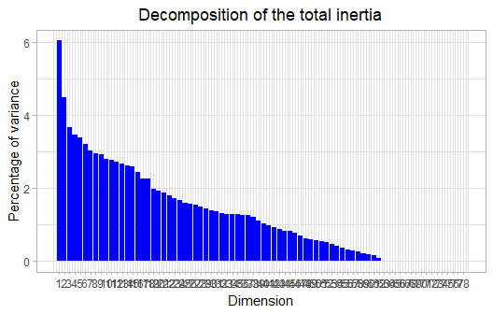

**Figure 2 - Decomposition of the total inertia**

An estimation of the right number of axis to interpret suggests to restrict the analysis to the description of the first 23 axis. These axis present an amount of inertia greater than those obtained by the 0.95-quantile of random distributions (65.62% against 52.88%). This observation suggests that only these axis are carrying a real information. As a consequence, the description will stand to these axis.

### 3. Description of the plane 1:2

## Warning: ggrepel: 1 unlabeled data points (too many overlaps). Consider  
## increasing max.overlaps

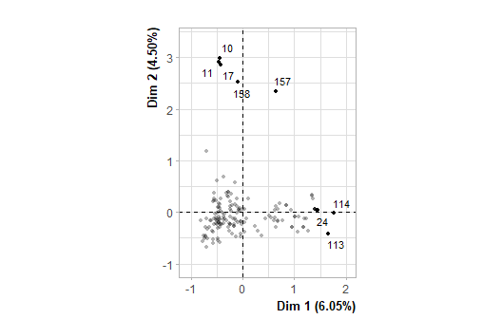

**Figure 3.1 - Individuals factor map (MCA)** *The labeled individuals are those with the higher contribution to the plane construction.*

## Warning: ggrepel: 4 unlabeled data points (too many overlaps). Consider  
## increasing max.overlaps

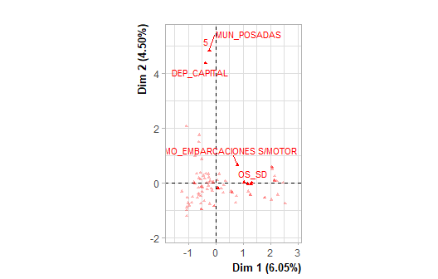

**Figure 3.2 - Variables factor map (MCA)** *The labeled variables are those the best shown on the plane.*

The **dimension 1** opposes individuals such as *114*, *115*, *24* and *113* (to the right of the graph, characterized by a strongly positive coordinate on the axis) to individuals such as *10*, *11*, *158*, *17* and *157* (to the left of the graph, characterized by a strongly negative coordinate on the axis).

The group in which the individuals *114*, *115*, *24* and *113* stand (characterized by a positive coordinate on the axis) is sharing :

* high frequency for factors like *ED=ED_SD*, *BEN=BEN_SD*, *OS=OS_SD*, *RAM=RAM_SD*, *MI=3*, *DEC=DEC_SÍ*, *CRE=CRE_SD*, *DEP=DEP_SD*, *DEP=DEP_RIO GRANDE DO SUL (BR)* and *MUN=MUN_SD* (factors are sorted from the most common).
* low frequency for factors like *OS=OS_NO*, *BEN=BEN_Sin ProgSocial*, *ED=ED_32-42 años*, *BEN=BEN_Algún ProgSocial*, *OS=OS_SI*, *RAM=RAM_ACTIVIDADES RURALES*, *MI=5*, *MUN=MUN_POSADAS*, *DEP=DEP_CAPITAL* and *DEC=DEC_NO* (factors are sorted from the rarest).

The group 2 (characterized by a negative coordinate on the axis) is sharing :

* high frequency for factors like *ED=ED_32-42 años*, *BEN=BEN_Sin ProgSocial*, *RAM=RAM_ACTIVIDADES RURALES*, *OS=OS_NO*, *MO=MO_MOTOCICLETA*, *MO=MO_SD*, *ED=ED_21-31 años*, *DEP=DEP_SAN PEDRO*, *MUN=MUN_SAN PEDRO* and *OS=OS_SI* (factors are sorted from the most common).
* low frequency for the factors *RAM=RAM_SD*, *OS=OS_SD*, *BEN=BEN_SD*, *ED=ED_SD*, *MO=MO_EMBARCACIONES S/MOTOR* and *MI=3* (factors are sorted from the rarest).

The group in which the individuals *10*, *11*, *158*, *17* and *157* stand (characterized by a negative coordinate on the axis) is sharing :

* high frequency for the factors *DEP=DEP_CAPITAL*, *MUN=MUN_POSADAS*, *MI=5*, *ED=ED_=>43 años*, *CRE=CRE_FUERA DE RIESGO*, *BEN=BEN_Algún ProgSocial* and *RAM=RAM_ADM PUBLICA/SERV PROFESIONALES* (factors are sorted from the most common).
* low frequency for the factors *CRE=CRE_SD*, *OS=OS_SD*, *BEN=BEN_SD* and *ED=ED_SD* (factors are sorted from the rarest).

The **dimension 2** opposes individuals such as *10*, *11*, *158*, *17* and *157* (to the top of the graph, characterized by a strongly positive coordinate on the axis) to individuals such as *114*, *115*, *24* and *113* (to the bottom of the graph, characterized by a strongly negative coordinate on the axis).

The group in which the individuals *10*, *11*, *158*, *17* and *157* stand (characterized by a positive coordinate on the axis) is sharing :

* high frequency for the factors *DEP=DEP_CAPITAL*, *MUN=MUN_POSADAS*, *MI=5*, *ED=ED_=>43 años*, *CRE=CRE_FUERA DE RIESGO*, *BEN=BEN_Algún ProgSocial* and *RAM=RAM_ADM PUBLICA/SERV PROFESIONALES* (factors are sorted from the most common).
* low frequency for the factors *CRE=CRE_SD*, *OS=OS_SD*, *BEN=BEN_SD* and *ED=ED_SD* (factors are sorted from the rarest).

The group in which the individuals *114*, *115*, *24* and *113* stand (characterized by a negative coordinate on the axis) is sharing :

* high frequency for factors like *ED=ED_SD*, *BEN=BEN_SD*, *OS=OS_SD*, *RAM=RAM_SD*, *MI=3*, *DEC=DEC_SÍ*, *CRE=CRE_SD*, *DEP=DEP_SD*, *DEP=DEP_RIO GRANDE DO SUL (BR)* and *MUN=MUN_SD* (factors are sorted from the most common).
* low frequency for factors like *OS=OS_NO*, *BEN=BEN_Sin ProgSocial*, *ED=ED_32-42 años*, *BEN=BEN_Algún ProgSocial*, *OS=OS_SI*, *RAM=RAM_ACTIVIDADES RURALES*, *MI=5*, *MUN=MUN_POSADAS*, *DEP=DEP_CAPITAL* and *DEC=DEC_NO* (factors are sorted from the rarest).

The group 3 (characterized by a negative coordinate on the axis) is sharing :

* high frequency for factors like *ED=ED_32-42 años*, *BEN=BEN_Sin ProgSocial*, *RAM=RAM_ACTIVIDADES RURALES*, *OS=OS_NO*, *MO=MO_MOTOCICLETA*, *MO=MO_SD*, *ED=ED_21-31 años*, *DEP=DEP_SAN PEDRO*, *MUN=MUN_SAN PEDRO* and *OS=OS_SI* (factors are sorted from the most common).
* low frequency for the factors *RAM=RAM_SD*, *OS=OS_SD*, *BEN=BEN_SD*, *ED=ED_SD*, *MO=MO_EMBARCACIONES S/MOTOR* and *MI=3* (factors are sorted from the rarest).

### 4. Description of the plane 3:4

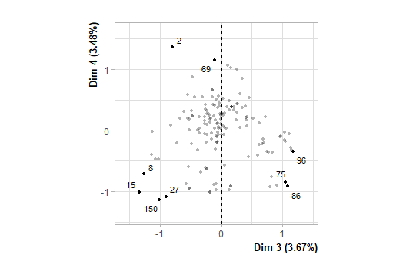

**Figure 4.1 - Individuals factor map (MCA)** *The labeled individuals are those with the higher contribution to the plane construction.*

## Warning: ggrepel: 1 unlabeled data points (too many overlaps). Consider  
## increasing max.overlaps

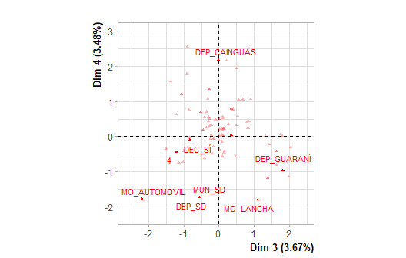

**Figure 4.2 - Variables factor map (MCA)** *The labeled variables are those the best shown on the plane.*

The **dimension 3** opposes individuals such as *86*, *75* and *96* (to the right of the graph, characterized by a strongly positive coordinate on the axis) to individuals such as *150*, *27*, *15* and *8* (to the left of the graph, characterized by a strongly negative coordinate on the axis).

The group in which the individuals *86*, *75* and *96* stand (characterized by a positive coordinate on the axis) is sharing :

* high frequency for factors like *DEP=DEP_GUARANÍ*, *DEC=DEC_NO*, *MUN=MUN_SAN VICENTE*, *MUN=MUN_EL SOBERBIO*, *RAM=RAM_ACTIVIDADES RURALES*, *DEP=DEP_SAN PEDRO*, *MUN=MUN_SAN PEDRO*, *MO=MO_MOTOCICLETA*, *MI=2* and *CRE=CRE_SD* (factors are sorted from the most common).
* low frequency for the factors *MUN=MUN_SD*, *DEP=DEP_SD*, *MI=4*, *DEC=DEC_SÍ*, *DEP=DEP_IGUAZÚ*, *RAM=RAM_CONSTRUCCION/MADERA* and *OS=OS_SD* (factors are sorted from the rarest).

The group in which the individuals *150*, *27*, *15* and *8* stand (characterized by a negative coordinate on the axis) is sharing :

* high frequency for the factors *DEP=DEP_SD*, *MUN=MUN_SD*, *DEC=DEC_SÍ*, *MI=4*, *DEP=DEP_GENERAL MANUEL BELGRANO*, *RAM=RAM_COMERCIO/TRANSPORTE/SERVICIOS (GRAL)*, *MO=MO_AUTOMOVIL* and *MUN=MUN_BERNARDO DE IRIGOYEN* (factors are sorted from the most common).
* low frequency for the factors *DEC=DEC_NO*, *DEP=DEP_IGUAZÚ*, *MI=2*, *DEP=DEP_GUARANÍ*, *RAM=RAM_CONSTRUCCION/MADERA*, *MO=MO_MOTOCICLETA*, *MUN=MUN_WANDA*, *OS=OS_NO* and *MI=1* (factors are sorted from the rarest).

The **dimension 4** opposes individuals such as *2* and *69* (to the top of the graph, characterized by a strongly positive coordinate on the axis) to individuals such as *150*, *27*, *15* and *8* (to the bottom of the graph, characterized by a strongly negative coordinate on the axis).

The group in which the individuals *2* and *69* stand (characterized by a positive coordinate on the axis) is sharing :

* high frequency for the factors *DEP=DEP_IGUAZÚ*, *RAM=RAM_CONSTRUCCION/MADERA*, *MUN=MUN_WANDA*, *DEP=DEP_CAINGUÁS*, *MI=1*, *MO=MO_SD*, *MUN=MUN_PUERTO LIBERTAD* and *MUN=MUN_CAMPO GRANDE* (factors are sorted from the most common).
* low frequency for the factors *MUN=MUN_SD*, *DEP=DEP_SD*, *MI=3*, *RAM=RAM_ACTIVIDADES RURALES*, *DEP=DEP_GUARANÍ*, *MO=MO_LANCHA* and *RAM=RAM_COMERCIO/TRANSPORTE/SERVICIOS (GRAL)* (factors are sorted from the rarest).

The group in which the individuals *150*, *27*, *15* and *8* stand (characterized by a negative coordinate on the axis) is sharing :

* high frequency for the factors *DEP=DEP_SD*, *MUN=MUN_SD*, *DEC=DEC_SÍ*, *MI=4*, *DEP=DEP_GENERAL MANUEL BELGRANO*, *RAM=RAM_COMERCIO/TRANSPORTE/SERVICIOS (GRAL)*, *MO=MO_AUTOMOVIL* and *MUN=MUN_BERNARDO DE IRIGOYEN* (factors are sorted from the most common).
* low frequency for the factors *DEC=DEC_NO*, *DEP=DEP_IGUAZÚ*, *MI=2*, *DEP=DEP_GUARANÍ*, *RAM=RAM_CONSTRUCCION/MADERA*, *MO=MO_MOTOCICLETA*, *MUN=MUN_WANDA*, *OS=OS_NO* and *MI=1* (factors are sorted from the rarest).

### 5. Description of the plane 5:6

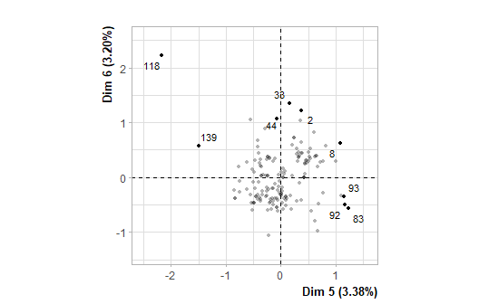

**Figure 5.1 - Individuals factor map (MCA)** *The labeled individuals are those with the higher contribution to the plane construction.*

## Warning: ggrepel: 2 unlabeled data points (too many overlaps). Consider  
## increasing max.overlaps

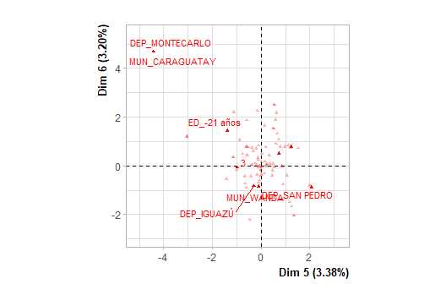

**Figure 5.2 - Variables factor map (MCA)** *The labeled variables are those the best shown on the plane.*

The **dimension 5** opposes individuals such as *92*, *93*, *8*, *2* and *83* (to the right of the graph, characterized by a strongly positive coordinate on the axis) to individuals such as *118*, *33* and *139* (to the left of the graph, characterized by a strongly negative coordinate on the axis).

The group in which the individuals *92*, *93*, *8*, *2* and *83* stand (characterized by a positive coordinate on the axis) is sharing :

* high frequency for the factors *DEP=DEP_GENERAL MANUEL BELGRANO*, *RAM=RAM_ACTIVIDADES RURALES*, *MUN=MUN_COMANDANTE ANDRESITO*, *DEP=DEP_SAN PEDRO*, *MUN=MUN_SAN PEDRO*, *MUN=MUN_BERNARDO DE IRIGOYEN*, *MUN=MUN_SAN ANTONIO*, *MI=2* and *MO=MO_AUTOMOVIL* (factors are sorted from the most common).
* low frequency for the factors *DEP=DEP_IGUAZÚ*, *MI=3*, *MUN=MUN_WANDA*, *RAM=RAM_COMERCIO/TRANSPORTE/SERVICIOS (GRAL)*, *MUN=MUN_PUERTO LIBERTAD*, *RAM=RAM_CONSTRUCCION/MADERA*, *OS=OS_SI*, *MO=MO_SD*, *MUN=MUN_ELDORADO* and *DEP=DEP_ELDORADO* (factors are sorted from the rarest).

The group in which the individuals *118*, *33* and *139* stand (characterized by a negative coordinate on the axis) is sharing :

* high frequency for the factors *ED=ED_-21 años*, *DEC=DEC_SÍ*, *GEN=GEN_MUJER* and *OS=OS_NO* (factors are sorted from the most common).
* low frequency for the factors *DEC=DEC_NO*, *GEN=GEN_VARÓN* and *DEP=DEP_IGUAZÚ* (factors are sorted from the rarest).

The group 3 (characterized by a negative coordinate on the axis) is sharing :

* high frequency for the factors *DEP=DEP_IGUAZÚ*, *MUN=MUN_WANDA*, *RAM=RAM_COMERCIO/TRANSPORTE/SERVICIOS (GRAL)*, *OS=OS_SI*, *MI=3*, *MUN=MUN_PUERTO LIBERTAD*, *DEC=DEC_NO*, *RAM=RAM_CONSTRUCCION/MADERA*, *DEP=DEP_ELDORADO* and *MUN=MUN_ELDORADO* (factors are sorted from the most common).
* low frequency for the factors *DEP=DEP_GENERAL MANUEL BELGRANO*, *RAM=RAM_ACTIVIDADES RURALES*, *MUN=MUN_COMANDANTE ANDRESITO*, *DEP=DEP_SAN PEDRO*, *DEC=DEC_SÍ*, *MUN=MUN_BERNARDO DE IRIGOYEN*, *MUN=MUN_SAN PEDRO*, *MUN=MUN_SAN ANTONIO* and *OS=OS_NO* (factors are sorted from the rarest).

The **dimension 6** opposes individuals such as *118*, *92*, *93*, *8*, *33*, *2*, *83* and *139* (to the top of the graph, characterized by a strongly positive coordinate on the axis) to individuals characterized by a strongly negative coordinate on the axis (to the bottom of the graph).

The group in which the individuals *118*, *33* and *139* stand (characterized by a positive coordinate on the axis) is sharing :

* high frequency for the factors *ED=ED_-21 años*, *DEC=DEC_SÍ*, *GEN=GEN_MUJER* and *OS=OS_NO* (factors are sorted from the most common).
* low frequency for the factors *DEC=DEC_NO*, *GEN=GEN_VARÓN* and *DEP=DEP_IGUAZÚ* (factors are sorted from the rarest).

The group in which the individuals *92*, *93*, *8*, *2* and *83* stand (characterized by a positive coordinate on the axis) is sharing :

* high frequency for the factors *DEP=DEP_GENERAL MANUEL BELGRANO*, *RAM=RAM_ACTIVIDADES RURALES*, *MUN=MUN_COMANDANTE ANDRESITO*, *DEP=DEP_SAN PEDRO*, *MUN=MUN_SAN PEDRO*, *MUN=MUN_BERNARDO DE IRIGOYEN*, *MUN=MUN_SAN ANTONIO*, *MI=2* and *MO=MO_AUTOMOVIL* (factors are sorted from the most common).
* low frequency for the factors *DEP=DEP_IGUAZÚ*, *MI=3*, *MUN=MUN_WANDA*, *RAM=RAM_COMERCIO/TRANSPORTE/SERVICIOS (GRAL)*, *MUN=MUN_PUERTO LIBERTAD*, *RAM=RAM_CONSTRUCCION/MADERA*, *OS=OS_SI*, *MO=MO_SD*, *MUN=MUN_ELDORADO* and *DEP=DEP_ELDORADO* (factors are sorted from the rarest).

The group 3 (characterized by a negative coordinate on the axis) is sharing :

* high frequency for the factors *DEP=DEP_IGUAZÚ*, *MUN=MUN_WANDA*, *RAM=RAM_COMERCIO/TRANSPORTE/SERVICIOS (GRAL)*, *OS=OS_SI*, *MI=3*, *MUN=MUN_PUERTO LIBERTAD*, *DEC=DEC_NO*, *RAM=RAM_CONSTRUCCION/MADERA*, *DEP=DEP_ELDORADO* and *MUN=MUN_ELDORADO* (factors are sorted from the most common).
* low frequency for the factors *DEP=DEP_GENERAL MANUEL BELGRANO*, *RAM=RAM_ACTIVIDADES RURALES*, *MUN=MUN_COMANDANTE ANDRESITO*, *DEP=DEP_SAN PEDRO*, *DEC=DEC_SÍ*, *MUN=MUN_BERNARDO DE IRIGOYEN*, *MUN=MUN_SAN PEDRO*, *MUN=MUN_SAN ANTONIO* and *OS=OS_NO* (factors are sorted from the rarest).

### 6. Description of the plane 7:8

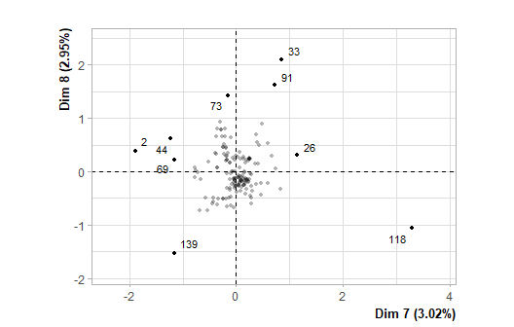

**Figure 6.1 - Individuals factor map (MCA)** *The labeled individuals are those with the higher contribution to the plane construction.*

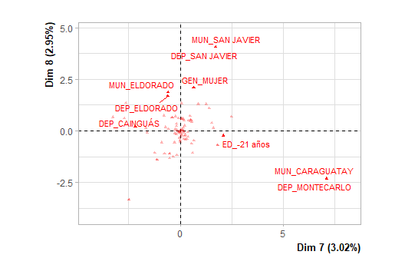

**Figure 6.2 - Variables factor map (MCA)** *The labeled variables are those the best shown on the plane.*

The **dimension 7** opposes individuals such as *118* (to the right of the graph, characterized by a strongly positive coordinate on the axis) to individuals such as *269139* (to the left of the graph, characterized by a strongly negative coordinate on the axis).

The group in which the individual *118* stands (characterized by a positive coordinate on the axis) is sharing :

* high frequency for the factors *DEP=DEP_MONTECARLO* and *MUN=MUN_CARAGUATAY* (factors are sorted from the most common).

The group in which the individuals *2*, *69* and *139* stand (characterized by a negative coordinate on the axis) is sharing :

* high frequency for the factors *DEP=DEP_GUARANÍ*, *ED=ED_=>43 años*, *GEN=GEN_VARÓN*, *DEP=DEP_CAINGUÁS* and *MUN=MUN_EL SOBERBIO* (factors are sorted from the most common).
* low frequency for the factors *DEP=DEP_ELDORADO*, *MUN=MUN_ELDORADO*, *RAM=RAM_COMERCIO/TRANSPORTE/SERVICIOS (GRAL)*, *MUN=MUN_SD*, *DEP=DEP_SD* and *GEN=GEN_MUJER* (factors are sorted from the rarest).

The **dimension 8** opposes individuals such as *73*, *33*, *91*, *44* and *26* (to the top of the graph, characterized by a strongly positive coordinate on the axis) to individuals such as *118*, *2*, *69* and *139* (to the bottom of the graph, characterized by a strongly negative coordinate on the axis).

The group in which the individuals *73*, *33*, *91*, *44* and *26* stand (characterized by a positive coordinate on the axis) is sharing :

* high frequency for the factors *DEP=DEP_ELDORADO*, *MUN=MUN_ELDORADO*, *RAM=RAM_COMERCIO/TRANSPORTE/SERVICIOS (GRAL)*, *DEP=DEP_SD*, *MUN=MUN_SD* and *GEN=GEN_MUJER* (factors are sorted from the most common).
* low frequency for the factors *DEP=DEP_GUARANÍ*, *ED=ED_=>43 años*, *GEN=GEN_VARÓN*, *MUN=MUN_EL SOBERBIO* and *DEP=DEP_CAINGUÁS* (factors are sorted from the rarest).

The group in which the individuals *2*, *69* and *139* stand (characterized by a negative coordinate on the axis) is sharing :

* high frequency for the factors *DEP=DEP_GUARANÍ*, *ED=ED_=>43 años*, *GEN=GEN_VARÓN*, *DEP=DEP_CAINGUÁS* and *MUN=MUN_EL SOBERBIO* (factors are sorted from the most common).
* low frequency for the factors *DEP=DEP_ELDORADO*, *MUN=MUN_ELDORADO*, *RAM=RAM_COMERCIO/TRANSPORTE/SERVICIOS (GRAL)*, *MUN=MUN_SD*, *DEP=DEP_SD* and *GEN=GEN_MUJER* (factors are sorted from the rarest).

The group in which the individual *118* stands (characterized by a negative coordinate on the axis) is sharing :

* high frequency for the factors *DEP=DEP_MONTECARLO* and *MUN=MUN_CARAGUATAY* (factors are sorted from the most common).

### 7. Description of the plane 9:10

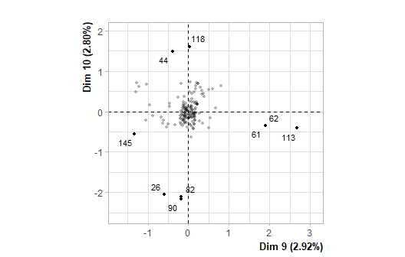

**Figure 7.1 - Individuals factor map (MCA)** *The labeled individuals are those with the higher contribution to the plane construction.*

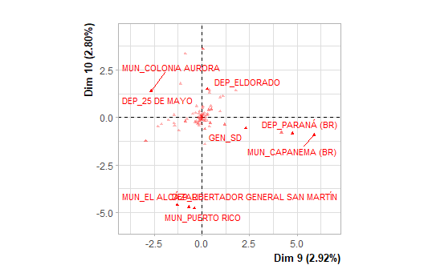

**Figure 7.2 - Variables factor map (MCA)** *The labeled variables are those the best shown on the plane.*

The **dimension 9** opposes individuals such as *113*, *61*, *62*, *44* and *118* (to the right of the graph, characterized by a strongly positive coordinate on the axis) to individuals such as ** and *145* (to the left of the graph, characterized by a strongly negative coordinate on the axis).

The group in which the individuals *44* and *118* stand (characterized by a positive coordinate on the axis) is sharing :

* high frequency for the factors *OS=OS_SI*, *DEP=DEP_ELDORADO*, *ED=ED_32-42 años*, *MUN=MUN_ELDORADO*, *BEN=BEN_Algún ProgSocial*, *DEP=DEP_SD*, *DEP=DEP_SAN PEDRO*, *MUN=MUN_SD* and *MO=MO_MOTOCICLETA* (factors are sorted from the most common).
* low frequency for the factors *OS=OS_SD*, *ED=ED_SD*, *BEN=BEN_SD*, *RAM=RAM_SD*, *DEP=DEP_CAINGUÁS*, *MUN=MUN_COLONIA AURORA* and *DEP=DEP_25 DE MAYO* (factors are sorted from the rarest).

The group in which the individuals *113*, *61* and *62* stand (characterized by a positive coordinate on the axis) is sharing :

* high frequency for the factors *DEP=DEP_PARANÁ (BR)*, *OS=OS_SD*, *BEN=BEN_SD*, *DEC=DEC_SÍ*, *ED=ED_SD* and *RAM=RAM_SD* (factors are sorted from the most common).
* low frequency for the variable *DEC=DEC_NO*.

The group in which the individual *145* stands (characterized by a negative coordinate on the axis) is sharing :

* high frequency for the factors *DEP=DEP_CAINGUÁS*, *ED=ED_SD*, *DEP=DEP_25 DE MAYO*, *MUN=MUN_COLONIA AURORA*, *OS=OS_SD*, *RAM=RAM_SD*, *BEN=BEN_SD*, *MUN=MUN_CAMPO GRANDE* and *MO=MO_EMBARCACIONES S/MOTOR* (factors are sorted from the most common).
* low frequency for the factors *OS=OS_SI*, *DEP=DEP_ELDORADO* and *ED=ED_32-42 años* (factors are sorted from the rarest).

The **dimension 10** opposes individuals such as *44* and *118* (to the top of the graph, characterized by a strongly positive coordinate on the axis) to individuals such as *90*, *82* and *26* (to the bottom of the graph, characterized by a strongly negative coordinate on the axis).

The group in which the individuals *44* and *118* stand (characterized by a positive coordinate on the axis) is sharing :

* high frequency for the factors *OS=OS_SI*, *DEP=DEP_ELDORADO*, *ED=ED_32-42 años*, *MUN=MUN_ELDORADO*, *BEN=BEN_Algún ProgSocial*, *DEP=DEP_SD*, *DEP=DEP_SAN PEDRO*, *MUN=MUN_SD* and *MO=MO_MOTOCICLETA* (factors are sorted from the most common).
* low frequency for the factors *OS=OS_SD*, *ED=ED_SD*, *BEN=BEN_SD*, *RAM=RAM_SD*, *DEP=DEP_CAINGUÁS*, *MUN=MUN_COLONIA AURORA* and *DEP=DEP_25 DE MAYO* (factors are sorted from the rarest).

The group in which the individuals *90*, *82* and *26* stand (characterized by a negative coordinate on the axis) is sharing :

* high frequency for the factors *DEP=DEP_LIBERTADOR GENERAL SAN MARTÍN* and *MUN=MUN_PUERTO RICO* (factors are sorted from the most common).

### 8. Description of the plane 11:12

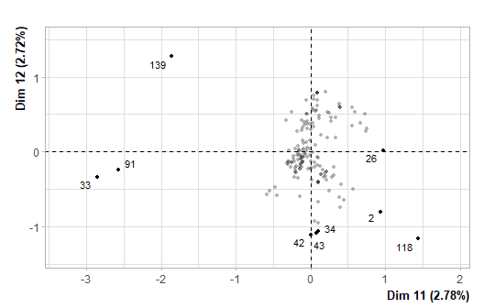

**Figure 8.1 - Individuals factor map (MCA)** *The labeled individuals are those with the higher contribution to the plane construction.*

## Warning: ggrepel: 2 unlabeled data points (too many overlaps). Consider  
## increasing max.overlaps

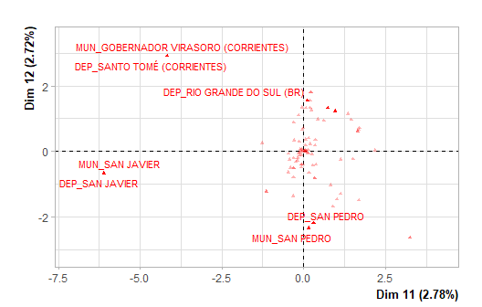

**Figure 8.2 - Variables factor map (MCA)** *The labeled variables are those the best shown on the plane.*

The **dimension 11** opposes individuals characterized by a strongly positive coordinate on the axis (to the right of the graph) to individuals such as *3391139* (to the left of the graph, characterized by a strongly negative coordinate on the axis).

The group 1 (characterized by a positive coordinate on the axis) is sharing :

* high frequency for the factors *DEP=DEP_ELDORADO*, *DEP=DEP_GUARANÍ*, *MUN=MUN_ELDORADO*, *MI=2*, *RAM=RAM_COMERCIO/TRANSPORTE/SERVICIOS (GRAL)*, *MUN=MUN_SAN VICENTE* and *DEP=DEP_RIO GRANDE DO SUL (BR)* (factors are sorted from the most common).
* low frequency for the factors *MUN=MUN_SD*, *DEP=DEP_SD*, *MI=1*, *ED=ED_32-42 años*, *MUN=MUN_SAN PEDRO* and *DEP=DEP_SAN PEDRO* (factors are sorted from the rarest).

The group in which the individuals *33*, *91* and *139* stand (characterized by a negative coordinate on the axis) is sharing :

* high frequency for the factors *DEP=DEP_SAN JAVIER* and *MUN=MUN_SAN JAVIER* (factors are sorted from the most common).

The **dimension 12** opposes individuals characterized by a strongly positive coordinate on the axis (to the top of the graph) to individuals such as *4234431182* (to the bottom of the graph, characterized by a strongly negative coordinate on the axis).

The group 1 (characterized by a positive coordinate on the axis) is sharing :

* high frequency for the factors *DEP=DEP_ELDORADO*, *DEP=DEP_GUARANÍ*, *MUN=MUN_ELDORADO*, *MI=2*, *RAM=RAM_COMERCIO/TRANSPORTE/SERVICIOS (GRAL)*, *MUN=MUN_SAN VICENTE* and *DEP=DEP_RIO GRANDE DO SUL (BR)* (factors are sorted from the most common).
* low frequency for the factors *MUN=MUN_SD*, *DEP=DEP_SD*, *MI=1*, *ED=ED_32-42 años*, *MUN=MUN_SAN PEDRO* and *DEP=DEP_SAN PEDRO* (factors are sorted from the rarest).

The group in which the individuals *42*, *34*, *43*, *118* and *2* stand (characterized by a negative coordinate on the axis) is sharing :

* high frequency for factors like *DEP=DEP_SD*, *MUN=MUN_SD*, *MI=1*, *DEP=DEP_SAN PEDRO*, *MUN=MUN_SAN PEDRO*, *ED=ED_32-42 años*, *DEP=DEP_IGUAZÚ*, *DEP=DEP_CAINGUÁS*, *DEP=DEP_25 DE MAYO* and *MUN=MUN_COLONIA AURORA* (factors are sorted from the most common).
* low frequency for the factors *DEP=DEP_ELDORADO*, *MI=2*, *MUN=MUN_ELDORADO*, *DEP=DEP_GUARANÍ*, *RAM=RAM_COMERCIO/TRANSPORTE/SERVICIOS (GRAL)* and *MUN=MUN_SAN VICENTE* (factors are sorted from the rarest).

### 9. Description of the plane 13:14

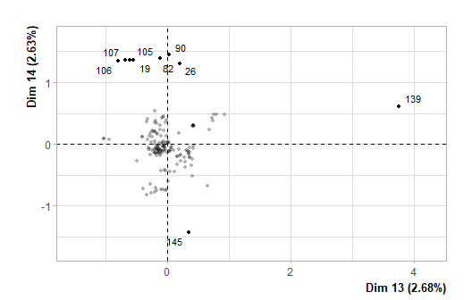

**Figure 9.1 - Individuals factor map (MCA)** *The labeled individuals are those with the higher contribution to the plane construction.*

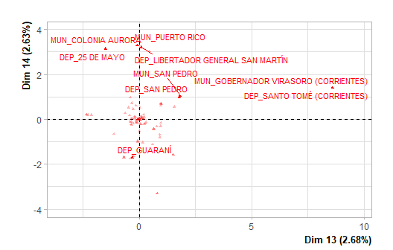

**Figure 9.2 - Variables factor map (MCA)** *The labeled variables are those the best shown on the plane.*

The **dimension 13** opposes individuals such as *139* (to the right of the graph, characterized by a strongly positive coordinate on the axis) to individuals such as *19106105107908226* (to the left of the graph, characterized by a strongly negative coordinate on the axis).

The group 1 (characterized by a positive coordinate on the axis) is sharing :

* high frequency for the factors *DEP=DEP_SD*, *MUN=MUN_SD*, *DEP=DEP_SAN PEDRO*, *MUN=MUN_SAN PEDRO*, *ED=ED_32-42 años*, *MI=4*, *MO=MO_EMBARCACIONES S/MOTOR* and *OS=OS_SI* (factors are sorted from the most common).
* low frequency for the factors *DEP=DEP_GUARANÍ* and *MI=2* (factors are sorted from the rarest).

The group in which the individual *139* stands (characterized by a positive coordinate on the axis) is sharing :

* high frequency for the factors *DEP=DEP_SANTO TOMÉ (CORRIENTES)* and *MUN=MUN_GOBERNADOR VIRASORO (CORRIENTES)* (factors are sorted from the most common).

The group 3 (characterized by a negative coordinate on the axis) is sharing :

* high frequency for the factors *DEP=DEP_GENERAL MANUEL BELGRANO*, *MUN=MUN_COMANDANTE ANDRESITO*, *MI=2*, *MO=MO_SD*, *BEN=BEN_Algún ProgSocial* and *ED=ED_SD* (factors are sorted from the most common).
* low frequency for the factors *BEN=BEN_Sin ProgSocial*, *MUN=MUN_SD*, *DEP=DEP_GUARANÍ* and *DEP=DEP_SD* (factors are sorted from the rarest).

The group in which the individuals *19*, *106*, *105*, *107*, *90*, *82* and *26* stand (characterized by a negative coordinate on the axis) is sharing :

* high frequency for the factors *DEP=DEP_25 DE MAYO*, *MUN=MUN_COLONIA AURORA*, *DEP=DEP_LIBERTADOR GENERAL SAN MARTÍN* and *MUN=MUN_PUERTO RICO* (factors are sorted from the most common).
* low frequency for the variable *OS=OS_SI*.

The **dimension 14** opposes individuals such as *19*, *106*, *105*, *107*, *90*, *82* and *26* (to the top of the graph, characterized by a strongly positive coordinate on the axis) to individuals such as ** and *145* (to the bottom of the graph, characterized by a strongly negative coordinate on the axis).

The group in which the individuals *19*, *106*, *105*, *107*, *90*, *82* and *26* stand (characterized by a positive coordinate on the axis) is sharing :

* high frequency for the factors *DEP=DEP_25 DE MAYO*, *MUN=MUN_COLONIA AURORA*, *DEP=DEP_LIBERTADOR GENERAL SAN MARTÍN* and *MUN=MUN_PUERTO RICO* (factors are sorted from the most common).
* low frequency for the variable *OS=OS_SI*.

The group in which the individual *145* stands (characterized by a negative coordinate on the axis) is sharing :

* high frequency for the factors *DEP=DEP_GUARANÍ*, *MUN=MUN_SAN VICENTE* and *MUN=MUN_EL SOBERBIO* (factors are sorted from the most common).
* low frequency for the factors *MUN=MUN_SD* and *DEP=DEP_SD* (factors are sorted from the rarest).

### 10. Description of the plane 15:16

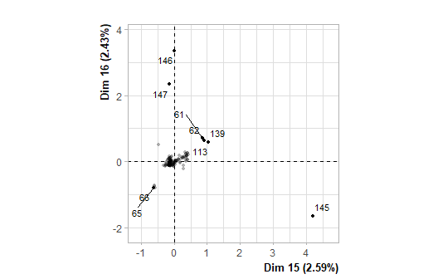

**Figure 10.1 - Individuals factor map (MCA)** *The labeled individuals are those with the higher contribution to the plane construction.*

## Warning: ggrepel: 1 unlabeled data points (too many overlaps). Consider  
## increasing max.overlaps

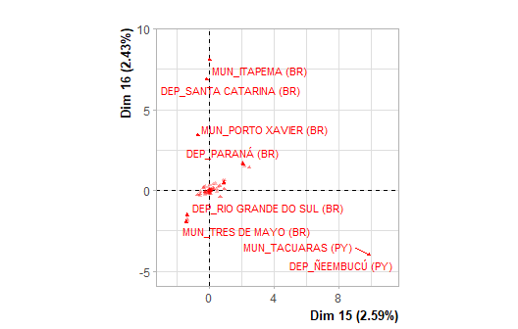

**Figure 10.2 - Variables factor map (MCA)** *The labeled variables are those the best shown on the plane.*

The **dimension 15** opposes individuals such as *145* (to the right of the graph, characterized by a strongly positive coordinate on the axis) to individuals such as *6566* (to the left of the graph, characterized by a strongly negative coordinate on the axis).

The group in which the individual *145* stands (characterized by a positive coordinate on the axis) is sharing :

* factors whose frequency does not differ significantly from the mean.

The group in which the individuals *65* and *66* stand (characterized by a negative coordinate on the axis) is sharing :

* high frequency for the variable *DEP=DEP_RIO GRANDE DO SUL (BR)*.
* low frequency for the variable *MI=4*.

The **dimension 16** opposes individuals such as *146* and *147* (to the top of the graph, characterized by a strongly positive coordinate on the axis) to individuals such as *65* and *66* (to the bottom of the graph, characterized by a strongly negative coordinate on the axis).

The group in which the individual *147* stands (characterized by a positive coordinate on the axis) is sharing :

* factors whose frequency does not differ significantly from the mean.

The group in which the individual *146* stands (characterized by a positive coordinate on the axis) is sharing :

* factors whose frequency does not differ significantly from the mean.

The group in which the individuals *65* and *66* stand (characterized by a negative coordinate on the axis) is sharing :

* high frequency for the variable *DEP=DEP_RIO GRANDE DO SUL (BR)*.
* low frequency for the variable *MI=4*.

### 11. Description of the plane 17:18

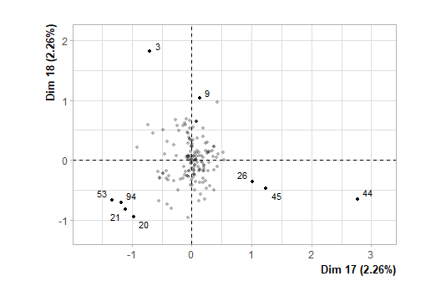

**Figure 11.1 - Individuals factor map (MCA)** *The labeled individuals are those with the higher contribution to the plane construction.*

## Warning: ggrepel: 1 unlabeled data points (too many overlaps). Consider  
## increasing max.overlaps

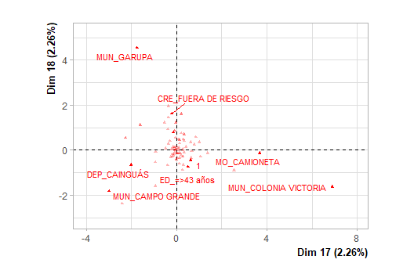

**Figure 11.2 - Variables factor map (MCA)** *The labeled variables are those the best shown on the plane.*

The **dimension 17** opposes individuals such as *44*, *45* and *26* (to the right of the graph, characterized by a strongly positive coordinate on the axis) to individuals such as *53*, *21*, *94* and *20* (to the left of the graph, characterized by a strongly negative coordinate on the axis).

The group in which the individuals *44*, *45* and *26* stand (characterized by a positive coordinate on the axis) is sharing :

* high frequency for the factors *DEP=DEP_IGUAZÚ*, *MI=1*, *ED=ED_=>43 años*, *MUN=MUN_PUERTO LIBERTAD*, *MUN=MUN_PUERTO IGUAZÚ* and *CRE=CRE_SD* (factors are sorted from the most common).
* low frequency for the factors *MI=2*, *ED=ED_21-31 años*, *DEP=DEP_GENERAL MANUEL BELGRANO*, *ED=ED_SD*, *CRE=CRE_FUERA DE RIESGO* and *MI=4* (factors are sorted from the rarest).

The group in which the individuals *53*, *21*, *94* and *20* stand (characterized by a negative coordinate on the axis) is sharing :

* high frequency for the factors *DEP=DEP_GENERAL MANUEL BELGRANO*, *ED=ED_SD*, *MUN=MUN_SAN ANTONIO*, *MI=2*, *DEC=DEC_NO*, *MUN=MUN_COMANDANTE ANDRESITO*, *CRE=CRE_SD*, *MO=MO_SD*, *MUN=MUN_CAMPO GRANDE* and *BEN=BEN_SD* (factors are sorted from the most common).
* low frequency for the factors *DEP=DEP_IGUAZÚ*, *RAM=RAM_CONSTRUCCION/MADERA*, *DEC=DEC_SÍ*, *CRE=CRE_FUERA DE RIESGO*, *MUN=MUN_WANDA*, *ED=ED_21-31 años* and *MI=4* (factors are sorted from the rarest).

The **dimension 18** opposes individuals such as *9* and *3* (to the top of the graph, characterized by a strongly positive coordinate on the axis) to individuals such as *44*, *53*, *21*, *94*, *45*, *20* and *26* (to the bottom of the graph, characterized by a strongly negative coordinate on the axis).

The group in which the individuals *9* and *3* stand (characterized by a positive coordinate on the axis) is sharing :

* high frequency for the factors *ED=ED_21-31 años*, *CRE=CRE_FUERA DE RIESGO*, *MI=4*, *RAM=RAM_CONSTRUCCION/MADERA*, *MUN=MUN_WANDA*, *MO=MO_MOTOCICLETA* and *BEN=BEN_Sin ProgSocial* (factors are sorted from the most common).
* low frequency for the factors *CRE=CRE_SD*, *ED=ED_=>43 años*, *MI=1*, *RAM=RAM_SD*, *MO=MO_SD* and *BEN=BEN_SD* (factors are sorted from the rarest).

The group in which the individuals *53*, *21*, *94* and *20* stand (characterized by a negative coordinate on the axis) is sharing :

* high frequency for the factors *DEP=DEP_GENERAL MANUEL BELGRANO*, *ED=ED_SD*, *MUN=MUN_SAN ANTONIO*, *MI=2*, *DEC=DEC_NO*, *MUN=MUN_COMANDANTE ANDRESITO*, *CRE=CRE_SD*, *MO=MO_SD*, *MUN=MUN_CAMPO GRANDE* and *BEN=BEN_SD* (factors are sorted from the most common).
* low frequency for the factors *DEP=DEP_IGUAZÚ*, *RAM=RAM_CONSTRUCCION/MADERA*, *DEC=DEC_SÍ*, *CRE=CRE_FUERA DE RIESGO*, *MUN=MUN_WANDA*, *ED=ED_21-31 años* and *MI=4* (factors are sorted from the rarest).

The group in which the individuals *44*, *45* and *26* stand (characterized by a negative coordinate on the axis) is sharing :

* high frequency for the factors *DEP=DEP_IGUAZÚ*, *MI=1*, *ED=ED_=>43 años*, *MUN=MUN_PUERTO LIBERTAD*, *MUN=MUN_PUERTO IGUAZÚ* and *CRE=CRE_SD* (factors are sorted from the most common).
* low frequency for the factors *MI=2*, *ED=ED_21-31 años*, *DEP=DEP_GENERAL MANUEL BELGRANO*, *ED=ED_SD*, *CRE=CRE_FUERA DE RIESGO* and *MI=4* (factors are sorted from the rarest).

### 12. Description of the plane 19:20

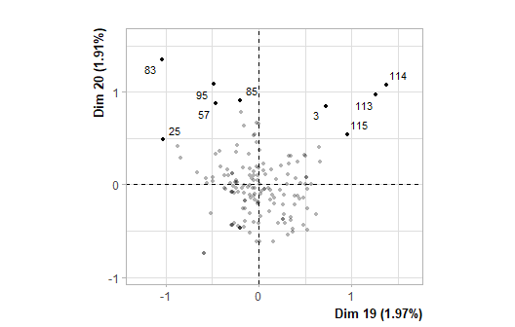

**Figure 12.1 - Individuals factor map (MCA)** *The labeled individuals are those with the higher contribution to the plane construction.*

## Warning: ggrepel: 2 unlabeled data points (too many overlaps). Consider  
## increasing max.overlaps

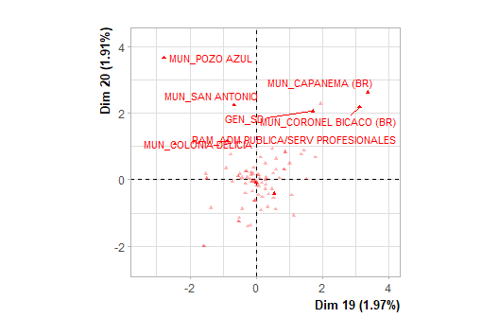

**Figure 12.2 - Variables factor map (MCA)** *The labeled variables are those the best shown on the plane.*

The **dimension 19** opposes individuals such as *114*, *115*, *113* and *3* (to the right of the graph, characterized by a strongly positive coordinate on the axis) to individuals such as *95*, *85*, *57*, *83* and *25* (to the left of the graph, characterized by a strongly negative coordinate on the axis).

The group 1 (characterized by a positive coordinate on the axis) is sharing :

* high frequency for the factors *RAM=RAM_COMERCIO/TRANSPORTE/SERVICIOS (GRAL)*, *ED=ED_32-42 años*, *GEN=GEN_VARÓN*, *MUN=MUN_ELDORADO*, *DEC=DEC_SÍ* and *OS=OS_NO* (factors are sorted from the most common).
* low frequency for the factors *RAM=RAM_ADM PUBLICA/SERV PROFESIONALES*, *MI=2*, *MUN=MUN_SAN ANTONIO*, *DEC=DEC_NO* and *MUN=MUN_WANDA* (factors are sorted from the rarest).

The group in which the individuals *114*, *115*, *113* and *3* stand (characterized by a positive coordinate on the axis) is sharing :

* high frequency for the factors *DEP=DEP_RIO GRANDE DO SUL (BR)*, *MUN=MUN_CORONEL BICACO (BR)* and *GEN=GEN_SD* (factors are sorted from the most common).

The group in which the individuals *95*, *85*, *57*, *83* and *25* stand (characterized by a negative coordinate on the axis) is sharing :

* high frequency for the factors *RAM=RAM_ADM PUBLICA/SERV PROFESIONALES*, *MI=2*, *MUN=MUN_SAN ANTONIO*, *MUN=MUN_WANDA*, *DEC=DEC_NO* and *ED=ED_=>43 años* (factors are sorted from the most common).
* low frequency for the factors *RAM=RAM_COMERCIO/TRANSPORTE/SERVICIOS (GRAL)*, *ED=ED_32-42 años*, *DEC=DEC_SÍ* and *MUN=MUN_ELDORADO* (factors are sorted from the rarest).

The **dimension 20** opposes individuals such as *95*, *114*, *85*, *57*, *83*, *25*, *115*, *113* and *3* (to the top of the graph, characterized by a strongly positive coordinate on the axis) to individuals characterized by a strongly negative coordinate on the axis (to the bottom of the graph).

The group in which the individuals *95*, *85*, *57*, *83* and *25* stand (characterized by a positive coordinate on the axis) is sharing :

* high frequency for the factors *RAM=RAM_ADM PUBLICA/SERV PROFESIONALES*, *MI=2*, *MUN=MUN_SAN ANTONIO*, *MUN=MUN_WANDA*, *DEC=DEC_NO* and *ED=ED_=>43 años* (factors are sorted from the most common).
* low frequency for the factors *RAM=RAM_COMERCIO/TRANSPORTE/SERVICIOS (GRAL)*, *ED=ED_32-42 años*, *DEC=DEC_SÍ* and *MUN=MUN_ELDORADO* (factors are sorted from the rarest).

The group in which the individuals *114*, *115*, *113* and *3* stand (characterized by a positive coordinate on the axis) is sharing :

* high frequency for the factors *DEP=DEP_RIO GRANDE DO SUL (BR)*, *MUN=MUN_CORONEL BICACO (BR)* and *GEN=GEN_SD* (factors are sorted from the most common).

The group 3 (characterized by a negative coordinate on the axis) is sharing :

* high frequency for the factors *RAM=RAM_COMERCIO/TRANSPORTE/SERVICIOS (GRAL)*, *ED=ED_32-42 años*, *GEN=GEN_VARÓN*, *MUN=MUN_ELDORADO*, *DEC=DEC_SÍ* and *OS=OS_NO* (factors are sorted from the most common).
* low frequency for the factors *RAM=RAM_ADM PUBLICA/SERV PROFESIONALES*, *MI=2*, *MUN=MUN_SAN ANTONIO*, *DEC=DEC_NO* and *MUN=MUN_WANDA* (factors are sorted from the rarest).

### 13. Description of the plane 21:22

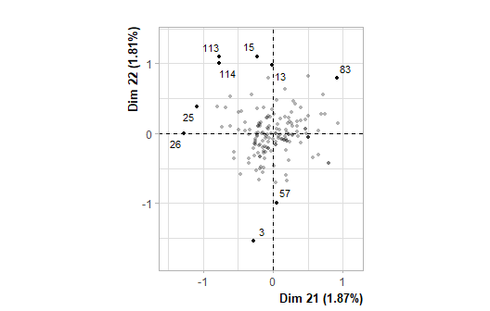

**Figure 13.1 - Individuals factor map (MCA)** *The labeled individuals are those with the higher contribution to the plane construction.*

## Warning: ggrepel: 1 unlabeled data points (too many overlaps). Consider  
## increasing max.overlaps

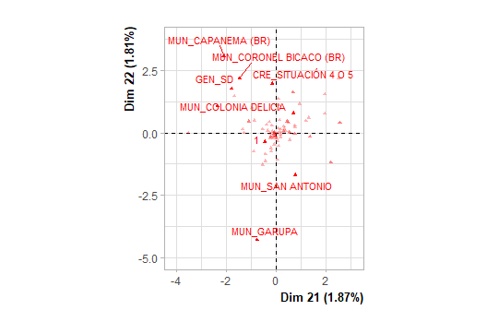

**Figure 13.2 - Variables factor map (MCA)** *The labeled variables are those the best shown on the plane.*

The **dimension 21** opposes individuals such as *83* (to the right of the graph, characterized by a strongly positive coordinate on the axis) to individuals such as *13572531511411326* (to the left of the graph, characterized by a strongly negative coordinate on the axis).

The group in which the individual *83* stands (characterized by a positive coordinate on the axis) is sharing :

* high frequency for the factors *RAM=RAM_COMERCIO/TRANSPORTE/SERVICIOS (GRAL)*, *BEN=BEN_Sin ProgSocial*, *ED=ED_32-42 años*, *MI=2*, *RAM=RAM_ADM PUBLICA/SERV PROFESIONALES*, *CRE=CRE_SD*, *GEN=GEN_VARÓN* and *OS=OS_SI* (factors are sorted from the most common).
* low frequency for the factors *RAM=RAM_SD*, *MI=1*, *BEN=BEN_SD*, *OS=OS_SD* and *ED=ED_21-31 años* (factors are sorted from the rarest).

The group in which the individuals *57* and *3* stand (characterized by a negative coordinate on the axis) is sharing :

* high frequency for the factors *MI=1*, *ED=ED_21-31 años*, *MO=MO_SD*, *GEN=GEN_MUJER*, *MUN=MUN_SAN VICENTE*, *MUN=MUN_PUERTO ESPERANZA* and *RAM=RAM_CONSTRUCCION/MADERA* (factors are sorted from the most common).
* low frequency for the factors *RAM=RAM_ADM PUBLICA/SERV PROFESIONALES*, *RAM=RAM_COMERCIO/TRANSPORTE/SERVICIOS (GRAL)* and *MI=2* (factors are sorted from the rarest).

The group in which the individuals *13*, *25*, *15*, *114*, *113* and *26* stand (characterized by a negative coordinate on the axis) is sharing :

* high frequency for the factors *GEN=GEN_SD*, *MI=4*, *DEP=DEP_ELDORADO*, *MUN=MUN_COMANDANTE ANDRESITO*, *MUN=MUN_COLONIA DELICIA*, *CRE=CRE_SITUACIÓN 4 O 5* and *MO=MO_AUTOMOVIL* (factors are sorted from the most common).
* low frequency for the factors *MO=MO_SD*, *CRE=CRE_SD*, *BEN=BEN_Sin ProgSocial* and *RAM=RAM_COMERCIO/TRANSPORTE/SERVICIOS (GRAL)* (factors are sorted from the rarest).

The **dimension 22** opposes individuals such as *13*, *25*, *15*, *114*, *83*, *113* and *26* (to the top of the graph, characterized by a strongly positive coordinate on the axis) to individuals such as *57* and *3* (to the bottom of the graph, characterized by a strongly negative coordinate on the axis).

The group in which the individual *83* stands (characterized by a positive coordinate on the axis) is sharing :

* high frequency for the factors *RAM=RAM_COMERCIO/TRANSPORTE/SERVICIOS (GRAL)*, *BEN=BEN_Sin ProgSocial*, *ED=ED_32-42 años*, *MI=2*, *RAM=RAM_ADM PUBLICA/SERV PROFESIONALES*, *CRE=CRE_SD*, *GEN=GEN_VARÓN* and *OS=OS_SI* (factors are sorted from the most common).
* low frequency for the factors *RAM=RAM_SD*, *MI=1*, *BEN=BEN_SD*, *OS=OS_SD* and *ED=ED_21-31 años* (factors are sorted from the rarest).

The group in which the individuals *13*, *25*, *15*, *114*, *113* and *26* stand (characterized by a positive coordinate on the axis) is sharing :

* high frequency for the factors *GEN=GEN_SD*, *MI=4*, *DEP=DEP_ELDORADO*, *MUN=MUN_COMANDANTE ANDRESITO*, *MUN=MUN_COLONIA DELICIA*, *CRE=CRE_SITUACIÓN 4 O 5* and *MO=MO_AUTOMOVIL* (factors are sorted from the most common).
* low frequency for the factors *MO=MO_SD*, *CRE=CRE_SD*, *BEN=BEN_Sin ProgSocial* and *RAM=RAM_COMERCIO/TRANSPORTE/SERVICIOS (GRAL)* (factors are sorted from the rarest).

The group in which the individuals *57* and *3* stand (characterized by a negative coordinate on the axis) is sharing :

* high frequency for the factors *MI=1*, *ED=ED_21-31 años*, *MO=MO_SD*, *GEN=GEN_MUJER*, *MUN=MUN_SAN VICENTE*, *MUN=MUN_PUERTO ESPERANZA* and *RAM=RAM_CONSTRUCCION/MADERA* (factors are sorted from the most common).
* low frequency for the factors *RAM=RAM_ADM PUBLICA/SERV PROFESIONALES*, *RAM=RAM_COMERCIO/TRANSPORTE/SERVICIOS (GRAL)* and *MI=2* (factors are sorted from the rarest).

### 14. Description of the dimension 23

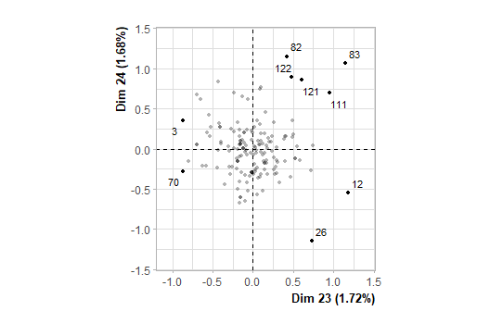

**Figure 14.1 - Individuals factor map (MCA)** *The labeled individuals are those with the higher contribution to the plane construction.*

## Warning: ggrepel: 6 unlabeled data points (too many overlaps). Consider  
## increasing max.overlaps

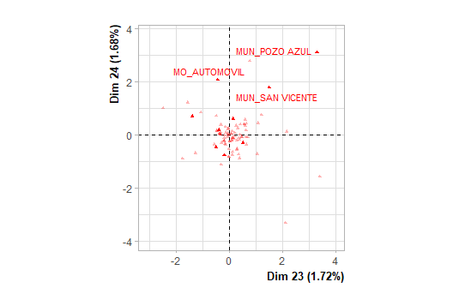

**Figure 14.2 - Variables factor map (MCA)** *The labeled variables are those the best shown on the plane.*

The **dimension 23** opposes individuals such as *121*, *122*, *111*, *83*, *82*, *12* and *26* (to the right of the graph, characterized by a strongly positive coordinate on the axis) to individuals such as *70* and *3* (to the left of the graph, characterized by a strongly negative coordinate on the axis).

The group in which the individuals *12* and *26* stand (characterized by a positive coordinate on the axis) is sharing :

* high frequency for the factors *OS=OS_SI*, *MO=MO_SD*, *MI=4* and *DEC=DEC_SÍ* (factors are sorted from the most common).
* low frequency for the factors *OS=OS_NO*, *MUN=MUN_PUERTO LIBERTAD*, *DEC=DEC_NO*, *MI=2*, *ED=ED_21-31 años*, *RAM=RAM_SD*, *MO=MO_MOTOCICLETA*, *BEN=BEN_SD* and *MUN=MUN_COMANDANTE ANDRESITO* (factors are sorted from the rarest).

The group in which the individuals *121*, *122*, *111*, *83* and *82* stand (characterized by a positive coordinate on the axis) is sharing :

* high frequency for the factors *MUN=MUN_SAN VICENTE*, *ED=ED_21-31 años*, *MUN=MUN_PUERTO RICO* and *DEP=DEP_GUARANÍ* (factors are sorted from the most common).

The group in which the individuals *70* and *3* stand (characterized by a negative coordinate on the axis) is sharing :

* high frequency for the factors *OS=OS_NO*, *MUN=MUN_PUERTO LIBERTAD* and *MUN=MUN_COMANDANTE ANDRESITO* (factors are sorted from the most common).
* low frequency for the factors *OS=OS_SI*, *MO=MO_SD* and *DEP=DEP_GUARANÍ* (factors are sorted from the rarest).

## Annexes