Classification

Dataset res.MCA

.

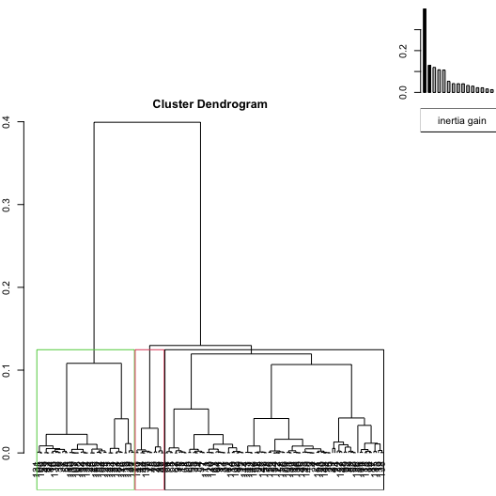

**Figure 1.1 - Hierarchical tree.**

The classification made on individuals reveals 3 clusters.

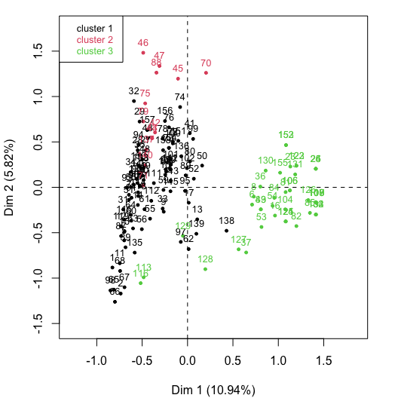

**Figure 1.2 - Ascending Hierarchical Classification of the individuals.**

The **cluster 1** is made of individuals such as *2*, *65*, *66*, *67* and *98*. This group is characterized by :

* high values for the variable *ESCOPETA*.

The **cluster 2** is made of individuals such as *45*, *46*, *47*, *70* and *88*. This group is characterized by :

* high values for the variables *RIFLES* and *MACHETES* (variables are sorted from the strongest).

The **cluster 3** is made of individuals sharing :

* low values for the variable *ESCOPETA*.

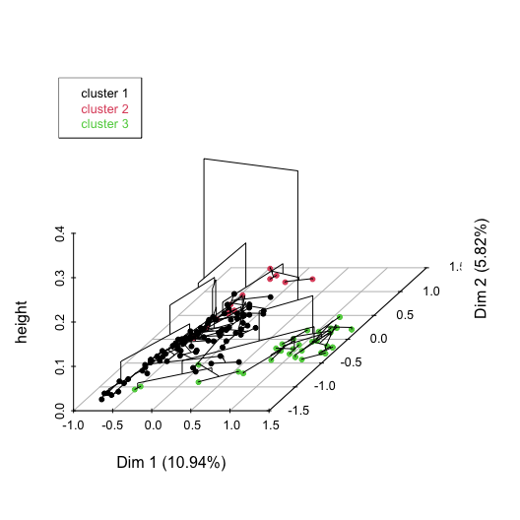

**Figure 1.3 - Hierarchical tree on the factorial map.**

The hierarchical tree can be drawn on the factorial map with the individuals colored according to their clusters.