Classification
Dataset res.MCA
.

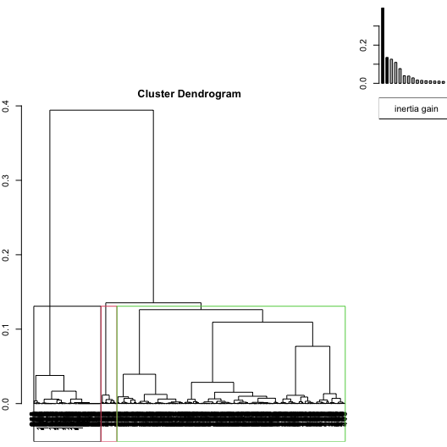
Figure 1.1 - Hierarchical tree.
The classification made on individuals reveals 3 clusters.
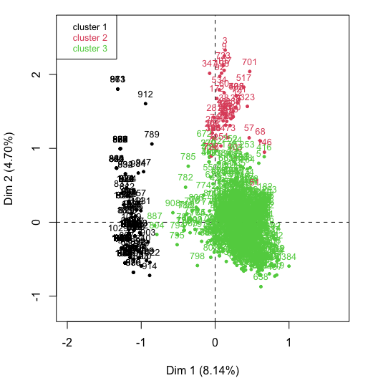
Figure 1.2 - Ascending Hierarchical Classification of the individuals.
The cluster 1 is made of individuals sharing :
- variables whose values do not differ significantly from the mean.
The cluster 2 is made of individuals sharing :
- variables whose values do not differ significantly from the mean.
The cluster 3 is made of individuals sharing :
- variables whose values do not differ significantly from the mean.
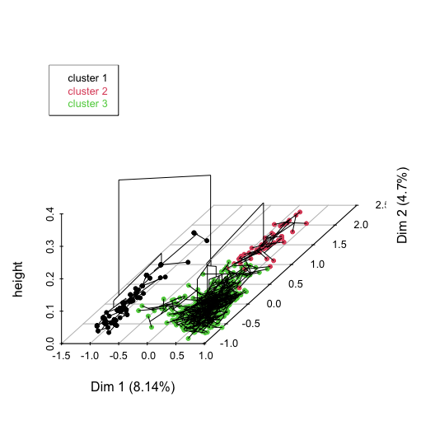
Figure 1.3 - Hierarchical tree on the factorial map.
The hierarchical tree can be drawn on the factorial map with the individuals colored according to their clusters.

