Classification

Dataset res.MCA

.

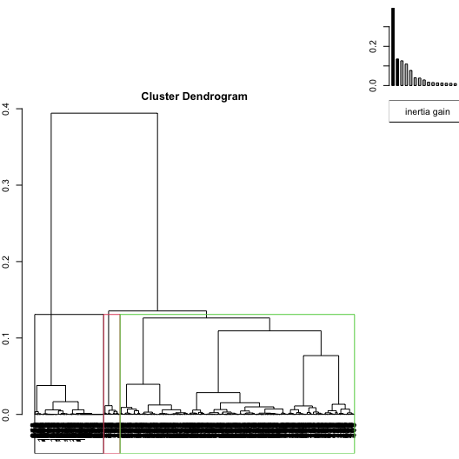

**Figure 1.1 - Hierarchical tree.**

The classification made on individuals reveals 3 clusters.

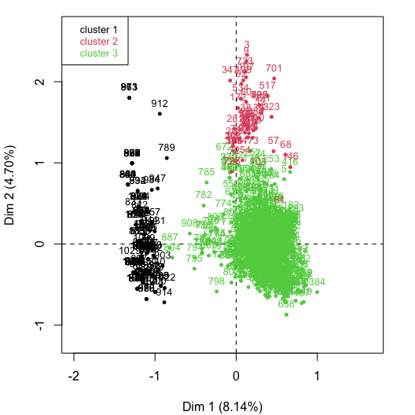

**Figure 1.2 - Ascending Hierarchical Classification of the individuals.**

The **cluster 1** is made of individuals sharing :

* variables whose values do not differ significantly from the mean.

The **cluster 2** is made of individuals sharing :

* variables whose values do not differ significantly from the mean.

The **cluster 3** is made of individuals sharing :

* variables whose values do not differ significantly from the mean.

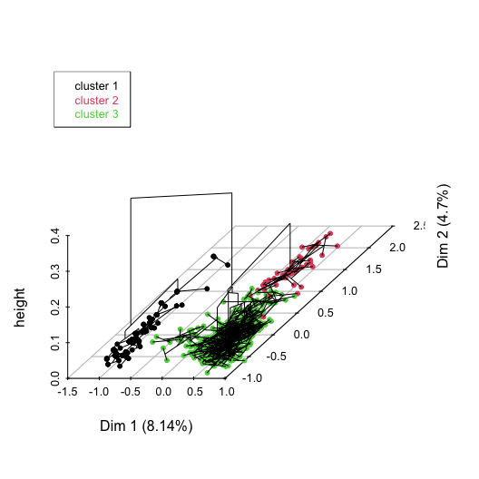

**Figure 1.3 - Hierarchical tree on the factorial map.**

The hierarchical tree can be drawn on the factorial map with the individuals colored according to their clusters.