Supplementary Information
Multi-dimensional decomposition of material extraction patterns: Projecting the MERCOSUR-EU trade agreement
Raimundo Elías Gómez

Table S1. GLORIA indicator classification
Classification of 367 GLORIA material satellite indicators into four MFA categories and 15 subcategories following EUROSTAT/UNEP-IRP conventions (EUROSTAT 2018).
MFA category | Subcategory | Number of indicators
Biomass | Crops | 142
Biomass | Crop residues | 89
Biomass | Grazed biomass | 52
Biomass | Wood | 31
Biomass | Fishery and aquatic products | 14
Metal ores | Iron | 3
Metal ores | Aluminium | 2
Metal ores | Copper | 2
Metal ores | Gold | 2
Metal ores | Other metals | 6
Non-metallic minerals | Construction minerals | 8
Non-metallic minerals | Industrial minerals | 6
Fossil fuels | Coal | 3
Fossil fuels | Oil | 3
Fossil fuels | Gas and peat | 4
Total |  | 367

Table S2. Rank selection diagnostics
NTF rank selection diagnostics for K = 2 to K = 10. For each rank: variance explained (R²), marginal R² gain relative to K − 1, and sparsity (proportion of loadings below 10⁻⁶). Results for K = 6 correspond to the final model fitted with 10 random initialisations; all other ranks were fitted with three initialisations.
K | R² | Marginal R² gain | Sparsity
2 | 0.47 | — | 0.42
3 | 0.56 | 0.090 | 0.48
4 | 0.63 | 0.070 | 0.53
5 | 0.70 | 0.021 | 0.57
6 | 0.75 | 0.050 | 0.60
7 | 0.76 | 0.010 | 0.63
8 | 0.78 | 0.020 | 0.65
9 | 0.79 | 0.010 | 0.67
10 | 0.80 | 0.010 | 0.69
Note: The K = 6 row reports results from the final 10-initialisation fit (R² = 0.75), which improves upon the 3-initialisation screening (R² = 0.74). The marginal R² gain is computed relative to K = 5 using the final model value; subsequent ranks (K = 7–10) use 3-initialisation screening values.

Table S3. Augmented Dickey-Fuller test results
Augmented Dickey-Fuller (ADF) tests for unit root in the six NTF temporal loading series. Three specifications: constant only, constant plus linear trend, and constant plus quadratic trend. Rejection of the null hypothesis confirms trend-stationarity, supporting the use of quadratic trend extrapolation for the scenario projections.
Component | Label | Constant | Constant + trend | Constant + quadratic
C1 | Agricultural crops | p < 0.01 | p < 0.01 | p < 0.01
C2 | Forestry and wood | p < 0.01 | p < 0.05 | p < 0.01
C3 | Fishery and aquatic | p < 0.01 | p < 0.01 | p < 0.01
C4 | Non-metallic minerals | p < 0.01 | p < 0.05 | p < 0.01
C5 | Livestock and grazing | p < 0.01 | p < 0.01 | p < 0.01
C6 | Metal ores | p < 0.05 | p = 0.079 | p < 0.05
Note: All series reject the unit root null at the 5% level under at least two of three specifications. C6 under constant-plus-trend (p = 0.079) is the only marginal case; rejection under constant and quadratic specifications confirms trend-stationarity.

Table S4. Tariff shock calibration rationale
For each NTF component, the principal tariff concessions were identified from the agreement's factsheets — quota volumes, applicable tariff rates, and the magnitude of the tariff reduction. The component receiving the largest combined concession — C5 (livestock), with a beef quota representing approximately a 32 percentage point reduction from the prevailing tariff (European Commission 2024b) — was assigned the highest shock parameter (δ = +15% for MERCOSUR exports to EU). The remaining components were scaled relative to C5 in proportion to the magnitude and tradability of their respective concessions.
Component | Label | Key concession | Tariff reduction magnitude | Assigned δ (MERC → EU) | Rationale
C5 | Livestock | Beef 99,000 t at 7.5%; poultry 180,000 t | ~32 pp from MFN rate | +15% | Largest quota + deepest tariff cut
C1 | Crops | Sugar 190,000 t duty-free; rice 60,000 t | ~20–25 pp on sugar/rice | +12% | Second-largest; high volume quotas
C6 | Metal ores | Critical minerals clause: Nb, Li, Ta | Variable; strategic access | +10% | Strategic clause; moderate volume
C3 | Fishery | Shrimp and fish quota expansion | ~10–15 pp | +8% | Moderate; limited tradable volume
C2 | Forestry | Bilateral liberalisation | ~5–10 pp | +6% | Moderate; already low barriers
C4 | Non-metallic | Minimal | ~0–2 pp | +2% | Construction minerals rarely traded
EU → MERCOSUR shocks are lower, reflecting the smaller material extraction impact of MERCOSUR's tariff reductions on EU manufactures. The absolute values are uncertain; the ordinal ranking (C5 > C1 > C6 > C3 > C2 > C4) is robust to reasonable alternative calibrations.

Table S5. Sector-level impact: top 20 sectors by projected agreement effect
Projected agreement-induced increase in material extraction by sector, computed as the percentage change between agreement and baseline scenarios at 2034 (full implementation). Percentage effects are symmetric across blocs because the tariff shock operates on shared temporal loadings.
Rank | Sector | Projected increase (%) | Dominant NTF component
1 | Raising of cattle | +10.8 | C5 Livestock
2 | Raising of sheep and goats | +10.8 | C5 Livestock
3 | Growing of cereals n.e.c. | +9.7 | C1 Crops
4 | Raising of animals n.e.c. and services to agriculture | +9.5 | C5 Livestock
5 | Food products and feeds n.e.c. | +8.6 | C1/C5
6 | Growing of vegetables | +8.5 | C1 Crops
7 | Growing of wheat | +8.5 | C1 Crops
8 | Growing of sugar cane/beet | +8.4 | C1 Crops
9 | Dairy products | +8.2 | C5 Livestock
10 | Growing of plant-based fibres | +8.0 | C1 Crops
11 | Growing of fruits and nuts | +7.8 | C1 Crops
12 | Growing of oil seeds | +7.6 | C1 Crops
13 | Forestry | +5.2 | C2 Forestry
14 | Sawmilling and wood | +5.0 | C2 Forestry
15 | Fishing | +4.8 | C3 Fishery
16 | Crustaceans and aquatic products | +4.5 | C3 Fishery
17 | Lead/zinc ore mining | +4.2 | C6 Metal ores
18 | Non-ferrous metal production | +4.0 | C6 Metal ores
19 | Quarrying of stone and sand | +1.5 | C4 Non-metallic
20 | Mining n.e.c. | +1.3 | C4 Non-metallic

Table S6. Comparison of LMDI and NTF decomposition results, 1990–2022
To illustrate the information gained by decomposing material extraction data with NTF rather than a standard two-dimensional method, the table below presents an LMDI (Log Mean Divisia Index) additive decomposition of the change in material extraction between 1990 and 2022, alongside the corresponding NTF component-level detail. The LMDI decomposes the total change into a scale effect (proportional growth of aggregate extraction) and a structure effect (shift in the composition across MFA categories), following the standard formulation in Ang (2015). NTF operates on the full four-dimensional tensor and identifies six latent extraction systems with country, sector, material, and temporal loadings.

Panel A. LMDI additive decomposition by bloc and MFA category
Bloc | MFA category | 1990 (Mt) | 2022 (Mt) | Change (Mt) | Scale effect (Mt) | Structure effect (Mt)
MERCOSUR | Biomass | 1,811 | 3,826 | +2,015 | +2,248 (112%) | −233 (−12%)
MERCOSUR | Metal ores | 268 | 657 | +388 | +362 (93%) | +26 (7%)
MERCOSUR | Non-metallic minerals | 509 | 1,414 | +904 | +739 (82%) | +165 (18%)
MERCOSUR | Fossil fuels | 80 | 250 | +170 | +125 (73%) | +46 (27%)
EU-27 | Biomass | 1,780 | 1,781 | +1 | −103 | +104
EU-27 | Metal ores | 167 | 199 | +33 | −11 | +43
EU-27 | Non-metallic minerals | 2,729 | 3,091 | +363 | −167 | +530
EU-27 | Fossil fuels | 1,104 | 384 | −720 | −39 (5%) | −681 (95%)
Note: Percentages in parentheses indicate each effect's share of the total change. The LMDI decomposition satisfies perfect decomposition (scale + structure = total change, zero residual). The method attributes MERCOSUR's biomass growth overwhelmingly to scale (+2,248 Mt, 112%) with a negative structural shift (−233 Mt), indicating that biomass grew slightly less than proportionally to total extraction. For the EU-27, the near-zero net change in biomass (+1 Mt) masks offsetting scale and structure effects.

Panel B. Comparison of decomposition granularity
Aspect | LMDI (Ang 2015) | NTF (this study)
Input dimensions | 2-way (bloc × MFA category) | 4-way (31 countries × 120 sectors × 15 materials × 33 years)
Factors identified | 2 (scale + structure) | 6 latent extraction systems
Sector attribution | Not available | 120 sectors with loadings per component
Country attribution | Separate analysis per bloc | Simultaneous; 31 country loadings per component
Cross-dimensional interactions | Lost by flattening | Preserved (e.g., C5 couples livestock sectors with crop residues and grazed biomass)
Interpretation of MERCOSUR biomass growth | Scale effect: +2,248 Mt | C1 (agricultural crops, +0.31/yr): cereals, vegetables, wheat; C5 (livestock, +0.41/yr): cattle raising, sheep — the fastest-growing component
Interpretation of EU-27 metal ores | Structure effect: +43 Mt | C6 (metal ores, −0.03/yr): declining trend dominated by Brazil (loading 0.42), Finland (0.34), Spain (0.31)
Prospective analysis | Requires external projection model | Temporal loadings directly projectable with scenario shocks
Note: LMDI identifies how much of the change is attributable to scale versus structural composition, but cannot identify which sectors, countries, or material subcategories drive the change within each MFA category. NTF identifies six interpretable extraction systems that simultaneously reveal country, sector, material, and temporal detail — information that is lost when multi-dimensional data are flattened into two-way matrices. The comparison demonstrates that NTF and LMDI answer complementary questions: LMDI for aggregate driver attribution, NTF for the identification of latent multi-dimensional extraction patterns.

Fig. S1. Full component loading profiles

Fig. S1. Full loading profiles for all four dimensions (country, sector, material, year) across the six NTF components (K = 6, R² = 0.75). Each row represents one component; columns display the country, sector, material subcategory, and temporal loadings, respectively. Loadings are unit-normalised.

Fig. S2. Sector loading comparison MERCOSUR vs EU-27
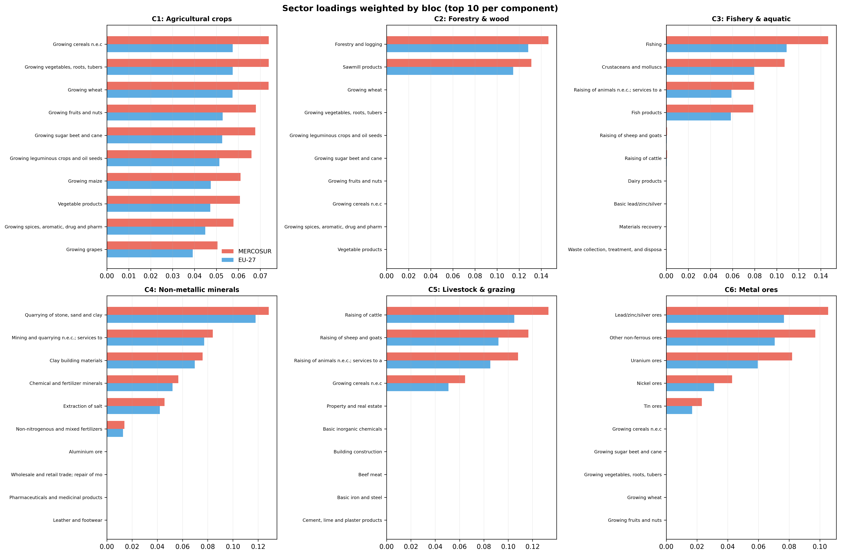
Fig. S2. Comparison of sector loadings between MERCOSUR-4 and EU-27 countries for each of the six NTF components. Top 10 sectors per component, weighted by bloc, showing bilateral sector loading profiles.

Fig. S3. Rank selection diagnostics
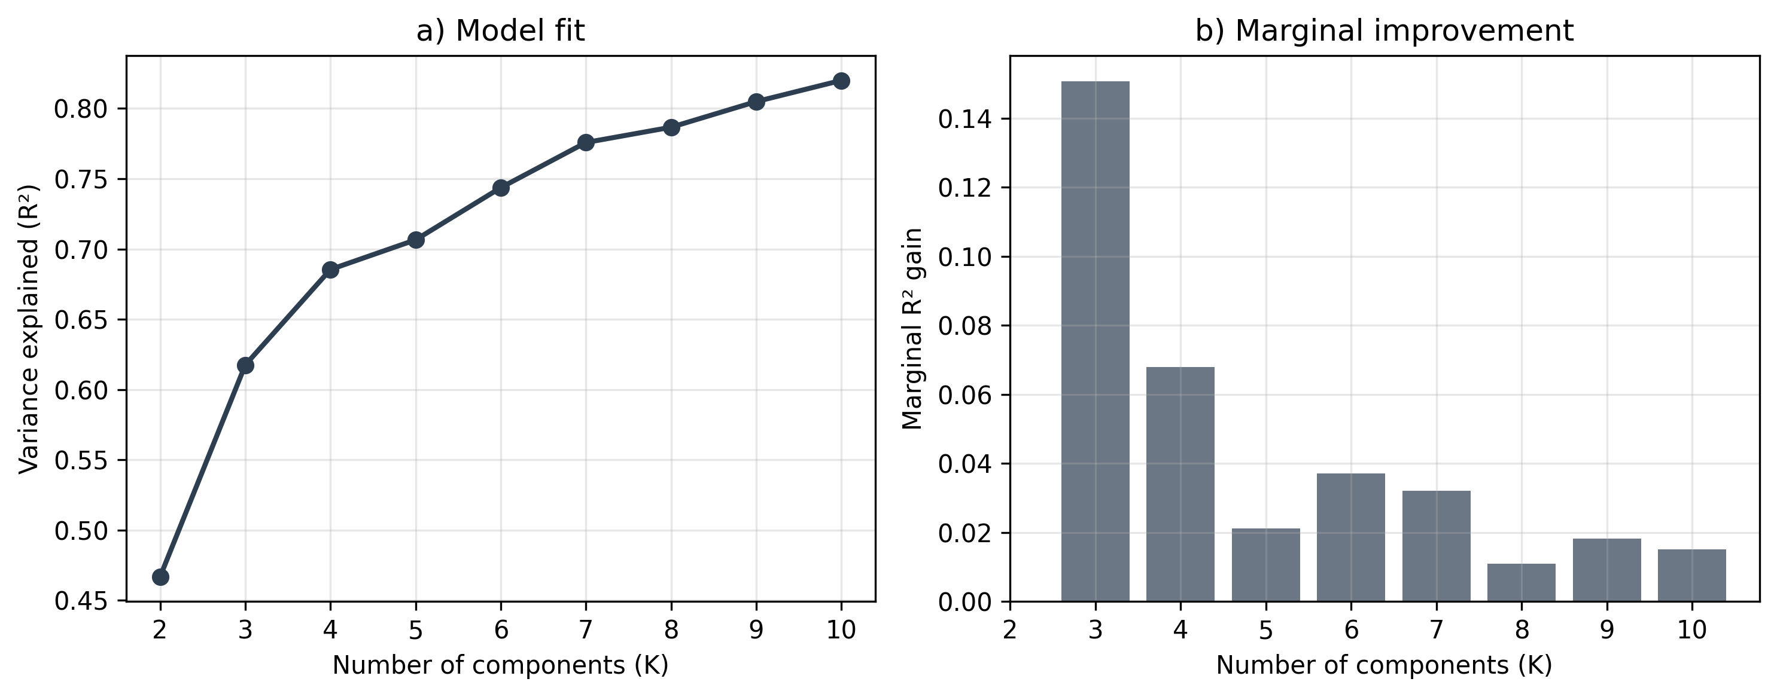
Fig. S3. Rank selection diagnostic plots: (a) variance explained (R²) as a function of K; (b) marginal R² gain per additional component. The elbow at K = 6 (R² = 0.75) indicates the selected rank; marginal gains fall below 0.02 for all K > 7.

Fig. S4. Temporal evolution of NTF components by bloc
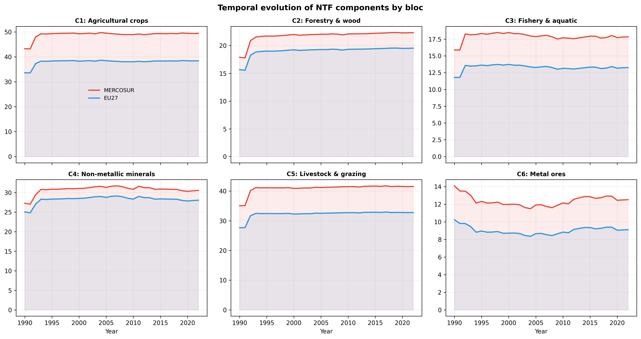
Fig. S4. Temporal evolution of NTF components by bloc, 1990–2022. Each panel shows the year loading weighted by the mean country loading for MERCOSUR (red) and EU-27 (blue). C5 (livestock and grazing) displays the widest and most rapidly expanding inter-bloc divergence, whilst C3 (fishery and aquatic) remains essentially stable for both blocs.

