**LAB 2**

*Consider the EZGas application.*

*EZGas is a crowdsourcing service that allows users to:*

* *collect prices of fuels in different gas stations*
* *locate gas stations in an area, along with the prices they practice.*

*1. Stakeholders*

|  |  |
| --- | --- |
| Stakeholders name | Description |
| User | Can be a Gas station or a driver according to the Sign in. If he is a Gas Station he can insert, update or delete his Gas Station data. If he is a Driver, he can search Gas stations. |
| Administrator | Uses the application to manage users. |

*2. Define the context diagram, and interfaces*

Context diagram

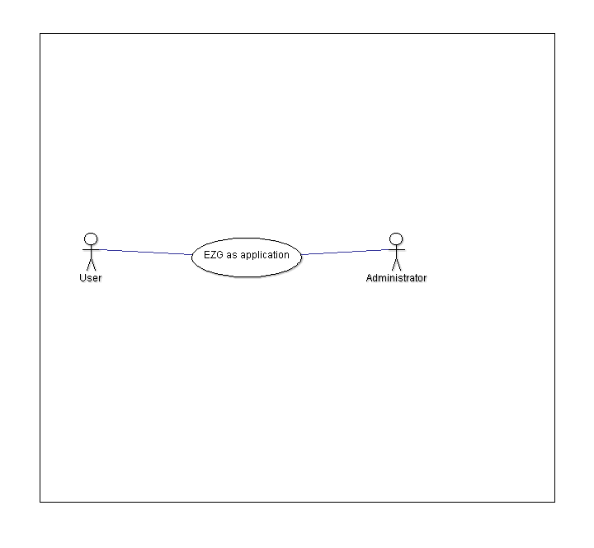

Interfaces

|  |  |  |
| --- | --- | --- |
| Actor | Physical interface | Logical interface |
| User | GUI | Screen and buttons |
| Administrator | GUI | Screen and buttons |

*3. Define personas and stories*

*John would like to know which are the current prices of the Gas stations around his area to understand which is the best for him.*

*John Sign in in the application as a Driver and can search Gas stations filtering by area, price or type (fuel, diesel..). These prices are inserted by Gas Stations (general user defined Gas station in the Sign in) that made the login as a Gas Station and that inserted their prices, type and area.*

*4. Define scenarios, use cases, and use case diagram*

*Use case diagram*

*Use cases*

**Use case 1, UC1 - Add Gas Station**

Use case: Insert Gas Station

Level: User goal

Scope: GUI

Intention in context: The Gas Station add his prices, type and area on the application

Stakeholder’s concerns:

1. Remember username and password
2. Insert correct data

Minimum Guarantees: The parameter values are consistent

Success Guarantees: The system’s value set by the Gas Station become effective for the system.

Primary actor: User

Support actors: -

Precondition: Sign in, Login

Trigger:

Main success scenario:

* The user Sign in as a Gas station
* The User makes the Login
* The Gas Station inserts his prices
* The system validates and confirms
* The Gas station inserts his area
* The system validates and confirms
* The gas station insert his type
* The system validates and confirms

**Use case 2, UC2 - Update Gas Station**

Use case: Update Gas Station

Level: User goal

Scope: GUI

Intention in context: The Gas Station update his prices, type and area

Stakeholder’s concerns:

1. Remember username and password
2. Insert correct data

Minimum Guarantees: The parameter values are consistent

Success Guarantees: The system’s value set by the Gas Station become effective for the system.

Primary actor: User

Support actors: -

Precondition: Sign in, Login

Trigger:

Main success scenario:

* The user Sign in as a Gas station
* The User makes the Login
* The Gas Station update his prices
* The system validates and confirms
* The Gas station update his area
* The system validates and confirms
* The gas station update his type
* The system validates and confirms

**Use case 3, UC3 - Remove Gas Station**

Use case: Remove Gas Station

Level: User goal

Scope: GUI

Intention in context: The Gas Station add his prices, type and area on the application

Stakeholder’s concerns: Remember username and password

Minimum Guarantees:

Success Guarantees: The Gas station is removed

Primary actor: User

Support actors: -

Precondition: Sign in, Login

Trigger:

Main success scenario:

* The user Sign in as a Gas station
* The User makes the Login
* The user delete the Gas station
* The system validates and confirms

**Use case 4, UC4 – Search by type**

Use case: Search by type

Level: User goal

Scope: GUI

Intention in context: The user wish to search Gas stations filtering by type

Stakeholder’s concerns: Remember username and password

Minimum Guarantees: The parameter values are consistent

Success Guarantees: The user is enabled to find Gas stations.

Primary actor: User

Support actors: -

Precondition: Sign in, Login

Trigger:

Main success scenario:

* The user Sign in
* The user makes the Login
* The user searches the Gas stations filtering by type

**Use case 5, UC5 – Search by price**

Use case: Search by price

Level: User goal

Scope: GUI

Intention in context: The user wish to search Gas stations filtering by price

Stakeholder’s concerns: Remember username and password

Minimum Guarantees: The parameter values are consistent

Success Guarantees: The user is enabled to find Gas stations.

Primary actor: User

Support actors: -

Precondition: Sign in, Login

Trigger:

Main success scenario:

* The user Sign in
* The user makes the Login
* The user searches the Gas stations filtering by price

**Use case 6, UC6 – Search by area**

Use case: Search by area

Level: User goal

Scope: GUI

Intention in context: The user wish to search Gas stations filtering by area

Stakeholder’s concerns: Remember username and password

Minimum Guarantees: The parameter values are consistent

Success Guarantees: The user is enabled to find Gas stations.

Primary actor: User

Support actors: -

Precondition: Sign in, Login

Trigger:

Main success scenario:

* The user Sign in
* The user makes the Login
* The user searches the Gas stations filtering by area

**Use case 7, UC7 - Login**

Use case: Login

Level: User

Scope: GUI

Intention in context: Insert username and password

Stakeholder’s concerns: Remember username and password

Minimum Guarantees: Successful Login

Success Guarantees: Username and password are valid

Primary actor: User

Support actors: -

Precondition: Sign in

Trigger:

Main success scenario:

* Sign in
* The user inserts his username and password
* The system validates and confirms

**Use case 8, UC8 – Sign in**

Use case: Sign in

Level: User

Scope: GUI

Intention in context: Decide username and password

Stakeholder’s concerns: Use an username that doesn’t exist and decide a password

Minimum Guarantees: Successful Sign in

Success Guarantees: Username and password are registered in the system

Primary actor: User

Support actors: -

Precondition: -

Trigger:

Main success scenario:

* The user inserts the username
* The system validates and confirms
* The user inserts the password
* The system validates and confirms

**Use case 9, UC9 – Users management**

Use case: Users management

Level: Administartor

Scope: GUI

Intention in context: Manage users

Stakeholder’s concerns: -

Minimum Guarantees: -

Success Guarantees: Operations are registered

Primary actor: Administrator

Support actors: -

Precondition: -

Trigger:

Main success scenario:

* Administrator manage users
* The system validates and confirms

*5. Define and number functional requirements*

|  |  |
| --- | --- |
| ID | Description |
| FR1 | Record prices of fuel of the Gas station |
| FR2 | Record area of Gas stations |
| FR3 | Record type of Gas station |
| FR4 | Find Gas stations by location |
| FR5 | Find Gas stations by price |
| FR6 | Find Gas stations by type |
| FR7 | Login management |
| FR8 | Sign in management |
| FR9 | Users management |

*6. Define and number non-functional requirements*

|  |  |
| --- | --- |
| ID | Description |
| NFR1 | Decimal numbers use (dot) as decimal separator |
| NFR2 | The price is represented in euro |

*7. Glossary*

