SM2715 Creative Coding

Final Project

GAO Ya 54380279

Wong Yan Ting 54388100

Title

BeeCut

(interactive game)

Inspiration

We got inspiration from the 2 games, “Stack” and “Scale”. The gameplay of “Stack” is to stack up the blocks as high as you can. Extra area will be cut out and blocks will become smaller. In the game of “Scale”, user need to cut and shrink the board by placing the slicer and keep the ball inside board.

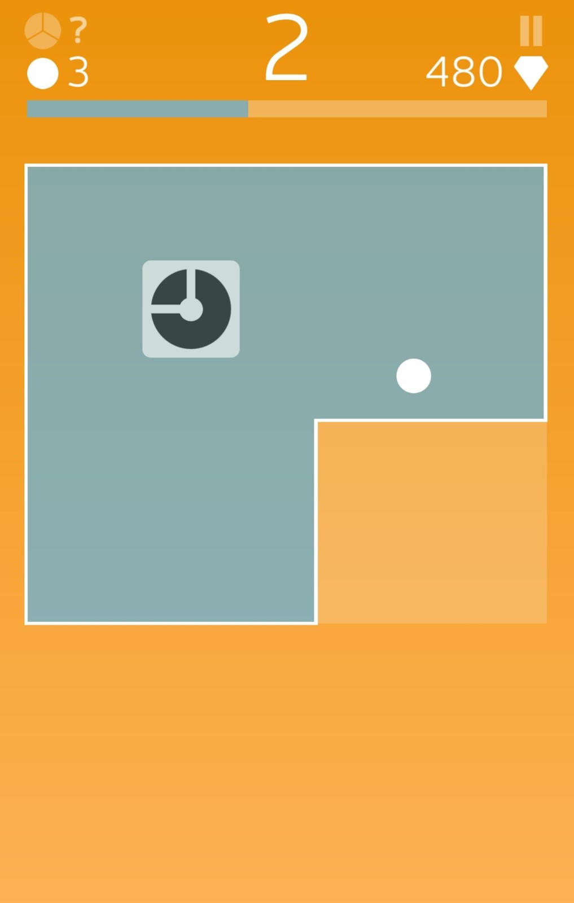

Overview – rectangle space

A pink square in the middle in the beginning. Some blue rectangles will come from left/right/top/bottom. Press SPACEBAR to stop the rectangle and it will stick to the pink square. Upper part of the square and the lower part of the rectangle will be cut and become a new rectangle. Score will plus one.

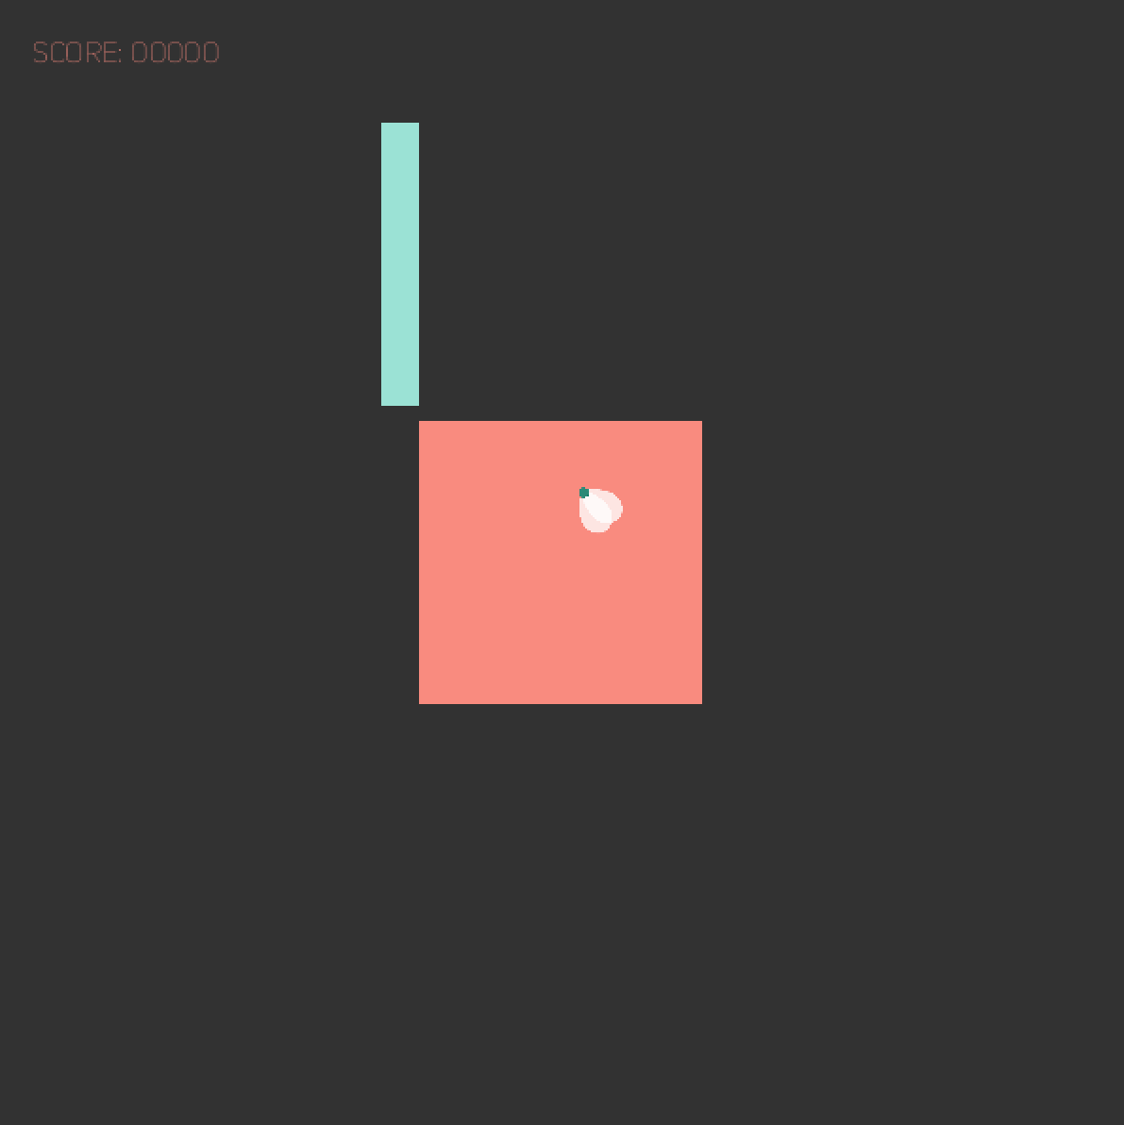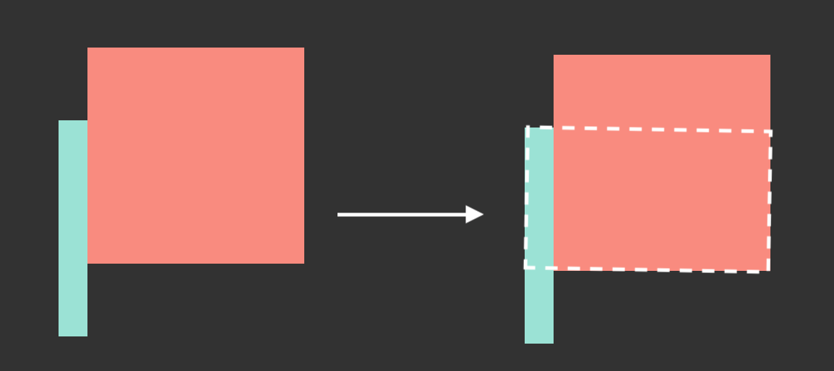

Overview – bee

A bee flies inside the rectangle area. Some yellow circles represent its tail.

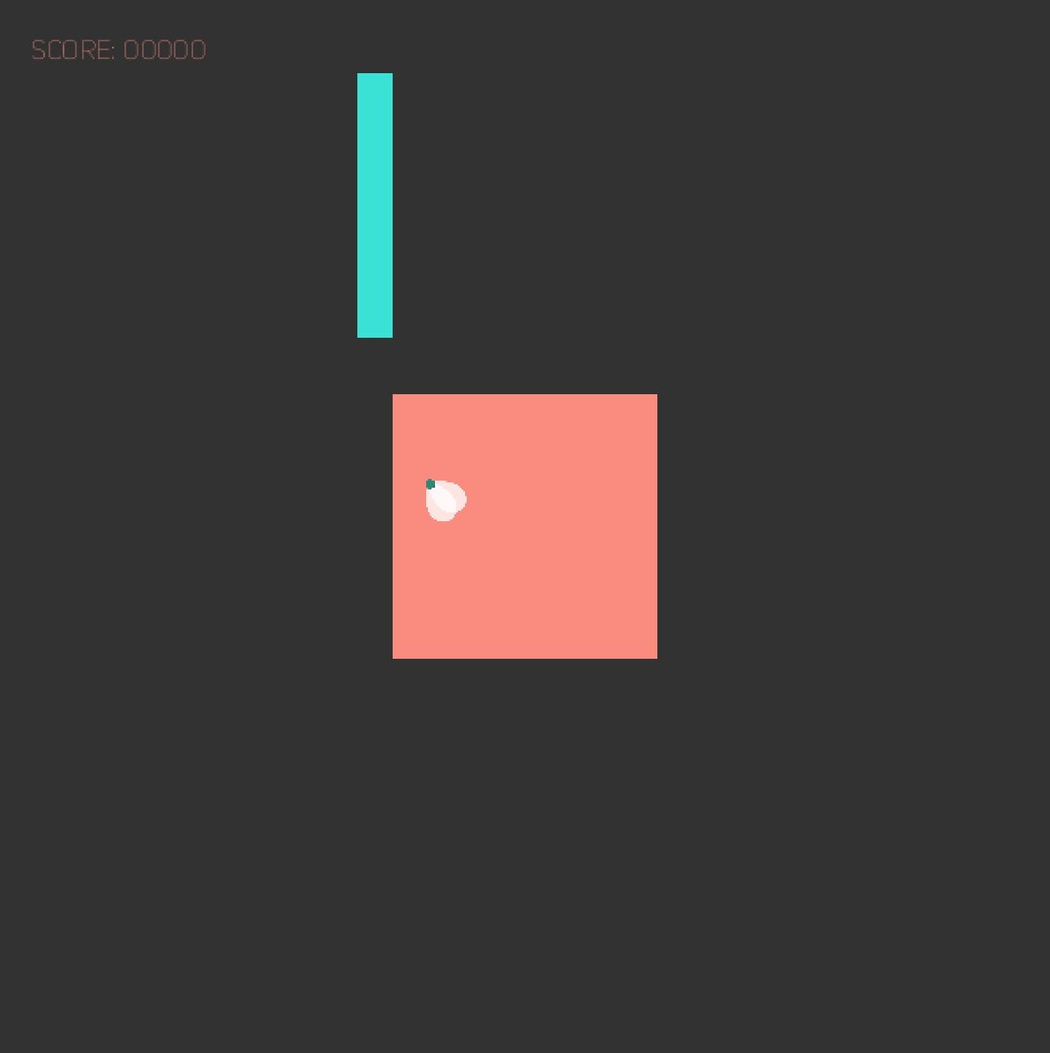

Overview – music

We choose the music piece “Canon in C”. Play a note when user presses SPACEBAR. Music visualization in the background.

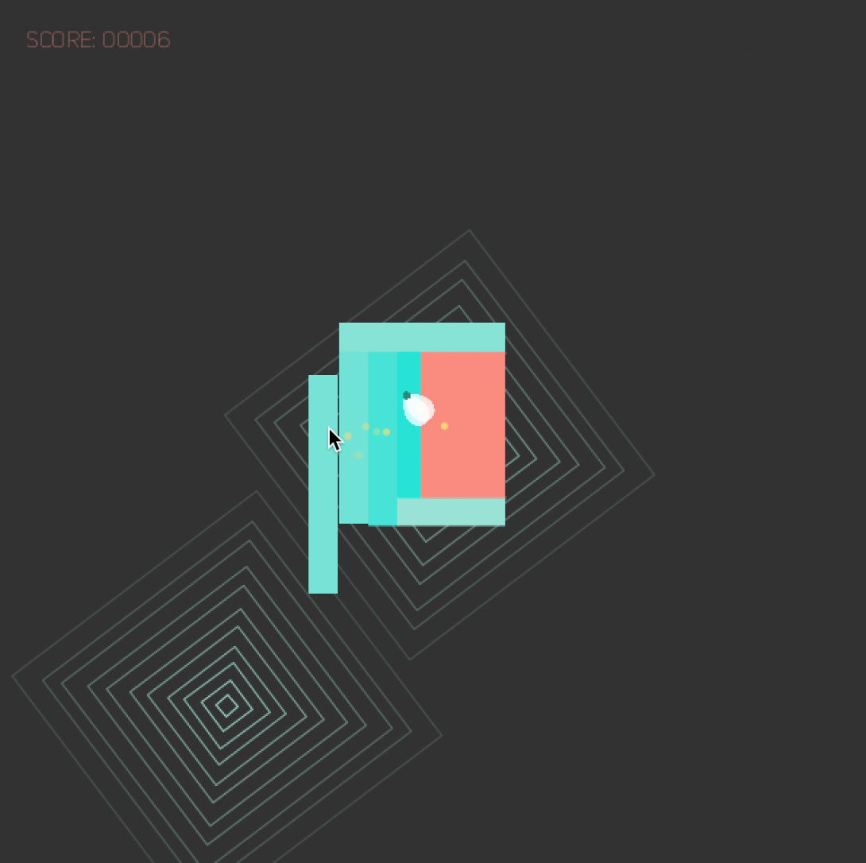

How to win

1. Don’t miss any blue rectangle coming from every direction (keep pressing SPACEBAR)

2. Keeping the bee inside the rectangle space

Game Control

Using a separate function to control the whole game flow. Adding and removing objects from arraylists. Changing the hardness of the game along the gameplay

Use of class (OOP)

- Main program

- myDeco class - music visualization

- myRect class - pink square and blue rectangles

- particle class - bee particle

Use of image

- 4 pictures of bee to make animation

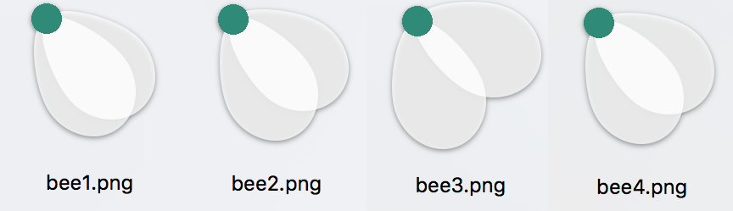

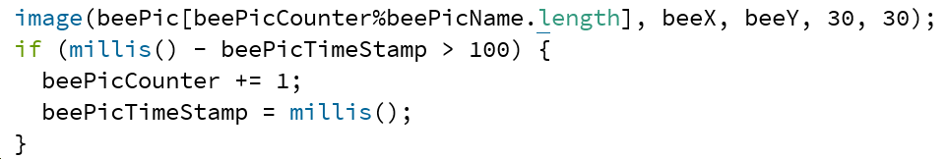

- Get image pixel for bee tail

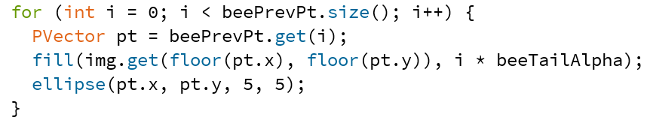

Use of noise()

In the bee movement, it moves randomly inside the rectangle space. It is a 2D noise, X and Y coordinates

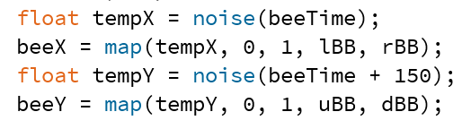

Use of particle system

In the bee dead animation, there are pink circle particles at the bee’s position.

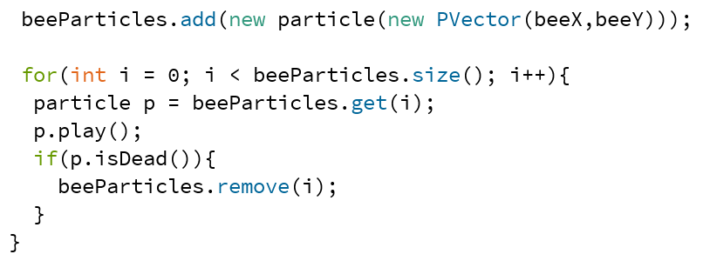

Use of sound

We are using the SoundCipher library, it plays music note in JavaSound synthesizer.

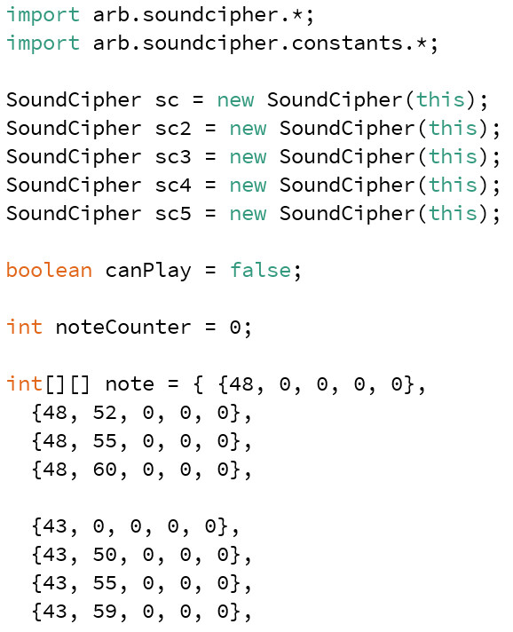

About the sound visualization, the number of the waves is generated according to the number of the notes. And the sizes of the waves are generated according to the pitches of the notes.

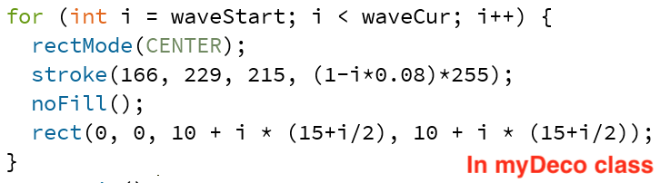

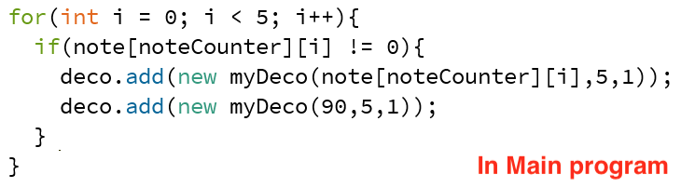

Use of voice control

We use the Amplitude value from the audio input. Player can clap hand or generate some sounds to control the game.

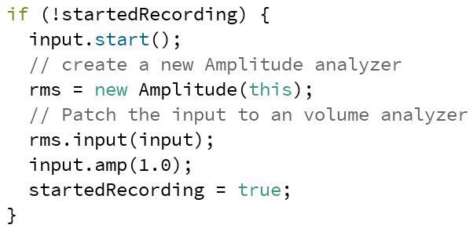

Use of Ranking system

Saving the ranking record to a .txt file. Showing the ranking when the game ends. Bubble sort is used when comparing the scores.

Version control

Thank you the help of GitHub.

Screenshots

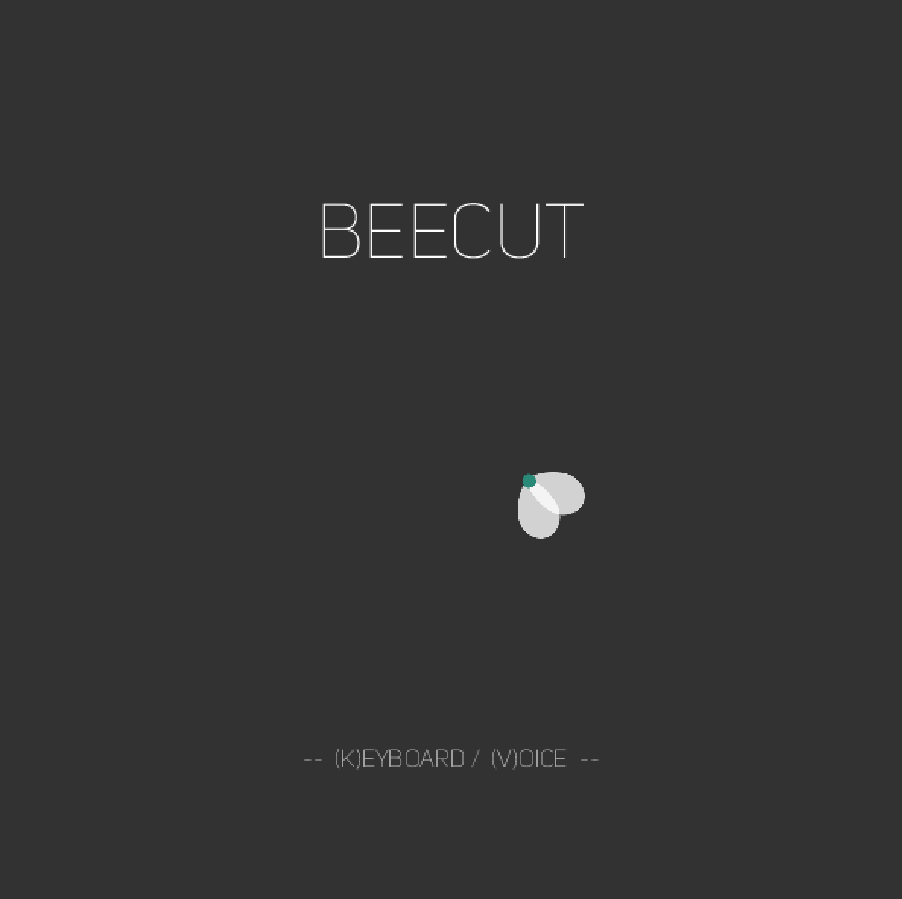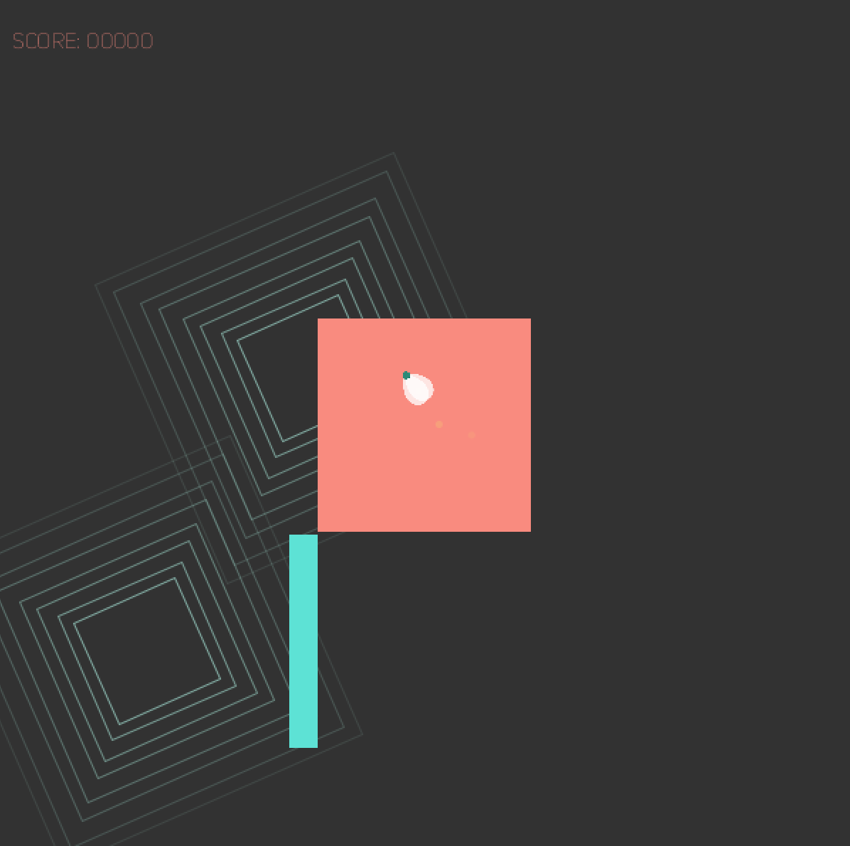

References

wk6_5b_Walk_PrelinNoise

wk11_02_ArrayListParticles

Simple Particle System - Daniel Shiffman <http://www.shiffman.net>