Question 1: Hello,

I'm new to search engines, and there are a lot of concepts I'm not educated on. To make my onboarding smoother, it'd help if you could provide me with some definitions of the following concepts:

* Records
* Indexing

I'm also struggling with understanding what types of metrics would be useful to include in the "Custom Ranking."

Cheers, George

**Answer 1:**

Hi George,

Thanks for reaching out to us. I will be very happy to help you understand the concepts so that you can get started using Algolia services very easily.

**Records** are nothing but a collection of information fields relating to a person, company or a specific entity in a database. For example, a record for a person can have fields for name, email, address and profession. These fields are referred to as columns or keys. A set of records creates a table in a database.

Next, to understand indexing we should know what an index is. Indexes can be created from one or more keys that helps you to quickly locate and access the record(s) in a database table. Creating indexes in tables, is referred to as **indexing**. To see how it works, you can think of it as the index in the back of a book. To look up a subject, we simply scan the index and flip to the respective page. This is comparably much faster instead of a book having no index where we have to scan the entire book to find the subject we are interested in.

If you would like to go into more details about these terminologies, please check out this [link](https://www.algolia.com/doc/guides/getting-started/what-is-algolia/).

Algolia provides many ways to configure your index and fine-tune your overall index relevancy. Apart from setting the configurations for searchable attributes, you can also use the custom ranking attributes.

Algolia’s default ranking includes a custom ranking field which allows you to add business metrics to the relevance calculation. To boost your relevancy rules, you can leverage any numerical or boolean attributes in your data. For example, you might consider adding popularity and high customer reviews for ranking items highest in an ecommerce website. To learn more about the configuration process, please find this [link](https://www.algolia.com/doc/guides/getting-started/the-implementation-process/).

Hope this helps. Please do not hesitate to react out, if you have any further questions.

Best,

Debika.

Question 2: Hello,

Sorry to give you the kind of feedback that I know you do not want to hear, but I really hate the new dashboard design. Clearing and deleting indexes are now several clicks away. I am needing to use these features while iterating, so this is inconvenient.

Regards, Matt

**Answer 2:**

Hi Matt,

Thanks for reaching out to us. We are constantly looking for product feedback, so that we can improve product and user experience. Thanks for reaching out to us and provide critical feedback.

The new dashboard allows you to clear and delete indices in a single bulk action. Please find the highlighted red box in the below attached screenshot. This will allow to perform the necessary actions on the indices.

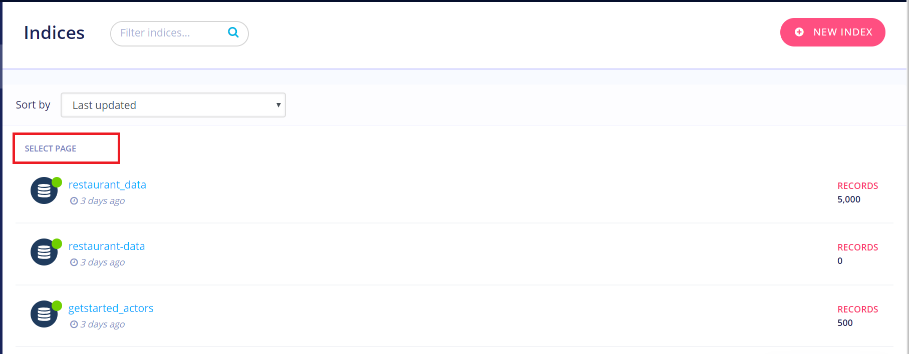

There is also another option to create and delete indices via the Algolia API. Please let me know if you would like to know more about it and I will be able to help you with that.

I hope this was helpful. Please do not hesitate to react out, if you have any further questions or feedback.

Best,

Debika.

Question 3: Hi,

I'm looking to integrate Algolia in my website. Will this be a lot of development work for me? What's the high level process look like?

Regards, Leo

**Answer 3:**

Hi Leo,

Thanks for reaching out to us. We are very excited to know that you are looking to use Algolia for your website. Please find the steps to configure:

1. Sign up for an account with Algolia to get your API keys. Select your dataset to index.
2. Next, push your data to Algolia. You can either do this via the client API or from the dashboard. Once it is successfully indexed, you can either view the results from the dashboard, browser or your development environment.
3. In addition to this, you can create a good search by configuring the relevance, giving you full control of your dataset. You can configure your index by selecting some attributes for searching, others for sorting and customized ranking and others for filters.
4. After you have successfully completed the above steps, the next step is to create an UI. We’ve made it easy for you to build a Search UI. With Algolia’s InstantSearch front-end libraries, you can implement almost any UI pattern with a complete selection of widgets. You can also customize and extend these widgets, or build your own and integrate them into InstantSearch.

And you are done! To become more familiar with the process, I would recommend you to take this onboarding [tutorial](https://www.algolia.com/doc/onboarding/) which will really help you in understanding the Algolia search experience.

I hope this was helpful. Please do not hesitate to react out, if you have any further questions.

Best,

Debika.