Tutorial:
- Download GIS Data:
  - Follow the instruction from MathWorks: https://www.mathworks.com/help/roadrunner/ug/download-gis-data-for-use-in-roadrunner.html
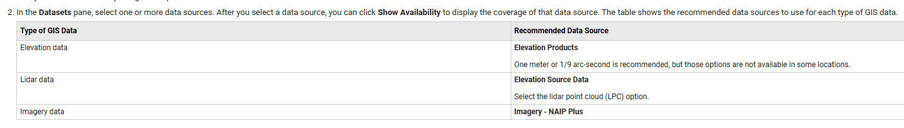
  - Install uGET to download GIS data from National MAP
    - https://apps.nationalmap.gov/uget-instructions/
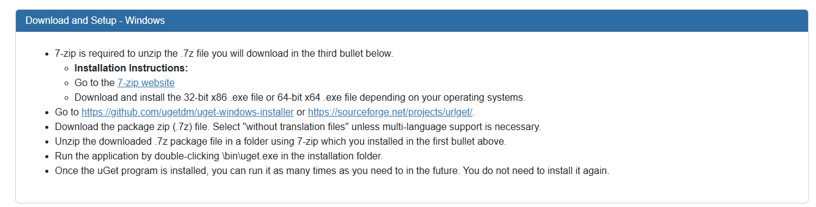
- You can download from Github. Go to the latest release. Click on the link under Asset. For example, uGet-2.2.3-1-win32.gtk3.exe. The download will start automatically.
- Run the application by double-clicking \bin\uget.exe in the installation folder.
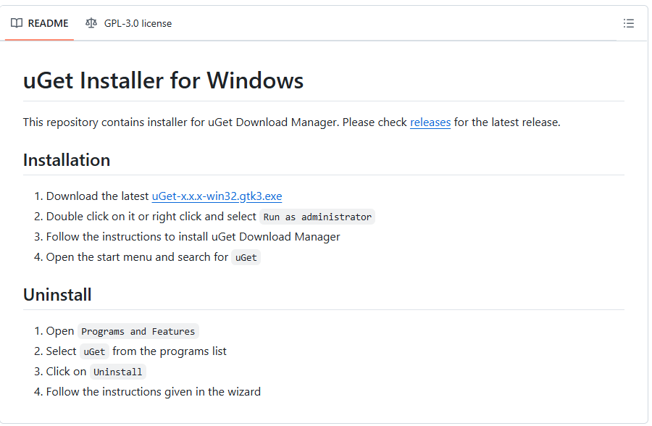
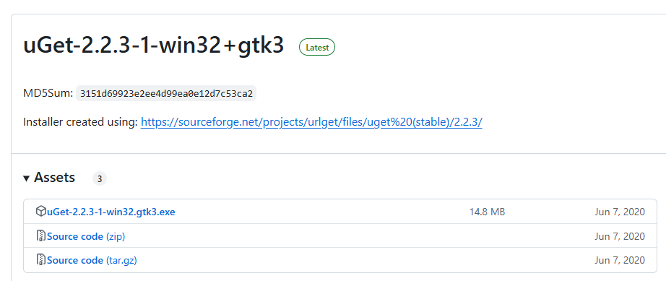
  - National Map Website: https://apps.nationalmap.gov/downloader/#/
- Finding Area of Interest
- Select different types of required data.
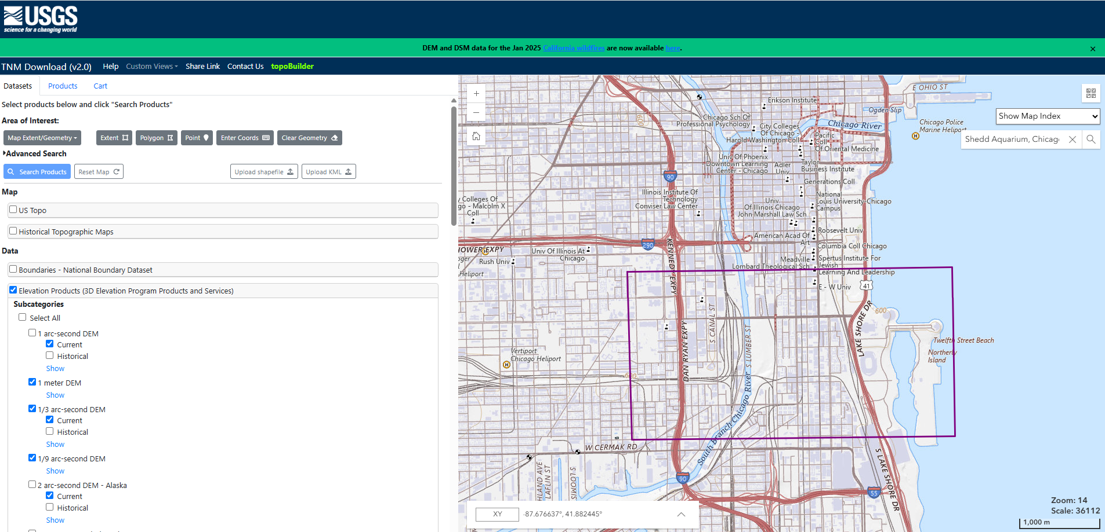
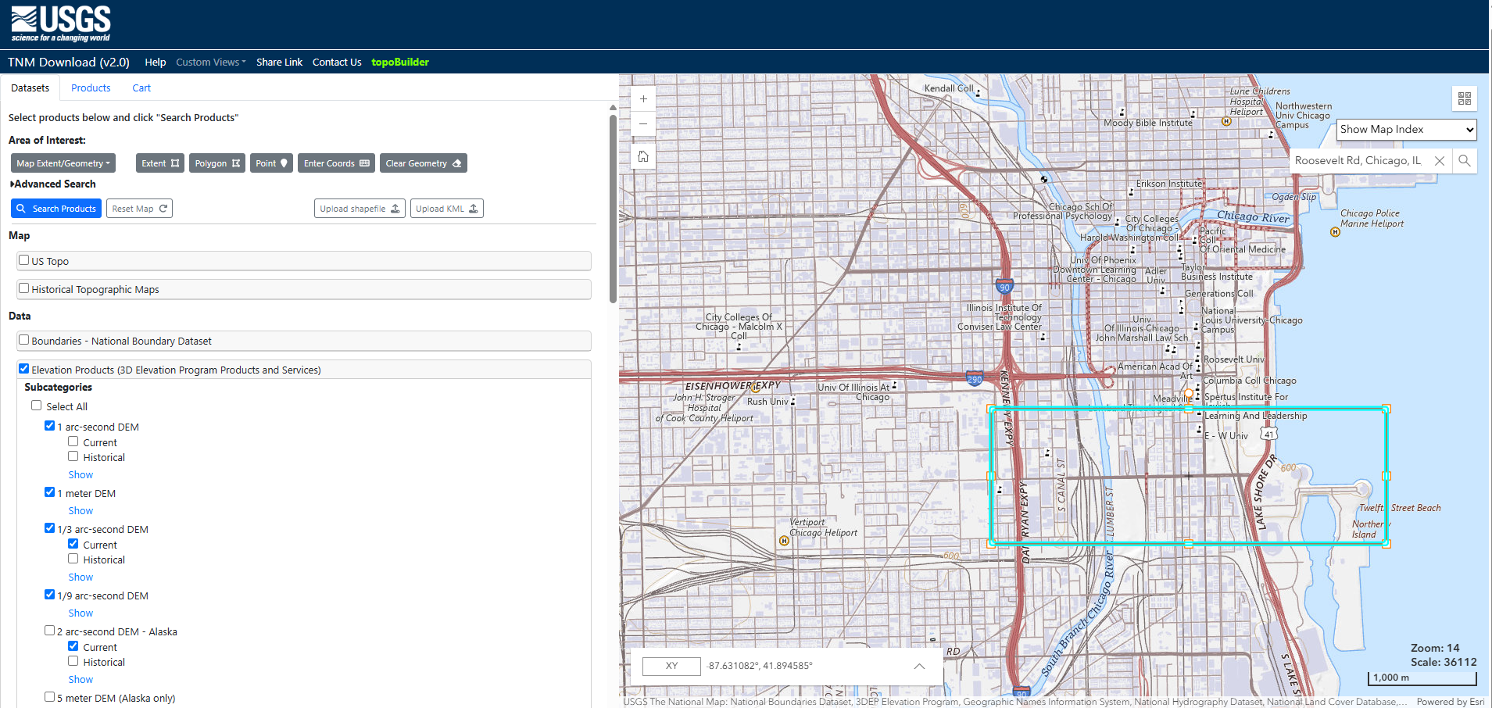
- Click “Search Products”. “Search Products” is not supported in the imagery category.
- From the “Products” tab add required products into the cart
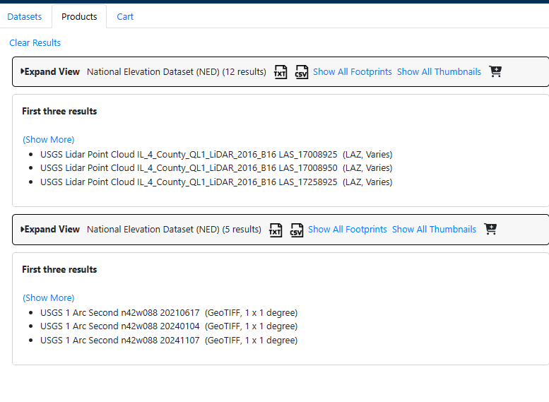
- Download txt file from the “Cart” Tab
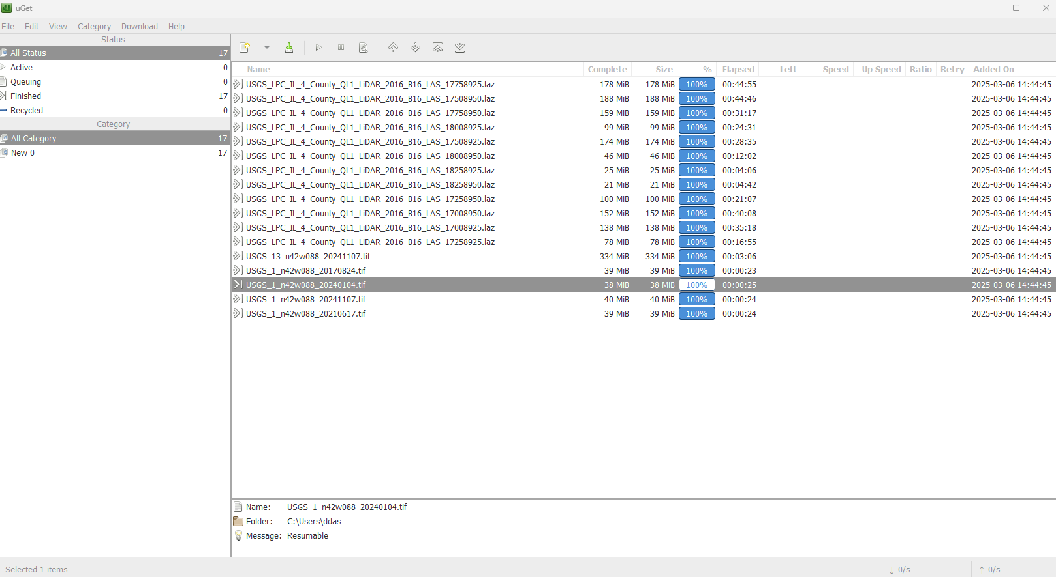
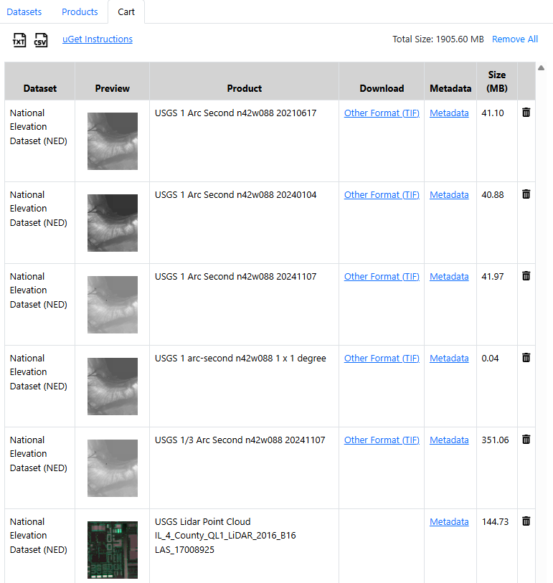
- Open “uGET” app to download Elevation data, Lidar Data, Imagery Data
- Specify the txt file to download the data in the uGET from File -> Batch Downloads/Text File Import (.txt)
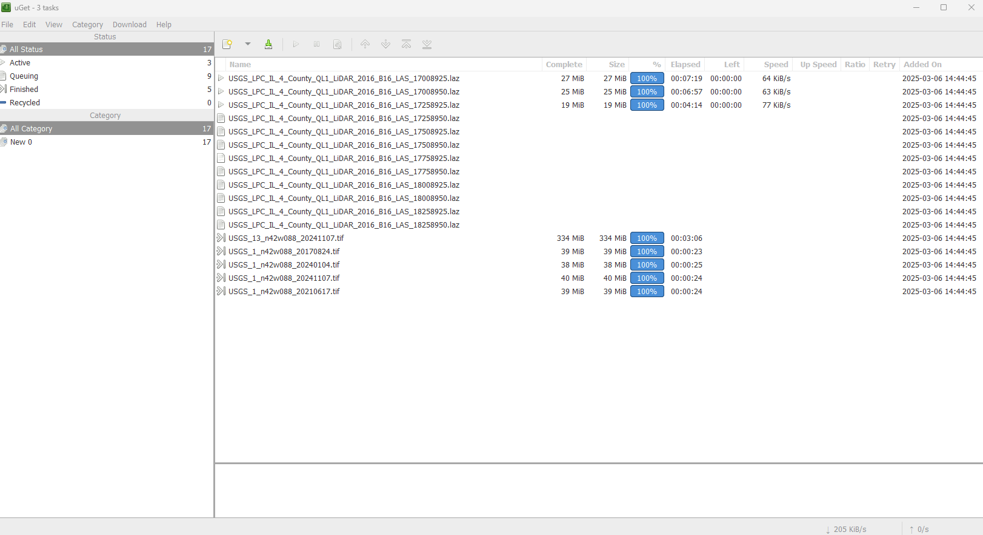
- Download imagery data from Earth Explorer. An account on EarthExplorer is required to enable imagery download.
https://earthexplorer.usgs.gov/
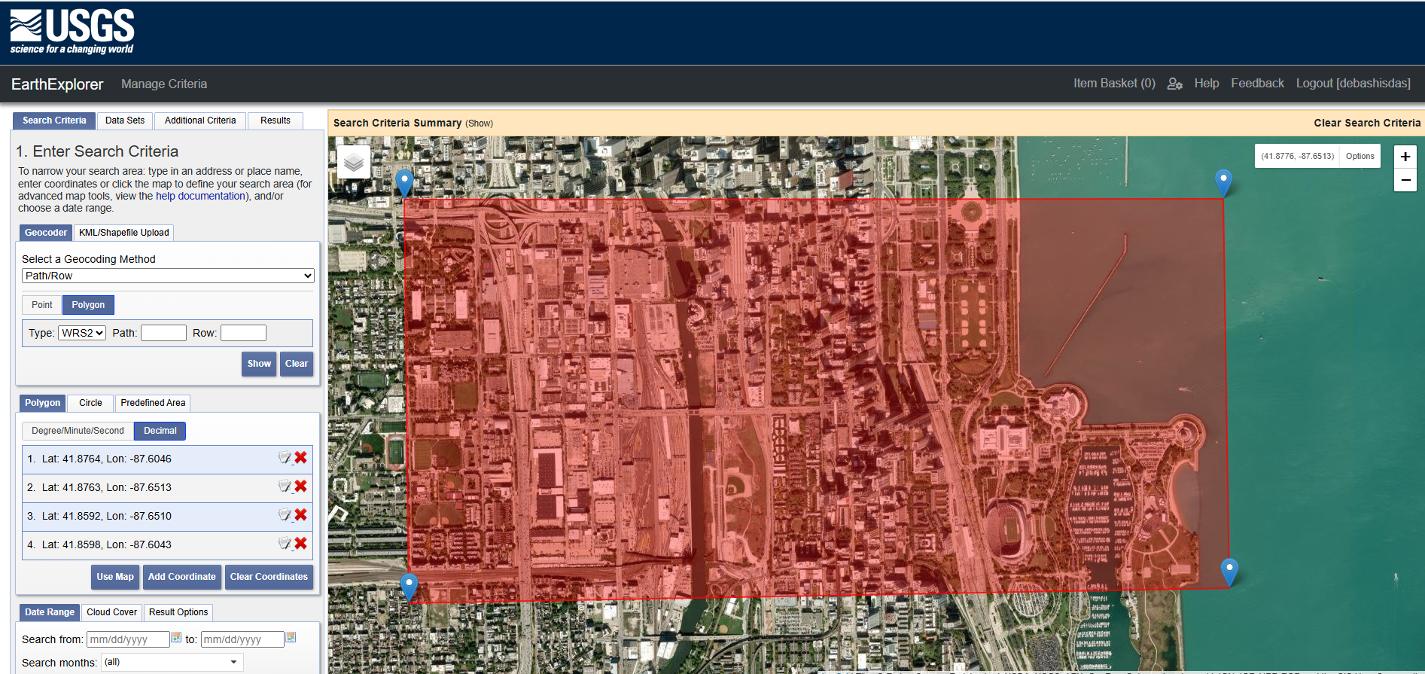
- From the Results tab find out the appropriate imagery data and download it
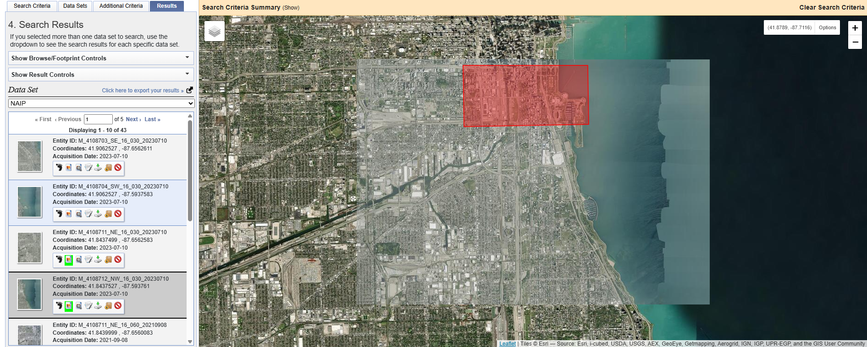

RoadRunner:
- Checkout RoadRunner Tutorial on MathWorks website
https://www.mathworks.com/solutions/automated-driving/roadrunner-tutorial.html
- Export to CARLA
https://www.mathworks.com/help/roadrunner/ug/export-to-carla.html
- Create Roads Around Imported GIS Assets
https://www.mathworks.com/help/roadrunner/ug/create-roads-around-imported-gis-assets.html

