#Install the following
sudo apt install libxcb-xinerama0

#Clone cmkae/mw
git clone https://www.trmc.osd.mil/bitbucket/scm/vug/tena-cmake-package.git
cd tena-cmake-package/
mv tena-cmake-package/cmake .

#Add following line in the /home/carma/carla-tena-adaptar/docker/Dockerfile
RUN find /home/carla -type f -exec sed -i 's/XERCESC_VERSION=3.2.3/XERCESC_VERSION=3.2.4/g' {} \;

#Change the ownership/permission in the /opt/TENA directory
ls -la
sudo chown -R carma:carma TENA
sudo chown -R carma:carma ./*

** Run TENA Console
#Excute the following command in a terminal sequetinally
cd /opt/TENA/Console-v2.0.1
source /home/carma/TENA/6.0.8/scripts/tenaenv-u2004-gcc9-64-v6.0.8.sh
./start.sh

optional: echo $TENA_HOME
output:/home/carma/TENA

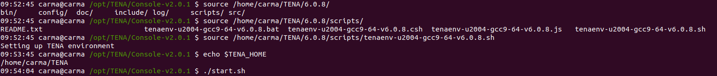

optional: ps aux |grep -i TENA
output: list of tena console is running or not

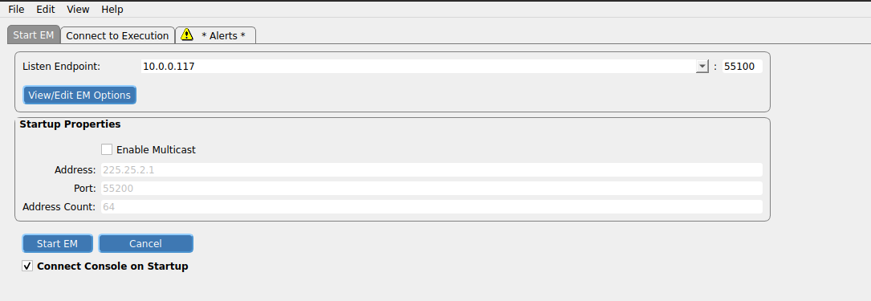
** Run TENA Canary
#Excute the following command in a terminal sequetinally
cd /home/carma/TENA/tenaCanary-v1.0.12
./start.sh
