Evolutionary Synthesis of Low Cost Decision Programs for Survival Under Uncertainty
Debi Prasad Ghosh
Debias Parametric Guru, Kolkata, India
22 September 2026

Abstract
Low cost decision calls can improve the survival of an embodied or software agent when they enable useful action before a deadline, make informative monitoring affordable, or support a protective response while more expensive verification proceeds. Low inference cost alone establishes none of these benefits. We develop a decision theoretic framework for programs assembled from typed probabilistic calls, deterministic rules, and permitted actions. The framework distinguishes threat incidence from the hazard of irreversible failure during deliberation, and distinguishes the probability of a threat from the probability that an action succeeds. Under a stated catastrophic loss model, the value of delayed verification is its conditional success probability multiplied by the probability of surviving the wait, less its incremental computational cost. A protective action can reduce the waiting hazard and reverse the preferred decision. A periodic monitoring model yields an exact detection probability and, in a small hazard regime, an optimal interval proportional to the square root of call cost. We formulate genetic search over program structure with inner fitting of probabilities and thresholds, while treating joint fitness, recombination, and preservation of groups as separate hypotheses. Reproducible analytical calculations illustrate the resulting boundaries. A proposed evaluation protocol compares evolved programs with deterministic rules, fitted cascades, greedy search, and mutation only search under matched budgets and distribution shifts. The analysis identifies the conditions under which inexpensive calls improve operational viability without claiming an empirical survival advantage for a particular model or search algorithm.
Keywords genetic programming; rational metareasoning; survival analysis; selective prediction; probability calibration; active sensing; typed decision interfaces

1 Introduction
An agent operating under uncertainty must allocate time and computation before it can allocate action. A robot may need to brake before it can identify an obstacle precisely. A software agent may need to suspend a transaction while it checks an unfamiliar request. A construction workflow may need to preserve a hold point while contradictory documents are reviewed. In each case, a more accurate answer can lose its value if it arrives after the relevant opportunity to act. Conversely, a fast answer can be harmful if the action it triggers is poorly chosen, irreversible, or repeatedly unnecessary.
The availability of inexpensive calls returning bounded decisions creates a practical opportunity to separate these functions. A call can supply a probability over a finite set of events or actions, while a surrounding program determines whether to act, verify, collect another observation, or stop. Jev is a contemporary example of this interface: TypeSafe describes a system that evaluates typed questions against supplied state and returns structured probabilistic answers [1, 2]. The analysis in this paper applies equally to a local classifier, a sensor interpretation module, a deterministic checker, or a constrained language model interface. It does not depend on an undisclosed internal architecture or on a particular training method.
The central question is whether cheaper calls change outcomes. Three mechanisms are plausible. Lower latency may allow action before failure. Lower observation cost may justify examining situations that were previously ignored. Lower evaluation cost may permit more extensive search over candidate policies. These mechanisms operate at different stages and require different evidence. Faster inference is a deployment property. More affordable monitoring is an allocation property. Improved genetic search is a training property. A benefit at one stage cannot establish a benefit at another.
Rational metareasoning provides the relevant starting point: computation is valuable through its expected effect on subsequent decisions, after accounting for its costs [4]. Selective classification similarly treats the choice to answer or defer as part of the predictor [5]. Biological defense regulation supplies a complementary perspective on asymmetric error costs [8]. Evolutionary search can then be considered as one method for discovering the structure of a decision program, rather than as the explanation for every improvement obtained by that program.
We make four contributions within this scope. First, we derive a conditional escalation rule with explicit waiting hazard and cost assumptions. Second, we extend the comparison to protective action followed by verification and derive a periodic monitoring tradeoff. Third, we specify a genotype, executable phenotype, and nested fitting procedure that preserve the distinction between structural search and statistical estimation. Fourth, we provide analytical examples and an experimental protocol that can distinguish the effect of a cheaper interface from the effects of decomposition, recalibration, and evolutionary search. These are analytical and methodological contributions; the program search and deployment experiments are proposed rather than reported as completed.

2 Operational setting and empirical scope

Survival and useful work
We use survival to mean avoidance of a defined catastrophic terminal outcome while carrying out an authorized task over a specified horizon. A safe stop or handoff may be an acceptable terminal outcome. Continued operation without useful work is not automatically successful. This definition covers biological analogies, simulated organisms, robots, and software workflows without equating all forms of failure or assigning an agent an unrestricted objective of preserving its own operation.
Let a policy choose among information calls and permitted actions using the available history. Its state includes observations, remaining time, resource budget, and the status of earlier calls. The environment supplies task outcomes, delayed labels where available, and terminal events. A complete objective must account for task completion and resource consumption as well as catastrophic failure. Otherwise, a controller can obtain high apparent safety simply by refusing every task or maintaining a permanent defensive posture.
For a finite sequence of decision intervals, let $r_{i}$ denote the probability of catastrophe in interval $i$, conditional on having survived all previous intervals under the evaluated policy. The chain rule gives
$$S_{N}=\prod_{i=1}^{N}{\text{(}1−r_{i}\text{)}}, −\text{log}S_{N}=\sum_{i=1}^{N}{−}\text{log}\text{(}1−r_{i}\text{)}.\text{ (1)}$$
No independence assumption is needed with this conditional definition. For small conditional risks, the negative logarithm of survival is approximately their sum. Multiplying unconditional error rates would generally be incorrect. Equation (1) also explains why ordinary average classification accuracy is insufficient: the probabilities must refer to the failures that actually end the episode, and those failures can depend on earlier actions and depleted resources.

A call is not its consequence
A decision call and the action chosen from its output have distinct costs. The call may consume money, energy, processor time, or network capacity. Its output may then trigger an expensive shutdown, inspection, maneuver, or transaction refusal. We express these costs in a common utility scale when adding them in an objective; a currency amount cannot be subtracted from a probability without an explicit conversion or normalization.
Latency is measured from the state becoming available to the effective action. It includes preprocessing, queueing, communication, inference, policy execution, and actuation. A mean service time is not sufficient when rare stalls cross important deadlines. Parallel calls, cached answers, and early protective actions change the relevant residual delay and must be represented explicitly.
Table 1 defines the principal quantities. The threat arrival rate and the waiting hazard have different meanings even when both are measured per second.
Table 1 Principal model quantities
Quantity | Meaning | Units or range
$ν$ | Rate at which threat episodes begin | Inverse time
$h\text{(}t\text{)}$ | Hazard of irreversible failure while waiting | Inverse time
$τ_{2}$ | Additional time required for verification | Time
$a_{1}$ | Conditional success probability of the immediate action | Zero to one
$a_{2}$ | Conditional success probability after surviving verification | Zero to one
$θ$ | Posterior probability that a threat is present | Zero to one
$C$ | Loss assigned to a catastrophic outcome | Utility loss
$k_{2}$ | Incremental cost of verification | Utility loss
$Δ$ | Interval between monitoring observations | Time
$g$ | Genotype specifying a decision program | Discrete program description

What current model evidence establishes
TypeSafe distinguishes output probabilities from a confidence field derived from their concentration [2]. A large confidence value therefore cannot automatically be interpreted as a separately validated probability of correctness. Domain labels are needed to assess whether event probabilities or action success estimates support the intended thresholds. Proper scores such as log loss and Brier loss assess forecasts against outcomes; expected calibration error alone does not reward useful discrimination [6, 7].
An independent phishing benchmark reports median call latencies of 239 ms for Jev and 687 ms for Haiku in its direct comparison, with respective accuracies of 62.6% and 81.3%. On a separate split, Jev’s five-signal fitted combiner reaches 95.0%, while a simple regex baseline reaches 91.8%; the comparable Haiku combiner reaches 93.2% and the reported paired accuracy comparison does not establish a difference between the two combiners [3]. These are task-specific results, not survival measurements. They motivate controls for decomposition, deterministic features, threshold selection, and latency. They do not support a universal rule that inexpensive calls are less accurate, or a universal deployment speed ratio.

3 Deliberation under a failure deadline

The conditional escalation boundary
Consider the instant after a fast call has returned. Its cost and elapsed time are already sunk. The controller can execute its immediate action or wait an additional duration for a verifier. Let $D$ be the remaining time to irreversible failure under the policy followed while waiting. Conditional on current information, define
$$s\text{(}τ\text{)}=\text{Pr}\text{(}D>τ\text{)}=\text{exp}​\text{[}−\int_{0}^{τ}{h}\text{(}u\text{)} du\text{]}.\text{ (2)}$$
This hazard describes how an unresolved situation becomes fatal. It is not generally the rate at which new threats arrive. For a constant hazard it reduces to $s\text{(}τ\text{)}=e^{−hτ}$. Uncertain threat presence can produce a mixture survival function rather than a single exponential. Equation (2) accommodates that distinction through the appropriate conditional hazard.
Assume initially that an unsuccessful selected action causes loss $C$, a successful action avoids that loss, and failure during the wait is absorbing. Let $a_{1}$ be immediate action success, and let $a_{2}$ be verifier action success conditional on surviving the wait and on the cases routed to that verifier. Verification incurs cost $k_{2}$, paid regardless of outcome. The expected losses are
$$L_{fast}=C\text{(}1−a_{1}\text{)}, L_{verify}=C\{1−s\text{(}τ_{2}\text{)}a_{2}\}+k_{2}.\text{ (3)}$$
Verification is preferable precisely when
$$a_{1}<s\text{(}τ_{2}\text{)}a_{2}−\frac{k_{2}}{C}.\text{ (4)}$$
The derivation counts success only when the agent survives the wait and then selects a successful action. The right side is an equivalent success value after computational cost. It need not itself be a probability. If it is negative, no immediate action with a nonnegative success probability is improved by waiting under these assumptions. For two-class classification under symmetric error costs, choosing the more probable label under an exact posterior gives at least one-half correctness. General actions need not have complementary success events, so that lower bound does not apply to every control problem.
The verifier’s accuracy must be estimated on the routed cases. Substituting its aggregate benchmark accuracy can overvalue escalation because cases that confuse the fast model can also confuse the verifier. A posterior probability of threat is likewise not interchangeable with action success. The same threat probability can support different actions when their effectiveness and consequences differ.

General losses and uncertain latency
The catastrophic binary loss assumption makes Equation (4) transparent but is restrictive. When classification mistakes have different consequences, compare posterior expected action losses directly. Let $r_{1}$ and $r_{2}$ be residual catastrophic failure probabilities after the immediate and verified actions. With zero noncatastrophic losses, the corresponding condition is
$$r_{1}>1−s\text{(}τ_{2}\text{)}+s\text{(}τ_{2}\text{)}r_{2}+\frac{k_{2}}{C}.\text{ (5)}$$
A full loss matrix replaces this expression when actions have partial benefit, reversible damage, or different false-alarm costs. Additional task loss during the wait must also be included. These extensions are decision problems, not calibration problems alone.
If verifier duration is random, its expected value requires the joint distribution of duration, survival, and decision quality. In particular, the product of an average waiting survival and an aggregate accuracy is not generally valid. Queue congestion may affect both what cases are delayed and whether their states become stale. If the verifier was launched speculatively, the comparison uses its remaining delay and remaining avoidable cost, rather than charging already incurred costs a second time.
Equation (4) predicts a monotone decrease in the attractiveness of waiting as cumulative hazard increases only while conditional action quality and cost remain fixed. A learned policy that violates that trend has not automatically failed: it may have learned protective actions, hazard-dependent task difficulty, or a different cost structure. The experiment must hold those factors constant before interpreting a deviation as evidence against the simplified model.

Protective action while verification proceeds
A controller need not choose between immediate commitment and complete inactivity. It may apply a reversible protective action, then verify while the environment is less dangerous. Suppose the protection takes time $τ_{g}$, changes the subsequent waiting hazard from $h$ to $h_{g}$, costs $k_{g}$, and permits verifier success probability $a_{2g}$. Under constant hazards and the same catastrophic loss model, its equivalent success value is
$$V_{g}=e^{−hτ_{g}−h_{g}τ_{2}}a_{2g}−\frac{k_{g}+k_{2}}{C}.\text{ (6)}$$
The controller compares this with immediate success $a_{1}$ and unprotected verification value $e^{−hτ_{2}}a_{2}−k_{2}/C$. Protection can make verification worthwhile even when unprotected deliberation is dominated. However, the comparison must include harm caused by the protective action itself, losses during its activation, and the cost of keeping it active. A permanent shutdown can otherwise become an artificial optimum.
Examples include suspending an uncertain software transaction, maintaining a construction hold point, or reducing a robot’s speed within an existing control envelope. The mechanism resembles the broad biological idea of defensive preparation followed by further assessment. It does not establish a one-to-one mapping onto a thalamic low road and a cortical high road; contemporary accounts emphasize multiple interacting pathways [15].

4 Defense thresholds and the price of observation
Let $θ$ denote the probability that a threat is present. Table 2 gives a simple action loss matrix. The protected-threat cost includes residual harm and the cost of defending in a true-threat state, while the false-alarm cost includes the consequences of defending in a harmless state.
Table 2 Loss matrix for a defensive action
Action | Harmless state | Threat state
Continue without defense | $0$ | $C_{miss}$
Defend | $C_{FA}$ | $C_{TP}$
If defense is beneficial in the threat state and the denominator is positive, minimizing posterior expected loss gives
$$θ>\frac{C_{FA}}{C_{FA}+C_{miss}−C_{TP}}.\text{ (7)}$$
The commonly cited expression with denominator $C_{FA}+C_{miss}$ assumes zero loss when defending against a true threat. With a miss cost of 1000 and false-alarm cost of 1, that model gives a threshold of approximately 0.001. It can be rational to accept many false alarms. This is the signal detection logic underlying Nesse’s smoke-detector principle [8]. The proportion of alarms that are false still depends on prevalence and on the distribution of observations; the cost ratio alone does not determine it.
A different convention gives a different threshold. If defense costs the same amount $c_{D}$ in either state and prevents all threat damage, compare $c_{D}$ with $θC_{miss}$, giving $θ>c_{D}/C_{miss}$. The loss specification must therefore accompany any numerical threshold.
Cheap observation does not directly lower Equation (7) once the observation has been obtained. Its sunk inference cost is common to both actions. It changes whether the controller can afford to observe the situation, how often it observes, and which additional evidence it acquires. Lowering the actual cost of defense changes the action threshold. Confusing these two prices exaggerates the benefit of inexpensive classification.
Calibration is distribution-dependent. A probability calibrated on one collection of emails, operating states, or project documents may fail after a change in prevalence or evidence quality. Moreover, a change in the waiting hazard can require a new escalation threshold even if the event probability remains calibrated. Threshold adaptation and probability recalibration are distinct operations. Label shift can require both, while a changed actuation deadline may require only the former.

5 Information acquisition and monitoring frequency

Conditional value of another call
Let $b$ represent the current belief state, and let $R^{*}\text{(}b\text{)}$ be the smallest expected downstream loss attainable with the currently available actions. A candidate call returns information $Z$. Ignoring physical evolution during the call initially, its value of information is
$$VOI\text{(}q∣b\text{)}=R^{*}\text{(}b\text{)}−E_{Z}\text{[}R^{*}\text{(}b∣Z\text{)}\text{]}.\text{ (8)}$$
The call is worthwhile when this reduction exceeds its inference cost and any loss caused by delay. In a dynamic setting the belief update and risk calculation must include how the environment changes while the call runs. This is an application of the metareasoning perspective [4], with the explicit timing model from Section 3.
Reducing call cost makes some previously unattractive observations worthwhile. For a fixed one-step decision problem, the newly adopted calls have value between the old and new costs. In a sequential program the effect can be broader: cheap observations may support a different monitoring schedule, enable a new decomposition, or change which later calls are useful. Consequently, a static interval argument is informative but does not exhaust the possible system-level effects.
Multiple answers do not have value merely because there are more of them. Their contribution is conditional on the evidence already available. Nor is statistical independence required for additional evidence to help. A second observation can reveal a shared nuisance variable and allow the first observation to be corrected. Conversely, two apparently different questions may return the same decision-relevant information. The appropriate comparison is the improvement in attainable task loss after conditioning on the existing answers.
For equally variable exchangeable estimates with common pairwise correlation $ρ$, the variance of their mean motivates the descriptive quantity
$$n_{eff}=\frac{n}{1+\text{(}n−1\text{)}ρ}.\text{ (9)}$$
This is not a general survival formula or a guarantee about majority voting. It applies to the variance of an average under those assumptions. Dependence in rare catastrophic errors requires direct measurement or a specified joint model. Errors from one model, one sensor, or one shared state builder can be correlated even when the questions are processed separately.

A periodic observation model
Consider threats that begin independently of a monitoring clock. Observations occur every $Δ$ seconds, so the delay from threat onset to the next observation is uniform on $\text{[}0,Δ\text{]}$. Conditional on an onset, the remaining time to failure is exponential with rate $h$, independent of monitoring phase. After observation, an additional fixed delay $ℓ$ precedes action. Let $a$ be the conditional probability that the observed response prevents catastrophe, independent of phase and deadline in this illustrative model.
The probability of successful intervention for a threat episode is
$$P_{save}\text{(}Δ\text{)}=ae^{−hℓ}\frac{1−e^{−hΔ}}{hΔ}.\text{ (10)}$$
The limit as $Δ$ tends to zero is $ae^{−hℓ}$, not necessarily one. Faster sampling cannot remove inference errors or fixed actuation delay. A sampling interval longer than a threat deadline reduces the chance of responding in time; it does not make timely response impossible for every onset phase.
Let threat onsets be Poisson with rate $ν$, with independent per-threat outcomes and no resource or queue interactions. Let $F_{fatal}\text{(}u\text{)}$ be the probability that a threat has caused irreversible failure within $u$ seconds of its onset, including the effect of possible intervention. For an initially threat-free system, independent marking gives
$$S\text{(}T\text{)}=\text{exp}​\text{[}−ν\int_{0}^{T}{F_{fatal}}\text{(}u\text{)} du\text{]}.\text{ (11)}$$
As the elapsed time after onset grows, $F_{fatal}\text{(}u\text{)}$ approaches $1−P_{save}\text{(}Δ\text{)}$. When the horizon is long compared with these transient delays, the leading exponential rate is therefore $ν\text{[}1−P_{save}\text{(}Δ\text{)}\text{]}$. Using $\text{exp}\{−νT\text{[}1−P_{save}\text{(}Δ\text{)}\text{]}\}$ as finite-horizon survival omits that initial transient. The independent-mark construction also abstracts away dependence induced by a shared monitoring clock. Overlapping threats, common-mode sensor failures, repeated false alarms, and budget exhaustion require an explicit episode model rather than an effective number of independent checks.

Optimal monitoring under call cost
If each observation costs $k$ utility units, a basic long-run loss rate is
$$J\text{(}Δ\text{)}=Cν\text{[}1−P_{save}\text{(}Δ\text{)}\text{]}+\frac{k}{Δ}.\text{ (12)}$$
This objective excludes false-alarm action costs for clarity. Those costs can be added through their rate and conditional severity. Never monitoring has loss rate $Cν$. If $k≥Cνae^{−hℓ}/h$, no finite monitoring interval improves that baseline in this model. When an interior optimum is worthwhile and $hΔ$ is small, expansion of Equation (10) yields the approximation
$$Δ^{*}≈\sqrt{\frac{2k}{Cνae^{−hℓ}h}}.\text{ (13)}$$
The square-root relation specifies one mechanism through which cheap calls can improve survival: a hundredfold cost reduction supports an approximately tenfold shorter optimal monitoring interval in this regime. It does not imply unlimited useful sampling. Minimum sensor periods, shared computational capacity, communication latency, correlated observations, and a finite budget constrain the feasible interval. For a serial service, its occupancy time can impose a lower bound on the sampling interval. Outside the small-hazard regime, Equation (12) should be optimized directly.

6 Evolutionary synthesis of the decision program

Genotype and executable phenotype
The genotype describes an executable program rather than a list of independently rewarded questions. A gene can specify a question and model version, an input projection, a typed edge, a permitted branch, a verification option, or membership in a group preserved during variation. The executable phenotype includes these structural choices and the numerical parameters fitted for them. Table 3 identifies which choices are candidates for discrete search and which should normally be estimated by a more direct procedure.
Table 3 Allocation of learning and search responsibilities
Component | Representation | Default treatment
Question identity and input scope | Fixed bank entry and state fields | Discrete selection
Model version and output event | Explicit typed interface | Fixed initially then compared
Branches and protective actions | Bounded program graph | Structural search
Combiner coefficients | Parameters of a specified statistical model | Ordinary fitting where tractable
Calibration and action thresholds | Estimated probabilities and loss-based decisions | Inner fitting on separate data
Variation groups | Question IDs or typed subgraphs | Tested linkage hypothesis
This division does not imply that all numerical fitting is convex. Logistic regression on a fixed feature expansion has a convex loss, while arbitrary programs with numerical constants may not. The general principle is to exploit the available solver structure rather than encode every adjustable quantity as a gene.
Typed interfaces constrain executable connections but do not certify semantic truth. An output type should identify the event being estimated and the conditions under which it is meaningful. A probability for a document mentioning approval is different from an authenticated approval record. The program must preserve that distinction. Likewise, a verifier’s probability on escalated cases requires a different validation population from its probability over all cases.

Fitness and within episode adaptation
A candidate is evaluated after its permitted inner fitting and adaptation procedures have been applied. One possible training objective is
$$Φ\text{(}g\text{)}=E\text{[}W_{g}\text{]}−C\text{Pr}\text{(}F_{g}\text{)}−E\text{[}K_{g}\text{]}−μL\text{(}g\text{)},\text{ (14)}$$
where $W_{g}$ is useful task value, $F_{g}$ is a catastrophic episode outcome, $K_{g}$ is accumulated operational cost, and $L\text{(}g\text{)}$ measures program complexity. If a task instead imposes a maximum acceptable failure probability, that requirement should be a constraint and feasible candidates should be compared on task value and cost. A penalty alone does not guarantee the constraint.
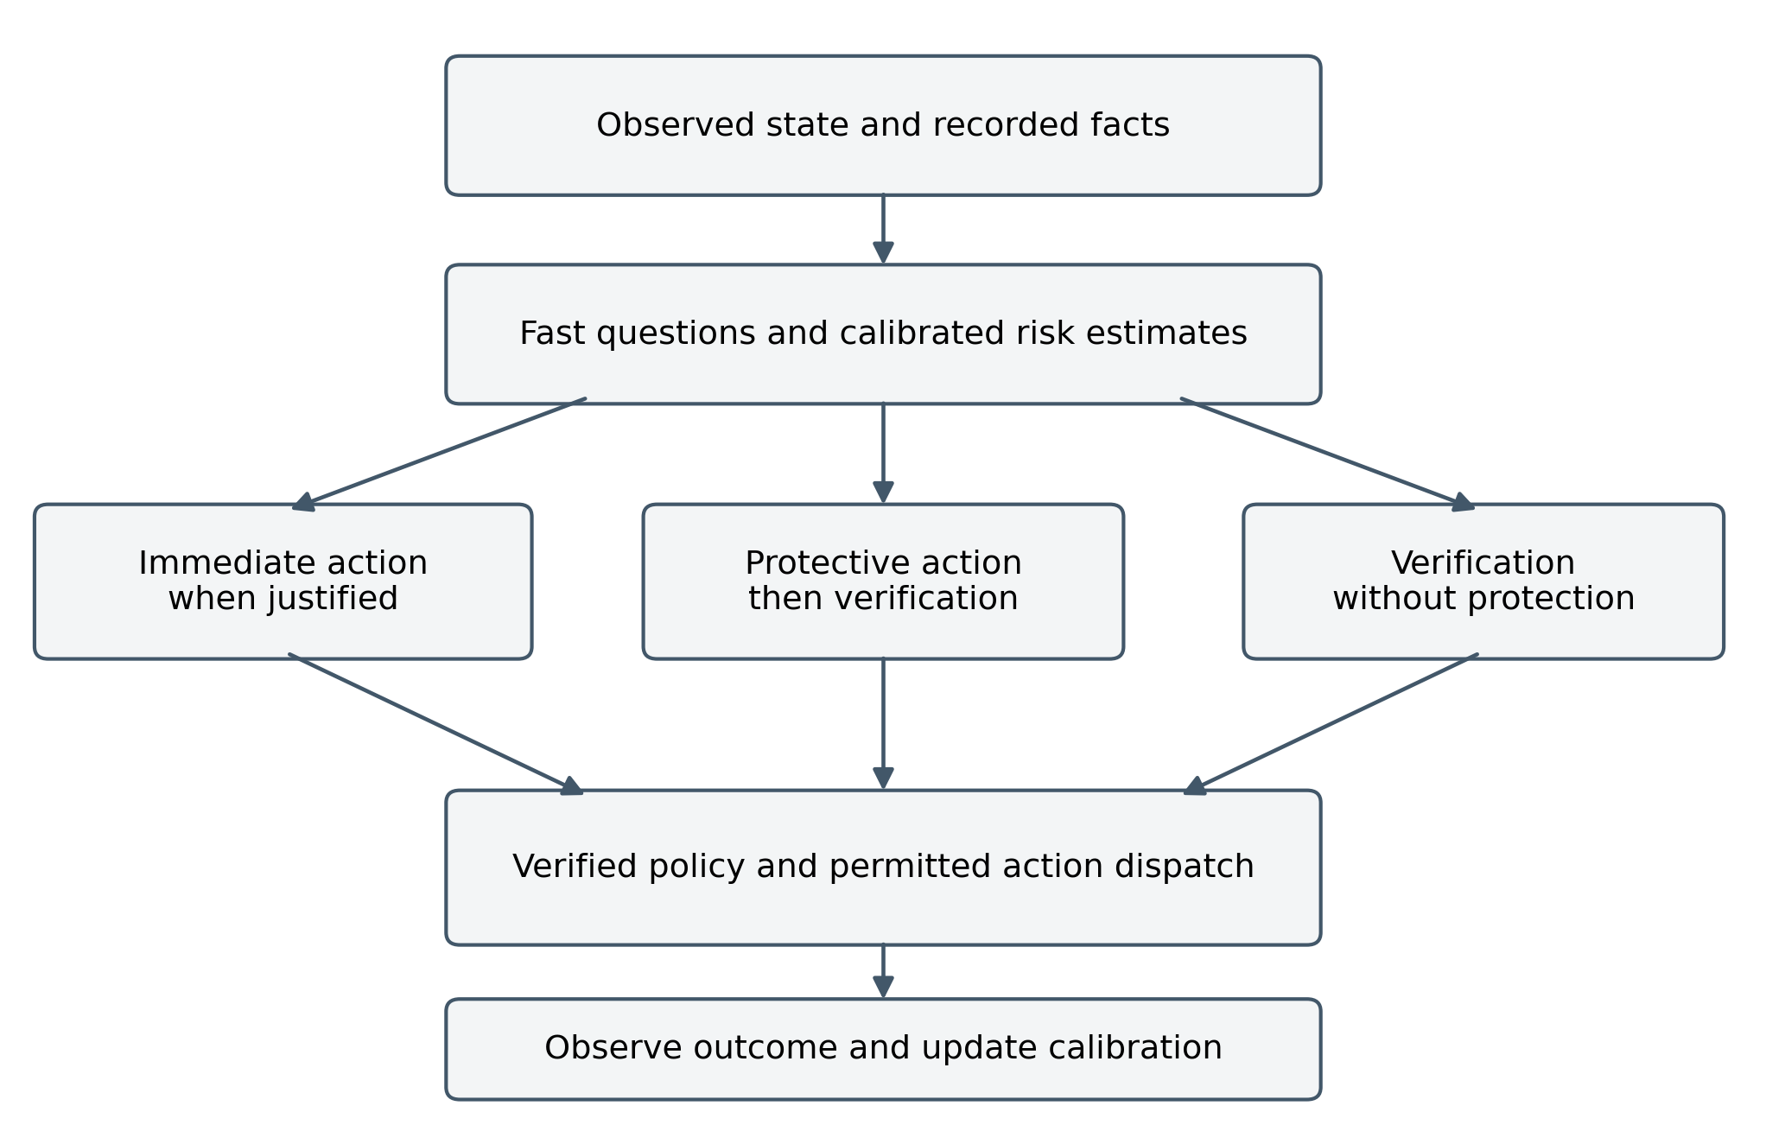
Figure 1 Proposed executable phenotype. The program chooses an immediate action, verification with protection, or verification without protection. Deterministic policy checks precede dispatch, and observed outcomes support later estimation. The diagram specifies functional roles rather than the internal architecture of any model.
Within an episode, a program may update a hazard estimate, a calibration model, or an action threshold using labels that become available. The outer genetic search can then favor structures that benefit from such adaptation. Hinton and Nowlan demonstrated in a deliberately simplified model that learning can change which genotypes receive useful fitness differences [9]. This motivates a nested design but does not guarantee a smoother or easier landscape for the present task. If fitted parameters are copied into offspring, the inheritance mechanism must be described separately from a design that refits them anew.
Episode evaluation needs enough exploration to observe adverse outcomes. A controller that suppresses every uncertain action may receive few labels about what would have happened without suppression. Logged outcomes are consequently policy-dependent and can be censored. Recalibration requires a valid sampling or experimental strategy; it cannot learn an unobserved counterfactual merely by waiting longer.

Joint fitness and recombination
Selecting a whole program gives credit to combinations that jointly affect the task. It does not eliminate redundant genes, population collapse, or overfitting. Duplicate deterministic questions can be neutral unless cost or complexity penalizes them. Repeated stochastic calls may carry a different value and should be represented as repeated measurements rather than silently deduplicated.
Linkage, recombination, and joint evaluation remain different hypotheses. Chromosome-origin models support selection for coordinated inheritance under specified ecological and replication assumptions [10]. Recombination can also help assemble independently beneficial changes; theoretical crossover gains have been shown for particular evolutionary algorithms on additive OneMax objectives [11]. Neither result establishes that a given question bank requires a GA. Linkage-tree methods provide candidate variation operators, but the value of their grouping must be tested against matched alternatives [12].
For a selected set of calls $S$, define value as an improvement in the task objective with the combiner family held fixed. A conditional interaction is
$$I_{ij}\text{(}S\text{)}=v\text{(}S∪\{i,j\}\text{)}−v\text{(}S∪\{i\}\text{)}−v\text{(}S∪\{j\}\text{)}+v\text{(}S\text{)}.\text{ (15)}$$
Measuring only the empty-background interaction can miss higher-order effects. Measuring it with a combiner unable to express the relevant interaction can also produce a false absence. Positive interaction can motivate coordinated search, but neither its presence nor its absence proves that crossover or a particular grouping will win. Theoretical greedy guarantees concern specified objectives and constraints; they do not automatically transfer to a noisy held-out survival objective [13, 14].

The cost of evolutionary evaluation
If a candidate evaluation uses $N$ episodes, each averaging $m$ calls, then its call expenditure is approximately $Nmk$, before simulation, fitting, and orchestration costs. A population search over $P$ candidates and $G$ generations has an upper-order call expenditure proportional to $GPNmk$ without caching or early termination. Cheap calls can reduce this bill materially. They do not remove the statistical requirement to distinguish candidates.
For $n$ independent evaluation episodes with zero catastrophic failures, the one-sided 95% binomial upper bound is
$$r_{upper}=1−{0.05}^{1/n}≈\frac{3}{n}.\text{ (16)}$$
For example, 3000 failure-free episodes bound the episode failure probability only near 0.001 under these assumptions. A genetic optimizer receiving the same apparently perfect score for many candidates has little evidence for choosing among their rare-event risks. Stress tests, stratified scenarios, and importance sampling may improve evaluation, but transformed sampling requires the appropriate probability weights. Raw success fractions from an adversarial scenario mix are not deployment survival probabilities.

7 Reproducible analytical results
The results in this section are deterministic calculations from the specified models. They are not measurements of a deployed agent, a Jev API experiment, or an evolutionary search. All input values, equations, and numerical procedures are stated so that the calculations can be reproduced independently.

Deliberation and protection
Set verifier success to 0.95, additional verification time to 20 seconds, and normalized verification cost to 0.002. Table 4 evaluates Equation (4). The final column is the largest immediate success probability below which verification is preferred; equality gives indifference.
Table 4 Escalation boundary under different waiting hazards
Constant hazard per second | Mean failure deadline | Survival during 20 seconds | Escalation boundary
0 | No waiting failure | 1.00000 | 0.94800
1 divided by 3600 | 1 hour | 0.99446 | 0.94274
0.01 | 100 seconds | 0.81873 | 0.77579
0.10 | 10 seconds | 0.13534 | 0.12657
The last row makes unprotected verification unattractive whenever the immediate action succeeds more often than about 12.7%. It does not imply that low classification accuracy is desirable: the comparison concerns action success, and additional actions such as protection or safe handoff may dominate both alternatives.
Now let the fast action succeed with probability 0.80. At a hazard of 0.10 per second, unprotected verification has success probability 0.12857 and equivalent success value 0.12657. Suppose a promptly applied protective action reduces the waiting hazard by 95%, adds normalized cost 0.005, and leaves verifier success unchanged. Its success probability becomes 0.85960 and its equivalent success value becomes 0.85260. Protection followed by verification then exceeds the immediate value 0.80. The result depends on the specified protection effectiveness and negligible activation delay; it is not an assertion that such protection is always available.
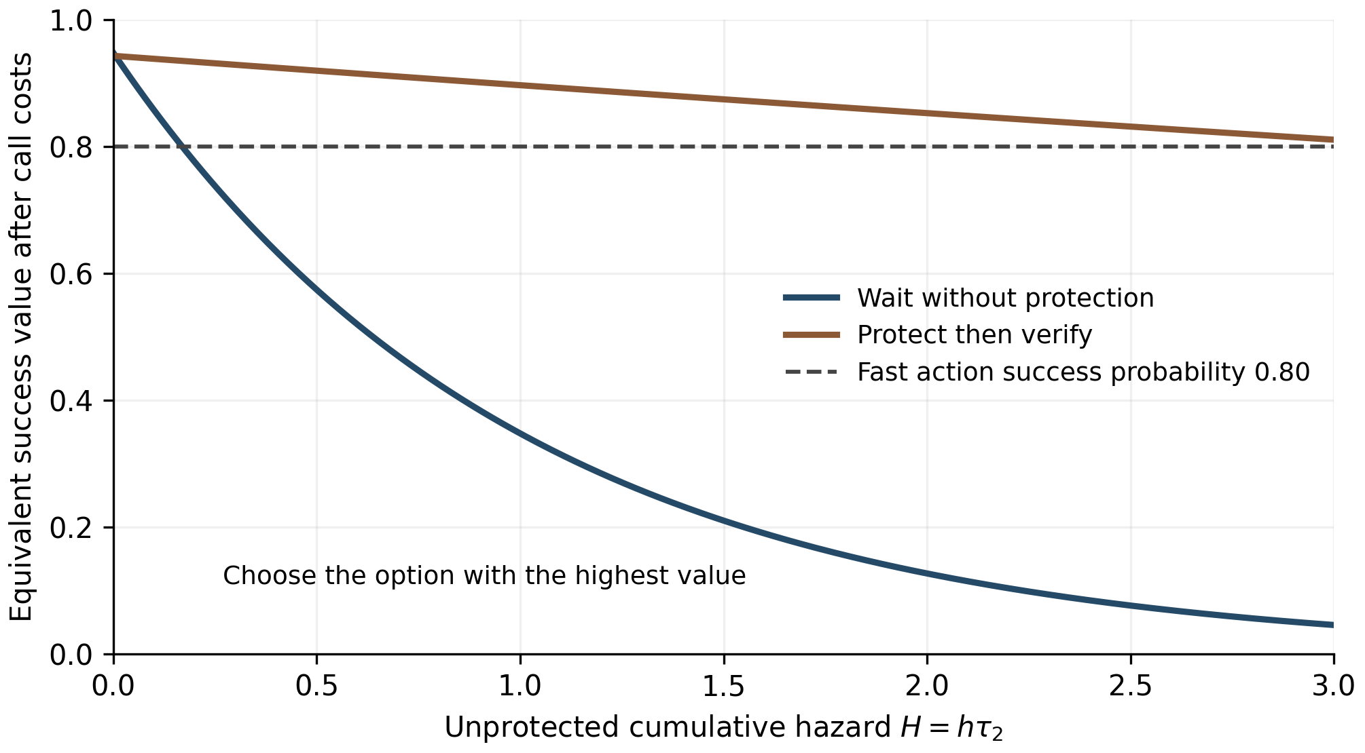
Figure 2 Analytical comparison of immediate action, unprotected verification, and protection followed by verification. Verification success is 0.95 and its normalized cost is 0.002. Protection reduces subsequent hazard to 5% of its initial value and adds normalized cost 0.005. The highest curve or reference line identifies the preferred option under the stated model.

Monitoring cost and sampling interval
For Equation (12), use catastrophic loss 100, threat incidence one per 300 seconds, waiting hazard 0.02 per second, perfect observed intervention, and zero additional actuation delay. Table 5 compares the numerical minimizer of the exact loss rate with Equation (13). The numerical minimization uses a bounded one-dimensional search over positive intervals; evaluating a sufficiently fine grid gives the same rounded values.
Table 5 Monitoring intervals at different call costs
Cost per call in loss units | Exact optimal interval in seconds | Small hazard approximation in seconds
0.001 | 0.550 | 0.548
0.010 | 1.752 | 1.732
0.100 | 5.688 | 5.477
1.000 | 19.709 | 17.321
The approximation is accurate for the cheaper calls, where the optimum lies in the small-hazard regime. Its error increases as the interval becomes a substantial fraction of the mean deadline. A practical controller must also impose its minimum feasible sampling interval before using either optimum.
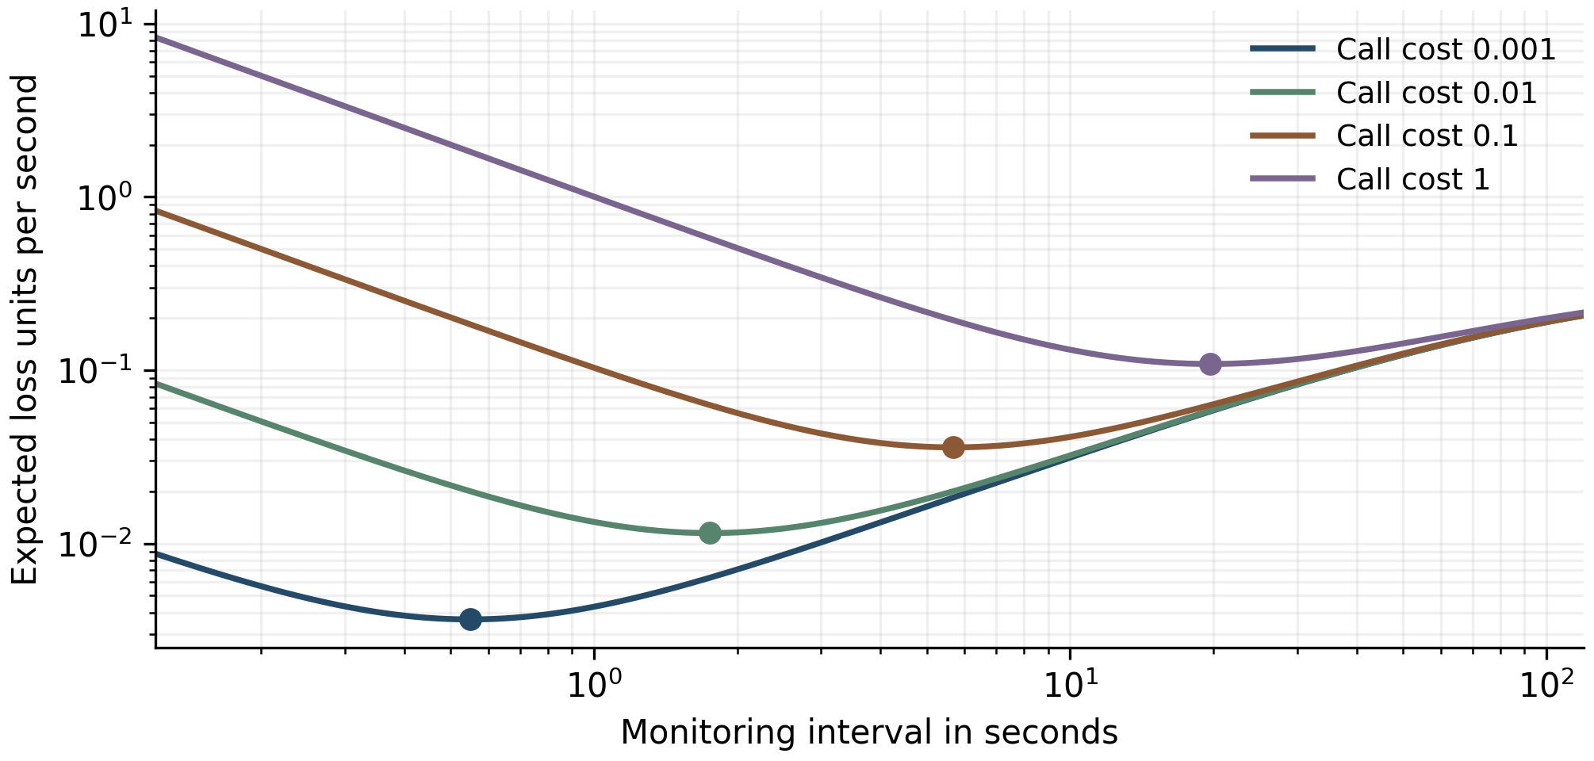
Figure 3 Exact expected loss rate against monitoring interval for the parameters of Table 5. Dots mark numerical minima. Lower call cost changes the optimal allocation of observations; the curve does not establish a corresponding advantage for a genetic optimizer.

8 Experimental design

Factorial comparisons
The evaluation should vary call cost and latency separately. A simulator can hold predictions fixed while changing their price, then hold price fixed while changing completion time. This separates an observation-budget benefit from a reaction-time benefit. A third intervention changes prediction quality while holding cost and latency fixed. All policies must operate against the same task rules and action consequences.
Threat incidence, deadline hazard, prevalence, miss severity, false-alarm costs, protective-action effectiveness, and the dependence among observations should be independently configurable. The basic analytical conditions should first be reproduced in a simulator that implements their assumptions. Later experiments can introduce queueing, state staleness, correlated sensor failures, overlapping threats, and resource depletion. The purpose is to identify which mechanism changes survival, not merely to construct a difficult benchmark.
Table 6 Comparisons that isolate the proposed mechanisms
Comparison | Quantity held fixed | Mechanism tested
Same predictions with different latency | Call cost and action quality | Value of earlier response
Same calls with different price | Latency and observations | Monitoring allocation
Protection enabled or disabled | Verifier and hazard before protection | Value of changing the waiting state
Single call and decomposed calls | Labels and evaluation split | Value of representation and composition
GA and mutation only search | Representation and evaluation budget | Contribution of recombination
Learned and random groups | Group sizes and variation budget | Contribution of preserving dependencies
Adaptation enabled or disabled after shift | Frozen initial structure | Contribution of within episode learning

Baselines and data allocation
The first baseline should use exact fields and deterministic checks wherever the task provides them. For a phishing task, comparable neural and deterministic versions of each concept should be assessed before assigning improvement to a model’s semantic capability. For construction, revision identifiers, dates, authorization records, and equipment interlocks play this role. A neural answer must add value conditional on these observations to justify its cost.
Further baselines include a single probabilistic call with fitted calibration and thresholds; a hand-specified multi-call cascade; a decomposed program with a fitted combiner; greedy selection with swaps or limited lookahead; random search; mutation only evolution; ordinary crossover; and variation that preserves learned groups. Small banks should be enumerated exactly to measure search error. Five binary inclusion choices produce 32 subsets; ten produce 1024. Enumeration is useful for diagnosing the problem even when the ultimate bank is larger.
Use separate data or episode seeds for inner coefficient fitting, outer structural selection, and final evaluation. Common random scenarios can reduce variance in paired policy comparisons, but repeatedly using those scenarios for optimization makes them training material. The final evaluation must use fresh episodes, and transfer tests should hold out meaningful sources such as threat families, email templates, or construction projects. If query wording is evolved, all prompts generated during the search count toward the model-selection process.
Cached answers are valid only for the interface and deployment conditions they represent. Record the model version, question wording, input projection, and batch context. Test repeatability and batch effects. If an actual deployment uses one stochastic draw, evaluate that deployment rather than silently substituting an average of repeated calls whose latency and cost were not charged.

Outcomes and uncertainty
Primary outcomes are catastrophic failure probability over a defined horizon, useful work completed, false-alarm burden, and total resource cost. Report the joint distribution where resource depletion or defensive downtime creates tradeoffs. Secondary outcomes include event-specific recall, proper scores, calibration within routed groups, and response-time quantiles. Accuracy alone can reverse the ranking of policies when misses and false alarms have different consequences.
For binary decisions, select thresholds using the stated action costs on development data and compare the resulting operating points on fresh data. Report cost curves when deployment costs are uncertain. Use paired intervals for proper-score and utility differences, and an appropriate paired test for binary accuracy. One model’s standalone binomial standard error is not the standard error of a paired comparison. Rare failure rates require exact or otherwise justified intervals and enough independent exposure.
Survival fitness remains a noisy and often sparse signal. Genetic algorithms can optimize non-differentiable episode objectives, but they do not avoid the need for informative evaluation. Search should report the number of fitted candidates, episode evaluations, calls, elapsed computation, and failures encountered. If an evolved policy beats a hand-built program only because it received more labeled evaluations, that result establishes a budget advantage rather than an algorithmic advantage.

Predictions and failure conditions
The first prediction concerns Equation (4): with fixed conditional action qualities and costs, the preference for unprotected verification decreases with cumulative waiting hazard. A simulator implementing those assumptions should recover the analytical boundary regardless of whether its policy was obtained by enumeration, direct optimization, or genetic search.
The second prediction concerns protection: reducing the waiting hazard can restore the value of verification, but only when its benefit exceeds activation risk, operating loss, and computational cost. Increasing protection cost or reducing its effectiveness should remove that advantage at the boundary specified by the extended model.
The third prediction concerns monitoring: in the small-hazard regime with no active capacity constraint, optimal observation intervals should scale approximately with the square root of call cost. A different scaling can arise when queueing, false alarms, or correlated observations become dominant; those mechanisms should be measured rather than absorbed into an unexplained fitted exponent.
The fourth prediction is algorithmic and remains open: crossover or learned groups must improve performance at matched search budgets over their corresponding ablations. Positive interactions alone do not guarantee that result. A GA that matches a fitted cascade without reducing cost, improving transfer, or finding better policies has not demonstrated an additional survival benefit.

9 Construction application and limitations
Consider a document-controlled release workflow for equipment startup. Exact inputs include the active revision, signed inspection records, and the current hold status. Neural calls can examine ambiguous instructions, identify possible contradictions, or locate evidence that a required condition has not been resolved. A fast gate may maintain the hold while a more detailed review proceeds. In this setting, the protective state is already part of the authorized workflow, and the main tradeoff is delay and review effort against the consequences of an erroneous release.
A verified dispatch rule can establish that no release command is issued without a required recorded authorization. It cannot establish that the record is truthful, the physical installation matches the document, or a neural interpretation is correct. Those are separate evidence and validation questions. Rapid mechanical protection belongs to the established local control system; a remote probabilistic service is assessed for advisory or supervisory functions with measured end-to-end timing.
The scientific limitations are substantial but specific. The exponential deadline model is memoryless and may be inappropriate for accelerating physical deterioration or deterministic deadlines. Costs can be uncertain or nonadditive across repeated actions. Properly calibrated marginal forecasts can still be inadequate for selected subgroups or composed events. More observations can reduce useful throughput or create correlated false alarms. Distribution shift can change event prevalence, conditional error, latency, or action effectiveness, each of which requires a different response.
The evolutionary model also has limits. Fitness values depend on the simulator, the available question bank, the combiner grammar, and the evaluation distribution. A genome can exploit a simulator artifact or a dataset construction cue. Increasing the number of candidates raises the opportunity for such exploitation even when every call is cheap. Biological examples motivate hypotheses about inheritance and adaptation, but they cannot certify the sign of a computational search advantage. In particular, a negative or positive interaction map is not a universal theorem about which crossover operator should succeed.
Finally, inexpensive evaluation does not substitute for deployment evidence. The numerical results in Section 7 verify algebraic consequences of explicit assumptions. Establishing survival gains requires the episode experiments of Section 8 and subsequent validation in the target workflow. The present framework identifies what those experiments must measure and which conclusions their results can support.

10 Conclusion
Low cost decision calls improve operational survival when they alter an effective action, an informative observation schedule, or the set of policies that can be evaluated within a fixed budget. Their value depends on the dynamics and consequences of the environment. The escalation boundary discounts a verifier’s conditional success by the probability of surviving its delay. Protective action can change that probability and make deliberation worthwhile. Periodic monitoring provides a second mechanism, with a square-root relation between call cost and the optimal interval under a stated approximation.
Genetic search supplies a possible method for constructing the resulting program. Its contribution is separate from the benefits of inexpensive calls, fitted calibration, deterministic checks, and decomposition. A credible evaluation must isolate joint program selection, recombination, and preservation of groups while measuring catastrophic risk, useful work, and resource use on fresh episodes. The resulting research question is concrete: under which task dynamics and budget constraints does an evolved program of bounded decision calls improve survival and useful performance over a comparably evaluated alternative?

References
- Almeida D. Introducing System One Models and Jev. TypeSafe AI; 15 September 2026. https://typesafe.ai/blog/introducing-system-one-models-and-jev. Accessed 22 September 2026.
- TypeSafe AI. Confidence. TypeSafe documentation. https://docs.typesafe.ai/confidence. Accessed 22 September 2026.
- anisselbd. Jev vs LLM a phishing decision benchmark with a calibration audit. Public research repository; reported evaluation 17 September 2026. https://github.com/anisselbd/jev-phishing-bench. Accessed 22 September 2026.
- Russell S, Wefald E. Principles of metareasoning. Artificial Intelligence. 1991;49:361–395. https://doi.org/10.1016/0004-3702(91)90015-C.
- El-Yaniv R, Wiener Y. On the foundations of noise-free selective classification. Journal of Machine Learning Research. 2010;11:1605–1641. https://jmlr.org/papers/v11/el-yaniv10a.html.
- Gneiting T, Raftery AE. Strictly proper scoring rules, prediction, and estimation. Journal of the American Statistical Association. 2007;102(477):359–378. https://doi.org/10.1198/016214506000001437.
- Guo C, Pleiss G, Sun Y, Weinberger KQ. On calibration of modern neural networks. Proceedings of the 34th International Conference on Machine Learning. 2017;70:1321–1330. https://arxiv.org/abs/1706.04599.
- Nesse RM. Natural selection and the regulation of defenses: A signal detection analysis of the smoke detector principle. Evolution and Human Behavior. 2005;26(1):88–105. https://doi.org/10.1016/j.evolhumbehav.2004.08.002.
- Hinton GE, Nowlan SJ. How learning can guide evolution. Complex Systems. 1987;1:495–502. https://www.cs.toronto.edu/~hinton/absps/evolution.htm.
- Maynard Smith J, Szathmáry E. The origin of chromosomes. I. Selection for linkage. Journal of Theoretical Biology. 1993;164(4):437–446. https://doi.org/10.1006/jtbi.1993.1165.
- Sudholt D. How crossover speeds up building block assembly in genetic algorithms. Evolutionary Computation. 2017;25(2):237–274. https://doi.org/10.1162/EVCO_a_00171.
- Thierens D. The linkage tree genetic algorithm. In: Parallel Problem Solving from Nature — PPSN XI. 2010:264–273. https://research-portal.uu.nl/en/publications/the-linkage-tree-genetic-algorithm/.
- Das A, Kempe D. Approximate submodularity and its applications: Subset selection, sparse approximation and dictionary selection. Journal of Machine Learning Research. 2018;19(3):1–34. https://jmlr.org/papers/v19/16-534.html.
- Elenberg ER, Khanna R, Dimakis AG, Negahban S. Restricted strong convexity implies weak submodularity. Annals of Statistics. 2018;46:3539–3568. https://arxiv.org/abs/1612.00804.
- Pessoa L, Adolphs R. Emotion processing and the amygdala: From a low road to many roads of evaluating biological significance. Nature Reviews Neuroscience. 2010;11:773–783. https://doi.org/10.1038/nrn2920.

