The Neuro Markov Boundary of the Cerebellar Circuit
  - Neuroscience evidence mathematical guarantees and analogies with AI agent harnesses
Debi Prasad Ghosh, debiprasadghosh@gmail.com
Founder and Principal Engineer, Debias Parametric Guru, Kolkata, India
Version 3 revised 18 October 2026, Original conceptual manuscript dated 11 May 2026, https://doi.org/10.13140/RG.2.2.21618.67528

Abstract
We develop a local process-interface hypothesis for cerebellar control that separates output mediation, release quality and admission of teaching signals. Three 2026 neuroscience studies strengthen the case for circuit-dependent teaching: disinhibitory interneuron pathways regulate climbing-fibre effects, while sustained granule-cell activity and post-reward climbing-fibre responses participate in delayed reward learning. These findings motivate a distinct plasticity-admission variable, rather than identifying teaching with movement release. We prove sufficient conditions for endpoint screening, a conditional-information bound on average predictive discrepancy, population credit-assignment identities and a Bayes release rule. A feedback counterexample shows why absence of a directed bypass does not alone establish observational conditional independence. An additional theorem establishes causal trace mediation for a completely enforced tool interface, without confusing that result with biological evidence. The five synthetic experiments from V2 are retained: output conditioning gives a near-null Gaussian screening estimate, bypass and measurement failures yield residual dependence, and action-specific indexing sharply improves learning under delayed feedback. An independent replication of the Gaussian bypass conditions is reported against their exact population values. Recent AI harness papers provide bounded analogies concerning executable interfaces, feedback records, validity filtering and resource constraints. We propose a falsifiable dissociation between teaching admission and acute output control, and a matched model-harness evaluation with event-misbinding and tool-bypass ablations. The mathematical guarantees apply to specified models and interfaces. Cerebellar statistical sufficiency, calibrated release and label-specific teaching remain empirical questions.
Keywords: cerebellum; conditional independence; causal mediation; disinhibition; teaching admission; eligibility traces; agent harness; delayed credit assignment.

1 Introduction
The original Neuro-Markov proposal interpreted forward prediction, timing, adaptation and inhibitory control as parts of a common boundary process [1]. Its central insight is that internally generated possibilities need not have the same status as outputs that influence the body. A circuit that shapes output and receives delayed feedback must preserve enough information to relate later consequences to earlier events. This problem is relevant to cerebellar control and to artificial agents that generate alternatives before acting.
Classical cerebellar learning and internal-model accounts provide the computational background [6-8]. Graphical-model terminology supplies the screening criterion [9]. The proposed process interpretation adds an explicit question about how output mediation and delayed teaching are organised, rather than changing the established computations by definition.
This revision adds a primary-source evidence update and explicit mathematical results. The main questions are whether a specified output record screens candidate information, whether causal mediation implies that statistical relation, how teaching should be attributed under delay, and which parts of the argument transfer to an AI harness. Established probability and decision-theory results are specialised here; we do not claim priority for their general forms. The proposed contribution is their consistent application to a testable cerebellar process hypothesis.
The experiments are deliberately small. They use known causal equations, independent random draws and simple learning rules so that failure has an interpretable cause. They are computational stress tests, not fits to neural recordings. A successful synthetic test establishes a property of the constructed system. It does not show that the cerebellum implements that system. Conversely, a counterexample can disprove an unrestricted mathematical implication even when the biological hypothesis remains plausible.

2 Biological motivation and the scope of the hypothesis
The anatomical interpretation retains an input side associated with pontine-mossy and related afferents, a representation and modulation side associated with granule-Purkinje circuitry, and an output side associated with cerebellar nuclear or relevant vestibular output. Mossy-fibre collaterals also reach the nuclei, so the forward circuit is not a strictly serial input-Purkinje-output chain. The abstract output equation must permit both afferent excitation and inhibitory modulation [1,2].
Inhibitory sign alone does not establish that consequential output is normally closed. Nuclear neurons have spontaneous activity, with Purkinje inhibition and afferent excitation changing that activity [2]. We therefore treat default-closed release as a possible task-dependent operating regime. Establishing it requires specifying a downstream consequence threshold and measuring how baseline excitation and inhibition place output relative to that threshold. Tonic inhibition cannot by itself identify the operating regime.
Climbing-fibre teaching is also richer than a released-action error label. Kimpo and colleagues showed that error-related activity can have different learning effects depending on the training condition [3]. Kostadinov and colleagues reported reward expectation, delivery and omission signals [4]; Larry and colleagues reported expected reward-size encoding [5]. These findings motivate contextual teaching and provenance, but they do not justify an absolute prohibition on learning before execution. We use commitment indexing specifically for attributing a realised outcome to the action that generated it.
The cerebellum is not proposed as the sole cortical route to the body. Any experiment must define a local loop, an observed endpoint and a prespecified set of non-cerebellar covariates. Expanding the background state after seeing residual dependence would make the hypothesis difficult to falsify. Likewise, defining the endpoint as whatever is screened by the cerebellum would make screening circular.

2 1 Neuroscience evidence available in 2026
We prioritised primary research concerning cerebellar inhibitory circuitry, climbing-fibre instruction and delayed reward learning, and checked publication dates rather than search-engine crawl dates. The selected studies directly change the model assumptions below. This is a targeted update, not a systematic review or a claim that every relevant study through the cutoff has been included.
Santos-Valencia and colleagues, found preferential climbing-fibre recruitment of disinhibitory MLI2 interneurons, which inhibit PC-targeting MLI1 cells. Their anatomical and physiological account emphasises glutamate spillover and shows that synchronous input can favour larger Purkinje dendritic calcium signals [10]. This supports a distinction between the occurrence of a climbing-fibre event and its capacity to induce plasticity; it does not establish a universal action-release gate.
Park and colleagues, published combined connectomics, recordings, modelling and behavioural perturbations. They reported rare functional direct climbing-fibre contacts onto disinhibitory interneurons, increased effectiveness with synchrony and impairment of CF-instructed learning when MLI-to-MLI inhibition was disrupted [11]. The direct-contact emphasis differs from the spillover account in [10]; the two should not be treated as identical anatomical demonstrations. Their convergent functional implication is that local circuit state helps determine teaching efficacy.
Filio and colleagues, published trained mice to act for delayed stimulation of dopamine-related reward circuitry. Granule-cell anticipatory activity stretched across one- or two-second delays, while many climbing fibres responded after reward delivery. Granule-cell inhibition impaired learning, and climbing-fibre self-stimulation supported moderate operant learning [12]. Separating reward from eating or drinking strengthens the case for predictive and instructive roles beyond consummatory movement. It does not identify individual eligibility traces, guarantee label-event matching or demonstrate a Markov boundary.

2 2 Separate admission of action and admission of teaching
Introduce r for consequential release and m for the effectiveness or admission of a teaching event. Let $e_{j}$ be an eligibility record associated with event j, $δ_{j}$ its attributed teaching value and $κ_{j}$ a validity indicator for the source-event match. An abstract update can depend on all three factors below. The expression is a modelling proposal, not a claim that a literal binary variable or event identifier has been found in the cerebellum.
$${Δθ}_{j} = η m_{j} κ_{j} δ_{j} e_{j}, m_{j} ∈ [0,1]$$
For a realised action outcome, κ requires that the outcome belongs to the originating released event. For a valid observational target or checked simulation, κ can be positive without action release. Circuit-dependent m controls whether an otherwise eligible signal changes the parameters. Thus, a correct source-event match and a permissive plasticity state are different requirements. A biological mechanism for either remains to be specified for each task.
The biological hypothesis now makes a concrete prediction: in a task with matched sensory inputs and mean climbing-fibre rates, changing climbing-fibre coherence or the relevant disinhibitory pathway will alter subsequent adaptation beyond its effect on acute output, while a perturbation of output gain can impair acute accuracy without introducing additional candidate dependence. The first dissociation is motivated by [10,11]; the joint dissociation with statistical screening is a new test of the present framework. Failure to obtain it with sufficient measurement sensitivity would weaken that extended hypothesis.

3 Mathematical definitions and results

3 1 Variables assumptions and the meaning of a boundary
All random variables take values in standard Borel spaces so regular conditional laws exist. Whenever densities, KL divergences or expectations are used, assume the required domination and integrability. C denotes candidate state, W prespecified background, S the input representation, G local modulation, A consequential output and E the measured endpoint. Let B = (S, G, A). A conditional screening set concerns a target and a specified variable universe; a minimal Markov boundary also requires that no proper subset supplies the same screen [9]. The three-part process interface B has a functional interpretation without automatically satisfying statistical minimality.
For an endpoint screen, assume E = f(A, W, U), with U independent of (C, S, G, A, W). This is a terminal-innovation assumption. It can hold in the open-loop simulators below, but must not be inferred merely from an anatomical diagram. In a feedback experiment, future output can contain information about the same disturbance that affects E, violating this assumption.
Theorem 1 Endpoint screening. Under the terminal-innovation assumption, E is conditionally independent of (C, S, G) given (A, W). Consequently, E is independent of C given (B, W).
$$P(E ∈ D | C,S,G,A,W) = K(D | A,W)$$
Proof. For any measurable endpoint set D, define K(D | a,w) as the integral of 1{f(a,w,u) ∈ D} against the law of U. Independence makes that law unchanged after conditioning on the upstream variables, giving the displayed equality almost surely. Integrating over S and G gives the first screen. Conditioning on their observed values also leaves the same kernel, giving the B-W screen. This last conclusion uses the explicit kernel, not a general principle that adding conditioning variables preserves independence. □
Lemma 1 Statistical minimality is a separate property. Suppose (E,A,W) is jointly Gaussian with E = aA + bW + U. If U is independent of the other variables, a and b are nonzero, and Var(A | W) and Var(W | A) are positive, then {A, W} is a minimal screen of E in the measured universe (C,S,G,A,W) whenever Theorem 1 holds.
Proof. Theorem 1 screens all the remaining measured variables. Dropping A leaves Cov(E, A | W) = a Var(A | W), which is nonzero. Dropping W leaves Cov(E, W | A) = b Var(W | A), which is nonzero. Dropping both cannot be sufficient, since if E were independent of (A, W), its nonzero covariance with at least one linear combination of them would be impossible. No proper subset of {A, W} is therefore a screen. The result does not say that an anatomical circuit is minimal or that dropping a measurement is equivalent to lesioning a circuit. □

3 2 Exact Gaussian reference and a feedback counterexample
Proposition 1 Gaussian bypass formula. Let Z = (A,W), and let E = ℓ(Z) + γC + U with jointly Gaussian (C,Z), U independent and normal with variance σ² > 0. Write v = Var(C | Z). Then the conditional information is given by the following expression.
$$I(C;E | Z) = \frac{1}{2} log(1 + \frac{γ²v}{σ²})$$
Proof. After conditioning on Z, the residual endpoint is γ times the residual of C plus U. Its conditional variance is γ²v + σ²; given C and Z it is σ². Subtracting the two Gaussian conditional entropies gives the expression. If v = 0, candidate information is already determined by Z and a bypass need not be detectable observationally. If γ = 0, the population information is exactly zero even though its sample estimator has a positive null bias. □
For Experiment 1, A = 0.96C + 0.68W + N, with Var(N) = 0.441556. Thus v = 0.441556 / 1.363156 and σ² = 0.25. Population information is 0.038934 nats for γ = 0.25 and 0.140299 nats for γ = 0.5. These are analytic reference values, not replacements for the original Monte Carlo estimates.
Proposition 2 No directed bypass does not imply observational screening. Let C, U and V be independent standard normal variables, A = C + U and E = U + V. Intervening on C has no effect on E, but conditioning on A makes C and E dependent.
$$Cov(C,E | A) = -\frac{1}{2}, I(C;E | A) = \frac{1}{2} log(\frac{3}{2}) > 0$$
Proof. The structural equation for E contains no descendant of C, so its interventional law is unchanged by do(C=c). Gaussian conditioning gives Var(C | A) = 1/2, Var(E | A) = 3/2 and conditional covariance −1/2. The squared partial correlation is 1/3; the Gaussian information formula gives the stated value. A is a collider for candidate and disturbance. The same problem can occur when a later output responds to an earlier environmental disturbance. Causal complete mediation and statistical screening therefore require different assumptions. □
Lemma 2 Sufficient temporal state. Suppose E = f($A_{record}$, $W_{record}$, U) and U is independent of the complete candidate and record variables. Then the output and background records screen C. A release-time snapshot need not do so.
Proof. Apply Theorem 1 with records substituted for A and W. For a snapshot counterexample, take A₀ = 0.7C + 0.5U₀, A₁ = 0.8C + 0.4U₁ and E = A₀ + A₁ + 0.5$U_{E}$, with independent standard normal innovations. Given A₀, the remaining term 0.8C creates positive conditional covariance; given (A₀,A₁), only independent $U_{E}$ remains. The full-record independence assumption must still be checked in a closed loop, as Proposition 2 shows. □

3 3 Approximate screening and learning updates
Theorem 2 Information as average predictive discrepancy. Let Z be a proposed screen and define L = I(C;E | Z), using natural logarithms. For any conditional endpoint density Q(E | Z), the following KL decomposition holds when its terms are finite.
$$E[D_{KL}(P(E | C,Z) ∥ Q(E | Z))] = L + E[D_{KL}(P(E | Z) ∥ Q(E | Z))]$$
Proof. Inside the expected log density ratio, insert P(E | Z), split the logarithm into two terms and apply the tower property to the second. The first term is conditional mutual information by definition. Nonnegativity of KL shows that P(E | Z) minimises the discrepancy among all candidate-free endpoint kernels. □
For completeness, write TV for total variation with values in [0,1]. Pinsker’s inequality and Jensen’s inequality give the bound below. Pinsker follows by reducing the two laws to a binary partition attaining total variation, applying the log-sum inequality, and using the binary bound KL(p∥q) ≥ 2(p−q)². Averaging the square-root bound and using concavity yields the display.
$$E[TV(P(E | C,Z),P(E | Z))] ≤ √(L/2)$$
For a loss in [0,1], the difference between its expectation under those two conditional laws is at most their TV, so its average discrepancy has the same bound. This is an observational average over the sampled (C,Z) distribution. It is neither a worst-case guarantee for every candidate nor an interventional safety certificate. A small surrogate estimate of L in misspecified neural data does not establish the true bound.
Corollary 1 Structural persistence under learning. At each event k, let upstream parameters be updated by any measurable rule using earlier records, including valid observations of unreleased candidates. If the terminal endpoint kernel and independent-innovation assumption of Theorem 1 remain valid after the update, endpoint screening continues to hold.
Proof. Condition on the realised upstream state and apply the same kernel argument as in Theorem 1. Parameter values can change the law of A without changing the conditional endpoint kernel. The proof never requires a release mask. If learning opens a new external side channel, changes the endpoint kernel through an omitted state, or couples output to endpoint innovation, the hypotheses cease to hold. □

3 4 Delayed credit and selective data
Lemma 3 Population credit assignment. Fix a parameter vector θ. Let x₁,…,$x_{K}$ be independent N(0,$I_{d}$) candidates, J an independent uniform index and y = βᵀ$x_{J}$ + ξ, where ξ is independent zero-mean noise. Define g(z) = E[(y−θᵀz)z]. For indexed features, an independent wrong feature, and the candidate mean, respectively, the following identities hold.
$$g_{indexed} = β-θ, g_{wrong} = -θ, g_{pooled} = \frac{β-θ}{K}$$
Proof. For indexed features, E[z$x_{J}$ᵀ] = I and E[zzᵀ] = I. For an independent wrong feature, the first covariance is zero and the second is I. For z = K⁻¹Σ$x_{j}$, both covariances are I/K. Multiplying by β and θ gives the identities. A further Gaussian conditioning calculation gives Var(y | $z_{pooled}$) = (1−1/K)‖β‖² + Var(ξ), so the pooled learner remains identifiable but faces greater label variance. These are population one-update identities at fixed θ or with fresh pairs. They are not a convergence theorem for the dependent online iterates in Experiment 3. □
Proposition 3 Release selection can remove identifiability. Suppose y = βᵀx + ξ, E[ξ | x] = 0, and release r is conditionally independent of ξ given x. Set $Σ_{r}$ = E[rxxᵀ]. The released-data population update equals $Σ_{r}$(β−θ). If $Σ_{r}$ is singular, released outcomes cannot identify all coefficient directions. If π(x) = P(r=1 | x) is positive almost surely and the weighted moments are finite, inverse-propensity weighting restores the full-data moment equation.
$$E[\frac{r}{π(x)}(y-θᵀx)x] = E[xxᵀ](β-θ)$$
Proof. Expand the residual and use the conditional zero mean of rξ given x. A null vector of $Σ_{r}$ has zero released-data quadratic excitation, so changing β along that vector cannot change the released linear predictions almost surely. For the weighted equation, condition on x and replace E[r | x] by π(x). Zero release probability on a region cannot be repaired by this weighting. Valid observational labels, targeted exploration or a different task can provide the missing information. □

3 5 Release quality and conditional risk budgets
Theorem 3 Bayes release rule. Given the complete pre-release information H, let p = P(F=1 | H) be the probability that releasing the candidate is harmful. Releasing incurs loss $L_{h}$ when harmful and zero otherwise. Holding incurs $L_{o}$ when the candidate would have been safe and zero otherwise. For positive costs, a Bayes rule releases when the following inequality is strict, holds when it is reversed, and permits either decision at equality.
$$p ≤ \frac{L_{o}}{L_{h}+L_{o}}$$
Proof. Conditional release loss is $L_{h}$ p and conditional hold loss is $L_{o}$(1−p). Comparing these two quantities and rearranging gives the threshold. This assumes the costs and conditional probability describe the deployment task. The heuristic magnitude threshold in Experiment 2 is not proved to implement this Bayes rule. □
Corollary 2 Sequential harm budget. At event i, let $H_{i}$ include the proposed action and all information used to decide release. Suppose $q_{i}$ is a valid conditional upper bound on P($F_{i}$=1 | $H_{i}$), and a predictable release rule permits action only when $q_{i}$ ≤ $ε_{i}$, with deterministic nonnegative budgets $ε_{i}$. Over n events, the probability of any released harmful action is at most $Σ_{i}$ $ε_{i}$.
Proof. With $r_{i}$ determined by $H_{i}$, E[$r_{i}$ $F_{i}$] = E[$r_{i}$ E($F_{i}$ | $H_{i}$)] ≤ E[$r_{i}$ $q_{i}$] ≤ $ε_{i}$. Apply the union bound. No independence between events is needed. Marginal calibration alone does not supply the conditional upper bounds assumed here, and a gate that always holds meets the harm bound while providing no useful throughput. □
These results separate four mathematical questions. Theorem 1 concerns statistical sufficiency under an innovation assumption; Proposition 2 concerns causal versus observational interpretation; Lemma 3 concerns attribution; Theorem 3 concerns decision quality. Proving one property does not establish the others or identify a neural implementation.

4 Numerical methods
The five experiments were executed for V2 and are retained here with their original seed-level results. Experiments 1 and 5 use 100 independent seeds and 6,000 independent observations per seed. Experiment 2 uses 30 seeds and 20,000 opportunities per seed. Experiment 3 uses 30 seeds, 8,000 trials and three delays for each learning rule. Experiment 4 uses 100 seeds with 100 labelled candidates per seed. Seeds and coefficients are fixed in the supplied script. Conditions share random draws within a seed for matched comparisons. The additional independent replication performed for V3 is described in Section 5 1.
We report the mean across seeds and a two-sided 95% Student t interval for that mean. These intervals quantify Monte Carlo uncertainty under the stated simulator; they are not biological population intervals and do not describe uncertainty over the model assumptions. No hyperparameter search or biological parameter fitting was performed. All quantities are dimensionless except for mutual information, measured in nats.
For Gaussian experiments, we regress both C and E on the conditioning variables, including an intercept, and compute the correlation of the residuals. Joint Gaussianity makes the resulting expression a conditional mutual-information estimator.
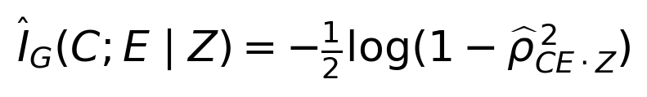
The estimator is nonnegative and has a positive finite-sample null floor. A positive interval for the mean estimator near zero is therefore not evidence against the exact model null. We report the intact model as an empirical null calibration. This estimator is not used to claim general nonlinear independence and would require replacement or supplementary tests for non-Gaussian neural data.

5 Experiment 1 Endpoint screening and failure controls
The forward simulator preserves a direct afferent-to-output contribution as well as an indirect modulation route. All C, W and epsilon variables are independent standard normal draws. The equations are as follows.
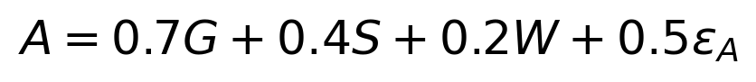
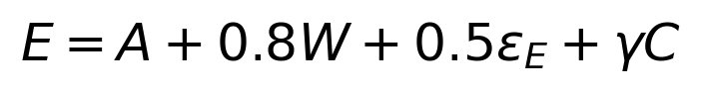
The intact model sets gamma to zero. Direct bypass controls set it to 0.25 or 0.5. Additional controls omit W, observe A with independent Gaussian measurement noise of standard deviation 0.5, or multiply the output contribution by two. In the gain control, the measured active output is also scaled by two. Thus, the control changes downstream amplitude without introducing a candidate bypass.
Table 1: Original endpoint screening estimates from V2
Condition | Conditioning variables | Estimated CMI and 95% interval
Intact endpoint | A and W | 0.000077 [0.000060, 0.000094]
Full process measurements | S G A and W | 0.000080 [0.000062, 0.000098]
Bypass strength 0.25 | A and W | 0.0401 [0.0394, 0.0408]
Bypass strength 0.50 | A and W | 0.1423 [0.1411, 0.1435]
Background omitted | A | 0.1278 [0.1266, 0.1289]
Output measurement noise | Noisy A and W | 0.0609 [0.0600, 0.0617]
Output gain doubled | Scaled A and W | 0.000077 [0.000060, 0.000094]

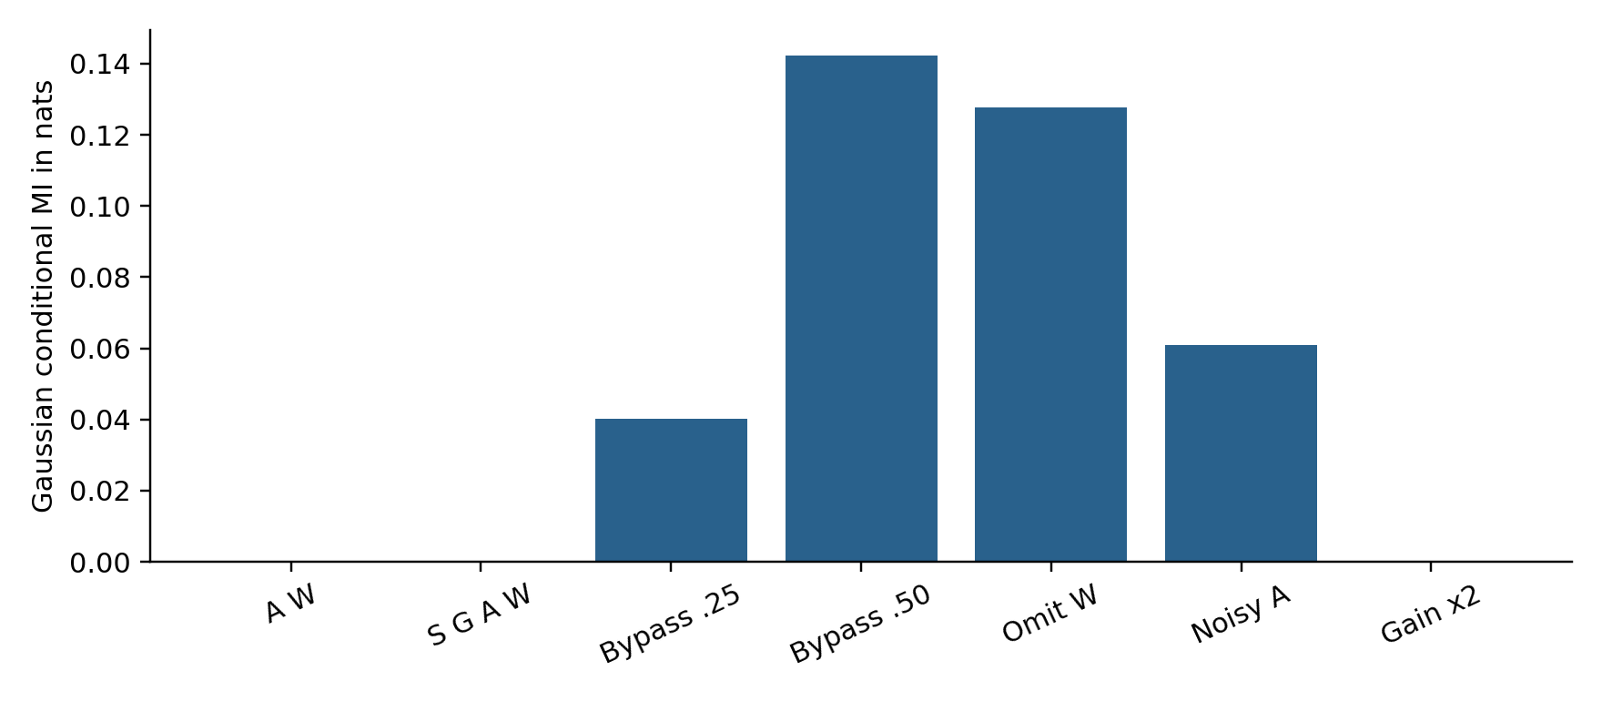
Figure 1. Gaussian screening estimates. Upstream measurements do not improve the essential endpoint screen in the intact model. Direct bypass, omitted background and output measurement noise all produce residual dependence. The gain control retains the intact estimate.
The intact A-W estimate is 0.000077 nats; the larger S-G-A-W set gives 0.000080 nats. A bypass of strength 0.5 raises the estimate to 0.1423 nats. Omitting W produces 0.1278 nats even though the simulator contains no direct candidate bypass. Measurement noise produces 0.0609 nats. Residual dependence therefore has multiple explanations. A biological observation of leakage must control for background omission and measurement error before interpreting it as a broken anatomical boundary.
The doubled-gain condition retains the screening estimate. It demonstrates that amplitude distortion does not necessarily violate the statistical relation. Conversely, low leakage cannot establish accurate amplitude, safe action or a normal phenotype. The intact screen is also not uniquely cerebellar: a conventional fully observed mediator would satisfy the same equation.

5 1 Independent replication against the population formula
The original seed means in Table 1 are retained. Proposition 1 exposes a precision issue: its exact population values lie below the original displayed 95% intervals for both nonzero bypass conditions. Those are nominal intervals for a finite-sample estimator, whose expectation also need not equal population information; a single seed ensemble is not a precision certificate. We therefore ran a separately seeded replication using the identical equations, 6,000 observations per seed and seeds 10000 through 10099, selected as a fixed disjoint block.
Table 2: Independent Gaussian replication in V3
Bypass γ | Exact population CMI | New mean and 95% interval
0.25 | 0.038934 | 0.039414 [0.038730, 0.040098]
0.50 | 0.140299 | 0.140913 [0.139680, 0.142146]

Both analytic reference values fall in the new nominal intervals. This is a numerical consistency check, not a new biological result or proof of interval coverage. The earlier estimates are not pooled away, and the new seed block does not replace the original supplement. Appendix B gives sufficient reproduction details for this additional calculation.

6 Experiment 2 Release calibration and opportunity cost
We next isolate the release decision. Candidate command u is uniform on [-1.5, 1.5] and load W is uniform on [0.6, 1.4]. The true consequence is their product; a noisy estimate adds independent normal error. Safe consequences have absolute magnitude at most one. The predictive policy releases when the estimated absolute magnitude is at most threshold h.
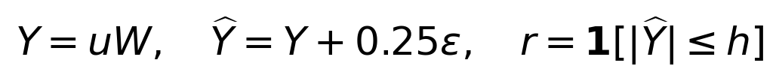
This estimate is supplied by the simulator and is not trained in this experiment. It represents a fixed predictor with specified accuracy, so the experiment tests the decision rule rather than the ability of a neural circuit to learn prediction. The main comparison uses h = 0.8. A sign-inverted rule releases when the same estimate exceeds 0.8. Always-release and always-hold policies provide two limiting controls.
Harm costs ten units and withholding a safe opportunity costs half a unit; withholding an unsafe opportunity has no cost in this toy task. These choices are explicit modelling assumptions. We also sweep 20 thresholds from 0.35 to 1.3 to display the release-harm tradeoff, without reporting the sample-minimising threshold as an independently validated optimum.
Table 3: Release policies and expected loss
Policy | Release fraction | Harm per opportunity | Expected cost
Predictive | 0.5589 | 0.0157 | 0.2363 [0.2329, 0.2396]
Sign inverted | 0.4411 | 0.2830 | 3.1018 [3.0904, 3.1132]
Always release | 1.0000 | 0.2987 | 2.9874 [2.9765, 2.9983]
Always hold | 0.0000 | 0.0000 | 0.3506 [0.3501, 0.3512]

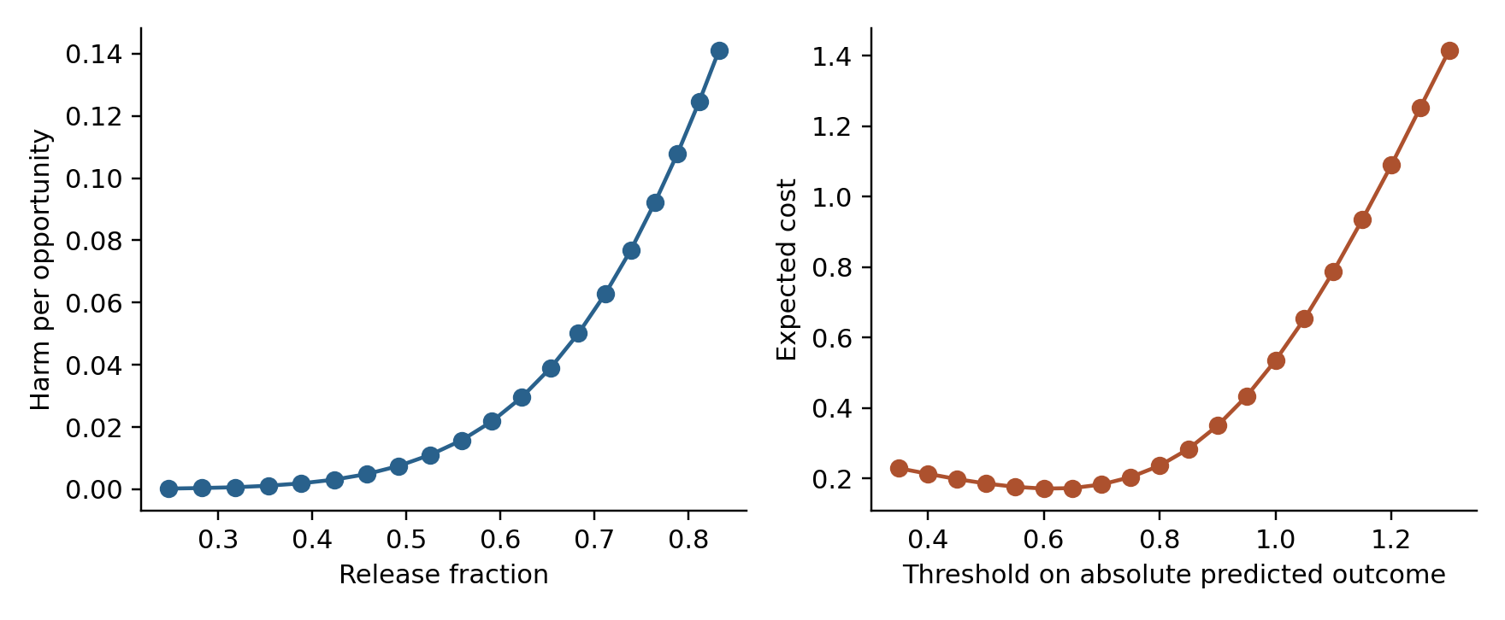
Figure 2. Threshold sweep for the fixed predictor. The left panel reports harmful releases against throughput. The right panel includes a penalty for holding safe opportunities. Curves show means over 30 seeds; raw curves are supplied in the supplement.
The predictive rule releases 55.89% of opportunities and causes harm on 1.57%, with expected cost 0.2363 [0.2329, 0.2396]. Always-release causes harm on 29.87%, with cost 2.9874. Always-hold has zero harm but cost 0.3506 because it loses every safe opportunity. The sign-inverted rule has cost 3.1018. Inhibition or a gate is therefore insufficient: the rule must be calibrated to a defined consequence and to the cost of withholding action.
Default-closed and default-open implementations of the same final release function would have identical static outcomes here. Their difference requires a fault or dynamics model, such as lost input, delayed inhibition or a stuck actuator. We do not simulate such faults and do not infer a biological default regime from this comparison. The endpoint would remain structurally mediated under every policy if it were generated only from the realised output and independent noise.

7 Experiment 3 Delayed outcome attribution
Each trial presents four independently drawn five-dimensional candidate vectors. A uniformly selected candidate is released with probability 0.6, independently of its features. The label for that candidate is its inner product with a fixed coefficient vector plus normal noise of standard deviation 0.1. A linear learner starts at zero. Its step size is 0.01, and labels arrive after 0, 5 or 20 trials.
At feedback arrival the learner performs an update only if the originating trial was released. All rules therefore already share a release mask. The experimental difference is which features receive the outcome, not whether release is required. The indexed rule retrieves the originating selected vector. The current rule uses the currently selected vector. The pooled rule uses the mean of all four candidates from the originating trial, including unchosen alternatives.
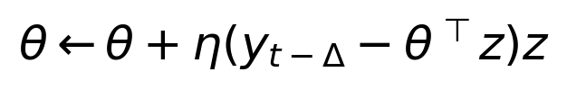
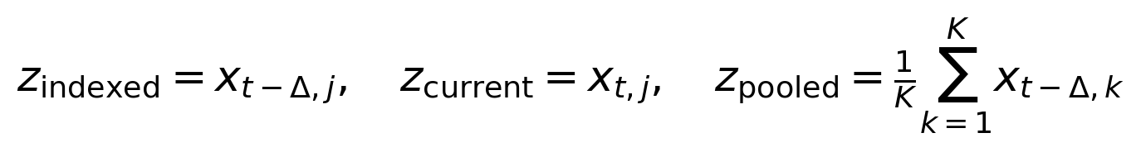
In the current rule, j denotes the candidate selected in the current trial; in the indexed rule it denotes the originating selection. Prediction is recomputed with the current parameters at arrival. Because test features are standard normal, squared coefficient error exactly equals noise-free expected excess prediction MSE. The irreducible observation-noise MSE of 0.01 is excluded. Every condition uses the same trial stream for a given seed.
Table 4: Delayed learning and candidate attribution
Delay in trials | Indexed MSE | Current candidate MSE | Pooled candidates MSE
0 | 0.000257 [0.000193, 0.000321] | 0.000257 [0.000193, 0.000321] | 0.0221 [0.0163, 0.0279]
5 | 0.000256 [0.000197, 0.000315] | 1.2988 [1.2250, 1.3726] | 0.0227 [0.0166, 0.0288]
20 | 0.000275 [0.000211, 0.000340] | 1.3415 [1.2720, 1.4110] | 0.0238 [0.0172, 0.0303]

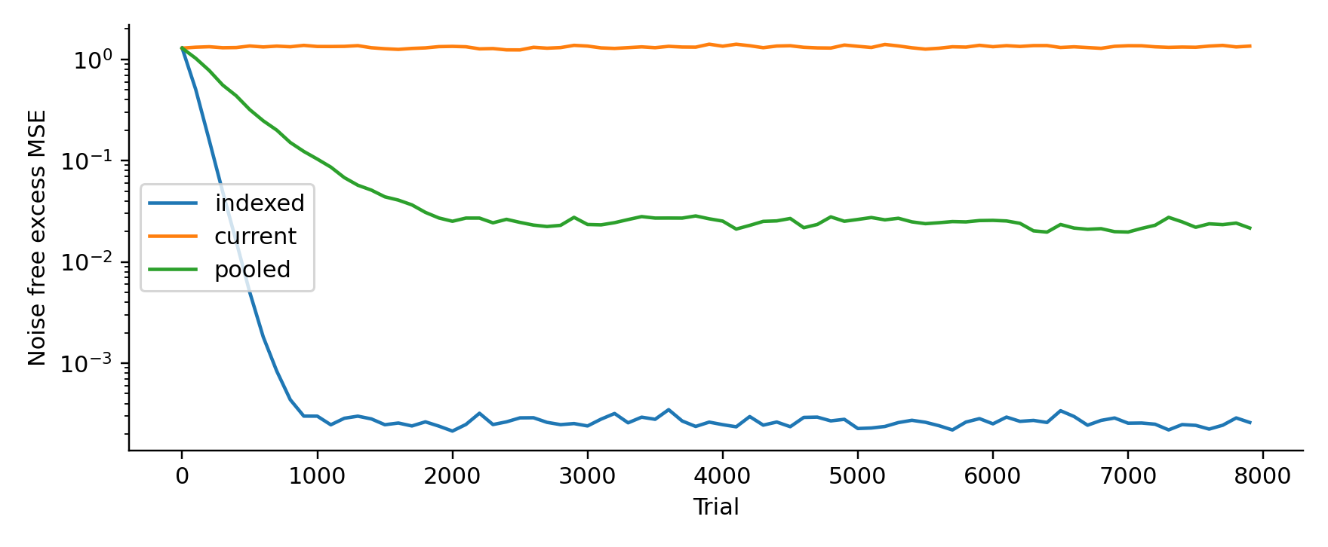
Figure 3. Mean noise-free excess MSE across 30 seeds at a delay of 20 trials. The indexed learner retains the originating chosen candidate. Pooling alternatives adds label uncertainty. Updating the unrelated current candidate fails to recover the true mapping.
At zero delay the indexed and current rules agree, as they should. At delay 20 the indexed error is 0.000275 [0.000211, 0.000340]; the current error is 1.3415 [1.2720, 1.4110]. The zero predictor has error 1.29, so the current rule is approximately nonlearning with additional update noise. The pooled error is 0.02376 [0.01723, 0.03028], about 86 times the indexed error, although much lower than the current-rule error.
Pooling is not constructed to be impossible. With exchangeable independent candidates and random selection, the conditional mean label given their average has the same coefficient vector. It remains learnable but has more residual label variance. This control prevents us from claiming that every update involving an unchosen candidate is necessarily biased. The evidence supports event-specific attribution under delay, not a general proof that commitment indexing is required for conditional independence.

8 Experiment 4 Valid observation of unreleased candidates
We test the strongest exclusion claim directly. Each seed generates 100 independent five-dimensional candidates and their own valid labels using the same coefficient vector, with noise standard deviation 0.2. Each candidate is marked released with probability 0.3. Ordinary least squares is fitted either to the released subset alone or to all valid labels, including labels for unreleased candidates. The second learner receives additional legitimate information. The comparison intentionally tests the value of that information, not sample-efficiency at equal label count.
Table 5: Learning from valid observational targets
Training information | Excess prediction MSE and 95% interval
Released subset only | 0.0086 [0.0073, 0.0100]
Released and valid observed candidates | 0.0020 [0.0017, 0.0023]

The error falls from 0.008618 to 0.002038, a reduction of approximately 76%. The labels for unexecuted candidates are externally provided in this simulator. Real biology would need a valid sensory, observational or simulated teaching source; this experiment does not show that such labels are always available. It does show that the unrestricted rule “no release implies no learning” is too strong.
Embedding either fitted predictor upstream of an endpoint equation E = f(A, W, independent noise) leaves that endpoint structurally screened by A and W. Thus observation-based learning does not inherently open a candidate-to-endpoint bypass. Whether a proposed biological observational-learning channel preserves the same structure is an empirical question. The revision replaces the universal exclusion with a provenance rule: an outcome may teach a candidate only when the teaching source legitimately identifies that candidate’s outcome or target.

9 Experiment 5 A snapshot is not always a delayed boundary
The final experiment gives one candidate two opportunities to affect output before the delayed endpoint. Independent standard normal innovations generate two output samples. Background and endpoint noise are also independent standard normals.
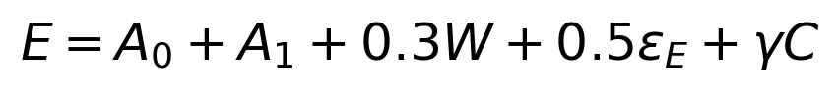
The intact trajectory model has gamma = 0. We compare conditioning on the first output and W with conditioning on both outputs and W. A positive control then adds a direct bypass of strength 0.5 while retaining both output samples.
Table 6: Snapshot and trajectory screening
Condition | Estimated CMI and 95% interval
Initial output snapshot | 0.2123 [0.2108, 0.2138]
Complete two-sample output trajectory | 0.000092 [0.000065, 0.000119]
Trajectory with direct bypass | 0.0683 [0.0673, 0.0692]

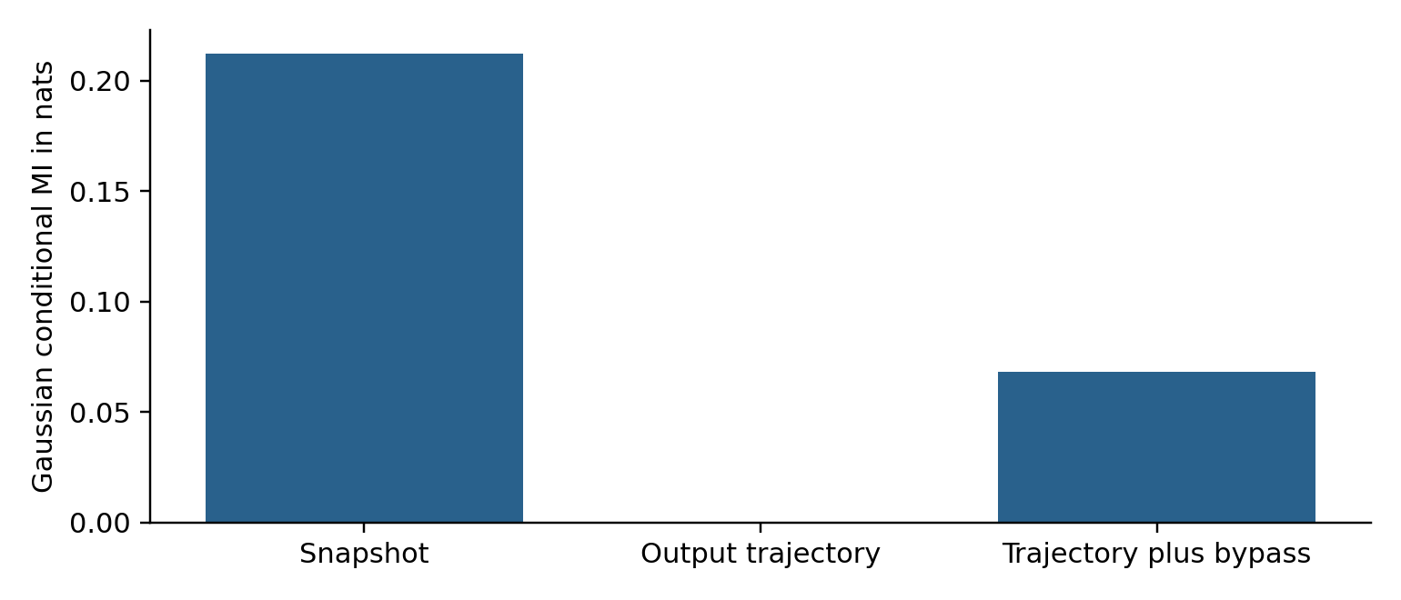
Figure 4. The delayed endpoint depends on both output samples. Observing the complete trajectory restores the model screen; observing only the initial output does not. A direct candidate bypass remains detectable after both outputs are included.
The snapshot estimate is 0.2123 nats. Including both output samples reduces it to 0.000092 nats, while the bypass control gives 0.06826 nats. The result does not refute a snapshot claim for a task whose initial output fully specifies its future effect. It identifies the additional sufficiency assumption required when later output carries further candidate influence. In an adaptive circuit, continuing feedback and updated control can make this issue especially important.

10 Interpretation and biological predictions

10 1 What the numerical evidence changes
The tested architecture can implement a local mediation screen, and correct event attribution improves delayed learning. Neither result alone identifies the cerebellum. The practical content of the hypothesis now lies in the joint organisation of contextual output modulation and teaching provenance. Existing forward-model accounts remain compatible with this organisation; this study does not demonstrate that the boundary account subsumes or outperforms them.
A biological study should first specify a loop and endpoint, record candidate-related and nuclear-output activity, and prespecify background variables. A nested prediction analysis can compare outcome prediction from output and background alone with prediction after adding candidate information. Held-out improvement is evidence of residual predictive dependence, with interpretation contingent on measurement accuracy, hidden state and model adequacy. A nonlinear analysis should not substitute Gaussian partial correlation without justification.
A stronger causal test would perturb candidate-related activity while experimentally matching or clamping the relevant output trajectory and relevant background pathways. Residual endpoint effects would challenge the specified mediation model. Merely finding that ordinary cortical perturbations change behaviour does not identify a bypass, because those perturbations can change the output interface itself.

10 2 Distinguishing teaching provenances from execution
A delayed teaching experiment should independently manipulate execution, validity of the target and correspondence between target and originating event. Add a manipulation of teaching efficacy, such as climbing-fibre coherence or the relevant disinhibitory pathway, while measuring mean input rate and acute performance. Estimate subsequent adaptation separately from immediate output changes. Valid targets for withheld movements test the exclusion rule; mismatched targets test attribution; a change in learning after input-rate matching tests teaching admission. A double dissociation would support the extended process hypothesis, whereas failure under adequate measurement sensitivity would challenge it. No exact software identifier or conditional-independence law is inferred from such a dissociation alone.
To test inhibitory operating regimes, measure the effect of reducing Purkinje activity while keeping afferent drive and task demands controlled. A default-closed interpretation requires a consequential output threshold, low baseline crossing probability and an appropriate causal change with disinhibition. Alternative findings could favour graded timing or gain modulation. No result from the present binary gate alone decides that question.

10 3 Pathology and nonmotor extensions
The original pathology taxonomy remains useful for generating hypotheses, but it is no longer presented as a taxonomy of conditional-independence failures. Dysmetria can result from incorrect output gain while screening is intact, as Experiment 1 illustrates. Impaired switching, tremor or ataxia may reflect dynamics or calibration without an additional candidate bypass. Conversely, residual dependence can appear solely because an output measurement is noisy.
For each proposed syndrome, the next model must reproduce a concrete observable, such as endpoint amplitude error, alternating-movement phase error or a tremor spectrum, and compare a boundary account against conventional control explanations. The present experiments contain no limbs, spiking neurons, oscillatory loop or lesion-specific physiology. They do not simulate these clinical syndromes.
Cognitive, language and affective extensions retain the same status as hypotheses from the conceptual manuscript. An investigator must define a candidate, a measurable commitment, an output interface and a valid delayed teaching signal within the selected loop. Motor analogies alone cannot establish that cognitive trajectories use the same release rule. Nonmotor tests should follow a successful operationalisation rather than be inferred from the mathematical notation.

11 AI harness research and the limits of the analogy

11 1 Recent primary research
We distinguish published neuroscience experiments from rapidly evolving AI manuscripts. The four agent papers below were available before the evidence cutoff; they are cited as arXiv manuscripts with explicit versions. Their reported benchmark findings are evidence about the evaluated systems, not established laws of harness design.
Harness as a Language introduces the JAZ invoke primitive and hooks for observation, replay, resource control and validation [13]. It is a useful example of an expressive core loop with explicit control interfaces. Crucially, a return-value validator is not automatically a pre-execution side-effect gate. Its local and dynamically scoped hooks also make coverage across recursive calls an explicit design issue. The analogy is to constrained interfaces, not to a literal correspondence between recursion and cerebellar anatomy.
Harnessing LLMs as Agents develops a resource-bounded language-model agent abstraction, charging for calls, context-memory traffic, storage and verification [14]. It motivates accounting for the cost of maintaining traces and checking outcomes. Its resource results are not biological energy laws, and we do not transfer their asymptotic bounds to cerebellar circuits.
Harness-Aware Distillation contrasts a teacher’s actions with and without harness information and filters preference pairs that conflict with harness records [15]. The filtering applies to the preference component; it is not a proof that all learning targets are correct. This supplies a precise software analogue for admitting a teaching target after a consistency check. It does not show that record consistency alone establishes causal attribution.
Finding the Right Fit evaluates model-harness combinations across tasks and reports ranking reversals and task-dependent advantages [16]. It makes a fixed-model comparison essential when testing an interface claim. The relevant lesson is that feedback formatting, recovery and completion checks belong to the evaluated system. The paper does not identify a universal best harness or test the present Neuro-Markov architecture.

11 2 A correspondence between functions rather than organs
Table 7 A partial functional correspondence with a harness
Cerebellar proposal | Engineering harness analogue
Candidate and context input | Proposed tool action and validated task state
Output modulation | A dispatcher enforcing scoped capabilities and release rules
Consequential output | The complete record of externally effective tool actions
Circuit dependent teaching efficacy | Admission of an update after source and target checks
Eligibility for a prior event | Action identifier with state version and execution time
Delayed consequence | A solver result or external outcome linked to that identifier

This is a partial functional mapping. A real cerebellum is recurrent, distributed, continuously active and embedded in other control routes. A software dispatcher can enforce capabilities and exact identifiers that are not known to exist biologically. “Harness” also covers prompts, memory, runtime and evaluation, far more than one neural circuit. A frozen foundation model can adapt its behaviour through mutable harness state without weight updates; θ in the abstract framework may describe that state or policy, rather than foundation-model weights.

11 3 A causal guarantee for an enforced tool interface
Theorem 4 Trace mediation for a complete dispatcher. Consider a finite-horizon engineering environment with initial state X₀ and transition $X_{i+1}$ = $F_{i}$($X_{i}$, $a_{i}$, $U_{i}$). Assume every model-originating consequential mutation is represented in a dispatcher-emitted action $a_{i}$, the model has no other path to change X, and the transition law does not inspect unreleased proposal text. For any two candidate-generation procedures, jointly imposing the same action trace and the same law of (X₀,U₀,…,$U_{n}$) gives identical environment-trajectory laws.
Proof. Couple the two executions with the same initial state and noise sequence, and clamp the same emitted actions. The initial states coincide. If the states coincide at step i, applying the same transition function to the same state, action and innovation gives identical states at step i+1. Induction proves pathwise equality and therefore equality in law. This is a causal noninterference result for the specified execution model. It does not assert observational conditional independence after conditioning on a feedback-dependent trace, which can fail as in Proposition 2. □
Complete coverage is a substantive assumption. A shell, plugin, recursive call or writable shared file with an unrecorded consequential side effect invalidates it. Logging after execution does not enforce coverage. The claim can be tested by attempting a prohibited state change through every available interface while holding the admitted trace fixed. A single successful bypass falsifies complete mediation for that runtime.

11 4 Construction example and a matched evaluation
For a structural-design assistant, separate drafting a design alternative, running a sandboxed solver and issuing a consequential drawing or procurement instruction. Register each released event with an immutable identifier, input-model hash, units, load case, code edition, tool version and result status. A delayed solver response must refer to that event. A checked simulation of an unissued alternative may supply a valid observational target, but should not be labelled as a realised construction outcome. A valid event can still be refused for learning if the target check fails.
The proposed evaluation fixes the foundation model, tasks, solver and token budget. Compare a logged-only loop, a complete dispatcher, and the same dispatcher plus teaching-target admission. Independently randomise feedback-event mismatches and attempts to use alternate tool paths. Measure engineering validity, useful completion, harmful-release rate, withheld-valid-action rate, attribution errors, recovery time and cost. A dispatcher should prevent tested bypasses; event binding should reduce misattribution; teaching admission should reduce learning from invalid targets. If these mechanisms provide no such improvements on held-out cases, the engineering transfer claim loses support.

12 Limitations and conclusion
The five original experiments remain intentionally simple and use no biological recordings. Their causal equations impose the screens they test, so the Gaussian tests serve as implementation and sensitivity checks. The new independent replication checks two bypass estimates against an analytic formula. None of these calculations measures neural conditional sufficiency, circuit-specific energy use or biological learning from observation. The numerical learner stores features perfectly; it does not implement finite eligibility traces or synchrony-dependent plasticity. Those remain experiments to be done.
The proofs are guarantees for explicit probability models, decision losses and execution interfaces. Their biological applicability depends on assumptions that anatomy alone cannot establish. In particular, feedback can invalidate terminal-innovation independence, omitted pathways can confound residual dependence, and marginally calibrated confidence cannot justify conditional risk bounds. Recent harness manuscripts are preliminary and their benchmark findings do not validate a cerebellar analogy. The next empirical step is to test the specified dissociation in one loop, and the next engineering step is the fixed-model dispatcher and teaching-admission ablation.
The revised Neuro-Markov hypothesis separates consequential output, the quality of release and the admissibility of teaching. Current neuroscience most directly strengthens circuit-dependent teaching admission, while the mathematical results specify when endpoint screening, delayed attribution and causal trace mediation do or do not follow. The preserved synthetic experiments support only their constructed computational claims. The theory now has explicit failure cases and paired biological and software tests, with the status of each claim stated at the point where it is used.

Data and code availability
The https://github.com/debiprasadghosh/ResearchOverFlow/tree/main/October2026/NeuroMarkovBoundary/Neuro_Markov_Numerical_Supplement.zip remains the source of the five V2 experiments, seed-level results and figures retained here. Its verify_results.py checks passed during this revision. The additional Gaussian replication is specified in Appendix B and was executed separately; it is not represented as part of that unchanged archive. All numerical observations in this paper are synthetic. No new animal, human, clinical or deployed agent benchmark data were collected.

References
1. Ghosh, D. P. (2026). The Neuro-Markov Boundary of the Cerebellar Circuit. Original conceptual manuscript dated 11 May 2026.
https://github.com/debiprasadghosh/ResearchOverFlow/tree/main/October2026/NeuroMarkovBoundary/The Neuro-Markov Boundary of the Cerebellar Circuit.docx
2. Zheng, N., and Raman, I. M. (2009). Ca currents activated by spontaneous firing and synaptic disinhibition in neurons of the cerebellar nuclei. Journal of Neuroscience, 29, 9826-9838. https://doi.org/10.1523/JNEUROSCI.2069-09.2009
3. Kimpo, R. R., Rinaldi, J. M., Kim, C. K., Payne, H. L., and Raymond, J. L. (2014). Gating of neural error signals during motor learning. eLife, 3, e02076. https://doi.org/10.7554/eLife.02076
4. Kostadinov, D., Beau, M., Blanco-Pozo, M., and Häusser, M. (2019). Predictive and reactive reward signals conveyed by climbing fiber inputs to cerebellar Purkinje cells. Nature Neuroscience, 22, 950-962. https://doi.org/10.1038/s41593-019-0381-8
5. Larry, N., Yarkoni, M., Lixenberg, A., and Joshua, M. (2019). Cerebellar climbing fibers encode expected reward size. eLife, 8, e46870. https://doi.org/10.7554/eLife.46870
6. Marr, D. (1969). A theory of cerebellar cortex. Journal of Physiology, 202, 437-470. Foundational context retained from the original manuscript.
7. Albus, J. S. (1971). A theory of cerebellar function. Mathematical Biosciences, 10, 25-61. Foundational context retained from the original manuscript.
8. Wolpert, D. M., Miall, R. C., and Kawato, M. (1998). Internal models in the cerebellum. Trends in Cognitive Sciences, 2, 338-347. Foundational context retained from the original manuscript.
9. Pearl, J. (1988). Probabilistic reasoning in intelligent systems. Morgan Kaufmann. Graphical-model context retained from the original manuscript.
10. Santos-Valencia, F., Lackey, E. P., Norton, A., et al. (2026). Climbing fibres recruit disinhibition to enhance Purkinje cell calcium signals. Nature, 653, 455-464. Published online 18 March 2026. https://doi.org/10.1038/s41586-026-10220-4
11. Park, C., Yang, Z., Nashef, A., et al. (2026). Synchronous climbing fiber activity enables instructive signaling for cerebellar learning through modulation of disinhibitory circuits. Nature Neuroscience, 29, 1425-1438. Published online 14 May 2026. https://doi.org/10.1038/s41593-026-02268-2
12. Filio, B. A., Otchere, A., Srinivasan, S., et al. (2026). Predictive and instructive cerebellar encoding of dopamine reward drives motivated behavior. Nature Neuroscience. Published online 16 September 2026. https://doi.org/10.1038/s41593-026-02449-z
13. Li, Z., Liu, J., Vukelic, M., et al. (2026). Harness as a Language: A Minimalist Agent Framework With Maximal Expressivity. arXiv:2609.26891v2, 30 September 2026; initially submitted 22 September. https://arxiv.org/abs/2609.26891v2
14. Zhao, Z., Guo, X., Zhang, J., Zhang, Y., and Chen, Y. (2026). Harnessing LLMs as Agents: What Does It Cost? arXiv:2610.02488v2, 6 October 2026; initially submitted 1 October. Resource-theory discussion based on the accessible author abstract and version metadata. https://arxiv.org/abs/2610.02488v2
15. Choi, M., Moon, T., Nam, G., and Lee, J. (2026). Harness-Aware Distillation for Small Language Model Agents. arXiv:2610.02858v1, 2 October 2026. https://arxiv.org/abs/2610.02858v1
16. Li, Y., Zhou, Y., Teng, Y. L., et al. (2026). Finding the Right Fit: Model-Harness Interactions across Agent Tasks. arXiv:2610.00917v1, 1 October 2026. https://arxiv.org/abs/2610.00917v1
https://github.com/debiprasadghosh/ResearchOverFlow/tree/main/October2026/NeuroMarkovBoundary

Appendix Revision record
Table 8 Earlier changes from the conceptual manuscript to V2
Original proposition | Status in this revision
S G A is a minimal local Markov boundary | B is a functional process interface. Statistical minimality is a separate question; A with W suffices in the endpoint simulator.
Purkinje inhibition implies default closed release | Task-dependent operating regime requiring evidence about baseline output and a consequential threshold.
No release implies no learning | Replaced by label-event validity. Own outcomes require originating-action attribution; valid observational targets can support learning.
Learning from unchosen candidates collapses screening | Not generally true. Screening persists under upstream learning if the endpoint factorisation and independent innovations remain valid.
Pathology reflects conditional independence failure | Retained only as a set of functional hypotheses. Calibration failure can coexist with screening.
A release-time state screens a delayed endpoint | Requires temporal sufficiency. A complete relevant output record may be necessary.

Appendix B Reproduction and scope of the new calculations
The new replication follows the E1 generator in neuro_markov_experiments.py exactly, including draw order. For each integer seed in range(10000,10100), use numpy.random.default_rng(seed) and n = 6000. Draw C, W, $ε_{S}$, $ε_{G}$, $ε_{A}$ and $ε_{E}$ successively as length-n standard normal arrays. Form S = C + 0.5W + 0.4$ε_{S}$; G = 0.8S + 0.3$ε_{G}$; A = 0.7G + 0.4S + 0.2W + 0.5$ε_{A}$; and $E_{γ}$ = A + 0.8W + 0.5$ε_{E}$ + γC. Regress C and $E_{γ}$ separately on columns [1,A,W] using numpy.linalg.lstsq with rcond=None. Let ρ be the correlation of the two residual arrays and record −0.5 log(1−ρ²). Report the mean over seeds and $t_{0.975,99}$ times the sample standard deviation divided by 10. Use γ = 0.25 and 0.5 with the same generated arrays. These instructions define the additional computation without modifying the original archive.
The new equations are native Word mathematics. The pre-existing numerical equations and plots retain the image representation used in V2. The theorems establish properties of explicitly defined models; no claim is made that all assumptions have been verified in cerebellar recordings. New references were checked against primary publication pages, author manuscripts or author-affiliated repositories. For reference 14, only the accessible author abstract and version history were used; no theorem from its unavailable full text is invoked.
V3 adds separate action and teaching-admission variables, Theorems 1-4, Lemmas 1-3, Propositions 1-3, Corollaries 1-2, the Gaussian population references and replication, and the harness evidence and evaluation design. The V2 results and their clinical and nonmotor limitations are preserved. The earlier revision record above documents the V1-to-V2 changes.

