Vocabucapillary Concept Bottlenecks
Native concept addresses, bounded localisation memory and certified concept explanations
Debi Prasad Ghosh, debiprasadghosh@gmail.com
Founder and Principal Engineer, Debias Parametric Guru, Kolkata, India
8 November 2026 · Preprint · Defensible Intelligence series
Abstract
Concept bottleneck models promise explanations in human vocabulary, yet three recurring failures limit that promise: concepts can be predicted from the wrong image regions, discovered concepts can be duplicates whose individual importances are unstable, and importance scores such as the TCAV sign fraction can be uninformative. We ask how the Vocabucapillary framework, in which a state is a sparse unit-mass code over vocabulary-associated addresses with bounded coefficient memory, can improve such models. We first show that existing concept models are already partial vocabulary coordinate systems: ACE assigns segments to concept addresses by a hard code, the vanilla CBM retains only the pooled concept mass, and the V2C-CBM classifier computes each class score as an expectation of concept activations under a softmax class code on the concept simplex. Using this common language we prove that any concept predictor depending only on pooled patch codes is permutation-invariant, so the concept trustworthiness score is not a function of its prediction state; that a bounded location statistic restores exact localisation, centroids and region-deletion effects; that peak localisation does not bound off-region reliance; that pruning a simplex class code has an exact error identity and an operational top-1 certificate; that the TCAV sign fraction equals one for every concept of a simplex-weighted linear bottleneck while the probability contrast is informative and sums to zero; and that near-duplicate concepts have vanishing restricted affine conditioning, a closed-form nearest-atom flip probability and an explicit merge error. A numerical study written in immutable C# on synthetic part-structured images supports each statement. At train correlation 0.95 and moderate part signal, a pooled CBM falls from 0.909 to 0.666 accuracy on decorrelated data with peak trust 0.352, whereas an address-locked Vocabucapillary readout keeps 0.800 and 0.815 with trust 0.857, and a learned readout with an address-locking penalty reaches 0.907 and 0.896. The pruning identity holds to 1.5×10⁻¹⁵, and observed duplicate flip rates match the analytic prediction. All data are synthetic; no claim is made about trained vision models.
Keywords: Vocabucapillary; concept bottleneck models; concept trustworthiness; automatic concept discovery; vision-to-concept tokenizer; bounded coefficient memory; identifiability; certified pruning

1 Motivation and scope
A concept bottleneck model (CBM) maps an input to a vector of human-named concepts and then maps those concepts to a label (Koh et al., 2020). The second map is transparent; the first is not. Three recent lines of work expose complementary weaknesses of the first map. Automatic Concept-based Explanations (ACE) discovers concepts by segmenting images, embedding segments in a CNN activation space, clustering them and ranking clusters by TCAV (Ghorbani et al., 2019); its authors report incoherent clusters and visually duplicated concepts with similar scores, and leave open whether such duplicates should be merged. Huang et al. (2024) show that CBM concepts are often predicted from irrelevant regions, introduce a concept trustworthiness score based on peak localisation, and attribute the failure to average pooling of the final feature map. V2C-CBM replaces language-model concept lists with a vocabulary of common words filtered by a CLIP model and quantises images into their nearest concept tokens (He et al., 2025).
Vocabucapillary represents a contextual state as a unit-mass, support-limited vector of coefficients over vocabulary-associated addresses, decodes it through a dictionary, and replaces a growing record list by bounded sufficient statistics of a coefficient kernel (Ghosh, 2026b; 2026d). Companion papers develop identifiability, exact deletion and anchored attribution for coefficient trajectories (Ghosh, 2026e), modality budgets (Ghosh, 2026i), Shapley structure (Ghosh, 2026j) and probabilistic codes (Ghosh, 2026h). The question of this paper is narrow and practical: which concrete changes to a concept model does this framework license, and which of them can be proved or numerically supported?
The answer separates three objects that existing concept models tend to merge: the code a model actually uses at each image location, the statistic it retains about those codes, and the readout that turns the statistic into concept and class probabilities. Each failure above lives in one of these objects, and each has a Vocabucapillary remedy with a precise guarantee and a precise limit.

1.1 Contributions
- A common formulation in which ACE, the vanilla CBM, prototype CBMs and V2C-CBM are read as vocabulary coordinate systems with stated codes, statistics and readouts (Section 2, Table 1).
- Ten results (Section 3): a permutation-invariance obstruction for pooled concept prediction; exact localisation, centroid and deletion identities from a bounded location statistic; a counterexample showing that peak-localisation trust does not bound off-region reliance; an exact pruning identity and operational certificate for simplex class codes; the degeneracy of the TCAV sign fraction for simplex-weighted bottlenecks and a zero-sum contrast replacement; conditioning, flip-probability and merge-error results for duplicate concepts; and bounded counters for ACE-style discovery filters.
- An immutable C# reference implementation (records, ImmutableArray, pure static functions and a pure SplitMix64 generator) and four numerical studies, with an independent NumPy cross-check of the conditioning computation (Section 4).
- Design recommendations, explicit limitations and a falsifiable validation protocol for trained vision-language models (Sections 5–7).
The paper is analytical and simulation-based. Its numerical results come from a synthetic part-structured world designed so that each mechanism can be isolated; they establish that the identities hold and that the predicted qualitative behaviour appears, not that any published model would improve by a stated amount.

2 Concept models as vocabulary coordinate systems

2.1 Notation
Let 𝒞 = {1, …, N} index a concept vocabulary, which may include a background address. A dictionary D = [d₁, …, d_{N}] ∈ ℝ^{d×N} holds unit-norm atoms: text embeddings E_{t}(c) in a CLIP-style model, prototypes in a part-prototype network, or cluster centres in ACE. An image x yields P local features z_{i} = f(x)_{i} (patches, super-pixel segments or tokens) with locations ℓ_{i}. The unit simplex is Δ^{N−1}. A positive Vocabucapillary code is c ∈ Δ^{N−1} with |supp(c)| ≤ s (Ghosh, 2026b, Definition 1).

2.2 Existing models in one language
Table 1 reads four published designs through the triple (code, statistic, readout). Two observations follow directly. First, the V2C-CBM classifier is already a Vocabucapillary readout: writing A(x) ∈ ℝ^{N} for the concept similarities and σ(W_{k}) for the softmax of row k of its class–concept matrix, its score is
ŷ_{k}(x) = Σ_{j} σ(W_{k})_{j} A_{j}(x) = 𝔼_{j∼σ(Wk)} [ A_{j}(x) ], (1)
an expectation of concept activation under a positive code on the concept simplex (He et al., 2025, Eq. 6). Second, the vanilla CBM and V2C-CBM retain only an image-level summary — a pooled feature or a single embedding — so whatever their concept vector says about where a concept was seen is reconstructed after the fact by an attribution method such as Grad-CAM++ (Huang et al., 2024).
Table 1. Four concept models read as (code, statistic, readout).
Model | Per-location code | Retained statistic | Concept / class readout | Localisation source
ACE (Ghorbani et al., 2019) | hard: segment → nearest K-means centre (s = 1) | cluster populations and image frequencies | TCAV sign fraction per concept | segment identity (retained exemplars)
Vanilla CBM (Koh et al., 2020) | none (dense features) | average-pooled feature z̄ | g(z̄) then h(g) | post-hoc Grad-CAM++
Prototype CBM (Huang et al., 2024) | prototype similarities per location | max over locations per prototype | linear in activations | top-N prototype maps averaged
V2C-CBM (He et al., 2025) | global image: top-K nearest concept tokens | one image embedding | ŷ = A·σ(W)^{T} (simplex class codes) | not provided
VC-CBM (this paper) | c_{i} = 𝒫_{s}(D^{T}z_{i}/τ), unit mass, support ≤ s | (m, S, K) bounded | address-locked or learned with locking penalty; pruned class codes | native: S and exact contributions

2.3 The Vocabucapillary concept bottleneck
Definition 1 (VC-CBM). Fix s ≥ 1 and τ > 0. For each location, the patch code is the top-s entropic projection
c_{i} = 𝒫_{s}(u_{i}), u_{i} = D^{T}z_{i}/τ, (c_{i})_{j} = 1[j ∈ T_{i}] exp(u_{ij}) / Σ_{l∈T(i)} exp(u_{il}), (2)
where T_{i} holds the s largest scores. The image retains the bounded concept memory
m = (1/P) Σ_{i} c_{i}, S = (1/P) Σ_{i} c_{i} e_{i}^{T}, K_{j} = Σ_{i} (c_{i})_{j} v_{i} / Σ_{i} (c_{i})_{j}, (3)
with e_{i} the one-hot location and v_{i} ∈ ℝ² its grid coordinates. The concept logit is either address-locked, θ_{j} = a_{j} + b_{j} m_{j}, or a learned readout θ_{j} = a_{j} + u_{j}^{T}m trained with an address-locking penalty λ‖u_{j}|_{off(j)}‖² on addresses whose home region differs from that of j. Class scores use simplex class codes as in Equation (1), optionally pruned to s_{k} addresses.
Equation (3) is the KV Coefficient aggregation (Ghosh, 2026a; 2026b, Theorem 6) with patch locations as values: m is the vocabulary mass and S the value statistic. Its size is N(1 + P) fields, or N(1 + 2) when only centroids are kept, independent of how many images or segments are aggregated when the same law is used across a stream.
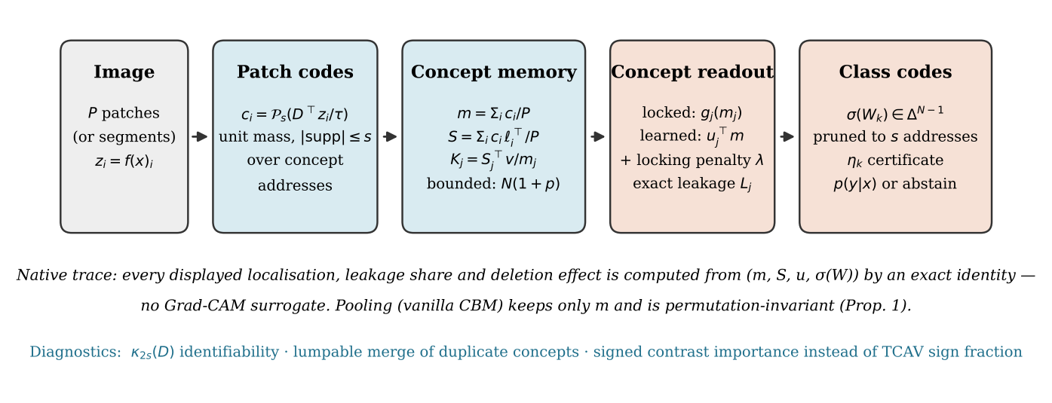
Figure 1. The Vocabucapillary concept bottleneck. Patch codes are unit-mass, support-limited vectors over concept addresses; the image retains a bounded memory of masses, a location statistic and centroids; the concept readout is address-locked or learned with a locking penalty; class scores are expectations under simplex class codes that can be pruned with a certificate.
Lemma 1 (Top-s entropic coding). On the simplex face of a support T, the unique minimiser of −⟨u, c⟩ + Σ_{j} c_{j} log c_{j} is the softmax of u restricted to T, with optimal value −log Σ_{j∈T} exp(u_{j}). Among supports of size s, the top-s support attains the smallest optimal value, so Equation (2) is the exact entropic code under a hard support cap.
Proof. Lagrangian stationarity on the face gives c_{j} ∝ exp(u_{j}); strict convexity of the negative entropy gives uniqueness. Substituting yields the value −log Σ_{j∈T} exp(u_{j}), which decreases when any member of T is replaced by an address with a larger score. Hence the s largest scores minimise it. The same rule appears with modality quotas in Ghosh (2026i, Theorem 4). ∎

3 Theory

3.1 Pooling erases localisation
Proposition 1 (Permutation invariance of pooled concept prediction). Let a concept predictor depend on an image only through m = (1/P)Σ_{i}c_{i}, or, for a vanilla CBM with a linear concept map, only through z̄ = (1/P)Σ_{i}z_{i}. Then any permutation of locations leaves every concept and class output unchanged, while the localisation statistic S changes whenever the permutation moves concept mass between regions. Consequently, a concept trustworthiness score defined from locations is not a function of the prediction state.
Proof. Finite sums commute, so m and z̄ are invariant. S is indexed by location, and a permutation σ maps S_{j}(i) to S_{j}(σ⁻¹(i)). If the permuted image is assigned a different trustworthiness but the same outputs, the score cannot be computed from those outputs or from the pooled state. ∎
This is the image-domain form of two Vocabucapillary results: vocabulary masses alone can lose contextual association (Ghosh, 2026b, Proposition 8), and commutative type counts lose order (Proposition 11). It makes precise the diagnosis of Huang et al. (2024): average pooling does not merely encourage region confusion; it discards the variable on which their score is defined, so any localisation must be supplied by a separate mechanism that the prediction never consulted. The proposition does not say that a pooled model is untrustworthy, only that its trustworthiness cannot be read from what it computes.

3.2 Native localisation and exact deletion
Proposition 2 (Exact native localisation). For the memory of Definition 1: (i) the share of concept j mass in region R is S_{j}(R)/m_{j}; (ii) K_{j} is the mass-weighted centroid used by the prediction-alignment loss of Huang et al. (2024) and is obtained from 3N retained numbers; (iii) replacing the codes of all locations in R by codes c′_{i} changes m_{j} by exactly (1/P)Σ_{i∈R}[(c′_{i})_{j} − (c_{i})_{j}], and for a learned readout changes the logit by exactly (1/P)Σ_{i∈R} u_{j}^{T}(c′_{i} − c_{i}).
Proof. Items (i) and (ii) are definitions of the retained sums. For (iii), m is a sum over locations and the readout is affine in m, so only the replaced terms change. ∎
The deletion identity is what the patch-drop experiment of Huang et al. (2024, Figure 4) estimates by rerunning the network. Here it is a closed form, provided the intervention is declared at the code boundary; replacing pixels and recomputing the backbone is a different intervention whose codes c′_{i} must be recomputed (Ghosh, 2026e, Definition 3). For a normalised coefficient-attention read instead of a sum, the analogous exact group deletion is Theorem 8 of Ghosh (2026e).
Definition 2 (Address leakage). For a learned readout and an image, write the logit contributions as γ_{k} = u_{jk} m_{k}. The address leakage of concept j is L_{j} = Σ_{k∉home(j)}|γ_{k}| / Σ_{k}|γ_{k}|, where home(j) contains the addresses sharing the home region of j. The background address is counted as off-region.
Proposition 3 (Peak trust does not bound reliance). There exist contributions for which the largest single location contribution lies in the home region while L_{j} is arbitrarily close to one.
Proof. Let one home location contribute a > 0 and each of P − 1 off-region locations contribute b with 0 < b < a. The peak is the home location, while the off-region share is (P − 1)b / (a + (P − 1)b), which tends to one as P grows for fixed b/a. ∎
The trustworthiness score of Huang et al. (2024, Equation 1) asks whether a fixed box centred at the peak of the localisation map contains the annotated part. Proposition 3 shows that such a score can certify a concept whose evidence is mostly elsewhere. A mass-based leakage and a deletion test measure what the peak cannot; Section 4.3 observes this gap numerically.
Proposition 4 (Correlation invariance of address locking). Let concept j be predicted by an address-locked readout θ_{j} = a + b m_{j}. If the conditional law of m_{j} given the concept label is the same under the training and test distributions, then the readout has the same accuracy on both, whatever the correlation between concept j and other concepts.
Proof. Accuracy is 𝔼_{y}[ℙ(1[θ_{j} > 0] = y | y)] weighted by the label marginal; both factors are unchanged when the label marginal and the conditional law of m_{j} are unchanged. Correlation with other concepts enters neither. ∎
The hypothesis is substantive: it fails when codes at address j are produced by off-region content, for example when the dictionary atom of j correlates with the atom of a spuriously associated concept. Locking therefore converts a shortcut problem into a dictionary-conditioning problem, which Section 3.4 makes measurable.

3.3 Class codes: pruning certificates and informative importance
Proposition 5 (Exact pruning identity and operational certificate). Let c = σ(W_{k}) and let c̃ keep the coordinates in T and renormalise, discarding mass η_{k}. Write ỹ_{k} = Σ_{j} c̃_{j}A_{j} and ā_{D} for the mean of A under the normalised discarded part. Then
ŷ_{k} − ỹ_{k} = η_{k} (ā_{D} − ỹ_{k}), |ŷ_{k} − ỹ_{k}| ≤ η_{k} (max_{j} A_{j} − min_{j} A_{j}). (4)
Moreover ŷ_{k} ∈ [(1 − η_{k})ỹ_{k} + η_{k} min A, (1 − η_{k})ỹ_{k} + η_{k} max A]. If the lower end of this interval for the pruned top class exceeds the upper end for every other class, the full and pruned classifiers have the same top-1 prediction. The certificate uses only pruned scores, the stored η_{k} and two scalars of A(x).
Proof. Write c = (1 − η_{k})c̃ + η_{k}r with r the normalised discarded part. Linearity gives ŷ_{k} = (1 − η_{k})ỹ_{k} + η_{k}ā_{D}, which rearranges to the identity. Since ā_{D} is an average of entries of A, it lies between their minimum and maximum. Disjoint intervals preserve the ordering of the top class against each competitor. ∎
This is the predictive analogue of the pruning lemma of the cacheless paper (Ghosh, 2026b, Lemma 10), and it applies verbatim to V2C-CBM, LaBo and any classifier of the form of Equation (1). It turns a choice of bottleneck size into a checkable statement: a class code with small discarded mass admits certified pruning, and a diffuse code does not.
Proposition 6 (TCAV degeneracy and a zero-sum contrast). For Equation (1), the directional derivative of ŷ_{k} along concept coordinate j equals σ(W_{k})_{j} > 0 for every input; a TCAV-style score, the fraction of class-k inputs with positive directional derivative, therefore equals one for every concept. For class probabilities p = softmax(γŷ),
∂p_{k}/∂A_{j} = γ p_{k} ( σ(W_{k})_{j} − Σ_{l} p_{l} σ(W_{l})_{j} ), Σ_{j} ∂p_{k}/∂A_{j} = 0. (5)
Proof. The first statement differentiates a linear function with positive weights. For the second, the softmax Jacobian gives ∂p_{k}/∂ŷ_{l} = γp_{k}(δ_{kl} − p_{l}), and ∂ŷ_{l}/∂A_{j} = σ(W_{l})_{j}. Summing over j uses Σ_{j}σ(W_{l})_{j} = 1 for every l, giving γp_{k}(1 − Σ_{l}p_{l}) = 0. ∎
The contrast is the class-head counterpart of the signed gate sensitivity of Ghosh (2026e, Theorem 7): a concept matters for class k only to the extent that k weights it more than the probability-weighted competition does, and a uniform shift of all concept activations has no effect. ACE ranks concepts by TCAV (Ghorbani et al., 2019); Proposition 6 shows that for a simplex-weighted linear bottleneck that ranking carries no information unless it is computed on probabilities or margins.

3.4 Duplicate concepts: identifiability, flips and merging
ACE reports three ocean-surface concepts with similar TCAV scores and asks whether they should be merged (Ghorbani et al., 2019, Appendix C); V2C-CBM lists near-synonyms such as "hot bowl" and "hot dishes" among the top concepts of one class (He et al., 2025, Table 3). Vocabucapillary supplies the relevant quantity, the restricted affine conditioning (Ghosh, 2026e, Equation 2)
κ_{2s}(D) = inf { ‖Dz‖₂ : ‖z‖₂ = 1, 1^{T}z = 0, |supp(z)| ≤ 2s }, (6)
which controls how far two s-sparse codes can differ while decoding to nearby points: ‖c − c′‖₂ ≤ ‖Dc − Dc′‖₂/κ_{2s}(D) (Ghosh, 2026e, Theorem 1).
Proposition 7 (Duplicates destroy identifiability; flip probability). For any two atoms, κ₂(D) ≤ ‖d_{a} − d_{b}‖/√2, and κ_{2s} is non-increasing in s. If a feature is h = d_{a} + σε with ε ∼ 𝒩(0, I) and only atoms a and b compete, a nearest-atom tokenizer assigns h to b with probability
ℙ(flip) = Q( ‖d_{a} − d_{b}‖ / (2σ) ), Q(t) = ℙ(𝒩(0,1) > t). (7)
Proof. Take z = (e_{a} − e_{b})/√2, which is feasible for s = 1. Supports of size at most 2s include those of smaller size, so the infimum cannot increase with s. For the flip, ‖h − d_{b}‖ < ‖h − d_{a}‖ is equivalent to ε^{T}(d_{b} − d_{a}) > ‖d_{a} − d_{b}‖²/(2σ); the left side is Gaussian with standard deviation ‖d_{a} − d_{b}‖. ∎
Thus a hard tokenizer of the ACE or V2C type assigns nearly half the instances of a concept to its duplicate once the atom gap is comparable to feature noise, and the two concepts then share importance arbitrarily. This explains, rather than merely describes, the "similar TCAV" observation.
Proposition 8 (Merge error for a linear class head). Merge addresses a and b into one address with activation (A_{a} + A_{b})/2 and class weight σ_{ka} + σ_{kb}. For every input and class, the score changes by exactly (σ_{ka} − σ_{kb})(A_{a} − A_{b})/2. The merge is exact for all inputs if and only if, for every class, σ_{ka} = σ_{kb} or A_{a} ≡ A_{b}.
Proof. The two original terms are σ_{ka}A_{a} + σ_{kb}A_{b}; the merged term is (σ_{ka} + σ_{kb})(A_{a} + A_{b})/2. Their difference expands to (σ_{ka} − σ_{kb})(A_{a} − A_{b})/2, which vanishes identically exactly under the stated condition. ∎
Equal head weights within the group is the lumpability condition of Ghosh (2026e, Theorem 5) specialised to a one-step linear head. The product form gives a usable rule for ACE’s open question: merge two concepts when the product of their activation gap and their head-weight gap is below the tolerated score error; keep them when either gap is large, because the model then genuinely distinguishes them.

3.5 Bounded discovery and the limit of top-K quantisation
Proposition 9 (Bounded ACE filters). ACE keeps a cluster when its segments come from many discovery images or when it is popular (Ghorbani et al., 2019, Appendix A). With hard codes, the popularity m_{j} = Σ_{segments} c_{j} and the image frequency F_{j} = Σ_{images} 1[Σ_{i∈image} (c_{i})_{j} > 0] are maintained by 2N counters and one per-image flag vector of length N, independent of the number of segments.
Proof. Both quantities are sums over a stream of terms computable from the current segment or the current image alone. ∎
Displaying exemplar segments, as ACE does, is a retrieval task and requires retained segments: exact recovery of arbitrary items from a bounded state is impossible (Ghosh, 2026b, Theorem 13). A Vocabucapillary concept browser should therefore store a small, declared exemplar reservoir beside the bounded counters and label it as such.
Remark (Carathéodory limit). V2C-CBM describes an image by its K = 5 nearest concept tokens. A positive exact reconstruction of a generic point in the convex hull of a dictionary with affine dimension a needs a + 1 atoms, and points representable with fewer occupy a set of zero relative volume (Ghosh, 2026b, Theorem 1). For a 768-dimensional embedding the generic requirement is 769 atoms. A five-token description is therefore a lossy summary whose residual should be reported, not an exact decomposition of the image embedding.
Proposition 10 (Uncertainty is not identified by concept codes). Two codes can decode to the same feature with different support and entropy (Ghosh, 2026b, Proposition 2). Concept-code entropy therefore cannot serve as a calibrated uncertainty; an abstention rule for a concept model must be stated on calibrated class probabilities, where the Bayes rule abstains when max_{k} p_{k} < 1 − a for abstention cost a (Ghosh, 2026b, Proposition 15).
Proof. Both statements are cited results applied to concept codes and class probabilities without change. ∎

4 Numerical study in immutable C#

4.1 Implementation and reproducibility
All computation is in C# on .NET 10 with no external packages. Vectors are ImmutableArray<double>; models, codes, memories and result rows are records; training is a pure fold over Newton (IRLS) iterations; randomness comes from a value-type SplitMix64 generator whose every draw returns the value and its successor state, with labelled forks so that experiments never share a mutable source. The root seed is 20261108 and the full run takes about 72 seconds on one CPU core. Results are written as CSV and plotted in Python. As an independent check, the restricted conditioning values κ₂ and κ₄ of one duplicate dictionary were recomputed in NumPy by singular value decomposition over all 31 465 four-atom supports; they agree with the C# closed-form eigenvalue computation to within 4×10⁻¹¹, the precision of the exported file. Appendix A lists the core types.
Synthetic world. Images are 6 × 6 grids of 16-dimensional patch features. Rows 0–1 form the head, rows 2–3 the wing and rows 4–5 the belly. Seven addresses are used: head::gray, head::black, wing::grey, wing::brown, belly::white, belly::pattern and background, each with a random unit atom. Each image draws one attribute per part; a patch carries its part attribute with probability 0.75 and background otherwise, and emits a·d + 0.6ε, with amplitude a = 1 except for head attributes, whose amplitude a_{head} ∈ {0.35, 0.6, 1.0} sets how visible the head is. The spurious correlation is ℙ(belly::white | head::gray) = ℙ(belly::pattern | head::black) = ρ. Training and in-distribution test sets have 2000 images each at the same ρ; a shift test set has 2000 images at ρ = 0.5. Patch codes use s = 2 and τ = 0.25.
Models. The pooled CBM fits a ridge-logistic concept predictor on the pooled feature z̄, the vanilla design. The VC address-locked model fits a logistic on m_{j} alone. The VC learned readout fits a logistic on all seven masses with locking penalty λ ∈ {0, 10, 100, 1000} on off-region addresses. Because every model is affine in its features, its per-location logit contributions are exact: w^{T}z_{i}/P for the pooled model and u_{j}^{T}c_{i}/P for the Vocabucapillary models. Thus the pooled model is not disadvantaged by an approximate attribution here; its difference lies in what the contributions are expressed in. Metrics: in-distribution and shift accuracy; peak trust, the fraction of correctly detected positives whose largest-contribution location lies in the home region (the score of Huang et al. adapted to region labels); drop survival, the fraction of positives still detected after the home region is re-emitted as background; and the leakage of Definition 2.

4.2 Pooling erases localisation (Proposition 1)
For 300 images at ρ = 0.8 and a_{head} = 0.6, the patches were randomly permuted. The largest change of any pooled feature coordinate was 3.3e-16 and of any concept mass 1.1e-16, both floating-point rounding, while the location statistic changed by a mean L1 distance of 1.543 out of a maximum of 2, and the head::gray centroid moved by 1.91 grid units on average. Every quantity a pooled model consumes is unchanged; the quantity a trustworthiness score needs is changed.
The native centroid rows, averaged over images containing each concept, are 1.45 and 1.38 for the head addresses, 2.30 and 2.51 for the wing and 3.58 and 3.60 for the belly, against region midpoints 0.5, 2.5 and 4.5. The order is correct, but the centroids are pulled toward the grid centre because the second slot of every s = 2 code assigns small mass to some address at every location. A mass-weighted centroid is exact about the code and inherits its diffuseness; a support cap of one, a sparse map with exact zeros, or a region-mass share should be preferred when centroids feed the alignment losses of Huang et al. (2024).

4.3 Spurious shortcuts, trust and address locking (Propositions 2–4)
Table 2 reports the two head concepts, where the shortcut acts, at ρ = 0.95. Figure 2 shows the dependence on ρ at a_{head} = 0.6 and Figure 3 the effect of the locking penalty.
Table 2. Head concepts at train correlation ρ = 0.95 (mean of head::gray and head::black).
a_{head} | Model | Acc (ρ = 0.95) | Acc (shift, ρ = 0.5) | Peak trust | Drop survival | Leakage
0.35 | Pooled CBM | 0.883 | 0.540 | 0.182 | 0.805 | —
0.35 | VC address-locked | 0.677 | 0.689 | 0.762 | 0.139 | —
0.35 | VC learned, λ = 0 | 0.921 | 0.577 | 0.457 | 0.838 | 0.634
0.35 | VC learned, λ = 1000 | 0.857 | 0.725 | 0.735 | 0.608 | 0.319
0.6 | Pooled CBM | 0.909 | 0.666 | 0.352 | 0.705 | —
0.6 | VC address-locked | 0.800 | 0.815 | 0.857 | 0.091 | —
0.6 | VC learned, λ = 0 | 0.956 | 0.763 | 0.787 | 0.740 | 0.467
0.6 | VC learned, λ = 1000 | 0.907 | 0.896 | 0.852 | 0.521 | 0.108
1 | Pooled CBM | 0.961 | 0.884 | 0.644 | 0.633 | —
1 | VC address-locked | 0.936 | 0.939 | 0.957 | 0.038 | —
1 | VC learned, λ = 0 | 0.992 | 0.965 | 0.950 | 0.672 | 0.323
1 | VC learned, λ = 1000 | 0.980 | 0.982 | 0.956 | 0.486 | 0.016
Drop survival above ½ indicates off-region evidence: for a readout that contrasts the two sibling head addresses, removing the head leaves an uninformed prediction near ½ (see ρ = 0.5 in Figure 2). Leakage is defined only for the address-level readout.
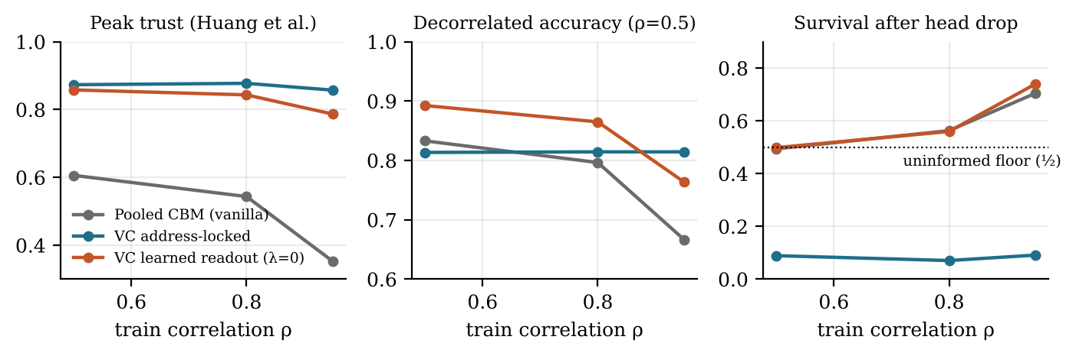
Figure 2. Head concepts versus train correlation ρ at a_{head} = 0.6. The pooled CBM loses peak trust and decorrelated accuracy as ρ grows; the address-locked readout is flat, as Proposition 4 predicts, and almost never survives deletion of the head region. The learned readout keeps high peak trust yet its drop survival rises with ρ like the pooled model.
Five findings follow.
- The pooled CBM reproduces the failure reported by Huang et al. (2024). At a_{head} = 0.6 its peak trust falls from 0.606 at ρ = 0.5 to 0.352 at ρ = 0.95, decorrelated accuracy falls from 0.833 to 0.666, and 0.705 of positives survive head deletion. The shortcut also degrades belly concepts: averaged over the four wing and belly concepts, its shift accuracy is 0.875, against 0.909 for the address-locked model.
- Address locking trades in-distribution accuracy for invariance. The locked model’s accuracy is 0.800 in distribution and 0.815 under shift, with drop survival 0.091. When the head is faint (a_{head} = 0.35) its in-distribution accuracy 0.677 is well below the pooled model’s 0.883, because it refuses evidence that is predictive in training. Proposition 4 holds approximately rather than exactly; the small residual gap is of the size that sampling and the weak correlation between belly and head atoms can produce.
- The learned readout is the most accurate and is not automatically trustworthy. Without locking it attains 0.956 in distribution but 0.763 under shift, and 0.740 of positives survive head deletion. Vocabucapillary does not prevent shortcut learning; it makes the shortcut visible in named addresses, with leakage 0.467.
- Peak trust misses the shortcut that leakage and deletion expose (Proposition 3). The same unlocked readout has peak trust 0.787: its single largest contribution is usually a head patch, while nearly half of its evidence comes from off-region addresses. A peak-based score would rate it trustworthy.
- The locking penalty is a usable dial. Raising λ from 0 to 1000 at a_{head} = 0.6 lowers leakage from 0.467 to 0.108 and raises shift accuracy from 0.763 to 0.896, while in-distribution accuracy 0.907 matches the pooled CBM’s 0.909. At a_{head} = 0.35 the dial cannot recover a signal that is not there: shift accuracy reaches 0.725, between the unlocked and fully locked values.
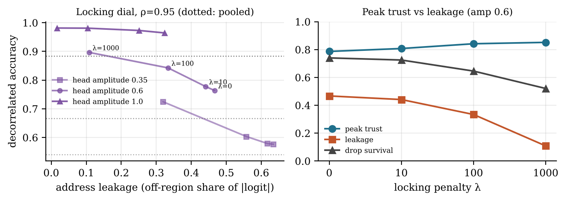
Figure 3. Left: leakage versus decorrelated accuracy as the locking penalty grows (ρ = 0.95); dotted lines mark the pooled CBM for each head amplitude. Right: at a_{head} = 0.6, peak trust stays high throughout, while leakage and drop survival reveal how much off-region evidence the readout uses.

4.4 Class codes: certified pruning and TCAV degeneracy (Propositions 5–6)
A V2C-form head was built with 50 classes and 500 concepts. Each class owns 10 concepts whose logits receive a boost b before the softmax over concepts, and 0.5 times standard Gaussian noise elsewhere; b = 5 gives diffuse class codes and b = 7 concentrated ones. Concept activations mimic CLIP cosines: 0.20 plus noise of standard deviation about 0.036, plus 0.08 on the owned concepts of the true class. Class probabilities use logit scale γ = 100. Each code was pruned to its s largest coefficients.
Table 3. Pruning simplex class codes (2000 test inputs). Certified = top-1 invariance proved by Proposition 5 from pruned quantities only; agreement = observed.
s | mean η (b = 5) | mean η (b = 7) | certified (b = 5) | certified (b = 7) | agreement (b = 5) | agreement (b = 7)
5 | 0.489 | 0.349 | 0.000 | 0.000 | 0.985 | 0.985
10 | 0.250 | 0.043 | 0.024 | 0.998 | 1.000 | 1.000
20 | 0.234 | 0.041 | 0.043 | 0.998 | 1.000 | 1.000
50 | 0.203 | 0.035 | 0.146 | 0.998 | 1.000 | 1.000
100 | 0.163 | 0.028 | 0.430 | 0.999 | 1.000 | 1.000
200 | 0.103 | 0.018 | 0.881 | 0.999 | 1.000 | 1.000
300 | 0.058 | 0.010 | 0.983 | 1.000 | 1.000 | 1.000
400 | 0.023 | 0.004 | 0.997 | 1.000 | 1.000 | 1.000
Across all 16 settings, the largest deviation from the identity of Equation (4) was 1.5e-15, and the largest ratio of the observed change to the bound η(max A − min A) was 0.489.
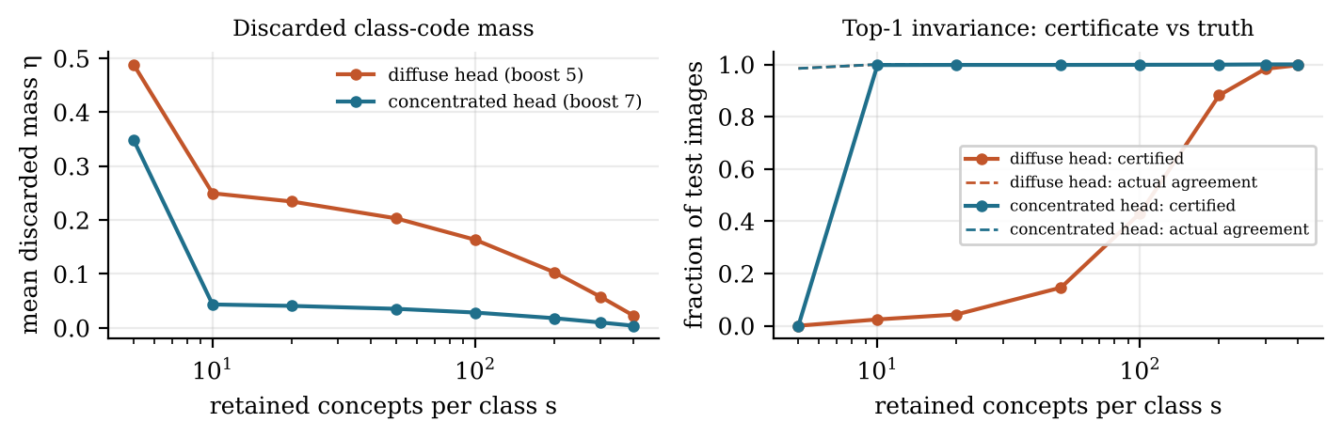
Figure 4. Left: mean discarded mass of the class codes. Right: certified (solid) versus observed (dashed) top-1 agreement. A concentrated head is certifiable at s = 10 for 99.75% of inputs; a diffuse head needs s ≈ 300 although its predictions rarely change.
The identity is exact to rounding and the bound is never violated. The certificate is conservative: with b = 5 and s = 10 it certifies 2.4% of inputs while 99.95% actually agree, because a worst-case discarded mean at the extreme of A is far from typical. With concentrated codes the same certificate covers 99.75% at s = 10. Pruning below the number of owned concepts (s = 5) breaks both heads: agreement falls to 98.45% and nothing is certified. The practical implication is that the concentration of the class codes, not the bottleneck width alone, decides whether a compact concept explanation can be certified, which motivates an entropy or mass-concentration penalty on σ(W) during training.
For TCAV, the fraction of the 25 000 class–concept pairs whose raw-score directional derivative is positive on every input was 1.000, exactly as Proposition 6 states. Using the probability contrast of Equation (5) instead, 100.0% of owned concepts and 2.8% of non-owned concepts had a positive contrast on a majority of their class’s inputs; the mean contrast was 1.018 for owned and -0.021 for non-owned concepts. The raw sign fraction cannot separate the concepts a class depends on from those it ignores; the contrast does.

4.5 Duplicate concepts (Propositions 7–8)
Thirty random unit atoms in ℝ²⁴ were augmented with one duplicate of atom 0 perturbed in a random direction by δ and renormalised. For each δ, κ₂ and κ₄ were computed exactly; 4000 features d₀ + 0.05ε were tokenised by nearest atom, and the observed fraction assigned to the duplicate was compared with Equation (7).
Table 4. Duplicate concepts: conditioning and tokenizer flips. After merging, κ₄ = 0.430 and the flip rate is 0 for every δ.
δ | atom gap | κ₂ | κ₄ | observed flip rate | predicted Q(gap / 2σ)
0.8 | 0.681 | 0.481 | 0.428 | 0.000 | 0.000
0.4 | 0.385 | 0.272 | 0.252 | 0.000 | 0.000
0.2 | 0.199 | 0.141 | 0.129 | 0.025 | 0.023
0.1 | 0.100 | 0.071 | 0.065 | 0.161 | 0.159
0.05 | 0.050 | 0.035 | 0.032 | 0.315 | 0.308
0.02 | 0.020 | 0.014 | 0.013 | 0.418 | 0.421

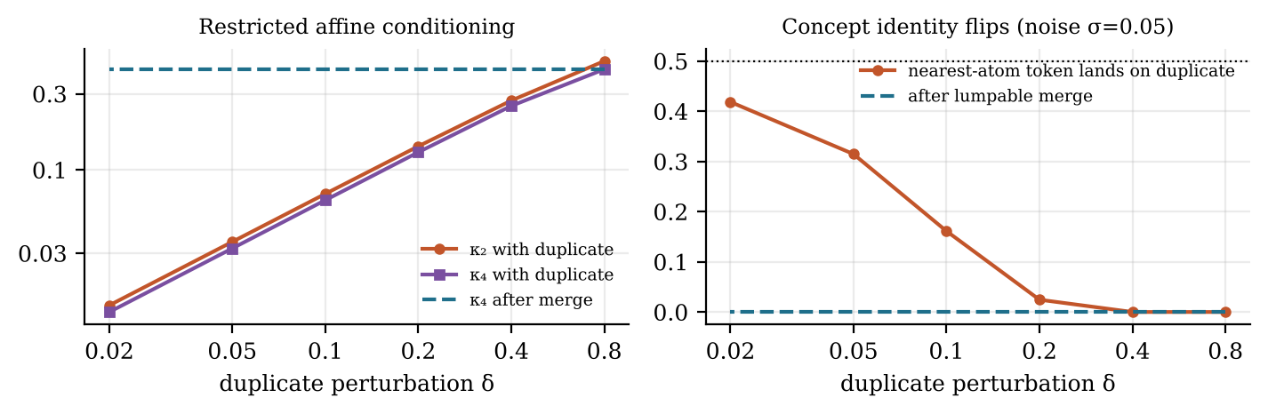
Figure 5. Left: restricted affine conditioning collapses linearly with the duplicate perturbation and is restored by merging. Right: the nearest-atom tokenizer assigns a growing share of a concept’s instances to its duplicate, approaching one half.
κ₂ equals the atom gap divided by √2 to the digits shown, κ₄ lies just below it, and the observed flip rates match the analytic Gaussian tail to within 0.7 percentage points, consistent with the binomial sampling error of 4000 trials. Merging restores κ₄ to the conditioning of the base dictionary. Proposition 8 then decides whether the merge is safe for the downstream head; that step needs the trained head weights and is not simulated here.

5 How Vocabucapillary improves concept models
The answer to the question of this paper is a set of changes, each tied to a failure in the source works and to the result that supports it.
- Keep a location statistic, not only a pooled one. Replace average pooling of features by patch codes and the bounded memory (m, S, K) of Definition 1. Pooled prediction is permutation-invariant (Proposition 1); the location statistic gives exact localisation, centroids and deletion effects (Proposition 2). This addresses the diagnosis of Huang et al. (2024) at the level of what is stored.
- Expose concept evidence in named addresses and lock it. Use an address-locked readout where invariance matters, or a learned readout with an address-locking penalty. Leakage is then an exact, reportable quantity (Definition 2), and locking moves a model along a measured accuracy–invariance trade-off (Section 4.3).
- Report leakage and deletion beside peak trust. Peak localisation can certify concepts whose evidence is mostly off-region (Proposition 3, Table 2). A trustworthiness benchmark should include a mass-based measure and a declared deletion intervention.
- Treat class weights as simplex codes and certify their pruning. For V2C- or LaBo-style heads, store η_{k} with each pruned code and issue the top-1 certificate of Proposition 5. Train with a concentration penalty when compact certified explanations are wanted (Section 4.4).
- Replace sign-fraction importance by signed contrasts. For simplex-weighted bottlenecks, compute concept importance on class probabilities or margins (Proposition 6), with simplex-respecting attributions where paths are needed (Ghosh, 2026e, Theorem 11).
- Diagnose and merge duplicates by conditioning and lumpability. Compute κ_{2s} of the concept dictionary, predict tokenizer instability from the atom gap (Proposition 7), and merge when the product of activation and head-weight gaps is below tolerance (Proposition 8). This answers ACE’s open question with a criterion rather than visual judgement.
- Run concept discovery as bounded aggregation with a declared exemplar reservoir. ACE’s frequency and popularity filters need only 2N counters (Proposition 9); exemplars require explicitly retained storage.
- Keep uncertainty and abstention on calibrated class probabilities. Concept-code entropy is not identified by the feature (Proposition 10); a reject option belongs at the predictive output.

6 Limitations
- All numerical results are synthetic. The part-structured world has linear Gaussian patch features, a seven-address vocabulary and known regions; real images have overlapping parts, scale variation and backbone features whose spatial alignment is itself uncertain, which is why Huang et al. (2024) add cross-layer and cross-image alignment.
- The dictionary is fixed and well conditioned except where duplicates are inserted deliberately. When concept atoms are learned end-to-end, a shortcut can be absorbed into the atom of a concept, and Proposition 4’s hypothesis can fail without any change to the readout.
- Exactness concerns the declared code boundary. Deleting pixels and recomputing a deep backbone is a different intervention from replacing codes, and its effect is not given by Proposition 2.
- The pruning certificate is worst-case and conservative for diffuse codes. A tighter certificate needs a bound on the discarded mean that is cheaper than computing it, for example from grouped tail statistics.
- Proposition 8 assumes a one-step linear head. Merging concepts that feed nonlinear continuations requires the general lumpability condition over the actual family of updates (Ghosh, 2026e, Theorem 5).
- The bounded memory adds N(1 + P) fields per image or N(1 + 2) for centroids; for vocabularies of tens of thousands of concepts this is not small, and selecting a vocabulary subset introduces a representational restriction (Ghosh, 2026b, Section 7.2).

7 Conjectures and a falsifiable validation protocol
Conjecture 1 (Trust at matched accuracy). On CUB-200-2011 with a CLIP or ResNet backbone, a VC-CBM with a learned readout and an address-locking penalty attains concept trustworthiness, measured by leakage and by part-annotation deletion, at least as high as the prototype CBM of Huang et al. (2024) at matched class accuracy. Refuted if at every λ either leakage is higher or accuracy is lower by more than one point.
Conjecture 2 (Peak trust over-certifies). On the same benchmark, the rank correlation between the peak-based trustworthiness score and drop survival across concepts is weak, and concepts with high peak trust but high leakage exist in non-negligible numbers. Refuted if peak trust predicts drop survival with rank correlation above 0.8 in magnitude.
Conjecture 3 (Certifiable compactness). Adding an entropy penalty on σ(W) to V2C-CBM training raises the fraction of test images certified by Proposition 5 at s = 10 above 90% on ImageNet with less than one point of accuracy loss. Refuted if no penalty strength achieves both.
Conjecture 4 (Duplicate prediction). For V2C-CBM concept vocabularies, pairs with small atom gap in CLIP text space have tokenizer co-assignment rates predicted by Equation (7) after estimating σ from image–text residuals. Refuted if the predicted and observed rates are uncorrelated across pairs.
The protocol records, for each run, the concept vocabulary version, dictionary conditioning, code support, locking penalty, intervention definition and certificate status, so that each explanatory claim can be traced to the evidence that supports it, as in the explanation harness of Ghosh (2026e).

8 Conclusion
Vocabucapillary improves concept models by changing what they store and what they are allowed to read. Pooled concept prediction cannot know where its concepts came from; a bounded location statistic can, exactly. Address-level readouts make shortcut evidence visible and controllable, and the simulations show both the benefit of locking and its price when the true signal is faint. Simplex class codes admit exact pruning identities and certificates, the TCAV sign fraction gives way to an informative zero-sum contrast, and duplicate concepts become a measurable conditioning problem with a closed-form flip rate and an explicit merge rule. None of this makes a concept model trustworthy by construction. It makes trustworthiness a quantity the model computes and reports, with stated assumptions under which the report is exact.

Appendix A. Core immutable C# types
The complete program (Core.cs, Codes.cs, Experiments.cs, Program.cs; about 700 lines) accompanies this paper. The excerpts below show the pure generator, the top-s entropic code, the bounded concept memory and the operational pruning certificate.
public readonly record struct Rng(ulong State)
{
public (ulong Value, Rng Next) NextUInt64()
{
ulong s = State + 0x9E3779B97F4A7C15UL, z = s;
z = (z ^ (z >> 30)) * 0xBF58476D1CE4E5B9UL;
z = (z ^ (z >> 27)) * 0x94D049BB133111EBUL;
return (z ^ (z >> 31), new Rng(s));
}
public Rng Fork(ulong label) => new(State ^ (label * 0xD1B54A32D192ED03UL));
}

public sealed record SimplexCode(ImmutableArray<double> Coefficients);

public static SimplexCode TopSEntropic(IReadOnlyList<double> scores, int s, double tau)
{
var keep = scores.Select((z, j) => (z, j)).OrderByDescending(t => t.z).Take(s).ToImmutableArray();
var w = V.Softmax(keep.Select(t => t.z / tau).ToImmutableArray());
var c = Enumerable.Range(0, scores.Count)
.Select(j => keep.Select((t, k) => t.j == j ? w[k] : 0.0).Sum()).ToImmutableArray();
return new SimplexCode(c);
}

public sealed record ConceptMemory(ImmutableArray<double> Mass,
ImmutableArray<ImmutableArray<double>> Location, ImmutableArray<(double Row, double Col)> Centroid)
{
public static ConceptMemory FromCodes(IReadOnlyList<SimplexCode> codes, int gridWidth)
{
int p = codes.Count, n = codes[0].Coefficients.Length;
var loc = Enumerable.Range(0, n)
.Select(j => codes.Select(c => c.Coefficients[j] / p).ToImmutableArray()).ToImmutableArray();
var mass = loc.Select(row => row.Sum()).ToImmutableArray();
var cen = loc.Select(row => row.Sum() <= 0 ? (double.NaN, double.NaN)
: (row.Select((x, i) => x * (i / gridWidth)).Sum() / row.Sum(),
row.Select((x, i) => x * (i % gridWidth)).Sum() / row.Sum())).ToImmutableArray();
return new ConceptMemory(mass, loc, cen);
}
}

// Proposition 5: certificate from pruned scores yt, discarded masses eta and min/max of A(x)
double lo(int k) => (1 - eta[k]) * yt[k] + eta[k] * x.Min();
double hi(int k) => (1 - eta[k]) * yt[k] + eta[k] * x.Max();
int topP = Enumerable.Range(0, yt.Length).MaxBy(k => yt[k]);
bool certified = Enumerable.Range(0, yt.Length).Where(k => k != topP).All(k => lo(topP) > hi(k));

References
Ghorbani, A., Wexler, J., Zou, J., & Kim, B. (2019). Towards automatic concept-based explanations. Advances in Neural Information Processing Systems, 32. https://arxiv.org/abs/1902.03129
Ghosh, D. P. (2026a). KV Coefficient Memory for Attentionlet [Preprint]. ResearchGate. https://doi.org/10.13140/RG.2.2.31586.70088
Ghosh, D. P. (2026b). Vocabucapillary for Cacheless Transformer [Preprint]. ResearchGate. https://doi.org/10.13140/RG.2.2.36209.44648
Ghosh, D. P. (2026c). Vocabuquantization for memory efficient Vocabucapillary language models [Preprint]. ResearchGate. https://doi.org/10.13140/RG.2.2.21571.98085
Ghosh, D. P. (2026d). Vocabucapillary memory for cacheless transformers and evidence guided AI [Preprint]. ResearchGate. https://doi.org/10.13140/RG.2.2.20759.33449
Ghosh, D. P. (2026e). Interpreting large language models through Vocabucapillary coefficient trajectories [Preprint]. ResearchGate. https://doi.org/10.13140/RG.2.2.27994.50884
Ghosh, D. P. (2026f). Sparse backpropagation and progressive capacity in Vocabucapillary language models [Preprint]. ResearchGate. https://doi.org/10.13140/RG.2.2.17692.24960
Ghosh, D. P. (2026g). Resolution adaptive MAML with Vocabucapillary memory [Preprint]. ResearchGate. https://doi.org/10.13140/RG.2.2.20418.54723
Ghosh, D. P. (2026h). Probabilistic Vocabucapillary for efficient meta learning [Preprint]. ResearchGate. https://doi.org/10.13140/RG.2.2.27011.46889
Ghosh, D. P. (2026i). Multimodal explainability through Vocabucapillary [Preprint]. ResearchGate. https://doi.org/10.13140/RG.2.2.34561.21608
Ghosh, D. P. (2026j). Efficient Shapley explanations for multimodal Vocabucapillary [Preprint]. ResearchGate. https://doi.org/10.13140/RG.2.2.16106.27841
He, H., Zhu, L., Zhang, X., Zeng, S., Chen, Q., & Lu, Y. (2025). V2C-CBM: Building concept bottlenecks with vision-to-concept tokenizer. Proceedings of the AAAI Conference on Artificial Intelligence. https://arxiv.org/abs/2501.04975
Huang, Q., Song, J., Hu, J., Zhang, H., Wang, Y., & Song, M. (2024). On the concept trustworthiness in concept bottleneck models. Proceedings of the AAAI Conference on Artificial Intelligence. https://arxiv.org/abs/2403.14349
Kim, B., Wattenberg, M., Gilmer, J., Cai, C., Wexler, J., Viegas, F., & Sayres, R. (2018). Interpretability beyond feature attribution: Quantitative testing with concept activation vectors (TCAV). Proceedings of the 35th International Conference on Machine Learning, 2668–2677.
Koh, P. W., Nguyen, T., Tang, Y. S., Mussmann, S., Pierson, E., Kim, B., & Liang, P. (2020). Concept bottleneck models. Proceedings of the 37th International Conference on Machine Learning, 5338–5348.
Yang, Y., Panagopoulou, A., Zhou, S., Jin, D., Callison-Burch, C., & Yatskar, M. (2023). Language in a bottle: Language model guided concept bottlenecks for interpretable image classification. Proceedings of the IEEE/CVF Conference on Computer Vision and Pattern Recognition, 19187–19197.

