Sheaf Geometry for Flexible Cognition
  - Shared task abstractions and preserved task specific information
Debi Prasad Ghosh • debiprasadghosh@gmail.com
Debias Parametric Guru • Kolkata India
23 October 2026 • https://doi.org/10.13140/RG.2.2.32517.31202

Abstract
Flexible cognition requires shared abstractions while retaining the details needed for a particular task. We extend a recurrent cellular sheaf model in which interregional interfaces compare selected features. A short exact sequence separates a shared quotient from task-detail directions and yields a connecting obstruction to coherent implementation. This revision develops effort-constrained lifting, exact spectral bounds for heat and resolvent inference, observable-level retention criteria, and generic-rank results for admissible extension families. The constrained-lifting theorem gives the minimum residual attainable within a finite correction budget. Sharp spectral factors yield a gap-free heat bound proportional to the square root of time and a resolvent bound proportional to the square root of its regularisation scale. A rank-increase example shows that arbitrarily small map changes can erase a formerly private contrast over sufficiently long times. Exact denoising-risk formulas distinguish preservation of task detail from optimal mean-square denoising. The supplied exploration script reproduces its algebraic checks, but its model comparisons use test-label selection and are retained only as exploratory results. A fresh rerun selects settings using separate validation data and confirms selective detail retention in this synthetic construction; a factorised block baseline reproduces the same operator. We correct the triangle cohomology claim, distinguish the kernel-sheaf and full-sheaf spectral gaps, and withdraw an unsupported general sample-efficiency claim. No neural recordings or evidence establishing a biological sheaf mechanism are reported.
Keywords: cellular sheaf, cognitive flexibility, quotient representation, lifting obstruction, task specificity activity, flow recurrent inference

1 Research question and extension of the cortical sheaf programme
The proposed extension is to make information sharing selective. Two regions can agree about an abstract rule without agreeing about every sensory feature, response parameter or episode identifier. In a cellular sheaf, endpoint restrictions expose only the features that an interface compares. Compatibility can therefore enforce a common rule while leaving other coordinates distinct. Flexible cognition becomes the problem of learning useful interfaces, retaining sufficient detail outside them, and selecting a coherent action when the task changes.
The earlier manuscript The Cortical Sheet as a Recurrent Cellular Sheaf [3] supplies the starting commitments. The horizontal base is a communication multigraph, layer-resolved population spaces are stalks, and recurrence is an explicit state update. A microcolumn is a possible anatomical support for a stalk rather than a complete recurrent sheaf network. Vertical laminar processing is an operator algebra; anatomical layer order does not supply a differential. We retain fixed restrictions within an inference episode and distinguish positive enforcement weights from changes in the restrictions themselves.
This paper adds a quotient-and-kernel decomposition of task information, an explicit lifting gate, a connection to the geometry of activity flow, and a task-conditioned readout. It does not require all task-specific information to lie in an individually isolated local channel. Some details can reside in globally constrained kernel sections, and some information can arrive through parallel inputs or persistent memory. Each case has a different mathematical guarantee, which we state separately.
The main architectural conclusion is precise: compress the information that needs to be shared, and retain a sufficient statistic for distinctions that downstream behaviour still needs. An expansion stage can change coding geometry; it cannot recover a distinction that every accessible channel has already erased. The sheaf construction specifies where that retained information can reside and when it can coexist with a shared abstraction.

2 What the new cortical evidence establishes
Chakravarthula, Ito, Tzalavras and Cole published Network geometry shapes the transformation of task representations across the human cortex in Nature Neuroscience on 22 October 2026 [1] and the September 3 2026 version of its bioRxiv preprint [2], with a slightly different title. The published abstract and bibliographic record were checked online; the detailed methods and numerical results discussed below were from the preprint.
The published abstract links low-dimensional connectivity to compression and greater similarity across tasks, and high-dimensional connectivity to expansion and conjunctive coding. The preprint analyses 16 visually presented tasks decomposed into 96 conditions. Although the source MDTB resource contains 24 participants, the matched task-and-rest analysis uses the 18 with resting-state scans. A separate HCP analysis uses 352 participants. The preprint reports a regional relationship between connectivity dimensionality and representational change of approximately r = 0.44, with spatial-autocorrelation controls [2]. These counts and effect sizes refer to that preprint version.
Activity flow predicts target patterns by weighted summation of observed source patterns using task-free functional connectivity. Its predictions reproduce important features of target representational geometry. This supports an explanatory contribution from connectivity geometry. Functional connectivity estimated from fMRI is not a measured synaptic restriction map, and predictive activity flow does not by itself establish intervention-level causation. The source paper also demonstrates that sufficiently strong nonlinear local computations can decouple connectivity dimensionality from representational change [2].
The strongest conceptual bridge is consequently at the regional population level. Parcels provide an empirical graph and measured population codes provide stalk coordinates. Extending the same fitted construction to microcolumns or named cortical layers would require measurements at that scale. The present fMRI evidence cannot assign the quotient to one lamina, prove a thalamic storage role, or establish a cortical cohomology group.
Source observation | Mathematical extension | Required additional evidence
Connectivity geometry predicts task geometry | Feature-selective interface maps constrain inference | Independent map calibration and held-out prediction
Greater cross-task similarity in compressed representations | A shared quotient removes selected distinctions | Cross-condition generalisation with task-factor controls
Expansion and conjunctive coding | Parallel detail and context support richer readout | Detail retention and context-specific behavioural tests
Activity flow approximates target patterns | A fitted transfer is compared with sheaf inference | Budget-matched scalar and unconstrained block models

These are proposed correspondences, not identifications already demonstrated by the source study. Similarity alone does not establish generalisation, and high dimensionality alone does not establish useful task specificity. Both must be assessed with behaviour or held-out computational targets.

3 A finite cellular sheaf with selective interfaces

3 1 State spaces and compatibility
Let G = (V, E) be a finite oriented multigraph. Orientation sets algebraic signs; it does not assert reciprocal anatomy. A real cellular sheaf F assigns a finite-dimensional inner-product space F(v) to each vertex and F(e) to each edge, with endpoint-to-interface maps Rᶠᵥₑ : F(v) → F(e). On a graph there are no higher incidence identities to check. Parallel routes can be represented by separate edges.
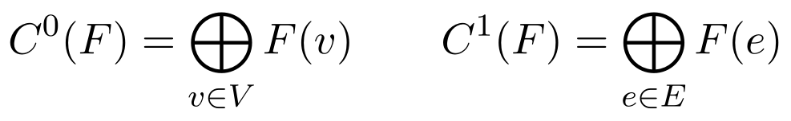
A section is an assignment of full local states whose interface descriptions agree. The endpoint maps can be rectangular, rank deficient and different at the two ends. They are not automatically vertex-to-vertex transports. Invertible transport, holonomy and local-system results apply only to a separately identified invertible sector [4].
For X whose columns are states across conditions, interface agreement concerns δF X. It does not imply Xᵤ = Xᵥ, equal regional representational similarity matrices, or identical task decoders. Heterogeneous local coordinates can express one compatible abstract variable in different ways. This is the mathematical source of agreement without collapse.

3 2 Geometry and calibration
Choose registered vertex and interface metrics before comparing dimensionality, residuals or intervention effects. A general invertible change of coordinates can alter singular values and participation ratios when metrics are silently held Euclidean. Cohomology dimensions are algebraically invariant under sheaf isomorphism; these numerical geometric measures require metrics to be transported with the coordinates. Orthogonal changes in a fixed metric are harmless.
Restrictions must be constrained by a declared feature interface or independent causal calibration. Resting-state regression gives a predictive candidate, not an automatic compatibility law. Multiple afferents may contribute to one target, so a target state cannot generally be equated with each source contribution independently. Aggregate source nodes, auxiliary summation variables or a factor-graph representation are needed when the intended law is an additive activity-flow equation.

4 Shared abstractions as a quotient sheaf
Let K contain task-detail directions and Q describe the information exposed as a common abstraction. Assume a cellwise short exact sequence of cellular sheaves and commuting incidence maps:
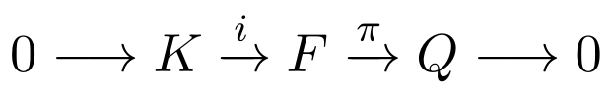
Exactness means that π is onto at every cell and its kernel is precisely the injected K. It is a model specification to be estimated and tested. The quotient has no intrinsic semantic meaning until shared task factors have been operationally defined. Likewise, K is not an automatic repository of useful detail; the task readout must actually use information in it.
Choose vector-space splittings F(a) ≅ K(a) ⊕ Q(a) at each cell a. These always exist over the reals but need not respect restrictions. In these coordinates the endpoint restrictions and coboundary have triangular form:
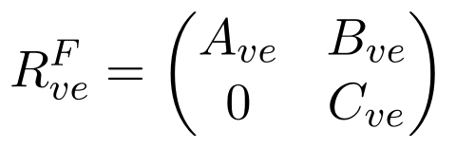
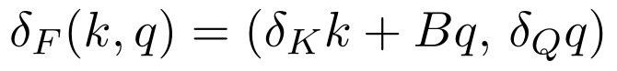
Here (Bq)ₑ = Bᵥₑqᵥ − Bᵤₑqᵤ; A and C are the restrictions of K and Q. The off-diagonal B describes how selecting an abstract state requires adjustments of task-detail coordinates. A direct-sum sheaf has B = 0 after compatible splittings, but a general extension does not. Local availability of an abstract representation therefore need not guarantee a coherent network-wide implementation.
Theorem 1 on coherent realisation: For q ∈ H⁰(Q), choose any degree-zero lift x with πx = q. There is a unique b ∈ C¹(K) with i b = δF x. The class ∂q = [b] ∈ H¹(K) is independent of the lift. A section f ∈ H⁰(F) with πf = q exists exactly when ∂q = 0. When a lift exists, all section lifts form an affine space over H⁰(K).
Proof. The commuting square gives πδF x = δQ q = 0, so exactness at degree one identifies δF x with i b. Another lift is x + i k and changes b by δK k. Thus, [b] is well defined. If its class is zero, choose k with δK k = −b, and x + i k is a section lifting q. Conversely a section lift makes the class zero. The difference of two section lifts lies in the injected kernel and has zero coboundary, hence is a section of K. □
This is the connecting homomorphism from the standard long exact sequence, written here in computational coordinates [4,6]. Its use for task-conditioned implementation is the proposed extension; the exact-sequence theorem itself is established mathematics. A nonzero ∂q means that this abstraction cannot be implemented under these interfaces without changing the abstraction, revising a constraint, or accepting residual disagreement.
Corollary 1 on simultaneous capacity: The full section dimension satisfies dim H⁰(F) = dim H⁰(K) + dim ker ∂. The quotient states attainable coherently are exactly ker ∂ ⊆ H⁰(Q).
Proof. The kernel of the restricted map π: H⁰(F) → H⁰(Q) is H⁰(K), and Theorem 1 identifies its image with ker ∂. Apply rank–nullity. □
A large locally defined quotient can therefore overstate usable shared capacity. The relevant global capacity is dim ker ∂, supplemented by the task-detail degrees of freedom in H⁰(K). This is a linear capacity count, not a bit capacity or a prediction of behavioural accuracy.

5 A quantitative certificate for a failed lift
Fix q ∈ H⁰(Q) and a lift x₀. Write b for its K-valued residual. Give C¹(K) a positive-definite weight W and C⁰(K) its registered metric. The minimum implementation error is
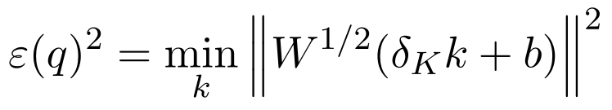
Define D = W¹ᐟ²δK, c = W¹ᐟ²b, and let P be the orthogonal projector onto ker D*. An asterisk denotes adjoint in the chosen metrics.
Theorem 2 on obstruction size: The minimum residual is ε(q) = ‖Pc‖. A minimum-norm correction is k* = −D†c, where † is the Moore–Penrose inverse. Exact lifting holds precisely when Pc = 0. Every minimizing correction differs from k* by an element of ker D.
Proof. Decompose c orthogonally as a component in im D and a component in ker D*. The term Dk can cancel the first component and cannot alter the second. The pseudoinverse cancels the image component with smallest correction norm, and its remaining ambiguity is ker D. □
Changing the initial lift replaces c by c + Dh and leaves Pc unchanged. Positive weights change the numerical size of the obstruction but not whether it vanishes. The harmonic representative is identified with H¹(K) after the metric is specified; it is not independent of the metric. This gives a computable implementation gate rather than a label inferred from a Betti number alone.
Proposition 1 on conditioning Let σ₊ be the smallest positive singular value of D. If D is nonzero then ‖k*‖ ≤ ‖c‖/σ₊. For a fixed linear lift choice and fixed D, changes in q give ‖Δk*‖ ≤ ‖D†‖ ‖Δc‖. If D = 0, the minimum-norm correction is zero and the residual is all of c.
Proof. Use ‖D†‖ = 1/σ₊ and linearity of the minimum-norm correction for fixed D. The zero case follows directly from the minimisation problem. □
Exact liftability and robust liftability are different. A nearly singular D can admit an exact section while requiring a large change in task-detail coordinates. An engineered gate should therefore test residual, correction size and parameter uncertainty, with tolerances set from readout performance. Neither ε nor σ₊ alone is an established neural confidence measure.

5 1 What the obstruction is not
The residual δF x₀ is exact in the full F complex and consequently represents zero in H¹(F). Its nonzero class can appear in H¹(K) because correction is restricted to K while q is held fixed. Confusing these coefficient systems would erase the meaning of the lifting test. Similarly, nonzero H¹(K) merely supplies a possible obstruction space; the particular ∂q can vanish. A graph cycle is neither necessary nor sufficient for nonzero H¹ of a general cellular sheaf.
For example, on one edge let both endpoint stalks be R and the edge stalk be R², with both restrictions t ↦ (t,0). The coboundary misses the second coordinate, so H¹ has dimension one even though the base is a tree. For an invertible local system on a tree the coboundary is onto and H¹ vanishes. The chosen restriction class, rather than the graph alone, determines which statement applies.

6 Preserving task details during compatibility inference
The kernel K of the quotient and the kernel of every exposed interface plays different roles. A K coordinate can be constrained across regions by δK and need not remain unchanged under inference. To identify completely protected local detail, stack the outgoing endpoint maps at each vertex and define
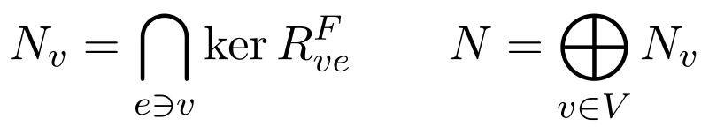
Every vector supported in N is a global section because all its interface images vanish. N is a direct sum of independently hidden local directions. Other sections can carry additional, globally coordinated detail.
Theorem 3 on protected local contrasts: With fixed restrictions and positive W, let L = δF* W δF. For the free symmetric dynamics ẋ = −Lx, or xₙ₊₁ = (I − ηL) xₙ with 0 < η < 2/λmax(L), the orthogonal projection onto N is constant. The dynamics converges to the orthogonal projection onto H⁰(F). For the same initial state this endpoint is independent of positive W. If L = 0 the state is fixed.
Proof. For n ∈ N, δF n = 0 and therefore Ln = 0. Self-adjointness implies P_N L = 0, so the N component is conserved. Positivity gives ker L = ker δF. Spectral decomposition eliminates every positive-eigenvalue component under the continuous or stated discrete dynamics and preserves the zero modes. Positive reweighting does not change the kernel or its orthogonal projector. □
This extends the earlier positive-reweighting result [3] by identifying an operational task-detail subspace. The result requires a fixed state metric and unforced symmetric relaxation. A task switch can change the readout or cue while retaining these maps; it cannot be described as weight-only modulation if measured feature restrictions rotate. Clamped conflicting cues, changed mobility, nonlinear updates and finite observation time do not inherit endpoint invariance automatically.
Proposition 2 on approximate protection: If z is an approximately private contrast with ‖W¹ᐟ²δF z‖ ≤ ε, then free continuous relaxation obeys ‖exp(−tL) z − z‖ ≤ t ‖δF*W¹ᐟ²‖ ε. The estimate uses the fixed operator and is informative only over a stated time horizon.
Proof. Write exp(−tL) z − z = −∫₀ᵗ exp(−sL) Lz ds. Positive semidefiniteness makes the semigroup a contraction. Bound ‖Lz‖ by ‖δF*W¹ᐟ²‖ ‖W¹ᐟ²δF z‖. □
The estimate predicts gradual leakage when nominally private directions are only approximately invisible. Indefinite retention is justified only for exact kernel components in this model. A private state can also be preserved by a separately specified memory update, but that is an additional mechanism.

6 1 A minimal example
Take two vertices with states x₁ = (s₁, p₁) and x₂ = (s₂, p₂), one scalar edge, and both restrictions (s,p) ↦ s. Compatibility aligns s₁ and s₂ while leaving p₁ and p₂ independent. Here dim H⁰(F) = 3, with one shared coordinate and two private coordinates. The scalar edge residual is s₂ − s₁.
The two private values remain available for separate task readouts. Full-state scalar consensus on the same two-dimensional node features would instead force both coordinates to agree, losing their difference. A conventional block model can implement exactly this selective coupling; the value of the sheaf formulation lies in its declared interfaces and compositional constraints, not in a new expressive power unavailable to block matrices.

7 Connecting activity flow to sheaf inference
The source model has the form Y = TX, where columns index task conditions, X stacks source states and T is a fitted connectivity transfer. A sheaf energy compares interfaces and does not automatically implement this directed input-output equation. We connect them by fixing a concrete inference problem:
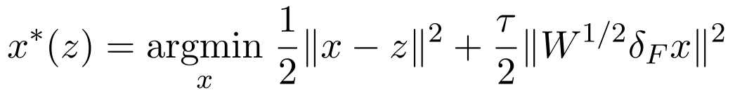
The fidelity term retains the cue z, so this is driven regularised inference rather than the free relaxation of Theorem 3. It is unique for every finite τ because I + τL is positive definite. If S selects or injects measured source coordinates and P selects target readouts, the effective transfer is T_eff = P Hτ S. Whether it predicts empirical activity flow is an estimation question.
Proposition 3 on the effective geometry: Hτ has eigenvalues 1/(1 + τλⱼ(L)). Every section direction has gain one; incompatible directions are attenuated. Thus, the spectrum and eigenvectors of the sheaf Laplacian determine which task contrasts survive this inference problem. Hτ is invertible at finite τ, so attenuation need not reduce exact rank before observation or thresholding.
Proof. Diagonalise the self-adjoint positive-semidefinite L and invert I + τL eigenvalue by eigenvalue. Zero eigenvalues have multiplier one, and all finite multipliers are positive. □
Regional input-output maps can be asymmetric even though Hτ is self-adjoint, because source injection and target observation differ. Nevertheless, not every empirical directed transfer is a subblock of a chosen resolvent. Rejecting that constrained fit is meaningful; adding enough unconstrained operators to reproduce every matrix would remove its explanatory content.

7 1 Eliminating unobserved regional states
Partition A = I + τL into retained coordinates r and unobserved coordinates h. Both principal blocks are positive definite. Eliminating h gives an exact reduced equation:
This Schur complement shows how parallel hidden routes modify the effective geometry and how hidden cues contribute to retained activity. It is a reduction of the chosen quadratic model, not evidence that a thalamic relay is memoryless or can always be removed. In general, it introduces dense couplings; it need not retain a prescribed edge-local sheaf parameterisation or preserve cohomology under a separately chosen coarsening.
Proposition 4 on perturbation stability: For positive-semidefinite L and L′ in a common metric and τ ≥ 0, the regularised states satisfy ‖Hτz − H′τz‖ ≤ τ‖L − L′‖‖z‖.
Proof. The inverse identity gives Hτ − H′τ = τHτ (L′ − L) H′τ. Each inverse has operator norm at most one. Apply submultiplicativity. □
The estimate gives a conservative tolerance for uncertain restrictions or weights. It is deliberately a bound on a declared input-output computation. It supplies no automatic claim about behaviour, and it can be loose when the perturbation acts outside the cue subspace.

8 Compression expansion and the information that remains available

8 1 Exact rank and effective dimensionality
For a nonzero positive-semidefinite covariance Σ, define participation ratio PR(Σ) = tr(Σ)²/tr(Σ²). It measures spectral spread, not algebraic rank. The supplied preprint uses the participation ratio of a task similarity eigenspectrum for representation dimensionality and of the unsquared singular-value spectrum for connectivity dimensionality [2]. These should be reproduced with the authors’ estimator in any replication. The population-covariance calculations below use PSD matrices and are not a reanalysis of cross-validated RSMs, which can be non-PSD or non-symmetric in finite samples.
Theorem 4 on linear limits: For deterministic linear activity flow Y = TX, rank Y ≤ min(rank T, rank X). With source covariance Σ, the target covariance is TΣT*. There is no general inequality PR(TΣT*) ≤ PR(Σ), nor a universal bound by the participation ratio of the singular values of T.
Proof. The rank inequality is the standard product-rank bound. For the failed PR bounds, take Σ = diag(100,1) and T = diag(0.1,1). The target covariance is I₂. Hence source PR is 10201/10001 ≈ 1.019998, target PR is 2, and the PR of the singular values of T is 1.21/1.01 ≈ 1.198020. Both ranks remain two. This counterexample violates both proposed PR upper bounds. □
Expansion in participation ratio can thus result from equalising variance across existing directions. It does not require newly created information. In addition, target dimensionality can exceed the average dimensionality of individual sources when distinct source subspaces are pooled. Two separate one-dimensional sources can jointly span two dimensions even though neither does so alone. The rank bound applies to the concatenated source matrix, rather than to an average over regions.
Proposition 5 on a conditional PR bound If T is injective on the source space, has singular values between a > 0 and b, and Σ is PSD and nonzero, then (a/b)⁴ PR(Σ) ≤ PR(TΣT*) ≤ (b/a)⁴ PR(Σ), together with the ordinary bound PR ≤ rank.
Proof. Set M = T*T, so a²I ≤ M ≤ b²I. The output trace lies between a²trΣ and b²trΣ. Its Frobenius norm equals ‖Σ¹ᐟ²MΣ¹ᐟ²‖F and lies between a²‖Σ‖F and b²‖Σ‖F, since the latter PSD matrix is bounded between a²Σ and b²Σ in Loewner order. Squaring and taking the ratio gives the result. □
This coarse estimate makes conditioning explicit. For noninjective transfers the positive lower bound can disappear. Singular values alone also omit alignment: even a high-rank transfer can transmit little task variance if its well-amplified right singular vectors miss the task-relevant source subspace. The sheaf extension therefore estimates both the interface geometry and the actual distribution of task contrasts.

8 2 Reinstatement requires retained detail
Theorem 5 on erased distinctions Suppose two histories a and b yield the same compressed state q. Any deterministic readout using only q gives the same output for both histories. Any stochastic readout whose conditional law depends only on q also has identical output laws. Distinct history-dependent actions require an additional accessible variable, different q, or additional observation.
Proof. Both evaluations condition on the same input, or on the same conditional output law. Their outputs or output distributions therefore coincide. □
A kernel state k, a parallel sensory input, an episodic register or the task cue can supply the additional variable. The pair (q,k) supports a readout y = g(q,k,c). Merely assigning a larger output layer to q does not restore erased distinctions. This is the most direct architectural implication of joining network compression to the sheaf framework.

8 3 Conjunctive codes
Proposition 6 on tensor readout Let Q and C be matrices of abstract and context feature columns. Across the complete Cartesian product of those columns, the conjunctive feature matrix is Q ⊗ C up to column order and has rank rank(Q)rank(C). It need not have that rank when only a restricted subset of combinations is observed.
Proof. The Kronecker-product rank identity gives the full Cartesian-product result. Removing columns can lower rank, which proves the qualification. □
The feature map (q, c) ↦ q ⊗ c is bilinear in the two inputs and nonlinear in their concatenation. A later linear readout can use these conjunctive features, but cannot attribute their creation to a single fixed linear map acting on q alone. A four-combination example with two independent basis vectors for each factor yields rank four for the tensor code. Such expansion changes linear separability without increasing information beyond the joint input.

9 Explicit examples deterministic verification and numerical exploration

9 1 A coherent abstraction with no coherent implementation
Take an oriented triangle with vertices 1, 2, 3 and edges 1→2, 2→3, 3→1. Let K and Q be constant scalar sheaves. Let each full stalk be R² and define target restrictions as I₂ and source restrictions on edge e as [[1, −bₑ], [0, 1]]. The quotient map selects q. For q₁ = q₂ = q₃ = 1, full compatibility requires
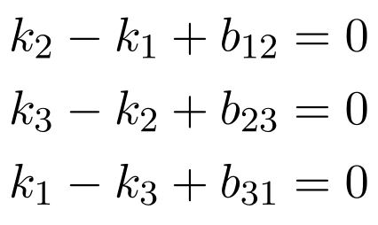
Summation gives the exact lift condition b₁₂ + b₂₃ + b₃₁ = 0. Every edge equation is individually solvable, while all three need not be jointly solvable. With identity residual weights, the unit harmonic vector is (1,1,1)/√3 and ε(q) = |b₁₂ + b₂₃ + b₃₁|/√3. Thus, the obstruction is explicit and has a declared coefficient sheaf.
For b = (1, 1, −2), a minimum-norm lift is k = (1, 0, −1), and ∂q vanishes. For b = (1,1,1), the minimum-norm correction is zero and ε = √3. The quotient section still exists in Q. If all three b values are rescaled continuously, the obstruction amplitude changes continuously even though the dimensions of the cohomology groups need not change. A dimension-only diagnostic would miss that variation.

9 2 Checked values
We evaluated the displayed matrices using NumPy double precision, SciPy matrix exponentiation and random seed 23 for the stability example. These calculations check formulas; they are not evidence about cognition. The complete constructions are specified here so that the results do not depend on a hidden dataset.
Check | Calculation | Result
Compatible triangle | ‖δK k* + b‖ | 2.48 × 10⁻¹⁶
Obstructed triangle | ε for b = (1,1,1) | 1.7320508075688774
Linear variance equalisation | Source PR → target PR | 1.0199980002 → 2.0000000000
Connectivity spectrum | PR of singular values of diag(0.1,1) | 1.1980198020
Protected private coordinates | Weights 0.2, 1 and 4 at time 20 | Private-coordinate error exactly 0
Resolvent perturbation | Observed change ≤ conservative bound | 0.06073055 ≤ 0.76063127

In the private-coordinate example each shared coordinate at time 20 has magnitude approximately 3.35 × 10⁻⁴ for edge weight 0.2, while faster weights are at numerical equilibrium. Equal asymptotic endpoints therefore coexist with unequal finite-time trajectories, as required by Theorem 3.

9 3 Reproduction recipe
Construct the triangle incidence matrix with rows (−1,1,0), (0,−1,1), (1,0,−1). For each b compute k = −pinv(D)b and residual Dk+b. For the private example use row δ = (−1,0,1,0), initial state (1,2,−1,−3), and exp(−20wδᵀδ). For PR use trace(S)²/trace(S@S). For stability draw A as a 7 by 10 standard-normal matrix, then E = 0.02 times the next such draw and z as the next length-10 normal draw, with numpy.random.default_rng(23). Set L=AᵀA, L′=(A+E)ᵀ(A+E), τ=0.3 and solve both resolvent equations. Numerical tolerances are 10⁻¹² for the triangle identities and the analytical upper bound is checked directly. The script explore.py, deposited with this version, reproduces these checks and every result in Sections 9.4 to 9.9 from fixed seeds 23, 2026, 7, 11, 5 and 99.

9 4 Scope of the numerical exploration
The checks in Section 9.2 confirm formulas on hand-built instances. This section probes the same statements at scale and in a synthetic task, asking where each result is tight, where it is conservative, and where the numerics point to a sharper statement. All computations use NumPy and SciPy in double precision with fixed seeds; the accompanying script explore.py regenerates every number and figure below in a few seconds. Every value in the Section 9.2 table was reproduced to the printed digits. The experiments concern the mathematics and a linear-Gaussian model task. They are not evidence about cortex and do not replace the empirical tests of Section 11.

9 5 Lifting capacity on random extension sheaves
We drew 600 random connected graphs with 4 to 8 vertices and edge probability between 0.3 and 0.8. Kernel and quotient stalks had dimension 1 to 3, the kernel restrictions A were Gaussian, every quotient restriction used one common Gaussian interface map so that H⁰(Q) is nontrivial, and the extension block B was either zero or Gaussian. For each instance we computed H⁰(F), H⁰(K), H⁰(Q), H¹(K) and the matrix of the connecting map ∂ from Theorem 1, using the harmonic projector of Theorem 2 as its codomain.
Corollary 1 held in all 600 reproduced instances with zero integer discrepancy. With B = 0 every quotient section lifted. With B ≠ 0 the mean lifting fraction was 0.41786, and local quotient capacity overstated attainable capacity in 66.24% of instances. No instance with H¹(K) = 0 was obstructed. The grouped lifting fraction generally declined with dim H¹(K), but it was not monotone: the means were 0.1068 at dimension 5 and 0.1111 at dimension 6. This is a descriptive pattern of the specified ensemble, not a monotonicity law.
In 99.0% of the B ≠ 0 instances the observed capacity matched max(0, dim H⁰(Q) − dim H¹(K)). The correct general theorem uses the maximum rank attainable within the admissible extension family, not an assumed arbitrary matrix of the same dimensions. Section 13.1 proves this distinction and gives a connected-base counterexample to the naive dimension subtraction. The reported percentage is an ensemble-specific observation.

9 6 Obstruction amplitude and exact but fragile lifts
Along the triangle family b(s) = (1, 1, −2) + s(1, 1, 1), the K and Q cohomology dimensions remain fixed while ε(q) = √3 |s|. The full sheaf F does change: dim H⁰(F) = dim H¹(F) = 2 at s = 0 and both dimensions equal 1 for s ≠ 0. Thus, obstruction amplitude varies within fixed nonzero-rank strata, but the zero crossing is a cohomological rank change. On the reproduced six-vertex example the operator norm of the connecting map scales linearly with B, taking values 0, 0.57747, 1.15494, 2.30988, 4.61976 and 9.23952 at the stated scale factors. Rank is insensitive to positive rescaling but can change at zero.
The twisted scalar kernel on the triangle has source gain h on edge 3→1. For h ≠ 1 its H⁰ and H¹ vanish and every quotient section lifts algebraically. At |1 − h| = 10⁻⁶ the computed correction norm is 5.19615 × 10⁶ and the largest residual across the sweep is approximately 1.20 × 10⁻⁹. This small residual alone understates the large correction cost. The inverse-gap upper bound becomes asymptotically tight as h approaches 1; it is not an equality on the entire family. Section 13.6 gives the exact solution and asymptotics.

9 7 Leakage of approximately private contrasts
In the two-node example of Section 6.1, perturb the restrictions to (s, p) ↦ s + μp. The contrast z = (0, 1, 0, −1) then satisfies ‖δF z‖ = 2μ. The linear-in-time bound of Proposition 2 held at every sampled time, but leakage saturates once t is of order one, after which the bound becomes uninformative (Figure 1c). The saturation level equalled ε/σ₊, where σ₊ = (2 + 2μ²)¹ᐟ² is the smallest positive singular value of δF: for μ = 10⁻³, 10⁻² and 10⁻¹ the limiting losses were 0.0014142, 0.014141 and 0.14072. This suggested a uniform-in-time statement, which we now prove.
Proposition 7 on uniform-in-time leakage Under the hypotheses of Proposition 2, suppose A_F = W_F¹ᐟ²δF is nonzero and let σF,+ be its smallest positive singular value. Let Π project onto H⁰(F). Then ‖exp(−tL)z − z‖ ≤ ‖(I − Π)z‖ ≤ ε/σF,+ for every t ≥ 0. Combined with Proposition 2, the loss is at most min(t‖A_F*‖ε, ε/σF,+). The first inequality tends to equality as t tends to infinity. If A_F = 0, the loss is identically zero and no positive singular value is defined.
Proof. Because exp(−tL) fixes Πz, exp(−tL)z − z = (exp(−tL) − I)(I − Π)z. On the orthogonal complement of ker L the operator exp(−tL) − I has eigenvalues exp(−tλ) − 1 in (−1, 0), so its norm there is at most one, and it tends to −I as t → ∞. Positivity of W gives ker L = ker W¹ᐟ²δF = H⁰(F), so (I − Π)z lies in the row space of W¹ᐟ²δF, where ‖W¹ᐟ²δF y‖ ≥ σ₊‖y‖. Finally, W¹ᐟ²δF(I − Π)z = W¹ᐟ²δF z, whose norm is at most ε. □
The protection bound uses σF,+, the positive gap of A_F = W_F¹ᐟ²δF. Lifting in Proposition 1 instead uses σK,+ for D_K = W_K¹ᐟ²δK. These are different operators on different spaces and have no general equality. A small relevant gap weakens its corresponding guarantee, but one numerical gap cannot certify both lifting and retention without an additional relation between the operators. Moreover, a lower bound on the perturbed positive gap is needed for a uniform small-leakage conclusion; Section 13.5 gives a rank-increase counterexample.
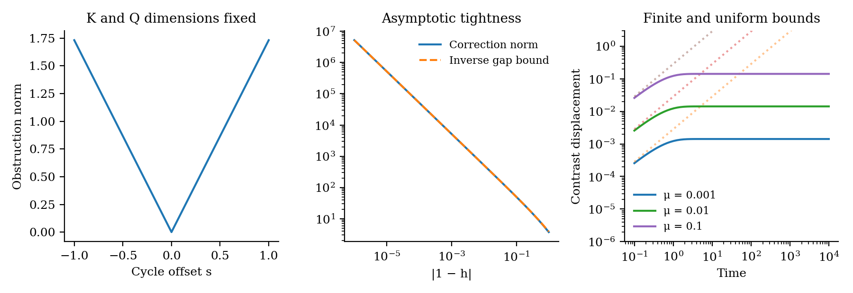
Figure 1: Reproduced numerical behaviour with corrected interpretation. Panel a holds K and Q dimensions fixed; F changes cohomology at s = 0. Panel b shows asymptotic tightness near h = 1. Panel c compares finite-time leakage with the linear-time estimate. The relevant lifting and protection gaps belong to different operators.

9 8 How conservative are the perturbation and participation-ratio bounds
Proposition 4 was reproduced on 2000 draws without violation. The observed-to-bound ratio had median 0.02254 and maximum 0.59416; the worst-cue operator ratio had median 0.04667 and maximum 0.73531. Resolvent attenuation and cue alignment can make the general bound conservative. These computations do not establish that an independently drawn matrix perturbation acts mainly in the source row space; that explanation would require an explicit subspace decomposition.
Proposition 5 was reproduced on 3000 Gaussian transfers and PSD covariances without violation. Its median admissible interval spanned 10.0136 orders of magnitude, and PR increased in 13.5667% of draws. The broad condition-number bound is therefore often uninformative in this ensemble. Actual PR changes depend jointly on the transfer spectrum, source spectrum and their relative orientation; this observation does not make conditioning irrelevant.

9 9 A synthetic test of selective preservation
To give Hypothesis 1 and Conjecture 1 a concrete computational analogue, we built eight regions on a ring with two chords (ten edges). Region v has stalk R⁴ holding Mᵥ(s, pᵥ), where Mᵥ is a random orthogonal matrix that gives each region its own coordinates, s ∈ {±1}² is a shared rule with four values and pᵥ is one of four region-specific details. Each interface exposes only the rule plane, Rᵥₑ = [I₂ 0]Mᵥᵀ, so every detail direction lies in the protected subspace N of Theorem 3. Observations add isotropic Gaussian noise with σ = 1.2. The sixteen combinations of rule and region-0 detail were split into twelve training and four held-out combinations, and every test used 4000 trials drawn only from the held-out combinations. Readouts are calibrated template decoders in each region's local frame: the rule is read from region 0, and detail from every region. Chance is 0.25 for both.
The original synthetic comparison uses the driven resolvent and a test-set τ sweep, with both learned-model hyperparameters selected against test decoding labels. In explore.py, max over test performance appears in the learned-interface sheaf loop as well as the block-ridge loop. These are oracle-selected exploratory results for both models. They do not constitute an untouched-test generalisation estimate. Section 13.8 reports a separate validation-only rerun, and the original figures and numbers are retained here for reproducibility rather than confirmatory inference.
Original exploratory model | Rule accuracy | Detail, all regions | Detail, region 0
No inference | 0.635 | 0.522 | 0.518
Scalar consensus, raw coordinates (best τ) | 0.635 | — | —
Scalar consensus, registered, matched rule accuracy | 0.981 | 0.333 | 0.341
Selective sheaf, true maps (τ ≈ 46) | 0.981 | 0.522 | 0.518
Sheaf, maps rotated θ = 0.2 rad (τ = 3) | 0.968 | 0.517 | 0.512
Sheaf, maps rotated θ = 0.8 rad (τ = 3) | 0.855 | 0.459 | 0.460
Block-linear ridge, n = 16 | 0.925 | 0.298 | 0.201
Learned-interface sheaf, n = 16 | 0.821 | 0.501 | 0.498
Block-linear ridge, n = 2048 | 0.979 | 0.496 | 0.372
Learned-interface sheaf, n = 2048 | 0.980 | 0.522 | 0.517

Four observations follow. First, with true maps the sheaf raised held-out rule accuracy from 0.635 to 0.981 while leaving detail accuracy exactly unchanged at every τ. In the driven problem, Proposition 3 gives unit gain on sections, and N consists of sections. Second, registered scalar consensus reached the same rule accuracy only by pulling detail down to 0.333, and its whole τ frontier is dominated by the sheaf (Figure 2a). In raw heterogeneous coordinates scalar consensus could not improve the rule at all, because agreement without registration mixes frames. Third, misspecification degrades gracefully: a 0.2 rad rotation of every interface cost 0.6 points of rule accuracy and 0.5 points of detail accuracy.
Fourth, the oracle-selected fits show that the block model learns the shared rule faster at small n while retaining less region-0 detail on the held-out combinations. This supports a possible recombination effect in the constructed task, not a theorem about sample complexity. The sheaf resolvent is itself a block-linear matrix and is exactly representable by a factorised baseline. The implementation fits one 2 by 4 restriction per region and reuses it at every incident edge: there are 64 unique fitted entries. The script’s count of 160 counts repeated endpoint slots rather than independent parameters. The block denoiser has 1024 entries; these unequal hypothesis classes and their supplied supervision must be stated when comparing fitted performance.
These results illustrate selective retention in a task built with known shared and private planes. Test-label selection, five training repetitions and a single graph prevent a confirmatory generalisation or sample-efficiency claim. The new validation-only rerun in Section 13.8 retains the qualitative pattern, while an exact factorised baseline reproduces the selective operator. Unknown interface dimension, nonlinear stalks, unlabelled shared factors and genuinely new graphs remain outside the evidence reported here.
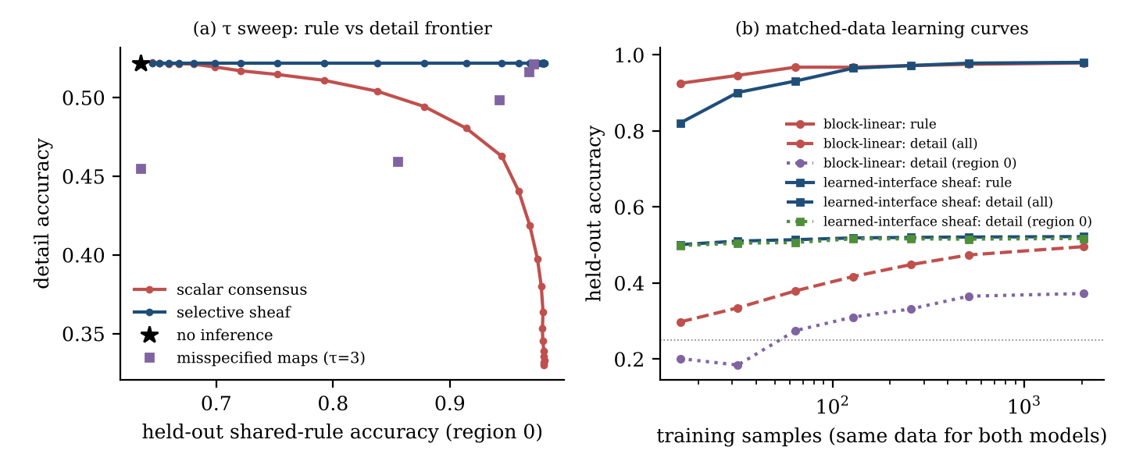
Figure 2: Original exploratory selective-preservation task. The τ sweep and both learned-model tuning procedures use test labels. These curves describe the supplied code and must not be read as untouched-test estimates. Section 13.8 supplies the separate validation-only rerun.

10 A concrete architecture for flexible cognition
At each regional or artificial module v, encode a state xᵥ whose quotient πᵥxᵥ exposes a shared rule while detail remains in the fibre. Use a graph of declared feature interfaces, hold its restrictions fixed during an episode, and run either free cue relaxation or the driven regularised inference problem. These are distinct operating modes. A task-specific readout accesses the coherent shared state together with the retained local or episodic variables needed for its output.
The proposal does not force a global direct-sum decomposition. Start with one if identification demands simplicity; add a nonzero extension term B only when held-out implementation errors justify it. Before accepting a quotient state q, test δQ q, then the restricted lifting residual ε(q), then the size and robustness of its correction. A q that is not a quotient section first requires quotient reconciliation; Theorem 2 cannot certify it by ignoring δQ q.
The implementation can preserve N coordinates explicitly and update the remaining coordinates by gradient or conjugate-gradient inference. If a task readout needs detail outside N, store its H⁰(K) coordinates, use a declared memory state, or constrain the optimisation accordingly. Such constraints alter the inference operator and must be included in its derivation. Protecting every unused coordinate would preserve nuisance information as well; task-factor supervision and retention tests determine what is useful.
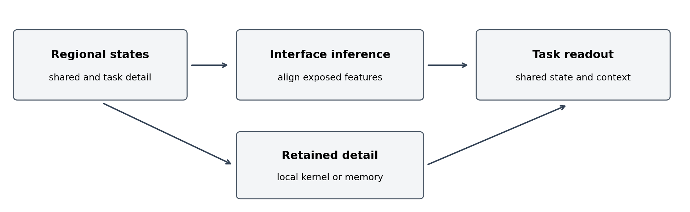
Figure 3: Proposed computational organisation. Interface inference shares selected features. A separate path preserves detail required by task readout. This is an engineered design, not an anatomical localisation.

10 1 Learning and identifiability
One candidate objective combine held-out task prediction, quotient prediction of prespecified shared factors, kernel prediction of required task details, compatibility energy and a complexity penalty. If shared factors should exclude task identity, measure the exclusion conditionally on relevant rule variables rather than assuming any compression achieves it. Conversely, task identity can be necessary context; removing it everywhere would defeat Theorem 5.
This is an objective family, not a claim that the optimum must generalise. Zero restrictions make compatibility trivially perfect; dimensional collapse can also look smooth. Fix interface dimensions, normalise admissible map scales, penalise unused channels, and evaluate task prediction and retention. Cellwise changes of splitting move coordinates between k and q without changing the underlying extension, so semantic labels need independent anchoring.
For dense endpoint maps from d-dimensional stalks to r-dimensional interfaces, one matrix-free residual and adjoint pass costs O(|E|rd); scalar diagonal residual weights add O(|E|r). T iterations cost O(T|E|rd), excluding encoding, feature construction, map learning and readout. Tensor features of dimensions a and b cost ab coordinates unless factorised. Hardware and end-to-end latency must be measured before asserting an advantage over a conventional recurrent backbone.

10 2 Relationship to current neural sheaf models
Neural Sheaf Diffusion [5] already uses learned restrictions to improve control of separation and oversmoothing. The present proposal uses that computational vocabulary but asks a distinct question: how to couple a shared quotient to retained task detail and certify coherent realisation. A compatible block-linear system has the same numerical expressivity. The intended gains are interpretable constraints, reusable interface structure and predictions under interventions, which require empirical demonstration rather than a claim of uniquely sheaf-based computation.

11 Neuroscientific hypotheses and discriminating experiments

11 1 Regional tests using the task battery
First reproduce the source study’s regional RSMs and dimensionality estimates using its actual pipeline. Fit feature coordinates on training sessions only; use subject-level splits for population generalisation and task-family splits for cross-task generalisation. Resting-state connectivity can constrain graph support and provide a predictive transfer candidate. It must not be estimated from held-out task responses that are later treated as an independent test.
Identify a shared factor, such as an abstract response rule, and independently vary implementation details such as effector and stimulus context. Report cross-condition decoding of the shared factor, conditional decoding of detail within a fixed shared factor, task performance and reliability. A low PR or a high RSM correlation cannot substitute for these measurements. Use held-out factor combinations to test genuine recombination rather than interpolation over familiar tasks.
Compare four models with matched observed input, feature dimension, fitting data and parameter or regularisation budget: activity flow; a scalar graph Laplacian in the same feature space; the constrained sheaf model; and an unconstrained block-linear model. Include an explicit shared-plus-private latent-factor model to test whether the quotient interpretation adds more than a familiar factorisation. A block model reproducing the sheaf matrix exactly is observationally equivalent and cannot be separated by relabelling its parameters.
Hypothesis 1 on selective preservation: At matched target accuracy, the calibrated interface model predicts held-out shared-factor generalisation and task-detail retention jointly better than scalar consensus on the same features. If it only improves smoothness or reproduces dimensionality, this hypothesis fails.
Model selection should use nested validation and subject-level uncertainty, with spatially structured nulls where regional correlations are assessed. Do not treat cortical parcels as independent participants. Prespecify effect thresholds from test-retest reliability and meaningful behavioural change; the present paper does not invent an effect size or claim a powered neural experiment.

11 2 Perturbing geometry and enforcement separately
The earlier RCS experiment [3] separates moderate modulation of constraint strength from alteration of feature-carrying restrictions. Retain that distinction here. A proposed positive-W intervention predicts changed transient rates with the same calibrated free-relaxation endpoint. A driver manipulation predicts a structured change in which contrasts align and which abstractions can be lifted. These predictions require a measured regime approximating the specified effective dynamics.
Hypothesis 2 on task detail A manipulation that selectively increases leakage of a calibrated detail subspace changes within-rule task-detail decoding more than shared-rule decoding, after controlling for observation gain. The resulting effect is predicted from held-out interface perturbations, not fitted retrospectively.
Theorem 3 is an endpoint result, so neural tests at fixed short latency must also estimate the transient. Proving preservation calls for an equivalence interval on decoding or geometry after registered gain correction; a nonsignificant difference is insufficient. A manipulation that rotates feature maps rejects its weight-only assignment within that declared range.
Hypothesis 3 on implementation failure A calibrated nonzero lifting residual predicts failure of a particular abstract rule to produce a mutually consistent task-specific implementation beyond cue similarity, conventional decoder uncertainty and task difficulty. Failure of this incremental held-out prediction rejects the obstruction diagnostic as useful for that instantiation.
Testing Hypothesis 3 requires independent multi-interface calibration. Regressing arbitrary B blocks on behavioural error and then reporting an obstruction-error association would be circular. To distinguish a topological constraint from ordinary underfitting, compare the constrained model with regularised residual and latent-factor baselines and test a new combination of individually calibrated interfaces.

11 3 Laminar and subcortical interpretation
A layer-resolved experiment can test whether local processing operators determine which features are exposed to interregional interfaces. It must independently identify operators, communication features and gains. Neither a six-layer diagram nor fMRI parcel geometry proves this mapping. If a double complex is introduced, the vertical residual maps and commuting chain-map identities must be specified and tested, as in the earlier manuscript [3].
Thalamic routing and hippocampal episodic access are plausible additional channels in the broader research programme. In this paper they are candidate implementations of access control and retained context, respectively. The present Nature study does not assign them these jobs. The architecture can be tested first with cortex-only regional data, then extended only when the added state and measured communication justify it.

12 Consequences for Construction AGI
Engineering, procurement and construction teams can share an abstract object or requirement while retaining discipline-specific information. For a steel member, a quotient might expose identity, revision, interface forces and selected geometric commitments. The engineering fibre retains analysis assumptions, procurement retains supplier and lot constraints, and construction retains erection sequence and site access. These examples specify information roles; they do not assert that all industrial constraints are linear.
A lifting test asks whether the current shared commitment has mutually compatible full implementations. Pairwise agreement about a revision number alone is insufficient if engineering requires a material grade that procurement cannot supply and construction cannot erect under the selected method. A linearised interface model can quantify one local incompatibility; a mixed discrete or nonlinear feasibility solver is required for the full case.
The triangle construction offers a minimal test harness: each team can solve its local interface equation, but the combined offsets need not close. Retaining task details prevents a shared summary from erasing why one implementation fails. The system should propose a corrected shared commitment or expose the unresolved interface rather than allowing a downstream expansion model to invent missing supplier or site facts.
The same distinction applies to memory. Shared schemas and routing can be reused without mixing private project content. This is an information-organisation analogy. A sheaf kernel is not a security mechanism: access permissions, provenance, revision control and confidentiality need their own enforcement. Likewise, a zero linear lifting residual does not certify physical safety or compliance beyond the stated constraints.

13 Further mathematical results
The following results extend the fixed-episode linear model. They separate three questions: whether a shared state can be realised, how much correction that realisation costs, and what information a readout can still recover. The proofs use finite-dimensional spectral and exact-sequence arguments. They do not claim that a cortical circuit implements the resulting optimisation problems.

13 1 Generic capacity within an admissible extension family
Fix K, Q, their metrics and a cellwise splitting. Let J_Q have orthonormal columns spanning H⁰(Q), let P_K project onto the cokernel of D_K = W_K¹ᐟ²δK, and let B range over a specified finite-dimensional affine family of admissible incidence blocks. Define its obstruction matrix and attainable maximum rank as follows.
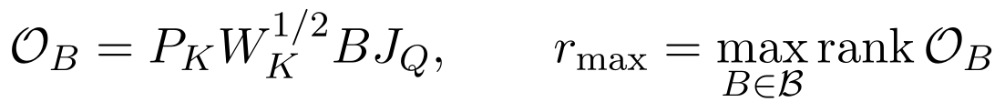
Theorem 6 on admissible generic rank If the parameters of B have a joint distribution absolutely continuous with respect to Lebesgue measure on the declared affine parameter space, the obstruction matrix has rank rmax almost surely. Consequently, the full section dimension equals the expression below almost surely. One may replace rmax by min(dim H⁰(Q), dim H¹(K)) only after proving that a member of the admissible family attains that rank.
Proof. Every matrix entry of the obstruction is affine in the parameters. If rmax is positive, at least one rmax by rmax minor is a nonzero polynomial because it is nonzero at an attaining parameter value. The lower-rank set lies in its zero set, which has Lebesgue measure zero. Higher rank is impossible by definition. If rmax is zero the conclusion is immediate. Corollary 1 converts the rank statement to section dimension. □
A connected graph does not remove support restrictions. On the path 0→1→2, put a one-dimensional Q stalk only at vertex 0, with all other Q stalks zero. Put a one-dimensional K stalk only at edge 1→2, with all other K stalks zero. Then H⁰(Q) and H¹(K) both have dimension one. Yet no incidence block B can couple vertex 0 to edge 1→2, so every connecting map is zero. Its maximum rank is zero, whereas the naive minimum of the two dimensions is one. Zero stalks are legitimate cellular-sheaf data; this example establishes a mathematical limitation rather than an anatomical claim.
The theorem explains why Gaussian experiments can show a stable rank pattern without proving the unrestricted dimension subtraction. A lower observed rank can reflect structural support, parameter tying or a special learned extension. It need not be a numerical failure.

13 2 Lifting under a finite correction budget
Write D = D_K, let c be the weighted residual of a fixed quotient lift, and let P project onto ker D*. The residual floor of Theorem 2 is only part of an implementability test. For a correction budget R ≥ 0 define
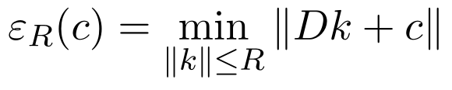
Theorem 7 on the correction frontier Let D have positive singular triplets (σᵢ,uᵢ,vᵢ), write cᵢ = uᵢ*c and c = Pc + Σᵢcᵢuᵢ. The unique minimiser of one half the squared residual plus λ/2 times the squared correction norm, for λ > 0, is the expression below. Its residual and norm obey the two displayed identities. If R is below the unregularised minimum-norm correction and that correction is nonzero, a unique λ > 0 makes ‖kλ‖ = R for 0 < R < ‖D†c‖, and this kλ solves the budgeted problem. At R = 0 the solution is zero; above the threshold the unregularised solution attains the residual floor.
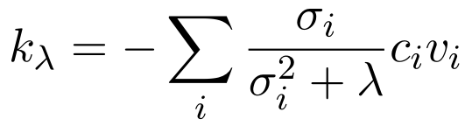
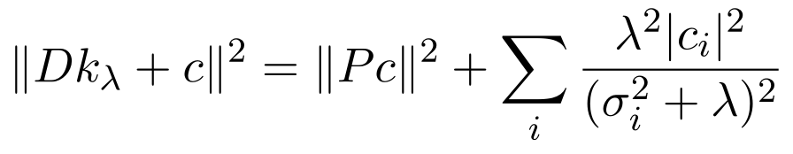
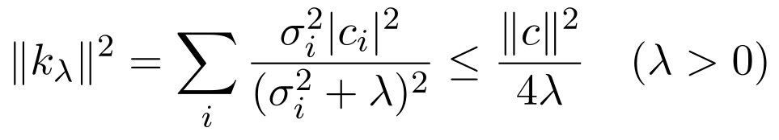
Proof. The normal equation is (D*D + λI)k = −D*c. Resolve it into the right singular vectors; no nullspace component is beneficial. Orthogonality separates the residual into its harmonic component and the displayed image components. Each nonzero contribution to the correction norm decreases strictly with λ, from its unregularised value to zero. Continuity yields the stated λ. The multiplier equation is the convex optimality condition for the ball constraint, so the candidate is globally optimal. Finally σ/(σ²+λ) ≤ 1/(2√λ), giving the norm bound. □
Thus exact implementation within radius R is possible precisely when Pc = 0 and ‖D†c‖ ≤ R. An allowed residual tolerance ζ instead requires εR(c) ≤ ζ. For fixed calibrated coordinates and metrics this is an operational effort gate. The correction norm depends on the chosen lift origin and units; unlike the zero obstruction condition, it is not intrinsic to an uncalibrated change of splitting.
For the triangle incidence matrix and c = (1,2,4), the residual floor is 7/√3 ≈ 4.04145 and the minimum correction norm is 1.24722. At λ = 1 the correction norm falls to 0.93541 while residual rises to 4.07738; at λ = 10 they are 0.28782 and 4.36975. Requiring a smaller correction has a quantifiable compatibility cost even though the cohomology dimensions are unchanged.

13 3 Sharp spectral bounds on retention
Let A = A_F = W_F¹ᐟ²δF and L = A*A. These symbols concern protection, whereas the previous subsection used D_K for lifting. Suppose A is nonzero and let its positive singular values be σᵢ. Define the spectral factors
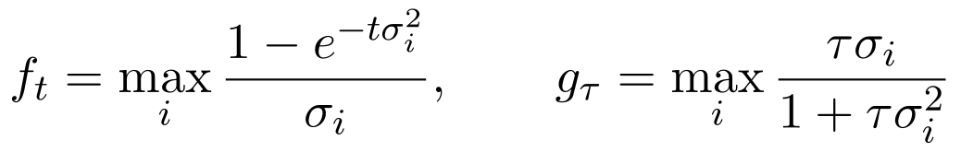
Theorem 8 on residual to displacement bounds: For every initial contrast z and t,τ ≥ 0, the two inequalities below hold. Each factor is the smallest possible constant multiplying ‖Az‖ for its fixed operator and time, simultaneously for all z. At zero time it is zero. If A is zero both displacements vanish.
Proof. Expand z in the right singular basis plus ker A. The kernel components cancel in the displacement. In the i-th positive mode, heat multiplies the original coefficient by exp(−tσᵢ²)−1 and the resolvent by −τσᵢ²/(1+τσᵢ²). Dividing these by the residual multiplier σᵢ gives the factors stated above. The norm ratio is bounded by the largest such scalar ratio. A contrast supported on an attaining singular vector achieves equality. □
Corollary 2 on gap free time bounds: The sharp factors satisfy the following bounds. The heat square-root coefficient has exact value sup over u > 0 of (1−exp(−u))/√u = 0.6381726863…, and the displayed rounded value is an upper bound.
Proof. For heat use 1−exp(−x) ≤ x, 1−exp(−x) ≤ 1 and the substitution u = tσ². Differentiation of (1−exp(−u))/√u gives the positive maximiser solving exp(u) = 2u+1, namely u ≈ 1.25643121. For the resolvent, τσ/(1+τσ²) is at most τσ, at most 1/σ and at most √τ/2 by 2√τ σ ≤ 1+τσ². □
The square-root bounds remain informative when no positive lower gap is known, over a specified time or regularisation scale. They do not imply that tiny residuals remain tiny after arbitrarily long relaxation. The inverse-gap bound controls all times only when the relevant positive gap stays bounded away from zero.
Proposition 8 on discrete overshoot For xₙ = (I−ηL)ⁿz with 0 < η < 2/λmax(L), the exact residual-to-displacement factor is the expression below. If η ≤ 1/λmax(L), the displacement is at most ‖Az‖/σF,+. For larger stable steps it can exceed that limit transiently, although it is always at most 2‖Az‖/σF,+.
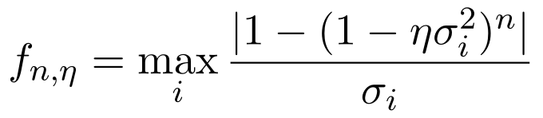
Proof. Apply the same singular-vector expansion with multipliers (1−ησᵢ²)ⁿ−1. Nonnegative multipliers before subtraction give absolute displacement at most one per unit initial coefficient in the smaller-step regime. A negative multiplier can overshoot, but every stable multiplier has absolute value below one. With L = 1, η = 1.5 and z = 1 the first-step displacement is 1.5 while residual divided by gap is one, proving that the heat bound cannot be transferred to every stable discrete step. □

13 4 Preserving a task readout rather than every state coordinate
Let C be a fixed linear task-detail readout in the calibrated state coordinates. Preserving its output for every cue is a stronger and more directly testable statement than finding a large section space.
Theorem 9 on observable invariance: For any fixed τ > 0, the following equivalence holds. The equivalent conditions also characterise invariance C exp(−tL) = C at any fixed t > 0. Thus every row of an invariant readout must lie in the section space in the chosen metric.
Proof. If CHτ = C, multiply on the right by I+τL to obtain C = C+τCL, so CL = 0. Conversely CL = 0 implies C(I+τL) = C and hence CHτ = C. The heat statement follows by spectral decomposition: every positive mode has multiplier strictly below one, so the corresponding row coefficients of C must vanish. □
For approximate preservation, multiply either displacement bound of Theorem 8 by ‖C‖. A classification readout with distinct rows aⱼ has a geometric margin m(z) = min over j ≠ y of (a_y−aⱼ)*z divided by ‖a_y−aⱼ‖. If this margin is positive and state displacement is strictly below m(z), the predicted label cannot change. The proof is Cauchy–Schwarz applied to each score difference. Alternatively apply the bound to the actual feature readout before evaluating its classification margin.
Readout invariance is not confidentiality or memory capacity. It establishes that a declared decoder sees the same output under a declared inference operator. Whether the decoder carries useful task details still requires a held-out target.

13 5 Small interface perturbations can change the limiting memory
Proposition 9 on rank increase: An arbitrarily small perturbation of A can destroy complete long-time retention of a previously private contrast. No uniform-in-time perturbation theorem with error tending to zero follows from map distance alone when rank can increase.
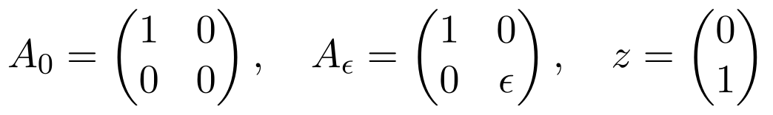
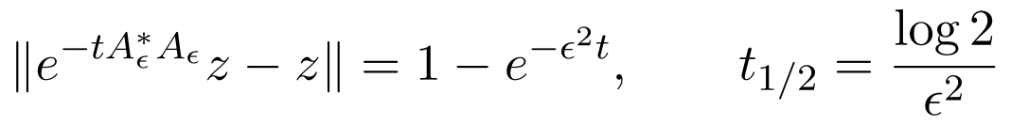
Proof. The first matrix has z in its kernel, whereas the perturbed matrix has no such kernel direction for ε > 0. Direct exponentiation gives the displayed loss. It tends to one at infinite time for every positive ε, despite ‖Aε−A₀‖ = ε. The half-loss time scales as ε⁻². Taking the supremum over time before ε tends to zero therefore gives one rather than zero. □
For ε = 0.1, 0.01 and 0.001, half-loss times are 69.31, 6931.47 and 693147.18 in the model time units. These are mathematical timescales, not biological durations. The two limits do not commute. In contrast, for a fixed finite horizon Theorem 8 bounds the loss by 0.638173√t ε‖z‖ when z lies in the original kernel and the map perturbation has norm at most ε.
Rank thresholds must therefore be reported with uncertainty. Calling a direction private because one fitted singular value falls below a chosen numerical cutoff does not establish infinite-time retention. A report should distinguish exact algebraic nullspaces, numerically unresolved modes and empirically useful finite-horizon retention.

13 6 Exact formulas for the fragile lift and the triangle rank change
Proposition 10 on the twisted triangle: For the matrix D_h with rows (−1,1,0), (0,−1,1), (1,0,−h), and residual c = (1,1,1), the exact solution of D_h k = −c is the expression below for h ≠ 1. Its correction norm and smallest singular value have the stated asymptotics as h tends to one.
Proof. The first two equations give k₂ = k₁−1 and k₃ = k₁−2. Substitute into the third to obtain the displayed vector. Multiplication verifies the result. At h = 1, the left and right unit null vectors are both (1,1,1)/√3. The rank-one perturbation has first-order coefficient magnitude |h−1|/3 between these null vectors, while the other singular values tend to √3. This follows equivalently from the determinant magnitude |1−h| divided by the product of the other two singular values. The correction vector has three leading entries 3/(h−1), yielding the norm asymptotic. □
For the extension family b(s), Theorem 1 gives a one-dimensional connecting map that is zero only at s = 0. The full triangle complex has equal degree-zero and degree-one dimensions, so its Euler characteristic is zero. Corollary 1 gives full H⁰ dimension two at zero and one elsewhere; Euler characteristic gives the same dimensions for H¹. K and Q stay fixed throughout. This corrects both the earlier prose and the interpretation of Figure 1.

13 7 Selective preservation and denoising optimise different targets
Work in registered regional coordinates on a connected n-node graph with ordinary Laplacian G and H = (I+τG)⁻¹. A shared scalar factor is constant across nodes. Private detail has mean zero and covariance vI across nodes, and observation noise is independent with covariance σ²I. The same formulas apply per coordinate for vector-valued independent factors. Orthogonal local coordinate changes do not change these mean-square risks.
Theorem 10 on exact expected risk Selective inference applies H to the shared coordinate and identity to detail; registered full-state scalar inference applies H to both. Their shared mean-square error per node is identical, and their detail risks are the following expressions.
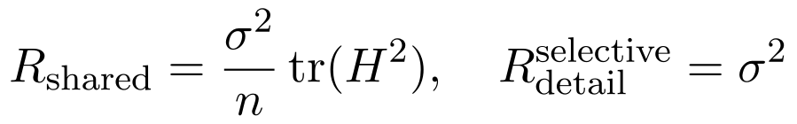
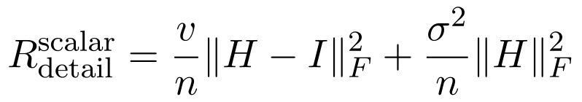
Proof. Since H1 = 1, the shared signal is unbiased and only filtered observation noise contributes, with covariance σ²H². For scalar detail, the error is (H−I)p+Hξ. Independence eliminates cross terms, and taking trace yields its risk. Selective detail error is just ξ. On a connected graph, H tends to 11*/n, whose squared Frobenius norm is one and whose complement has squared Frobenius norm n−1, giving the limit. □
This proves equality of shared-coordinate predictions for the two known-map models at every τ, while selective inference preserves each detail observation exactly. It does not prove superiority for every loss. With n = 8, v = 0.5 and σ² = 1.44, the limiting scalar detail MSE is 0.6175, below the selective value 1.44. Scalar averaging can reduce MSE while reducing the categorical identity accuracy in the supplied toy. The Gaussian-detail model used for the risk theorem has the same second moments per coordinate as the four template details but a different full distribution; the MSE formula needs only those second moments.
A factorised block operator H on the shared sector and identity on detail is exactly the selective sheaf resolvent in this example. Its predictions are indistinguishable. The meaningful contribution is the interface specification and its testable transfer structure; expressivity, loss dominance and universal sample efficiency do not follow from the sheaf label.

13 8 A rerun with separate validation data
We reproduced the supplied script, then ran a separate model-selection protocol. The graph and coordinate frames were drawn with seed 5, as in the original experiment. Validation uses 2000 new samples from the twelve training combinations with seed 802. Test uses 4000 new samples from the four excluded combinations with seed 803. For n = 16, 64, 256 and 2048, five training draws use seed 1000+10n+rep for rep = 0,…,4. Both models are fitted on those same draws. Test labels are used only after the settings are selected in this rerun.
Select τ for the learned interfaces from {0.3,1,3,10,30,100} and ridge penalty from {0.01,0.1,1,10,100}, maximising validation shared-rule accuracy plus mean regional detail accuracy. The validation distribution covers familiar combinations; it does not reveal the excluded test combinations. The template decoder and interface dimension remain supplied oracle information. This is a post hoc corrected rerun, not a preregistered experiment or a proof of statistical significance.
Training n | Rule S and B | All detail S and B | Region zero detail S and B
16 | 0.8216 / 0.9223 | 0.5014 / 0.2977 | 0.5125 / 0.1999
64 | 0.9325 / 0.9675 | 0.5139 / 0.3806 | 0.5210 / 0.2787
256 | 0.9731 / 0.9728 | 0.5192 / 0.4482 | 0.5319 / 0.3402
2048 | 0.9813 / 0.9789 | 0.5195 / 0.4949 | 0.5298 / 0.3821

Table 4: Means over five training draws. S denotes learned-interface sheaf and B block ridge. At n = 16, between-draw standard deviations for rule accuracy are 0.0436 and 0.0314, and for region-zero detail 0.0246 and 0.1196, respectively. These are descriptive standard deviations conditional on one fixed graph, validation set and test set. They are not independent graph-level confidence intervals.
The corrected rerun retains the qualitative contrast: at small n the block model learns the rule faster, while the selective model retains more detail. At n = 2048 the rule means are 0.98135 and 0.97895, and region-zero detail means are 0.52980 and 0.38205. These results do not establish a general sample-efficiency advantage. They show a specific inductive-bias effect under a constructed combination shift.
For known maps at fixed τ = 3, without any tuning in this rerun, raw rule accuracy is 0.631; both selective and registered scalar inference reach 0.975. Mean detail accuracy is 0.51978 under selective inference and 0.39794 under scalar inference. A factorised block baseline differs from the selective Laplacian by only 1.17 × 10⁻¹⁵ in Frobenius norm and gives exactly the same reported decoding accuracies. The comparison therefore supports selective coupling, not a unique sheaf computational advantage.

13 9 Numerical checks and reproducibility
Four hundred random residual-to-displacement and ridge-identity checks used NumPy default_rng(32026), 5 by 9 Gaussian matrices and random cues. The largest observed-to-sharp-bound ratios were 0.99113 for heat and 0.99568 for resolvent inference; the ridge residual identity differed by at most 1.03 × 10⁻¹⁴. These checks supplement the proofs and do not replace them. We also evaluated the exact triangle rank strata and the discrete overshoot example.
For the 400 checks, each iteration draws A, z and c in that order; the positive heat time and resolvent scale are 10 to independent uniform powers on [−3,2], and λ is 10 to a uniform power on [−4,2]. SVD supplies the displayed spectral formulas. The constrained triangle uses c = (1,2,4) and λ = 0, 0.01, 0.1, 1 and 10. The rank-increase checks use the displayed diagonal matrices. The validation rerun uses the sampling, rotation and decoder functions in the attached explore.py; its changes are the seed streams, validation-only selection and exact factorised comparator described above.
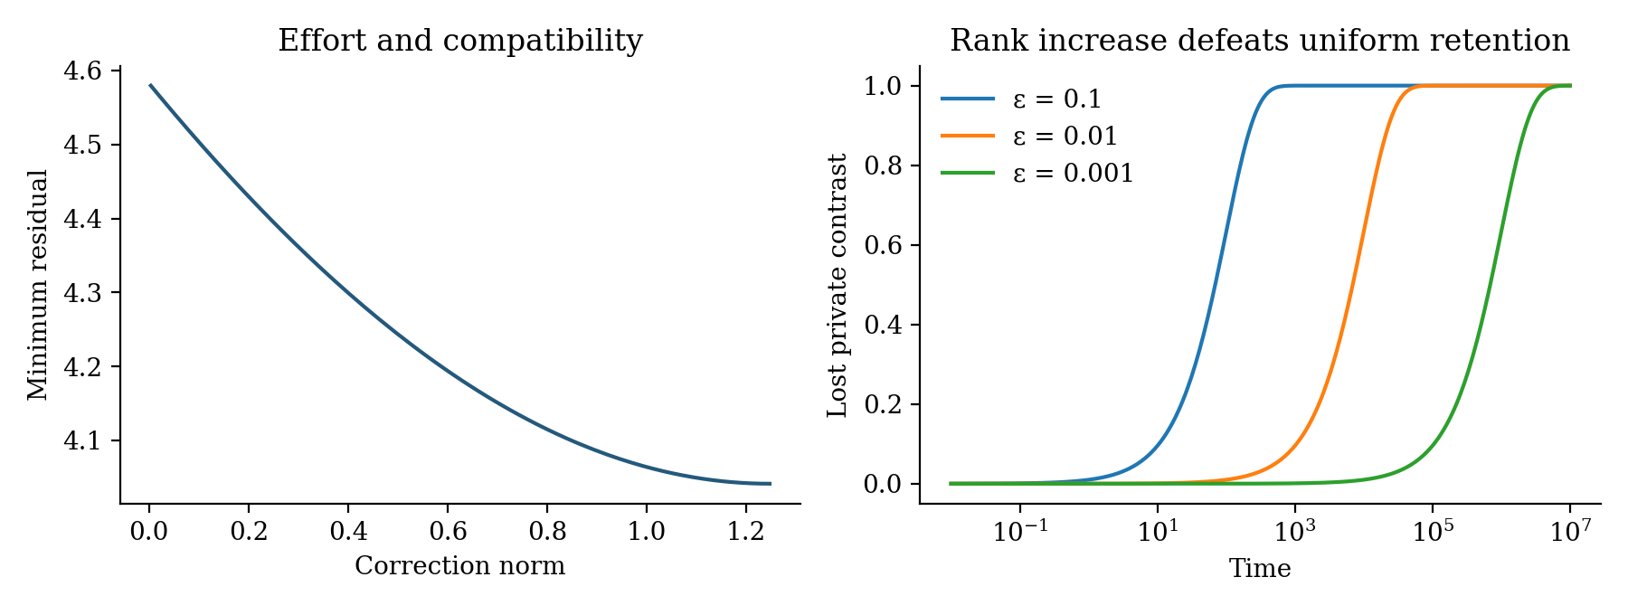
Figure 4: New analytical examples. Left shows correction effort against minimum compatibility residual for the fixed triangle. Right shows complete eventual loss after a small rank-increasing perturbation, despite long finite periods of approximate retention. Time units are those of the mathematical model.

14 Open mathematical directions
Conjecture 1 on sample efficiency is withdrawn in its general quotient-readout form. Neither the section-dimension formula nor the present simulations establish that shared-factor readouts require fewer examples than matched alternatives. A prospective replacement concerns joint task and detail performance on unseen combinations with independently identified interfaces, equal supervision and validation-only model selection. It remains unproved and must be compared with a factorised block model as well as an unconstrained denoiser.
A useful theorem would specify a shared representation class, bounded observation noise, minimum singular values and a distribution of task-specific readouts. The dimension formula alone is insufficient for a sample-complexity claim. Misspecified shared factors can induce negative transfer even when the section space is large.
Conjecture 2 on robust transfer After fixing the task-relevant metric and conditioning, lifting cost and retained-detail observability jointly predict out-of-combination task performance better than representation PR alone. The proposed joint predictor is rejected if it fails the prespecified held-out comparison.
For nonlinear task manifolds, a cellwise smooth surjection with a compatible kernel of differentials gives a local tangent exact sequence only under constant-rank and commutation hypotheses. Theorems 1 and 2 then describe a local linearised problem. A vanishing tangent obstruction does not ensure a finite nonlinear global lift. Curvature, multiple solution branches and discrete context changes require additional analysis.
For time-varying episodes, keep fixed restrictions while testing weight modulation, or explicitly index sheaves Fₜ and define comparison maps between them. Task switching need not be a morphism preserving every section. Across sampling scales, use declared cochain maps and persistence or zigzag comparisons; quotienting a graph or averaging regional states does not generally preserve H¹. These restrictions preserve the earlier programme’s distinction between horizontal topology, local algebra and analytic dynamics.

15 Discussion and conclusion
The cortical geometry study motivates a specific extension of the sheaf programme: distinguish the information that must agree across tasks from the information that must remain available for a particular implementation. Selective endpoint maps allow both requirements in one network. The quotient describes a candidate abstraction, kernel sections describe compatible task detail, and the connecting map decides which abstractions admit coherent realisation.
The mathematical contribution is an explicit synthesis rather than a claim that standard exact-sequence or spectral results are new. It combines a computable lifting obstruction, protected local contrasts, a resolvent connection to activity flow, and careful distinctions between rank expansion, participation-ratio expansion and nonlinear conjunction. The triangle example demonstrates a failure that a local abstraction alone cannot reveal; the two-node example demonstrates detail preservation under selective compatibility.
The numerical exploration supports exact capacity accounting and illustrates large correction costs near a closing kernel gap. This revision adds finite-effort lifting, sharp time-dependent retention bounds, a rank-change limitation and observable-level preservation tests. Its validation-only toy rerun retains detail better than full-state scalar consensus, while an equivalent factorised block model gives identical predictions. The lifting and retention gaps must be estimated separately.
The empirical burden remains substantial. Functional connectivity does not identify the sheaf, RSM compression does not prove transfer, and the presence of a kernel does not prove that behaviour can retrieve its contents. The proposed regional and intervention tests address these gaps through independent calibration and held-out comparisons. If a scalar, latent-factor or unconstrained block model predicts the same outcomes at the same cost, the added sheaf interpretation has not established an operational advantage.
A concrete next study is to fit the shared-plus-detail construction on factorised tasks, test new factor combinations, and perturb the independently calibrated interfaces. That study can determine whether network geometry supports flexible cognition through selective agreement with accessible detail, as proposed here.

References
Project repository ResearchOverFlow SheafCognition https://github.com/debiprasadghosh/ResearchOverFlow/tree/main/October2026/SheafCognition
[1] Chakravarthula, L. N. C., Ito, T., Tzalavras, A. and Cole, M. W. (2026). Network geometry shapes the transformation of task representations across the human cortex. Nature Neuroscience. Published 22 October 2026. https://doi.org/10.1038/s41593-026-02486-8. Publisher abstract and publication metadata checked 23 October 2026; version-of-record full text not retrieved.
[2] Chakravarthula, L. N. C., Ito, T., Tzalavras, A. and Cole, M. W. (2026). Network geometry shapes the transformation of task representations across human cortex. bioRxiv, version 3, posted 3 September 2026. https://doi.org/10.1101/2025.03.14.643366. Detailed source: user-supplied file 2025.03.14.643366v3.full.pdf. Sections cited include Results, Discussion and Methods on pages 4–12 and 25–29.
[3] Ghosh, D. P. (2026). The Cortical Sheet as a Recurrent Cellular Sheaf: Horizontal Topology and Vertical Algebra. Unpublished research manuscript, September 2026. Current supplied-project manuscript read in full for this extension. https://github.com/debiprasadghosh/ResearchOverFlow/tree/main/September2026/Sheaf
[4] Hansen, J. and Ghrist, R. (2019). Toward a spectral theory of cellular sheaves. Journal of Applied and Computational Topology 3, 315–358. https://doi.org/10.1007/s41468-019-00038-7. Open manuscript https://arxiv.org/abs/1808.01513.
[5] Bodnar, C., Di Giovanni, F., Chamberlain, B. P., Liò, P. and Bronstein, M. M. (2022). Neural Sheaf Diffusion: A Topological Perspective on Heterophily and Oversmoothing in GNNs. Advances in Neural Information Processing Systems 35. https://arxiv.org/abs/2202.04579.
[6] The Stacks Project Authors. Homological Algebra. Section 12.13, Complexes. https://stacks.math.columbia.edu/tag/010V. General background for complexes and the cohomology exact sequence. The relevant finite-dimensional connecting-map proof is given in full in Theorem 1.

