From Attention to Attestation
A Falsifiable Conjecture on Post-Attention Architecture
Debi Prasad Ghosh, debiprasadghosh@gmail.com
July 28, 2026, https://doi.org/10.13140/RG.2.2.22969.94564

Abstract
Current language models make content durable mainly by changing parameters, extending context, or writing to external memory. This paper conjectures a different post-attention architecture in which durable knowledge and consequential action require attestation: a claim must be staged, supported by evidence external to the claiming process, and admitted by a hard commit gate. The proposal is motivated by public evidence that Safe Superintelligence Inc. has pursued a new research direction, that its work is considered ready to scale, and that NVIDIA expects SSI’s insights to contribute to the development of current and future compute platforms. The technical contribution is not a claim about SSI, but a coherent architecture built around a consistency–compression equilibrium. Local models form a cellular sheaf over a learned two-dimensional CW complex; certificates are attached as 2-cells along the cycles they jointly validate. Two collapse modes are identified. Learned restriction maps can collapse to zero, producing perfect consistency about nothing, while learned topology can delete edges, producing perfect consistency without shared knowledge. The first is addressed by partial-isometry restriction maps, so consolidation becomes rank selection rather than magnitude decay. The second is addressed by making compression the proposer of shared structure and consistency the veto, rather than combining both as freely tradeable penalties. Differentiable sheaf-Laplacian energy trains local consistency, integral cohomology audits finite-order obstructions, persistent certificate filtrations measure validator independence, and the weakest positive spectral mode directs offline replay. The conjecture predicts a hardware signature dominated by sparse iterative solvers, irregular memory access, boundary-matrix reduction, persistent metadata, and dependency-DAG invalidation rather than by dense matrix multiplication alone. This prediction supplies an external falsification path through NVIDIA’s post-Rubin platform roadmap.
Keywords: attestation; cellular sheaves; CW complexes; memory consolidation; partial isometries; persistent homology; safe AI; hardware–algorithm co-design
Epistemic status
This paper is a falsifiable architectural conjecture assembled from public statements, established mathematical tools, and the author’s prior framework. It does not claim access to Safe Superintelligence Inc.’s confidential research, nor does it claim that the company is implementing the architecture proposed here.

Contents
- 1. Introduction
- 2. Evidential Base and Epistemic Boundary
- 3. The Architectural Conjecture
- 4. From Witnessing to Attestation: Certificates as 2-Cells
- 5. The Mathematical Substrate
- 6. The Main Result: Consistency Against Compression
- 7. Spectral Audit and Targeted Consolidation
- 8. Torsion, Aggregate Guarantees, and Discrete Safety
- 9. Validator Independence as a Persistence Parameter
- 10. Commit Discipline and Safety Invariants
- 11. Learning, Revision, and Certified Self-Generated Data
- 12. Computational Cost and the Hardware Signature
- 13. Falsification Programme
- 14. Objections and Open Problems
- 15. Conclusion
- Appendix A. Minimal Formal Model
- Appendix B. A Worked Torsion Example
- References

1. Introduction
The Transformer transformed sequence modelling by replacing recurrence with attention and thereby exposing large parts of training to parallel computation. The decoder-only form introduced in generative pre-training subsequently became the principal workhorse of large language models. Its success was architectural and industrial at once: attention mapped unusually well onto dense linear algebra, and dense linear algebra mapped unusually well onto increasingly capable accelerators. The result was not merely a model family but a hardware–software–capital system organised around scalable next-token prediction [1–3].
This paper asks what a credible successor would have to change. The answer proposed here is not “remove attention.” Attention may remain valuable for bounded perception, exact local retrieval, and candidate generation. The deeper transition is from prediction-weighted content to admissibility-gated content: from a system in which a high-scoring representation can flow directly into memory or action, to one in which consequential state must be attested by evidence whose provenance is external to the claiming process.
The word attestation is used deliberately. In hardware security, remote attestation concerns a claim about a system state backed by evidence that a verifier can appraise under an explicit policy [4]. The analogy is exact enough to be useful but not so exact as to prescribe implementation. A post-attention intelligence should not treat its own confidence as proof of its own state. It should distinguish the claimant, the evidence producer, the verifier, the appraisal policy, and the relying process that decides whether a claim may alter durable memory or authorise action.
The central proposal is a witnessed consolidating architecture with a hard commit discipline. Perception and generation produce candidates. A staging layer preserves them without granting them the status of belief. Local models are joined through learned overlaps. Independent verification attaches certificates as 2-cells to the cycles of local models they reconcile. Consolidation compresses episodes into reusable structure, but only through partial-isometry maps that preserve the shared subspace and discard the complement by rank selection. Safety invariants are not penalties in a weighted loss. They are admissibility conditions of the commit gate.
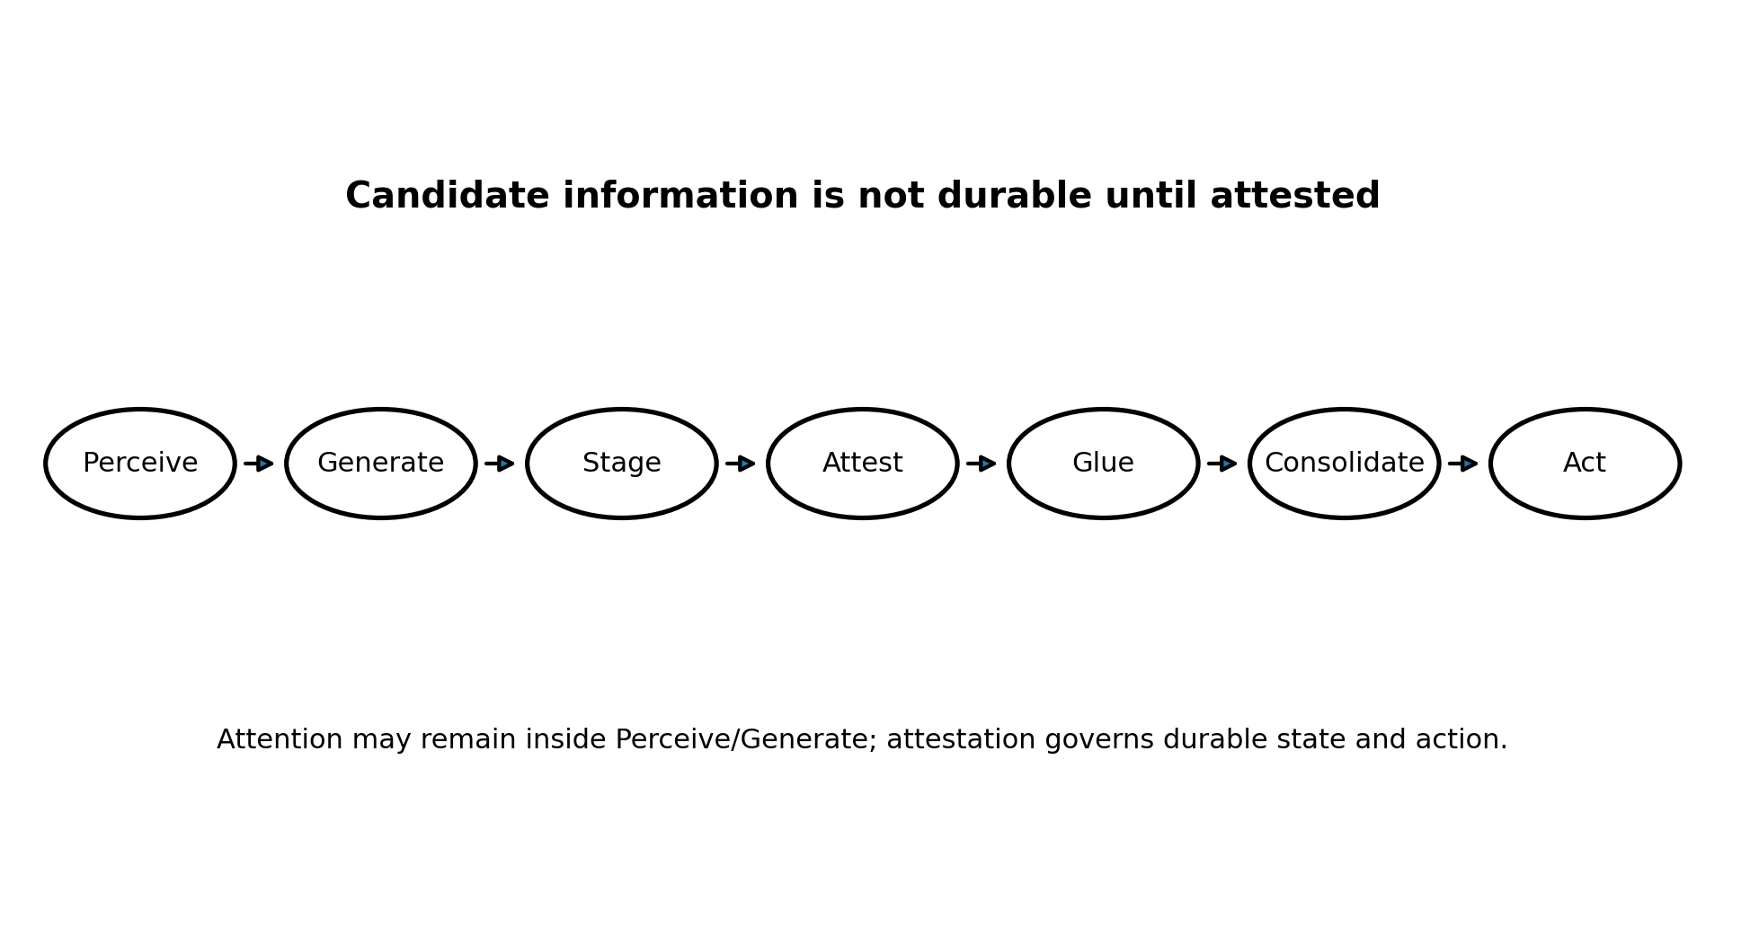
Figure 1. The conjectured intelligence cycle. Attention can remain inside perception and generation; attestation governs durable memory and consequential action.
The sharpest result is negative. A naïve differentiable consistency objective has two trivial collapse modes. First, if restriction maps are learned, driving them to zero makes every local assignment perfectly consistent. Second, if topology is learned, deleting every edge removes every disagreement. These are not minor regularisation problems. The first forces consolidation to be implemented through partial isometries and rank selection; the second forces consistency and compression into an adversarial or constrained equilibrium. The architecture cannot be defined as a weighted sum of individually desirable properties.
The paper is deliberately falsifiable. It predicts that a substantial implementation of the architecture would spend meaningful runtime on sparse matrix–vector products, Lanczos-type eigensolvers, integer or binary boundary-matrix reduction, provenance-DAG traversal, and persistent irregular state. These operations are memory-bound and structurally unlike the dense matrix multiplications around which current AI accelerators are optimised. If post-Rubin NVIDIA platforms remain almost exclusively centred on larger dense tensor throughput, longer attention windows, and softmax/MoE acceleration, the conjecture loses support. If they expose persistent sparse state, graph and reduction primitives, attestation metadata, and asynchronous verification as first-class architectural features, it gains support.

2. Evidential Base and Epistemic Boundary
The conjecture is constrained by five public observations. First, NVIDIA and Safe Superintelligence Inc. announced a long-term strategic partnership in July 2026. Second, NVIDIA stated that SSI had pursued a new research direction for approximately two years and that the research was ready to scale. Third, NVIDIA described having received rare access to SSI’s closely guarded work before entering the partnership. Fourth, the companies stated that SSI’s insights into the future of AI would contribute to the technical advancement of NVIDIA’s current and future compute platforms. Fifth, Ilya Sutskever publicly argued at NeurIPS 2024 that pre-training in its familiar form would end because compute can grow while high-quality human-generated internet data cannot [5,6].
The fourth observation is the most informative. A laboratory that has merely produced a better Transformer needs capacity, allocation, networking, and compiler support. It does not obviously need a formal role in shaping future compute platforms. Co-development language is more naturally explained by a workload whose bottlenecks differ from those already dominant. This does not prove an architectural change: the research could be a training, reasoning, or alignment method that remains Transformer-based. It does, however, justify asking what workload would make hardware–algorithm co-design strategically necessary.
Boundary of the claim
All statements about SSI’s internal algorithm are conjectural. The paper claims only that the architecture developed below is consistent with the public clues, mathematically coherent after explicit repairs, and externally testable through computational and hardware signatures.

The title also marks a conceptual shift rather than a company claim. “Safe superintelligence” is not used as a capitalised target in the subtitle, avoiding ambiguity with the company. “Attestation” is not a synonym for confidence, reward, or chain-of-thought. It means a state claim backed by separately produced evidence and admitted under a non-tradeable policy.

3. The Architectural Conjecture

3.1 Token interface, structured substrate
Tokens remain an effective interface. Text, code, speech transcripts, and symbolic traces can still enter and leave as sequences. The conjecture is that durable internal state is no longer organised primarily as a flat sequence of token embeddings. It is organised around objects, agents, events, relations, goals, causal dependencies, permissions, and propositions carrying provenance. This distinction allows the external behaviour to remain chatbot-like while the internal ontology changes substantially.

3.2 Attention demoted, not abolished
Two criticisms of self-attention should be separated. Quadratic scaling with sequence length is a complexity problem, and many partial remedies exist. The absence of architecturally enforced identity, causality, authority, and revision is an ontology problem. Better kernels address the first; they do not address the second. The conjecture therefore demotes attention to a bounded perceptual and retrieval operator. Attention proposes relations within an active working set, while durable state is maintained through a structured recurrent and external memory substrate.

3.3 A hybrid recurrent backbone
A pure fixed-size recurrent state is unlikely to be sufficient. Selective state-space models demonstrate attractive linear scaling and content-dependent forgetting [7], but theoretical and empirical work shows that fixed-size recurrent states can be disadvantaged on exact copying and retrieval tasks [8]. The defensible design is hybrid: a stratified recurrent scan carries temporal continuity and compressed state, while bounded attention or explicit retrieval preserves exact access where compression would be destructive.
Sₜ₊₁ = F(Sₜ, xₜ, gₜ), with Sₜ = (Sₜᵉᵖ, Sₜᵒᵇʲ, Sₜᶜᵃᵘˢ, Sₜᶜᵒⁿˢᵗ) (1)
The gate gₜ determines which stratum may change. Evidence thresholds rise with depth. A single observation may update an episode. Repeated independent evidence may update an object or causal model. Constitutional state—action authority, identity boundaries, irreversible-operation rules—cannot be modified by an ordinary forward pass.

3.4 Content–constraint duality
Every candidate item carries content and constraint together. Let z = [x; ξ], where x is the representational content and ξ contains provenance, scope, permissions, tests, and dependencies. A content vector without an attached constraint is not merely low-confidence; it is structurally ineligible for durable commitment. This converts provenance from optional metadata into part of the state type.

3.5 Three computational modes
The architecture has training, serving, and sleep. Serving accumulates staged candidates and performs low-latency local checks. Sleep is an offline phase for replay, spectral audit, certificate acquisition, topology revision, compression, and selective commit. Its workload is bursty, memory-bound, and latency-tolerant, unlike either dense pre-training or autoregressive serving. This third mode becomes important in the hardware analysis.

4. From Witnessing to Attestation: Certificates as 2-Cells

4.1 Why a graph is insufficient
If local models and their pairwise overlaps are represented only by a graph, the knowledge substrate is a 1-complex. Then δ¹ = 0, every 1-cochain is closed, and H¹ = coker δ⁰. In that setting cohomology cannot distinguish a discrepancy that violates a higher-order rule from a discrepancy that merely reflects incomplete coupling. The apparatus is one-dimensional while using two-dimensional language. A genuine consistency architecture is therefore obliged to construct 2-cells.

4.2 The certificate cell
Let vertices denote local models and edges denote shared variables or transport maps. A certificate is a verification event attached as a 2-cell along the precise loop of local models that it jointly reconciles. The witness does not emit a scalar confidence. It changes the topology of the knowledge complex. Verification becomes a cell-attachment operation, and the resulting complex records not only what is believed but what has been checked together.
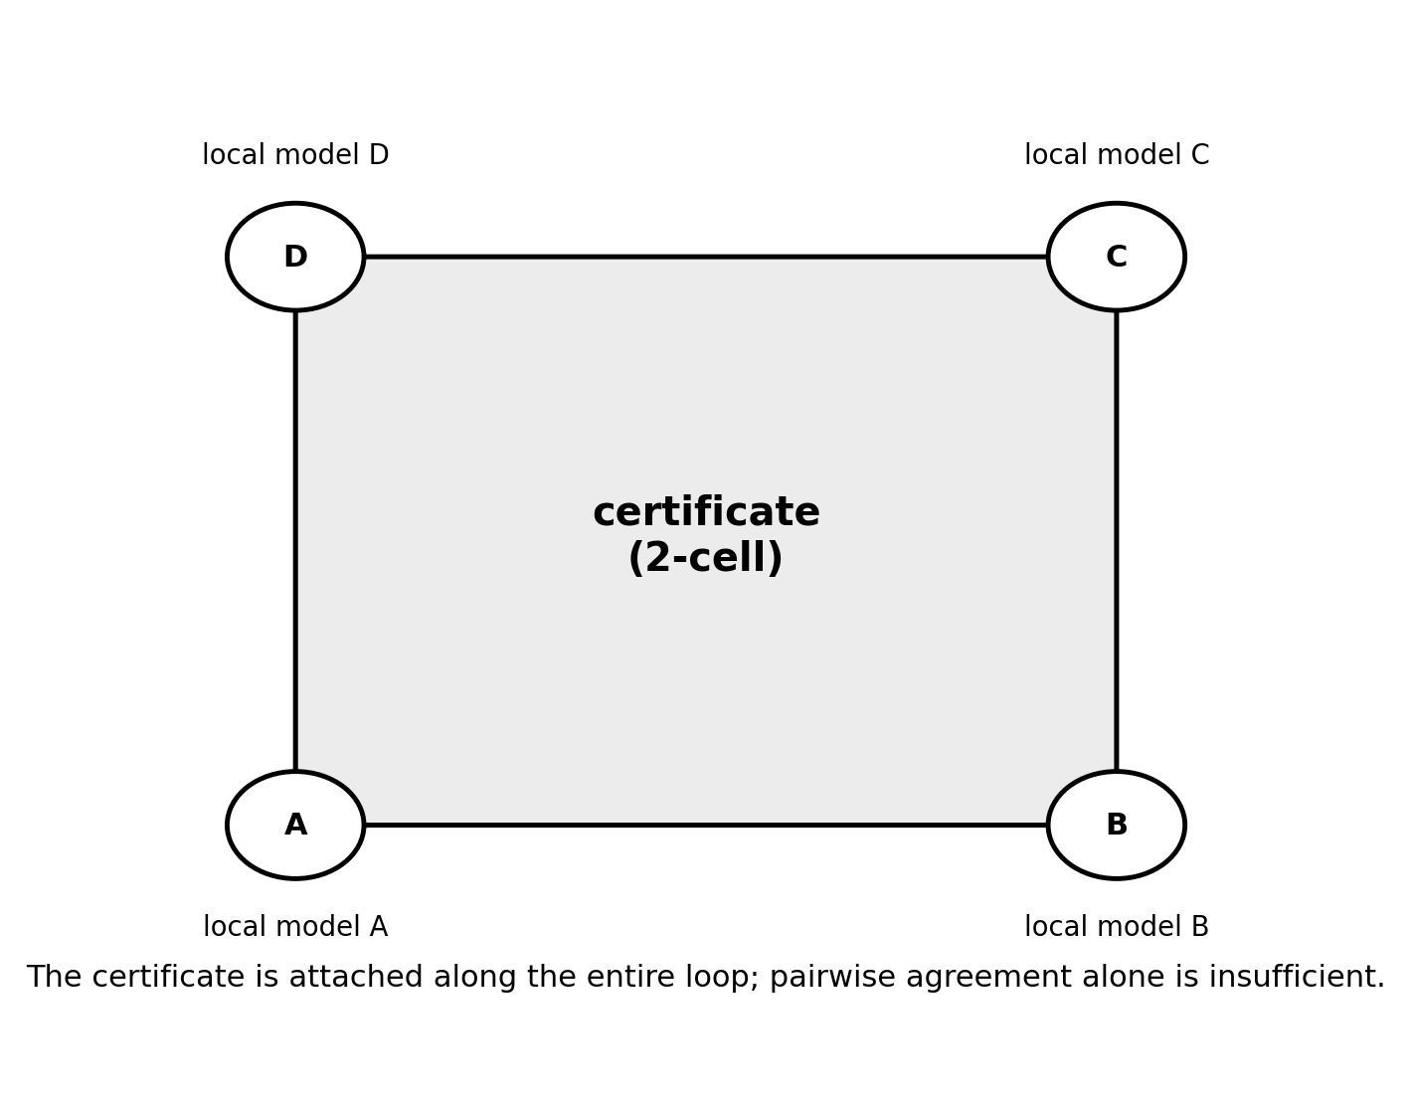
Figure 2. A certificate is a 2-cell attached along the complete validation loop. It is not a scalar score on a node or edge.
This construction should not be confused with the de Silva–Carlsson witness complex used in topological data analysis, where landmarks and witnesses induce simplices [9]. The present construction is a CW or presentation-style knowledge complex whose 2-cells are explicit verification events. The relation between candidate entities and evidence may separately generate Dowker complexes, but the attestation cell is an operational commitment record rather than a landmark approximation.

4.3 Pairwise agreement and holonomy
Pairwise compatibility does not imply global compatibility. Transport around a cycle can compose to a non-identity transformation even when every adjacent pair appears consistent. The relevant failure is holonomy: local agreements accumulate a global mismatch. A certificate attached to the cycle asserts that the composed transport has been independently checked on the shared subspace. This is precisely the information absent from edge-wise losses.

4.4 Dowker duality as an identity mechanism
Candidate entities and evidentiary witnesses can be represented as a bipartite relation R ⊆ I × J. Dowker’s theorem associates two complexes—one on entities connected by shared witnesses and one on witnesses connected by shared entities—and gives them the same homotopy type [10]. The architectural inference is that identity need not be a point in embedding space. It can be the stable incidence structure of the evidence that supports the candidate. Similarity may nominate a merge; only an evidentiary relation can attest it.

5. The Mathematical Substrate

5.1 A cellular sheaf on a two-dimensional complex
Let X be a finite two-dimensional regular CW complex with vertices V, edges E, and certificate 2-cells P. A cellular sheaf 𝓕 assigns a vector space 𝓕(σ) to each cell σ and a restriction map 𝓕_{σ◁τ}: 𝓕(σ) → 𝓕(τ) to each face relation σ ◁ τ. The cochain spaces are
C⁰(X;𝓕)= ⨁ᵥ∈V 𝓕(v), C¹(X;𝓕)= ⨁ₑ∈E 𝓕(e), C²(X;𝓕)= ⨁ₚ∈P 𝓕(p). (2)
The coboundary maps δ⁰: C⁰ → C¹ and δ¹: C¹ → C² encode pairwise disagreement and certified cycle disagreement. The cochain condition δ¹δ⁰ = 0 is not merely mathematical hygiene. It states that a globally induced assignment cannot violate a correctly represented certificate cell.
H⁰(X;𝓕)=ker δ⁰, H¹(X;𝓕)=ker δ¹ / im δ⁰. (3)

5.2 Differentiable consistency and structural fragility
The zero-degree sheaf Laplacian is L₀ = (δ⁰)*δ⁰. Hodge theory gives ker L₀ ≅ H⁰(X;𝓕) [11]. A particular assignment z has differentiable inconsistency energy
E₀(z)=‖δ⁰z‖² = ⟨z,L₀z⟩. (4)
E₀(z) is a property of the current assignment. By contrast, the smallest positive eigenvalue λmin+(L₀) is a property of the coupling structure. It measures the least energetic non-global mode and therefore the fragility of the agreement geometry. The associated eigenvector localises the weakly constrained fault line. Near-zero positive modes are not themselves contradictions; they are almost-global assignments that can separate under small perturbations.

5.3 The role of H¹
H¹ does not score contradiction generically. Given the 2-cells and their higher-order constraints, it classifies closed discrepancy patterns modulo those generated by revising vertex assignments. A nonzero class is a discrepancy that survives all permitted local repairs. This division of labour is essential: spectral energy supports training and localisation, while cohomology audits whether the residual discrepancy is repairable within the current model or reflects a structural obstruction.

6. The Main Result: Consistency Against Compression
The naïve architecture appears to admit a conventional objective: task loss plus consistency, witness, compression, and safety terms. That formulation is wrong. It hides two distinct collapse modes, and the repair of the first directly conflicts with the intended memory-consolidation mechanism.

6.1 Collapse I: zero restriction maps
E₀(z)= Σₑ=(u,v) ‖𝓕_{v◁e}zᵥ − 𝓕_{u◁e}zᵤ‖². (5)
If the restriction maps are learned and E₀ is minimised, setting every restriction map to zero yields E₀(z)=0 for every assignment. The model reports perfect agreement because it has erased every overlap. The basin is broad and easy to reach by magnitude shrinkage. It is consistency without content.
Orthogonal restriction maps prevent magnitude collapse and have been used in sheaf-neural-network constructions [12–14]. But an orthogonal map is an isometry. It cannot compress. A memory system whose consolidation objective is to convert many episodes into lower-dimensional reusable structure cannot use full-rank orthogonal maps everywhere. The anti-collapse solution and the consolidation requirement therefore conflict.

6.2 Partial isometries and rank-selected consolidation
The proposed resolution is to make each restriction map a partial isometry. It is isometric on a learned shared subspace and annihilates the orthogonal complement. Algebraically, for a map F: U → W,
F*F = Pₛ, FF* = Pᵣ, rank(F)=r, (6)
where Pₛ and Pᵣ are orthogonal projections onto the initial and range subspaces. Magnitude shrinkage cannot create false agreement on the retained overlap, while rank r controls how much structure is shared. Consolidation becomes rank selection, not coefficient decay. Information is discarded by deciding that it is not part of the overlap, not by weakening the meaning of the overlap.
This also repairs the holonomy mechanism. Transport is invertible on the shared subspace, exactly where cycle composition must be evaluated. The complement may be legitimately local and need not participate in global gluing.

6.3 Collapse II: deleting the topology
A deeper collapse occurs when X itself is learned. Since every edge contributes a possible disagreement, a consistency-minimising learner can delete edges and separate the complex into isolated vertices. No overlaps produce no contradictions and no knowledge integration. This is consistency without a world.
Minimum-description-length pressure is the only intrinsic counterforce. Shared objects, rules, and submodels reduce total description length; refusing every overlap requires repeated local representations. Compression therefore proposes couplings while consistency audits them. The two terms are not independent virtues. Each prevents the other’s trivial optimum.
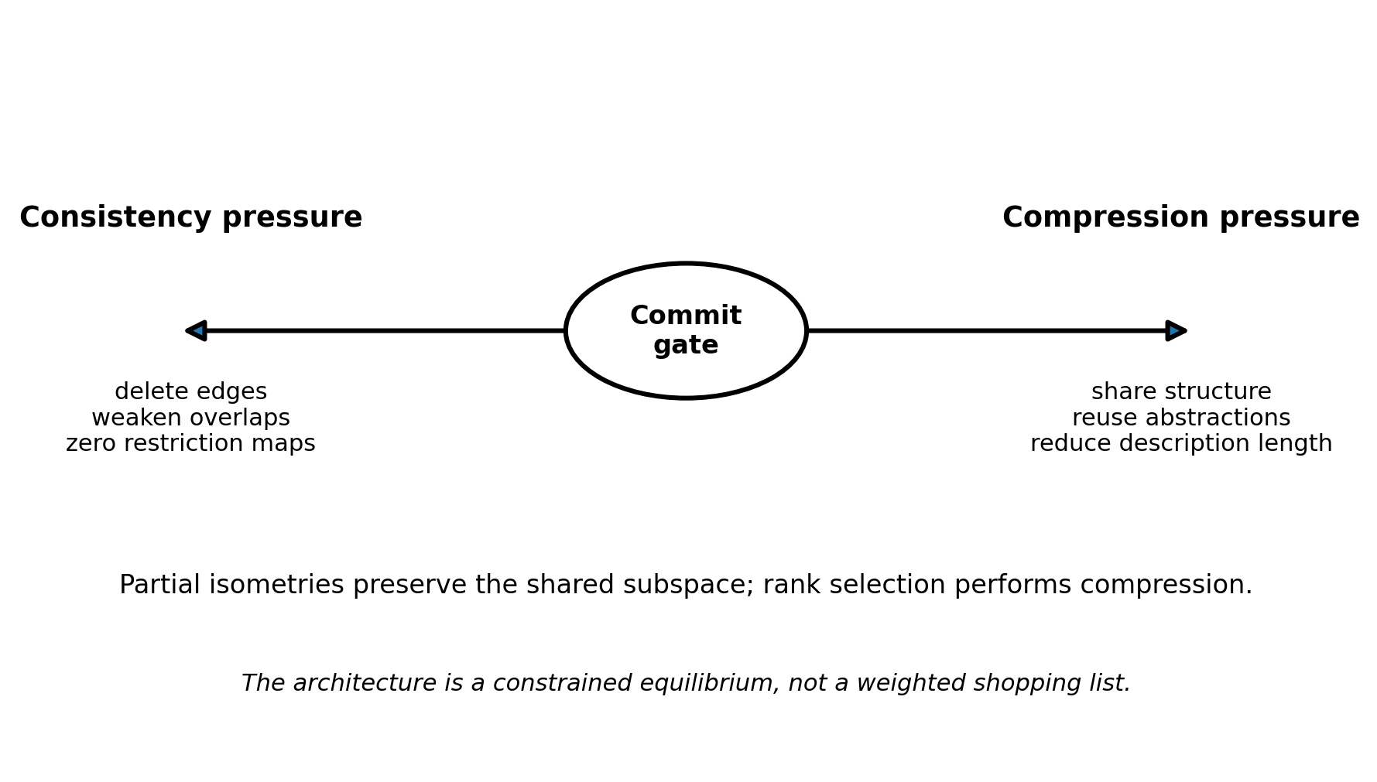
Figure 3. The central equilibrium. Compression proposes reusable shared structure; consistency and attestation veto unsafe sharing. Partial isometries make compression a rank decision rather than magnitude shrinkage.

6.4 A constrained equilibrium, not a weighted sum
A scalar objective of the form Ltask + λ₁E + λ₂LMDL is possible mathematically, but it makes every property tradeable and gives no principled protection against collapse at extreme weights. The architecture should instead be procedural or bilevel. A compression proposer nominates new shared subspaces, edges, and abstractions to reduce description length. An attestation gate accepts a proposal only if consistency energy, certificate requirements, spectral robustness, and hard invariants pass explicit thresholds.
Propose: (X′,𝓕′,z′) ∈ argmin DL(X,𝓕,z) subject to resource bounds, (7)
Commit only if: E₀(z′)≤ε, λmin+(L₀′)≥η, A(c)≥τ, and Iₖ(z′)=true ∀k. (8)
This is the paper’s main architectural finding. Compression is the generative pressure that prevents disintegration; attestation is the veto that prevents false gluing. The architecture lives at their constrained equilibrium.

Table 1. Collapse modes and architectural repairs
Failure mode | Trivial solution | Why it is attractive | Architectural repair
Restriction collapse | All restriction maps F=0 | Zero consistency energy for every assignment | Partial isometries; compress by rank selection
Topology collapse | Delete all edges | No overlaps, hence no disagreement | Compression proposes sharing; attestation vetoes unsafe sharing
Certificate collapse | Generator fabricates its own 2-cells | Every obstruction can be declared resolved | Persistence filtered by validator independence
Invariant trade-off | Put safety in a weighted loss | Enough task gain can purchase violation | Hard constraints in the commit gate

7. Spectral Audit and Targeted Consolidation

7.1 Energy versus fragility
The distinction between assignment energy and structural fragility assigns different computational roles. E₀(z) belongs in differentiable training and online monitoring. λmin+(L₀) belongs in audit and consolidation scheduling. A low energy assignment can still inhabit a fragile geometry, while a robust geometry can temporarily contain a high-energy candidate that has not yet been reconciled.

7.2 The weakest mode identifies where to sleep
Let v+ be an eigenvector associated with λmin+(L₀). Its local energy contributions identify the cells and overlaps responsible for the weakest global mode. This makes sleep selective. Instead of replaying experience uniformly or in proportion to frequency, the system replays and re-verifies the evidence concentrated near the spectral fault line.
p(replay at cell σ) ∝ local_energyσ(v+). (9)
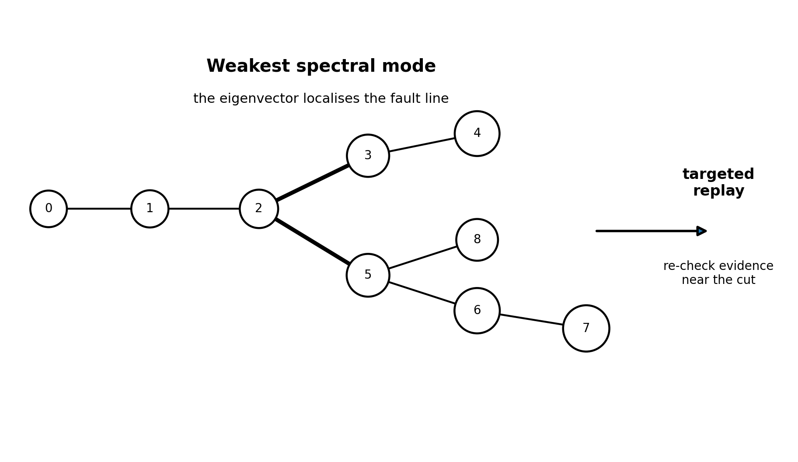
Figure 4. The smallest positive eigenvector localises the weakly constrained mode and provides a target for offline replay and re-verification.
A Lanczos iteration can estimate the extremal positive mode using sparse matrix–vector products. The spectral computation is not free, but it performs two jobs at once: it reports robustness and identifies the region to revisit. This is a stronger operational use of the sheaf spectrum than treating the spectral gap as a scalar regulariser.

7.3 A dynamic sleep loop
Sleep rewrites the complex; the rewritten complex has a new spectrum; the new spectrum redirects the next sleep phase. The process may converge, cycle, or exhibit hysteresis. A defensible implementation should therefore version the complex, retain rollback points, and require monotone improvement in an external audit measure rather than assuming that repeated consolidation necessarily settles.

8. Torsion, Aggregate Guarantees, and Discrete Safety

8.1 Why real-valued training is incomplete
Differentiable learning is naturally performed over real vector spaces. Real coefficients, however, erase torsion. If a homology class has finite order n, tensoring with ℚ or ℝ sends it to zero. A safety audit performed only with real-valued energies can therefore miss finite-order obstructions involving parity, modular rules, periodic authority, or repeated composition.
ℚ ⊗ (ℤ/nℤ) = 0. (10)

8.2 Certificates with multiplicity
Consider a CW complex with one 1-cell γ and a 2-cell attached by a degree-n map. Its cellular boundary sends the 2-cell to nγ, producing H₁ ≅ ℤ/nℤ. In attestation language, the certificate validates n traversals or an aggregate block, but does not validate one instance. This supplies a mechanism for the distinction between “the policy is safe in distribution” and “this action is safe now.”
The strong claim should be read carefully. Distributional guarantees are not always torsion classes. Rather, a multiplicity-bound certificate creates a concrete class of cases in which aggregate validation becomes torsion and disappears under real coefficients. The example proves a possibility that any complete safety architecture must be able to represent.

8.3 Dual audit
The proposed system therefore has two mathematical layers. A real-valued spectral layer supports gradient training, approximate consistency, and localisation. An integral or modular layer audits finite-order relations at commit time. The first is differentiable; the second is discrete and non-tradeable. Their separation mirrors the broader architecture: proposal can be soft, commitment cannot.

9. Validator Independence as a Persistence Parameter

9.1 The fabricated-certificate attack
Once certificates can kill cohomological obstructions, a generator has an obvious attack: fabricate a 2-cell for its own output. This is the attestation analogue of a sham audit or reward hacking. A system that grades its own work can attach enough certificates to make every discrepancy appear resolved.

9.2 Independence filtration
Let d(c)∈[0,1] measure dependence between a certificate-producing process and the content generator, where 0 denotes operational independence and 1 denotes maximal correlation. Construct a sublevel filtration Xq containing only certificates with d(c)≤q. Independent certificates enter early; correlated certificates enter late. Track discrepancy classes through this filtration.
X₀ ⊆ Xq₁ ⊆ Xq₂ ⊆ ··· ⊆ X₁, q₁<q₂. (11)
The death parameter of a discrepancy class is the minimum validator dependence required to eliminate it. A class killed by a low-dependence certificate is strongly attested. A class that disappears only after highly correlated certificates are admitted has been weakly or circularly validated. The audit question is not simply whether H¹ vanishes, but how much validator dependence is required to make it vanish.
This unifies two previously separate concerns: topological audit and correlated verification. As generators and validators are co-trained, their errors may become correlated even when their architectures differ. The filtration makes that degradation an explicit parameter rather than an informal warning. Zigzag persistence becomes relevant when certificates, dependencies, and local models are inserted and removed over time rather than forming a nested filtration [15].

10. Commit Discipline and Safety Invariants

10.1 Staging before belief
Every observation and generated inference first enters a staging area. Staged content can support temporary reasoning but cannot alter constitutional state, create irreversible side effects, or serve as an unqualified premise for future training. This is a two-phase commit discipline borrowed from reliable systems: prepare, then commit.

10.2 Stored, derivable, and permitted
The architecture distinguishes three sets. Stored content is present in memory. Derivable content follows from stored content under an explicit inference system. Permitted content may be used for a specified action in a specified jurisdiction. Current neural models often collapse these distinctions into availability in parameters or context. Attestation makes the distinctions operational.

10.3 Invariants are admissibility conditions
If identity boundaries, provenance requirements, action authority, or irreversible-operation rules are truly invariant, they cannot appear as λ-weighted penalties. Any weighted penalty is tradeable by construction. A sufficiently large improvement elsewhere can purchase the violation. Invariants must reside in the type system and commit gate.
Commit(z) = 1 iff A(z)=1 ∧ I₁(z)=···=Iₘ(z)=1. (12)
The training objective may optimise prediction, consistency energy, witness acquisition, and compression, but only over candidates that remain subject to hard admissibility. This is the conceptual heart of “attention to attestation”: probability ranks candidates; attestation decides what is allowed to become state.

11. Learning, Revision, and Certified Self-Generated Data

11.1 Discrete write actions
Writing durable memory involves discrete choices: ignore, stage, link, revise, split, merge, certify, or reject. Gradients do not pass naturally through these actions. Straight-through estimators, continuous relaxations, policy gradients, or search over write programmes may be required. The difficulty is not incidental; it is the computational price of making commitment explicit rather than hiding it inside continuous weight updates.

11.2 Dependency-aware revision
Committed claims carry provenance DAGs. When a premise changes, the system invalidates only conclusions whose certificates or derivations depend on it. Because beliefs and certificates can appear, disappear, and reappear, ordinary persistence over nested filtrations is insufficient; zigzag persistence is a natural audit tool. Directed dependency may also require directed or path-homological invariants rather than treating every edge as reversible.

11.3 Certified synthetic data
Sutskever’s “one internet” argument points toward self-generated data, but unfiltered self-training risks reinforcing errors. In the proposed architecture, generated problems, proofs, simulations, and strategies enter training only after receiving machine-checkable or independently reproducible certificates. The same attestation mechanism that protects memory therefore protects the future data distribution. Generated content is cheap; certified generated content is the scarce resource.
The system should also track certificate lineage. If a verifier is trained predominantly on the generator’s outputs, nominal independence can conceal causal dependence. The persistence filtration of Section 9 provides a quantitative audit surface for this problem.

12. Computational Cost and the Hardware Signature

12.1 The dominant kernels
The consistency and attestation machinery has a distinctive computational profile. The key operations are sparse, low-intensity, irregular, and metadata-heavy. They achieve a small fraction of peak performance on processors designed primarily for dense tensor multiplication.
Operation | Approximate cost | Arithmetic intensity | Current GPU fit
Assignment energy zᵀL₀z | One sparse matvec; O(nnz) | Very low | Memory-bound
λmin+ and eigenvector | k Lanczos iterations; k sparse matvecs | Very low; sequential dependence | Poor relative to GEMM
Certificate persistence | Boundary-matrix reduction over F₂ or integers | Low arithmetic; irregular reduction | Poor / combinatorial
Provenance invalidation | DAG traversal and pointer chasing | Near-zero | Poor
Partial-isometry rank update | Small SVD/QR plus sparse routing | Mixed; many small matrices | Under-utilises large tensor cores
Sleep replay scheduling | Priority queues and sparse gathers | Low | Memory and control bound

Not one of these operations is primarily a large GEMM. The architecture would still use dense compute for perception, generation, local representation learning, and perhaps simulation. The prediction is that a meaningful fraction of total runtime—especially sleep and commit—moves into the workload class on which present GPUs are least efficient.

12.2 Why co-design would matter
NVIDIA’s Vera Rubin platform remains strongly optimised for large-scale training and inference, with major emphasis on tensor throughput, memory bandwidth, interconnect, mixture-of-experts, and massive-context workloads [16,17]. NVIDIA has also identified Feynman as the next major architecture beyond Rubin [18]. If the conjectured workload is real, co-design would need to influence that later platform rather than merely request more Rubin systems.
Candidate hardware features include persistent sparse state resident near compute; high-rate irregular gather/scatter; first-class associative scan; efficient small-matrix orthogonal and partial-isometry updates; sparse eigensolver support; integer and binary reduction primitives; metadata-carrying tensors; hardware-separated verifier contexts; and asynchronous commit queues. The prediction is not that all features must appear, but that the roadmap should visibly broaden beyond dense tensor arithmetic in the direction of persistent structured state and attestation.
Hardware falsifier
If Feynman-era systems remain overwhelmingly organised around denser GEMMs, higher HBM bandwidth for larger KV caches, and faster softmax/MoE execution—with no first-class support for persistent sparse state, graph reduction, certificate metadata, or verification isolation—the architectural conjecture loses evidence.

13. Falsification Programme
A conjecture about a secret research programme is scientifically useful only if it can fail without a leak. The following experiments test the architecture itself, while the final prediction tests the external hardware signature.
- Zero-map collapse test. Train a sheaf consistency model with unconstrained restriction maps and verify whether norms shrink toward zero while task loss remains acceptable.
- Partial-isometry test. Replace orthogonal or unconstrained maps with rank-variable partial isometries. Measure whether the system preserves overlap semantics while achieving better consolidation ratio.
- Topology-deletion test. Allow edge learning under consistency loss alone, then under the compression-proposal/attestation-veto procedure. Compare connectivity, description length, and downstream transfer.
- Certificate-cell test. Construct tasks where every pairwise relation is locally consistent but transport around a cycle is inconsistent. Test whether explicit 2-cells detect and repair the failure.
- Torsion test. Use modular or repeated-composition constraints whose obstruction vanishes over real coefficients. Compare real spectral audit with integral or finite-field audit.
- Validator-independence persistence test. Gradually increase shared parameters, data, or training signals between generator and verifier. Measure how discrepancy-class death parameters shift.
- Spectral replay test. Compare uniform replay, surprise-based replay, and weakest-mode-directed replay on retention, contradiction repair, and consolidation efficiency.
- Commit-invariant test. Compare λ-penalised safety constraints with hard commit gates under adversarial pressure that offers large task reward for violation.
- Hardware profile test. Profile the end-to-end system and determine whether sparse audit and attestation consume a strategically meaningful fraction of time and energy.
- Roadmap test. Evaluate whether post-Rubin NVIDIA systems expose architectural support aligned with the measured bottlenecks.
Observation | Supports the conjecture | Weakens or falsifies the conjecture
Model behaviour | Durable memory requires staged external evidence | Confidence or reward alone is sufficient
Topology | Certificates create operational 2-cells | Graph-only pairwise consistency performs equally well
Consolidation | Rank selection beats magnitude shrinkage | Ordinary orthogonal maps compress without loss of function
Safety audit | Integral/modular checks catch failures missed by real scores | Real-valued spectral checks are complete on target tasks
Replay | Weakest spectral mode improves repair efficiency | Uniform or frequency replay dominates
Hardware | Sparse, persistent, verification-oriented primitives emerge | Roadmap remains dense-attention-centric

14. Objections and Open Problems

14.1 The Bitter Lesson
The strongest objection is that every mechanism in this paper imposes structure. Sutton’s Bitter Lesson argues that general methods that exploit increasing computation tend to outperform hand-designed representations [19]. Sutskever is among the most prominent architects of the scaling view, making a turn toward structure initially less likely.
The conjecture does not claim that structure beats scale. It claims that once data growth slows, a consistency–compression equilibrium may become a better-conditioned use of scale than unconstrained next-token prediction. The topology, overlaps, certificates, and ranks are learned wherever possible; the hand-designed contribution is the commitment rule. This is narrower than neuro-symbolic programming and closer to changing the objective and system boundary under which learned structure is allowed to become durable.

14.2 The deflationary explanation
SSI’s new direction may be an alignment or reasoning method implemented on an ordinary Transformer. NVIDIA’s co-development language may be standard partnership language. If so, the proposed architecture is still a research programme, but it is not a plausible reconstruction of SSI’s work. This remains the strongest single alternative and is not ruled out by public evidence.

14.3 Where does the complex come from?
MDL prevents topology disintegration but does not uniquely construct X. Candidate mechanisms include object-centric segmentation, causal discovery, retrieval co-occurrence, programme traces, task-conditioned graph induction, and human-defined ontologies. Each introduces different failure modes. The base-complex construction is the largest unresolved technical hole.

14.4 Certificate independence is costly
An independent verifier cannot be perfectly independent if it shares data, hardware, optimisation culture, or synthetic training distributions with the generator. Maintaining several full models may be prohibitively expensive, while smaller verifiers may lack capability. Independence should therefore be treated as graded and audited, not assumed. Whether co-training has a stable fixed point or only a slow slide toward correlation is open.

14.5 Sleep may not converge
Each consolidation step changes the complex and redirects future replay. The resulting dynamical system may oscillate, split, or over-compress. Convergence theorems would require assumptions about rank updates, certificate monotonicity, and the external audit measure. Until such results exist, sleep must be versioned, reversible, and bounded by rollback.

14.6 Torsion semantics require discipline
Torsion is not a universal synonym for distributional safety. It arises in specific attachment and composition structures. The architecture must define which cycles, multiplicities, and coefficient systems have operational meaning. Otherwise integral topology becomes decorative mathematics rather than a safety instrument.

15. Conclusion
The proposed transition is not from attention to recurrence, nor from neural to symbolic computation. It is from prediction to admissibility as the rule governing durable state. Attention may continue to generate excellent candidates. A post-attention architecture becomes different only when those candidates cannot silently become memory, identity, rule, or action.
The paper’s central mechanism is the constrained equilibrium between compression and consistency. Compression must create shared structure or the knowledge complex disintegrates into isolated episodes. Consistency must veto unsafe sharing or compression creates false identities and false rules. Partial-isometry restriction maps resolve the local version of this conflict by preserving the shared subspace while allowing rank-selected consolidation. Certificates resolve the higher-order version by attaching 2-cells along the cycles they independently validate.
The resulting architecture separates differentiable training from discrete commitment. Sheaf-Laplacian energy and spectral modes support learning and targeted replay. Cohomology distinguishes locally repairable discrepancy from structural obstruction once genuine 2-cells exist. Integral audit preserves finite-order effects erased over real coefficients. Persistence filtered by validator dependence resists fabricated certificates. Hard invariants remain outside the weighted objective.
The conjecture is ambitious but not unbounded. Most components already exist separately: attention, selective state-space models, sheaf neural networks, persistence, verifier–generator loops, MDL, and trusted attestation. The unusual contribution is the commit discipline that assembles them: no durable memory without an independently admissible certificate, and no shared structure without surviving the consistency–compression equilibrium.
If this architecture—or something structurally similar—underlies a future frontier system, the hardware will reveal it. Sparse iterative audit, persistent irregular state, combinatorial reduction, and provenance processing will become material workloads. NVIDIA’s future platform choices therefore provide a public test. The conjecture does not need to know SSI’s secret. It needs to be right or wrong about what a post-attention intelligence would force a machine to do.

Appendix A. Minimal Formal Model
Let Xt=(Vt,Et,Pt) be a versioned finite 2-complex. Each vertex v carries a local state zv∈𝓕(v). Each edge e=(u,v) carries an overlap space 𝓕(e) and two partial-isometry restriction maps. Each 2-cell p carries a certificate state, a boundary word ∂p in the edges, a validator lineage, and an independence score.
δ⁰z(e)=𝓕_{v◁e}zᵥ−𝓕_{u◁e}zᵤ, (13)
δ¹y(p)=Σₑ∈∂p [p:e] 𝓕_{e◁p}y(e). (14)
A proposal Π transforms (Xt,𝓕t,zt) into a candidate (X′,𝓕′,z′) by adding or deleting cells, changing ranks, or consolidating states. The proposal is staged. An audit computes task utility, description length, local energy, spectral fragility, certificate persistence, discrete torsion checks, provenance effects, and invariant satisfaction. Only a passing proposal becomes version t+1.
(Xt₊₁,𝓕t₊₁,zt₊₁)= Commit(Π(Xt,𝓕t,zt), Audit). (15)
The model deliberately leaves the proposal mechanism open. It can be neural, search-based, evolutionary, or programme-synthetic. The architectural commitment lies in the separation between proposal and durable commit.

Appendix B. A Worked Torsion Example
Start with one vertex and one oriented 1-cell γ, giving a circle. Attach a 2-cell p by wrapping its boundary n times around γ. The cellular chain complex in degrees two and one is C₂≅ℤ → C₁≅ℤ with boundary map ∂₂ multiplication by n. Therefore
H₁(X;ℤ)=ker ∂₁ / im ∂₂ = ℤ / nℤ. (16)
Over ℝ, multiplication by n is an isomorphism and H₁(X;ℝ)=0. The finite-order class is invisible. Operationally, the 2-cell certifies nγ as a block while leaving γ uncertified as an individual traversal. A real-valued aggregate score can therefore report closure although an instance-level entitlement remains unresolved. The example does not prove that every distributional guarantee is torsion; it proves that aggregate certification can have precisely this mathematical form.

References
[1] Vaswani, A., Shazeer, N., Parmar, N., et al. (2017). Attention Is All You Need. Advances in Neural Information Processing Systems 30.
[2] Radford, A., Narasimhan, K., Salimans, T., and Sutskever, I. (2018). Improving Language Understanding by Generative Pre-Training. OpenAI technical report.
[3] OpenAI. (2023). GPT-4 Technical Report. arXiv:2303.08774.
[4] Birkholz, H., Thaler, D., Richardson, M., Smith, N., and Pan, W. (2023). Remote ATtestation procedureS (RATS) Architecture. RFC 9334.
[5] NVIDIA. (2026, July 27). Ilya Sutskever’s Safe Superintelligence Inc. and NVIDIA Announce Long-Term Strategic Partnership. NVIDIA Newsroom.
[6] Reuters. (2024, December 14). AI with reasoning power will be less predictable, Ilya Sutskever says.
[7] Gu, A., and Dao, T. (2023/2024). Mamba: Linear-Time Sequence Modeling with Selective State Spaces. arXiv:2312.00752.
[8] Jelassi, S., Brandfonbrener, D., Kakade, S., and Malach, E. (2024). Repeat After Me: Transformers are Better than State Space Models at Copying. arXiv:2402.01032.
[9] de Silva, V., and Carlsson, G. (2004). Topological Estimation Using Witness Complexes. Symposium on Point-Based Graphics, 157–166.
[10] Dowker, C. H. (1952). Homology Groups of Relations. Annals of Mathematics, 56(1), 84–95.
[11] Hansen, J., and Ghrist, R. (2019). Toward a Spectral Theory of Cellular Sheaves. Journal of Applied and Computational Topology, 3, 315–358.
[12] Hansen, J., and Gebhart, T. (2020). Sheaf Neural Networks. arXiv:2012.06333.
[13] Bodnar, C., Di Giovanni, F., Chamberlain, B. P., Liò, P., and Bronstein, M. M. (2022). Neural Sheaf Diffusion: A Topological Perspective on Heterophily and Oversmoothing in GNNs. Advances in Neural Information Processing Systems 35.
[14] Barbero, F., Bodnar, C., Sáez de Ocáriz Borde, H., Bronstein, M., Veličković, P., and Liò, P. (2022). Sheaf Neural Networks with Connection Laplacians. Proceedings of Machine Learning Research 196, 28–36.
[15] Carlsson, G., and de Silva, V. (2010). Zigzag Persistence. Foundations of Computational Mathematics, 10, 367–405.
[16] NVIDIA. (2026, January 5). NVIDIA Kicks Off the Next Generation of AI With Rubin. NVIDIA Newsroom.
[17] NVIDIA Developer Blog. (2026, January 5). Inside the NVIDIA Vera Rubin Platform: Six New Chips, One AI Supercomputer.
[18] NVIDIA. (2026, March 19). NVIDIA GTC 2026: Live Updates on What’s Next in AI. NVIDIA Blog.
[19] Sutton, R. S. (2019). The Bitter Lesson.
[20] Edelsbrunner, H., and Harer, J. (2010). Computational Topology: An Introduction. American Mathematical Society.
[21] Golub, G. H., and Van Loan, C. F. (2013). Matrix Computations, 4th ed. Johns Hopkins University Press.
[22] Hatcher, A. (2002). Algebraic Topology. Cambridge University Press.
[23] Ghosh, D. P. (2024). Stratified Mamba (S7): Stratified Selective Scan of Structured SSM. DOI: 10.13140/RG.2.2.16959.07847.
[24] Ghosh, D. P. (2026). ISET: Invertible Sequence Embedding from Transformer. DOI: 10.13140/RG.2.2.36457.67684.
[25] Ghosh, D. P. (2026). Inhibit the Average. DOI: 10.13140/RG.2.2.16306.77763.

