The Price of Perfect One-Shot Learning
Why the Interpolating Delta Step Is Exactly the Irreversible One
D. P. Ghosh
Defensible Intelligence Series · Concluding Paper
July 23, 2026
https://doi.org/10.13140/RG.2.2.26476.12161

Abstract
A gated delta memory updates a compressed state by retaining or decaying its previous contents, reading the value currently associated with an active key, and writing the residual. This paper proves that the scalar governing perfect one-shot interpolation is exactly the scalar governing the invertibility of the write operator. For the affine update studied here, the active residual is multiplied by 1 − β‖k‖², while the matrix determinant lemma gives the same value for the determinant of the write operator. At β‖k‖² = 1, the write becomes the orthogonal projector onto k⊥: the current sample is interpolated exactly because the previous state component parallel to the active key is annihilated. Perfect one-shot interpolation therefore incurs a codimension-one loss of state provenance. The spectrum yields an exact active-key erasure curve Eₖ = 1 − |1 − β‖k‖²| for 0 ≤ β‖k‖² ≤ 2. Its jurisdiction is local: it measures erasure along the active write direction, not all historical provenance, which belongs to the nonlinear fibres of the history-to-state encoder. The theorem is then placed within the Uniform–Coarse Pivot of the Defensible Intelligence framework: the delta write supplies local uniform contraction of the active residual, while dissipative retention and projection can hold the recurrent trajectory inside a bornological envelope. A parallel addressable memory is consequently the structural complement of compressed learning. Periodic exact attention is an engineering implementation of that complement; hippocampal indexing is proposed as its biological analogue. Finally, the biological control parameter cᵦᵢₒ is shown to be estimable directly from the pre/post residual ratio, turning the framework’s principal debt into a measurable prediction.
Keywords: delta rule; one-shot learning; fast-weight memory; provenance; singular update; orthogonal projection; linear attention; cerebellum; Uniform–Coarse Pivot; addressable memory
Status and claim discipline
[LB-math] denotes exact algebraic or spectral results. [LB-rule] denotes architectural consequences that follow from those results. [SUP] denotes established cerebellar physiology. [CAND] denotes a falsifiable biological or architectural mapping. [DEBT] marks a quantity or mechanism still requiring measurement. Biological readings are structural isomorphisms, never claims of literal identity.

1. Introduction
Compressed adaptive memory is valuable because it replaces an ever-growing history with a fixed-size state. A current key can be presented, the state can be queried for its associated value, and the discrepancy can be written back without revisiting every earlier item. The same efficiency creates the structural question of this paper: what must the state forget when it learns a new association perfectly in one step?
The question arose while comparing linear-attention architectures with the cerebellar kernel machine developed in the Defensible Intelligence series. The first correction was conceptual. A kernel is not the opposite of linear attention; kernel feature maps are one mechanism by which attention becomes linear in sequence length. Kernel expansion and temporal compression occupy different axes. A kernel expands one present input across features, whereas a recurrent attention state compresses many past inputs across time. This yields the biologically useful duality: the cerebellum expands the present through mossy-fibre–granule-cell recoding and compresses the past into a learned Purkinje readout.
The second correction was equally important. Climbing fibres are not quadratic attention. Quadratic sequence cost, strong synaptic influence, and error-dependent plasticity are distinct ideas. Climbing fibres do not compare all previous cerebellar states pairwise. Their defensible computational analogue is the instructive write gate of a delta update: they determine when and how strongly a compressed map is corrected. This interpretation remains candidate at the level of a precise numerical residual, although the instructive role of climbing fibres is supported by established physiology.
Once those corrections were made, the gated update could be examined directly. Five further refinements were required: the Uniform–Coarse decomposition is coupled rather than disjoint; the coarse-side guarantee is a bounded orbit rather than total boundedness; strict decay is sufficient but not necessary; history aliasing must be established for the actual gated recurrence rather than for additive accumulation; and history-level non-injectivity must be separated from one-step invertibility. These repairs did more than remove errors. They placed the contraction factor and the write determinant beside one another, where they were found to be the same scalar.
The paper’s central result is therefore not an analogy between a brain circuit and an attention mechanism. It is an exact theorem about replacement in a delta memory, followed by a carefully tiered biological and architectural reading. Perfect one-shot interpolation is achieved by deleting the old state component in the very direction in which the new answer is written. The price is not a vague loss of “information” but a codimension-one, spectrally quantified loss of state provenance.

2. Mathematical setup: expansion, compression, and the gated delta state
Let kₜ ∈ ℝᵈᵏ be the active key or context, vₜ ∈ ℝᵈᵛ the target value, Sₜ₋₁ ∈ ℝᵈᵏˣᵈᵛ the compressed associative state, βₜ ≥ 0 the write strength, and Dₜ = Diag(αₜ) a retention operator. The conditioned update is
Writing S̃ₜ₋₁ = DₜSₜ₋₁, Equation (1) becomes the familiar residual-correction form
Define the pre-write residual eₜ = vₜ − S̃ₜ₋₁ᵀkₜ. The update then consists of three operations: retention or decay of the previous state, readout of the state’s present prediction for the active key, and residual-driven writing. The feature map that produced kₜ may be high-dimensional, while Sₜ remains fixed-size across arbitrarily long histories. The architecture therefore expands the present and compresses the past.
Axis separation
Feature axis: a kernel feature map expands one present input across representational coordinates.
Sequence axis: a recurrent attention state compresses many past inputs across time.
Pivot axis: uniform and coarse structure regulate, respectively, local settling and the global operating envelope.
These axes may interact, but they are not identical.

3. The corrected Uniform–Coarse Pivot

3.1 Local uniform contraction
Substituting Equation (2) into the post-write residual gives
Thus the active residual contracts whenever 0 < βₜ‖kₜ‖² < 2. For 0 < βₜ‖kₜ‖² < 1 the residual approaches zero without changing sign; for 1 < βₜ‖kₜ‖² < 2 it contracts with overshoot. This is the uniform side of the pivot: repeated correction enters progressively tighter error entourages around the activated context. The statement is local. It concerns the residual associated with the active key, not the norm of the entire state.

3.2 A bornological envelope
Let Aₜ = I − βₜkₜkₜᵀ and Bₜ = βₜkₜvₜᵀ. Then Sₜ = AₜDₜSₜ₋₁ + Bₜ. If 0 ≤ βₜ‖kₜ‖² ≤ 2, then ‖Aₜ‖₂ ≤ 1. If additionally ‖Dₜ‖₂ ≤ ρ < 1 and ‖Bₜ‖ ≤ M, iteration yields
Equation (4) supplies a bounded orbit or bornological envelope, the coarse side of the pivot. “Total boundedness” would be the wrong name here because it belongs to uniform-space theory. In finite-dimensional Euclidean spaces boundedness implies total boundedness, but the conceptual placement still matters: the claim being made is that the trajectory does not escape its large-scale envelope.
Strict decay is a clean sufficient condition, not a universal necessity. Even with Dₜ = I, a sufficiently rich sequence of projections Aₜ can prevent unbounded growth. The projection, retention gate, and write term jointly determine stability. The write may lower the active residual while raising the global state norm; the projection may aid stability; and retention changes the equilibrium residual. The correct synthesis is therefore coupled rather than factorial:
Correct pivot statement
A gated delta recurrence is a local uniform contraction embedded in a globally dissipative coarse envelope. The two functions are coupled: projection, retention, and writing jointly determine both convergence and boundedness.
This sharpens the earlier cerebellar deposit, which placed trial-indexed settling on the uniform side and movement-indexed traversal on the coarse side. The present algebra shows that the learning recurrence already instantiates both roles before motor execution supplies a second, organism-level realization of coarse boundedness.

4. The Write–Erase Theorem
Theorem 1 — Write–Erase Theorem [LB-math]
Let F(S) be the affine update in Equation (1), with D invertible, and let e = v − (DS)ᵀk be the pre-write residual. Then:
1. Residual evolution: e⁺ = (1 − β‖k‖²)e.
2. Write determinant: det(I − βkkᵀ) = 1 − β‖k‖².
3. Full transition determinant: det J(F) = det(D)(1 − β‖k‖²).
4. Coincidence: β‖k‖² = 1 ⇔ e⁺ = 0 ⇔ det(I − βkkᵀ) = 0.
5. Identification: at this value, I − βkkᵀ = P(k⊥), the rank-(dₖ − 1) orthogonal projector onto k⊥.
6. Consequence: the post-write state is insensitive to the old decayed-state component parallel to k; that component cannot be recovered from Sₜ alone.

4.1 Proof
For (1), transpose Equation (2), multiply by k, and subtract from v:
For the determinant statement, apply the matrix determinant lemma det(I + uvᵀ) = 1 + vᵀu with u = −βk and v = k. The full transition determinant follows because the affine write βkvᵀ has zero state derivative and determinants multiply: det(AD) = det(A)det(D). At β = 1/‖k‖², the write operator is symmetric and idempotent: A² = A. It fixes every vector in k⊥ and annihilates k, hence A = P(k⊥). Decomposing each column of DS into k-parallel and k-orthogonal components shows that the former is removed before the new component βkvᵀ is added. Distinct prior states differing only in that removed component therefore produce the same post-write state.
The theorem identifies one operation seen from two sides. The active residual vanishes because the old answer along k has been erased, and the write is singular because the erased direction cannot be reconstructed.
Exact slogan
The delta write interpolates perfectly by deleting the old answer in the direction where the new answer is written.
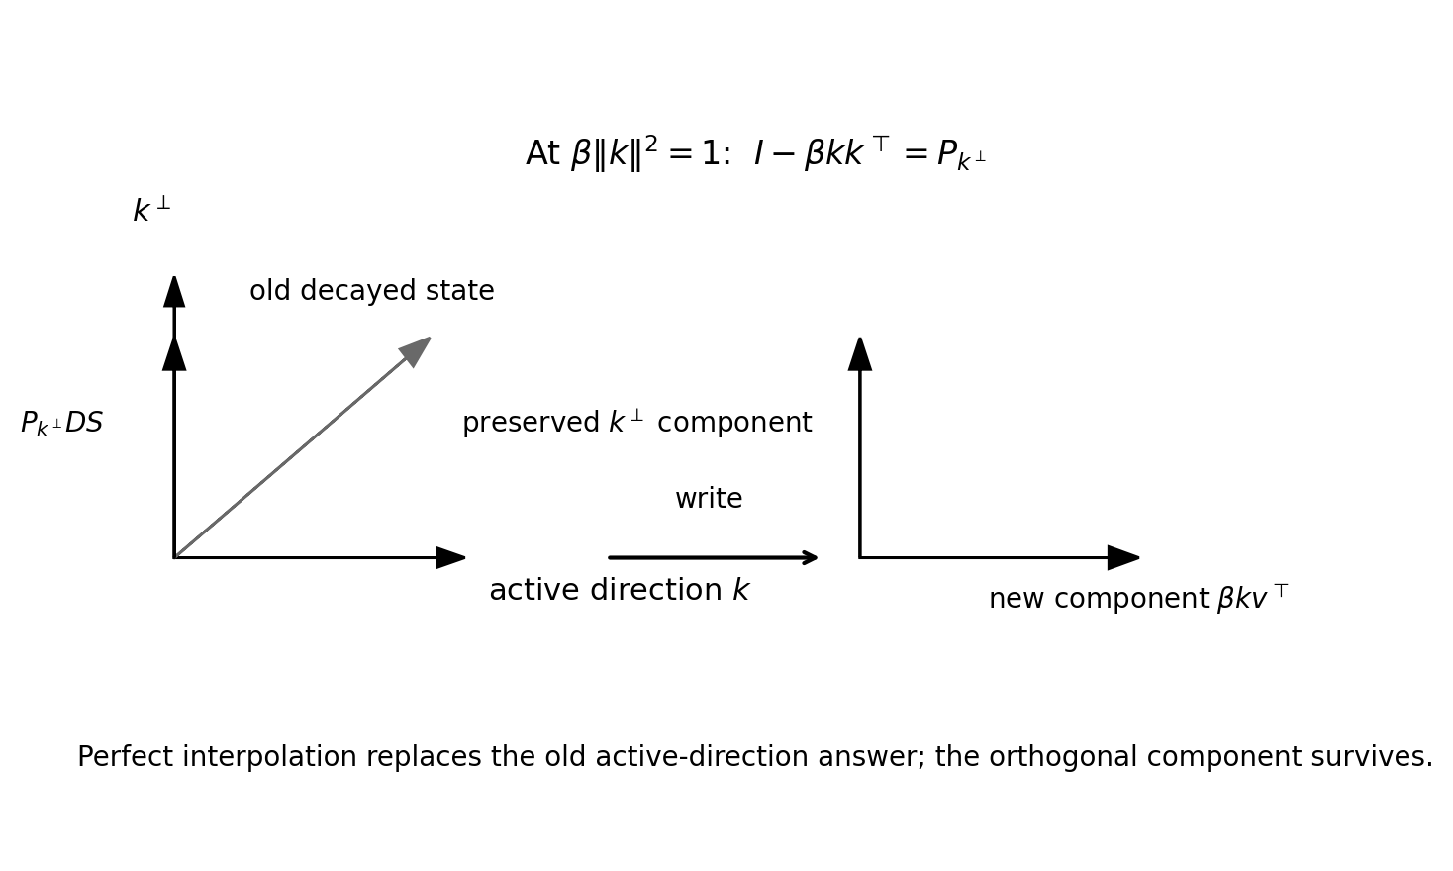
Figure 1. At the perfect interpolation point, the write operator is the orthogonal projector onto k⊥. The previous active-direction component is erased and replaced by the new target component.

5. The exact erasure curve
Set c = β‖k‖² and A = I − βkkᵀ. The eigenvalues of A are 1 on k⊥ and 1 − c on span(k). Because A is symmetric, its singular values are 1,…,1,|1−c|. Define
Rₖ is the one-step retention coefficient of the old state along the active key direction; Eₖ is the corresponding erasure coefficient. Both are exact spectral quantities. Their jurisdiction is deliberately narrow. They do not measure all history-level provenance, which depends on the fibres of the full nonlinear history encoder.

c | Residual factor | Rₖ | Eₖ | Interpretation
0 | 1.00 | 1.00 | 0.00 | No learning; full active-direction retention
0.5 | 0.50 | 0.50 | 0.50 | Partial correction
1 | 0.00 | 0.00 | 1.00 | Perfect interpolation; maximal active-direction erasure
1.5 | −0.50 | 0.50 | 0.50 | Contractive overshoot
2 | −1.00 | 1.00 | 0.00 | No contraction; sign reversal

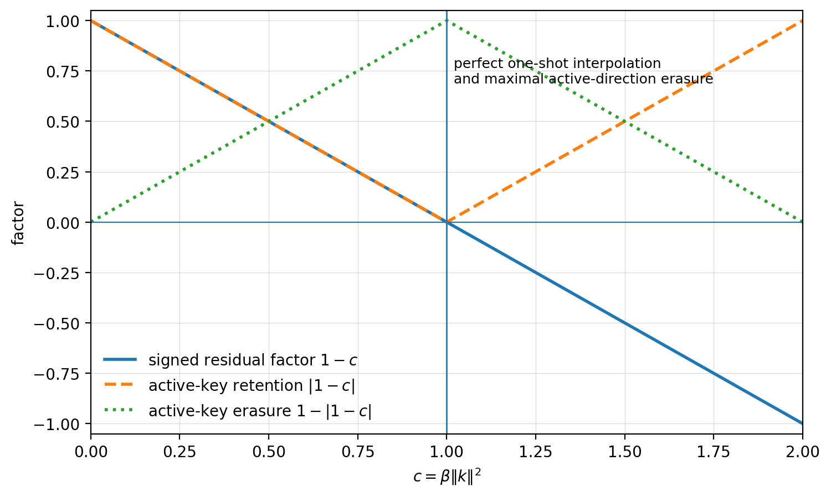
Figure 2. The signed residual factor, active-key retention, and active-key erasure as functions of c = β‖k‖². Perfect one-shot interpolation occurs exactly at maximal active-direction erasure.
The point c = 1 should not be called “optimal learning.” It is optimal only for eliminating the current sample residual in one update. Under noisy instruction, conflicting targets, stochastic approximation, generalization across nearby keys, and long-horizon stability–plasticity trade-offs, smaller steps may be preferable. The exact statement is narrower:
Corollary 1 — Price of perfect one-shot interpolation
The perfect one-shot interpolation step is exactly the singular write step. At c = 1, the current residual is zeroed and the previous active-direction state is maximally erased.

6. History aliasing, nullspaces, and the scope of provenance
The singular write at c = 1 is not the only source of provenance loss. A fixed-size recurrent state compresses an unbounded family of possible histories, so the complete history-to-state encoder is generally non-injective even when each conditioned step is invertible. Let
Distinct histories h and h′ may satisfy Cₜ(h) = Cₜ(h′). Because Cₜ is generally nonlinear, the relevant objects are aliasing fibres or equivalence classes, not a linear kernel. A valid collision can be constructed directly for a repeated normalized key a and scalar retention α: choose an arbitrary first target c₀ and the second target b − (1−β)αc₀. The resulting two-step state equals the one-step state obtained by writing b. Infinitely many histories therefore terminate in the same compressed state.
Three objects must remain distinct:
• The readout nullspace ker(Sᵀ), consisting of key directions invisible to the current compressed state.
• The nonlinear aliasing fibres of Cₜ, consisting of distinct histories that terminate in the same recurrent state.
• A rank-limited Purkinje readout nullspace in the biological mapping, consisting of context distinctions not expressed by that particular readout.
These objects are isomorphic in role, not identical in mathematics: each identifies distinctions that downstream teaching cannot recover from the compressed representation alone. The qualifier is essential. New sensory evidence, a changed key, a reversible log, an episodic index, or another parallel store may reintroduce a distinction that the compressed state has lost.

7. The spectral echo of the Earned Zero
A preceding framework paper studied a return operator f∗ through the difference operator I − f∗ and found that the vanishing of det(I − f∗) changes the invariant and cokernel structure. The present theorem has the same spectral form but a different object and consequence. In both cases the decisive event is
For the delta write, T = βkkᵀ has active-direction eigenvalue c = β‖k‖². At c = 1, I − T loses the active direction. For the return-map setting, a unit eigenvalue of f∗ makes I − f∗ singular and modifies the associated cokernel or mapping-torus invariant. The zeros mean different things: homological persistence in one case, active-key annihilation in the other. The link is therefore a shared spectral form, not an identity of topology and learning.
Framework fence
The recurrence of the form I − T inside the corpus does not license the identification of the objects it acts on. The shared result is spectral: a unit eigenvalue creates a zero direction. The interpretation of that zero remains domain-specific.

8. Cerebellar interpretation: expansion, delta writing, and the measurable debt

8.1 Expansion of the present, compression of the past
The cerebellar comparison is now cleanly divided. Mossy fibres and the granule-cell layer supply a high-dimensional expansion of the present context. Purkinje cells implement a comparatively thin learned readout over that expansion. Past trials are not retained as an addressable sequence inside the readout; their consequences are compressed into synaptic state. Climbing fibres supply an instructive signal that gates plasticity. The established instructive role is [SUP]; identifying climbing-fibre activity with the exact residual e in Equation (3) remains [CAND], because climbing fibres multiplex sensory, predictive, reward, salience, and movement-related signals.

8.2 The biological control parameter
The load-bearing biological quantity is not β or ‖k‖ separately but the effective active-code eigenvalue
When the pre- and post-update residuals are scalar or remain collinear, Equation (3) yields a direct estimator. If the sign is known and no overshoot occurs,
More generally, the signed ratio or vector regression should be used so that overshoot is not mistaken for a smaller step. The practical advantage is important: one need not separately measure the effective learning rate and the normalization of the active granule code. Their product is recoverable from behaviour or physiology through the residual change.
Biological prediction [CAND]
If cerebellar one-trial adaptation nearly eliminates the active-context residual, the previous response component in the same effective direction should become correspondingly difficult to reconstruct from the Purkinje state alone.
The principal debt is now experimentally sharp. Does cerebellar plasticity operate near cᵦᵢₒ = 1, accepting high active-direction erasure for rapid interpolation, or well below it, preserving more prior state at the cost of slower correction? The answer sets the provenance price of cerebellar learning. Additional debts concern whether granule codes are normalized consistently enough for cᵦᵢₒ to be compared across contexts, how retention D should be identified across microzones and timescales, and how the nonlinear fibres of the biological history encoder should be characterized.

9. Architectural consequence: compression requires a parallel addressable memory
A recurrent compressed state cannot reconstruct distinctions that its write and history encoder have identified. Exact retrieval therefore cannot be understood as a repair performed inside the compressed state. It is a bypass: the original token or episode remains stored elsewhere and is consulted through a separate addressable path. Periodic full attention in a hybrid architecture exemplifies the engineering solution. The full token history remains available, so an exact attention layer can retrieve from it when the compressed state has aliased or erased relevant branch information.
The corresponding biological proposal places fast expansion-plus-compression in the cerebellum and branch-sensitive or episodic retrieval in the hippocampal–cortical system. The hippocampus should not be said to recover provenance from the Purkinje state. It supplies another store or index through which the lost distinction may remain addressable. This mapping is [CAND], but the design principle follows directly from the theorem and the encoder’s non-injectivity:
Design principle [LB-rule]
Compression supports fast calibrated execution; provenance requires a parallel addressable memory.
The principle also clarifies what does and does not count as a refutation. A side channel, reversible log, exact-attention cache, or episodic buffer does not show that compression retained provenance. It shows that the architecture paid for provenance separately, exactly as the theorem says it must.

10. Falsifiers and open debts
The paper separates mathematical falsification from biological and architectural falsification.
1. State-level falsifier. At c = 1, if the old active-direction component can be reconstructed from the post-write state Sₜ alone, with k, v, and D known and with no auxiliary state or parallel store, the annihilation consequence of Theorem 1 is false.
2. Biological falsifier. If cerebellar plasticity is shown not to be residual-driven in the relevant regime—tracking a raw target without dependence on the pre-existing prediction—the precise delta identification fails, although the expansion/compression division may survive.
3. Architectural falsifier. If a purely compressed fixed-state architecture preserves arbitrary branch provenance without an external history, reversible augmentation, or parallel addressable store, the proposed complementarity between compression and provenance is false.
4. Pivot falsifier. If the active residual does not obey the contraction law associated with the update, or if the bounded-orbit claim is made without satisfying any dissipative or projection-based stability condition, the Uniform–Coarse reading has been imported rather than derived.
Open debts remain. The nonlinear geometry of the encoder fibres has only been shown to be nontrivial; it has not been classified. The interaction of multiple non-orthogonal keys may distribute erasure across subspaces rather than along isolated directions. The statistically optimal choice of c under noise is outside the one-sample theorem. Finally, the biological value of cᵦᵢₒ and the existence of a recoverable parallel episodic trace during cerebellar adaptation require direct experimental work.

11. Discussion
The theorem gives a precise version of the stability–plasticity tension for a rank-one delta write. Learning and recoverability are not merely competing engineering preferences. They are linked through the spectrum of the same operator. The active residual is multiplied by 1−c, and the old active-direction state is multiplied in singular value by |1−c|. At c=1, perfect replacement and irreversible erasure coincide because both are produced by the same orthogonal projection.
The result should not be generalized beyond its jurisdiction. It does not say that all one-shot learning destroys an entire memory, that the whole recurrent state is rank-deficient, or that no prior information survives elsewhere. The loss is codimension one with respect to the active key direction for a single write. Across many writes, the history encoder may create much richer aliasing fibres. Conversely, an architecture may retain full provenance in a separate store even while its fast state is aggressively compressive.
This separation of fast calibrated execution from parallel provenance is especially natural in biological systems. The cerebellum is optimized for rapid, bounded, context-sensitive calibration and does not need to be the organism’s exhaustive episodic archive. A hippocampal index can preserve branch-sensitive events while the cerebellar state learns a compact policy or forward map. The architecture is then not redundant: the systems solve different consequences of the same compression problem.
The theorem also extends the Uniform–Coarse Pivot. The deposited account distinguished trial-indexed settling from movement-indexed traversal. Here the update rule itself has a local contraction and a global envelope, while the price of rapid settling is measured spectrally. Uniformity, coarse boundedness, and provenance thus become three distinct but interacting questions: does the residual settle, does the state remain inside its operating envelope, and can the path by which the state arrived still be reconstructed?
Finally, the spectral relation to the Earned Zero is methodologically important. Frameworks often become vulnerable when they treat repeated mathematical forms as identities. Here the same singular difference operator I−T appears in two domains, but the zero has different semantics. The correct gain is a reusable pattern—unit eigenvalues create unrecoverable directions or persistent classes—held behind the framework’s standing fence of isomorphism, not identity.

12. Conclusion
A delta memory pays for perfect one-shot interpolation with a codimension-one loss of state provenance. The same scalar 1−β‖k‖² governs both the survival of the active residual and the determinant of the write operator. Away from the singular point, learning and recoverability coexist in a graded tension quantified by Eₖ = 1−|1−β‖k‖²|. At the singular point, the old active-direction state is exactly erased so that the new target can be written exactly. This is not a defect that better tuning removes; it is the algebra of replacement.
The result turns the original cerebellum–attention comparison into a broader architectural law. The cerebellum expands the present, compresses the past, and settles local error inside a bounded operating envelope. What compression discards cannot be restored from the compressed state alone. A parallel addressable memory is therefore not an optional embellishment but the structural complement of fast calibrated learning. Compression supports calibrated execution; a parallel addressable memory preserves what compression must forget.

References
Albus, J. S. (1971). A theory of cerebellar function. Mathematical Biosciences, 10(1–2), 25–61.
Ghosh, D. P. (2026). Settling and Traversing: The Cerebellum as a Kernel Machine at the Uniform–Coarse Pivot. https://doi.org/10.13140/RG.2.2.31186.72648
Ghosh, D. P. (2026). The Earned Zero. https://doi.org/10.13140/RG.2.2.24798.40002.
Horn, R. A., & Johnson, C. R. (2013). Matrix Analysis (2nd ed.). Cambridge University Press.
Ito, M. (1982). Cerebellar control of the vestibulo-ocular reflex—around the flocculus hypothesis. Annual Review of Neuroscience, 5, 275–296.
Katharopoulos, A., Vyas, A., Pappas, N., & Fleuret, F. (2020). Transformers are RNNs: Fast autoregressive Transformers with linear attention. Proceedings of the 37th International Conference on Machine Learning, 5156–5165.
Kimi Team. (2025). Kimi Linear: An expressive, efficient attention architecture. arXiv:2510.26692.
Marr, D. (1969). A theory of cerebellar cortex. Journal of Physiology, 202(2), 437–470.
Schlag, I., Irie, K., & Schmidhuber, J. (2021). Linear Transformers are secretly fast weight programmers. Proceedings of the 38th International Conference on Machine Learning, 9355–9366.
Widrow, B., & Hoff, M. E. (1960). Adaptive switching circuits. IRE WESCON Convention Record, 4, 96–104.
Yamazaki, T., & Tanaka, S. (2007). The cerebellum as a liquid state machine. Neural Networks, 20(3), 290–297.
Author note. This paper concludes the delta-memory exploration line within the Defensible Intelligence series. The mathematical claims are exact for the stated update. The cerebellar and hippocampal readings are structural mappings and remain subject to biological measurement.

