Specification as Density
Spec-Driven Development through Diffusion Evolution with an LLM Critic: What Survives the Mapping, What Breaks, and How to Repair It
Debi Prasad Ghosh
Founder and Principal Engineer, Debias Parametric Guru, Kolkata, India
debiprasadghosh@gmail.com
Research proposal • 13 October 2026

Abstract
Denoising diffusion models (DDPM, DDIM) learn to sample a distribution from examples x₀. Diffusion Evolution (DE; Zhang, Hartl, Hazan & Levin, ICLR 2025) removes that requirement: it needs only a fitness f and a monotone map g so that the target density is p(x₀ = x) ∝ g[f(x)], and it estimates the denoising target x̂₀ by fitness-weighted kernel averaging over the current population. This paper studies the proposal that a specification plus an LLM critic that scores conformance to it can supply g[f(x)], turning DE into a population-based engine for spec-driven development (SDD) with no reference implementations.
We show that the mapping is sound in outline but rests on three load-bearing assumptions that do not hold as stated. (A1) DE is not a sampler of g: because it weights population nodes by g without dividing by their own density, it compounds selection; on a controlled two-mode landscape the final population follows roughly g^γ with γ ≈ 2.4–2.5. Dividing by a kernel density estimate q̂ (weights g/q̂) restores the target mass to within 0.015. (A2) A stochastic critic is not f: with exponential g and heteroscedastic critic noise σ(x), the effective fitness becomes f + βσ²(x)/(2k), so the population migrates toward regions where the critic is least certain. The predicted crossover noise levels (0.174 and 0.347 for k = 1 and k = 4 critic samples) match simulation (≈0.19 and ≈0.36); a debiased estimator and an interval lower-bound weighting remove the effect up to a predictable breakdown point. (A3) Program space has no Gaussian kernel: we give a discrete, stochastic-parent form of DE whose expected step equals the DE step, with a scale-free step fraction λₜ = 1 − cₓ√(αₜ/αₜ₋₁) and a behavioural-distance kernel.
The constructive result is that DE’s reproductive isolation turns the final population into a probe of specification ambiguity: behaviourally distinct survivors that all satisfy the spec are a certificate that the spec underdetermines the program, and their disagreement inputs are exactly the clarifying questions to ask its author. In a toy program-synthesis study the behavioural entropy of spec-satisfying survivors falls from 1.95 bits (one example) to 0 bits (three or more), but the diagnostic is sound and incomplete: at two examples entropy is only 0.23 bits while 99% of the population implements the wrong intent. All critic experiments use a parameterised simulated critic; a protocol and pre-registered predictions for real-LLM validation are given.

Keywords: diffusion evolution; spec-driven development; LLM-as-judge; program synthesis; self-normalised importance sampling; Goodhart’s law; specification ambiguity; interval critics.

1. Introduction
A diffusion model trained in the standard way needs a dataset. DDPM (Ho et al., 2020) and DDIM (Song et al., 2021) learn a denoiser from samples x₀ ∼ p_data and then run the learned reverse process. If what we want is a program that satisfies a specification, there is no such dataset: the whole point is that the correct implementations do not yet exist.
Diffusion Evolution (Zhang et al., 2025) changes the input requirement. It does not learn a denoiser. It treats the current population as the set of evaluation points, assigns each a weight g[f(x)], and estimates the denoising target for every individual as a fitness-weighted average of its neighbours under the forward-process Gaussian. The only problem-specific object is the fitness. The observation that motivates this paper is short: if a specification can be turned into a fitness, DE can search for its implementations without examples, and an LLM that reads the specification and judges a candidate is a natural source of that fitness.
The observation is correct as far as it goes. The question this paper asks is what it silently assumes. Three assumptions carry the weight:
- A1 (density). DE samples the density p ∝ g[f]. If it does, the final population is a calibrated distribution over implementations; if it does not, population statistics (diversity, mode masses) cannot be read as properties of the specification.
- A2 (fitness). The critic score is the fitness. An LLM critic is stochastic, biased and heteroscedastic. If DE’s weighting interacts with those properties, it optimises the critic’s error structure rather than the specification.
- A3 (geometry). Program space supports the Gaussian kernel N(xₜ; √αₜ x, 1−αₜ) and the averaging step. Programs are discrete; the average of two programs is not a program.
Each assumption is tested here by derivation and by controlled simulation. The contributions are:
- C1. A proof that DE’s x̂₀ estimator is a self-normalised importance-sampling estimator with the proposal correction omitted, a measurement of the resulting over-concentration, and a one-line repair (weights g/q̂) that restores the target masses (Section 4.1).
- C2. The variance-bonus proposition: under exponential g, critic noise acts as fitness, f_eff = f + βσ²/(2k), with closed-form crossover predictions, two repairs, and their own predicted failure points (Section 4.2).
- C3. A bias decomposition showing what an execution gate can and cannot protect against (Section 4.3).
- C4. Discrete stochastic-parent DE for program space, unbiased in mean for the continuous case, with a scale-free step schedule and behavioural kernel (Section 4.4).
- C5. Specification-ambiguity diagnostics from the final population, with the soundness/incompleteness split made explicit, and a spec-refinement loop that turns surviving disagreement into clarifying questions (Section 4.5).
- C6. A Python validation suite and a C# reference implementation of the corrected continuous step, checked against each other (Appendix C).

2. Background

2.1 Diffusion samplers need x₀
The forward process blends a clean sample with Gaussian noise:
xₜ = √αₜ · x₀ + √(1 − αₜ) · ε, ε ∼ N(0, I), α₀ ≈ 1, α_T ≈ 0 (1)
A network ε_θ(xₜ, t) is trained on samples of x₀. Written in terms of the implied clean estimate x̂₀ = (xₜ − √(1−αₜ) ε̂)/√αₜ, the DDIM update is
xₜ₋₁ = √αₜ₋₁ · x̂₀ + √(1 − αₜ₋₁ − σₜ²) · ε̂ + σₜ · w, w ∼ N(0, I) (2)
Everything problem-specific enters through x̂₀, and in a trained model x̂₀ is learned from data.

2.2 Diffusion Evolution needs only g[f(x)]
DE replaces the network by a Bayesian estimate computed over the current population Xₜ = {xₜ⁽¹⁾, …, xₜ⁽ᴺ⁾}. With target p(x₀ = x) = g[f(x)], Bayes’ rule and a mean-squared-error reading of the denoiser give
x̂₀(xₜ) = (1/Z) Σⱼ g[f(xⱼ)] · N(xₜ; √αₜ xⱼ, 1 − αₜ) · xⱼ (3)
with normaliser Z = Σⱼ g[f(xⱼ)] · N(xₜ; √αₜ xⱼ, 1 − αₜ),
and the DDIM update (2) with ε̂ = (xₜ − √αₜ x̂₀)/√(1−αₜ). The paper interprets g as selection, the shrinking Gaussian as reproductive isolation (neighbourhood radius ∝ √((1−αₜ)/αₜ)), and σₜw as mutation; uses the cosine schedule αₜ = cos(πt/T)/2 + 1/2; and introduces a latent variant in which distances are computed after a random projection. It notes discrete and non-Gaussian diffusion as open directions. We use their Algorithm 1 verbatim as the baseline.

2.3 Spec-driven development
Spec-driven development toolkits (for example GitHub’s Spec Kit and AWS’s Kiro) make a written specification the primary artefact and drive an agent through specify → plan → implement loops. These loops are essentially single-trajectory: one candidate is revised under critique. Program-search systems that use LLMs inside an evolutionary loop — ELM (Lehman et al., 2022), FunSearch (Romera-Paredes et al., 2024), AlphaEvolve (Novikov et al., 2025) — use programmatic evaluators and LLMs as mutation operators. The proposal studied here differs in two respects: the fitness itself comes from an LLM reading a natural-language specification, and the selection law is DE’s kernel-local, density-targeting one rather than elitist or island-based selection.

3. Formal setup
Let X be a space of candidate programs and S a specification. Write A_S ⊆ X for the programs that satisfy S under a chosen semantics, and I ⊆ A_S for the programs that implement the author’s intent. The gap A_S \ I is specification ambiguity; it is not observable from S alone.
An LLM critic returns, for each query, a score modelled as
s(x) = f*(x) + b(x) + σ(x) · ξ, ξ ∼ N(0, 1) independent across queries (4)
where f*(x) is the ideal conformance to S, b(x) a systematic bias (documented LLM-judge biases include position, verbosity and self-preference; Zheng et al., 2023), and σ(x) a heteroscedastic noise level — typically larger for long, unusual or borderline candidates. Averaging k independent queries gives s̄ₖ with variance σ²/k. The density map throughout is exponential, g(s) = exp(βs), the natural choice for unbounded scores; Section 4.2 explains why this choice interacts with noise.
The spec-induced target is π_S(x) ∝ g[f*(x)]. In the idealised limit g → 1[x ∈ A_S] it is the uniform distribution on A_S, which is the object an SDD engine should want: every implementation that the specification admits, with no preference the specification does not express.

4. Theory

4.1 A1 fails: DE compounds selection
Read equation (3) as an estimator. The exact posterior mean under prior g is E[x₀ | xₜ] = ∫ x g(x) K_t(xₜ, x) dx / ∫ g(x) K_t(xₜ, x) dx, an integral against Lebesgue measure. DE replaces both integrals by sums over population points. If the population at step t has density qₜ, self-normalised importance sampling (Owen, 2013) gives a consistent estimate only with weights g/qₜ:
Proposition 1 (missing proposal correction).
Let xⱼ be i.i.d. with density qₜ > 0 wherever g > 0. As N → ∞, the DE estimator (3) converges to the posterior mean under the effective prior g · qₜ, not under g. The estimator with weights g(xⱼ)/qₜ(xⱼ) converges to the posterior mean under g.
Proof. Numerator and denominator of (3) are, after division by N, sample means of g(x)K(x)x and g(x)K(x) with x ∼ qₜ; by the law of large numbers they converge to ∫ g qₜ K x and ∫ g qₜ K, and the ratio converges by the continuous-mapping theorem. Replacing g by g/qₜ cancels qₜ. ∎

Since qₜ is itself shaped by earlier weighting, the effective prior is reweighted step after step. We do not have a closed form for the fixed point, so we state the consequence as a measurable conjecture: the final population of uncorrected DE concentrates more sharply than g, approximately as g^γ with γ > 1. Section 6.1 measures γ ≈ 2.4–2.5 on a two-mode landscape and shows that estimating qₜ by a Gaussian kernel density estimate q̂ and using weights g/q̂ restores the target masses.
This matters for SDD in one direction only. For pure optimisation, over-concentration is often harmless or helpful. For any use that reads the population as a distribution — counting implementation classes, estimating how much of the admissible set a spec leaves open, reporting confidence — uncorrected DE overstates the dominance of whichever class leads early.

4.2 A2 fails: critic noise becomes fitness
Suppose the critic is queried k times per candidate per step and the weight is g = exp(β s̄ₖ). For Gaussian noise the conditional expectation of the weight is the moment-generating function:
E[ exp(β s̄ₖ) | x ] = exp( β f(x) + β² σ(x)² / (2k) ) (5)
Proposition 2 (variance bonus).
Under the conditions of Proposition 1, with fresh critic noise at every step and kernel neighbourhoods containing many candidates of locally constant f and σ, DE with noisy weights behaves as DE with noiseless weights for the effective fitness
f_eff(x) = f(x) + β σ(x)² / (2k).
Proof. The noise enters numerator and denominator of (3) linearly through the weights; averaging over many neighbours replaces each weight by its conditional expectation (law of large numbers, then continuous mapping for the ratio). Equation (5) gives that expectation. ∎
Corollary (crossover). Two modes with true fitness f_A > f_B and critic noise σ_A, σ_B exchange dominance when σ_B² > σ_A² + 2kΔ/β, Δ = f_A − f_B.

The direction of the effect is the problem. LLM critics are least certain on the candidates that are hardest to judge — long, unusual, or borderline. Proposition 2 says that exponential weighting rewards exactly that uncertainty: the population drifts toward the region of program space where the critic is guessing. This is a selection pressure toward critic confusion, distinct from and additive to the familiar reward-hacking pressure toward critic bias.
Three repairs follow from (5):
- Averaging. k queries shrink the bonus by 1/k; crossover moves from √(2Δ/β) to √(2kΔ/β). It delays the problem; it does not remove it.
- Debiasing. Use log g = β s̄ₖ − β² v̂/(2k), with v̂ the sample variance. For Gaussian noise s̄ₖ and v̂ are independent and (k−1)v̂/σ² ∼ χ²ₖ₋₁, so the residual log-bonus is r(σ) = a − ((k−1)/2) ln(1 + 2a/(k−1)), a = β²σ²/(2k): positive but much smaller than a.
- Interval lower bound. Let the critic report an interval [s̄ₖ − κ ŝ/√k, s̄ₖ + κ ŝ/√k] and weight by its lower end. To first order f_eff = f − κσ/√k + βσ²/(2k): the linear penalty dominates for σ < 2κ√k/β, and the quadratic bonus returns beyond it. This is the natural point of contact with interval-valued scoring: the uncertainty the scalar critic hides becomes an explicit object the weighting can be pessimistic about.
Each repair therefore has its own predicted breakdown point, which Section 6.2 tests.

4.3 Bias: what an execution gate protects
With systematic bias b(x), DE targets g[f + b]. As β grows the population concentrates on argmax (f + b), which is the reward-over-optimisation pattern measured for learned reward models (Gao et al., 2023). Two forms of protection are available and they are not equivalent:
- Hard gate. g(x) = 1[x passes executable checks E_S] · exp(β s(x)). The bias can only reorder candidates inside the gated set; it cannot move mass outside it. Protection is exactly as strong as E_S ⊇-approximates A_S.
- Soft blend. g = exp(β(λ·exec + (1−λ)·s)). The bias can still buy its way past failed checks when b is large relative to λ. A blend is a trade, not a guarantee.
The gate does nothing about bias that correlates with passing the checks. Verbosity bias is a clean example: a longer program can pass all visible tests and still be preferred by the critic for its length. Section 6.3 shows exactly this signature.

4.4 A3 fails: a discrete form of DE
The DE update is affine in x̂₀. Write it as xₜ₋₁ = cₓ xₜ + c₀ x̂₀ + σₜ w with
cₓ = √((1 − αₜ₋₁ − σₜ²)/(1 − αₜ)), c₀ = √αₜ₋₁ − cₓ √αₜ (6)
and observe that x̂₀ is the mean of the parent posterior πₜ(j | i) ∝ g(xⱼ) Kₜ(xᵢ, xⱼ). Sampling a parent instead of averaging gives:
Proposition 3 (stochastic-parent DE).
Let j ∼ πₜ(· | i) and xₜ₋₁ = cₓ xᵢ + c₀ xⱼ + σₜ w. Then E[xₜ₋₁ | Xₜ] equals the DE update, and the conditional variance exceeds DE’s by c₀² Var_π(xⱼ).
Proof. Linearity of expectation; the mixture variance decomposes into the within-step Gaussian term and c₀² times the variance of the parent distribution. ∎
Scale-free form. Dividing by √αₜ₋₁ and writing yₜ = xₜ/√αₜ, the deterministic part becomes yₜ₋₁ = (1 − λₜ) yₜ + λₜ xⱼ with λₜ = 1 − cₓ √(αₜ/αₜ₋₁), since c₀/√αₜ₋₁ + cₓ√(αₜ/αₜ₋₁) = 1. λₜ is the fraction of the way toward the parent that one DDIM step covers.

Proposition 3 removes the averaging step, which is the part of DE that has no meaning on programs. What remains needs three ingredients that do exist in program space:
- A kernel. Kₜ(x, x′) = exp(−d(x, x′)²/(2hₜ²)), hₜ² = c²(1 − αₜ)/αₜ, matching DE’s neighbourhood radius. We use behavioural distance d — the fraction of probe inputs on which two programs disagree — so that reproductive isolation separates semantic species rather than syntactic ones. Embedding distance (the analogue of DE’s random-projection latent variant) is an alternative.
- A move toward the parent. With probability λₜ, replace xᵢ by the parent or by a crossover of parent and xᵢ; otherwise keep xᵢ. In an LLM-based system this is the natural place for an LLM edit operator (“revise A to adopt the approach of B”).
- Mutation. Apply a random edit with probability tied to the relative noise σₜ/√αₜ₋₁.
Proposition 3 guarantees the mean behaviour only in the continuous case. In program space the discrete DE is a principled heuristic: same selection law, same isolation schedule, same step fractions, with no claim of exactness.

4.5 The population as a measurement of the specification
Kernel locality is DE’s main advantage over elitist evolution: distinct high-fitness regions do not compete once hₜ is small. In SDD the distinct regions have a meaning. Let Fₜ be the final individuals that pass the specification’s executable checks, partitioned into behavioural classes by their outputs on a probe set. Define the specification entropy
H_S = − Σ_c p_c log₂ p_c, p_c = fraction of Fₜ in behavioural class c (7)
Proposition 4 (sound, not complete).
(i) If H_S > 0, the specification is ambiguous with respect to the probe set: two programs that both satisfy every executable check disagree on some probe input. (ii) H_S = 0 does not imply that S is unambiguous.
Proof. (i) is immediate: the two classes are explicit witnesses. (ii) The search may never reach a second admissible class, or may reach it and lose it to selection — including the selection compounding of Section 4.1. ∎

Part (i) makes the population constructive. For any two surviving classes, a disagreement input x is a concrete question for the author: what should the program return on x? Adding the answer to S eliminates at least one class. This gives a refinement loop that the single-trajectory SDD tools lack: specify → evolve → find surviving disagreement → ask → tighten S → evolve. Part (ii) is the warning: an empty disagreement set is not a certificate of a complete specification, and Section 6.3 shows a case where it is badly misleading.

4.6 Cost
One run costs N · T · k critic calls plus N · T executions, less cache hits (behavioural caching by program hash is exact for deterministic programs). DE’s accelerated schedules reduce T substantially (Zhang et al. report cart-pole solved in 10 generations), but k now multiplies everything: Proposition 2 makes k a correctness parameter, not only a variance parameter. The cheapest effective configuration is a hard execution gate (cheap, exact) followed by k ≥ 4 critic calls only on gated candidates.

5. The SDD-DE algorithm
Algorithm 1. Spec-Driven Diffusion Evolution (SDD-DE)
Input: specification S (natural-language intent + executable checks E_S + probe inputs), population size N, steps T, critic samples k, sharpness β, schedule αₜ, kernel scale c.
1. Initialise N candidates (LLM drafts from S, or random programs).
2. For t = T, …, 1:
a. For each candidate: run E_S → gate eᵢ ∈ {0,1}; query the critic k times on (S, xᵢ, test traces) → s̄ᵢ, ŝᵢ.
b. log gᵢ = β(s̄ᵢ − κ ŝᵢ/√k) if eᵢ = 1, else −∞ (or a large penalty). [Sections 4.2–4.3]
c. If the population is to be read as a distribution: log gᵢ ← log gᵢ − log q̂(xᵢ). [Section 4.1]
d. Behavioural distances dᵢⱼ on the probe set; Kᵢⱼ = exp(−dᵢⱼ²/(2c²(1−αₜ)/αₜ)).
e. For each i: draw parent j ∝ gⱼ Kᵢⱼ; with probability λₜ = 1 − cₓ√(αₜ/αₜ₋₁) move xᵢ toward xⱼ (copy, crossover, or LLM-guided merge); with probability ∝ σₜ/√αₜ₋₁ mutate. [Section 4.4]
3. Partition gated survivors into behavioural classes; report H_S and one representative per class.
4. If H_S > 0: compute disagreement inputs between classes and return them as clarifying questions; on answers, add them to E_S and repeat. [Section 4.5]

6. Experiments
All experiments are small and controlled; their purpose is to test the propositions, not to benchmark program synthesis. Continuous experiments use DE’s Algorithm 1 exactly, with the cosine schedule and DDPM noise (η = 1). The critic in Sections 6.2–6.3 is simulated from model (4) with chosen f*, b, σ; no LLM was queried. Results are means ± standard deviation over 20 seeds unless stated. Code is in Appendix B.

6.1 Does DE sample g? (Proposition 1)
Landscape: g(x) = exp(−(x+1)²/(2·0.15²)) + h_B · exp(−(x−1)²/(2·0.15²)) in one dimension, so that the target fraction of mass in mode A is 1/(1 + h_B) exactly. N = 512, T = 50.
Table 1. Fraction of the final population in mode A. Target is the exact g-mass.
h_B | Target | DE (Alg. 1) | DE, stochastic parent | DE, weights g/q̂
1.0 | 0.500 | 0.472 ± 0.065 | 0.507 ± 0.060 | 0.490 ± 0.023
0.5 | 0.667 | 0.839 ± 0.046 | 0.839 ± 0.037 | 0.673 ± 0.021
0.25 | 0.800 | 0.971 ± 0.014 | 0.970 ± 0.014 | 0.812 ± 0.019

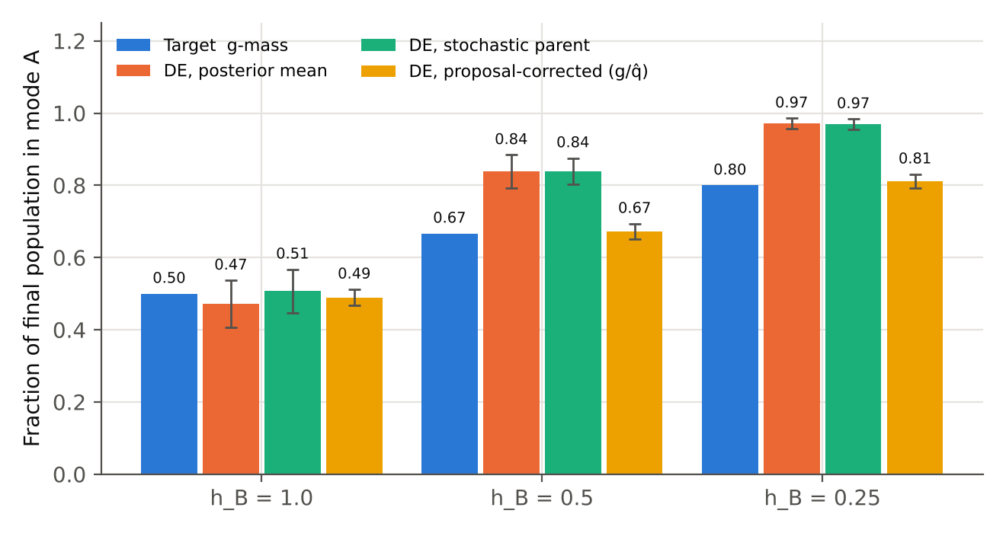
Figure 1. Uncorrected DE (orange, green) over-concentrates on the higher mode; dividing weights by a kernel density estimate of the population (yellow) recovers the target mass (blue). Error bars: ±1 s.d. over 20 seeds.
At equal heights DE is unbiased by symmetry. At h_B = 0.5 the target odds are 2:1 and DE delivers 5.2:1; at h_B = 0.25 the target odds are 4:1 and DE delivers 33.9:1. Writing DE’s odds as (target odds)^γ gives γ = 2.38 and 2.53. The stochastic-parent variant behaves identically, as Proposition 3 predicts for the mean. The proposal-corrected weights g/q̂ (Scott-bandwidth Gaussian KDE over the current population) give 0.673 and 0.812 against targets 0.667 and 0.800, with standard deviations two to three times smaller than uncorrected DE.
Verdict on A1. False as stated, repairable at O(N²) extra cost per step (the same order as DE’s own kernel computation).

6.2 Does critic noise become fitness? (Proposition 2)
Landscape: f(x) = max(exp(−(x+1)²/(2·0.25²)), 0.85·exp(−(x−1)²/(2·0.25²))), so mode A is truly better by Δ = 0.15. The critic adds noise σ_A = 0.02 on A and σ_B on B, fresh at every query; β = 10, N = 256, T = 40. The noiseless run puts 0.985 of the population in A.
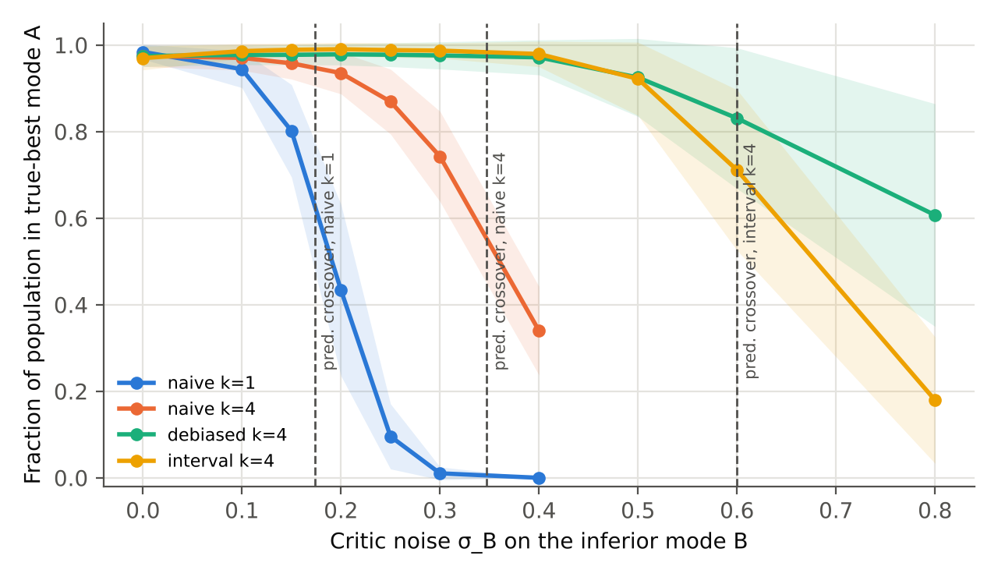
Figure 2. Fraction of the population in the truly better mode A as critic noise on the worse mode grows. Dashed lines are the crossovers predicted by Proposition 2 and its interval corollary. Bands: ±1 s.d.
Table 2. Fraction of population in mode A by critic noise σ_B (means over 20 seeds).
Weighting | σ_B=0 | σ_B=0.1 | σ_B=0.15 | σ_B=0.2 | σ_B=0.25 | σ_B=0.3 | σ_B=0.4
naive k=1 | 0.98 | 0.94 | 0.80 | 0.43 | 0.10 | 0.01 | 0.00
naive k=4 | 0.97 | 0.97 | 0.96 | 0.94 | 0.87 | 0.74 | 0.34
debiased k=4 | 0.97 | 0.98 | 0.98 | 0.98 | 0.98 | 0.98 | 0.97
interval k=4 | 0.97 | 0.99 | 0.99 | 0.99 | 0.99 | 0.99 | 0.98

Weighting | σ_B=0.5 | σ_B=0.6 | σ_B=0.8
debiased k=4 | 0.93 ± 0.09 | 0.83 ± 0.16 | 0.61 ± 0.26
interval k=4 | 0.92 ± 0.08 | 0.71 ± 0.19 | 0.18 ± 0.15

Table 3. Predicted versus observed crossover (population in A falls through 0.5). Observed values are linear interpolations between tested noise levels.
Weighting | Prediction | Observed | Agreement
naive, k = 1 | 0.174 (Prop. 2) | ≈ 0.19 | yes, slightly conservative
naive, k = 4 | 0.347 (Prop. 2) | ≈ 0.36 | yes, slightly conservative
interval lower bound, k = 4, κ = 1 | 0.60 (first-order) | ≈ 0.68 | yes, slightly conservative
debiased, k = 4 | 0.51 (exact χ² residual) | > 0.8 | no — far more robust than predicted

The variance bonus is real and its location is predicted. With one critic sample, noise of 0.25 on the worse mode moves 90% of the population there — an LLM critic that is merely uncertain about a worse family of programs captures the search. Four samples double the tolerable noise. Both repairs hold the true mode to σ_B = 0.4.
One prediction failed, and it is reported as such. The large-N limit predicts the debiased estimator should lose mode A at σ_B ≈ 0.51; it still holds 61% at 0.8. The limit argument replaces each weight by its expectation, which is a poor description when log-weights have large variance (here Var[log w] exceeds 10): finite populations see the typical weight, not the mean one, and the typical weight of the debiased estimator carries less bonus than its mean. We have not isolated this mechanism further; it means Proposition 2 is an upper bound on damage in the heavy-tailed regime, accurate only when log-weight variance is moderate.
Verdict on A2. False as stated. The critic’s uncertainty is a selection pressure, quantitatively as Proposition 2 says. Repeated queries plus either repair are required, not optional.

6.3 Program space, critic bias, and specification ambiguity
DSL: integer expressions over x with constants {0, 1, 2, 3} and operators {+, −, ×}, at most 15 nodes. Hidden intent: f(x) = x² + 1. The specification’s executable part is the first m examples from the list x = 0, 1, 2, −1, 3, −2; behavioural distance uses probes x ∈ {−5, …, 5}. Discrete stochastic-parent DE (Section 4.4): N = 200, T = 40, β = 8, c = 3. A candidate is correct if it matches the intent on all probes.
Ambiguity. With execution-only fitness, Figure 3 and Table 5 show the specification entropy of spec-satisfying survivors as examples are added.
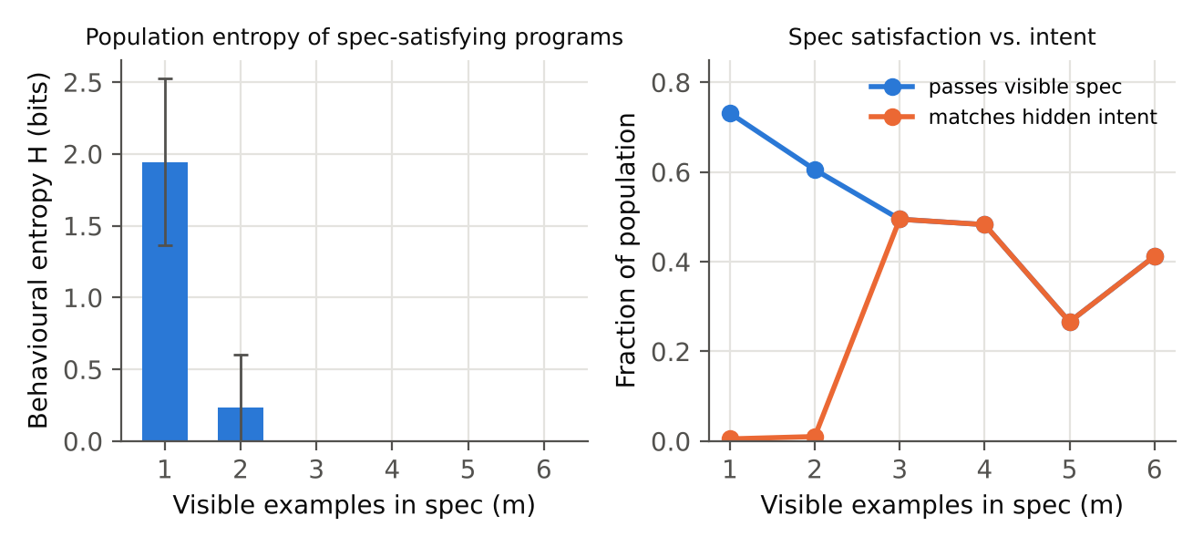
Figure 3. Left: behavioural entropy of survivors that satisfy the visible specification. Right: fraction of the population satisfying the visible specification versus implementing the hidden intent. At m = 2 the population satisfies the spec but almost none of it implements the intent, while the entropy is near zero.
Table 4. Execution-only SDD-DE as the specification grows (20 seeds). ‘Found’ is the fraction of seeds whose final population contains at least one correct program.
m | Passes spec | Correct | H_S (bits) | Classes | Found
1 | 0.731 | 0.005 | 1.94 ± 0.58 | 19.50 | 0.45
2 | 0.605 | 0.010 | 0.23 ± 0.37 | 2.25 | 0.45
3 | 0.495 | 0.495 | 0.00 ± 0.00 | 0.95 | 0.95
4 | 0.483 | 0.483 | 0.00 ± 0.00 | 0.90 | 0.90
5 | 0.266 | 0.266 | 0.00 ± 0.00 | 0.60 | 0.60
6 | 0.412 | 0.412 | 0.00 ± 0.00 | 0.80 | 0.80

With one example the survivors split into about 20 behavioural classes (1.94 bits): DE has found that "f(0) = 1" admits many programs, and every pair of classes yields a clarifying question. From three examples on, every survivor that satisfies the spec is the intended program and H_S = 0 — here correctly.
The instructive case is m = 2 (f(0) = 1, f(1) = 2). The spec admits both x + 1 and x² + 1, among others. Yet H_S is only 0.23 bits, and 98% of spec-satisfying survivors implement something other than the intent. The search reaches the simpler class first and selection compounding (Section 4.1) consolidates it. This is Proposition 4(ii) observed: low entropy here is a property of the search, not of the specification. A practical rule follows: report H_S > 0 as a certificate, and treat H_S = 0 as inconclusive unless the run used proposal-corrected weights and enough diversity pressure to make a second class reachable.
Critic sources. At m = 2, we compare fitness sources. The simulated critic is s = 0.5·(hidden-intent accuracy) + 0.5·(visible accuracy) + b·(size/15) + 0.1ξ, i.e. it reads half of the intent from the natural-language spec and has a verbosity bias b.
Table 5. Fitness sources at the ambiguous specification m = 2 (20 seeds, mean ± s.d.).
Fitness source | Correct | Passes spec | H_S (bits) | Mean size
execution only | 0.01 ± 0.02 | 0.61 | 0.23 | 11.76
LLM critic only | 0.36 ± 0.25 | 0.59 | 0.36 | 13.03
hybrid (exec gate x critic) | 0.42 ± 0.28 | 0.63 | 0.29 | 13.14
critic, no verbosity bias | 0.42 ± 0.22 | 0.58 | 0.50 | 11.64

Three observations. First, an LLM critic is useful precisely where executable checks are weak: by carrying part of the intent it raises correctness from 0.01 to 0.36. That is the real value of the proposal — the critic transmits information the examples do not. Second, verbosity bias leaves a measurable signature: mean program size rises from 11.64 to 13.03 with no gain in correctness, and the execution gate does not remove it (13.14) because long programs pass the gate — exactly Section 4.3. Third, the gate helps modestly (correct 0.42 vs 0.36); the seed-to-seed spread is large, so this ordering is suggestive, not established.
Table 6. Kernel scale c (isolation strength) at m = 3, execution-only fitness.
c | Correct (final population) | Found | Mean size
0.35 | 0.08 ± 0.06 | 0.85 | 9.32
1.0 | 0.19 ± 0.13 | 0.80 | 10.22
3.0 | 0.49 ± 0.14 | 0.95 | 11.49
10.0 | 0.62 ± 0.27 | 0.85 | 12.40

Strong isolation (small c) keeps failing behavioural species alive: with c = 0.35 only 8% of the final population is correct even though 85% of runs find the intent. Reproductive isolation is a diversity mechanism, and on a plateau-heavy, discrete fitness it also protects dead ends. The scale c must be set with the purpose in mind — large for implementation, smaller when the goal is to surface alternative admissible classes for the ambiguity loop.

7. Discussion

7.1 What survives of the original claim
The core claim survives: DE needs no x₀, and a specification can define its target through a critic. The experiments add something stronger than the claim: in a population with kernel-local selection, the specification’s ambiguity becomes observable and actionable, which single-trajectory SDD cannot provide. What does not survive is the reading of the final population as a sample from ‘the distribution the specification defines’. Without proposal correction it is a sharpened version of that distribution; without noise handling it is a distribution shaped partly by where the critic is unsure; and without an execution gate it inherits the critic’s biases in full.

7.2 Falsifiable predictions for a real-LLM study
The simulated critic is the main limitation. The following predictions are stated in advance for a study with an actual LLM critic on a code benchmark with hidden tests:
- P1. Measure per-candidate critic variance by repeated querying. Under g = exp(βs) with k = 1, survivors’ mean critic variance exceeds the initial population’s, and exceeds the variance of survivors under debiased or interval weighting.
- P2. The fraction of survivors with hidden-test failures rises with β·σ̄² at fixed true pass rate, and the crossover follows σ² ≈ 2kΔ/β to within 25% where log-weight variance is below about 4.
- P3. Survivor length grows relative to an execution-only control by an amount that scales with the critic’s measured length preference, and the hard gate does not remove this growth.
- P4. Every pair of distinct behavioural classes among gated survivors yields a disagreement input that the specification’s author judges to be a genuine open question at a rate well above that for random inputs.
- P5. Proposal-corrected DE yields higher H_S than uncorrected DE on deliberately ambiguous specifications at equal budget.

7.3 Relation to other LLM-evolution systems
FunSearch and AlphaEvolve pair LLM mutation with programmatic evaluation and elitist or island selection. SDD-DE is complementary rather than competing: the LLM edit operator slots into step 2e of Algorithm 1 as the ‘move toward the parent’ operator, and DE contributes the selection law — kernel-local competition on a schedule — and the density reading that makes ambiguity measurable. DE without proposal correction is closely related to sequential Monte Carlo samplers and annealed importance sampling (Neal, 2001; Del Moral, Doucet & Jasra, 2006) with the importance correction dropped; Proposition 1 can be read as putting it back. Effective sample size of the weights (Kong, 1992) is a natural adaptive control for β and for when to stop.

8. Limitations
- The critic is simulated. Its noise is Gaussian and independent; real LLM noise is discrete, correlated across nearby prompts, and affected by caching and temperature.
- Proposition 2 is a large-N limit and failed quantitatively for the debiased estimator in the heavy-tailed regime (Section 6.2).
- The sharpening exponent γ is measured on one landscape; we have no theory for it.
- The program-synthesis study uses an 11-point probe set, a tiny DSL and one intent. Behavioural distance on probes is itself a specification choice that can hide ambiguity outside the probes.
- The KDE correction is evaluated only in one dimension; in high dimensions it must be computed in a latent or behavioural space, where its accuracy is untested.

9. Conclusion
Turning a specification into a density and sampling it with Diffusion Evolution is a sound idea with three hidden assumptions, each of which fails in a specific, measurable way: DE over-concentrates relative to g, exponential weighting turns critic uncertainty into fitness, and DE’s averaging step does not exist in program space. Each failure has a repair derived from the same mathematics that exposed it — proposal-corrected weights, debiased or interval-lower-bound critic scores with repeated queries, and stochastic-parent discrete DE with a behavioural kernel. With those repairs the framework yields something specification-driven development currently lacks: a population whose surviving disagreements are certificates of specification ambiguity and, at the same time, the questions that resolve it.

References
Austin, J., Johnson, D. D., Ho, J., Tarlow, D., & van den Berg, R. (2021). Structured denoising diffusion models in discrete state-spaces. NeurIPS 34.
Del Moral, P., Doucet, A., & Jasra, A. (2006). Sequential Monte Carlo samplers. Journal of the Royal Statistical Society B, 68(3), 411–436.
Gao, L., Schulman, J., & Hilton, J. (2023). Scaling laws for reward model overoptimization. ICML 2023. arXiv:2210.10760.
Hartl, B., Zhang, Y., Hazan, H., & Levin, M. (2024). Heuristically adaptive diffusion-model evolutionary strategy. arXiv:2411.13420.
Ho, J., Jain, A., & Abbeel, P. (2020). Denoising diffusion probabilistic models. NeurIPS 33.
Johnson, W. B., & Lindenstrauss, J. (1984). Extensions of Lipschitz mappings into a Hilbert space. Contemporary Mathematics, 26, 189–206.
Kong, A. (1992). A note on importance sampling using standardized weights. Technical Report 348, Department of Statistics, University of Chicago.
Lehman, J., Gordon, J., Jain, S., Ndousse, K., Yeh, C., & Stanley, K. O. (2022). Evolution through large models. arXiv:2206.08896.
Neal, R. M. (2001). Annealed importance sampling. Statistics and Computing, 11(2), 125–139.
Nichol, A. Q., & Dhariwal, P. (2021). Improved denoising diffusion probabilistic models. ICML 2021.
Novikov, A., et al. (2025). AlphaEvolve: A coding agent for scientific and algorithmic discovery. arXiv:2506.13131.
Owen, A. B. (2013). Monte Carlo Theory, Methods and Examples. Online book, Chapter 9 (importance sampling).
Romera-Paredes, B., et al. (2024). Mathematical discoveries from program search with large language models. Nature, 625, 468–475.
Song, J., Meng, C., & Ermon, S. (2021). Denoising diffusion implicit models. ICLR 2021.
Zhang, Y., Hartl, B., Hazan, H., & Levin, M. (2025). Diffusion models are evolutionary algorithms. ICLR 2025. arXiv:2410.02543.
Zheng, L., et al. (2023). Judging LLM-as-a-judge with MT-Bench and Chatbot Arena. NeurIPS 2023 Datasets and Benchmarks. arXiv:2306.05685.
https://github.com/debiprasadghosh/ResearchOverFlow/tree/main/October2026/SpecificationAsDensity

Appendix A. Derivation details

A.1 Moment-generating function of the averaged critic score
s̄ₖ = f + (σ/√k) Z with Z ∼ N(0,1), so E[e^{βs̄ₖ}] = e^{βf} E[e^{(βσ/√k)Z}] = e^{βf + β²σ²/(2k)}.

A.2 Residual bonus of the debiased estimator
For Gaussian samples, s̄ₖ and v̂ are independent and v̂ = σ² χ²_ν / ν with ν = k − 1. With a = β²σ²/(2k): E[exp(βs̄ₖ − β²v̂/(2k))] = e^{βf + a} · E[e^{−a χ²_ν/ν}] = e^{βf + a} (1 + 2a/ν)^{−ν/2}. Hence the log-bonus r(σ) = a − (ν/2) ln(1 + 2a/ν), which is positive, O(a²/ν) for small a, and asymptotically linear in a. For β = 10, k = 4, Δ = 0.15, solving r(σ) = βΔ gives σ ≈ 0.507.

A.3 Interval lower bound
Treating ŝ ≈ σ, log w = β s̄ₖ − βκσ/√k and E[w] = exp(βf − βκσ/√k + a). With σ_A ≈ 0 the crossover solves βσ²/(2k) − κσ/√k = Δ; for β = 10, k = 4, κ = 1, Δ = 0.15 this is 1.25σ² − 0.5σ − 0.15 = 0, σ = 0.60.

A.4 Step-fraction identity
c₀ = √αₜ₋₁ − cₓ√αₜ, so c₀/√αₜ₋₁ = 1 − cₓ√(αₜ/αₜ₋₁) = λₜ, and the two coefficients of the scale-free update sum to one. For the cosine schedule with T = 40 and η = 1, λₜ is about 0.93 at the first and last steps and falls to about 0.15 mid-run; its sum over the run is about 12, i.e. a candidate is expected to move to a parent about twelve times.

Appendix B. Experimental details
- Continuous runs (6.1–6.2): Algorithm 1 of Zhang et al. (2025) verbatim; αₜ = cos(πt/T)/2 + 1/2 clipped to [10⁻⁴, 1 − 10⁻⁴]; σₜ = √((1−αₜ₋₁)/(1−αₜ)·(1−αₜ/αₜ₋₁)), capped below √(1 − αₜ₋₁); initial population N(0, 1); one critic reading (k samples) per individual per step; weights renormalised in log space.
- KDE correction: Gaussian kernel, bandwidth 1.06 · sd · N^(−1/5), evaluated over the current population at every step.
- Discrete runs (6.3): random trees of depth ≤ 3 with leaf probability 0.3; subtree crossover and subtree-replacement mutation, rejecting children above 15 nodes; outputs clipped to [−99, 99] for distance computation; on parent move, copy the parent with probability 1/2 else crossover(parent, self); mutation probability min(0.5, 0.5·σₜ/√αₜ₋₁); the hard gate subtracts 2 from the critic score (factor e^{−2β} in g).
- Seeds 0–19 (continuous E1, discrete), 100–119 (E2). Runtimes: about one minute per experiment family on a single CPU core.

Appendix C. C# reference implementation
An immutable-style C# implementation of the continuous step with the three critic weightings and the optional proposal correction. It was compiled with the .NET 8 SDK and checked against the Python suite on the Section 6.1 landscape (h_B = 0.5, 10 seeds): uncorrected 0.841 (Python 0.839), corrected 0.675 (Python 0.673; target 0.667).
using System;
using System.Collections.Generic;
using System.Linq;

namespace SddDe;

/// <summary>One k-sample reading of the critic for one candidate.</summary>
public sealed record CriticReading(double Mean, double Sd, int K);

public enum WeightMode { Naive, Debiased, IntervalLower }

public sealed record DeConfig(int Steps, double Beta, WeightMode Mode, bool ProposalCorrect, double Kappa = 1.0);

public static class DiffusionEvolution
{
public static IReadOnlyList<double> CosineSchedule(int steps) =>
Enumerable.Range(0, steps + 1)
.Select(t => Math.Clamp(Math.Cos(Math.PI * t / steps) / 2 + 0.5, 1e-4, 1 - 1e-4))
.ToArray();

/// <summary>log g for a noisy critic reading (Section 4.2).</summary>
public static double LogWeight(CriticReading r, double beta, WeightMode mode, double kappa) => mode switch
{
WeightMode.Naive => beta * r.Mean,
WeightMode.Debiased => beta * r.Mean - beta * beta * r.Sd * r.Sd / (2.0 * r.K),
WeightMode.IntervalLower => beta * (r.Mean - kappa * r.Sd / Math.Sqrt(r.K)),
_ => throw new ArgumentOutOfRangeException(nameof(mode))
};

static double SqDist(IReadOnlyList<double> a, IReadOnlyList<double> b, double scaleB) =>
a.Select((x, d) => (x - scaleB * b[d]) * (x - scaleB * b[d])).Sum();

/// <summary>log q-hat(x_j): Gaussian KDE of the current population (Scott-type bandwidth).</summary>
static IReadOnlyList<double> LogKde(IReadOnlyList<IReadOnlyList<double>> pop)
{
int n = pop.Count, dim = pop[0].Count;
double sd = Enumerable.Range(0, dim).Average(d =>
{
double m = pop.Average(p => p[d]);
return Math.Sqrt(pop.Average(p => (p[d] - m) * (p[d] - m)));
});
double h2 = Math.Pow(1.06 * Math.Max(sd, 1e-6) * Math.Pow(n, -0.2), 2);
return pop.Select(xj => LogSumExp(pop.Select(xk => -SqDist(xj, xk, 1.0) / (2 * h2)).ToArray()) - Math.Log(n))
.ToArray();
}

static double LogSumExp(IReadOnlyList<double> v)
{
double m = v.Max();
return m + Math.Log(v.Sum(x => Math.Exp(x - m)));
}

/// <summary>One DE step (Zhang et al. 2025, Alg. 1) with optional proposal correction g/q-hat.</summary>
public static IReadOnlyList<IReadOnlyList<double>> Step(
IReadOnlyList<IReadOnlyList<double>> pop,
IReadOnlyList<double> logG,
double alphaT, double alphaPrev,
bool proposalCorrect,
Func<double> gaussian)
{
var logQ = proposalCorrect
? logG.Zip(LogKde(pop), (g, q) => g - q).ToArray()
: logG.ToArray();
double sigma = Math.Min(
Math.Sqrt(Math.Max((1 - alphaPrev) / (1 - alphaT) * (1 - alphaT / alphaPrev), 0)),
0.999 * Math.Sqrt(1 - alphaPrev));
double sa = Math.Sqrt(alphaT);

return pop.Select(xi =>
{
var logits = pop.Select((xj, j) => logQ[j] - SqDist(xi, xj, sa) / (2 * (1 - alphaT))).ToArray();
double lse = LogSumExp(logits);
var w = logits.Select(l => Math.Exp(l - lse)).ToArray();
var x0 = Enumerable.Range(0, xi.Count).Select(d => pop.Select((xj, j) => w[j] * xj[d]).Sum()).ToArray();
double cx = Math.Sqrt(Math.Max(1 - alphaPrev - sigma * sigma, 0) / (1 - alphaT));
return (IReadOnlyList<double>)Enumerable.Range(0, xi.Count)
.Select(d => Math.Sqrt(alphaPrev) * x0[d] + cx * (xi[d] - sa * x0[d]) + sigma * gaussian())
.ToArray();
}).ToArray();
}

/// <summary>Full run. critic(x) returns a k-sample reading; it is the only problem-specific input.</summary>
public static IReadOnlyList<IReadOnlyList<double>> Run(
int n, int dim, DeConfig cfg, Func<IReadOnlyList<double>, CriticReading> critic, Func<double> gaussian)
{
var alpha = CosineSchedule(cfg.Steps);
IReadOnlyList<IReadOnlyList<double>> pop = Enumerable.Range(0, n)
.Select(_ => (IReadOnlyList<double>)Enumerable.Range(0, dim).Select(__ => gaussian()).ToArray())
.ToArray();
for (int t = cfg.Steps; t >= 1; t--)
{
var logG = pop.Select(x => LogWeight(critic(x), cfg.Beta, cfg.Mode, cfg.Kappa)).ToArray();
pop = Step(pop, logG, alpha[t], alpha[t - 1], cfg.ProposalCorrect, gaussian);
}
return pop;
}
}

