Forgetting Is a Subgroup: Coset Registers and Finite-by-Unipotent Recurrent Memory
Debi Prasad Ghosh
Debias Parametric Guru, Kolkata, India
Draft manuscript - August 2026
Abstract
Recurrent models must decide which distinctions between histories to preserve. In standard architectures that decision is implicit in a compressed hidden state, so it cannot be inspected, transferred, or changed without retraining. We make forgetting an explicit algebraic object. Transitions over a semantic graph generate a path groupoid; after choosing a base object, a learned finite quotient $Γ$ fixes which composite routes count as equal. A learned orthogonal representation $τ:Γ→O\left(d\right)$ transports features, while memory is a right-updated left-coset register $Jγ_{t}∈J∖Γ$. The subgroup $J$ is the forgetting policy. The associated covering graph need not be materialized: its cellular cochain complex is isomorphic to the base complex with stalks tensored by $R\left[J∖Γ\right]$ and edge maps $ρ_{e}⊗P_{J}\left(g_{e}\right)$, giving work linear, rather than quadratic, in sheet count. An implicit reconciliation layer uses $L_{J}+μI$, so forward inference and adjoint credit assignment solve with the same sparse self-adjoint operator. Granularity cannot in general be learned as the stabilizer of a continuously optimized task vector: under a faithful finite-group action, nontrivial stabilizers occur only on a measure-zero union of fixed subspaces. We instead select $J$ by closure-aware task risk on the subgroup lattice. Any nested chain has at most $⌊\log_{2}\left[Γ:J_{0}\right]⌋$ strict refinements, but admissible granularities form a lattice rather than a single chain. Our central theorem is negative and exact: for a finite $m$-sheeted cover, normalized pullback is an isometry onto a reducing subspace of the pulled-back sheaf Laplacian and commutes with the connecting morphism. Consequently, finite refinement conserves the harmonic norm of every inherited lifting obstruction; branching cannot repair an inherited interpretation, only supersede it with a section unavailable at coarser granularity. Maschke splitting shows that a nonzero obstruction requires the middle extension to escape the common finite quotient of its endpoints. On the circle this escaping component is the unipotent block of an iterate of the monodromy, yielding polynomial rather than exponential accumulation. Exact $S_{3}$ experiments recover the legal branching state counts $6→3→1$ and $6→2→1$, expose the impossibility of the often-assumed chain $6→3→2→1$, verify zero-shot subgroup switching with transport frozen, and numerically confirm obstruction conservation on covers. The proposal is a structured memory-transport subsystem, not a claim about an entire nonlinear network or a specific cortical mechanism.
Keywords: recurrent memory; forgetting; coset register; subgroup lattice; cellular sheaf; covering space; lifting obstruction; finite-by-unipotent dynamics

1. Introduction
A recurrent model compresses a history $h_{t}=\left(x_{1},…,x_{t}\right)$ into a state $s_{t}$. This compression is normally judged by predictive performance, but the induced equivalence relation on histories remains hidden. Two histories have been forgotten as distinct when they produce the same effective state, yet a dense hidden vector does not say which distinction was removed, whether the removal is stable under composition, or whether another task can request a finer state without relearning the transport dynamics.
This paper starts from a stricter requirement: a forgetting policy should be an inspectable object with a composition law. If transitions are represented by elements of a finite group $Γ$, then declaring the elements of a subgroup $J≤Γ$ unobservable identifies histories that differ by $J$. The surviving memory state is a coset $Jγ_{t}$. A larger subgroup forgets more. Inclusion $J⊆K$ gives a canonical coarsening map $J∖Γ→K∖Γ$. The policy therefore has an algebra, a state count, a lattice of alternatives, and an audit trail.
The proposal has two interacting sectors. The first is finite and recurrent: a coset register and an orthogonal transport representation compile periodic contextual distinctions into permutations and norm-preserving maps. The second is an extension sector. It records the part of compatibility that cannot factor through the finite quotient. When this sector is constrained to be unipotent of bounded depth, repeated transport accumulates polynomially rather than exponentially. This division does not claim that a whole nonlinear model is stable; it isolates a memory-transport subsystem for which recurrence and accumulation can be stated exactly.
Cellular sheaves provide the compatibility language. Local features live on the vertices and edges of a semantic graph, restriction maps translate them, and a sheaf Laplacian reconciles them. A short exact sequence
$$0→S→F→Q→0$$
separates a latent correction sheaf $S$ from an observable quotient sheaf $Q$. Its connecting morphism
$$∂:H^{0}\left(X;Q\right)→H^{1}\left(X;S\right)$$
measures whether a globally consistent quotient interpretation lifts to a globally consistent full interpretation. This is the paper's point of contact between architecture and topology.
The central result limits what additional sheets can accomplish. Pulling an interpretation to a finite cover does not reduce its normalized harmonic obstruction. If performance improves after refinement, the improvement must use a genuinely sheet-dependent section outside the pullback image. We summarize this as supersession, not repair.
The contributions are:
- Explicit forgetting. We represent a forgetting policy by a subgroup $J$ and recurrent memory by $Jγ_{t}∈J∖Γ$.
- Virtual covers. We show how the $\left|J∖Γ\right|$ sheets compile into a permutation register tensored with base stalks, with work linear in sheet count.
- Closure-aware selection. We formulate task-conditioned subgroup selection, prove why generic continuous stabilizers do not learn useful granularities, and distinguish subgroup lattices from subgroup filtrations.
- Obstruction conservation. We prove that normalized finite-cover pullback preserves the harmonic magnitude of inherited lifting obstructions.
- Finite-by-unipotent dynamics. We identify the non-finite extension sector and bound its growth polynomially under bounded-depth unipotent structure.
- Exact synthetic verification. We verify the subgroup lattice, closure effects, cover conservation, superseding sections, and growth laws in small reproducible examples.

2. Related work

2.1 Recurrent memory and the problem of forgetting
Vanishing and exploding gradients arise from repeated Jacobian products in recurrent networks [1,2]. LSTM and related gates provide learned mechanisms for retaining and discarding coordinates [3]. Orthogonal and unitary RNNs instead constrain recurrence to preserve norms [4,5], while GORU combines orthogonal evolution with explicit gates because exact norm preservation alone makes irrelevant information difficult to forget [6]. These methods decide how much a coordinate is retained. Our question is different: which compositional distinctions between histories are identified? A subgroup supplies a closed equivalence policy rather than a coordinate-wise attenuation coefficient.
Backpropagation through time (BPTT) remains a valid general training method [7]. We do not replace it for arbitrary nonlinear recurrence. The self-adjoint solve described below applies to an implicit sheaf-reconciliation module, where the same operator appears in the forward and adjoint equations.

2.2 Structured state-space and implicit models
Structured state-space models such as S4 exploit algebraic parameterizations to process long sequences efficiently [8]. Selective state-space models such as Mamba make parts of the recurrence input-dependent while retaining linear scaling in sequence length [9]. Our use of "structured state space" is narrower and algebraic: the state separates a finite periodic quotient from a bounded-depth unipotent accumulator. It can be used inside a broader SSM, but does not assume S4 or Mamba dynamics.
Deep equilibrium models use implicit differentiation through a solved fixed point, reducing activation storage [10]. Our implicit layer is simpler: it solves a regularized sheaf Laplacian. Self-adjointness makes the forward and adjoint linear systems share the same matrix and preconditioner.

2.3 Cellular sheaves in learning
Cellular sheaves attach vector spaces to cells and linear restriction maps to incidences. Their Hodge Laplacians extend graph Laplacians while retaining a cohomological interpretation [11-13]. Sheaf neural networks and neural sheaf diffusion learn restriction maps for graph representation learning, especially where relations are signed, asymmetric, or heterophilic [14,15]. We use the same basic algebra but focus on covering refinement, short exact sequences, and the distinction between inherited and sheet-dependent interpretations.

2.4 Persistence and algebraic granularity
Persistent homology studies algebraic information across a filtration [16]. Here the primary object is not a homology group of a filtered space. A nested sequence of forgetting subgroups induces a persistence module of function spaces on coset sets. The analogy is useful only after a legal subgroup chain has been specified. The entire set of admissible policies is generally a lattice, not a filtration.
Group-equivariant learning constrains representations to respect a chosen symmetry [17]. Our finite transport $τ$ is equivariant, but the main novelty is allowing a task to select a subgroup of distinctions to forget while the transport remains fixed.

3. Algebraic problem formulation

3.1 Semantic transitions and a finite quotient
Let $X=\left(V,E\right)$ be a finite directed semantic graph. An oriented edge $e:x→y$ denotes an admissible transition. Formally, walks and formal inverse edges generate the free path groupoid $Π\left(X\right)$. If $X$ is connected and a base vertex $x_{0}$ plus a spanning tree are chosen, closed walks at $x_{0}$ generate the free group $π_{1}\left(X,x_{0}\right)$.
A finite quotient is a functor
$$g:Π\left(X\right)→Γ$$
into a finite group $Γ$, or equivalently a compatible edge labeling $e↦g_{e}$ with $g_{\overset{‾}{e}}=g_{e}^{−1}$. The product along a walk $w=e_{1}⋯e_{t}$ is
$$γ\left(w\right)=g_{e_{1}}g_{e_{2}}⋯g_{e_{t}}.$$
The quotient can be fixed from domain structure, learned from transition data with a finite codebook, or learned as a presentation followed by finite-quotient selection. The theory below assumes that $Γ$ and its edge labels have been obtained; learning finite presentations is outside scope.

3.2 Forgetting as a subgroup
Choose a subgroup $J≤Γ$. Histories whose products differ by left multiplication by $J$ are treated as equivalent. The memory state is a left coset
$$c_{t}=Jγ_{t}∈J∖Γ, γ_{t}=γ_{t−1}g_{e_{t}}.$$
It updates by right multiplication:
$$c_{t}=c_{t−1}⋅g_{e_{t}}=Jγ_{t−1}g_{e_{t}}.$$
This action is well-defined for any subgroup $J$; normality is not required. The register contains
$$m_{J}=\left[Γ:J\right]=\left|J∖Γ\right|$$
states. At the extremes, $J=\{1\}$ preserves every quotient distinction and $J=Γ$ preserves none.
If $J⊆K$, the canonical coarsening map is
$$π_{J,K}:J∖Γ→K∖Γ, Jγ↦Kγ.$$
This is the formal sense in which a larger subgroup forgets more. Incomparable subgroups are alternative policies, not consecutive levels.

3.3 Transport and state
Let $τ:Γ→O\left(d\right)$ be an orthogonal representation. A minimal recurrent state is
$$s_{t}=\left(c_{t},z_{t}\right), c_{t}=Jγ_{t}, z_{t}=ϕ​\left(τ\left(g_{e_{t}}\right)z_{t−1},x_{t}\right),$$
where $ϕ$ is a local update. Orthogonality controls the transport factor; it does not guarantee stability of the nonlinear update $ϕ$.
For an explicit sheet representation, let $P_{J}\left(g\right)$ be the permutation matrix of the right action of $g$ on $J∖Γ$. A state $Z_{t}∈R^{m_{J}×d}$ updates structurally as
$$Z_{t}=Φ​\left(P_{J}\left(g_{e_{t}}\right)Z_{t−1}τ{\left(g_{e_{t}}\right)}^{T},x_{t}\right).$$
The permutation changes the sheet index and the orthogonal factor transports the feature coordinates.

4. Virtual covers and the recurrent architecture
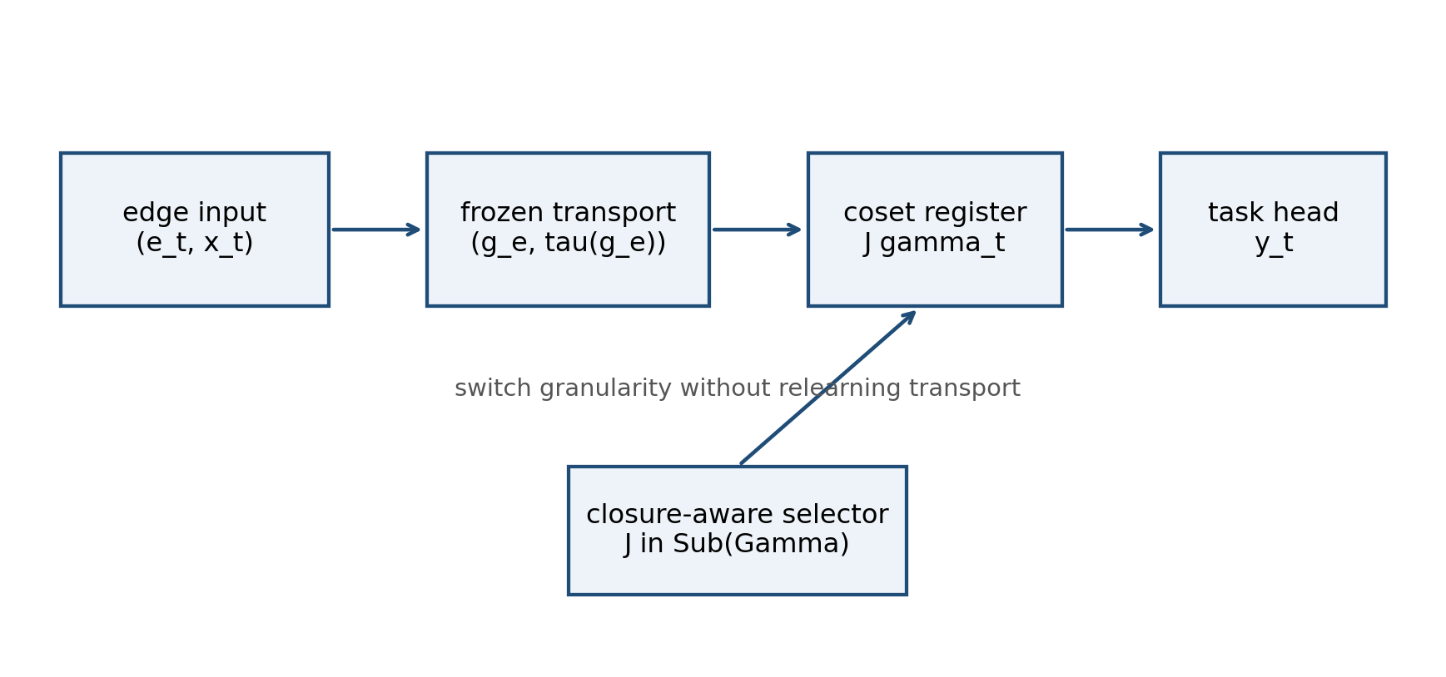
Figure 1. Architecture of the proposed memory subsystem. The subgroup can change without relearning the finite transport.

4.1 Cover compilation
The subgroup $J$ defines a covering associated with the transitive $Γ$-set $J∖Γ$. Building a separate copy of the semantic graph for every sheet is unnecessary.
Let $S$ be a cellular sheaf on $X$ with vertex and edge stalks $S\left(v\right)$ and $S\left(e\right)$ and restriction maps $ρ_{v→e}$. The cochains of the lifted sheaf on the $m_{J}$-sheeted cover are canonically identified with base cochains whose stalks are tensored with the permutation module:
$$C^{k}\left(X_{J};r^{*}S\right)≅C^{k}​\left(X;S⊗R\left[J∖Γ\right]\right).$$
Under this identification, an edge transport has the form
$${\tilde{ρ}}_{e}=ρ_{e}⊗P_{J}\left(g_{e}\right).$$
Because $P_{J}\left(g_{e}\right)$ has exactly one nonzero entry per row, applying ${\tilde{ρ}}_{e}$ requires a gather/scatter over sheets plus $m_{J}$ applications of $ρ_{e}$. For fixed stalk dimension, work and memory are $O\left(m_{J}\right)$, not $O\left(m_{J}^{2}\right)$. A dense matrix on the flattened sheet-feature space would destroy this advantage.

4.2 Sheaf reconciliation and a shared forward/adjoint solve
Let $d_{J}:C_{J}^{0}→C_{J}^{1}$ be the lifted coboundary and
$$L_{J}=d_{J}^{*}d_{J}$$
the degree-zero sheaf Laplacian. Given a local evidence vector $b$, define the reconciled state as the solution of
$$\left(L_{J}+μI\right)h=b, μ>0.$$
The regularizer makes the system positive definite. If a loss $ℓ$ depends on $h$, implicit differentiation gives
$$\left(L_{J}+μI\right)λ=∇_{h}ℓ.$$
The forward state $h$ and adjoint $λ$ therefore require two solves with the same sparse self-adjoint matrix. A factorization or preconditioner can be reused. This statement applies to the reconciliation module; other learned nonlinear components may still require ordinary backpropagation or BPTT.

4.3 Parameter separation
We separate three timescales:
- Transport learning: learn edge labels $g_{e}$, orthogonal transport $τ\left(g\right)$, and base restriction maps $ρ_{e}$ across a task family.
- Forgetting selection: choose $J$ for a task or operating condition while transport is frozen.
- Task decoding: fit or select a small head on the chosen coset-feature state.
This separation is what makes granularity switching inspectable. Changing $J$ changes a finite state partition and a permutation module, not the learned meaning of every edge.

5. Learning a forgetting policy

5.1 Why continuous stabilizers are generically trivial
One tempting proposal is to optimize a continuous task vector $u∈R^{d}$ and define forgetting as its stabilizer
$${Stab}_{Γ}\left(u\right)=\{g∈Γ:τ\left(g\right)u=u\}.$$
This normally returns the identity subgroup.
Proposition 1 (generic stabilizer degeneracy). Let $τ:Γ→GL\left(d,R\right)$ be a faithful representation of a finite group. Assume $Fix\left(τ\left(g\right)\right)$ is a proper subspace for every $g≠1$. Then the set of $u$ with nontrivial stabilizer has Lebesgue measure zero.
Proof. A nontrivial stabilizer means $u∈Fix\left(τ\left(g\right)\right)$ for some $g≠1$. Hence the exceptional set is the finite union
$$\underset{g≠1}{⋃}Fix\left(τ\left(g\right)\right).$$
Each member is a proper linear subspace and therefore has measure zero. A finite union of measure-zero sets has measure zero. $▫$
Nontrivial stabilizers can be encouraged by explicit symmetry constraints or discrete regularization, but they should not be expected as a by-product of unconstrained continuous optimization.

5.2 Task risk on the subgroup lattice
Let $G$ be a random history product in $Γ$, $Y$ a task target, and $C_{J}=JG$ the coset memory. A canonical information-theoretic risk is
$$R\left(J\right)=H\left(Y∣C_{J},Z\right),$$
where $Z$ denotes retained non-group features. More generally, $R\left(J\right)$ can be Bayes risk or held-out task loss. If $J⊆K$, then $C_{K}$ is a function of $C_{J}$, so data processing gives
$$R\left(J\right)≤R\left(K\right)$$
for conditional entropy and for ideal Bayes risk under a proper loss. More forgetting cannot add task information.
A capacity-regularized objective is
$$L_{β}\left(J\right)=R\left(J\right)+βlog\left[Γ:J\right].$$
The first term penalizes harmful forgetting; the second penalizes register size.

5.3 Closure-aware moves
Testing generators independently is incorrect. If $A$ is the current subgroup and $g$ is a proposed forgotten generator, the candidate is not $A∪\{g\}$ but its subgroup closure
$$A′=⟨A,g⟩.$$
The correct marginal cost is
$$Δ\left(g∣A\right)=R\left(⟨A,g⟩\right)−R\left(A\right).$$
Two generators that are individually inexpensive can jointly generate a large subgroup and remove many additional distinctions. Algorithm 1 therefore evaluates every move after closure.
Algorithm 1: Closure-aware subgroup selection
- Initialize $A←J_{0}$.
- Enumerate candidate generators $g∉A$ or adjacent supergroups in the subgroup lattice.
- For each candidate, compute $K_{g}=⟨A,g⟩$, its task risk $R\left(K_{g}\right)$, and compression gain $log\left[A′:A\right]$.
- Accept the legal move with the best risk-compression tradeoff, subject to a validation constraint.
- Repeat until no accepted supergroup improves the objective.
Searching adjacent supergroups avoids repeatedly proposing generators with the same closure. For small $Γ$, the subgroup lattice can be enumerated exactly. Larger quotients require lattice search, learned proposals, or domain-specified candidate policies.

5.4 Filtrations, persistence modules, and a chain-length bound
For $J⊆K$, define an averaging map
$$A_{J,K}:R\left[J∖Γ\right]→R\left[K∖Γ\right]$$
that sums or averages fine coset coordinates inside each coarse coset. Along a chain
$$J_{0}⊊J_{1}⊊⋯⊊J_{r},$$
these maps form a persistence module. A distinction that survives across a long tolerance interval is robust for that selected chain.
Proposition 2 (chain-length bound). Every strict subgroup chain above $J_{0}$ has length
$$r≤floor​\left(\log_{2}\left[Γ:J_{0}\right]\right).$$
Proof. Each strict inclusion has integer index at least two, so
$$\left[Γ:J_{0}\right]=\left[Γ:J_{r}\right]\prod_{i=0}^{r−1}{\left[J_{i+1}:J_{i}\right]}≥2^{r}.$$
Taking logarithms proves the claim. $▫$
The full policy space is still a lattice. In particular, a list of state counts is not automatically a filtration: each later count must divide the earlier count.

6. Finite cover refinement conserves lifting obstructions

6.1 Connecting morphism as a lifting test
Let
$$0→S\overset{i}{→}F\overset{p}{→}Q→0$$
be a short exact sequence of finite-dimensional cellular sheaves on a finite connected graph $X$. Assume $S$ is a Hilbert local system. For $q∈H^{0}\left(X;Q\right)$, choose a zero-cochain lift $\tilde{q}∈C^{0}\left(X;F\right)$ with $p\tilde{q}=q$. Because $q$ is globally consistent, $d_{F}\tilde{q}$ lies in $i\left(C^{1}\left(X;S\right)\right)$. Its cohomology class is independent of the lift and defines
$$∂\left[q\right]=\left[i^{−1}d_{F}\tilde{q}\right]∈H^{1}\left(X;S\right).$$
The class vanishes exactly when $q$ lifts to a global section of $F$.
Choose inner products on stalks. On a graph, the harmonic representative of a class in $H^{1}$ is its orthogonal projection to
$$H^{1}\left(X;S\right)=kerd_{S}^{*}.$$
We measure obstruction magnitude by the norm of this representative.

6.2 The conservation theorem
Let $r:X′→X$ be an $m$-sheeted covering. Pullback repeats every base cochain once on each sheet. Consequently,
$$∥r^{*}c∥^{2}=m∥c∥^{2}.$$
Define normalized pullback ${\hat{r}}^{*}=m^{−1/2}r^{*}$.
Theorem 3 (finite-cover conservation). Under the assumptions above, normalized pullback is an isometry onto a reducing subspace of the pulled-back Hodge Laplacian and is natural with respect to the connecting morphism. In degree one,
$$P_{H′} ∂′​\left({\hat{r}}^{*}\left[q\right]\right)={\hat{r}}^{*}P_{H} ∂\left[q\right].$$
Therefore
$$∥P_{H′}∂′​\left({\hat{r}}^{*}\left[q\right]\right)∥=∥P_{H}∂\left[q\right]∥.$$
Proof. Covering maps are local incidence isomorphisms. With pulled-back stalk inner products, the cellular coboundaries satisfy
$$d′{\hat{r}}^{*}={\hat{r}}^{*}d \text{and} d′^{*}{\hat{r}}^{*}={\hat{r}}^{*}d^{*}.$$
Hence the Hodge Laplacians intertwine:
$$Δ′{\hat{r}}^{*}={\hat{r}}^{*}Δ.$$
The image of ${\hat{r}}^{*}$ is invariant under the self-adjoint operator $Δ′$, so its orthogonal complement is also invariant; the image is reducing. Spectral projection onto the zero eigenspace therefore commutes with normalized pullback:
$$P_{H′}{\hat{r}}^{*}={\hat{r}}^{*}P_{H}.$$
The long exact cohomology sequence is natural under pullback, so $∂′{\hat{r}}^{*}={\hat{r}}^{*}∂$. Combining the identities gives the first equation. Isometry gives equality of norms. $▫$
Corollary 3.1 (no inherited repair). If $∂\left[q\right]≠0$, no finite cover makes the inherited interpretation ${\hat{r}}^{*}q$ liftable. Any liftable interpretation on the cover must have a component outside $im{\hat{r}}^{*}$.
The corollary is deliberately negative. More sheets do not edit an inherited interpretation into consistency. They may create new sheet-dependent interpretations that were unavailable on the base.

6.3 When can the obstruction be nonzero?
For a connected graph, local systems correspond to representations of $π_{1}\left(X\right)$. The short exact sheaf sequence corresponds to a short exact sequence of modules.
Theorem 4 (finite monodromy forces splitting). Work over $R$ or $C$. If the monodromies of $S$, $F$, and $Q$ all factor through one finite group $G$, then the short exact sequence splits $G$-equivariantly and $∂=0$.
Proof. By Maschke's theorem, finite-dimensional representations of a finite group over characteristic zero are semisimple. Every short exact sequence of $G$-modules splits. The corresponding local-system sequence splits, so every global quotient section has a global full lift. $▫$
Thus nonzero $∂$ requires the middle extension to escape the common finite quotient, even if both endpoint systems are finite. This escaping extension is the accumulating sector absent from the coset register.

6.4 Closed form on the circle
Let $X=S^{1}$ with fundamental-group generator $z$. In a stalkwise splitting $F≅S⊕Q$, write the monodromy as
$$R\left(z\right)=\left[\begin{matrix}A & B \\ 0 & C\end{matrix}\right],$$
where $A^{n}=C^{n}=I$ and $A,C$ are orthogonal. A global quotient section is $q∈ker\left(C−I\right)$. Its connecting class is
$$∂\left[q\right]=\left[Bq\right]∈coker\left(A−I\right).$$
The $n$th iterate is
$$R{\left(z\right)}^{n}=\left[\begin{matrix}I & Σ \\ 0 & I\end{matrix}\right], Σ=\sum_{k=0}^{n−1}{A^{n−1−k}}BC^{k}.$$
For $Cq=q$,
$$Σq=\left(\sum_{j=0}^{n−1}{A^{j}}\right)Bq.$$
Because finite-order orthogonal $A$ satisfies
$$ker\left(\sum_{j=0}^{n−1}{A^{j}}\right)=im\left(A−I\right),$$
we obtain:
Proposition 5 (circle criterion). For $q∈ker\left(C−I\right)$,
$$∂\left[q\right]≠0 ⇔ Σq≠0.$$
The unipotent block does not equal the obstruction as an abstract object. Rather, $∂$ detects the task-visible component of the extension that fails to compile into finite monodromy.

7. Finite-by-unipotent recurrent dynamics

7.1 Structural definition
Let $Π$ be the path group or a chosen recurrent transition group. A representation $R:Π→GL\left(D\right)$ is finite-by-unipotent of depth $r$ if there is an invariant flag
$$0=V_{0}⊂V_{1}⊂⋯⊂V_{r}=R^{D}$$
such that the induced action on the associated graded space $⨁_{i}V_{i}/V_{i−1}$ factors through a finite group and the kernel acts by unipotent upper-triangular maps of nilpotency index at most $r$.
After an iterate $n$ that kills the finite diagonal action, a recurrent operator has the form
$$R^{n}=I+N, N^{r}=0.$$
Therefore
$${\left(R^{n}\right)}^{k}={\left(I+N\right)}^{k}=\sum_{j=0}^{r−1}{\left({k \atop j}\right)}N^{j}.$$
Theorem 6 (polynomial accumulation). Along repeated cycles, the norm contributed by the unipotent sector is $O\left(k^{r−1}\right)$. The finite quotient sector is periodic and norm-bounded under orthogonal transport.
This avoids exponential drift inside the structured transport subsystem. It does not prevent an input-dependent nonlinear update, decoder, optimizer, or coupling outside the subsystem from becoming unstable.

7.2 Interpretation
The decomposition gives two kinds of memory:
- Recurrent register: finite contextual distinctions return exactly after a bounded period.
- Accumulator: extension information does not return, but bounded nilpotent depth restricts its growth to a polynomial.
The first compiles into a permutation/orthogonal register. The second is the part that can carry a lifting obstruction and cannot be represented by the finite quotient alone.

8. Exact synthetic experiments
The experiments are diagnostic rather than benchmark-scale. They test four falsifiable structural predictions.

8.1 Experimental questions
- Do subgroup policies produce the predicted state counts and task information?
- Does closure change the cost of proposed forgetting moves?
- Is the normalized inherited lifting obstruction exactly conserved under finite covers?
- Does a bounded-depth extension accumulate polynomially rather than exponentially?
All calculations use exact finite-group enumeration or double-precision linear algebra. The code enumerates all six elements of $S_{3}$ and all examples are deterministic.

8.2 The $S_{3}$ policy lattice
Let $Γ=S_{3}$. We use four policies: the identity subgroup, a selected transposition subgroup $C_{2}$, the alternating subgroup $A_{3}$, and $S_{3}$ itself. Their registers contain 6, 3, 2, and 1 states.
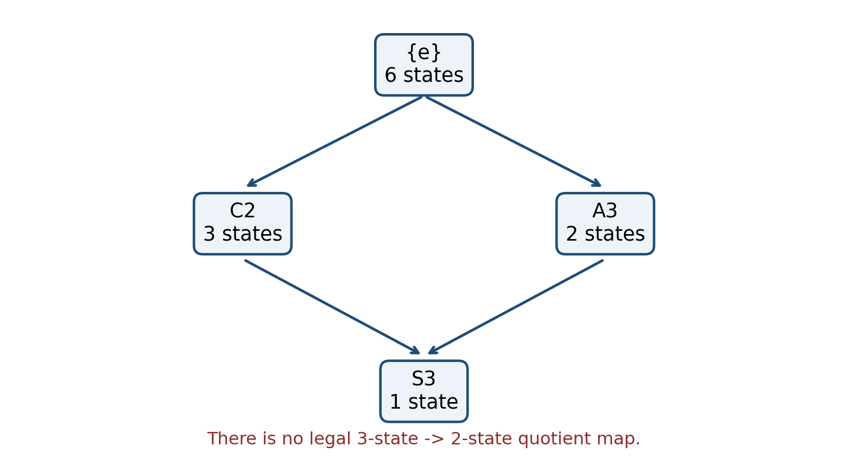
Figure 2. Relevant part of the subgroup lattice of S3. The 3-state and 2-state policies are incomparable.
This corrects a superficially plausible but impossible filtration $6→3→2→1$. The policies with three and two states are both coarsenings of the six-state policy, but neither coarsens the other. The legal chains are
$$6→3→1 \text{and} 6→2→1.$$
We define four uniform tasks whose labels are exactly the corresponding cosets. Table 1 reports Bayes accuracy when a task is decoded from each memory policy.
Memory policy | Fine task (6) | $C_{2}$ task (3) | $A_{3}$ task (2) | Constant task (1)
Identity: 6 states | 1.000 | 1.000 | 1.000 | 1.000
$C_{2}$: 3 states | 0.500 | 1.000 | 0.500 | 1.000
$A_{3}$: 2 states | 0.333 | 0.333 | 1.000 | 1.000
$S_{3}$: 1 state | 0.167 | 0.333 | 0.500 | 1.000
Table 1. Exact Bayes accuracy under uniform $S_{3}$ histories. Matched policy-task pairs are lossless. Incomparable policies cannot be converted without returning to a common refinement or retraining an information source.
Switching among these registers requires only changing $J$ and its permutation module; the edge products and transport representation remain frozen. This is the paper's limited, exact meaning of zero-shot granularity switching.

8.3 Closure-aware forgetting
Starting from the identity subgroup, forgetting either transposition $a=\left(12\right)$ or $b=\left(23\right)$ alone generates a subgroup of order two and reduces six states to three. Forgetting both does not create a four-element set. Their closure is
$$⟨a,b⟩=S_{3},$$
which reduces the register to one state. Under a uniform history distribution, each single move forgets $\log_{2}2=1$ bit of identity information, while the joint closure forgets $\log_{2}6=2.585$ bits. The extra $0.585$ bits are invisible to independent thresholding.

8.4 Cover conservation and supersession
Consider the circle example with $S=R$, $Q=R^{2}$,
$$A=1, C=\left[\begin{matrix}0 & 1 \\ 1 & 0\end{matrix}\right], B=\left[\begin{matrix}1 & 1\end{matrix}\right].$$
The inherited quotient section $q_{+}={\left(1,1\right)}^{T}$ has base obstruction norm 2. On an $m$-sheeted cover, the raw norm is $2\sqrt{m}$, while normalized pullback returns exactly 2 for every $m=1,…,8$.
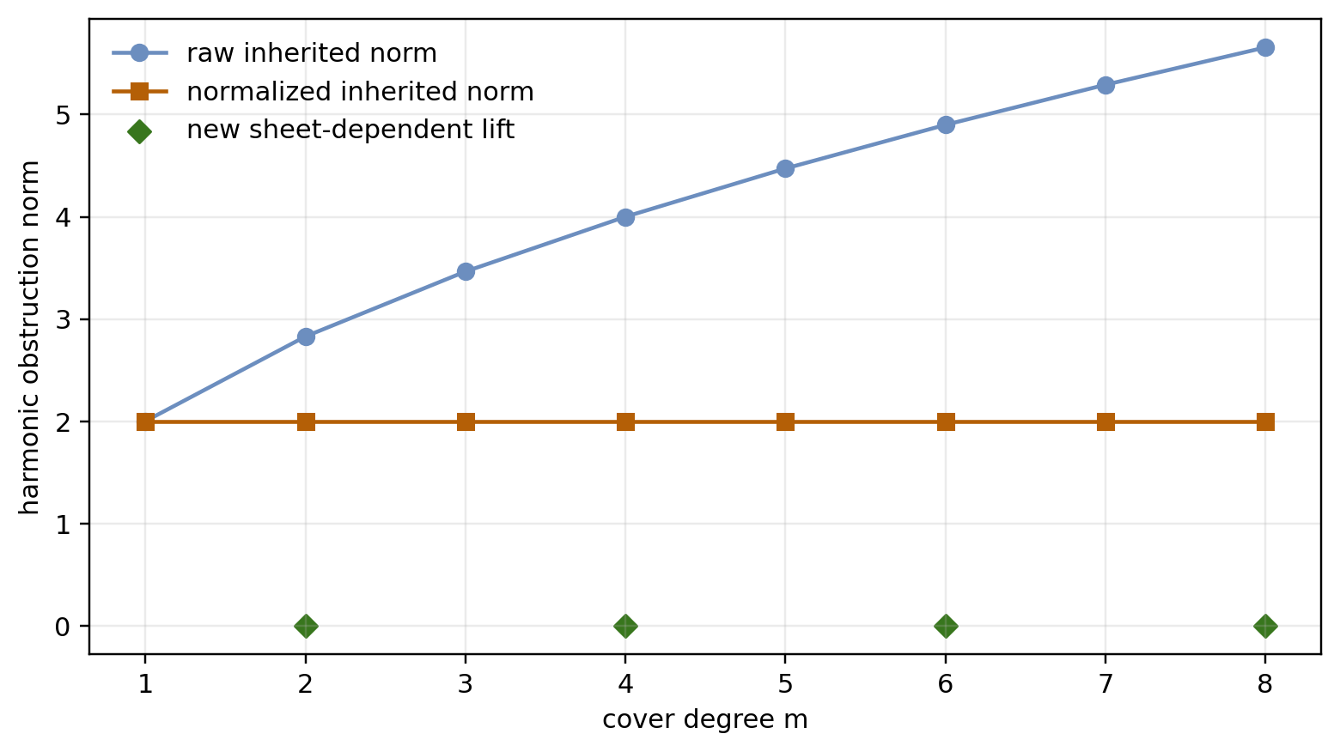
Figure 3. Raw obstruction grows with replicated volume, while normalized inherited obstruction is exactly conserved. Even covers admit a new anti-invariant section with zero obstruction.
For even $m$, the cover also admits a sheet-dependent quotient section generated by $q_{−}={\left(1,−1\right)}^{T}$. It is not pulled back from a base global section. Because $Bq_{−}=0$ and the values alternate under $C$, its obstruction is zero. The cover therefore helps by supplying a new interpretation, not by repairing $q_{+}$.

8.5 Polynomial versus exponential growth
For the same example, the full monodromy is
$$T=\left[\begin{matrix}1 & 1 & 1 \\ 0 & 0 & 1 \\ 0 & 1 & 0\end{matrix}\right].$$
Its diagonal quotient has period two and
$$T^{2}=\left[\begin{matrix}1 & 2 & 2 \\ 0 & 1 & 0 \\ 0 & 0 & 1\end{matrix}\right]$$
is unipotent of depth two. Starting from ${\left(0,1,1\right)}^{T}$, the state norm after 250 steps is 500.002, exactly matching $\sqrt{{\left(2t\right)}^{2}+2}$. An unconstrained recurrence with spectral radius 1.05 reaches 280,439.875 at the same horizon.
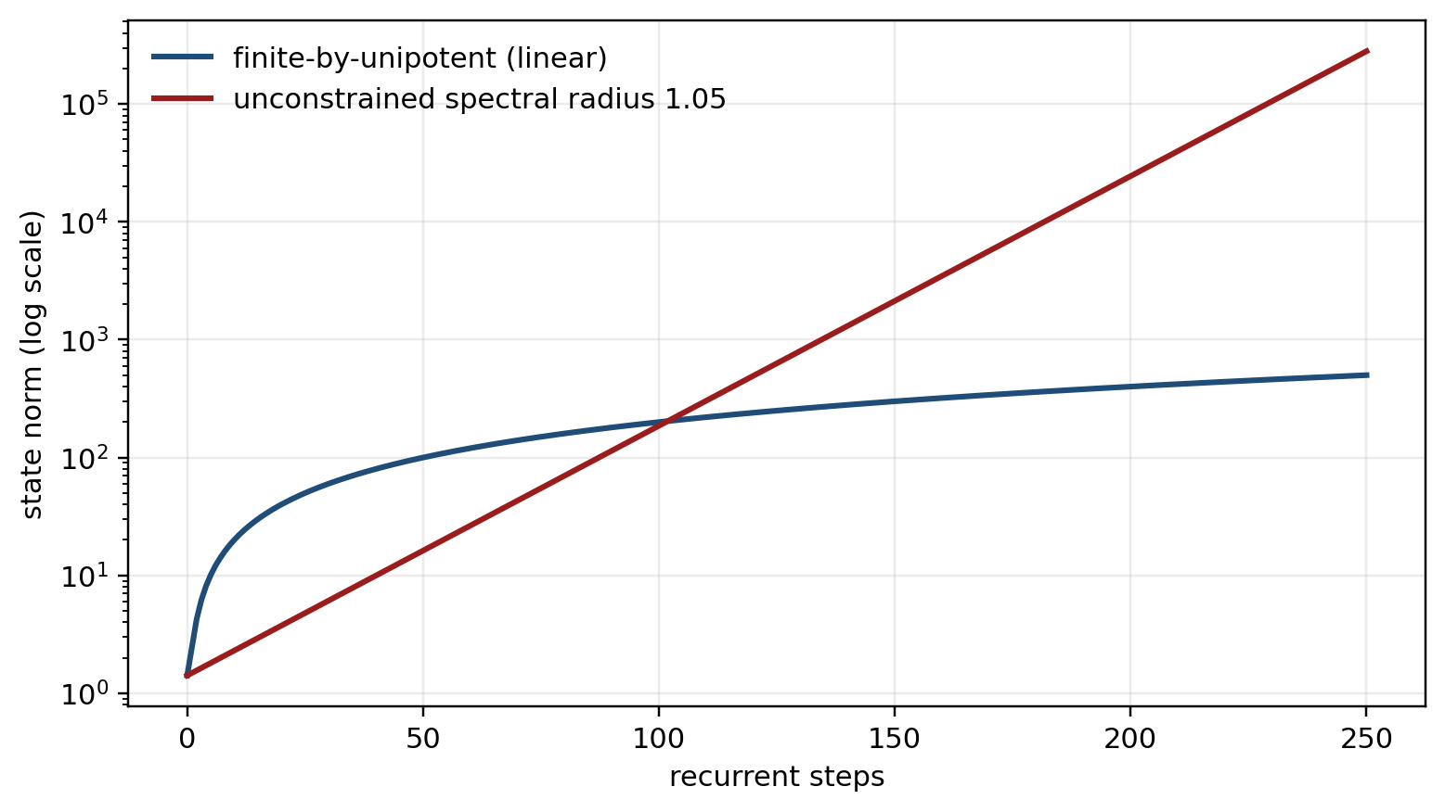
Figure 4. A depth-two unipotent extension grows linearly, while a recurrence with spectral radius 1.05 eventually grows exponentially.

8.6 Complexity accounting
Let $m=\left[Γ:J\right]$, base stalk dimension $d$, and let one base edge map cost $C_{ρ}\left(d\right)$. Applying $ρ_{e}⊗P_{J}\left(g_{e}\right)$ costs
$$O​\left(m C_{ρ}\left(d\right)+md\right).$$
For a dense $d×d$ restriction map, this is $O\left(md^{2}\right)$. Treating the lifted operator as an arbitrary dense $\left(md\right)×\left(md\right)$ matrix would cost $O\left(m^{2}d^{2}\right)$ and store $O\left(m^{2}d^{2}\right)$ entries. The linear sheet scaling is therefore a consequence of preserving the Kronecker-permutation structure, not a property of arbitrary cover implementations.

9. Discussion

9.1 What refinement can and cannot buy
The conservation theorem gives a software test. Measure the normalized harmonic residual of an inherited interpretation before and after branching. It should be unchanged up to numerical tolerance. A reported reduction without a sheet-dependent component suggests a normalization error, an inconsistent pullback, or leakage between the inherited and new subspaces.
The result also changes the interpretation of adaptive memory. Refinement does not progressively correct the same coarse state. It expands the hypothesis space. A better solution must use coordinates that distinguish sheets. This distinction matters in mixture systems, branching search, context splitting, and multi-hypothesis tracking.

9.2 Lattice-valued control rather than a scalar dial
Memory granularity is often described as a scalar from fine to coarse. The $S_{3}$ example shows why that picture is incomplete. A three-state policy can preserve "which pair-coset?" while discarding parity; a two-state policy can preserve parity while discarding the pair-coset. Neither contains the other's information. A controller must sometimes choose a branch, not merely turn a dial.
For deployment, this suggests returning the selected subgroup, its index, its generators, its immediate supergroups/subgroups, and validation risk. These fields make the forgetting decision auditable.

9.3 Relationship to gates and SSMs
A gate can attenuate or erase coordinates without declaring a compositional equivalence relation. A coset register declares exactly which route products are identified. The two mechanisms can coexist: gates can manage local continuous features while $J$ manages discrete provenance.
Likewise, the architecture is compatible with a broader SSM. The finite quotient provides exact recurrence, the unipotent sector provides controlled accumulation, and a selective nonlinear block can process input content. Only the structured transport sector receives the polynomial-growth guarantee.

9.4 Neuroscience analogy, explicitly limited
The architecture suggests a cautious analogy for memory consolidation: fast contextual state may select among a small number of task-relevant history partitions while slower transport parameters remain comparatively stable. A refinement would then introduce a context distinction rather than rewrite an inherited interpretation.
This is not an anatomical claim. The present work does not identify the coset register with hippocampus, the transport representation with entorhinal cortex, the sheaf Laplacian with neocortical feedback, or the adjoint solve with biological backpropagation. Those mappings would require independent neural measurements and falsifiable experiments. At most, the mathematics motivates questions such as whether neural population states show task-dependent quotient structure, whether context splitting creates new state components, and whether inherited residuals are conserved under experimentally induced refinement.

9.5 Potential experiments beyond the synthetic setting
Three empirical programs would test the architecture rather than its metaphors:
- Compositional navigation: train on paths whose transition algebra has a known finite quotient, then test whether learned states cluster by predicted cosets and switch across task subgroups with transport frozen.
- Repeated compartments with cycles: use an environment containing a genuine cycle, not only a chain, and test whether neural or model state returns after the predicted monodromy period.
- Controlled context splitting: introduce a cue that makes two previously merged histories task-distinct. Test whether improvement uses a new sheet-dependent component while the inherited component's normalized residual remains constant.

10. Limitations
First, the experiments are exact synthetic checks, not evidence of competitive performance on language, control, or neuroscience benchmarks. Second, discovering a useful finite quotient $Γ$ from raw data is nontrivial and is assumed rather than solved. Third, subgroup enumeration can be expensive for large groups; the chain-length bound does not bound the total size of the subgroup lattice. Fourth, orthogonal transport and unipotent accumulation constrain only one subsystem. Nonlinear couplings can reintroduce instability. Fifth, the sheaf theorem assumes a genuine finite covering with pulled-back inner products; arbitrary graph refinements, attention branches, or learned duplications need not satisfy it. Sixth, nonzero extension structure need not obstruct every task section: $∂$ can vanish on a kernel. Finally, the neuroscience discussion is a research analogy and carries no clinical or anatomical conclusion.

11. Conclusion
Forgetting can be made explicit. A subgroup $J$ states which composite history distinctions are erased; the coset register $J∖Γ$ states what remains. This turns memory granularity from an opaque side effect of hidden-state compression into a finite, inspectable policy.
The same algebra also imposes a limit. Refining a cover cannot reduce the normalized lifting obstruction of an interpretation inherited from the base. Improvement must come from a genuinely new, sheet-dependent interpretation. The finite quotient therefore handles recurrence, while a controlled unipotent extension handles what does not compile into periodic memory.
The resulting design principle is compact:
$$\text{periodic transport} ⊕ \text{polynomial accumulation} ⊕ \text{subgroup-valued forgetting}.$$
It is a proposal for a defensible memory-transport subsystem: explicit about what is forgotten, exact about what refinement cannot repair, and modest about what remains unproved.

Appendix A. Additional proof details

A.1 Well-defined coset update
Suppose $Jγ=Jγ′$. Then $γ′=jγ$ for some $j∈J$. For every $g∈Γ$,
$$Jγ′g=Jjγg=Jγg.$$
Thus right multiplication is a well-defined action on left cosets even when $J$ is not normal.

A.2 Reducing-subspace identity
Let $U=im{\hat{r}}^{*}$. Intertwining gives $Δ′U⊆U$. Since $Δ′$ is self-adjoint, for $u∈U$ and $v∈U^{⊥}$,
$$⟨Δ′v,u⟩=⟨v,Δ′u⟩=0.$$
Hence $Δ′U^{⊥}⊆U^{⊥}$. The spectral projector onto $kerΔ′$ preserves both subspaces and agrees with normalized pullback on $U$.

A.3 Circle criterion
For finite-order orthogonal $A$, decompose $S=ker\left(A−I\right)⊕ker{\left(A−I\right)}^{⊥}$. The averaging operator
$$N_{A}=I+A+⋯+A^{n−1}$$
acts as $nI$ on $ker\left(A−I\right)$ and as zero on its orthogonal complement. Orthogonality also gives
$$im\left(A−I\right)=ker{\left(A−I\right)}^{⊥}.$$
Therefore $N_{A}Bq=0$ exactly when $Bq∈im\left(A−I\right)$, which is exactly the vanishing condition for $\left[Bq\right]∈coker\left(A−I\right)$.

Appendix B. Reproducibility specification
The synthetic experiment script uses the following deterministic steps:
- Represent each permutation in $S_{3}$ by a tuple of images of $\left(1,2,3\right)$.
- Enumerate subgroup closure under composition and inverse.
- Enumerate left cosets and compute Bayes accuracy by majority label within each memory coset.
- Compute cover norms from explicitly repeated residuals and normalize by $m^{−1/2}$.
- Iterate the displayed $3×3$ monodromy and a diagonal 1.05 baseline for 250 steps.
No random seed is required. Numerical equality is checked against closed forms. Source code is supplied alongside the working manuscript during development and can be included in a public repository at submission.

References
- Bengio, Y., Simard, P., and Frasconi, P. "Learning Long-Term Dependencies with Gradient Descent Is Difficult." IEEE Transactions on Neural Networks 5(2), 157-166 (1994). https://doi.org/10.1109/72.279181
- Pascanu, R., Mikolov, T., and Bengio, Y. "On the Difficulty of Training Recurrent Neural Networks." Proceedings of ICML, 1310-1318 (2013). https://proceedings.mlr.press/v28/pascanu13.html
- Hochreiter, S., and Schmidhuber, J. "Long Short-Term Memory." Neural Computation 9(8), 1735-1780 (1997). https://doi.org/10.1162/neco.1997.9.8.1735
- Arjovsky, M., Shah, A., and Bengio, Y. "Unitary Evolution Recurrent Neural Networks." Proceedings of ICML, 1120-1128 (2016). https://proceedings.mlr.press/v48/arjovsky16.html
- Wisdom, S., Powers, T., Hershey, J. R., Le Roux, J., and Atlas, L. "Full-Capacity Unitary Recurrent Neural Networks." Advances in Neural Information Processing Systems 29 (2016). https://proceedings.neurips.cc/paper/2016/hash/d9ff90f4000eacd3a6c9cb27f78994cf-Abstract.html
- Jing, L., Gülçehre, Ç., Peurifoy, J., Shen, Y., Tegmark, M., Soljačić, M., and Bengio, Y. "Gated Orthogonal Recurrent Units: On Learning to Forget." Neural Computation 31(4), 765-783 (2019). https://doi.org/10.1162/neco_a_01174
- Williams, R. J., and Zipser, D. "Gradient-Based Learning Algorithms for Recurrent Networks and Their Computational Complexity." In Backpropagation: Theory, Architectures, and Applications, 433-486 (1995).
- Gu, A., Goel, K., and Ré, C. "Efficiently Modeling Long Sequences with Structured State Spaces." International Conference on Learning Representations (2022). https://openreview.net/forum?id=uYLFoz1vlAC
- Gu, A., and Dao, T. "Mamba: Linear-Time Sequence Modeling with Selective State Spaces." First Conference on Language Modeling (2024). https://openreview.net/forum?id=tEYskw1VY2
- Bai, S., Kolter, J. Z., and Koltun, V. "Deep Equilibrium Models." Advances in Neural Information Processing Systems 32 (2019). https://proceedings.neurips.cc/paper/2019/hash/01386bd6d8e091c2ab4c7c7de644d37b-Abstract.html
- Curry, J. M. Sheaves, Cosheaves and Applications. Ph.D. thesis, University of Pennsylvania (2014). https://arxiv.org/abs/1303.3255
- Robinson, M. Topological Signal Processing. Springer (2014). https://doi.org/10.1007/978-3-642-36104-3
- Hansen, J., and Ghrist, R. "Toward a Spectral Theory of Cellular Sheaves." Journal of Applied and Computational Topology 3, 315-358 (2019). https://doi.org/10.1007/s41468-019-00038-7
- Hansen, J., and Gebhart, T. "Sheaf Neural Networks." NeurIPS 2020 Workshop on Topological Data Analysis and Beyond (2020). https://arxiv.org/abs/2012.06333
- Bodnar, C., Di Giovanni, F., Chamberlain, B. P., Liò, P., and Bronstein, M. M. "Neural Sheaf Diffusion: A Topological Perspective on Heterophily and Oversmoothing in GNNs." Advances in Neural Information Processing Systems 35, 18527-18541 (2022). https://proceedings.neurips.cc/paper_files/paper/2022/hash/75c45fca2aa416ada062b26cc4fb7641-Abstract-Conference.html
- Zomorodian, A., and Carlsson, G. "Computing Persistent Homology." Discrete & Computational Geometry 33, 249-274 (2005). https://doi.org/10.1007/s00454-004-1146-y
- Cohen, T. S., and Welling, M. "Group Equivariant Convolutional Networks." Proceedings of ICML, 2990-2999 (2016). https://proceedings.mlr.press/v48/cohenc16.html
- Hatcher, A. Algebraic Topology. Cambridge University Press (2002). https://pi.math.cornell.edu/~hatcher/AT/AT.pdf
- Brown, K. S. Cohomology of Groups. Springer (1982). https://doi.org/10.1007/978-1-4684-9327-6
- Serre, J.-P. Linear Representations of Finite Groups. Springer (1977). https://doi.org/10.1007/978-1-4684-9458-7

