From CAD Primitives to Structural Meaning
  - Cosheaf Ascent, Cohomological Audit, and Extension Lifting for Engineering Drawing Intelligence
Debi Prasad Ghosh, Ph.D., debiprasadghosh@gmail.com
Founder & Principal Engineer, Debias Parametric Guru, Kolkata, India, https://www.linkedin.com/company/debias-parametric-guru/
Civil & Structural Engineer | B.E., IIEST Shibpur | M.E., Jadavpur University | Ph.D., IISc Bengaluru | 25+ years in engineering design and automation
Companion to: Short Exact Sequences for Engineering Drawing Intelligence
Conference Theme: Artificial Intelligence and Machine Learning in Structural Engineering

Abstract
Experienced structural engineers do not perceive a two-dimensional drawing as a flat set of lines, arcs, dimensions, symbols, and tables. They reconstruct a hierarchy: graphical primitives become grids, columns, floors, truss panels, frames, views, and ultimately a coherent structural system. Current drawing-intelligence pipelines generally attempt direct detection or vector embedding, but they do not explicitly represent the three distinct operations involved in expert reading. This conceptual paper proposes a practitioner-oriented architecture with three operations: cosheaf-like ascent, sheaf-like audit, and extension lifting. The ascent is covariant: local primitives are aggregated into motifs and assemblies. The audit is contravariant: a proposed building interpretation is restricted back to the evidence it claims to explain, and independently measured overlap disagreements determine whether local meanings can coexist. The lift addresses partial drawings. Using a short exact sequence 0 -> K -> F -> Q -> 0 and the connecting map partial: H^0(Q) -> H^1(K), a partial observation is completable under a template only when its obstruction vanishes; the family of completions is then a torsor over H^0(K). This corrects the common interpretation of a missing component as a direct certification: the same empty bay may indicate a missing beam in a continuous frame or an intentional gap at an expansion joint. The paper further argues that a pattern catcher cannot use one monolithic real-valued feature stalk. Geometry, integer incidence, orientation parity, semantic roles, and provenance require a typed coefficient stack with distinct audits; confidence should remain external as a filtration. Candidate states and overlap witnesses must also be separate data structures, otherwise forming edge mismatches by differencing interior values makes the cohomological gate exact by construction and therefore silent. The proposed architecture offers a path from CAD primitives to auditable structural world models for drawing interpretation, model generation, anomaly detection, design review, and engineering AGI.
Keywords: engineering drawing intelligence; structural engineering AI; CAD interpretation; cosheaf; sheaf cohomology; extension problem; pattern recognition; structural world model; provenance
Central practitioner rule: Do not ask only whether a line is unusual. Ask which structural template makes the observed drawing lift to a coherent whole, and whether that proposed whole restricts back to independently witnessed evidence.

1. Introduction
A structural drawing is computationally sparse and cognitively dense. At file level it may contain little more than line segments, arcs, polylines, text, dimensions, hatch patterns, symbols, layers, and tables. At engineering level the same drawing may contain a floor framing plan, a roof truss elevation, a portal-frame assembly, a foundation layout, a transfer system, or an isometric representation of an industrial structure. The engineering object is therefore not stored explicitly in the primitive file. It is reconstructed by a reader who knows what structural patterns look like, how incomplete patterns should continue, and which apparent continuations are prohibited by joints, releases, gaps, or changes of system.
This gap has practical consequences for artificial intelligence and machine learning in structural engineering. A vision model can detect lines and symbols; a graph model can learn adjacency; an object detector can nominate columns or beams. Yet a usable engineering system must go further. It must explain why a line is being treated as a grid rather than a slab edge, why several triangular motifs constitute one truss, whether an empty bay contains an omitted beam or an intentional expansion joint, and whether a proposed building view remains consistent with dimensions, text, tables, and details on overlapping regions. The problem is not merely classification. It is local-to-global construction, verification, and completion.
The architecture developed here is motivated by the procedural account of experienced drawing reading: catch a minimal pattern; use that pattern to claim relevant primitives; reconstruct the expected pattern; identify missing, altered, and extra components; and then search the remaining evidence with other pattern catchers. Elementary patterns form a first semantic level, assemblies a second, and a complete structural view a higher level. The decisive mathematical correction is that this process contains three operations rather than one. Upward pattern composition is not cohomology. It is covariant and is best described as cosheaf-like or colimit-shaped. Cohomology enters in the opposite direction, when a high-level interpretation is restricted to the local evidence and audited on overlaps. A third operation, extension lifting, determines whether an incomplete observation can be completed under a selected template and, if so, how many completions remain possible.
This paper is conceptual. The algebraic and topological statements are standard or directly checkable; their use as an engineering-AI architecture is a candidate design proposal. The purpose is to give engineering practitioners a precise representation contract for building and testing drawing-intelligence systems, not to claim that experienced engineers literally compute sheaf cohomology.

2. Why Flat Drawings Are Poor Inputs for Engineering AI
Most CAD exchange formats preserve drawing operations rather than engineering meaning. A beam may be represented by two parallel lines, one centreline, a polyline, a block, or merely a note. A column may be a rectangle, circle, cross, filled hatch, centre mark, or table entry. A floor plan and a truss elevation can use similar primitives while expressing different structural relations. Dimensions and text often carry the decisive evidence, but they are stored separately from the geometry they qualify.
An experienced engineer implicitly creates a hierarchy such as the following:
drawing primitives -> local motifs -> structural assemblies -> view type -> building system | (1)

The corresponding machine representation should not stop at a primitive graph. It should retain multiple levels and the links between them. A practical hierarchy is shown in Table 1.
Level | Typical objects | Primary engineering question
D0: primitives | lines, arcs, polylines, text, dimensions, symbols, tables | What graphical evidence is present?
P(0): local patterns | grid family, column signature, beam chain, truss panel, support symbol | Which minimum structural motifs are nominated?
P(1): assemblies | floor framing, truss, portal frame, foundation group, bracing system | Which motifs compose into one functional system?
P(2): structural view | plan, elevation, section, isometric, schedule-linked detail | What view and structural object best explain the assemblies?
World model | multi-view building, analysis model, provenance and revisions | Can the interpretation be used, checked, revised, and signed?

Table 1. A semantic hierarchy for reading structural drawings.
The hierarchy is not a rigid taxonomy imposed after detection. It is an active inference structure. Lower-level catchers nominate evidence for higher levels; higher-level templates in turn predict what lower-level components should be present. This bidirectionality is exactly why a purely bottom-up detector or purely top-down template matcher is insufficient.

3. The Experienced-Engineer Reading Loop
A pattern catcher is the minimum operational unit of the proposed architecture. It does not need to recognize an entire building. It needs only enough evidence to nominate a local structural interpretation and expose what that interpretation would require next.

3.1 Minimum signatures
A grid catcher may begin from repeated near-parallel lines, approximately regular spacing, grid bubbles, aligned dimensions, and recurring column intersections. A truss catcher may begin from two approximately continuous chord chains, repeated panels, diagonal web members, and support regions. A floor catcher may combine elevation labels, repeated beam lines, slab edges, openings, and dimension chains. These signatures can be parametric, topological, geometric, learned, or hybrid.

3.2 Soft claiming and reconstruction
Once nominated, the catcher assigns soft claims to relevant primitives rather than deleting them from further consideration. One line may legitimately participate as a grid witness, a column centreline, and a dimension extension. Exclusive assignment would create disjoint catcher regions; the overlap cochain space would become empty and the audit would have nothing to test. Soft claiming is therefore not a later refinement. It is a precondition for verification.
w_next(e) = w_current(e) [1 - p(e | C_i)] | (2)

The catcher then reconstructs an ideal or expected pattern and produces three residual classes: missing components, altered components, and extra components. Altered evidence is a candidate obstruction. Extra evidence drives recursion and alternative pattern search. Missing evidence requires the separate lifting operation developed in Section 6; it is not automatically an error or a certified omission.

3.3 Recursive pattern search
The first set of caught motifs forms P(0). A second-level catcher consumes P(0) to form P(1), such as a floor framing system assembled from grids, columns, beams, and slab boundaries. Higher catchers infer view type and whole-building organization. At each stage the system must preserve the claimed primitives, confidence, role assignments, and source provenance so that a later hypothesis can be restricted back to the evidence.

4. Three Operations: Cosheaf Up, Sheaf Down, Lift Across
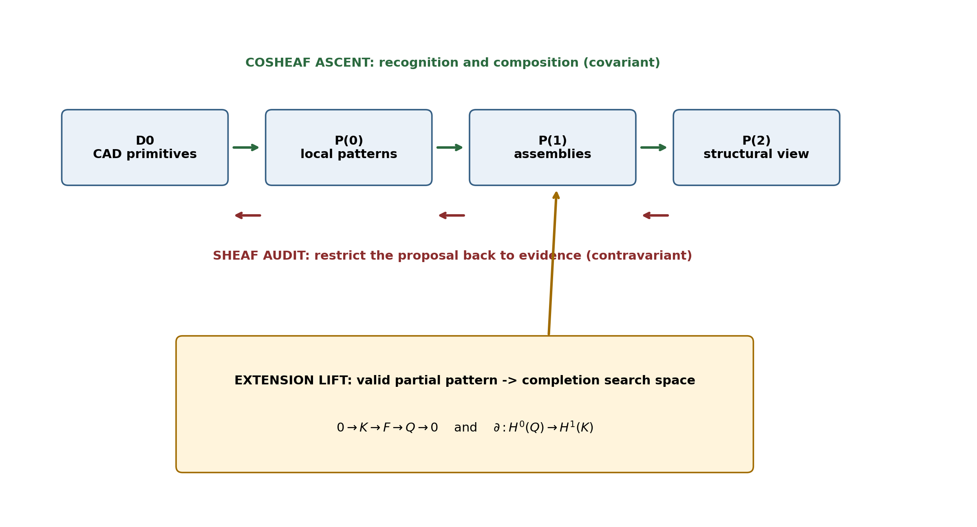
Figure 1. The architecture requires three operations with different variance and different questions.

4.1 Cosheaf ascent: constructing the interpretation
The upward sequence D0 -> P(0) -> P(1) -> P(2) aggregates local contributions into larger objects. It is covariant: evidence and local patterns are pushed into motifs, assemblies, and structural views. The precise language is cosheaf-like, colimit-shaped, and grammar-like. Covariance alone does not make the process homology; homology may later characterize the shape of what was constructed, but it is not the construction mechanism.
The engineering role of ascent is proposal. It answers: What larger structural object can be built from these local patterns? Modern machine learning is naturally useful here. Detectors, graph neural networks, geometric learning, language models, and probabilistic grammars can all propose candidate compositions.

4.2 Sheaf audit: testing whether meanings coexist
The audit runs in the opposite direction. A proposed floor, truss, or building interpretation must restrict back to the regions and primitives it claims to explain. Local candidate states are compared on overlaps, not merely in their interiors. In an abelian channel, a family of independently measured overlap mismatches forms a 1-cochain z. The relevant class is [z] in H^1. A nonzero class means that no reassignment of local interior states can resolve the cyclic disagreement.
C^0(U,F) --^{delta^0}--> C^1(U,F) --^{delta^1}--> C^2(U,F), delta^1 delta^0 = 0 | (3)

For example, grid, column, and floor catchers may each make plausible local claims about the same line. If their pairwise overlaps form the boundary of a triangle with no witnessed triple overlap, the nerve is homotopy equivalent to a circle and constant-coefficient H^1 has one cycle-supported channel. This jurisdiction matters: a genuine triple overlap fills the triangle and removes that particular channel; degenerate restriction maps may also create cohomology on a tree. The audit depends on both topology and coefficients.

4.3 Extension lifting: determining what may complete a partial pattern
The third operation is neither aggregation nor refusal. It asks whether a partial observation can be extended to a complete pattern under a selected template. Let F be the sheaf of complete pattern states, Q the observable quotient carried by the drawing, and K the completion data omitted from observation. Under a short exact sequence:
0 -> K -> F -> Q -> 0 | (4)

the long exact sequence supplies the connecting map:
partial: H^0(Q) -> H^1(K) | (5)

For a partial observation q in H^0(Q), partial(q) is the obstruction to lifting q into a complete section of F. If partial(q) is nonzero, the selected template cannot complete the observation consistently. If partial(q) is zero, a lift exists. Under the usual exactness assumptions, the family of lifts is a torsor under H^0(K). For vector-valued K, its dimension gives the number of free completion parameters; for discrete or nonabelian K, rank, cardinality, or torsor structure replaces dimension.
The corrected statement: A missing component is a conditional completion obligation, not an unconditional certification. It becomes a directed search target only after the template has passed its restriction audit and the lifting obstruction vanishes.

5. The Exactness-Collapse Trap
The most important implementation failure is easy to introduce. Suppose every catcher stores one interior value s_i and the system constructs the edge mismatch by differencing those values:
z_ij = s_j restricted to U_ij - s_i restricted to U_ij | (6)

Then z equals delta^0 s by construction. Its cohomology class is zero by definition. The audit is not merely weak; it is identically silent. Optimizing the interior candidates cannot repair this, because the obstruction channel was removed when the witness was manufactured from the candidates.
To obtain a genuine audit, overlap evidence must be measured independently. In drawings this evidence can come from dimension chains, coordinate labels, text annotations, section marks, scale information, layer conventions, symbol orientation, cross-referenced tables, or separate drawing views. The key architectural division is therefore between candidate states and witness states.
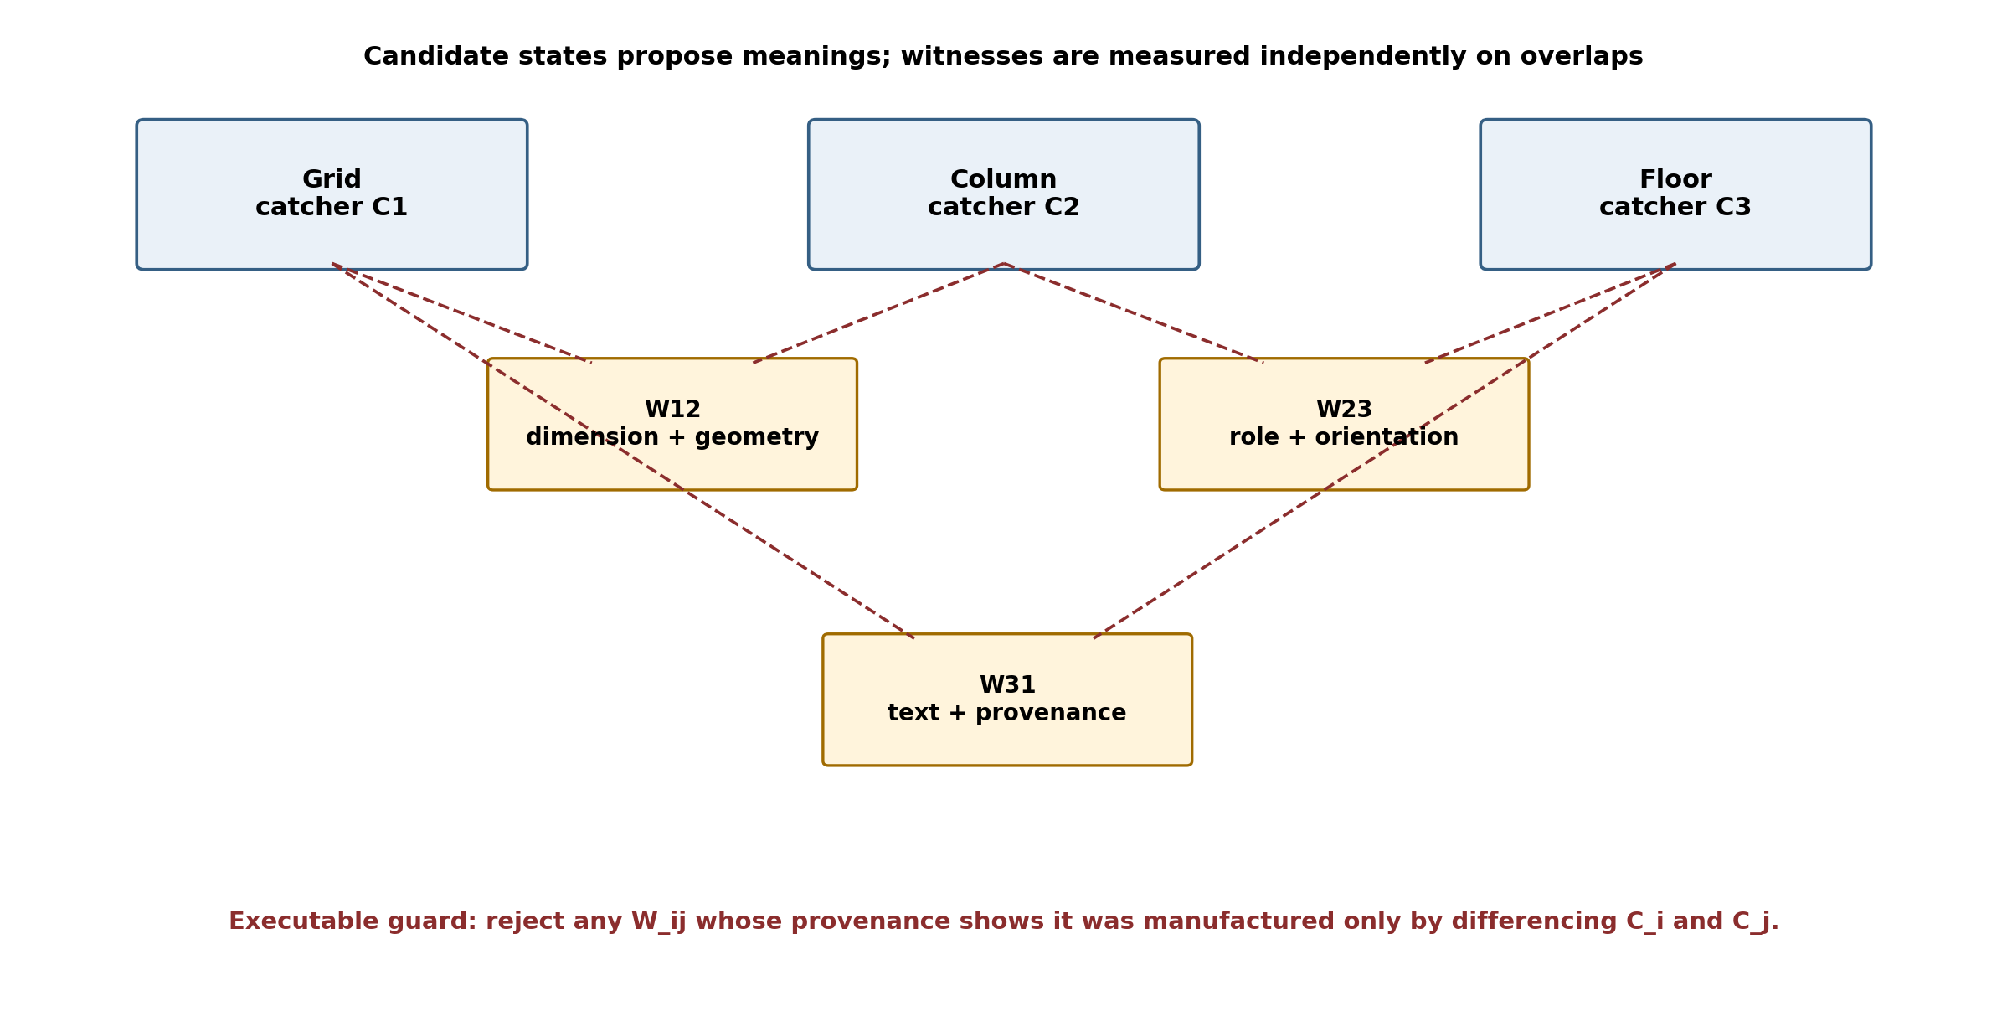
Figure 2. Candidate and witness data must be separate. Provenance makes exactness collapse mechanically detectable.
Object | Contains | Permitted source
Candidate C_i | pattern type, local chart, role assignments, claimed primitives, completion obligations, confidence, provenance | interior evidence and learned proposal
Witness W_ij | measured transition, dimension evidence, orientation relation, role compatibility, source provenance | independent evidence on the overlap
Guard | interior/overlap provenance tag and construction rule | reject W_ij if it is only delta of two candidate interiors

Table 2. Candidate-witness separation as an executable design guard.
This is an engineering-software requirement, not merely a mathematical caution. The data schema should prevent a candidate-derived residual from being registered as an independent witness. Provenance must record whether evidence was measured on an overlap or inferred from interiors. The guard should run automatically during graph construction.

6. Why a Missing Beam Is a Lifting Problem
Consider four columns at x = 0, 6, 12, and 18 m. Beams are visible in the first and third bays; the middle bay contains no beam line. A conventional anomaly detector sees one residual: a gap in a repeated beam sequence. An experienced engineer does not decide from the residual alone. The engineer tests the observation against candidate templates.
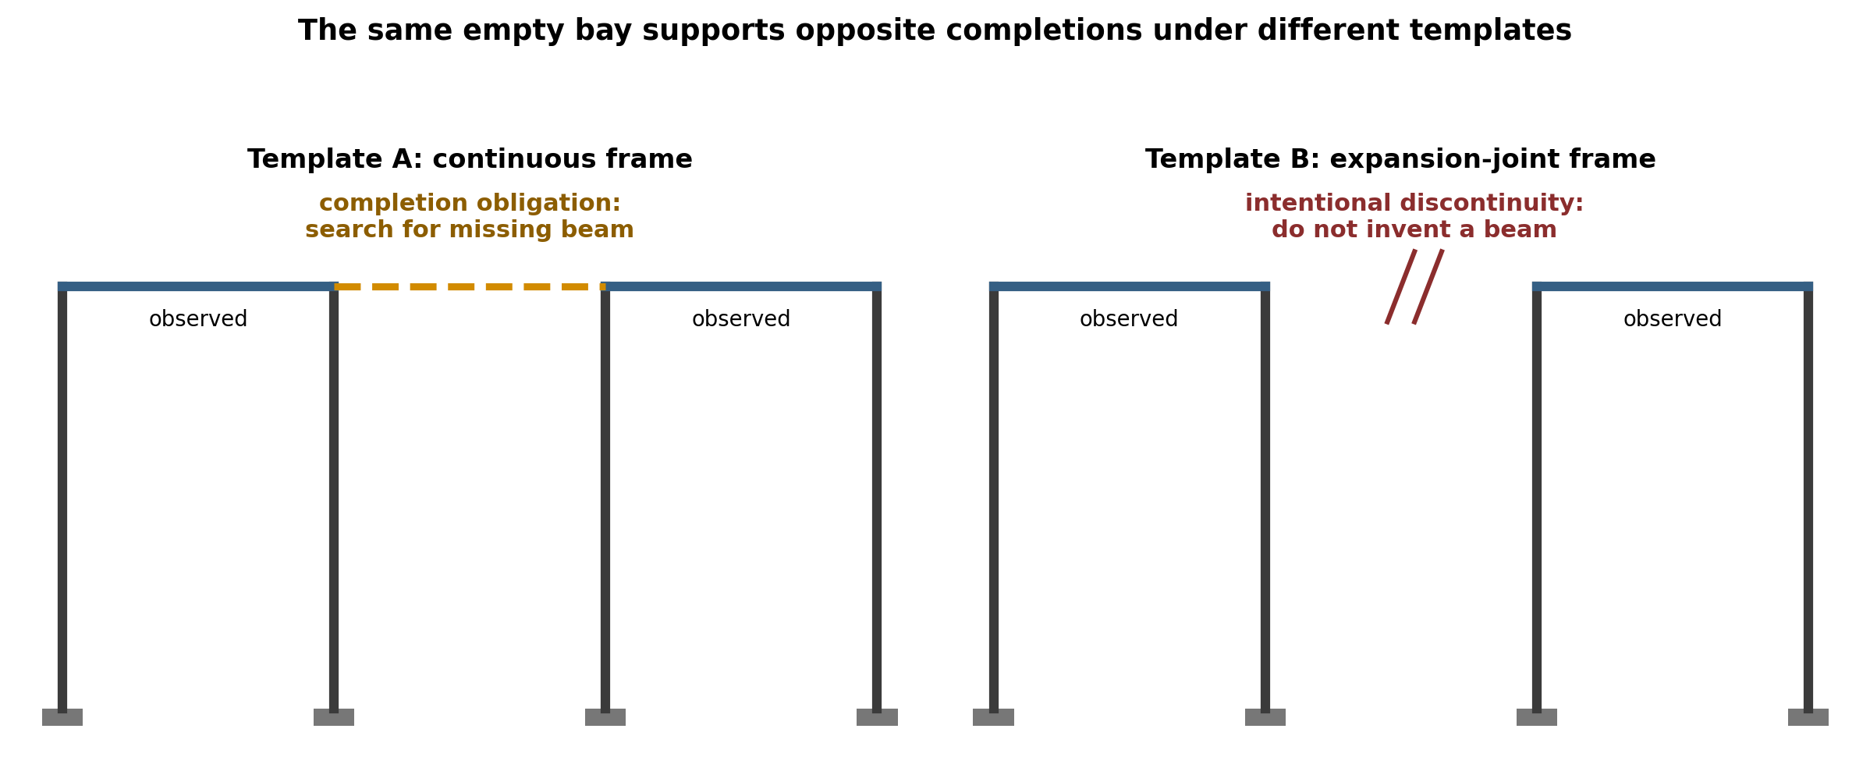
Figure 3. Identical observed residuals generate opposite completion obligations under different templates.
Candidate template | Interpretation of the empty bay | Required action
Continuous moment or gravity frame | a beam is expected and may be omitted, obscured, or misdrawn | search dimensions, details, schedules, and adjacent views; propose a lift
Expansion-joint frame | the discontinuity is intentional and structurally meaningful | preserve the gap; refuse automatic completion
Transfer or partial framing system | completion may exist at another level, offset, or elevation | refine the cover and search related views
Unknown template | the residual is underdetermined | defer commitment and retain alternatives

Table 3. The residual does not determine the completion; the template and lift do.
The same missing graphic component therefore supports opposite engineering predictions. This is why missing cannot be treated as a direct certification. A template can predict a nonexistent beam as confidently as it predicts a genuinely omitted one. The correct workflow is: nominate a template; audit its overlaps and restrictions; compute or approximate the lifting obstruction; and only then create completion obligations.
The torsor formulation has a practical advantage. It explicitly represents underdetermination. If H^0(K) is trivial, the completion is unique. If it has one free parameter, the system may know that a beam must exist but not its section, offset, or exact endpoint. With two or more degrees of freedom, the system should return a family of candidate completions rather than hallucinating one definitive object.

7. The Catcher Stalk Must Be a Typed Coefficient Stack
A convenient implementation would embed every catcher state into one real vector and apply one differentiable loss. That convenience is mathematically unsafe. Structural drawings carry continuous geometry, integer incidence, parity and orientation, semantic roles, and provenance. These objects have different algebra. A single real-valued stalk can average away a contradiction that is exact in a discrete channel.

7.1 Orientation demonstrates the failure of averaging
Take three overlapping regions with orientation transitions. An even number of reversals closes; an odd number does not. In Z/2 the holonomy is 0, 0, and 1 for the consistent, two-reversal, and one-reversal cases. A real embedding may produce means +1.000, -0.333, and +0.333. No threshold separates the parity classes because a valid even-reversal case lies below the invalid odd-reversal case. The embedding has not made the invariant noisy; it has erased it.
Configuration | Z/2 holonomy | Illustrative real mean | Engineering reading
all orientations consistent | 0 | +1.000 | globally orientable
two reversals | 0 | -0.333 | still globally orientable
one reversal | 1 | +0.333 | orientation contradiction

Table 4. A real average cannot recover a parity obstruction.

7.2 Required channels
Channel | Natural coefficients or structure | Typical drawing content | Audit
Geometric chart | SE(2), Aff(2), or metric/affine data | origin, scale, local axes, rotation, translation | nonabelian holonomy; product of transitions
Integral incidence | Z and finite quotients where needed | floor, bay and panel counts; multiplicity; winding | integer cochains; exact incidence constraints
Orientation/parity | Z/2 or orientation local system | mirroring, axis reversal, alternating web direction, front/back | parity or orientation class, exact
Semantic role | finite groupoid or typed relation system | grid, column centreline, slab edge, dimension line, chord, section cut | trivializability through allowed role transitions
Provenance/witness | immutable records and evidence graph | source primitive, annotation, drawing, revision, catcher, interior/overlap | construction guard and traceability

Table 5. Typed coefficient channels and their distinct audits.
The geometric channel is generally nonabelian. On a triple overlap, chart transitions satisfy g_ij g_jk g_ki = e rather than an additive sum. The corresponding nonabelian H^1 is generally a pointed set modulo local gauge changes, not an abelian group. The semantic-role channel is not a vector space either: roles do not subtract, and one-hot differences do not constitute a semantic audit. Allowed coexistence and transition rules must be encoded explicitly.
Integral incidence should not be rationalized prematurely. Tensoring integral data with real coefficients can remove torsion and parity information. Not every incidence problem contains torsion, but a system that only stores real embeddings cannot discover when it does.

8. Confidence Is a Filtration, Not a Coefficient
Machine-learning systems naturally attach confidence to detections. The unsafe move is to multiply a discrete class by confidence and place the result in the same feature vector. A low-confidence orientation reversal scaled toward zero is no longer represented as a reversal. Uncertainty about whether the evidence is real has been confused with absence of the invariant.
Confidence should instead define a filtration. For a threshold tau, retain evidence whose confidence is at least tau, construct the corresponding subcomplex, and run each channel's audit at full precision. Sweeping tau produces a persistence profile. A contradiction that survives across a wide interval is structurally durable; one that appears only when low-confidence primitives are admitted is likely drafting noise.
K_tau1 subseteq K_tau2 subseteq ... subseteq K_taun | (7)

Practical consequence: Continuous geometric residuals may use tolerances. Integer, parity, and role-validity channels require exact semantics on whatever evidence has entered the filtered complex. There is no "almost even" orientation loop.

9. From Pattern Catchers to a Structural World Model
The output should be more than a list of recognized symbols. It should be a multi-level structural world model that preserves how every higher-level object was assembled, audited, and completed. Each object should carry both engineering content and a certificate trail.
- Primitive layer: CAD entity identifier, geometry, layer, style, source drawing, revision, and confidence.
- Pattern layer: catcher type, minimum signature, claimed primitives, local chart, role assignments, and residual classes.
- Assembly layer: member chains, grids, bays, floors, frames, trusses, diaphragms, supports, openings, and interfaces.
- View layer: plan/elevation/section/isometric classification, projection relationships, scale, and cross-view correspondences.
- Audit layer: overlap witnesses, nerve or cover, channel-specific classes, unresolved contradictions, and refinement history.
- Lift layer: template identity, completion obstruction, family of valid completions, search obligations, and deferred alternatives.
- Provenance layer: evidence source, revision lineage, authoring or extraction operation, and commit/refusal decision.
This representation can connect 2D drawings to analytical models, BIM objects, calculation sheets, schedules, and site observations. A beam object should retain the linework that suggested it, the grid and floor patterns that contextualized it, the dimensions and tables that witnessed it, and the lift or audit that justified its inclusion.

10. A Hybrid AI and Rule-Based Implementation
The architecture does not require every component to be hand-coded. It defines where learned components may propose and where deterministic structures must audit. A practical implementation can combine geometric rules, computer vision, graph learning, language models, and algebraic-topological checks.
Stage | Likely implementation | Output
1. Parse and normalize | CAD API, PDF vector extraction, OCR only where necessary, layer/style normalization | typed primitives D0
2. Generate local candidates | rule-based catchers, object detectors, geometric transformers, graph neural networks | soft candidate states C_i
3. Build overlaps | shared primitives, spatial intersections, common dimensions, cross-view references | cover and witnessed nerve
4. Measure witnesses | independent geometry, text, dimensions, tables, and source comparisons | W_ij transition evidence
5. Run channel audits | linear cohomology, integer/parity checks, nonabelian holonomy, role groupoid constraints | accept, refine, or refuse
6. Select templates and lift | pattern grammar, retrieval, probabilistic template ranking, extension solver | completion family and search obligations
7. Restrict and commit | round-trip to primitives, provenance checks, engineering rules | audited structural world model
8. Learn from review | engineer corrections, versioned witness updates, offline catalogue expansion | improved catchers without erasing audit history

Table 6. An implementable pipeline for drawing intelligence.

10.1 Pattern catalogue and learned discovery
Early systems can begin with an authored catalogue: grid families, common column symbols, floor framing templates, portal frames, roof trusses, bracing layouts, stair and opening patterns, foundations, supports, and standard view conventions. The long-term research problem is catalogue growth. New motifs should be proposed from recurrent residual structures, but a newly learned catcher should not be committed merely because it compresses data well. Its minimum signature, restrictions, role transitions, and witness requirements must be validated against engineer-reviewed examples.

10.2 Refinement rather than forced commitment
When an audit fails, the system should not immediately discard all candidates. It can refine the cover, split a drawing region, admit another view, retrieve a detail, lower or raise the confidence filtration, or test an alternative template. Failure is therefore an actionable state: accept, refine, defer, repair, or refuse.

11. Engineering Use Cases

11.1 Drawing-to-analysis-model generation
A world model can generate nodes, members, plates, supports, offsets, and releases only after the structural hierarchy is inferred. The audit prevents a plausible graphical continuation from becoming an analytical member when dimension, support, or expansion-joint evidence contradicts it. The lift exposes where human confirmation is required.

11.2 Drawing consistency and revision checking
Plan, elevation, section, schedules, and analysis files can be treated as local sections over overlapping project domains. A revision that moves a grid line without updating a column schedule produces independently witnessed disagreement. Provenance identifies whether the conflict is inherited from an old revision or newly introduced.

11.3 Retrieval and engineering RAG
Instead of retrieving documents only by text similarity, a system can retrieve structurally corresponding patterns: the same truss topology, floor-bay organization, support class, or expansion-joint condition. The typed stack prevents semantic retrieval from confusing a mirrored or parity-incompatible detail with a valid precedent.

11.4 Anomaly detection and design review
Conventional anomaly detection identifies deviations from a learned average. The proposed system distinguishes three cases: an altered component that fails to glue; an extra component not explained by current patterns; and a partial pattern that admits one or more lifts. These require different engineering actions and should not be collapsed into one anomaly score.

11.5 Multi-view reconstruction
Plan, elevation, section, and isometric drawings provide different local charts on one structure. Their transitions are naturally affine or rigid transformations with scale and projection conventions. Nonabelian holonomy supplies a direct consistency test around a cycle of views, while the lift can reconstruct components visible in only one view or hidden in another.

12. Falsifiable Experimental Programme
A conceptual architecture becomes useful only when it generates comparisons that can fail. The following experiments can be run on real drawing sets with engineer-annotated ground truth.
Experiment | Compared systems | Primary metric | Refutation condition
Soft versus exclusive claims | overlapping catcher assignments versus hard partition | inconsistencies detected; downstream precision/recall | exclusive assignment performs equally well and overlap audits add no information
Independent versus derived witnesses | W_ij measured on overlaps versus delta of candidate interiors | nontrivial class detection and false-clear rate | candidate-derived witnesses catch the same cyclic inconsistencies
Typed stack versus real embedding | SE(2)/Z/Z2/groupoid channels versus monolithic R^n | orientation, parity, incidence and role-error detection | real embedding matches typed audits without special labels
Lift versus anomaly-only completion | template-conditioned extension solver versus missing-line classifier | correct missing/intentional-gap discrimination | lift produces no gain or mostly spurious completions
Confidence filtration versus weighted coefficients | persistent full-precision audits versus confidence-scaled discrete values | stability under noise and drafting artifacts | weighted values preserve all discrete classes equally well
Round-trip restriction | world-model proposal with and without restriction to source primitives | engineering acceptance and traceability | restriction adds cost but no reduction in unsafe commits

Table 7. Falsifiable tests for the proposed architecture.
A suitable benchmark should contain clean drawings, incomplete drawings, intentional discontinuities, cross-view contradictions, mirrored details, off-by-one panel counts, dimension conflicts, and revision mismatches. Evaluation should separate proposal quality from audit quality. A system may propose the right template but fail to witness it, or propose the wrong template and be correctly refused.

13. Scope, Limitations, and Open Engineering Debts
Four debts should be resolved before claiming a production system.
- Pattern-catalogue debt: the initial catalogue is authored. A defensible method for learning new pattern types remains open.
- Restriction-map debt: restrictions are the model. Their specification, learning, versioning, and review require explicit engineering governance.
- Role-groupoid debt: allowed role coexistence and transitions encode the ontology. A wrong ontology can make an invalid drawing appear consistent.
- Computational debt: nonabelian and mixed-coefficient audits are more expensive than one vector loss. Selective escalation and sparse covers will be required.
The framework also does not claim that every drawing contradiction is cohomological or that topology should replace engineering rules. Geometry and deterministic logic remain the fastest way to catch many grids, columns, bays, floors, and trusses. Homology can characterize connected components, cycles, and cavities of detected geometry. Cohomology audits whether local meanings coexist. Extension lifting asks which completions are licensed. Each tool has a separate jurisdiction.
Finally, the account of experienced engineers is a design hypothesis based on practitioner introspection. Cognitive experiments would be required to establish whether human experts actually use an equivalent two-directional and lifting process. The architecture stands or falls primarily as an engineering system, not as a literal model of the brain.

14. Discussion: From Fluent Recognition to Defensible Drawing Intelligence
The dominant AI pattern is to map inputs into a common real vector space, optimize a loss, and decode a label or object. That strategy is powerful for proposal generation but insufficient for professional engineering. A structural drawing carries invariants that should not be averaged, meanings that must be compared on overlaps, and absences whose interpretation depends on the selected template. The architecture developed here does not reject machine learning. It assigns machine learning its strongest role: generating and ranking candidate patterns. It then adds structures that a learned average does not supply automatically.
The three-operation formulation also clarifies responsibility. Cosheaf ascent is creative and permissive: it proposes larger wholes from local evidence. Sheaf audit is restrictive: it forces the proposal to meet independently measured overlaps and allows refusal. Extension lifting is constructive but conditional: after the template survives, it identifies what completions remain possible and where evidence should be sought. None can replace the others.
For engineering practitioners, the practical outcome is a system that does not merely say, 'a beam is probably missing.' It says, 'under the continuous-frame template, the current observation has a vanishing completion obstruction and admits this family of beam completions; under the expansion-joint template no beam is required; these dimensions, role assignments, and cross-view witnesses currently favour the second interpretation; therefore automatic insertion is withheld.' That is a qualitatively different standard of drawing intelligence.

15. Conclusion
Experienced engineers read structural drawings by reconstructing meaning that the file does not explicitly contain. A machine intended to support engineering judgment must therefore do more than detect graphical primitives or embed them in a feature space. It must construct a structural interpretation, verify that interpretation against local evidence, and handle incomplete drawings without confusing template-conditioned completion with unconditional certainty.
This paper has proposed a three-operation architecture. Cosheaf-like ascent builds motifs, assemblies, views, and structural systems covariantly. Sheaf-like audit restricts those proposals back to independently witnessed overlaps and determines whether local meanings can coexist. Extension lifting uses the connecting map of a short exact sequence to determine whether a partial pattern can be completed under a template and to represent the resulting family of completions. The lifting reframe is the central result: a missing component is a coordinate of a valid lift, not a certification by itself.
Implementation requires a typed coefficient stack rather than one real-valued stalk, an external confidence filtration, soft overlapping claims, witnessed higher intersections, and a strict separation between candidate states and overlap witnesses. Together these requirements provide a route from CAD primitives to structural world models that can explain, revise, defer, and refuse. The proposed standard for Engineering AGI is therefore concise: cosheaf up, sheaf down, lift across - and commit only after the round trip succeeds.

References
Battaglia, P. W., Hamrick, J. B., Bapst, V., et al. (2018). Relational inductive biases, deep learning, and graph networks. arXiv:1806.01261.
Bredon, G. E. (1997). Sheaf Theory (2nd ed.). Springer.
Curry, J. (2014). Sheaves, Cosheaves and Applications. Doctoral dissertation, University of Pennsylvania.
Eastman, C., Teicholz, P., Sacks, R., and Liston, K. (2018). BIM Handbook: A Guide to Building Information Modeling for Owners, Designers, Engineers, Contractors, and Facility Managers (3rd ed.). Wiley.
Edelsbrunner, H., and Harer, J. (2010). Computational Topology: An Introduction. American Mathematical Society.
Ghrist, R. (2014). Elementary Applied Topology. Createspace.
Ghosh, D. P. (2026). The Geometry of Defensible Action: An Enrichment-Ladder Theory of Certifiable Intelligence. DOI: 10.13140/RG.2.2.24454.54080.
Ghosh, D. P. (2026). Hypercovering and Descent: A Thalamo-Cortical Algorithm for Defensible Multimodal Gluing. DOI: 10.13140/RG.2.2.31337.45929.
Ghosh, D. P. (2026). Nerve-Attention: The Simplicial Domain of Audit. DOI: 10.13140/RG.2.2.27630.57925.
Ghosh, D. P. (2026). The Restriction Vertex: The Algebra of Restriction, Its Realization as Cortical Feedback, and the Executive Veto. DOI: 10.13140/RG.2.2.18717.68323.
Ghosh, D. P. (2026). The Direct and Indirect Axes and the Construction AGI Island. DOI: 10.13140/RG.2.2.26647.53922.
Ghosh, D. P. (2026). Which Way Do the Arrows Run? Pattern Ascent, Cohomological Audit, and the Two Directions of Reading a Drawing. Exploration note.
Ghosh, D. P. (2026). Cosheaf Up, Sheaf Down, Lift Across: The Coefficient Stack, and Why 'Missing' Is a Lifting Problem Rather Than a Certification. Exploration note.
Hatcher, A. (2002). Algebraic Topology. Cambridge University Press.
Kipf, T. N., and Welling, M. (2017). Semi-Supervised Classification with Graph Convolutional Networks. International Conference on Learning Representations.
Robinson, M. (2014). Topological Signal Processing. Springer.

Author Biography
Debi Prasad Ghosh, Ph.D., is Founder and Principal Engineer at Debias Parametric Guru. He is a civil and structural engineering professional with approximately twenty-five years of experience spanning structural analysis, design automation, finite-element software, industrial and infrastructure engineering, structural dynamics, and AI-enabled engineering systems. His doctoral research addressed artificial intelligence in mechanics. His current work focuses on Construction AGI, auditable engineering intelligence, parametric design, knowledge-driven automation, and mathematical architectures for defensible machine reasoning.

