Iso Within, Exact Across
  - A Long-Exact-Sequence Architecture for Multidiscipline Engineering Integration and Project Revision Control

Debi Prasad Ghosh, Ph.D., debiprasadghosh@gmail.com
Founder & Principal Engineer, Debias Parametric Guru, Kolkata, India
Civil & Structural Engineer | B.E., IIEST Shibpur | M.E., Jadavpur University | Ph.D., IISc Bengaluru
25+ years in structural engineering, design automation, finite-element workflows, and engineering AI
Practitioner research paper | Defensible Engineering Intelligence

Abstract
Architecture, Civil, Structural, Mechanical, Piping, Electrical, and Instrumentation & Automation each maintain discipline-specific drawings, models, calculations, and assumptions. Within a discipline, a drawing-to-model interface may be lossless and therefore isomorphic. Across disciplines, however, the project must be assembled from restricted interface views, and from one revision to the next the integrated project must retain a defensible account of what changed. This paper develops a practitioner-facing mathematical architecture for those two problems. Horizontal integration is formulated as descent: the combined model is the equalizer of discipline restrictions, datum disagreements are audited by cocycle or holonomy closure, transform interfaces are tested by the global rank of their restriction operator, multi-party occupancy is treated as joint constraint satisfaction, and missing seam deliverables are handled by a separate short-exact-sequence lifting gate. Vertical project evolution is represented by the long exact sequence of a pair when revision n embeds in revision n+1, or by a mapping cone or zigzag when revisions delete, relocate, or reclassify objects. The resulting two-axis model distinguishes internal isomorphism, coordination coherence, interface completeness, and revision provenance. It also prevents three recurrent implementation errors: treating pairwise clearance as joint feasibility, treating graph cycle rank as general sheaf cohomology, and interpreting exactness of a derived sequence as certification of engineering correctness. The paper concludes with an executable gate architecture, a relative Mayer-Vietoris provenance model, and a structured claim schema that requires the coefficient system and disabled regime to travel with every mathematical result.
Keywords: multidiscipline engineering integration; isomorphism; long exact sequence; relative homology; descent; Mayer-Vietoris; engineering revisions; interface register; sheaf cohomology; Construction AGI
Third companion paper
This paper follows From CAD Primitives to Structural Meaning and Short at Every Step, Exact at Every Interface. It moves from drawing completion to multidiscipline integration and revision provenance.

Practitioner Summary
- Use isomorphism only within a discipline when its coordination model contains exactly the same relevant information as its issued representation; retain the specified map, not merely the fact that an isomorphism exists.
- Treat integration across disciplines as an equalizer or descent problem. The combined project is the family of discipline states that agree on every declared interface.
- Separate five gates: direct residual, joint feasibility, datum-loop closure, transform-span, and seam completion. They answer different questions and use different mathematics.
- Use the long exact sequence of (X_{n+1}, X_n) only for monotone revisions. Use a mapping cone or zigzag when elements are deleted, relocated, merged, or reclassified.
- Exactness of the long exact sequence accounts for change; it does not certify that revision n+1 is coordinated, complete, safe, or releasable.
- Keep the full private discipline model distinct from its coordination image A_i subset X. The pair (X,A_i) measures project content relative to what that discipline carries into coordination.
- Make the interface register a first-class model. Integration can create sleeve, support, fire-stopping, earthing, access, and responsibility objects that belong to no discipline-local model.
- State the coefficient system, restrictions, jurisdiction, disabled regime, falsifier, and executable guard with every audit claim.

1. Introduction
Large engineering projects are not designed by one model. They are negotiated among discipline models that differ in purpose, vocabulary, granularity, and ownership. Architecture organizes space and use. Civil engineering establishes grading, roads, drainage, and external infrastructure. Structural engineering carries loads. Mechanical and piping systems move air, fluids, and equipment services. Electrical systems distribute power. Instrumentation and automation impose sensing, control, interlock, and communication requirements. Each discipline is internally meaningful, but the project exists only when these meanings coexist in one buildable state.
Digital coordination tools often flatten this structure into file federation and geometric clash detection. That is useful but incomplete. A combined model can be geometrically clash-free while missing a fire-stop, a trimming detail, an earthing bridge, an access envelope, a design responsibility, or a release witness. Conversely, a pair of objects may geometrically overlap yet be deliberately coordinated because one is an opening or reserved zone. The required architecture must therefore distinguish representation, compatibility, feasibility, completion, and revision provenance.
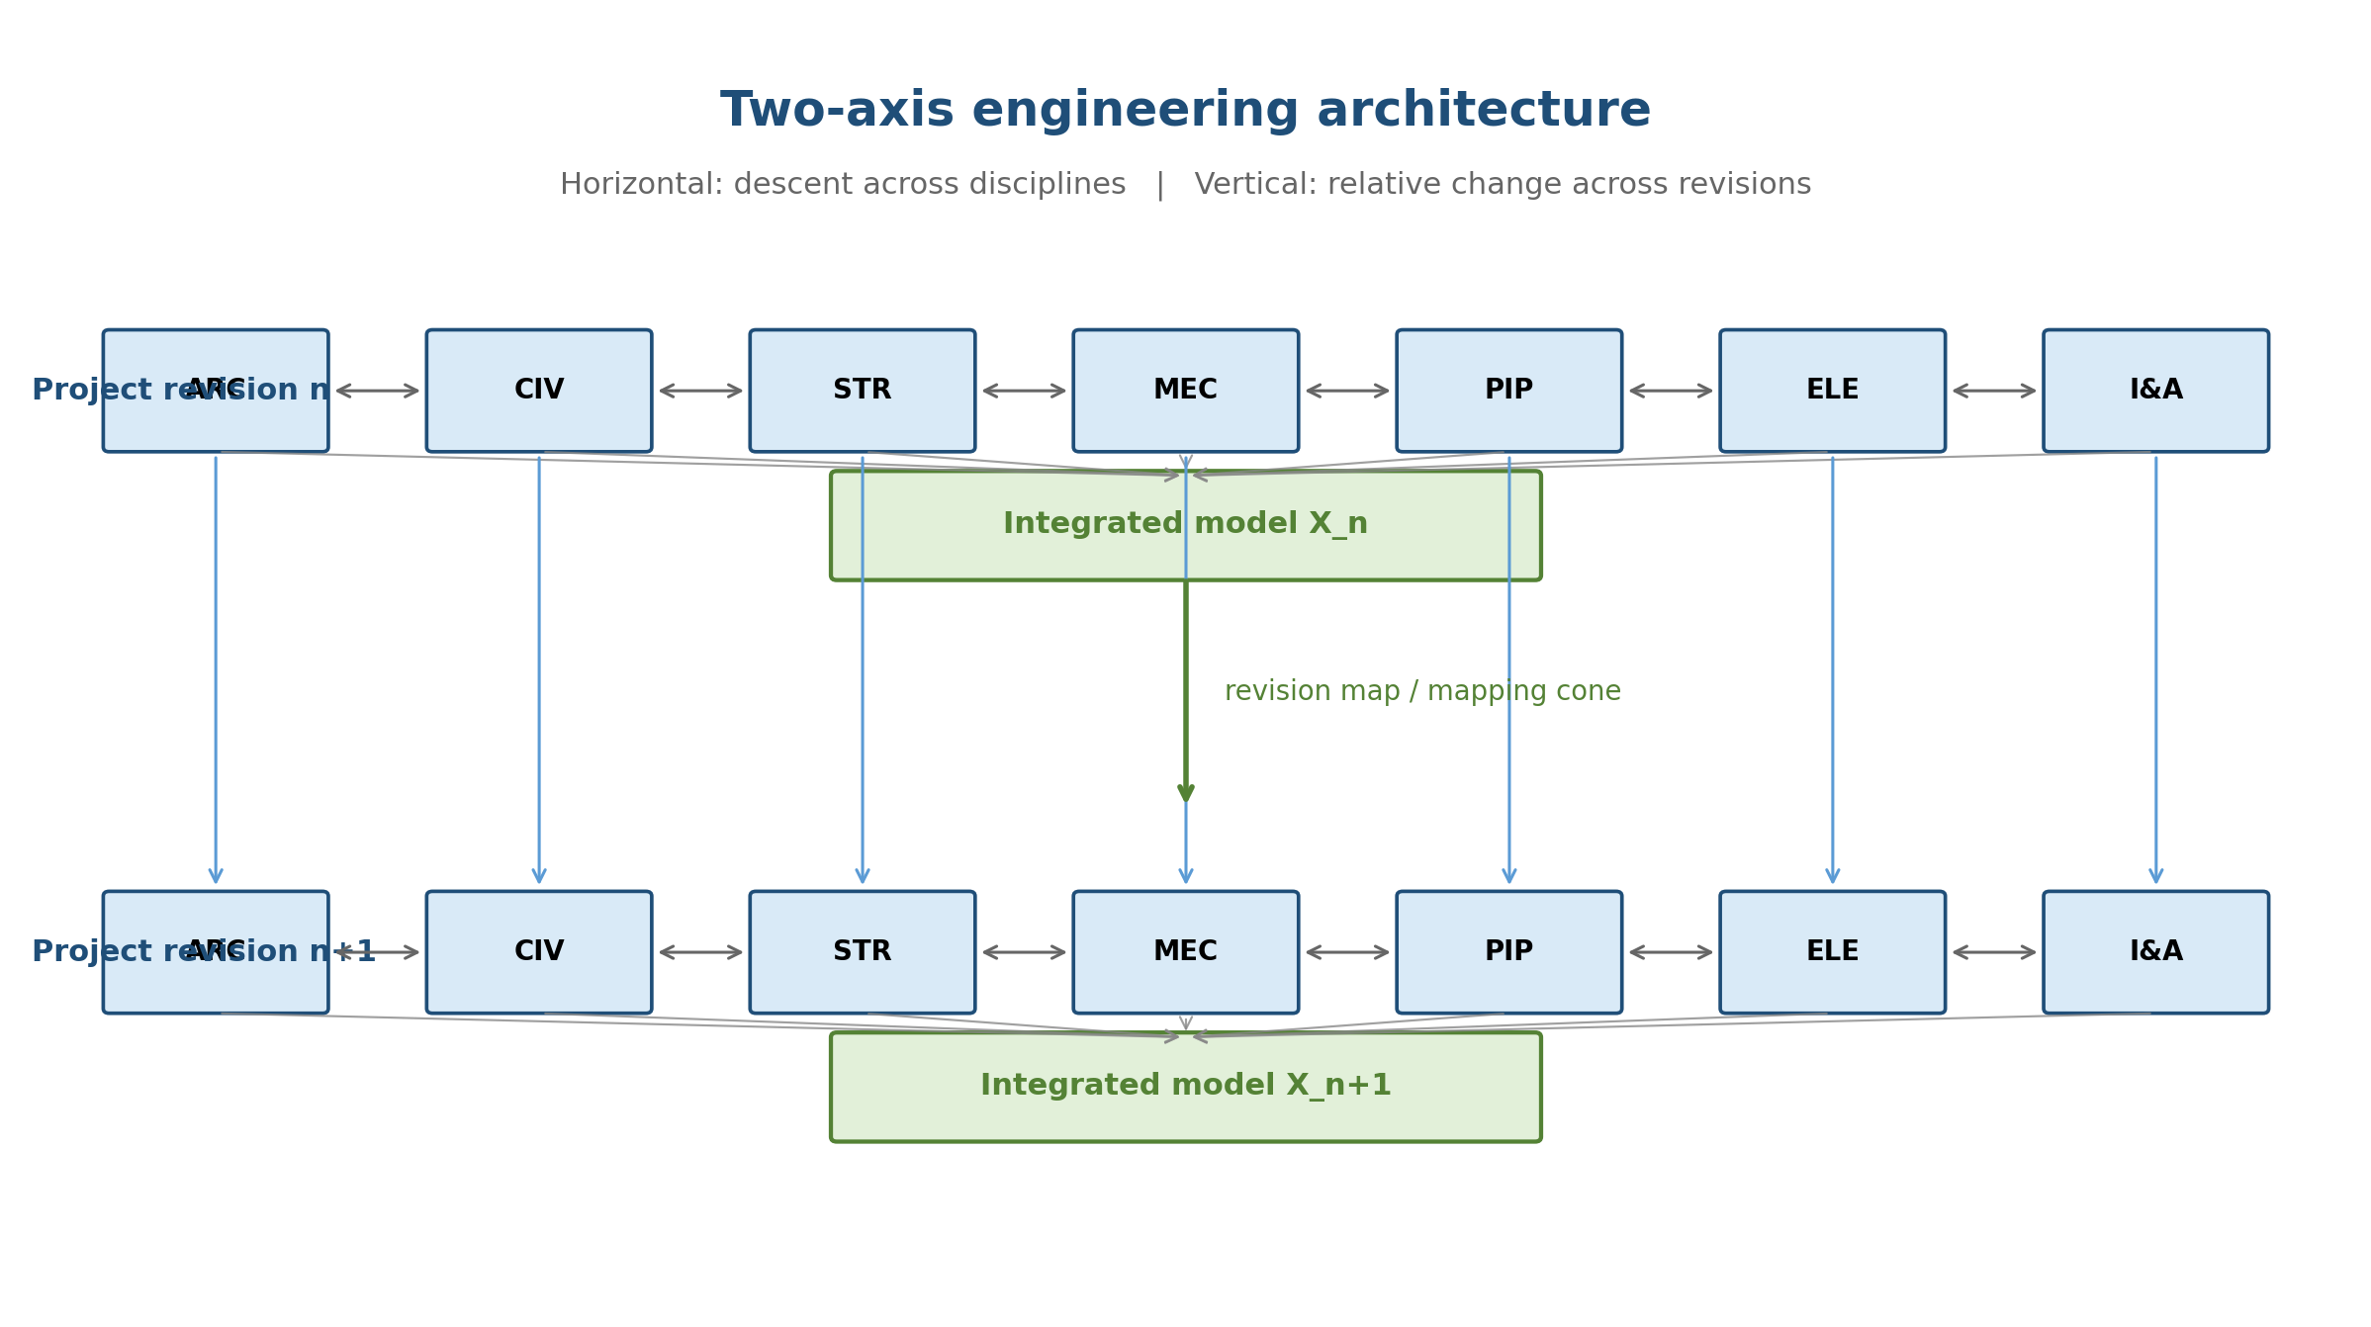
Figure 1. The project has two independent axes: descent across disciplines and relative evolution across revisions.
The preceding companion papers developed the vertical drawing-intelligence problem. A partial drawing was modeled through a tower of short exact sequences: one hidden completion layer, one complete pattern layer, and one observable layer at each adjacent semantic interface. The present paper addresses the next scale. First, how do discipline-specific models integrate into one project? Second, how does project revision n become revision n+1 without losing the origin, attachment, and responsibility of each change?
The answer is not one universal exact sequence. It is a two-axis architecture. Across disciplines, integration is descent over shared interfaces. Across revisions, project evolution induces a long exact sequence in relative homology, or a mapping-cone sequence when the revision is not a literal inclusion. The same project may therefore be internally isomorphic within a discipline, nontrivially constrained across disciplines, and exact in its accounting of revision change while still failing engineering coordination.
This paper is conceptual and practitioner-oriented. The algebraic-topological constructions are standard; the contribution is their separation into executable engineering gates, together with their explicit disabled regimes and modelling jurisdictions.

2. The Engineering Problem: Seven Models, One Project, Many Revisions
Let D denote the discipline set {ARC, CIV, STR, MEC, PIP, ELE, I&A}. At revision n, each discipline maintains a private model ẼA_d^n and exposes a coordination representation A_d^n. The integrated model is X_n. The distinction between ẼA_d^n and A_d^n is essential: a structural analysis model contains load combinations, solver settings, code interpretations, and design checks that need not appear in the combined coordination model. The coordination image A_d^n may be treated as a subobject of X_n; the complete private model usually cannot.
Ã_dⁿ —^{r_d}→ A_dⁿ ↪ X_n
The projection r_d is intentionally lossy. It selects what other disciplines are entitled to see and what the integrated project needs to coordinate. This creates three distinct questions:
1. Is the discipline coordination representation faithful to the relevant discipline information?
2. Can the seven coordination representations coexist as one integrated project?
3. What changed when the integrated project moved from revision n to revision n+1?
Isomorphism addresses the first question under a strong zero-kernel condition. Descent and constraint satisfaction address the second. Relative homology and mapping cones address the third. Collapsing these questions into one generic notion of exactness removes the condition that tells an implementation which gate to run.
Object | Engineering meaning | Typical content
Ã_dⁿ | Private discipline model | assumptions, calculations, analysis states, detailed objects
A_dⁿ | Coordination image | shared geometry, loads, interfaces, release attributes
A_deⁿ | Pairwise seam | penetration, support, datum, clearance, transfer data
A_defⁿ | Triple coordination zone | corridor, riser, plantroom, equipment envelope
X_n | Integrated project state | compatible discipline tuple plus authored seam objects

3. Isomorphism Within a Discipline

3.1 The degenerate short exact sequence
0 → A —f→ B → 0
Exactness at A gives ker f = 0, so f is injective. Exactness at B gives im f = B, so f is surjective. In an abelian category, f is therefore an isomorphism. The result is mathematically elementary but architecturally decisive: it is a scope condition saying that no completion machinery is needed at that interface.
0 → A —f→ B → 0 exact ⇔ f is an isomorphism
For discipline d, the completion sequence is
0 → K_d → F_d → Q_d → 0
If K_d = 0, then F_d ≅ Q_d. The observable coordination representation already carries the complete discipline state relevant to that interface. The connecting obstruction is identically zero, the lift is unique, and there is no torsor, branching, optimization, or backtracking.

3.2 The isomorphism is a specified translation
Knowing only that A and B are isomorphic is weaker than possessing the actual map f. The set Iso(A,B), when nonempty, is a torsor under automorphisms. Engineering models can be equivalent while admitting different axis permutations, grid labels, unit conventions, member numbering schemes, or coordinate frames. The sequence identifies the particular reversible translation that preserves provenance.
Practitioner rule
Where K_d = 0, translate rather than complete. Retain and audit the explicit isomorphism; do not merely contract the two representations and discard the map.

3.3 Internal completeness does not imply project coherence
Even if every discipline satisfies K_d = 0, the integrated project may still be inconsistent. A constant datum channel on a cycle can have nonzero H¹ while every discipline drawing-to-model map is an isomorphism. Nothing is hidden within a discipline, yet the disciplines fail to agree globally. Completion and gluing are independent gates.
Completion obstruction | Coordination obstruction | Project state
0 | 0 | complete and coherent
0 | nonzero | complete but inconsistent
nonzero | 0 | incomplete but coherent so far
nonzero | nonzero | incomplete and inconsistent

4. Integration Across Disciplines Is Descent
For each pair of disciplines d and e sharing an interface, let F_de be the interface object and let ρ_{d,de}: F_d → F_de and ρ_{e,de}: F_e → F_de be restriction maps. An integrated state is a tuple whose restrictions agree at every seam.
I = { (s_d)_d : ρ_{d,de}(s_d) = ρ_{e,de}(s_e) for every declared interface de }
Categorically, I is an equalizer or inverse limit. In an additive setting, define the degree-zero Čech differential
(δ⁰s)_{de} = ρ_{e,de}(s_e) − ρ_{d,de}(s_d).
Then I = ker δ⁰, and the beginning of the descent complex is
0 → I → ∏_d F_d —δ⁰→ ∏_{d<e} F_de —δ¹→ ∏_{d<e<f} F_def → ⋯
Exactness at ∏F_d holds by the definition of I. Exactness at the pairwise-interface term requires im δ⁰ = ker δ¹. The quotient ker δ¹ / im δ⁰ is H¹. A nonzero class is a discrepancy pattern satisfying the higher closure condition but not repairable by permitted discipline-level adjustments.
Do not say “integration is an exact map”
The precise statement is that the descent complex is exact at a specified term. Exactness is a property of the sequence at that object, not a generic adjective attached to the coordination software.

5. Five Independent Integration Gates
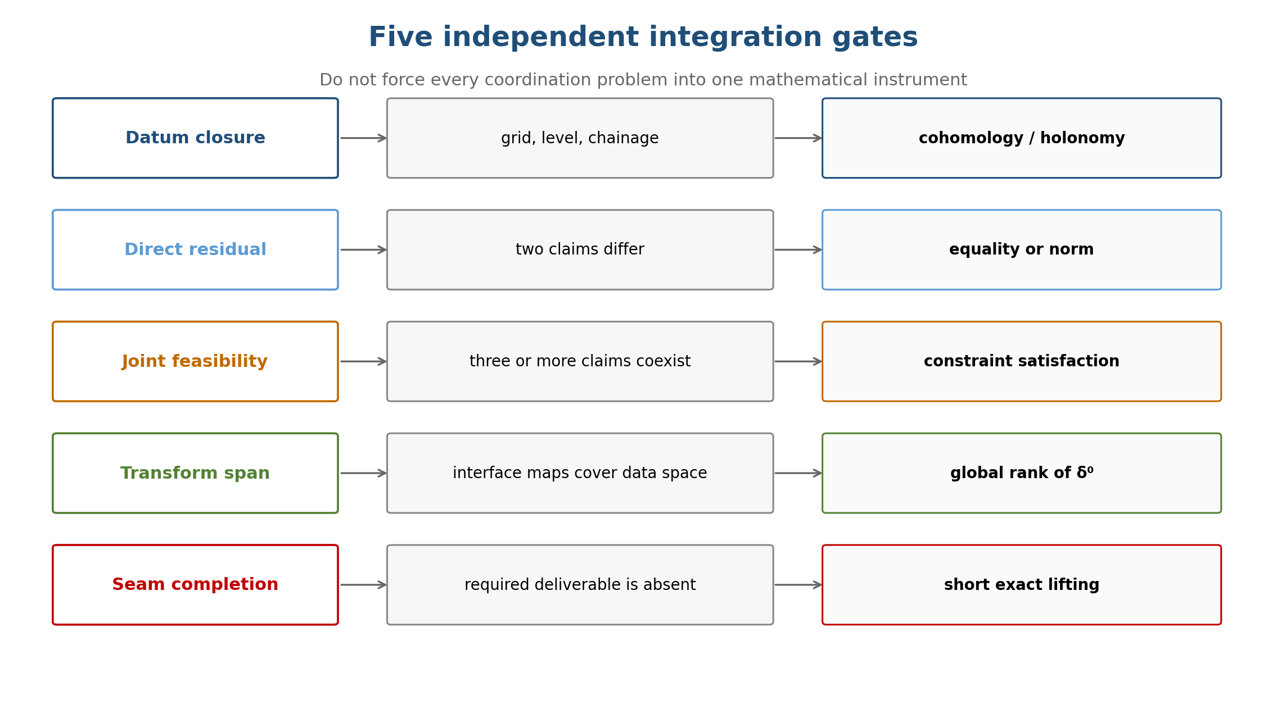
Figure 2. Integration requires several independent gates; no single invariant is entitled to answer all coordination questions.
The project must classify the engineering claim before selecting the audit. A single interface can carry several channels simultaneously. A pipe support may include a shared elevation datum, a force transformation, a discrete support type, an inequality clearance envelope, and a missing approval witness. The correct decomposition is by claim channel, not by whole interface.
Gate | Question | Mathematical instrument | Typical example
Direct residual | Do two shared claims differ? | equality test or norm | different opening coordinates
Joint feasibility | Can all claims coexist? | constraint satisfaction | beam + duct + tray in one zone
Datum closure | Can pairwise datum shifts be globally trivialized? | additive cocycle or holonomy | grid or benchmark loop misclosure
Transform span | Can discipline exports express every interface discrepancy? | global rank / structural rank of δ⁰ | load-to-reaction or demand-to-capacity interface
Seam completion | Are required interface deliverables present? | short exact lifting | sleeve, fire stop, support steel, earthing bridge

6. Why Cycle Rank Is Not General Coordination Capacity
For a finite-dimensional cellular sheaf on a graph nerve, C⁰ is the direct sum of discipline stalks and C¹ is the direct sum of interface stalks. With no witnessed 2-simplices,
H¹ = coker δ⁰, dim H¹ = dim C¹ − rank(δ⁰).
If every edge stalk has dimension n, this becomes
dim H¹ = nE − rank(δ⁰).
The graph cycle rank β₁ = E − V + C equals dim H¹ only for a rank-one constant sheaf. For rank r constant coefficients, dim H¹ = rβ₁. With nonconstant restrictions or holonomy, the two quantities can diverge in either direction: H¹ may vanish on a cycle or be nonzero on a tree.
The obstruction is global failure of the incidence-restriction operator to span C¹. It can arise from local interface span deficiency or from global coupling. Edgewise surjectivity is not sufficient because the same discipline variable participates in all incident edge equations.
H¹ = (⊕_e F(e)) / im(δ⁰ : ⊕_v F(v) → ⊕_e F(e)).
A wide model domain mV ≫ nE makes full row rank possible but does not guarantee it. The block sparsity pattern must permit structural full row rank. For every interface subset S, the exposed capacity of the incident disciplines must be sufficient for the data demanded by S. Only after this structural test should numerical or symbolic rank be used.
Coefficient-system guard
Every cohomological claim must state the base ring or group, stalks, restriction maps, holonomy, and complex dimension. “Coefficients over R” is not enough: two R-valued sheaves on the same triangle can have different H¹.

7. Datum Closure and Higher-Order Feasibility

7.1 Datum loops are genuinely cohomological
Suppose three disciplines maintain local origins and publish pairwise shifts z_AB, z_BC, and z_CA. A global origin assignment exists exactly when the loop sum vanishes.
z_AB + z_BC + z_CA = 0.
The shifts (3.0, −5.0, 2.0) close and can be repaired by discipline re-originings. The shifts (3.0, −5.0, 2.5) misclose by 0.5; no assignment of local origins can reproduce all three. This is a genuine class. A hub-only comparison topology has no redundant datum loop and therefore cannot test loop closure.

7.2 Pairwise clearance is not joint feasibility
A 600 mm corridor zone contains a 300 mm structural beam, a 250 mm duct, and a 200 mm cable tray. Every pair occupies at most 550 mm, yet the three together require 750 mm. Pairwise clash detection is structurally incapable of evaluating the joint inequality if it never constructs the shared three-discipline zone.
The topological rule has two sides. A clique is not automatically a simplex: three pairwise interfaces do not prove that one common coordination zone exists. Conversely, once a shared triple zone is witnessed, it must be represented and tested; reducing it to its edges omits the constraint that can fail.
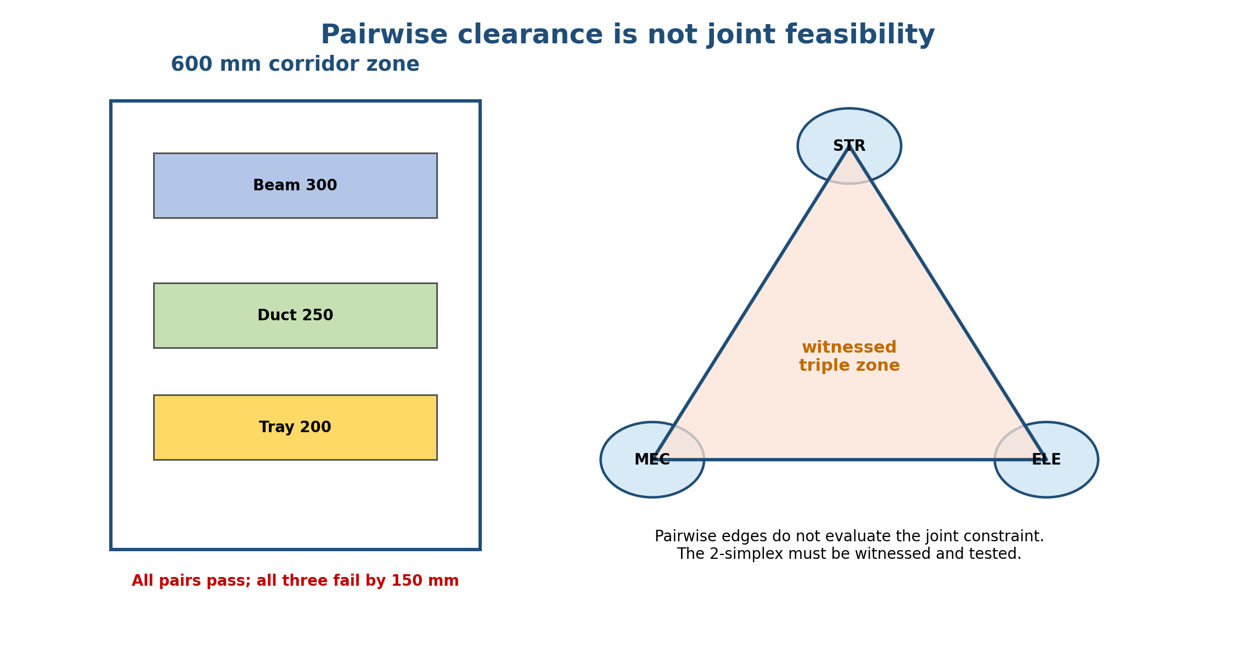
Figure 3. A witnessed three-discipline zone can fail even when every pair passes. This is a joint-feasibility result, not a cohomology computation.

Error | Representation failure | Engineering consequence
Invented simplex | fill a triangle without a witnessed common zone | false multi-party constraint
Omitted simplex | real common zone represented only by pairwise edges | missed joint clash or capacity failure

8. The Completion Problem Reappears at the Seam
Even when every discipline is internally complete, integration can create objects that are not contained in any discipline-local model: penetration sleeves, reinforcement trimming, fire stopping, support steel, access envelopes, movement-joint continuity, control interlocks, and responsibility assignments. These should be modeled as explicit seam objects rather than assumed to belong implicitly to one participant.
0 → K_de → F_de^complete → Q_de^observed → 0
The descent gate asks whether discipline restrictions agree at the seam. The lifting gate asks whether the seam specification itself is complete. They are independent. An interface can be mutually agreed yet incomplete, or fully specified yet contradictory.
The interface register is a model, not a spreadsheet afterthought
It is the authored representation of K_integration: who owns each sleeve, support, fire-stop, access zone, continuity detail, approval, and release witness. When these objects are explicitly modeled, the corresponding completion kernel can be driven to zero.

9. Project n to Project n+1: The Long Exact Sequence

9.1 Monotone revision
When revision n is genuinely included in revision n+1, there is a short exact sequence of chain complexes
0 → C_•(X_n) → C_•(X_{n+1}) → C_•(X_{n+1},X_n) → 0.
It induces the long exact sequence
⋯ → H_k(X_n) → H_k(X_{n+1}) → H_k(X_{n+1},X_n) —∂_n→ H_{k−1}(X_n) → ⋯
The relative group H_k(X_{n+1},X_n) represents project-level structure introduced by revision n+1 relative to revision n. The connecting map records how that new structure attaches to, terminates on, or creates obligations in the earlier project state.
Relative object | Engineering reading
new relative 0-class | new isolated item, zone, responsibility, or unconnected deliverable
new relative 1-class | new routing, loop, continuity path, or interface cycle
connecting image in H_{k−1}(X_n) | old-project supports, terminations, openings, loads, or approvals required by the change

9.2 Exactness accounts for change; it does not certify design
The long exact sequence is exact because it is derived from an exact sequence of chain complexes. This means that every class is algebraically accounted for: the image of one map is the kernel of the next. It does not mean that X_{n+1} is coordinated, complete, code-compliant, constructible, or safe. A revision can be perfectly represented by the long exact sequence and still contain a serious clash or missing interface item.
Critical separation
Relative exactness answers “what changed and where does it attach?” Descent and feasibility answer “can the disciplines coexist?” Lifting answers “is the interface complete?” Never substitute one verdict for another.

9.3 Non-monotone revision
Real revisions delete, relocate, split, merge, and reclassify objects. Then X_n is not literally a subset of X_{n+1}. Given a trustworthy revision map f_n: X_n → X_{n+1}, use the mapping cone.
⋯ → H_k(X_n) —(f_n)_*→ H_k(X_{n+1}) → H_k(Cone f_n) → H_{k−1}(X_n) → ⋯
The cone records the generalized difference between versions. When no single forward map honestly represents the revision, use a zigzag through a common comparison object, such as the retained common part.
X_n ← X_n ∩ X_{n+1} → X_{n+1}.
This avoids pretending that deletion was addition or that a relocated object retained an identity that the provenance ledger cannot support.

10. Each Discipline as a Subobject of the Combined Project
Let A_i^n ⊆ X_n be the coordination image of discipline i, not its entire private model. The pair (X_n,A_i^n) induces
⋯ → H_k(A_i^n) → H_k(X_n) → H_k(X_n,A_i^n) —∂_i^n→ H_{k−1}(A_i^n) → ⋯
The relative term describes integrated-project content modulo what discipline i already carries. Its boundary identifies the obligations that project-level features impose on that discipline. A new pipe route may be a Piping object, but its relative boundary against Structural can identify support reactions, sleeves, trimming, and embedded plates.
A revision map of pairs produces a commutative ladder of long exact sequences. This tracks change inside the discipline, change in the combined project, change relative to the discipline, and migration of interface obligations between revisions.
(X_n,A_i^n) → (X_{n+1},A_i^{n+1}) induces a natural ladder of long exact sequences.
Practitioner report example
Revision n+1 introduced three new project-level interface classes relative to Structural. Two terminate on existing beams as support obligations; one remains unassigned at a slab penetration.

11. Where Did the Change Originate? Relative Mayer-Vietoris
The individual pair sequences describe the project relative to one discipline at a time. They do not by themselves reconstruct how all disciplines assemble. For a cover X = ∪A_i, Mayer-Vietoris and its higher Čech form retain pairwise, triple, and higher overlaps.
E₁^{p,q} = ⊕_{i₀<⋯<i_p} H_q(A_{i₀…i_p}^{n+1}, A_{i₀…i_p}^{n}) ⇒ H_{p+q}(X_{n+1},X_n).
The overlap degree p provides revision provenance:
p | Origin of change | Example
0 | inside an individual discipline | new pipe route or new beam
1 | pairwise interface | new sleeve, support, or load transfer
2 | triple coordination zone | route-support-tray conflict in a corridor
3+ | higher integration seam | plantroom or shutdown sequence involving many disciplines

The total relative group records the project change. The spectral sequence identifies whether the change was born inside a discipline, at a pairwise seam, or in a higher coordination zone. This is the difference between a revision list and a defensible revision provenance system.

12. Executable Architecture for an Engineering Platform
An industrial implementation should not begin with homology software. It should begin with explicit schemas for disciplines, interfaces, claims, witnesses, and revision maps. The algebraic objects should be compiled from those schemas and validated before any audit runs.
Layer | Required data | Build-time guard | Runtime output
Discipline translation | F_d, Q_d, map p_d | test kernel and explicit isomorphism where K_d=0 | translation or lift requirement
Interface restriction | F_de and restriction maps | type channel; verify structural rank and provenance | residual or span deficiency
Higher zone | witnessed F_def… | refuse clique completion without common-domain evidence | joint feasibility verdict
Seam completion | K_de, F_de, Q_de | ordered exactness diagnostics stalkwise | missing deliverables and lift family
Revision | inclusion, map, or zigzag | verify identity/provenance of objects across versions | relative classes and attachments
Release | claim objects and witnesses | schema-validation of jurisdiction and disabled regime | signable engineering decision

12.1 Gate orchestration
1. Classify each claim channel: datum, transform, direct residual, feasibility, completion, or provenance.
2. Test whether the discipline interface is isomorphic; when K_d = 0, skip lift-and-search but preserve the explicit map.
3. Build the interface nerve from witnessed shared domains. Do not infer higher simplices from pairwise links.
4. Run direct residual and joint feasibility gates before invoking cohomology.
5. Enable datum closure only with a declared constant or local coefficient system; enable transform H¹ only after structural-rank analysis shows the gate can fire.
6. Run seam lifting on explicit interface deliverables and report exactness stalkwise.
7. Choose inclusion, mapping cone, or zigzag for each revision transition.
8. Assemble revision provenance by discipline and overlap degree; never interpret sequence exactness as a release certificate.

12.2 Practitioner dashboard
A useful dashboard does not show one project health score. It reports independent fields and their locations:
- Discipline translation: isomorphic, lift required, or visibility conflict.
- Coordination residuals: declared datum or transform mismatches.
- Higher-order feasibility: passed and failed witnessed zones.
- Datum closure: loop misclosures with support on the discipline nerve.
- Seam completion: missing interface objects and responsible parties.
- Revision provenance: new relative classes, attachments, deletions, and unresolved identity mappings.
- Release state: which independent gates have passed and which remain disabled or untested.

13. Worked Multidiscipline Revision Scenario
Consider an industrial building at revision n. Structural has issued a beam layout. Mechanical has issued a supply duct. Electrical has issued a tray route. Piping later introduces a new utility line in revision n+1. The line crosses a slab and passes through a corridor shared by Structural, Mechanical, and Electrical.
1. Within Piping, the published route and coordination model are isomorphic for the shared geometry. No Piping completion lift is required at that representation interface.
2. The route-to-slab interface creates a seam kernel: sleeve size, trimming reinforcement, fire stop, and responsibility assignment are not supplied by the Piping route alone.
3. The corridor is a witnessed four-party zone. Pairwise clearances can pass while the joint occupancy envelope fails; the feasibility gate evaluates the full constraint.
4. The route carries a local coordinate transform. If datum shifts around the participating discipline loop misclose, the datum gate produces a nontrivial class; if the channel is a generic transform, the platform checks the global rank of δ⁰ rather than counting loops.
5. The project revision is not purely additive if an existing tray is relocated. The mapping cone or a zigzag records both the new pipe and the altered tray without pretending that X_n embeds unchanged in X_{n+1}.
6. The relative Mayer-Vietoris page assigns origins: Piping route at overlap degree 0; sleeve and support at degree 1; corridor conflict at degree 2.
7. Release is permitted only after the feasibility conflict is resolved, seam objects are completed, datum closure passes where applicable, and revision identities are witnessed.
Why this matters
A conventional clash report lists objects. The two-axis architecture distinguishes the origin of the change, the type of coordination failure, the missing interface deliverable, and the old-project obligation created by the revision.

14. Typed Claims and Coefficient-System Discipline
The development of this architecture repeatedly exposed a specific failure mode: a true result was restated after removing the condition that told an implementation where it applied. The remedy is to emit implementation-facing results as structured claim objects.
Claim = (statement, type, coefficient system, conditions, jurisdiction, disabled regime, falsifier, guard).
Field | Purpose
Statement | the proposition or engineering rule
Type | isomorphism, obstruction, bound, feasibility condition, or design rule
Coefficient system | base ring/group, stalks, restrictions, holonomy, complex dimension
Conditions | hypotheses under which the statement is valid
Jurisdiction | which gate and engineering question the statement answers
Disabled regime | structural condition under which the gate cannot fire
Falsifier | observation that would refute the claim
Guard | build-time or runtime check that enforces the condition

The claim schema must itself be validated. A prose rule does not automatically govern the sentence stating it. A schema can require every implementation-facing claim to carry its jurisdiction and coefficient system before it is admitted to the release logic.

15. Limitations, Debts, and Falsifiers
The architecture is a formal design proposal, not yet a validated industrial product. Its strongest claims are structural and falsifiable.
Debt or claim | Test or falsifier
Discipline coordination images A_i can be defined consistently | build a representative ontology and show stable restriction maps across projects
Datum-loop classes improve coordination | compare defect detection with and without direct loop closure on survey/grid data
Transform H¹ is useful beyond rank diagnostics | find real transform-only interfaces with nonzero irreparable classes after local adjustments
Higher-overlap feasibility adds value | measure late clashes found only by triple or higher joint checks
Interface register reduces omissions | compare missing seam deliverables before and after explicit K_integration modelling
Relative provenance improves revision review | compare review time and unresolved change identity against document-diff baselines
Claim schema reduces jurisdiction errors | apply it independently to a corpus of engineering-AI claims and measure defect reduction

The mathematical model also has jurisdictions. Ordinary relative homology assumes an inclusion; mapping cones assume a trustworthy map; zigzags require a defensible comparison object. Cellular sheaf formulas depend on the declared coefficient system and complex dimension. Constraint satisfaction may dominate routine coordination even where cohomology is available. These are not weaknesses to hide; they are the conditions that make the architecture implementable.

16. Conclusion
Multidiscipline engineering integration is not one act of file federation and not one universal exact map. It is a layered construction. Within a discipline, a zero completion kernel can make the drawing-to-model interface isomorphic and eliminate unnecessary lifting. Across disciplines, the combined project is an equalizer of restrictions, with separate gates for direct disagreement, joint feasibility, datum closure, transform span, and seam completion. Across revisions, a long exact sequence accounts for relative change when the revision is monotone, while mapping cones and zigzags preserve provenance when it is not.
The practical contribution is the separation of questions. Exactness of a derived sequence does not certify engineering correctness. A vanishing lifting obstruction does not prove coordination. Pairwise clearance does not establish joint feasibility. Cycle rank does not determine general sheaf H¹. Internal completeness does not eliminate interface completion. Each claim requires its type, coefficient system, conditions, jurisdiction, disabled regime, falsifier, and executable guard.
Closing practitioner rule
Iso within. Restrict across. Witness higher overlaps. Lift at the seams. Track revisions relatively. Exactness accounts for every map—but global release is earned only when every independent gate has passed.

References
1. Bredon, G. E. (1997). Sheaf Theory, 2nd ed. Springer.
2. Curry, J. (2014). Sheaves, Cosheaves and Applications. Ph.D. dissertation, University of Pennsylvania.
3. Ghrist, R. (2014). Elementary Applied Topology. Createspace.
4. Hansen, J., and Ghrist, R. (2019). Toward a spectral theory of cellular sheaves. Journal of Applied and Computational Topology, 3, 315–358.
5. Hatcher, A. (2002). Algebraic Topology. Cambridge University Press.
6. Mac Lane, S. (1998). Categories for the Working Mathematician, 2nd ed. Springer.
7. Weibel, C. A. (1994). An Introduction to Homological Algebra. Cambridge University Press.
8. Ghosh, D. P. (2026). From CAD Primitives to Structural Meaning: Cosheaf Ascent, Cohomological Audit, and Extension Lifting for Engineering Drawing Intelligence. Companion manuscript, Debias Parametric Guru.
9. Ghosh, D. P. (2026). Short at Every Step, Exact at Every Interface: A Short-Exact-Sequence Architecture for Completing Structural Drawings and Auditing Engineering AI. Companion manuscript, Debias Parametric Guru.
10. Ghosh, D. P. (2026). Dynamic Predictive Gluing. Defensible Intelligence Series.
11. Ghosh, D. P. (2026). Hypercovering and Descent. Defensible Intelligence Series.
12. Ghosh, D. P. (2026). The Restriction Vertex. Defensible Intelligence Series.

Author Note
Debi Prasad Ghosh is Founder & Principal Engineer at Debias Parametric Guru, Kolkata, India. He is a civil and structural engineer with more than twenty-five years of experience spanning industrial and infrastructure engineering, structural analysis, design automation, finite-element software, and AI-enabled engineering systems. He holds a B.E. from IIEST Shibpur, an M.C.E. from Jadavpur University, and a Ph.D. from the Indian Institute of Science, Bengaluru. His current work develops algebraic, topological, provenance-aware, and AGI-aligned architectures for defensible engineering intelligence.

