Orbit-Assisted Rain Reconsidered
A Falsifiability-First Assessment of Orbital Ocean Heating
for Precipitation Enhancement
Conceptual Research Paper
Debi Prasad Ghosh
July 2026
Author’s note
Orbit-Assisted Rain (OAR) is presented here as an original conceptual proposal and falsification exercise. It is not an existing government programme, commercial product, or experimentally validated rainfall technology.

Abstract
Orbit-Assisted Rain (OAR) proposes the use of steerable orbital reflectors to add solar energy to a bounded ocean region, increase evaporation, and assist downwind precipitation. This paper evaluates the concept before developing a rainfall-control architecture. A falsifiability-first Gate-0 model couples four constraints that are often assessed separately: the finite optical footprint of the Sun, fixed-target access from low Earth orbit, transient air-sea energy partition, and the survivability of very-large-area reflector spacecraft. At an illustrative altitude of 500 km, the Sun’s 0.53° angular diameter imposes a minimum approximately 4.63 km optical footprint. With a target-relative elevation threshold of 45°, an ideal overhead pass lasts approximately 126.9 s in a 94.47 min orbit, corresponding to only 2.239% of the orbital period. Under an explicitly optimistic optical chain and a provisional evaporative fraction of 0.40, an additional vapour target of 10⁶ m³/day requires 93.1 km² of continuously acting aperture. Dividing by the ideal overhead-pass fraction yields 4,159 km² of deployed reflector area, even after assuming away the dominant ground-track and eclipse losses. Scaling the illustrative atmospheric-drag calculation to that area produces an annual drag-compensation propellant requirement of approximately 4.2 × 10⁴ to 4.3 × 10⁵ tonnes for a thermospheric-density range of 10⁻¹³ to 10⁻¹² kg/m³ and an electric-propulsion specific impulse of 2,000 s. Solar-radiation force scales to approximately 38 kN. Moreover, measured ocean cool-skin recovery times of seconds to minutes are far shorter than a single-satellite revisit interval, implying isolated cold-start pulses rather than an accumulating thermal anomaly. The analysis concludes that the rainfall-assistance thesis fails at Gate 0 under the examined mechanism. A narrower experiment remains defensible: testing whether one orbital optical pulse can produce a measurable, reproducible, and ecologically acceptable incremental latent-heat-flux anomaly over an instrumented ocean patch, without a cloud or rainfall claim.
Keywords: orbital reflector; ocean-surface heat flux; weather modification; time-averaged aperture; satellite drag; solar-radiation pressure; falsifiability; precipitation enhancement
Central result
The physically decisive quantity is not mirror area or duty cycle separately, but their coupled product with fixed-target occupancy and spacecraft survivability. The rainfall-scale aperture demanded by the ocean energy budget makes the orbital platform unsustainable; a feasible platform, in turn, cannot revisit fast enough to maintain the required ocean-skin anomaly.

1. Introduction
Water stress and rainfall variability motivate continued investigation of desalination, storage, recycling, demand management, cloud microphysics, and other forms of water-system intervention. Space-based reflectors add a more speculative possibility: redirecting solar radiation from orbit to a selected ocean region so that incremental surface heating increases evaporation and moisture availability. The intuitive narrative is attractive because the energy source is solar, the working fluid is seawater, and the intervention appears geographically steerable.
However, rainfall is not a direct output of evaporation. Precipitation depends on atmospheric transport, instability, lifting, cloud microphysics, and the counterfactual weather state. The World Meteorological Organization continues to emphasise the limited scientific understanding, measurement difficulties, and need for well-executed experiments in weather modification [1]. OAR must therefore be assessed first as an energy-and-orbit problem, not as a control algorithm for clouds.
The methodological premise of this paper is falsifiability-first engineering. Before specifying thermal pixels, atmospheric guidance, artificial-intelligence control, or a commercial rainfall guarantee, the proposal must survive the load-bearing calculations that determine whether a physically meaningful perturbation can be delivered at all. This ordering prevents governance sophistication from disguising a negative physical verdict.
The contribution is a coupled Gate-0 analysis. It first derives the minimum optical footprint and delivered power. It then replaces an independently chosen duty cycle with the time-averaged effective aperture available to one fixed target. The required deployed area is coupled to drag, solar-radiation pressure, propulsion, and target revisit. Finally, the ocean-skin recovery timescale is compared with orbital revisit, exposing a closed impossibility loop: a persistent anomaly demands dense revisit; dense revisit demands enormous deployed area; enormous deployed area creates prohibitive orbital-survivability requirements.

2. OAR Concept and Scope of the Assessment
The original OAR mechanism contains three consecutive transformations:
- Orbital optical transformation: a reflector constellation redirects sunlight to an authorised ocean target.
- Ocean-surface transformation: absorbed radiation is partitioned into latent heat, sensible heat, outgoing longwave radiation, and heat storage or mixing.
- Atmospheric transformation: any additional vapour is transported, diluted, condensed, and potentially precipitated downwind.
The present paper evaluates whether the first two transformations can produce a material perturbation before the third transformation is considered. It does not simulate a monsoon, forecast cloud formation, or attribute precipitation. The target of 10⁶ m³/day of additional vapour is used as an illustrative scale against which the architecture can be falsified; it is not proposed as a contractual requirement.
Falsification rule
If the orbit-optics-ocean system cannot supply a material and sustainable additional vapour flux, no improvement in weather forecasting, artificial intelligence, cloud microphysics, or governance can rescue the rainfall claim.

3. Baseline Physical Model

3.1 Extended-source optical footprint
The Sun is not a point source. Its apparent angular diameter near Earth is approximately 0.53°. An ideal flat mirror therefore forms an extended solar image rather than a laser-like point. Ignoring pointing error, surface slope, diffraction, atmospheric scattering, and cloud effects, the minimum footprint diameter at orbital altitude h is
D_min = 2h tan(θ_⊙ / 2) ≈ hθ_⊙ (1)
For h = 500 km and θ⊙ = 0.53°, Equation (1) gives D_min = 4.63 km and a circular footprint area of approximately 16.80 km². This is a lower bound. Any real reflector figure error, attitude jitter, atmospheric scattering, or safety margin enlarges it.
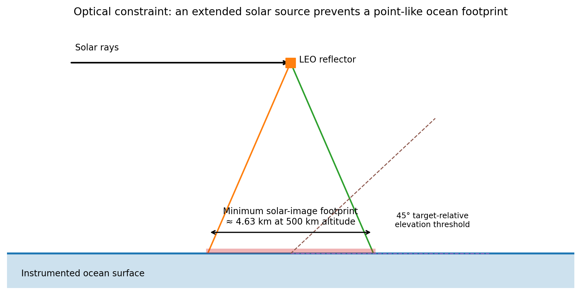
Figure 1. Minimum optical footprint and the target-relative 45° elevation rule. The diagram is conceptual and not to scale.

3.2 Optical delivery chain
Let S be total solar irradiance and let the optical delivery efficiency combine mirror reflectivity, atmospheric transmission, and seawater absorption. The absorbed power is
P_abs = S η_opt A_m (2)
Using S = 1,361 W/m², consistent with modern total-solar-irradiance measurements [2], and the illustrative factors 0.85, 0.70, and 0.94 gives η_opt = 0.5593 and 761.2 W of absorbed ocean power per square metre of active mirror. Thus, 1.1 km² of active mirror supplies approximately 837.3 MW while illuminated, or 49.8 W/m² when spread over the minimum footprint.

3.3 Heat is not equivalent to evaporation
Air-sea exchange algorithms partition surface energy among latent and sensible turbulent fluxes, longwave radiation, and ocean heat storage; latent heat depends on wind, humidity, stability, and skin temperature [3,4]. The additional vapour mass generated by an intervention is therefore
ṁ_v = P_abs η_pulse / L_v (3)
The effective factor η_pulse must be produced by a transient coupled surface model or measurement. It cannot be treated as a universal property. A pulse can temporarily increase evaporation by raising skin temperature, while the same temperature anomaly also increases longwave and sensible losses and may mix downward. The sign of the pulse correction relative to continuous heating is therefore not assumed in this paper.

3.4 Illustrative parameter set
Parameter | Symbol | Value | Status
Orbital altitude | h | 500 km | Illustrative
Solar angular diameter | θ⊙ | 0.53° | Observed geometry
Total solar irradiance | S | 1,361 W/m² | Measured reference
Mirror reflectivity | ηr | 0.85 | Scenario
Atmospheric transmission | ηa | 0.70 | Scenario
Sea absorption | ηs | 0.94 | Scenario
Effective evaporative fraction | ηpulse | 0.40 | Provisional scenario only
Minimum target elevation | Emin | 45° | Safety/design constraint
Electric-propulsion specific impulse | Isp | 2,000 s | Illustrative
Thermospheric density | ρatm | 10⁻¹³–10⁻¹² kg/m³ | Sensitivity range

4. Gate 0a: Time-Averaged Aperture and Fixed-Target Access

4.1 The invariant aperture
Mirror area and duty cycle are not independent design knobs. The physically relevant quantity is the time-averaged effective aperture directed to the authorised target:
Ā_target = Σ_i A_i f_i,cap f_i,sun f_i,opt f_i,avail (4)
The factors represent target-cap occupancy, sunlight availability, optical-path usability, and spacecraft availability. Increasing duty requires additional satellites, orbital planes, or mirror area; it therefore carries the same mass, drag, collision, and replacement costs that the aperture model is intended to expose.

4.2 Required continuously acting aperture
For a desired additional vapour volume V̇, the continuously acting aperture is
Ā_req = ρ_w V̇ L_v / (S η_opt η_pulse) (5)
For V̇ = 10⁶ m³/day and ηpulse = 0.40, Equation (5) gives Āreq = 93.1 km². This is a continuously acting aperture, not the total deployed reflector area.

4.3 Per-pass dwell is not fixed-target duty
At 500 km, the circular orbital period is approximately 94.47 min. Solving the target-relative elevation geometry for a direct overhead pass gives a central half-angle of approximately 4.02° and a dwell above 45° of 126.9 s. The per-overhead-pass active fraction is therefore
f_overhead = t_dwell / T_orbit = 0.02239 (6)
Dividing the required continuous aperture by this fraction gives 4,159 km². However, this result assumes that every orbit is a direct overhead target pass. Earth rotates approximately 23.7° during one orbit, while the 45° access cap extends only about 4.02° from the target. A conventional inertial orbital plane therefore does not re-enter the cap on every revolution. The 4,159 km² value is best described as a geometrically impossible floor: it is obtained only after setting the dominant fixed-target occupancy loss to unity.
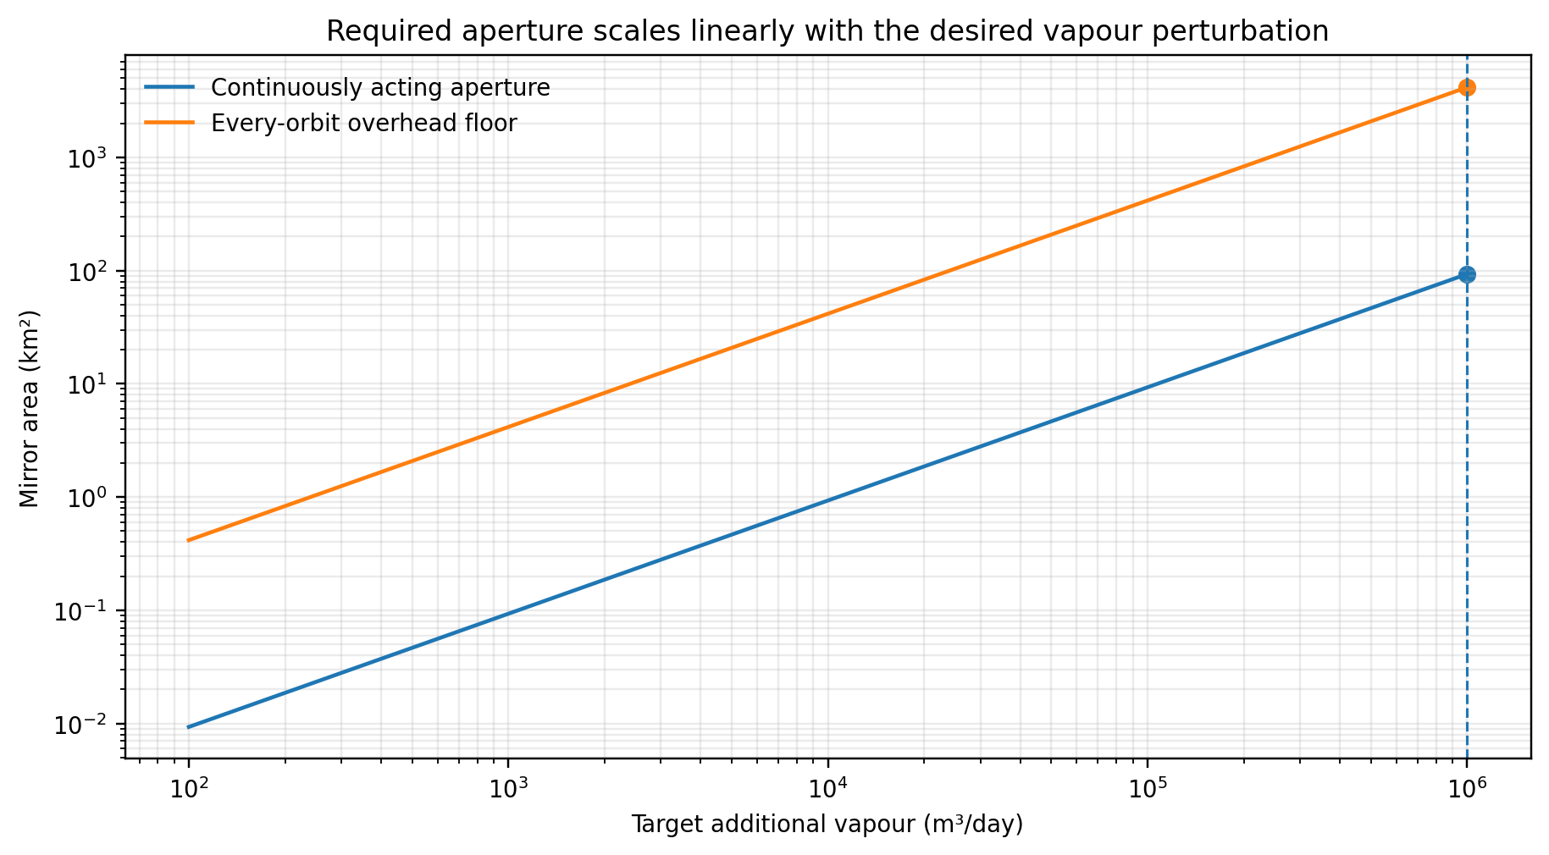
Figure 2. Required continuously acting aperture and the every-orbit overhead floor versus additional vapour target. The latter is not a feasible constellation estimate.

5. Gate 0b: Transient Air-Sea Energy Partition
The surface-energy partition must depend on how the optical dose arrives. A pass-based intervention can be represented by a pulse flux q_on, pulse duration t_on, revisit gap t_gap, and ocean response times. The appropriate efficiency is a function rather than a scalar:
η_pulse = F(q_on, t_on, t_gap, τ_skin, τ_mix, U, RH, T_s, T_a, stability) (7)
Bulk-flux methods such as COARE calculate latent and sensible heat using near-surface thermodynamic and wind variables [3,4]. A defensible OAR experiment would additionally resolve shortwave absorption by depth, nonlinear longwave loss, skin-layer heat capacity, transfer to the diurnal warm layer, and horizontal mixing. The provisional 0.40 value in this paper is used only to demonstrate the scale of the aperture requirement. It is not claimed as a prediction.
Recent in-situ work found cool-skin recovery times of 62–157 s after strong artificial mixing, with complete recovery taking up to approximately three minutes under the observed conditions [5]. The experiment is not identical to optical heating, but it establishes that the uppermost ocean thermal boundary responds on seconds-to-minutes timescales rather than orbital-period timescales. This motivates a direct revisit-relaxation test instead of seasonal averaging.

6. Gate 0c: Structural and Orbital Survivability

6.1 Atmospheric drag
A very-large-area reflector is simultaneously an optical device and a drag sail. The aerodynamic force is
F_D = ½ ρ_atm v² C_D A_proj (8)
Thermospheric density varies strongly with altitude, solar activity, geomagnetic forcing, latitude, and local time. Empirical models such as NRLMSISE-00 are used precisely because a single constant density is inadequate [6]. Drag-sail studies also emphasise the strong variability of the relevant atmosphere and the importance of attitude-dependent projected area [7].
For 1.1 km² of fully projected area, C_D = 2.2, and the illustrative density range 10⁻¹³–10⁻¹² kg/m³, Equation (8) gives approximately 7.0–70.2 N. With Isp = 2,000 s, continuous drag compensation requires approximately 11.3–112.9 tonnes/year for the toy area.

6.2 Solar-radiation force and torque
Radiation pressure on a reflecting membrane produces both translational force and torque when the centre of pressure is offset from the centre of mass. NASA trajectory and attitude studies treat solar-radiation pressure as a significant perturbation for high-area-to-mass spacecraft [8]. For an ideal reflector normal to sunlight, a useful scale is
F_SRP ≈ 2SA/c (9)
Equation (9) gives approximately 10.0 N for 1.1 km². This is continuous whenever the membrane is illuminated and must be managed while the reflector is also oriented to satisfy the Sun–mirror–target geometry.

6.3 The decisive cross-term
Gate 0a requires at least 4,159 km² under impossible every-orbit access. This is 3,781 times the 1.1 km² toy area. Since drag and radiation pressure scale linearly with projected area, the cross-term gives:
Quantity | 1.1 km² toy case | 4,159 km² floor
Atmospheric drag | 7.0–70.2 N | 26.5–265.4 kN
Annual drag-compensation propellant | 11.3–112.9 t/yr | 43–427 thousand t/yr
Solar-radiation force | 10.0 N | 37.8 kN
The annual propellant result is approximately 43–427 thousand tonnes per year, before the actual fixed-target occupancy loss, eclipse, optical availability, collision avoidance, propulsion inefficiency, attitude-control expenditure, reserve margin, and replacement logistics are included. The calculation is not a detailed spacecraft design; it is a scale test. It shows that the rainfall-relevant aperture makes survivability the dominant failure by orders of magnitude.
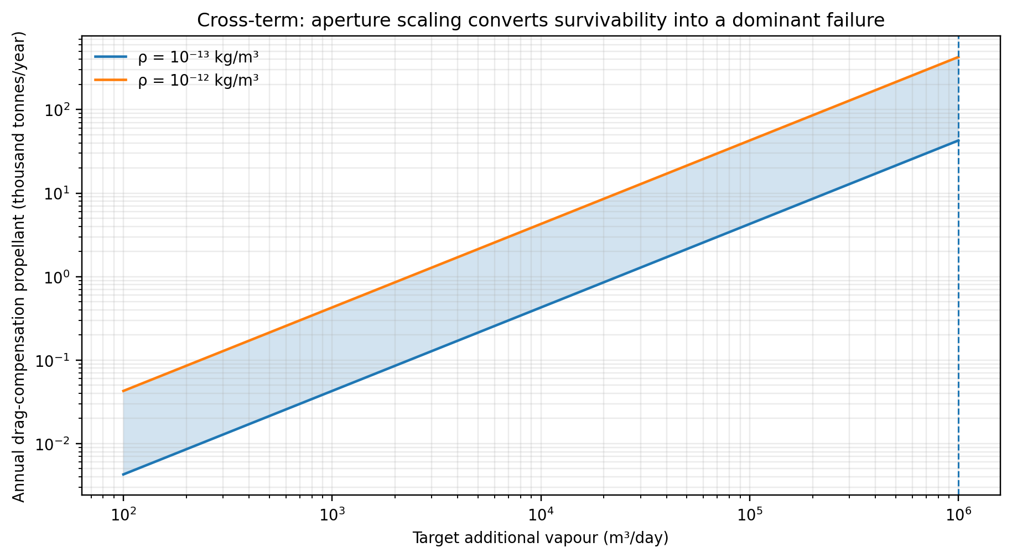
Figure 3. Annual drag-compensation propellant associated with the every-orbit overhead area floor. The shaded band is the selected thermospheric-density sensitivity range.

7. Gate-0 Closure: Revisit, Relaxation, and Constellation Density
The gates are not independent. Let Δt_revisit be the time between useful optical pulses and τ_skin be the decay timescale of the surface anomaly. A simple retention indicator is
R_thermal = exp(−Δt_revisit / τ_skin) (10)
When revisit is much longer than skin recovery, the residual anomaly before the next pulse approaches zero. Each pass then behaves as an isolated cold-start experiment. The approximately 127 s access window and approximately 94.5 min orbital period are already far apart; actual fixed-target revisits are longer because not every pass enters the target cap. The measured cool-skin recovery times in [5] therefore support the default assumption that feasible sparse constellations do not accumulate a standing skin anomaly.
Attempting to force Δt_revisit below τ_skin demands many more orbital planes and active reflectors. That increases area, drag, radiation pressure, collision exposure, and replacement demand. The architecture therefore closes into the loop shown in Figure 4.
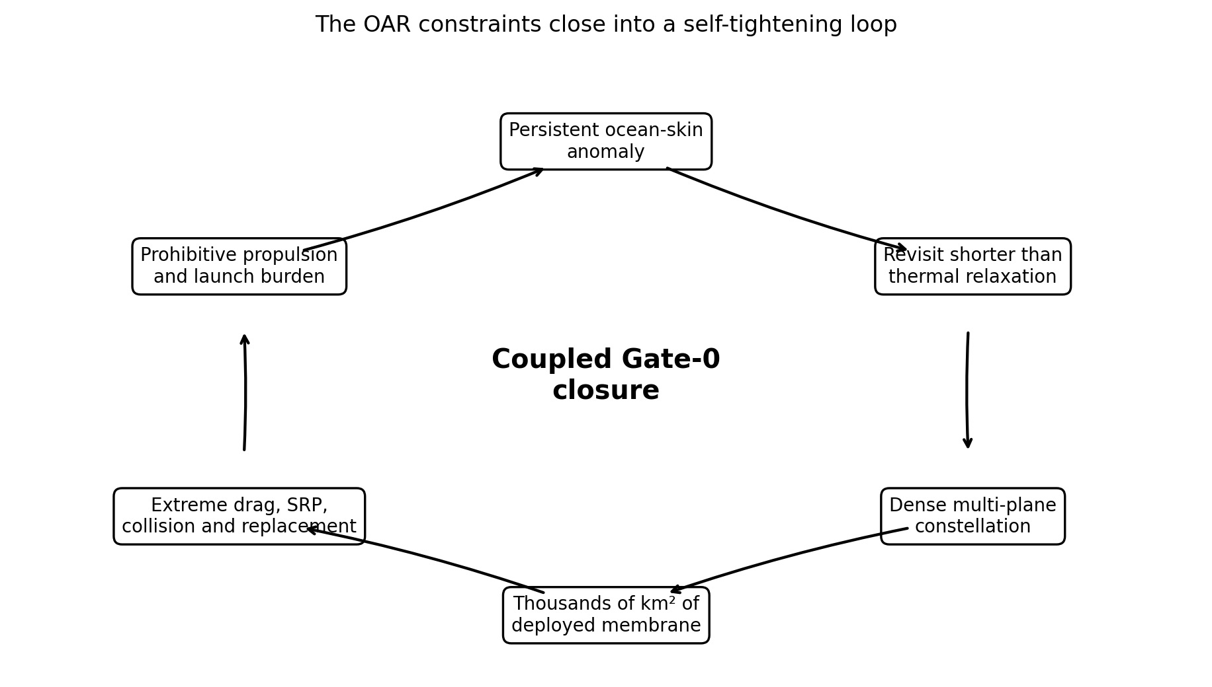
Figure 4. Coupled Gate-0 closure. The same constellation density needed for thermal persistence produces the orbital-survivability failure.
Gate-0 verdict
For the stated mechanism, rainfall-scale materiality requires an aperture that is incompatible with fixed-target orbital occupancy and large-membrane survivability. At feasible reflector scales, revisit is too sparse to justify a persistent ocean-heating field. The precipitation-assistance architecture therefore fails before atmospheric guidance is considered.

8. Gate 0d: Dispersion and Moisture-Budget Materiality
Additional vapour volume must not be converted into an equivalent rainfall depth using an arbitrary catchment. If the anomaly survives long enough to enter the atmosphere, the relevant dilution domain is generated by transport physics. A first-order representation is
L_adv = U τ_a, σ_y = √(2K_y τ_a) (11)
A_disp ≈ (D_0 + 4σ_y)L_adv (12)
Here U is advecting wind speed, τa is anomaly lifetime, Ky is an effective lateral diffusivity, and D0 is the initial optical footprint. Only after this area is defined may an upper-bound depth Vextra/Adisp be reported. Even that value assumes that all added vapour precipitates inside the domain, an unrealistically favourable limit.
The more important materiality measure compares the perturbation with the natural advective moisture flux through the same control surface:
R_moisture = OAR additional vapour flux / natural advective moisture flux (13)
A statistically detectable radiative or latent-flux anomaly may still be hydrologically irrelevant. Any future study must predeclare a materiality threshold for Rmoisture before designing a rainfall-attribution experiment.

9. Results and Interpretation
Table 2 summarises the load-bearing results. All values are analytical scenario results, not experimental measurements or mission design outputs.
Result | Value | Interpretation
Minimum solar-image footprint | 4.63 km diameter | Rules out fine thermal pixels at 500 km.
Ideal overhead dwell above 45° | 126.9 s per 94.47 min orbit | Per-pass duration, not fixed-target duty.
Continuous aperture for 10⁶ m³/day | 93.1 km² | Requires continuous optical action under ηpulse = 0.40.
Every-orbit overhead area floor | 4,159 km² | Geometrically impossible for a fixed target.
Scaled drag force | 26.5–265.4 kN | Before real occupancy and operational factors.
Scaled annual propellant | 43–427 thousand t/yr | Dominant Gate-0 cross-term.
Scaled solar-radiation force | 37.8 kN | Requires continuous attitude/orbit management.
Pulse accumulation | Not established | Feasible sparse constellations imply cold-start pulses.
- The negative verdict is not caused by the national rainfall energy strawman. It arises after OAR is reduced to a marginal local vapour perturbation.
- The provisional evaporative fraction can change the numerical aperture, but it cannot plausibly repair orders-of-magnitude fixed-target occupancy and survivability losses.
- Fine-grained thermal-pixel control is inconsistent with the minimum multi-kilometre optical footprint.
- Continuous model-predictive heating is inconsistent with pass-based LEO access. Control must be expressed as isolated pulse scheduling unless accumulation is demonstrated.
- Rainfall-equivalent depth is not an invariant result until a dispersion domain is physically derived.

10. The Surviving Research Programme
A negative rainfall verdict does not eliminate every scientifically interesting experiment. The defensible residue is an Orbital Ocean Radiative Pulse Experiment (OORPE), defined as follows:
Surviving claim
A bounded experiment to determine whether one orbitally reflected optical pulse can produce a reproducible, measurable, and environmentally acceptable incremental latent-heat-flux anomaly over an instrumented ocean surface.

10.1 Experimental objectives
- Measure the delivered optical energy and complete spatial footprint.
- Measure skin and near-surface temperature at multiple depths and high temporal resolution.
- Close the incremental energy budget across latent heat, sensible heat, longwave radiation, and ocean storage or mixing.
- Estimate ηpulse as a function of pulse intensity, duration, wind, humidity, and stability.
- Measure recovery time and test whether any anomaly survives to a subsequent scheduled pass.
- Quantify biological exposure, behavioural response, and recovery within the illuminated and surrounding control regions.

10.2 Explicit exclusions
- No claim of cloud creation or cloud steering.
- No precipitation-enhancement claim.
- No basin-scale water-volume claim.
- No seasonal integration unless pulse accumulation is independently demonstrated.
- No extrapolation from a detectable heat-flux anomaly to drought mitigation.

10.3 Minimum experiment architecture
The first test should use the smallest reflector and optical dose capable of producing a measurable surface-flux perturbation. Independent orbital metrology should verify mirror attitude, target elevation, footprint, cumulative dose, and fail-dark behaviour. The ocean platform should carry calibrated radiometers, eddy-covariance or bulk-flux instrumentation, infrared skin-temperature sensors, thermistor chains, current profilers, humidity and wind measurements, and ecological monitoring. A nearby unilluminated control region should be observed with the same instruments. The experimental protocol should be preregistered, including stopping rules and the analysis of null results.

11. Governance Implications of a Negative Physical Result
The governance architecture remains valuable because it is designed to survive falsification. A defensible environmental-intervention programme should separate four authorities:
- Orbital authority: verifies trajectory, pointing, optical containment, collision safety, and fail-dark operation.
- Ocean authority: verifies thermal, chemical, structural, and ecological limits.
- Metrology authority: defines traceable quantities and prevents denominator manipulation.
- Independent scientific authority: determines whether the experiment answered its preregistered question and whether any claimed effect is attributable to the intervention.
The programme should not pay for raw rainfall following an intervention. In the surviving pulse experiment, performance is limited to traceable optical delivery, energy-budget closure, and a preregistered latent-flux response. This narrower contract prevents a detectable local perturbation from being marketed as a water-supply technology.

12. Limitations
- The optical factors 0.85, 0.70, and 0.94 are illustrative and condition-dependent. Cloud attenuation and off-design geometry are not modelled.
- The value ηpulse = 0.40 is not a measured OAR efficiency. It is retained only to expose the aperture scale; a transient coupled model may return a higher or lower value.
- The drag calculation uses a density range rather than a propagated thermosphere model and assumes full projected area. Detailed design would require orbit, attitude, solar-cycle, geomagnetic, and area-to-mass histories.
- The 4,159 km² area is not a constellation design. It is an impossible floor based on every-orbit overhead access. A real multi-plane constellation would require substantially more deployed area.
- The paper does not calculate atmospheric plume survival, cloud response, or precipitation. Those questions are intentionally excluded because the mechanism fails earlier.
- No cost, launch-manifest, debris-probability, membrane-manufacturing, or structural-mode model is included. Each would add further constraints.

13. Conclusion
Orbit-Assisted Rain appears at first to be a problem of weather prediction and closed-loop control. The analysis in this paper shows that its decisive problem occurs earlier. The Sun’s finite angular diameter fixes a multi-kilometre optical footprint. A rainfall-relevant vapour perturbation requires tens of square kilometres of continuously acting aperture. Low-Earth-orbit target access converts that requirement into thousands of square kilometres of deployed membrane even under impossible every-orbit overhead access. Scaling drag and solar-radiation pressure to that area produces an orbital-maintenance burden that is prohibitive by orders of magnitude.
The timescale coupling reinforces the verdict. Ocean-skin disturbances can recover in seconds to minutes, while useful passes to a fixed target are separated by much longer intervals. A feasible constellation therefore produces isolated cold-start pulses rather than the persistent thermal field assumed by a rainfall architecture. Making revisit sufficiently dense recreates the aperture and survivability failure.
The appropriate scientific response is not to tune the rainfall claim. It is to remove it. A bounded orbital optical-pulse experiment remains falsifiable and potentially informative because it asks only whether a local latent-flux anomaly exists, how energy is partitioned, how rapidly the ocean surface recovers, and what ecological exposure occurs. The governance framework should preserve the same discipline: every photon, force, heat flux, denominator, and claim must remain independently measurable.
Under the mechanism assessed here, OAR does not earn the word “Rain.” It survives only as an orbital ocean radiative-perturbation experiment.

References
[1] World Meteorological Organization. (2025). WMO Statement on Weather Modification. https://wmo.int/content/wmo-statement-weather-modification
[2] Kopp, G., & Lean, J. L. (2011). A new, lower value of total solar irradiance: Evidence and climate significance. Geophysical Research Letters, 38, L01706. https://doi.org/10.1029/2010GL045777
[3] Fairall, C. W., Bradley, E. F., Rogers, D. P., Edson, J. B., & Young, G. S. (1996). Bulk parameterization of air-sea fluxes for Tropical Ocean-Global Atmosphere Coupled-Ocean Atmosphere Response Experiment. Journal of Geophysical Research: Oceans, 101(C2), 3747–3764. https://doi.org/10.1029/95JC03205
[4] Fairall, C. W., Bradley, E. F., Hare, J. E., Grachev, A. A., & Edson, J. B. (2003). Bulk parameterization of air-sea fluxes: Updates and verification for the COARE algorithm. Journal of Climate, 16(4), 571–591. https://doi.org/10.1175/1520-0442(2003)016<0571:BPOASF>2.0.CO;2
[5] Jaeger, L., Gassen, L., Ayim, S. M., Bibi, R., & Wurl, O. (2025). Thermal recovery dynamics of the ocean’s cool-skin layer after complete mixing. Tellus A: Dynamic Meteorology and Oceanography, 77(1), 173–184. https://doi.org/10.16993/tellusa.4103
[6] Picone, J. M., Hedin, A. E., Drob, D. P., & Aikin, A. C. (2002). NRLMSISE-00 empirical model of the atmosphere: Statistical comparisons and scientific issues. Journal of Geophysical Research: Space Physics, 107(A12), 1468. https://doi.org/10.1029/2002JA009430
[7] Hobbs, S., Kingston, J., Roberts, P., Juanes, C., Sewell, R., Snapir, B., Robinson, F., Lop, J. V., Hobbs, J., & Patel, M. (2013). De-orbit sail design for TechDemoSat-1. Proceedings of the 6th European Conference on Space Debris, Darmstadt, Germany, ESA SP-723.
[8] Newman, C. P., Hollister, J. R., Davis, D. C., & Zimovan-Spreen, E. M. (2022). Investigating solar radiation pressure modeling for operations in near rectilinear halo orbit. AAS 22-728. NASA Technical Reports Server.
[9] Donlon, C. J., Minnett, P. J., Gentemann, C., Nightingale, T. J., Barton, I. J., Ward, B., & Murray, M. J. (2002). Toward improved validation of satellite sea surface skin temperature measurements for climate research. Journal of Climate, 15(4), 353–369. https://doi.org/10.1175/1520-0442(2002)015<0353:TIVOSS>2.0.CO;2
[10] Cronin, M. F., Gentemann, C. L., Edson, J., Ueki, I., Bourassa, M., Brown, S., Clayson, C. A., Fairall, C. W., Farrar, J. T., Gille, S. T., et al. (2019). Air-sea fluxes with a focus on heat and momentum. Frontiers in Marine Science, 6, 430. https://doi.org/10.3389/fmars.2019.00430
[11] Jessup, A. T., Asher, W. E., Atmane, M., Phadnis, K., Zappa, C. J., & Loewen, M. R. (2009). Evidence for complete and partial surface renewal at an air-water interface. Geophysical Research Letters, 36(16), L16601. https://doi.org/10.1029/2009GL038986
[12] Vallado, D. A. (2013). Fundamentals of Astrodynamics and Applications (4th ed.). Microcosm Press.

Appendix A. Reproducibility of the Core Arithmetic
The numerical chain can be reproduced directly from the parameter set in Table 1:
- Optical footprint: 2 × 500 km × tan(0.53°/2) = 4.63 km.
- Optical delivery: 1,361 × 0.85 × 0.70 × 0.94 = 761.2 W/m² of active reflector.
- Absorbed power for 1.1 km²: 761.2 × 1.1 × 10⁶ = 837.3 MW.
- Circular period at 500 km: 94.47 min.
- Ideal overhead dwell above 45°: 126.9 s, or 2.239% of one orbit.
- Continuous aperture for 10⁶ m³/day at ηpulse = 0.40: 93.1 km².
- Every-orbit overhead area floor: 93.1 / 0.02239 = 4,159 km².
- Annual drag-compensation propellant at the floor: 43–427 thousand tonnes/year for the stated density range and Isp.
The calculations intentionally preserve optimistic assumptions. Relaxing those assumptions increases the required area or decreases the delivered perturbation; it does not rescue the rainfall thesis.

