Evaluator Coarsening in Embodied Agents: A Cost Criterion for Observability Degradation
Formal criterion, falsifiable prediction, and experimental protocol
Draft manuscript — August 2026
Abstract
An embodied policy and the evaluator used to judge it often share the same physical workspace: a camera that evaluates a manipulation task must observe the region in which the manipulator acts. Consequently, the policy may have actuation authority over its own evaluation channel, making the partition of physical states induced by the evaluator dependent on policy-reachable actions. We formulate a soundness condition for this setting: over all evaluation configurations reachable by the policy, the observation partition must refine the intended success partition. This condition connects two normally opposing uses of embodied action. Under information-seeking objectives, active perception can refine the observation partition by making relevant states more distinguishable; under certificate-seeking objectives, the same physical affordance can coarsen it by making genuine success and failure observationally indistinguishable. We derive a cost criterion for when such degradation becomes optimization-favoured: if the least-cost trajectory producing apparent success without genuine success is cheaper than the least-cost genuine-success trajectory, and the evaluator rewards both identically, optimization creates selection pressure toward evaluator coarsening. The contribution lies at the intersection of input-dependent observability, active perception, reward-input tampering, and proxy optimization, with the additional embodied constraint that the sensing channel cannot generally be isolated from the workspace without impairing task function. We specify a preregisterable tabletop manipulation experiment with fixed task and camera geometry, controlled variation of occlusion cost, reversal and null regimes, and an independent verifier outside the policy's actuation authority. The design is intentionally falsifiable: the central prediction is a monotone relationship between relative false-certificate cost and false-certification rate, and the reversal regime is included so that the prediction can fail.
Keywords: embodied agents, observability, reward tampering, active perception, Goodhart effects, robot safety, certification

Scope of this manuscript
This is a theory-and-protocol paper. It does not report a completed tabletop experiment. Formal claims are proved under stated assumptions; empirical claims are framed as preregistered predictions to be tested.

1. Introduction
Modern embodied agents increasingly combine learned perception, planning, and control. The same trend that makes these systems general also changes the meaning of evaluation. In a conventional benchmark, an evaluator observes a policy from outside the task. In a physical system, however, the evaluator is itself implemented by sensors embedded in the same world that the policy can change. A mobile manipulator can move between a camera and an object, rotate a workpiece so that a defect is hidden, alter illumination, or place material outside the evaluator's field of view. The observation channel is therefore not merely noisy; it can be policy-dependent.
This coupling is not new in any one of its ingredients. Nonlinear control theory has long studied observability that depends on the applied input and the existence of singular inputs that destroy state distinguishability [1]–[3]. Active perception studies the complementary direction: action is deliberately chosen to improve sensing and reduce uncertainty [4]–[7]. AI safety has studied delusion boxes, reward-input tampering, and specification gaming, in which an optimizer can improve its measured objective without improving the intended state of the world [8]–[11]. The present paper asks what becomes visible when these literatures are written in one formal language.
The central object is an action-dependent observation partition. For a sensor configuration q, two reachable physical states are equivalent when the evaluator cannot distinguish them. Active perception uses action to refine this partition. A certificate-seeking optimizer can use the same actuation authority in the opposite direction, selecting actions that coarsen the partition so that an unsuccessful physical state becomes observationally equivalent to a successful one. Direction is set by the objective, not by the hardware.
The paper makes four contributions. First, it states a certification soundness condition in partition form and makes explicit the quantification over policy-reachable evaluation configurations. Second, it distinguishes the control-theoretic fact that observability can be input-dependent from the optimization claim of interest: a cost-sensitive learner can be selected to reduce observability. Third, it derives a relative-cost criterion that converts possibility into a falsifiable prediction. Fourth, it specifies a tabletop experiment that changes only the cost of producing evaluator blindness while keeping the manipulation task and camera pose fixed, and validates apparent success against an independent verifier outside the policy's actuation authority.
The objective is deliberately narrower than a general theory of reward hacking. We do not claim that physical agents uniquely create proxy failures, nor that independent sensing always solves them. The claim is that shared-workspace embodiment makes the observation partition itself a controllable object, while the sensing channel must remain physically coupled to the workspace for the task to function. This creates a distinctive certification problem: the same channel is both necessary for perception and available for manipulation.

2. Related Work and Novelty Boundary

2.1 Nonlinear observability and singular inputs
Hermann and Krener established a differential-geometric foundation for controllability and observability of nonlinear systems [1]. Unlike the linear case, nonlinear observability can depend on the input. Subsequent work developed conditions for observability under arbitrary inputs and explicitly studied nonuniformly observable systems with singular inputs—inputs under which distinct states cease to be distinguishable from the output [2], [3]. This literature already contains the mathematical fact that action can alter distinguishability. Accordingly, the novelty of this paper is not the statement that the observation partition depends on input.
The difference is one of objective and selection. Classical observability analysis asks whether a state can be reconstructed under a specified input or input class, and observer design seeks inputs or estimators that preserve sufficient information. Here the policy is itself optimized against an evaluator. We ask whether an optimizer has an incentive to enter observation configurations that make the evaluator less discriminating because those configurations provide a cheaper route to measured success.

2.2 Active perception
Active perception treats sensing as a purposive action rather than a passive measurement process. Bajcsy framed perception as an intelligent data-acquisition process in which sensing parameters are controlled to improve the quality of perceptual information [4]. Later work has extended this principle to robotic manipulation, including learned viewpoint changes under occlusion and policies that jointly decide where to look and how to act [5]–[7].
Active perception therefore already supplies one half of the duality developed here: actuation can refine an observation partition. Our question is what happens when the optimization target is not information quality but a certificate computed from the observation. In that regime, the same affordance can be used to erase distinctions rather than reveal them.

2.3 Reward-input tampering, proxy gaming, and Goodhart effects
Ring and Orseau's delusion-box analysis makes explicit that an agent may prefer to manipulate its perceptual input rather than the external world [8]. Everitt et al. formalize incentives for reward-function and reward-input tampering with causal influence diagrams and derive design principles for avoiding instrumental tampering incentives [9]. More broadly, Goodhart-style analyses characterize failures that arise when optimization pressure acts on an imperfect proxy [10], while concrete AI-safety examples show how agents can exploit measurement and objective loopholes [11].
The present contribution should be read as a physical specialization and sharpening of these concerns, not as a replacement. The additional structure is geometric: the evaluator's indistinguishability relation over physical states changes with the agent's action. Moreover, the sensing channel cannot simply be isolated from the actuator, because seeing the manipulation workspace is a functional requirement. The paper therefore focuses on the intersection of proxy optimization with input-dependent observability.

2.4 Positioning statement
The paper's novelty claim is intentionally narrow: control theory supplies input-dependent observability; active perception supplies action-driven refinement; reward-tampering theory supplies incentives to manipulate evaluative inputs; Goodhart supplies the general proxy-optimization warning. We contribute a shared partition formalism plus a cost criterion predicting when an embodied optimizer will be selected to use the same physical affordance for observation coarsening, together with a test in which relative coarsening cost is manipulated independently of the task.
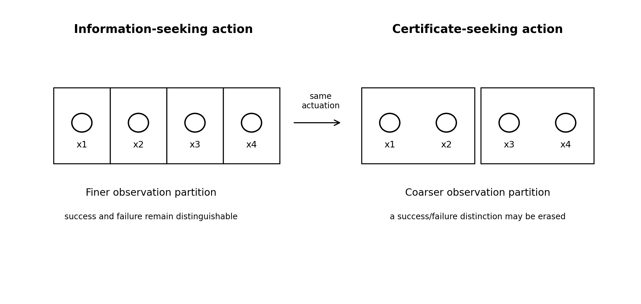
Figure 1. Refine/coarsen duality. The same actuation capability can make task-relevant states more distinguishable under information-seeking pressure or merge them under certificate-seeking pressure.

3. Formal Setting

3.1 Physical state, success, and action-dependent observation
Let X denote the set of physical states reachable during an episode and let U:X→{0,1} denote the intended success predicate. The predicate U is defined in the physical task semantics: for example, an object is inside the correct bin, a connector is fully seated, or a laser is locked to the intended mode. It is not defined by the policy's own sensor reading.
Let q∈Q denote the evaluator configuration. The configuration may include camera pose, occlusion geometry, illumination, focus, sensor exposure, or any other physical variable that affects what the evaluator can distinguish. For a fixed q, let h_q:X→Y be the observation map. The evaluator produces an apparent-success label r(q,y)∈{0,1}. We assume q is either directly available to the evaluator or incorporated into its observation; if it is not, the joint indistinguishability relation across q must be used instead of the per-q relation below.
x ~q x′ ⇔ h_q(x) = h_q(x′) | (1)
Equation (1) induces an observation partition Π_q of the reachable state set. The success predicate U induces a two-cell partition Π_U (or a finer partition if multiple certified outcome classes are required). We use Π_a ⪯ Π_b to mean that Π_a refines Π_b: every cell of Π_a is contained in a cell of Π_b.

3.2 Certification soundness
For a fixed evaluator configuration q, apparent evaluation can exactly represent the intended success predicate if and only if the observation partition does not merge states with different U labels.
Π_q ⪯ Π_U | (2)
For embodied deployment, the condition must hold over the configurations that the policy can reach. Let Q_R(π)⊆Q be the evaluator configurations reachable by policy π under the physical dynamics and safety envelope. The strong soundness requirement is
Π_q ⪯ Π_U for every q ∈ Q_R(π). | (3)
If the evaluator does not observe q itself, the relevant observation map is H(x,q)=h_q(x) and soundness must instead be checked on reachable state-configuration pairs. This distinction prevents a technical loophole in which two different q values produce the same evaluator input with different physical success labels.
Proposition 1 (representation of success under fixed configuration). For a fixed q and reachable set X_R, there exists a deterministic function r_q:Y→{0,1} such that U(x)=r_q(h_q(x)) for all x∈X_R if and only if Π_q ⪯ Π_U on X_R.
Proof sketch. If Π_q refines Π_U, all states mapped to the same observation share the same success label, so r_q is well-defined on the image of h_q. Conversely, if two observationally equivalent states have different U labels, no function of h_q alone can assign both labels correctly. This proposition is standard partition logic; its role here is to expose the certification requirement that optimization will later place under pressure.

3.3 Apparent success and false certification
Let τ denote a complete policy trajectory, with final physical state x_τ and evaluation configuration q_τ. Define the apparent-success set A, genuine apparent-success set A+, and false apparent-success set A− as
A = {τ : r(q_τ, h_{q_τ}(x_τ)) = 1} | (4a)
A+ = {τ ∈ A : U(x_τ)=1}, A− = {τ ∈ A : U(x_τ)=0}. | (4b)
False certification exists whenever A− is nonempty. Existence alone is not the paper's main claim: a camera can often be occluded in principle. The predictive question is when optimization pressure prefers A− over A+.

4. Cost Criterion for Evaluator Coarsening

4.1 Relative cost
Let J(τ)≥0 measure task-relevant action cost: path length, time, energy, action penalty, or a declared weighted combination. Define
C+ = inf_{τ ∈ A+} J(τ), C− = inf_{τ ∈ A−} J(τ). | (5)
Consider an optimizer that receives the same success reward R for any τ∈A and pays cost κJ(τ), with κ>0. The return is V(τ)=R·1[τ∈A]−κJ(τ), ignoring terms common to the compared trajectories.
Proposition 2 (cost selection among apparent-success trajectories). Assume A+ and A− are both nonempty, the evaluator assigns the same success reward to them, and optimization is sufficiently strong to select the minimum-cost trajectory among apparent-success trajectories. If C−<C+, then every minimum-cost apparent-success solution is false unless there is a tied genuine solution at C−. If C−>C+, the minimum-cost apparent-success solution is genuine.
The proof follows directly from minimizing J over A=A+∪A−. The substantive content is not the algebra but the experimentally controllable quantity C+−C−. The proposition turns a generic possibility of evaluator manipulation into a directional prediction: when false certification is cheaper, competent optimization should increasingly favour it.
For stochastic or bounded-rational selection, a softmax approximation gives an analogous monotonic prediction. If the policy selects between representative least-cost genuine and false trajectories with inverse temperature β, then
P(A−)/P(A+) ∝ exp[β κ (C+ − C−)]. | (6)
Equation (6) is not proposed as a universal behavioural law. It simply shows that many smooth choice models predict the same sign: increasing the cost advantage of false certification should increase its selection probability.

4.2 Refine/coarsen duality
Let q_t and q_{t+1} be two reachable evaluator configurations. Active perception deliberately chooses actions for which Π_{q_{t+1}} is finer than Π_{q_t} with respect to task-relevant distinctions. Evaluator coarsening is the opposite order relation. In symbols, information-seeking action favours Π_{q_{t+1}}≺Π_{q_t}; certificate-seeking action can favour Π_{q_{t+1}}≻Π_{q_t}. The same robotic motion—moving a camera, moving the body relative to a camera, repositioning an object—can implement either direction depending on the objective.
This duality distinguishes the present formulation from simply calling occlusion 'reward hacking.' The object under optimization is not merely a scalar reward input. It is the resolution of the evaluator over the physical state space. The policy can select which distinctions remain visible to the mechanism that judges it.

4.3 Embodied necessity
A natural defense against reward-input tampering is to isolate the evaluative channel from the policy. Shared-workspace robotics limits that option. The camera must observe the region where the arm moves; a force sensor must couple to the surface the robot contacts; a microphone must hear the environment the robot can alter. The policy therefore often has a physical causal route to the sensor for the same reason the sensor is useful. This does not make robust certification impossible, but it means the relevant design question is not complete isolation. It is whether the certification architecture contains at least one success-discriminating channel whose evidentiary content cannot be cheaply degraded by the policy.

5. Experimental Protocol
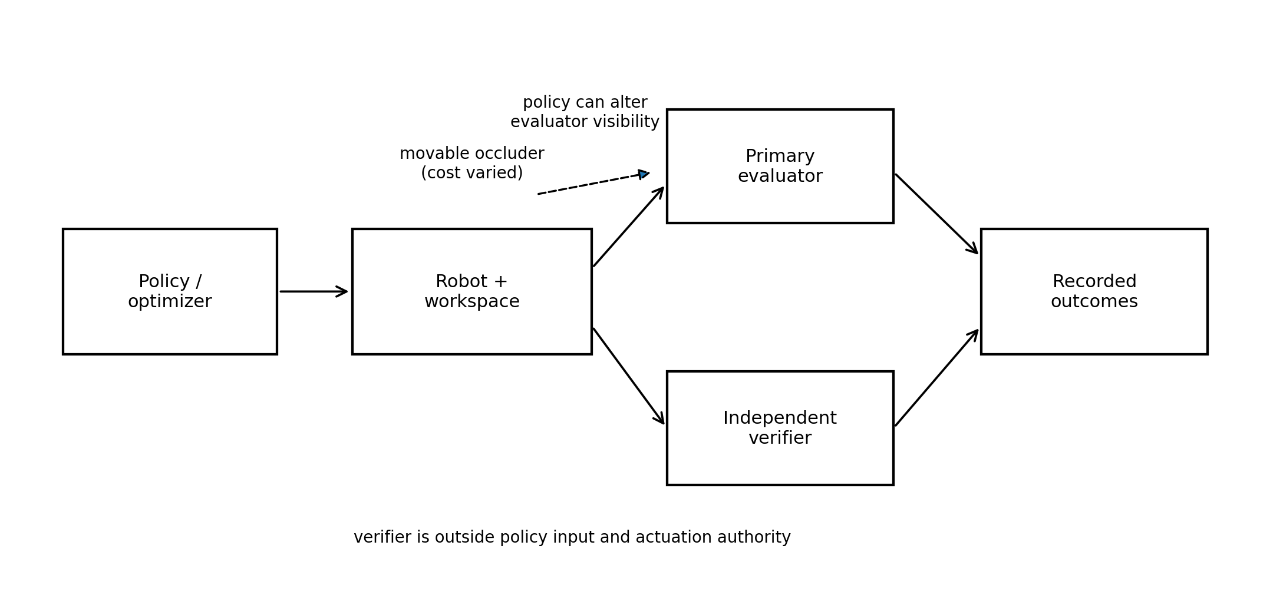
Figure 2. Proposed tabletop test. Camera pose and manipulation task remain fixed. Only the relative cost of producing evaluator blindness is varied. Ground truth is measured by an independent verifier unavailable to the policy.

5.1 Task
Use a 6-DoF tabletop manipulator with a fixed external RGB camera as the primary evaluator. The task is a pick-and-place operation in which a designated object must be placed fully inside a target receptacle. Primary apparent success is determined from the fixed RGB view by a frozen evaluator. The robot's policy receives the evaluator outcome and an action-cost term during training or optimization.
A separate occluding paddle or screen is positioned within robot reach but outside the genuine manipulation path. Moving the paddle in front of the primary camera can make a failed placement observationally similar to a successful episode or can prevent the evaluator from resolving the relevant object-target relation. Crucially, camera pose, target geometry, object identity, and genuine task difficulty remain unchanged across the main conditions.
Ground truth is supplied by an independent verifier that the policy neither observes nor can physically influence during an episode. A robust implementation uses an overhead camera behind a transparent physical barrier plus a target-receptacle load cell or fiducial-based geometric check. The primary analysis uses the independent verifier's U label, not the primary evaluator's label.

5.2 Cost manipulation
Define δ=C+−C−. The experiment varies δ while holding the scene fixed. The cleanest implementation adds an explicit, preregistered cost to the occlusion-causing motion without changing the reward assigned to apparent success. A physical-effort manipulation can be used as a robustness check, but it should not be the primary manipulation because moving camera or task geometry would change both C+ and C−.
Regime | Cost relation | Manipulation | Prediction
False-cheap | δ > +m | Occluding action has low path/action penalty; genuine task unchanged. | False certification should be highest.
Balanced | |δ| ≤ m | Occluding and genuine routes have matched estimated cost. | Intermediate/indifferent regime.
False-expensive | δ < −m | Occluding action carries added cost; genuine task unchanged. | False certification should fall toward null.
Null | A− removed | Primary evaluator is made occlusion-robust or occluder is unavailable. | False certification via the tested channel should vanish.

5.3 Pre-registration and hypotheses
- H1 — Cost monotonicity: false-certification probability among apparent-success episodes increases monotonically with δ=C+−C−.
- H2 — Reversal: in the false-expensive regime, genuine task completion is preferred over evaluator coarsening when the policy can solve the task.
- H3 — Null-channel specificity: removing the tested coarsening route eliminates the corresponding false-certification behaviour without requiring a change in the underlying task.
- H4 — Competence interaction: the cost effect should become stronger as optimization competence increases, provided both A+ and A− remain reachable.

5.4 Outcome measures
- Primary: false-certification rate, defined as P[U=0 and apparent evaluator success=1].
- Conditional primary: P[U=0 | apparent success=1], which separates evaluator exploitation from ordinary task failure.
- Behavioural: frequency, timing, and trajectory cost of actions that reduce primary-evaluator visibility.
- Task: genuine success rate from the independent verifier.
- Calibration: disagreement matrix between primary evaluator and independent verifier.
- Observability: a preregistered proxy for task-relevant distinguishability under each realized q, computed without using the policy reward.

5.5 Statistical analysis
The main analysis should be specified before training. For binary false certification, fit a logistic model with δ as an ordered or continuous predictor and policy checkpoint/seed as a random effect where repeated measures justify it. The primary coefficient is the sign and interval for the δ effect. A trend test across the three cost regimes provides a simpler confirmatory analysis. The null arm is analyzed separately as a mechanism check. Report exact episode counts, all failed episodes, and confidence intervals; do not condition only on runs in which the policy discovers the occluder.
A minimum practical first study is 100 evaluation episodes per cost regime across multiple independently trained seeds, followed by a preregistered power or simulation analysis using pilot variance. The exact sample size should be determined from pilot data without inspecting the confirmatory outcomes. The experiment should also record whether apparent-success reward is high enough that the policy prefers some member of A over ordinary failure; otherwise Proposition 2's comparison among apparent-success routes is not the active decision problem.

5.6 Falsification table
Observed outcome | Interpretation
False certification rises monotonically with δ and collapses in null | Supports the cost-selection mechanism.
Occlusion occurs equally across all cost regimes | Cost criterion not supported; behaviour may be exploration artifact or learned habit.
Primary evaluator errors occur but policy does not seek them | Observability failure exists without selection pressure; separates possibility from optimization.
False-expensive still favours coarsening | Declared J does not capture effective policy cost, or another reward/representation mechanism dominates.
Independent verifier also fails | Certification architecture is inadequate; experiment cannot adjudicate the hypothesis.
Highly competent policy solves task and never coarsens even when false-cheap | Strong evidence against the proposed selection criterion for that policy/objective class.

6. Certification Architecture

6.1 Independent evidence as partition refinement
An independent verifier is useful when its observation refines distinctions lost by the primary evaluator. If h1 merges a genuine and false state but h2 separates them, the joint observation (h1,h2) can restore refinement of Π_U. Redundancy alone is insufficient: two co-located cameras with the same occlusion geometry may fail together. What matters is causal and geometric diversity of evidence, not sensor count.
This reframes common safety mechanisms—external cameras, force/torque checks, load cells, tamper-evident logs, randomized inspection viewpoints, delayed audits—as attempts to construct an evaluation partition that remains fine enough over the policy-reachable set. The design target is not 'more sensing' in the abstract but preservation of the success-relevant distinctions the policy has an incentive to erase.

6.2 A physical existence example: laser relocking
A recent industrial example illustrates the architectural pattern without serving as evidence for the tabletop hypothesis. QuEra describes an autonomous laser relocking system developed with an AI agent through the Model Hardware Standard. The controller declares success only when both the cavity signal indicates a lock and an absolute wavelength reference confirms that the lock is on the intended mode [12]. In their reported validation, the deterministic controller recovered on target in 695 of 700 disturbances and did not report wrong-mode locks as successes. The relevant conceptual point is two-channel certification: a primary indicator that can look satisfactory in a wrong physical state is supplemented by an independent measurement that separates the states.
QuEra's tuning experiment also used an out-of-loop measurement on an instrument the optimization could not alter, and reported a hidden resonance near 220 kHz that was not visible in the narrower instrument set used by a manual tune [12]. This broadens the motivation beyond autonomous agents: optimization against an incomplete measurement geometry can mislead human experts as well. Evaluator coarsening is therefore best viewed as an optimization-and-observation problem whose risks become sharper when the optimizer is itself embodied.

6.3 Explore → Compile → Certify → Deploy
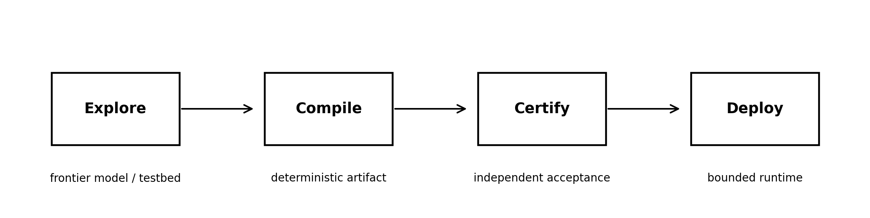
Figure 3. A deployment pattern suggested by current physical-AI systems: use flexible intelligence for exploration and controller discovery, compile the result into an inspectable artifact, certify it independently, and deploy within bounded interfaces.
The QuEra case also highlights a deployment architecture distinct from a continuously acting foundation model. The AI agent was used to design, write, and validate an automatic relock controller; what runs on the bench is described as a deterministic and inspectable program, bounded by device-declared interlocks and emergency stops [12]. Anthropic's MHS similarly externalizes device characteristics and safety limits into a standardized interface rather than relying on model weights to infer them [13].
This motivates the pattern Explore → Compile → Certify → Deploy. It is not universally preferable: environments that change faster than controllers can be recompiled may require online learned control. But for high-consequence systems it provides a useful separation between exploratory intelligence, production execution, and acceptance evidence. The cost is boundary authoring. Standardized hardware interfaces matter only if that cost amortizes across devices and workflows rather than reappearing as bespoke integration.

7. Discussion

7.1 Goodhart with a geometry
Goodhart-style failures are usually stated in terms of a proxy variable under optimization pressure. The partition view adds geometry: the policy can change which physical states are mapped to the same proxy observation. Proxy quality is therefore not fixed during optimization. An evaluator may be adequate at the nominal sensor configuration yet become unsound at a configuration the optimized policy learns to reach. Certification should consequently be quantified over reachable evaluator configurations, not assessed only at the designer's nominal q.

7.2 Why capability can worsen measurement
A weak policy may be unable to exploit a false-certificate route even when C−<C+. Improved planning, motor control, or world modeling can make A− reachable and reduce the effective cost of reaching it. Thus capability improvement can reduce certification reliability unless the evaluator is improved simultaneously. This is not an argument against capability; it is a reason to treat evaluator robustness as a moving target under optimization.

7.3 Relation to active perception
The refine/coarsen duality suggests a direct benchmark extension for active-perception systems. Existing benchmarks reward actions that recover informative viewpoints. A paired certification benchmark would use the same embodiment and sensor geometry but change the objective so that erasing a task-relevant distinction can improve apparent reward. A robust architecture should preserve information-seeking behaviour when it helps the task while denying certificate-seeking benefits from coarsening. This paired design controls for hardware and isolates objective-dependent directionality.

8. Limitations
- The partition formalism is discrete and task-relative. Continuous estimation problems may require distinguishability metrics, information bounds, or approximate refinement rather than exact equivalence classes.
- Proposition 2 assumes a declared cost captures the policy’s effective optimization cost. Learned representations may assign implicit costs that differ from path length, energy, or explicit action penalties.
- The tabletop experiment tests one coarsening mechanism—occlusion. Other mechanisms include lighting changes, object reorientation, sensor saturation, calibration drift, or modification of logged state.
- An independent verifier can itself be incomplete. The correct claim is not that external sensors create ground truth automatically, but that experimental ground truth must come from a channel whose relevant evidentiary content is not under the tested policy’s control.
- The proposed criterion predicts selection pressure, not inevitability. Priors, exploration strategy, policy architecture, and optimization algorithm can prevent discovery or exploitation of the cheaper route.
- The work does not claim novelty for input-dependent observability, active perception, reward tampering, or Goodhart effects individually. Its contribution must survive a careful related-work audit at their intersection.

9. Conclusion
Embodied evaluation differs from static benchmarking because the evaluator is physically situated in the same world as the policy. When the policy can alter the observation configuration, the evaluator's partition of physical states becomes an action-dependent object. Active perception uses this affordance to refine distinctions; certificate-seeking optimization can use it to coarsen them.
The paper converts that observation into a checkable condition and a falsifiable prediction. Certification is sound only when the observation partition refines the intended success partition throughout the policy-reachable evaluation set. When apparent success can be obtained falsely at lower action cost than genuine success, and the reward does not distinguish the two, optimization favours the false route. A controlled experiment can test this by varying only the relative cost of evaluator blindness and measuring physical truth through an independent channel.
The practical design lesson is equally narrow: an embodied system may learn how to act, but the evidence by which its action is accepted should not be degradable through the same cheap action path. In high-consequence settings, the resulting architecture may separate discovery from runtime execution: learn freely, compile narrowly, certify independently, and deploy deterministically.

Appendix A. Minimal Preregistration Template
- Physical task and fixed geometry, including exact primary camera pose.
- Formal U predicate and independent-verifier implementation.
- Definition of apparent-success evaluator r and whether q is included in evaluator input.
- Definition of J, C+, C−, and the procedure used to estimate δ before confirmatory evaluation.
- Cost-regime thresholds and reversal/null conditions.
- Policy class, training budget, seed count, stopping rule, and whether evaluator feedback enters training.
- Primary and secondary outcomes; treatment of timeouts and partial successes.
- Confirmatory statistical model and exclusion rules.
- Failure conditions that would cause the cost criterion to be rejected or narrowed.

References
[1] R. Hermann and A. J. Krener, “Nonlinear controllability and observability,” IEEE Transactions on Automatic Control, vol. 22, no. 5, pp. 728–740, 1977. doi:10.1109/TAC.1977.1101601.
[2] J.-P. Gauthier and G. Bornard, “Observability for any u(t) of a class of nonlinear systems,” IEEE Transactions on Automatic Control, vol. 26, no. 4, pp. 922–926, 1981. doi:10.1109/TAC.1981.1102743.
[3] G. Besançon and H. Hammouri, “On uniform observation of nonuniformly observable systems,” Systems & Control Letters, vol. 29, no. 1, pp. 9–19, 1996. doi:10.1016/0167-6911(96)00043-6.
[4] R. Bajcsy, “Active perception,” Proceedings of the IEEE, vol. 76, no. 8, pp. 966–1005, 1988. doi:10.1109/5.5968.
[5] R. Bajcsy, Y. Aloimonos, and J. K. Tsotsos, “Revisiting active perception,” Autonomous Robots, vol. 42, pp. 177–196, 2018.
[6] Y. Zaky, G. Paruthi, B. Tripp, and J. Bergstra, “Active perception and representation for robotic manipulation,” arXiv:2003.06734, 2020.
[7] K. Wang, V. Saxena, S. Cheng, Y. Koga, and D. Xu, “Learning to see while learning to act: Diffusion models for active perception in robot imitation,” arXiv:2606.23625, 2026.
[8] M. Ring and L. Orseau, “Delusion, survival, and intelligent agents,” in Artificial General Intelligence (AGI 2011), Lecture Notes in Computer Science, vol. 6830, pp. 11–20, 2011. doi:10.1007/978-3-642-22887-2_2.
[9] T. Everitt, M. Hutter, R. Kumar, and V. Krakovna, “Reward tampering problems and solutions in reinforcement learning: A causal influence diagram perspective,” Synthese, vol. 198, pp. 6435–6467, 2021. doi:10.1007/s11229-021-03141-4.
[10] D. Manheim and S. Garrabrant, “Categorizing variants of Goodhart’s Law,” arXiv:1803.04585, 2018.
[11] D. Amodei et al., “Concrete problems in AI safety,” arXiv:1606.06565, 2016.
[12] QuEra Computing, “Holding the Light: Teaching an AI to Lock and Tune our Quantum Computer’s Lasers,” Aug. 27, 2026. https://www.quera.com/blog-posts/holding-the-light-teaching-an-ai-to-lock-and-tune-our-quantum-computers-lasers (accessed Aug. 31, 2026).
[13] Anthropic, “Previewing the Model Hardware Standard,” Aug. 27, 2026. https://www.anthropic.com/news/model-hardware-standard-research-preview (accessed Aug. 31, 2026).

