Measuring Cross-Embodiment Transfer Separately from Zero-Shot Competence: Estimands, Confounds, and Experimental Design
A source-audited measurement paper for vision-language-action models
Draft manuscript — August 2026
Abstract
Recent work reports that vision-language-action models benefit from embodied human demonstrations only after robot pretraining becomes sufficiently diverse across scenes, tasks, and embodiments, and interprets this pattern as evidence for increasingly embodiment-agnostic representations. We argue that the current evidence supports a narrower and more useful question: how should cross-embodiment transfer be measured independently of zero-shot competence and independently of the engineering used to decode source demonstrations? We first reframe humans as one source embodiment within an embodiment-transfer matrix, consistent with reported comparisons in which human-to-robot and non-target-robot-to-robot transfer show similar qualitative behavior. We then identify three unresolved confounds in the available evidence. The human action representation is explicitly engineered around relative end-effector kinematics and contains no direct force, torque, or compliance channel; therefore current results establish semantic-kinematic transfer rather than dynamical transfer. Transfer is also measured on a sparse pretraining-diversity grid with only twenty to forty evaluations per experiment, making claims of ordering between transfer and competence premature. Finally, preprocessing strength is entangled with the source representation through head and wrist cameras, visual SLAM, 3D hand reconstruction, and subtask annotation. We define an embodiment-transfer effect matrix Λ(D,P) whose entries are source-versus-baseline treatment effects, report target-data effects separately rather than normalizing by a noisy denominator, and specify equivalence-based criteria for claiming transfer/competence separation. We propose a controlled D×P design that holds data volume and compute fixed, treats semantic, kinematic, and dynamical novelty as distinct axes, and admits a negative result: if transfer disappears whenever engineered decoding is weakened regardless of pretraining diversity, the phenomenon is source-to-target decoding engineering rather than a scaling effect.
Keywords: vision-language-action models, cross-embodiment transfer, human demonstrations, robot foundation models, pretraining diversity, equivalence testing, robot learning

Scope of this manuscript
This manuscript is deliberately scoped as a measurement/reanalysis-and-design paper. It does not claim that a new large-scale D×P pretraining sweep has been run. Existing evidence is taken from published primary sources; the proposed factorial experiments are future confirmatory work.

1. Introduction
Generalist robot policies are increasingly trained across heterogeneous datasets, embodiments, tasks, and environments. Open X-Embodiment demonstrated positive transfer from data pooled across many robot platforms [3], Octo made cross-embodiment pretraining a central design objective for a generalist policy [4], and newer VLA systems explicitly target open-world or cross-platform generalization [2], [6]. A parallel line of work seeks to reduce dependence on expensive robot teleoperation by learning from human demonstrations or human video [1], [8]–[11].
A recent study by Kareer et al. provides unusually useful evidence because it varies the diversity of VLA pretraining and asks when targeted human data begins to improve robot performance [1]. The paper reports larger transfer gains at higher pretraining diversity and suggests that diverse pretraining produces increasingly embodiment-agnostic representations. The result is important, but the strongest scientific opportunity is not the headline claim that human-to-robot transfer 'emerges.' It is the possibility that transferability from another embodiment can change independently of the target policy's zero-shot competence.
That possibility is currently under-measured. Human demonstrations are not a special statistical category if their transfer resembles transfer from a non-target robot. The source pipeline is also far from raw passive video: the reported demonstrations use head and wrist cameras, visual SLAM, reconstructed 3D hand keypoints, relative 6-DoF end-effector actions, and text subtask annotations [1]. Finally, the benchmark varies scenes, objects, and tasks but does not isolate physical dynamics; no direct force, torque, or compliance channel exists in the human action representation [1].
This paper therefore makes a methodological contribution. We define what should be estimated if the research question is whether pretraining diversity buys cross-embodiment transfer separately from direct competence. We represent transfer as a source-target matrix, avoid unstable ratios of noisy treatment effects, require equivalence—not nonsignificance—to claim that competence is unchanged, and explicitly model preprocessing strength. We then specify experiments that separately test semantic, kinematic, and dynamical transfer.
The design is intentionally capable of deflating the motivating hypothesis. If the apparent transfer effect is explained primarily by source preprocessing, or if transfer gains and competence gains cannot be separated once statistical power and baseline-floor effects are controlled, then the appropriate conclusion is narrower: cross-embodiment transfer is useful, but no distinct diversity-driven transfer mechanism has been established.

2. Background

2.1 Cross-embodiment robot pretraining
The Open X-Embodiment collaboration assembled more than one million real-robot trajectories spanning 22 embodiments and reported positive cross-robot transfer with RT-X models [3]. Octo was subsequently pretrained on approximately 800,000 trajectories from a curated Open X-Embodiment mixture and demonstrated adaptation across multiple robotic platforms and new observation/action spaces [4]. These systems establish the basic empirical premise that heterogeneous robot experience can improve a target policy.
Cross-embodiment modeling has since become an explicit architectural problem. X-VLA uses embodiment-specific soft prompts to exploit heterogeneous data sources [6], while other work studies how far shared policies can be pushed across manipulation and navigation embodiments [7]. Recent work on action priors argues that the action module itself benefits from cross-embodiment temporal motion pretraining before visual-language alignment [14]. Together, these papers make it inappropriate to treat human data as categorically separate from robot-to-robot transfer without a direct comparison.

2.2 Learning from humans
Human-derived data enters robot learning through several interfaces. MimicPlay uses human play video to learn high-level latent plans that guide a low-level controller trained on robot demonstrations [8]. Universal Manipulation Interface (UMI) collects portable human demonstrations with a hand-held gripper and deliberately engineered relative trajectory representations [9]. EMMA co-trains egocentric human full-body motion with static robot data for mobile manipulation [10], and EgoVLA predicts human wrist and hand actions from egocentric video before retargeting to robot actions [11]. These methods differ in how much source-to-target structure is supplied by hardware, tracking, retargeting, or representation design.
The central methodological implication is that 'human video' is not a single data modality. A raw third-person clip with no action labels, an egocentric recording with inferred hand pose, and an instrumented demonstration with reconstructed 6-DoF motion impose very different preprocessing burdens. Any scaling claim must separate what the model learns from what the preprocessing pipeline has already decoded.

2.3 The motivating human-to-robot result
Kareer et al. collect 3 hours each for Bussing, Spice, and Dresser and 5 hours for Sort Eggs, for 14 hours of targeted human demonstrations [1]. The apparatus provides a head-mounted camera and optional left/right wrist cameras. Processing reconstructs the 6-DoF head trajectory with visual SLAM, estimates 17 three-dimensional keypoints per hand, defines a human end-effector from palm/middle/ring-finger keypoints, and converts motion to relative 6-DoF end-effector actions. Text subtasks are also annotated. Human gripper actions are not estimated and are instead learned from robot data [1].
The reported target-task improvements for the strongest recipe are Spice 32%→71%, Dresser 25%→50%, Bussing 53→63% normalized score, and Sort Eggs 57%→78% sorting accuracy [1]. Each experiment uses between 20 and 40 evaluations and reports one standard error [1]. These results establish that targeted embodied human data can improve performance under the tested recipe. They do not by themselves identify which aspect of cross-embodiment knowledge transfers.
Task | Generalization axis | Reported change | Interpretive caution
Spice | Scene | 32% → 71% | Unseen target kitchen; binary success.
Dresser | Scene | 25% → 50% | Unseen bedroom/dresser; binary success.
Bussing | Object | 53 → 63% score | New kitchen tools; normalized item-placement score.
Sort Eggs | Task | 57% → 78% accuracy | Sorting concept appears in human data, not robot task data.

3. Source Audit: What the Existing Evidence Does and Does Not Show

3.1 Humans are a source embodiment, not a privileged category
The same study directly compares human data with target-robot and non-target-robot data. For Sort Eggs and Dresser, comparable human fine-tuning is reported to be nearly as effective as target-robot data; for Bussing, target-robot data performs better. The authors also collect 400 UR5 demonstrations (7.45 hours) for Bussing and find that human→ARX and UR5→ARX transfer both improve over baseline but neither matches target-ARX data [1]. This is precisely the comparison needed to deflate a special 'human gate' interpretation. The natural object is cross-embodiment transfer, with humans as one source row.
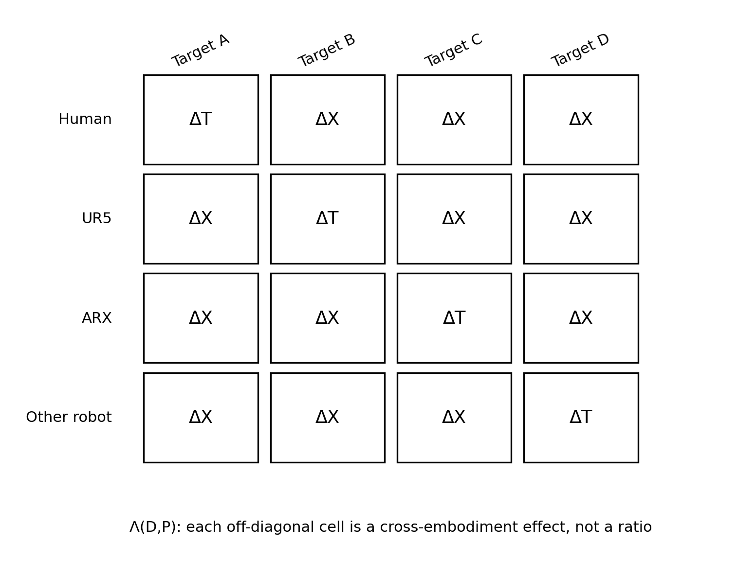
Figure 1. Proposed embodiment-transfer effect matrix Λ(D,P). Humans are one source embodiment among others. Diagonal cells correspond to target-embodiment data effects; off-diagonal cells are cross-embodiment effects.

3.2 Low-level transfer is not the same as dynamics transfer
Kareer et al. show that transfer is not confined to high-level language subtasks: Bussing and Eggs are evaluated without a high-level policy, and ablations on the mobile tasks indicate benefits through both high- and low-level components [1]. But 'low level' in this architecture means relative end-effector action prediction. The human representation contains visual and kinematic information; it has no direct force, torque, compliance, or contact-model supervision, and even gripper openness is absent [1].
The paper itself describes the collection protocol as isolating transfer to visual and kinematic differences between humans and robots [1]. The benchmark axes are scene, object, and task. Accordingly, the evidence supports semantic-kinematic transfer. It does not establish that a representation learned across embodiments captures transferable physical dynamics.

3.3 Failure descriptions are referential rather than dynamical
The reported qualitative failures reinforce this boundary. When only the high-level policy receives human data, the low-level policy may select the wrong bottle or wrong destination. When only the low-level policy receives human data, the high-level policy may continue issuing an already-completed subtask or choose an incorrect placement instruction [1]. These are failures of reference, task stage, and semantic grounding. They are not demonstrations of failure under changed mass, friction, inertia, or compliance. This does not weaken the reported transfer; it narrows what should be inferred from it.

3.4 The most interesting evidence is transfer/competence dissociation
Appendix B of the paper notes intervals in which increased pretraining diversity does not improve the robot-only zero-shot curve but does increase the gain from human data—for example Dresser between high-diversity checkpoints and Eggs from mid-diversity through the full cross-embodiment mixture [1]. This is more scientifically interesting than the claim that both competence and transfer improve with scale, because it suggests they may be distinct response variables.
However, the current grid has only the reported diversity checkpoints (0%, 25%, 50%, 75%, 100%, and 100%+cross-embodiment) and each experiment uses only 20–40 evaluations [1]. Sort Eggs is also a structurally weak test of dissociation because the robot-only data lacks the sorting concept; a flat baseline can therefore arise from task coverage rather than a distinct transfer mechanism. A claim that transfer rises 'before' competence requires a denser grid and tasks whose baseline competence is free to move in the mid-range.

3.5 Preprocessing is a causal variable, not a footnote
The human pipeline contains at least three forms of engineered decoding: sensorization (head and wrist cameras), geometric reconstruction (SLAM and 3D hand keypoints), and language annotation of subtasks [1]. The wrist-camera ablation already shows task-dependent effects: wrist views help Dresser and Bussing but not Spice and Eggs [1]. Therefore a change in the usefulness of human data can arise either because the pretrained model has learned more transferable structure or because the source representation has been made easier to decode.
This motivates a second experimental variable P: preprocessing strength. The core scaling question is not whether transfer improves when both model diversity and source engineering improve. It is whether increasing pretraining diversity increases transfer at fixed preprocessing, and whether diversity can substitute for engineered decoding when P is weakened.

4. Estimands: Separate Effects Before Normalizing Them

4.1 Notation
Let D index pretraining diversity and P index preprocessing strength. Let t be the target embodiment and s the source embodiment. Define B_t(D) as performance after the declared target-policy fine-tuning recipe without supplementary source data. Define S_{s→t}(D,P) as performance after adding a fixed amount of source-embodiment data processed at level P. Define T_t(D) as performance after adding a comparable amount of target-embodiment data.
ΔX(D,P; s→t) = S_{s→t}(D,P) − B_t(D) | (1)
ΔT(D; t) = T_t(D) − B_t(D). | (2)
The primary transfer object is the matrix
Λ(D,P) = [ ΔX(D,P; s→t) ]_{s,t}. | (3)
Humans occupy one source row. Target-data effects are reported separately as ΔT rather than used as a denominator.

4.2 Why the ratio estimator should not be primary
A tempting normalization is (S−B)/(T−B), interpreted as the fraction of target-data benefit reproduced by source data. This ratio is unstable exactly where the motivating hypothesis is most interesting: T−B can approach zero when target-data benefit is small, can change sign under negative transfer, and is itself estimated with noise. Ratios of uncertain quantities can have heavy-tailed or even unbounded confidence sets; Fieller's classical analysis exists precisely because ordinary delta-method intuition can fail [15].
The remedy is simple: report ΔX and ΔT separately as primary estimands. If a bounded metric requires a secondary normalized visualization, a ceiling-normalized effect such as (S−B)/(1−B) may be used when the scale has a meaningful upper bound, but it should not replace the raw treatment effects and it does not solve task-to-task comparability by itself.

4.3 Raw-outcome modeling
Inference should be based on raw trial outcomes rather than ratios of plotted means. Binary task success naturally admits a hierarchical Bernoulli/logistic model. Item-count tasks such as Bussing and Sort Eggs are better represented by binomial or beta-binomial episode models when item-level outcomes are available. The hierarchy should account for task, seed, embodiment pair, and repeated evaluation where appropriate. This avoids pretending that all normalized 0–1 scores have identical sampling distributions.
Small samples make this especially important. For a Bernoulli outcome near p=0.5, the standard error of a sample proportion is approximately 0.112 at n=20 and 0.079 at n=40. That range is only a benchmark because some tasks use count scores, but it illustrates why sparse checkpoints should not be turned into ordering claims from visual separation alone.

5. What Would Count as Separation from Competence?

5.1 Equivalence, not nonsignificance
Let C_t(D)=B_t(D) denote zero-shot or baseline competence at diversity D. Suppose two adjacent diversity levels D1<D2 are compared. A failure to reject C_t(D2)=C_t(D1) does not establish that competence is unchanged. To claim separation, the competence change should satisfy a preregistered practical-equivalence criterion while the transfer effect changes by a practically meaningful amount.
| C_t(D2) − C_t(D1) | < εC | (4)
ΔX(D2,P;s→t) − ΔX(D1,P;s→t) > δX. | (5)
The margins εC and δX must be specified before seeing confirmatory results. Frequentist two-one-sided tests or Bayesian regions of practical equivalence can implement the competence criterion; the methodological point is that 'not significant' is not evidence of equality [16].

5.2 Avoid floor- and ceiling-pinned tasks
A task is unsuitable for the main separation claim when B_t(D) is mechanically pinned near zero because the target data never contains the relevant task concept, or near one because the task is already saturated. Such tasks can still test transfer, but they cannot distinguish a special transfer response from an immovable competence baseline. Confirmatory tasks should therefore be selected so that B_t(D) spans a preregistered mid-range over the diversity sweep.

5.3 Dense diversity grid
The original diversity checkpoints are sufficient to reveal a trend but not to establish ordering. A confirmatory design should use a denser grid—e.g., 8–12 diversity levels—constructed by sampling from a fixed pool of scene-task-embodiment domains. Total number of training episodes, optimization steps, model size, and token/action budget should be held approximately fixed across D. Otherwise 'diversity' is confounded with data volume or compute.

6. Preprocessing Strength as a Factor
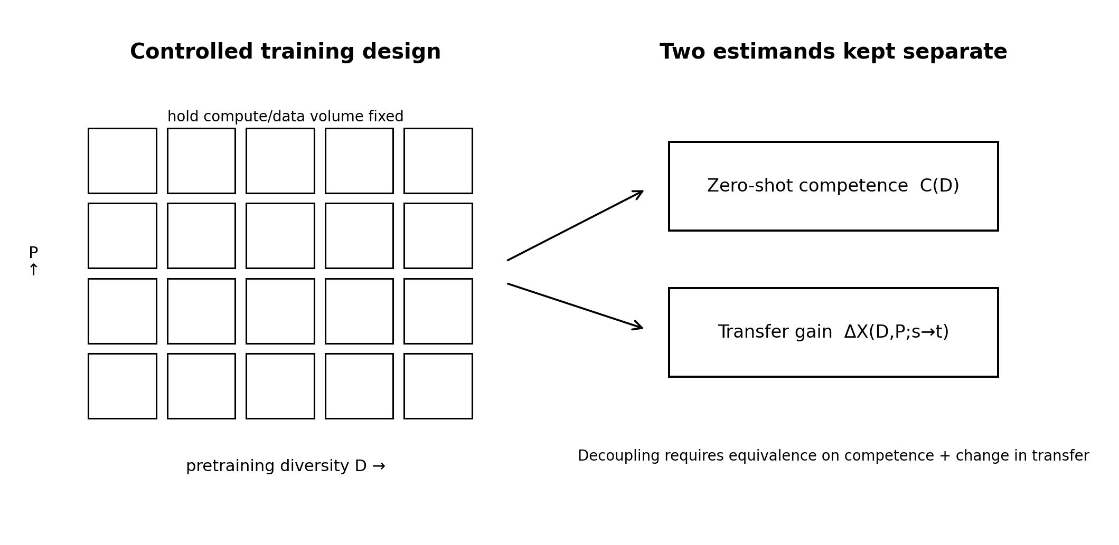
Figure 2. Proposed factorial design. Pretraining diversity D and preprocessing strength P are manipulated separately. Zero-shot competence C(D) and cross-embodiment transfer ΔX(D,P) remain separate estimands.
Define P as the source-decoding budget required before the data enter the common policy learner. The goal is not to create an artificial scalar that perfectly orders all pipelines, but to preregister a small set of nested conditions with known information content.
Level | Source representation | Interpretation
P3: full instrumented | Head + wrist cameras; SLAM; 3D hand reconstruction; manual/verified subtasks. | Closest to the motivating recipe.
P2: reduced sensors | Head camera only; same reconstruction and annotation stack. | Tests dependence on wrist instrumentation.
P1: reduced decoding | Head camera; fixed automatic hand/action reconstruction; automatic subtask labels or no subtask labels depending on experiment. | Tests sensitivity to engineered decoding quality.
P0: passive-video extension | No action-bearing instrumentation; latent-action/video model required. | Different learning interface; reserve for a separate follow-up unless architecture is held constant.

The key interaction is whether increasing D compensates for reducing P. If ∂ΔX/∂P dominates and transfer remains weak at low P regardless of D, the result is primarily a decoding-engineering phenomenon. If higher D systematically preserves or recovers transfer under weaker P, diverse pretraining is buying source interpretability rather than merely direct task competence.

7. Three Axes of Transfer

7.1 Semantic novelty
Semantic transfer changes object identity, instruction, category, or task rule while keeping the physical interaction regime familiar. Sort Eggs is a clear example: the target robot can already pick and place eggs, while the sorting rule is introduced through human data [1]. This axis asks whether a source embodiment transfers what to do.

7.2 Kinematic novelty
Kinematic transfer changes morphology, coordinate mapping, reachable poses, or trajectory realization while preserving task semantics and broadly similar contact dynamics. Relative end-effector representations, UMI-style interfaces, and embodiment-specific prompts are all mechanisms for reducing or learning this gap [6], [9]. This axis asks whether a source embodiment transfers how motion should be geometrically organized.

7.3 Dynamical novelty
Dynamical transfer changes mass, inertia, friction, compliance, or force response while holding object identity and desired pose trajectory as constant as practicable. This is the bottom-left cell left largely open by the motivating experiment. Recent force-aware VLA work underscores that contact-rich control can require explicit force information beyond vision and position trajectories [13].
A clean dynamics benchmark should avoid deformables or liquids in the first experiment because they simultaneously alter geometry and dynamics. Better manipulations include visually identical objects with hidden mass inserts, surfaces with different calibrated friction coefficients, or handles with adjustable compliance. The desired end-effector trajectory is specified identically; only the force/dynamics required to realize it changes. If a source embodiment's dynamics experience improves target performance here, the claim of embodiment-general physical representation becomes substantially stronger.
Axis | Change | Hold fixed | Primary interpretation
Semantic | New category/rule/instruction | Mass, friction, morphology approximately fixed | Task/object knowledge transfer
Kinematic | Source/target morphology or coordinate mapping | Task semantics and contact regime fixed | Embodiment geometry transfer
Dynamical | Mass, friction, compliance, inertia | Object identity and desired trajectory fixed | Physical interaction transfer

8. Proposed Confirmatory Experiment

8.1 Factorial structure
The full confirmatory design crosses pretraining diversity D, preprocessing P, source embodiment s, target embodiment t, and novelty axis A. Because the complete Cartesian product is expensive, a staged design is preferable. Stage 1 estimates D×P on two source-target pairs and tasks with mid-range baselines. Stage 2 expands the source-target matrix at the most informative D and P levels. Stage 3 introduces dynamics-specific tasks and force-aware source data.

8.2 Diversity construction
- Create a fixed universe of scene-task-embodiment domains before training.
- Construct nested or randomized domain subsets for 8–12 D levels while holding total episode count and optimizer steps fixed.
- Repeat subset construction across multiple diversity seeds so a particular domain choice is not confused with diversity itself.
- Include at least one condition that adds non-target embodiments without adding target-embodiment task coverage.
- Keep model architecture and post-training recipe fixed across the primary sweep.

8.3 Evaluation design
Use substantially more evaluations per cell than the motivating 20–40. A realistic plan is 100–200 episodes per key confirmatory cell, with fewer screening trials at intermediate cells, adjusted after simulation-based power analysis. Report raw episode outcomes and task-level denominators. Predefine the mid-range baseline criterion, εC, δX, and the multiplicity strategy before running the sweep.

8.4 Primary hypotheses
- H1 — Cross-embodiment effect: at fixed P, at least one off-diagonal Λ entry increases with D after controlling data volume and compute.
- H2 — Transfer/competence separation: there exists a preregistered interval where competence is statistically equivalent within ±εC while ΔX increases by at least δX.
- H3 — Preprocessing substitution: the marginal penalty of reducing P decreases as D increases.
- H4 — Human deflation: after matching source data quantity and representation quality, the human row is not categorically different from non-target robot rows; differences are quantitative and task-dependent.
- H5 — Dynamics test: source experience from altered dynamics improves target performance under dynamics novelty when semantics and desired kinematics are held fixed.

8.5 Failure conditions
Outcome | Interpretation
ΔX rises only when B rises | No evidence of transfer/competence separation; diversity may simply improve the whole policy.
Separation appears only on floor-pinned tasks | Artifact of task coverage; reject general separation claim.
Reducing P eliminates transfer at every D | Source decoding, not diversity, is load-bearing.
Human row behaves like matched robot rows | Supports cross-embodiment framing; rejects special human category.
Dynamics transfer absent | Restrict claim to semantic-kinematic transfer.
Ratio metric changes while ΔX does not | Normalization artifact; illustrates why separate estimands are necessary.

9. Statistical Analysis Plan

9.1 Hierarchical outcome models
Fit task-appropriate hierarchical models directly to raw evaluation outcomes. For binary success, use a logistic mixed model with fixed effects for D, P, source embodiment, relevant interactions, and novelty axis, plus random intercepts/slopes for task and training seed where supported. For count outcomes, use binomial or beta-binomial models with episode opportunity counts. Avoid collapsing heterogeneous tasks into a single normalized mean before inference.

9.2 Equivalence testing
For candidate separation intervals, first test or estimate practical equivalence of competence within ±εC. Only intervals satisfying that criterion are eligible for a claim of transfer/competence separation. Then estimate the change in ΔX with uncertainty. This order prevents post hoc selection of visually flat competence intervals. The equivalence margin should be justified in task units—for example, an absolute success-rate change below a declared operational threshold—rather than chosen from the observed standard error [16].

9.3 Ratios only as secondary summaries
If a source-to-target relative efficiency ratio is reported for interpretability, its confidence set should be computed with a method appropriate for ratios, such as Fieller intervals or a bootstrap that respects the hierarchical sampling unit [15]. Cells with denominators near zero should be flagged as non-estimable rather than regularized into apparently precise values. The scientific conclusions should remain based on ΔX and ΔT separately.

10. Resource and Collaboration Requirements
The strongest version of the paper requires controlled VLA pretraining runs across multiple diversity levels and preprocessing conditions. That is a materially different resource requirement from reanalyzing published evaluations. A small independent group can complete the source audit, estimator paper, and perhaps post-training experiments on open models such as Octo or other available checkpoints. A definitive D×P pretraining sweep, however, likely requires collaboration with a laboratory or company that already maintains heterogeneous robot datasets, VLA training infrastructure, and multiple embodiments.
This resource constraint should shape the publication sequence rather than be hidden. Version 1 can be submitted as a measurement/experimental-design paper if the venue accepts methodological robotics work, accompanied by reproducible analysis code for simulated and public aggregate examples. Version 2 becomes an empirical result only after the controlled sweep exists. The title used here is intentionally compatible with the first scope and does not assert that separation has already been demonstrated.

11. Relationship to Certification
Cross-embodiment transfer studies assume that evaluation scores identify genuine task success. For embodied policies, that assumption can fail when the policy can alter the evaluator's observation channel. A complementary certification program therefore asks whether apparent success remains physically identifiable under policy-reachable sensor configurations. In practical experimental design, independent or causally protected verification should precede fine-grained scaling claims. Otherwise an apparent transfer gain can partly reflect a changed ability to satisfy the evaluator rather than a changed ability to satisfy the task.
This dependence is methodological rather than rhetorical: trustworthy measurement is a precondition for estimating Λ(D,P). It motivates an ordering for the broader research program—certification before scaling—not because certification solves representation learning, but because it establishes that the dependent variable means what the scaling study says it means.

12. Limitations
- The proposed matrix Λ depends on a declared fine-tuning recipe and source-data budget; it is not an intrinsic property of an embodiment pair.
- Pretraining diversity is multidimensional. Scene, task, morphology, sensor, and dynamics diversity may have different effects; a scalar D is an experimental index, not a universal sufficient statistic.
- Preprocessing strength P is only partially ordered. Some pipelines trade manual annotation for stronger learned latent-action models rather than simply containing more or less information.
- The published human-to-robot study does not release enough raw evaluation detail in the paper text alone to support a definitive reanalysis of all uncertainty; new claims should therefore rely on new raw trials or author-released evaluation data.
- Dynamics transfer may require modalities not present in conventional VLAs. Adding force/torque input changes the architecture and must be treated as a designed extension rather than silently attributed to visual pretraining.
- A negative result on separation would not imply that diverse pretraining is unhelpful. It would imply only that its contribution cannot be cleanly separated from direct competence under the tested design.

13. Conclusion
The strongest defensible interpretation of current human-to-robot VLA evidence is not that robots have crossed a gate that makes human experience generally readable. The evidence shows targeted cross-embodiment transfer under a carefully engineered visual-kinematic representation, and it includes intriguing intervals where transfer gain and zero-shot competence appear to move differently. Those intervals deserve direct measurement rather than extrapolation.
The paper therefore replaces a scalar readability story with an embodiment-transfer matrix Λ(D,P), keeps source-transfer and target-data effects separate, and requires practical equivalence before claiming competence is unchanged. Humans become one source row. Preprocessing becomes an experimental factor. Semantic, kinematic, and dynamical novelty become separate axes rather than one word—'embodiment.'
This framing is useful precisely because it can fail. If transfer depends primarily on engineered decoding, then the research agenda is better tracking and representation alignment. If diversity improves off-diagonal transfer independently of direct competence and progressively substitutes for preprocessing, then there is evidence for a more general cross-embodiment abstraction. If transfer reaches controlled dynamical novelty, the case becomes stronger still. Source-before-synthesis requires that each of these claims be earned separately.

Appendix A. Recommended Reporting Table
Field | Minimum report
D | Exact domain mixture and diversity construction; total episodes fixed?
P | Sensors, tracking, annotations, action extraction, human labor, automatic models.
s→t | Named source and target embodiment; action/observation spaces.
B | Raw baseline outcomes with n and uncertainty.
S | Raw source-augmented outcomes with n and uncertainty.
T | Raw target-data outcomes with n and uncertainty.
ΔX | S−B with interval.
ΔT | T−B with interval.
Competence equivalence | Margin εC and test/posterior result.
Novelty axis | Semantic, kinematic, dynamical; what was held fixed.

Appendix B. Source-Before-Synthesis Checklist
1. Read the primary paper, including appendices and failure descriptions, before adopting its headline interpretation.
2. Extract the actual source representation and instrumentation; do not call instrumented action-bearing data “raw video.”
3. Record trial counts and uncertainty before comparing headline percentages.
4. Check whether human transfer is different from robot-to-robot transfer before treating humans as a special category.
5. Separate semantic, kinematic, and dynamical claims according to what information is present in the source channel.
6. Define estimands before normalization; never let a noisy denominator create the phenomenon.
7. Use equivalence to support “unchanged,” not failure to reach statistical significance.
8. Pre-register the negative result that would reduce a scaling claim to an engineering claim.

References
[1] S. Kareer, K. Pertsch, J. Darpinian, J. Hoffman, D. Xu, S. Levine, C. Finn, and S. Nair, “Emergence of Human to Robot Transfer in Vision-Language-Action Models,” arXiv:2512.22414, Dec. 27, 2025.
[2] Physical Intelligence et al., “π0.5: A Vision-Language-Action Model with Open-World Generalization,” arXiv:2504.16054, 2025.
[3] Open X-Embodiment Collaboration et al., “Open X-Embodiment: Robotic Learning Datasets and RT-X Models,” arXiv:2310.08864, 2023.
[4] Octo Model Team et al., “Octo: An Open-Source Generalist Robot Policy,” arXiv:2405.12213, 2024.
[5] B. Zitkovich et al., “RT-2: Vision-Language-Action Models Transfer Web Knowledge to Robotic Control,” in Proceedings of the Conference on Robot Learning, PMLR, pp. 2165–2183, 2023.
[6] J. Zheng et al., “X-VLA: Soft-Prompted Transformer as Scalable Cross-Embodiment Vision-Language-Action Model,” arXiv:2510.10274, 2025.
[7] J. Yang, C. Glossop, A. Bhorkar, D. Shah, Q. Vuong, C. Finn, D. Sadigh, and S. Levine, “Pushing the Limits of Cross-Embodiment Learning for Manipulation and Navigation,” arXiv:2402.19432, 2024.
[8] C. Wang, L. Fan, J. Sun, R. Zhang, L. Fei-Fei, D. Xu, Y. Zhu, and A. Anandkumar, “MimicPlay: Long-Horizon Imitation Learning by Watching Human Play,” Proceedings of the 7th Conference on Robot Learning, PMLR 229, pp. 201–221, 2023.
[9] C. Chi, Z. Xu, C. Pan, E. Cousineau, B. Burchfiel, S. Feng, R. Tedrake, and S. Song, “Universal Manipulation Interface: In-The-Wild Robot Teaching Without In-The-Wild Robots,” arXiv:2402.10329, 2024.
[10] L. Y. Zhu, P. Kuppili, R. Punamiya, P. Aphiwetsa, D. Patel, S. Kareer, S. Ha, and D. Xu, “EMMA: Scaling Mobile Manipulation via Egocentric Human Data,” arXiv:2509.04443, 2025; subsequently listed as IEEE Robotics and Automation Letters, 2026.
[11] R. Yang et al., “EgoVLA: Learning Vision-Language-Action Models from Egocentric Human Videos,” arXiv:2507.12440, 2025.
[12] D. Jing, T. Zhang, J. Liu, J. Zhao, Z. Sun, L. E. Li, Z. Lu, and M. Ding, “Learning Action Priors for Cross-embodiment Robot Manipulation,” arXiv:2606.26095, 2026.
[13] Y. Li et al., “ForceVLA2: Unleashing Hybrid Force-Position Control with Force Awareness for Contact-Rich Manipulation,” arXiv:2603.15169, 2026.
[14] A. Gelman, J. B. Carlin, H. S. Stern, D. B. Dunson, A. Vehtari, and D. B. Rubin, Bayesian Data Analysis, 3rd ed. Boca Raton, FL: CRC Press, 2013.
[15] E. C. Fieller, “Some problems in interval estimation,” Journal of the Royal Statistical Society: Series B (Methodological), vol. 16, no. 2, pp. 175–185, 1954.
[16] D. Lakens, “Equivalence tests: A practical primer for t tests, correlations, and meta-analyses,” Social Psychological and Personality Science, vol. 8, no. 4, pp. 355–362, 2017. doi:10.1177/1948550617697177.

