Second Foundation Revisited
  - Relational Memory, Compressed Working States, and Mechanism-Aware Consolidation
Debi Prasad Ghosh, Ph.D., debiprasadghosh@gmail.com
Founder & Principal Engineer, Debias Parametric Guru, Kolkata, India
Independent research programme in Defensible Intelligence and computational architectures
Conceptual computational neuroscience paper | Architectural hypotheses are explicitly tiered
A neuroscience sequel to: Second Foundation: Knowledge Graph vs Sentence Embedding for Long-Term & Short-Term Memory (2023)

Abstract
The 2023 Second Foundation paper proposed a dual-representation memory architecture: compact association or sentence-like embeddings for durable storage, and task-local knowledge graphs for compositional reasoning, with a larger hippocampal graph supporting accumulation before sleep-dependent consolidation. This neuroscience sequel retains the central architectural insight—different operations require different representations—but revises the literal biological mapping. The brain is unlikely to store a language-like knowledge graph or a sentence embedding as such. A more defensible architecture contains at least five coupled objects: a distributed neocortical substrate that gradually extracts statistical and relational structure; a hippocampal system that rapidly indexes episodes and supports relational reconstruction; a task-local workspace assembled from retrieved cortical and hippocampal content; a low-dimensional population state used for current computation and action; and replay mechanisms that support both offline consolidation and online prospective planning. In this formulation, graph topology and neural geometry are complementary descriptions rather than mutually exclusive stores. A relational structure can be expressed through many population embeddings, and a compressed neural state can omit the provenance needed to reconstruct the full relation system. The paper also imports a methodological result from the finite-element companion: a correct verdict is unusable without its mechanism. Absent decodable delay activity may mean memory loss, activity-silent retention, transformed coding, or a closed retrieval gate—mechanisms requiring opposite experimental responses. The proposed claim object therefore includes mechanism, coefficient or coding regime, conditions, jurisdiction, disabled regime, falsifier, and guard. The paper presents a revised Second Foundation architecture, distinguishes established neuroscience from architectural analogy, derives testable predictions for relational reconstruction, replay, working-memory state transitions, and schema consolidation, and proposes experiments capable of falsifying the graph–execution-state account.
Keywords: hippocampus; neocortex; working memory; relational memory; knowledge graph; neural manifold; replay; memory consolidation; complementary learning systems; mechanism-aware claims

Reader Summary
- Retain the 2023 principle that structured relational reasoning and compact execution states need different representations connected by explicit transformations.
- Do not identify a biological long-term memory with a sentence embedding or a hippocampal trace with a literal knowledge graph. Those are architectural analogies.
- Treat the hippocampus as a rapid episodic and relational index, the neocortex as a distributed slow-learning substrate, and working memory as a task-local state assembled through retrieval and attention.
- Distinguish relational topology from neural geometry. The same graph can have many embeddings; the same low-dimensional state can support different relations under different readouts.
- Use replay in two jurisdictions: offline memory consolidation and online prospective planning. Neither role should be inferred merely from the presence of replay-like sequences.
- Attach mechanism to every neural verdict. No persistent activity can mean no memory, latent retention, transformed representation, retrieval failure, or an insensitive decoder.
- Test the architecture through perturbation, re-cueing, graph-generalization tasks, replay-content analysis, and representational geometry—not by metaphor alone.

1. Introduction
Second Foundation: Knowledge Graph vs Sentence Embedding for Long-Term & Short-Term Memory was written in 2023 to answer an architectural question in artificial intelligence: should an external memory be stored as a structured graph or as dense semantic vectors? Its answer was deliberately plural. Dense representations support similarity retrieval and compact storage; graph representations support explicit relations, compositional reasoning, and the addition of new facts. The paper proposed an iterative working graph assembled from retrieved neighbours and a larger hippocampal graph that accumulated information before sleep-dependent consolidation.
Three years of subsequent work in the Defensible Intelligence programme changes the question. The issue is no longer which one of two stores the brain uses. The brain can maintain distributed synaptic structure, rapidly learned episodic indices, transient population activity, activity-silent states, and dynamically reconstructed relational workspaces at the same time. Graph and embedding are therefore better understood as complementary descriptions of a multi-stage computation than as mutually exclusive memory formats.
This paper is a neuroscience sequel rather than a retrospective defence. It preserves the 2023 insight that a task-optimized representation should not replace the durable relational representation from which it was derived. It revises claims that were too literal, introduces a five-object memory architecture, and makes mechanism a required part of every claim. The paper does not claim that neurons store triples or sentence vectors. It asks whether a relation-rich substrate and a compressed execution state are both required to explain memory, reasoning, replay, and consolidation.

2. What the 2023 paper proposed—and what this sequel changes
Table 1. The sequel retains the architecture and narrows the biological claims.
2023 formulation | What survives | What is revised
Knowledge graph and sentence embedding serve different operations | Representation plurality and explicit conversion remain central | Neither object is treated as a literal biological storage format
Long-term memory is compact and association-like | Distributed cortical memory is high-capacity and statistical | It is not adequately characterized as one sentence embedding
Working memory constructs a task-local graph | Reasoning requires selective relational reconstruction | Working memory is not necessarily a separate graph store; it can be a dynamic state over activated long-term content
A larger hippocampal graph accumulates experience before sleep | Hippocampus rapidly binds episodes and supports retrieval/replay | A literal merge-friendly hippocampal KG is an architectural hypothesis, not an established anatomical object
Sleep replay converts recent memory into durable memory | Replay participates in consolidation | Replay also supports online planning; sleep-stage assignments are more complex than a one-to-one System 1/System 2 mapping

3. Representation duality without storage dualism
A graph specifies entities and relations. A population code specifies a location, trajectory, or distribution in neural state space. These are different mathematical objects, but one can be mapped into the other for a task. The existence of such a map does not imply that one representation is the permanent store and the other a temporary copy.
Let G = (V,E,τ,π) denote a task-relevant relational structure, with typed relations τ and provenance π. Let Φ_θ map that structure, under task context θ, into a neural population state z_t in a lower-dimensional execution space.
Φ_θ : G_θ -> z_t ∈ R^d
The map is generally many-to-one. Different relational structures may produce similar execution states when the task ignores their differences. Conversely, the same relational structure may be represented by different neural geometries across individuals, contexts, remapping events, or learning stages. A readout state is therefore not a self-describing memory.
This is the central transfer from the finite-element companion. A compressed execution representation can be sufficient for the current computation while being insufficient for provenance, reconstruction, or future reasoning. The brain need not choose graph or embedding. It needs mechanisms that assemble, transform, and re-enter relation-rich memory from task-specific neural dynamics.

4. A five-object neuroscience architecture
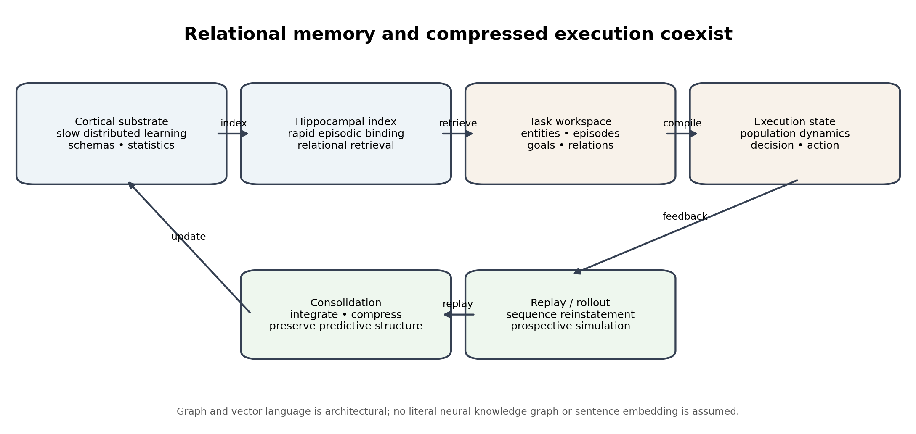
Figure 1. Revised Second Foundation architecture: distributed memory, episodic indexing, relational reconstruction, and compact execution are distinct but coupled.
Table 2. The five objects should not be collapsed into one memory store.
Object | Candidate biological role | Computational function
Distributed cortical substrate C | Slowly learned distributed synaptic and population structure across neocortex | Semantic regularities, schemas, category structure, predictive relations
Hippocampal relational index H | Rapid episodic binding and indexing of distributed cortical patterns | Fast learning, pattern separation/completion, relational and sequential retrieval
Task-local workspace W_θ | Coordinated hippocampal, prefrontal, parietal, and modality-specific activity | Select and bind the entities, episodes, goals, and relations relevant now
Execution state z_t | Low-dimensional or dynamically coded population state | Comparison, planning, response selection, and behavioural control
Replay/consolidation operator U | Hippocampal-cortical reactivation during rest, sleep, and deliberation | Reinstatement, planning rollout, integration, schema update, predictive compression

The architecture can be written schematically as
W_θ = Retrieve_θ(C,H), z_t = Φ_θ(W_θ), a_t = Ψ_θ(z_t)
(C,H)_{n+1} = U((C,H)_n, Replay(W_θ,z_{1:T},outcome))
These equations are an architectural proposal. They do not identify a specific synapse, oscillation, or anatomical loop with a software function. Their value is to prevent one observed representation from being asked to serve every memory operation.

5. Hippocampal indexing and complementary learning systems
The hippocampal indexing theory proposes that the hippocampus stores an index to distributed neocortical activity patterns associated with an experience. Complementary learning systems theory assigns rapid learning of individual episodes to the hippocampal system and slow extraction of shared structure to neocortex. Both frameworks support the sequel's central distinction between a rapid relational access structure and a distributed long-term substrate.
This does not imply that the hippocampus is a database of explicit triples. An index can be sparse, distributed, sequential, and content-addressable. The relevant claim is functional: a new episode can be bound rapidly without requiring immediate rewriting of the full cortical statistical structure, and later retrieval can reinstate a distributed pattern.
Relational and cognitive-map models strengthen this interpretation. The Tolman-Eichenbaum Machine shows how hippocampal-entorhinal computations can support generalization across spatial and non-spatial relational structures. Human studies of grid-like coding for conceptual knowledge further suggest that relational organization can be expressed geometrically in population activity. These findings bridge graph topology and neural geometry without making them identical.

6. Working memory is a state of access, not one storage format
The 2023 paper treated short-term or working memory as the location where a task-specific knowledge graph is assembled. The sequel retains task-local assembly but removes the claim that working memory must be a separate graph store.
Working-memory theories span persistent spiking activity, short-term synaptic plasticity, dynamically transformed population subspaces, and activated portions of long-term memory. Current evidence does not support one universal mechanism for every unattended or prioritized item. Indeed, recent single-neuron evidence in human medial temporal lobe reports persistent coding of attended and unattended items under conditions previously described as activity-silent, while other studies support latent or dynamically recoverable states. The correct architecture must permit multiple mechanisms.
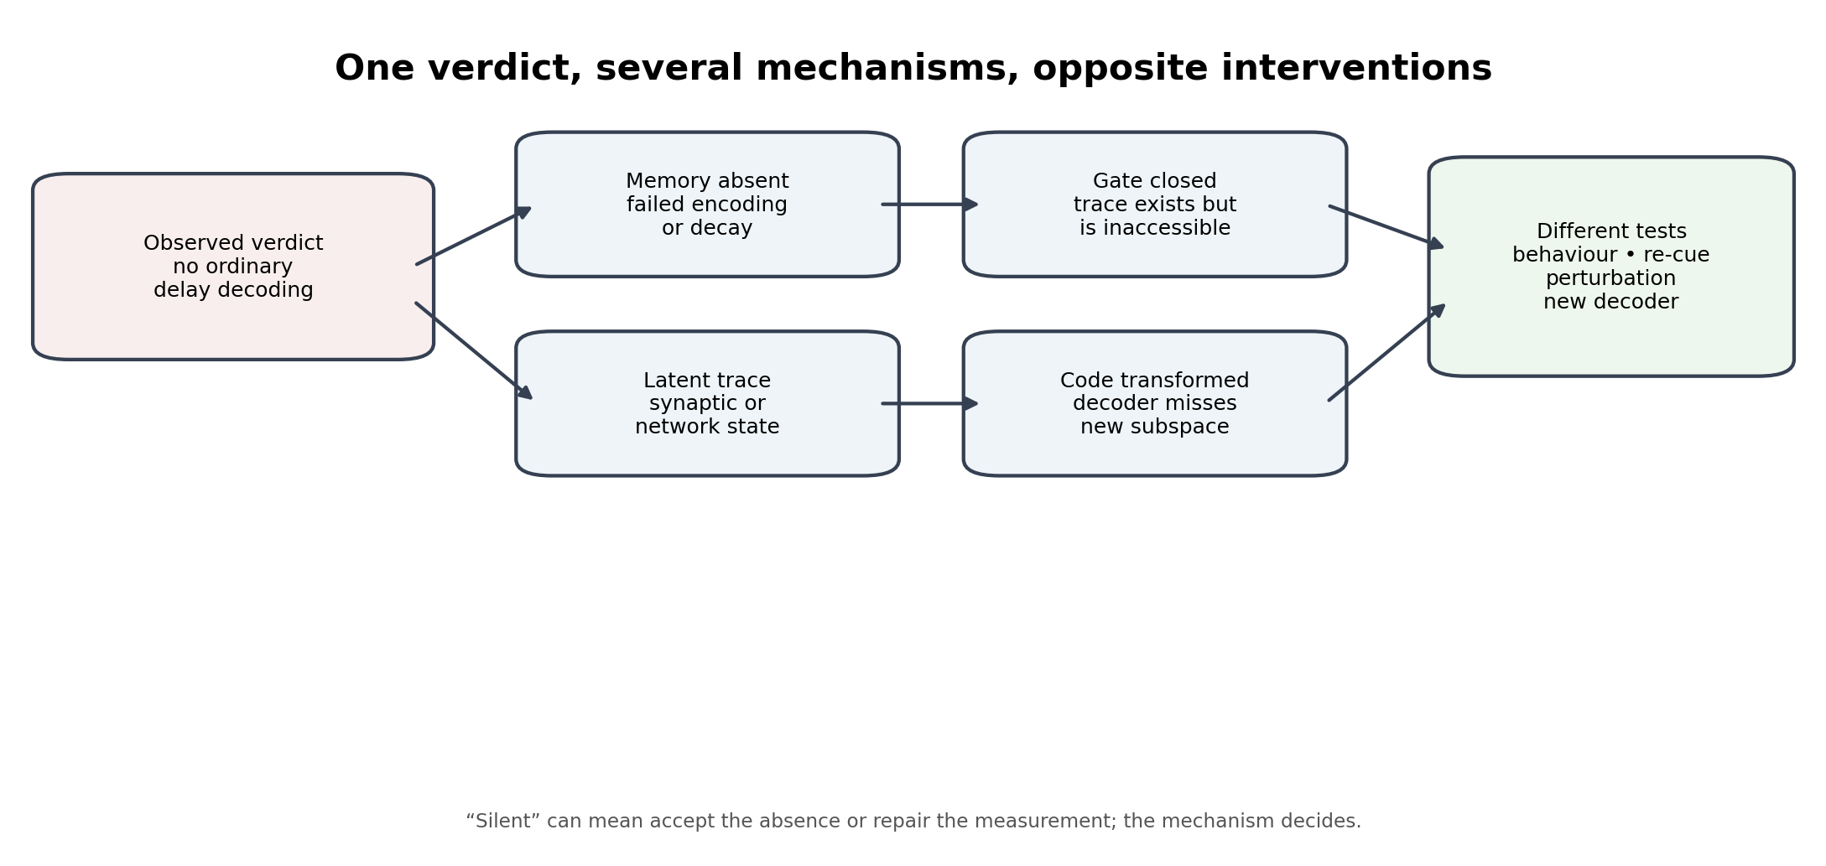
Figure 2. “No decodable activity” is a verdict shared by several mechanisms that require different experiments.
Table 3. A mechanism-aware working-memory diagnosis.
Observed result | Possible mechanism | Discriminating intervention
No sustained decodable delay activity | The item was not encoded or has decayed | Behavioural recall and recognition; re-presentation control
No ordinary decoder signal | Representation has rotated or moved to another subspace | Cross-temporal, nonlinear, or subspace-aware decoding
No active signal but later recall succeeds | Latent synaptic or network state retains the item | Perturbation or re-cue designed to reactivate the state
Memory exists but cannot guide behaviour | Retrieval or attentional gate is closed | Cueing, priority manipulation, hippocampal-prefrontal interaction measures
Decoder reports memory but behaviour fails | Readout is epiphenomenal or inaccessible to action | Causal perturbation and trial-level brain-behaviour coupling

A rule written in prose does not govern the sentence that writes it. A neural claim must therefore carry its mechanism as a required field, not as optional interpretation.

7. Task-local relational reconstruction
Reasoning does not require the entire long-term memory structure to be active at once. A cue, goal, or current sensory state can retrieve a limited neighbourhood of relevant entities, episodes, transitions, and causal relations. The resulting workspace resembles the task-local graph in the 2023 paper, but it is better understood as a transient relational organization distributed across interacting circuits.
The hippocampus may contribute rapid relational binding and sequence reinstatement; prefrontal cortex may maintain goals, control retrieval, and determine whether further simulation is worthwhile; modality-specific and association cortices supply content. Planning models in which prefrontal dynamics trigger hippocampal replay and are then modified by the replay provide a concrete example of such bidirectional control.
The graph-like content of a workspace is defined by which relational queries it can support, not by whether one can locate a literal adjacency list in the tissue. An experiment should therefore test relational generalization, path inference, and compositional transfer in addition to decoding individual items.

8. Low-dimensional execution states
Population activity often occupies lower-dimensional manifolds relative to the number of recorded neurons. Such compression is useful for rapid control, comparison, and readout. It is the neuroscience analogue of a task-optimized execution view, not proof that long-term memory itself is one flat vector.
A neural state z_t should be interpreted together with the context-dependent map Φ_θ and readout Ψ_θ. Without the mapping and task context, geometric proximity can conflate distinct relations. Conversely, relationally equivalent structures can be embedded differently while supporting the same behaviour.
The sequel therefore replaces the 2023 storage statement 'long-term memory is sentence embedding' with a narrower claim: cognition repeatedly compiles relation-rich distributed memory into compact population states suitable for the present operation. The durable substrate and the execution state should both be studied, along with the transformations between them.

9. Replay has two jurisdictions
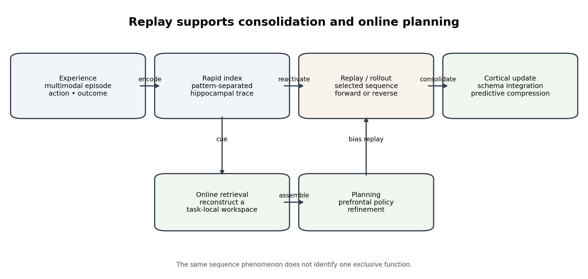
Figure 3. Replay can support slow memory consolidation and fast online planning; the same sequence phenomenon does not imply one exclusive mechanism.
Hippocampal replay has been associated with the reinstatement of recent experience and coordinated cortical activity during rest and sleep. Complementary learning systems accounts use replay to interleave new episodes with established cortical knowledge and reduce catastrophic interference. Schema research shows that cortical integration can accelerate when new information fits prior structure.
Replay also occurs in awake deliberation and can support prospective evaluation. Recent computational work models prefrontal control of whether to plan, with hippocampal-like rollouts modifying prefrontal policy dynamics. Thus replay should not be assigned exclusively to offline consolidation.
The 2023 analogy between replay direction and bidirectional language models is therefore too literal. Forward and reverse replay are observed sequence organizations with possible roles in learning, credit assignment, retrieval, and planning. Their function must be inferred from timing, content, downstream effects, and causal perturbation—not from sequence direction alone.

10. Mechanism-aware memory claims
The FEA companion identified an eighth failure pattern: a correct verdict reported for the wrong mechanism. Neuroscience is particularly vulnerable to this error because the same behavioural or decoding result can be produced by distinct circuit states. A usable claim should be represented as:
Claim = (statement, type, mechanism, coding regime, conditions, jurisdiction, disabled regime, falsifier, guard)
Table 4. The mechanism field prevents a measurement verdict from becoming an unsupported memory theory.
Field | Example: no decodable delay activity
Statement | A standard linear decoder does not recover item identity during the delay.
Type | Measurement result, not yet a storage-mechanism conclusion.
Mechanism | Unknown among decay, transformed coding, latent state, gating, or sampling failure.
Coding regime | Recorded cell population, temporal resolution, decoder class, and neural subspace.
Conditions | Task, attention state, delay length, cueing, and recording location.
Jurisdiction | Decodability under the specified measurement pipeline.
Disabled regime | The decoder is insensitive to a transformed or sparse code.
Falsifier | Successful cross-validated decoding or causal reactivation under matched conditions.
Guard | Require perturbation, alternative decoders, and behavioural access tests before declaring the memory absent.

11. Relational topology and neural geometry should be measured separately
A relational task defines a graph or hypergraph of states, transitions, roles, or causal dependencies. Neural recording defines an embedding geometry. The sequel predicts that these two objects can dissociate.
The same relational graph may undergo neural remapping while preserving task performance. Conversely, similar geometric distances may represent different relational roles under different tasks or contexts. Therefore a complete analysis should estimate both relational structure—paths, neighbourhoods, cycles, hierarchy—and neural geometry—distance, angle, manifold dimension, subspace rotation, and dynamics.
The practical implication is that representational similarity alone cannot establish relational memory. The experiment must show that neural states support the relevant composition or generalization, such as transitive inference, shortcut discovery, role transfer, or planning across novel combinations.

12. Testable predictions
- Task-local relation prediction: during multi-step reasoning, hippocampal-prefrontal interactions should preferentially reactivate the relational neighbourhood relevant to the current subgoal rather than the globally most similar memories.
- Topology-geometry dissociation: relational performance should remain stable across some neural remappings, while targeted disruption of relational transitions should impair compositional inference even when item decoding remains intact.
- Mechanism-specific silence: trials with absent ordinary delay decoding should separate into behaviourally lost, perturbation-recoverable, and transformed-subspace classes rather than one homogeneous activity-silent category.
- Replay provenance: replay sequences that support consolidation should preserve relational or causal dependencies better than a similarity-only resampling control.
- Schema-dependent compilation: new information fitting an established cortical schema should require less hippocampal replay or should produce faster stabilization of cortical relational geometry than schema-incongruent information.
- Online planning loop: replay content should causally modify subsequent prefrontal state and behaviour in a direction determined by the evaluated outcome of the replayed trajectory.
- Compression with retained structure: consolidation should reduce episode-specific representational complexity while preserving relations that predict future behaviour or support transfer.

13. Experimental programme
Table 5. Experiments should discriminate mechanisms, not only report decoding verdicts.
Paradigm | Measurements | Falsifiable comparison
Learn an abstract graph, then remap sensory labels | Hippocampal/entorhinal and prefrontal population geometry; relational inference accuracy | Relational topology preserved despite changed sensory embedding versus item-similarity account
Retro-cue working-memory task | Single-neuron or population decoding, perturbation, behaviour | Lost trace versus transformed or latent trace
Sleep after schema-consistent and inconsistent learning | Replay content, spindle/ripple coupling, next-day generalization | Schema-dependent integration versus uniform replay
Planning task with variable opportunity cost | Replay timing, PFC state change, choice behaviour | Replay as causal policy refinement versus epiphenomenal sequence
Graph reasoning with lesions or stimulation | Item memory, path inference, role transfer | Dissociation between content retention and relational composition

14. Implications for artificial memory systems
The sequel returns to the AI problem that motivated the 2023 paper. An artificial memory system should not force durable relational knowledge, rapid episodic storage, task-local reasoning, and execution into one vector database or one graph database.
A defensible architecture can maintain a provenance-first relational store, a rapid episodic index, a task-local reasoning complex, and a compressed execution state. Replay then becomes a controlled process for updating durable structure from selected experiences and for testing prospective trajectories. The conversion maps and their information loss must be explicit.
The neuroscience lesson is not to imitate anatomy superficially. It is to separate operations, identify the mechanism producing each verdict, and preserve enough structure to reconstruct why a compressed state led to an action.

15. Jurisdictions and limitations
- Knowledge graph, sheaf, embedding, compiler, and execution-state language is computational. It does not establish literal neural data structures.
- Hippocampal indexing, complementary learning systems, cognitive maps, and working-memory theories overlap but are not one settled unified theory.
- Population recordings observe limited cells, regions, and timescales. Apparent low dimension or silence may reflect measurement and decoder constraints.
- Replay has multiple proposed functions. Sequence reactivation alone does not identify consolidation, planning, credit assignment, or retrieval as the mechanism.
- The proposed five-object architecture is falsifiable only when its objects are operationalized through tasks, neural measurements, interventions, and competing models.
- The author is presenting an interdisciplinary architectural synthesis from an engineering and AI research programme, not claiming clinical or experimental-neuroscience authority.

16. Conclusion
The 2023 Second Foundation paper was right to reject a forced choice between graph and embedding. Its neuroscience mapping, however, must be made more precise. The brain appears to combine rapid episodic indexing, distributed cortical learning, dynamically assembled working states, low-dimensional execution dynamics, and replay across several timescales. No single one of these objects should be asked to serve as the complete memory architecture.
The revised proposal treats relational topology and neural geometry as complementary. A task-local relational workspace is assembled from cortical and hippocampal resources and compiled into a population state suitable for current action. Replay can update long-term structure and can also support online planning. The transformation is not an inverse: compact execution states do not carry all provenance and relational detail.
Most importantly, the sequel adds mechanism to the claim object. The same neural verdict can arise from memory loss, latent retention, transformed coding, retrieval gating, or an insensitive decoder. A statement without its mechanism cannot tell the experimenter whether to accept a silence or repair the measurement.
Retain relational structure. Compile task-local states. Test mechanisms, not metaphors. Consolidate only what replay and behaviour jointly support.

References
[1] Ghosh, D. P. (2023). Second Foundation: Knowledge Graph vs Sentence Embedding for Long-Term & Short-Term Memory. DOI: 10.13140/RG.2.2.16935.52645.
[2] Teyler, T. J., & DiScenna, P. (1986). The hippocampal memory indexing theory. Behavioral Neuroscience, 100(2), 147-154.
[3] Teyler, T. J., & Rudy, J. W. (2007). The hippocampal indexing theory and episodic memory: updating the index. Hippocampus, 17(12), 1158-1169.
[4] McClelland, J. L., McNaughton, B. L., & O'Reilly, R. C. (1995). Why there are complementary learning systems in the hippocampus and neocortex. Psychological Review, 102(3), 419-457.
[5] O'Reilly, R. C., Bhattacharyya, R., Howard, M. D., & Ketz, N. (2014). Complementary learning systems. Cognitive Science, 38(6), 1229-1248.
[6] Squire, L. R., Genzel, L., Wixted, J. T., & Morris, R. G. M. (2015). Memory consolidation. Cold Spring Harbor Perspectives in Biology, 7(8), a021766.
[7] Wilson, M. A., & McNaughton, B. L. (1994). Reactivation of hippocampal ensemble memories during sleep. Science, 265(5172), 676-679.
[8] Ji, D., & Wilson, M. A. (2007). Coordinated memory replay in the visual cortex and hippocampus during sleep. Nature Neuroscience, 10(1), 100-107.
[9] Chen, Z. S., & Wilson, M. A. (2023). How our understanding of memory replay evolves. Journal of Neurophysiology, 129, 1413-1425.
[10] Tse, D. et al. (2007). Schemas and memory consolidation. Science, 316(5821), 76-82.
[11] Whittington, J. C. R. et al. (2020). The Tolman-Eichenbaum Machine: unifying space and relational memory through generalization in the hippocampal formation. Cell, 183(5), 1249-1263.e23.
[12] Constantinescu, A. O., O'Reilly, J. X., & Behrens, T. E. J. (2016). Organizing conceptual knowledge in humans with a gridlike code. Science, 352(6292), 1464-1468.
[13] Momennejad, I. (2020). Learning structures: predictive representations, replay, and generalization. Current Opinion in Behavioral Sciences, 32, 155-166.
[14] Stokes, M. G. (2015). Activity-silent working memory in prefrontal cortex: a dynamic coding framework. Trends in Cognitive Sciences, 19(7), 394-405.
[15] Mongillo, G., Barak, O., & Tsodyks, M. (2008). Synaptic theory of working memory. Science, 319(5869), 1543-1546.
[16] Lundqvist, M., Herman, P., & Miller, E. K. (2018). Working memory: delay activity, yes! Persistent activity? Maybe not. Journal of Neuroscience, 38(32), 7013-7019.
[17] Rose, N. S. et al. (2016). Reactivation of latent working memories with transcranial magnetic stimulation. Science, 354(6316), 1136-1139.
[18] Wolff, M. J., Jochim, J., Akyürek, E. G., & Stokes, M. G. (2017). Dynamic hidden states underlying working-memory-guided behavior. Nature Neuroscience, 20, 864-871.
[19] Paluch, K. et al. (2025). Unattended working memory items are coded by persistent activity in human medial temporal lobe neurons. Nature Human Behaviour. DOI: 10.1038/s41562-025-02235-0.
[20] Jensen, K. T., Hennequin, G., & Mattar, M. G. (2024). A recurrent network model of planning explains hippocampal replay and human behavior. Nature Neuroscience, 27, 1340-1348.
[21] Mattar, M. G., & Daw, N. D. (2018). Prioritized memory access explains planning and hippocampal replay. Nature Neuroscience, 21, 1609-1617.
[22] Staresina, B. P. et al. (2015). Hierarchical nesting of slow oscillations, spindles and ripples in the human hippocampus during sleep. Nature Neuroscience, 18, 1679-1686.
[23] Ólafsdóttir, H. F., Carpenter, F., & Barry, C. (2016). Coordinated grid and place cell replay during rest. Nature Neuroscience, 19, 792-794.
[24] Garvert, M. M., Dolan, R. J., & Behrens, T. E. J. (2017). A map of abstract relational knowledge in the human hippocampal-entorhinal cortex. eLife, 6, e17086.
[25] Bausch, M. et al. (2021). Concept neurons in the human medial temporal lobe flexibly represent abstract relations between concepts. Nature Communications, 12, 6164.
[26] Panichello, M. F., & Buschman, T. J. (2021). Shared mechanisms underlie the control of working memory and attention. Nature, 592, 601-605.
[27] Nadel, L., & Moscovitch, M. (1997). Memory consolidation, retrograde amnesia and the hippocampal complex. Current Opinion in Neurobiology, 7(2), 217-227.
[28] Millidge, B., Seth, A., & Buckley, C. L. (2022). Predictive coding: a theoretical and experimental review. Neural Computation, 34(1), 1-44.

