Short at Every Step, Exact at Every Interface
  - A Short-Exact-Sequence Architecture for Completing Structural Drawings and Auditing Engineering AI
Debi Prasad Ghosh, Ph.D., debiprasadghosh@gmail.com
Founder & Principal Engineer, Debias Parametric Guru, Kolkata, India, https://www.linkedin.com/company/debias-parametric-guru/
Civil & Structural Engineer | B.E., IIEST Shibpur | M.E., Jadavpur University | Ph.D., IISc Bengaluru | 25+ years in engineering design and automation
Companion to: From CAD Primitives to Structural Meaning
Conference Theme: Artificial Intelligence and Machine Learning in Structural Engineering

Abstract
Experienced structural engineers routinely infer complete systems from incomplete two-dimensional drawings. A visible set of lines, dimensions, symbols, and schedules is interpreted as grids, bays, frames, trusses, floors, supports, and ultimately a building. Artificial intelligence systems generally treat this as classification or geometric completion. The companion architecture developed here argues that the decisive operation is more precise: each adjacent semantic interface should be modelled by a short exact sequence of sheaves, 0 -> K_r -> F_r -> Q_r -> 0, separating hidden completion variables, complete engineering states, and observable drawing states. Exactness is not assumed as a metaphor for cleanliness; it becomes a checkable modelling contract. Injectivity prevents redundant completion coordinates, the complex condition p_r o i_r = 0 prevents variables declared hidden from remaining visible, and middle exactness im i_r = ker p_r prevents silent holes that the drawing erases but the template fails to represent. Because surjectivity of a sheaf morphism is local rather than necessarily global, applying global sections produces a non-vacuous connecting obstruction partial_r: H^0(Q_r) -> H^1(K_r). A nonzero class rejects the current completion template; a zero class establishes existence of a global lift but generally returns a family rather than a unique answer. Consequently, a multi-level drawing hierarchy is not one long exact sequence and its connecting maps do not compose. It is a tower of short exact sequences searched by candidate promotion and mathematically compelled backtracking. The paper develops stalkwise exactness fields, ordered executable diagnostics, discrete-versus-continuous lift typing, stratified ambiguity profiles, recursive search counts, policy-dependent cost models, and claim objects that carry type, conditions, jurisdiction, disabled regime, falsifier, and guard. The proposal converts short exact sequences from abstract algebra into an engineering software contract for drawing interpretation, model generation, anomaly diagnosis, and defensible structural AI.
Keywords: short exact sequence; structural drawing intelligence; engineering AI; sheaf cohomology; lifting obstruction; exactness field; CAD interpretation; structural world model; backtracking; claim schema

Practitioner Summary
- Use one short exact sequence at each adjacent semantic interface, not one sequence for the entire drawing hierarchy.
- Treat exactness as a model-validation contract: no redundant hidden variables, no hidden variable that remains visible, and no unmodelled information erased by the drawing.
- Preserve local solvability without forcing global solvability; the gap is the lifting obstruction that lets the audit reject an inconsistent completion.
- When the obstruction vanishes, search a family of admissible completions; do not assume the system has discovered one unique missing member.
- Report exactness stalkwise by bay, joint, grid intersection, view overlap, and assembly interface; project-wide ranks can conceal local defects.
- Classify lift families before searching them: finite alternatives are enumerated, continuous families are optimized, and singular families require stratum-aware methods.
Short at every step. Exact at every interface. Local everywhere. Global only when earned.

1. Introduction
Structural drawings are deliberately economical. A plan, elevation, section, or isometric view does not repeat the complete three-dimensional engineering object. It exposes only the information needed for a particular task, at a particular scale, in a particular projection. Experienced engineers compensate for this economy by reconstructing what the drawing omits. They infer continuity across views, distinguish intentional joints from missing members, reconcile dimension chains with grids, and carry local patterns upward until a complete structural interpretation emerges.
For artificial intelligence, that reconstruction is commonly posed as object detection, graph completion, or generative inpainting. Those techniques are useful, but they do not by themselves answer the engineering question: under which structural template does the observed drawing admit a complete, globally consistent realization? The same empty bay may indicate a missing beam in a continuous frame or an intentional gap at an expansion joint. A pixel-level residual does not determine the answer. The template, its hidden variables, and the compatibility of local completions determine it.
The companion paper From CAD Primitives to Structural Meaning introduced three operations: cosheaf-like ascent constructs motifs and assemblies; sheaf-like restriction audits whether higher interpretations explain their evidence; and extension lifting determines whether a partial observation can be completed under a selected template. The present paper isolates the algebraic mechanism of that third operation and develops it for engineering practice: a tower of short exact sequences, one at each adjacent semantic interface.
The contribution is not the invention of short exact sequences or sheaf cohomology. Those are standard mathematics. The contribution is an implementation-oriented reading of them as a contract for structural drawing intelligence. The contract makes three kinds of model defect executable, preserves the nontrivial gap between local and global completion, explains why hierarchical interpretation requires backtracking, and produces practitioner-facing outputs such as: “exact in 47 of 49 bays; Bay B4 contains one silent out-of-plane completion direction; Grid D7 has a visibility conflict.”
The paper is conceptual. The mathematical statements are standard or directly verifiable in finite demonstrators. Their application to engineering drawing intelligence is a candidate architecture to be tested on real drawing sets.

2. Why the Hierarchy Needs Short Exact Sequences
A structural drawing hierarchy may be written schematically as primitives -> elementary patterns -> assemblies -> complete building. This is useful as a semantic ladder, but it is not one short exact sequence. In algebra, “short” has a precise meaning: a sequence with three substantive objects bounded by zeros.
0 → K —i→ F —p→ Q → 0
At one engineering interface, K contains completion information hidden by the observation, F contains the complete pattern state, and Q contains the observable drawing state. The sequence is short because it models one hidden layer, one complete layer, and one observable quotient. It is exact when the maps represent their relationship without collapse, leakage, or omission.
Object | Engineering interpretation | Examples
K - completion kernel | Information genuinely erased or omitted by the drawing at this interface | out-of-plane eccentricity; hidden member continuation; unresolved orientation; omitted panel parameter
F - complete state | The engineering object before projection or omission | complete bay frame; fully typed truss panel; coordinated plan-elevation assembly
Q - observable quotient | What the drawing or extracted file actually exposes | visible lines; dimensions; symbols; text; view-specific geometry
Table 1. Engineering meaning of the three objects in a short exact sequence.
A full hierarchy therefore requires a tower, not a single sequence. Each adjacent interface has its own K_r, F_r, Q_r and its own connecting obstruction. The benefit of this local decomposition is engineering tractability: exactness can be tested and repaired at the specific interface where a drawing loses information.
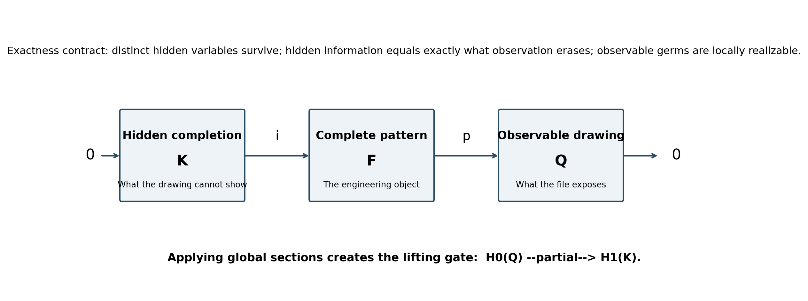
Figure 1. One short exact sequence model one engineering interface and creates a global lifting obstruction after applying global sections.

3. Exactness as an Engineering Contract
The phrase “no loose entity is left” captures the intent of exactness, but exactness is sharper and more useful because it separates three requirements.

3.1 Injectivity: no redundant completion coordinates
The map i: K -> F must be injective. Distinct completion states must remain distinct when embedded into the complete pattern. If ker i is nontrivial, the template contains hidden coordinates that produce no independent engineering state. In software terms, the completion model is redundant or non-identifiable. Two parameters may purport to represent different hidden conditions while always producing the same completed frame.
d_red = dim ker i
A nonzero d_red is not harmless over-parameterization. It makes completion obligations ambiguous, complicates optimization, and can allow an AI system to report several “alternatives” that are only different parameter names for the same structure.

3.2 The complex condition: hidden information must remain hidden
Before middle exactness can even be discussed, the maps must form a complex:
p ∘ i = 0
Anything declared to lie in the hidden completion kernel must disappear under observation. If p o i is nonzero, the template has classified some visible information as hidden. This is a visibility conflict, not a reversed exactness inclusion. In practical terms, a variable described by the model as unobservable may in fact be explicitly dimensioned or symbolized in the drawing.
d_vis = rank(p ∘ i)
If d_vis is nonzero, the interface is not a complex. Subsequent exactness deficits must not be interpreted until this fault is repaired.

3.3 Middle exactness: no silent holes
Once p ∘ i = 0, im i is automatically contained in ker p. Exactness at F requires equality:
im i = ker p
The difference between the two spaces is the dangerous failure. If im i is strictly smaller than ker p, the observation erases information that the template does not represent in its completion kernel. The AI system cannot request evidence for a variable its ontology does not contain. An out-of-plane eccentricity may disappear in a plan projection while the pattern model contains no eccentricity channel; the resulting omission is silent.
d_sil = dim ker p - dim im i, interpreted only after d_vis = 0
All three quantities must vanish for a finite-dimensional interface to satisfy the intended short exactness contract.
Configuration | d_red | d_vis | d_sil | Engineering verdict
Healthy interface | 0 | 0 | 0 | Exact
K too small | 0 | 0 | 1 | Silent hole: drawing erases an unmodelled direction
Visibility conflict | 0 | 1 | not interpreted | Not a complex: a declared hidden variable remains visible
i not injective | 1 | 0 | 0 | Redundant or non-identifiable completion parameter
Table 2. Ordered exactness diagnostics. A negative raw d_sil is an error flag that the complex condition failed, not a fourth physical class.
The order is essential. The guard must short-circuit: first remove redundancy, then test whether the maps form a complex, and only then evaluate the silent-hole deficit.

4. Local Surjectivity and the Non-Vacuous Lifting Gate
The final condition in a short exact sequence is surjectivity of p as a sheaf morphism. For engineering practice, this must not be misread as global solvability. Sheaf surjectivity is local: every observable germ has a local complete realization. It does not imply that all local realizations glue into one global structure.
Applying the global-sections functor produces the beginning of the long exact sequence:
0 → H⁰(K) → H⁰(F) → H⁰(Q) —∂→ H¹(K) → ⋯
For an observed drawing state q in H^0(Q), exactness gives:
∂(q) = 0 ⇔ q admits a global lift in H⁰(F)
This is the lifting audit. A nonzero connecting class says that the selected template can explain the observation locally but cannot complete it globally. A zero class establishes existence of at least one completion under that template.
The distinction is load-bearing. If the global-section map H^0(F) -> H^0(Q) were surjective on all admissible observations, partial would be identically zero. The architecture would contain a mathematically named gate that could never refuse. Local-but-not-forced-global surjectivity is therefore the non-degeneracy condition that keeps the lifting audit alive.
Disabled-gate regime: if every observable global state is already the image of a global complete state, the connecting obstruction is identically zero and contributes no audit capacity.
The classical exponential sequence offers a useful mathematical witness: local logarithms can exist everywhere while a global logarithm fails because of winding. In structural drawings, the parallel is straightforward: each local grid, beam, and column relation may admit a plausible completion, yet no single building interpretation satisfies all of them around a closed chain of views or assemblies.

5. Missing Is a Lifting Problem, Not a Certification
An empty location in a drawing does not certify that a structural member is missing. It raises a template-dependent extension question. Consider four columns at x = 0, 6, 12, and 18 m. Beams are visible in the first and third bays; the middle bay contains no beam line.
Candidate template | Interpretation of the same empty middle bay | Required action
Continuous frame | A beam is absent from a bay that should be continuous | Search other views, schedules, or revisions for the missing beam
Expansion-joint frame | No beam should cross the joint | Preserve the gap and verify joint details
Transfer or concealed-member template | The load path may continue through another element or plane | Retrieve section/elevation evidence before committing
Table 3. One graphical residual can support opposite completion obligations under different templates.
The observation alone does not determine what belongs there. The correct statement is conditional: if the selected template and its restriction maps are valid, a vanishing obstruction identifies a family of admissible completions. The absent member is a coordinate of a lift, not an unconditional fact.
When a lift exists, the set of completions is generally not a vector space with a preferred zero. Under the usual abelian hypotheses, it is a torsor over H^0(K). The torsor language is useful because it records non-uniqueness without declaring one completion canonical.
Lift(q) is nonempty and is acted on freely and transitively by H^0(K)
A trivial H^0(K) gives at most one completion after existence is established. A finite group gives finitely many alternatives. A continuous group gives a family that must be optimized or constrained. The lifting gate answers “can this observation be completed?” The lift family answers “in how many structurally different ways?”

6. A Tower of Short Exact Sequences
Because “short” refers to one hidden-complete-observable interface, the semantic hierarchy is modelled by one short exact sequence per adjacent level.
Level | Representative interface | Completion kernel K_r | Observable quotient Q_r
0 | drawing primitives -> elementary pattern | unseen primitive roles, missing local dimensions, hidden orientation | lines, arcs, symbols, text, dimensions
1 | elementary patterns -> assembly | unseen joints, member continuations, panel parameters | recognized grids, columns, beams, truss motifs
2 | assemblies -> building/view system | cross-view correspondences, projection variables, global load-path choices | floor, frame, truss, support, and view assemblies
Table 4. A tower of short exact sequences for drawing interpretation.
0 → K_r → F_r → Q_r → 0, ∂_r: H⁰(Q_r) → H¹(K_r)
The connecting maps do not compose into a single vertical formula. If partial_r(q_r) = 0, the result is not a canonical element for the next level; it is a family Lift(q_r). A candidate f_r must be selected, promoted to a next-level observation q_{r+1}(f_r), and audited there.
find f_r ∈ Lift(q_r) such that ∂_{r+1}(q_{r+1}(f_r)) = 0
If the higher obstruction is nonzero, the system must return to the lower lift family and select another candidate. Backtracking is therefore compelled by the non-uniqueness of lifting. An architecture that attempted to compose connecting maps would erase the very candidate family to which it must return.
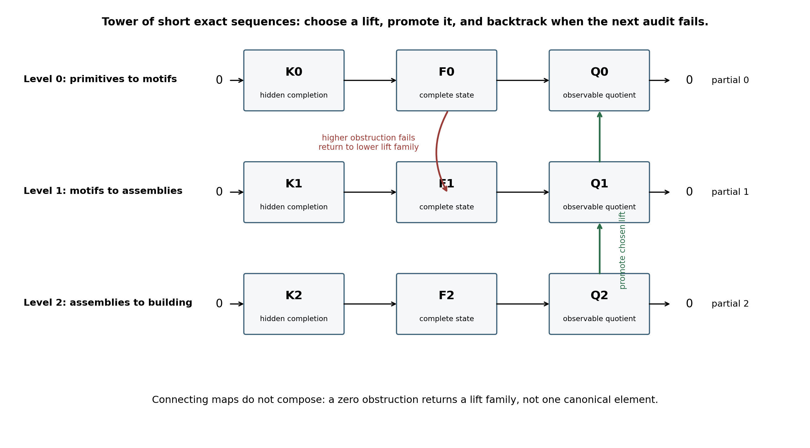
Figure 2. The drawing hierarchy is a tower of short exact sequences. Candidate promotion and backtracking occur between the connecting maps.

7. Exactness Is a Field, Not a Project-Wide Triple
A sequence of sheaves is exact if and only if it is exact at every stalk. Therefore, exactness must be checked at the locations where drawing information and structural meaning meet: bays, joints, grid intersections, drawing regions, view overlaps, panel interfaces, and assembly boundaries.
x ↦ E(x) = (d_red(x), d_vis(x), d_sil(x))
A single global rank calculation is unsafe. A surplus or redundancy in one region can numerically conceal a deficit in another, whereas sheaf exactness allows no compensation between stalks. The correct output is an exactness field that can be summarized but not replaced by a project-wide score.
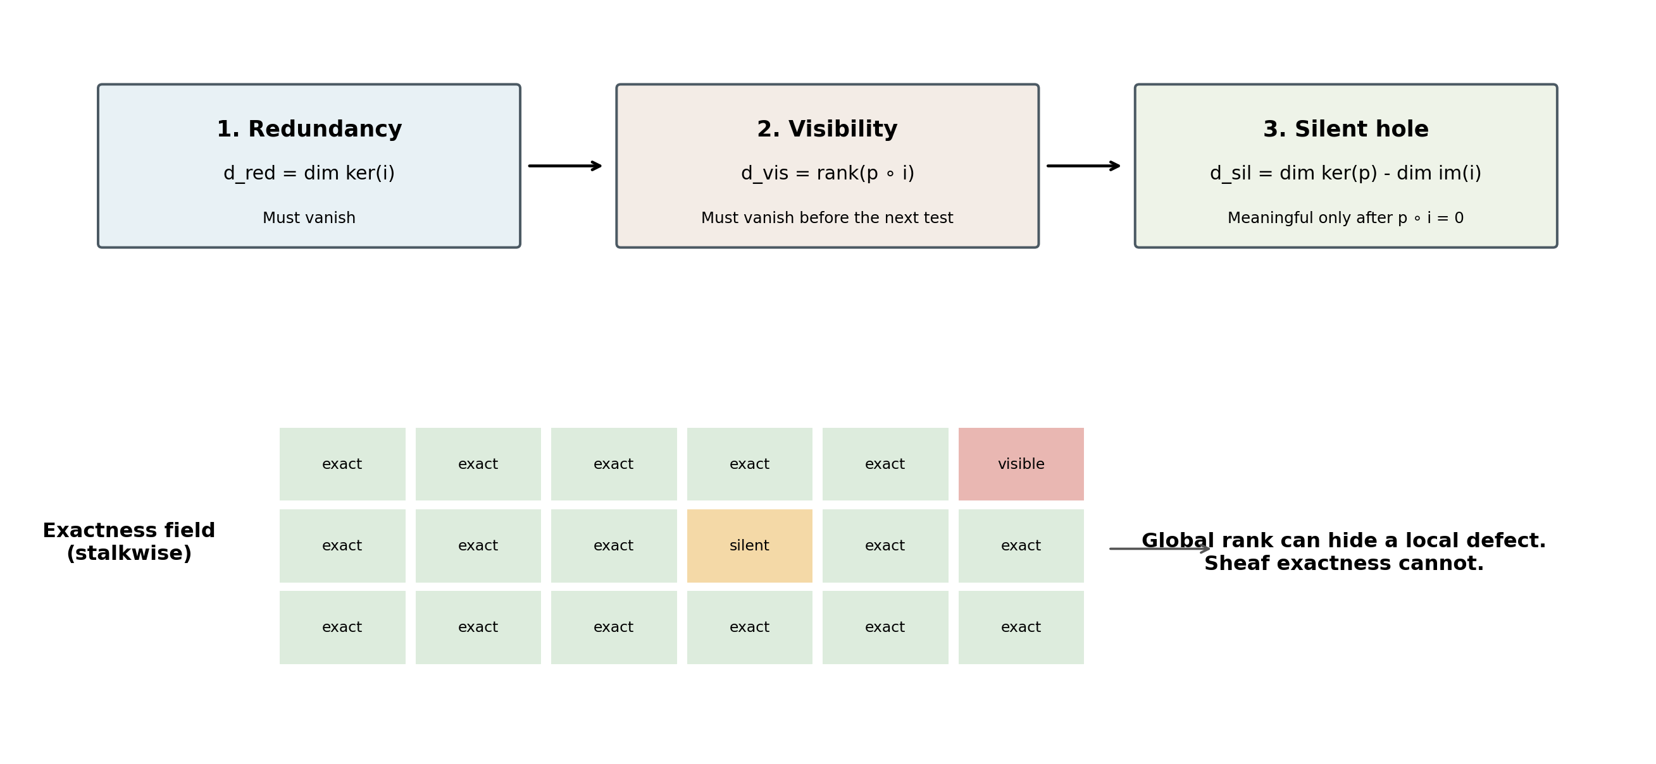
Figure 3. The exactness diagnostic is ordered and stalkwise. A project-wide matrix can conceal a local silent hole or visibility conflict.
A practitioner-facing report may read:
The drawing-to-frame interface is exact in 47 of 49 bays. Bay B4 contains one silent out-of-plane completion direction. Grid D7 contains a visibility conflict: a variable classified as hidden is explicitly dimensioned. No redundant completion parameters were found elsewhere.
This output is actionable because it states where the model fails and which repair is required. A silent hole demands ontology expansion; a visibility conflict demands correction of the observation map or hidden-variable classification; redundancy demands parameter reduction or quotienting.

8. Search Among Lift Families
A vanishing obstruction establishes existence, not uniqueness. The system must classify the lift family before selecting a search method. Discrete cardinality and continuous dimension are different mathematical types and must never be collapsed into one ambiguity score.
Lift structure | Meaning | Primary computational treatment
Finite set | A fixed number of distinct alternatives | enumeration or combinatorial search
Finite group action | Alternatives related by symmetry | enumerate representatives and quotient equivalent states
Convex subset of R^d | Continuous, well-structured completion family | convex optimization
Compact smooth manifold | Continuous family with intrinsic geometry | constrained manifold optimization
Non-convex subset | Multiple basins or disconnected feasible zones | global/local optimization with bounds or certificates
Stratified or singular space | Degrees of freedom change across configurations | stratum-aware search, boundary transitions, continuation
Table 5. The structure of the lift family, not a scalar confidence, selects the search algorithm.
For a genuine torsor over a group such as (Z/2) x R^2, one report (n, d, G) is sufficient: two components, each two-dimensional, with the stated group structure. Once higher constraints cut branches differently, different components may have different dimensions. More generally, a connected constrained family may be singular and contain strata of different dimensions.
Lift(q_r) = ⨆ S_{r,α,β}
The stratified ambiguity profile should record the stratum, its dimension, its algebraic or geometric structure, and the frontier relation describing which strata lie in the closure of others. This matters in engineering degeneracies. A family may be freely adjustable for ordinary bay widths, reduce to one degree of freedom when supports align, and become uniquely determined when grids coincide.
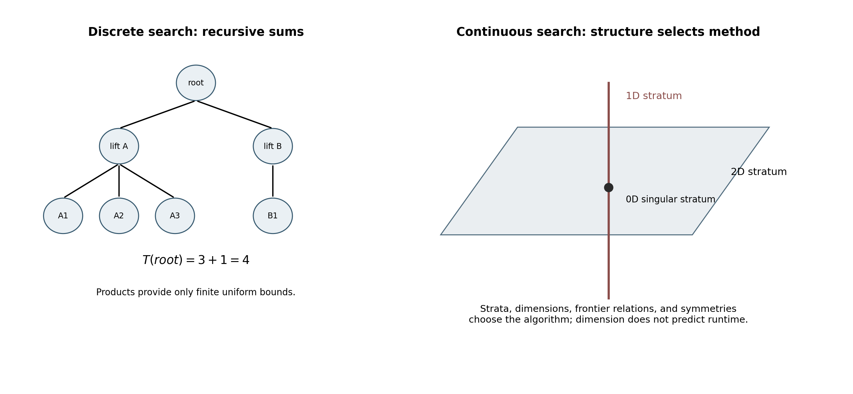
Figure 4. Discrete alternatives are counted recursively; continuous and singular lift families require geometry-aware search.
Dimension is a type, not a time. It identifies intrinsic search geometry but does not predict runtime. Runtime also depends on boundedness, convexity, conditioning, constraints, singularities, initialization, and the cost of evaluating the next obstruction.

9. Recursive Counting and Policy-Dependent Cost
The number of accepted discrete interpretations is counted recursively. Let h be a search history and T(h) the number of accepted terminal completions below it. Then:
T(h) = sum over admissible children f of T(h,f), with T(terminal) = 1
Products of branching counts do not count a selected path or the whole tree. They survive only as uniform worst-case bounds when depth and branching are finite:
T(root) ≤ ∏_r B_r, B_r = sup_h |Lift(q_r(h))|
Actual counts are reduced by nonuniform branching and early obstruction pruning. For example, a root with two lifts whose successor counts are three and one has four leaves, not six. The tree is 3 + 1, not 2 x 3.
Computational work is also recursive and depends on search policy. Exhaustive certification must investigate every surviving component. A first-valid policy may stop after the first globally accepted interpretation. A best-valid policy may need lower bounds and branch-and-bound logic. A bounded-alternative policy may return a prescribed number of candidates to the engineer.
W_pi(h) = audit cost + policy-dependent sum of search and continuation costs over selected children
A flat sum over complete paths is accurate only when paths are solved independently and shared intermediate work is negligible. Real systems can reuse extracted geometry, overlap witnesses, and partial audits across sibling branches. Caching and memoization may therefore lower cost without changing the mathematical search space.
Policy | Stopping condition | Engineering use
Exhaustive | all admissible terminal interpretations evaluated | certification, conflict enumeration, design-review evidence
First valid | first globally admissible interpretation found | rapid preliminary model generation
Best valid | optimal admissible interpretation under an explicit objective | automated model selection or design synthesis
Bounded alternatives | return k diverse admissible interpretations | engineer-in-the-loop review under ambiguity
Table 6. Search cost is not defined until the stopping policy is stated.

10. Disabled-Gate Regimes
A recurring danger in advanced AI architecture is a gate that exists in notation but is structurally unable to fire. Every audit specification should therefore state its disabled regime alongside its trigger.
Audit or diagnostic | Intended nonzero event | Disabled regime
Overlap cohomology | independently measured overlap inconsistency | edge residual manufactured as delta^0 of interior values, making the class exact by construction
Cycle-supported H^1 channel | cyclic inconsistency among overlapping catchers | domain pruned to a structure with no applicable cycle-supported capacity under the chosen coefficients
Lifting obstruction partial | locally solvable observation with no global completion | global-section map forced surjective, making partial identically zero
Silent-hole deficit | unmodelled information erased by observation | evaluated before verifying p ∘ i = 0, producing meaningless negative values
Discrete ambiguity count | finite alternatives requiring enumeration | continuous or infinite lift family misrepresented as a branch count
Simple (n,d,G) profile | homogeneous torsor-like lift family | constraints create components or strata with different dimensions
Table 7. Every audit must name the structural regime in which it becomes silent or ill-typed.
This discipline is stronger than unit testing on a few examples. It asks whether the architecture has made a nonzero answer impossible before data are supplied. The check should be encoded in schemas, constructors, and validation tests rather than left as prose guidance.

11. Implementation Blueprint
A production drawing-intelligence system can implement the short-exact-sequence architecture as a set of typed interface objects. Each semantic level maintains complete-state candidates, observable quotients, completion kernels, maps, exactness diagnostics, lift families, and provenance.
Data object | Minimum fields | Executable guard
Interface specification | level, region/stalk, K schema, F schema, Q schema, maps i and p | schema versions compatible; required coefficient channels present
Exactness record | d_red, d_vis, d_sil, diagnostic order, witness matrices | d_sil unavailable until d_vis = 0
Observation section q | drawing entities, dimensions, labels, view, revision, provenance | all evidence traceable to source primitives
Lift result | obstruction class, existence flag, components/strata, dimensions, group structure | no unique-completion claim unless the lift family is singleton
Promotion map | candidate lift to next-level observable | preserves provenance and exposes all assumptions
Search state | history, surviving branches, policy, cached computations | recursive count and cost use the stated policy
Claim object | statement, type, conditions, jurisdiction, disabled regime, falsifier, guard | reject implementation-facing claims with missing fields
Table 8. Suggested data structures for an executable short-exact-sequence pipeline.
The interface validator should run stalkwise. For finite linearized demonstrators, the ordered guard is straightforward:
- Compute dim ker i. If nonzero, reject the completion parameterization as redundant.
- Compute rank(p o i). If nonzero, reject the pair of maps because they do not form a complex.
- Only then compute dim ker p - dim im i. If nonzero, report a silent completion direction.
- Confirm local surjectivity of p on the admissible germs used by the interface.
- Apply global sections and evaluate the connecting obstruction on each proposed observation.
- If the obstruction vanishes, classify the lift family before selecting enumeration, optimization, or stratified search.
- Promote each selected candidate to the next level; backtrack when a higher obstruction fails.
The architecture should preserve immutable provenance through every step. A completion obligation must record the template that generated it, the local observation on which it rests, the exact sequence version used, the obstruction result, and the higher-level tests that later accepted or rejected it.

12. The Claim Object: Typed Before Implemented
The development of this architecture repeatedly exposed claims that became incorrect when their conditions were omitted. A missing member was called a certification although it was template-dependent; a reversed inclusion was claimed although the maps did not form a complex; a dimension was multiplied as if it were a branch count; a product bound was stated as a tree identity; and an internal case series was called empirical without population-level evidence.
The common defect was not simply excessive confidence. It was an untyped statement: the condition that told an implementation when the claim applied had been removed. For implementation-facing work, the deliverable should therefore be a structured claim object rather than prose alone.
Claim = (statement, type, conditions, jurisdiction, disabled regime, falsifier, guard)
Field | Purpose | Example for the lifting obstruction
Statement | what is asserted | partial(q) = 0 iff q has a global lift
Type | mathematical or engineering role | obstruction criterion
Conditions | hypotheses required | short exact sequence of sheaves; q in H^0(Q)
Jurisdiction | what the result actually decides | existence of completion under the selected template
Disabled regime | when the mechanism cannot produce information | global-section map surjective on all admissible observations
Falsifier | observation that would refute the statement | partial(q) = 0 with no global lift under the stated hypotheses
Guard | executable check or explicit debt | validate hypotheses and test the non-degeneracy of the global-section map
Table 9. A schema-validated claim object makes jurisdiction structurally mandatory.
The claim-object rule is itself an internal methodological design rule. Its present jurisdiction is this Defensible Intelligence development process and implementation-facing technical work of the same kind. General improvement beyond this line remains to be tested. The appropriate guard is a schema validator that rejects claims with missing required fields, while allowing fields to be marked “not yet defined” only with an explicit implementation debt.
A rule written in prose does not automatically govern the sentence that states the rule. A required schema field does.

13. Engineering Applications

13.1 Drawing-to-analysis-model generation
A generated finite-element model should be treated as a lift of the observed drawing through a sequence of semantic interfaces. Nodes, members, plates, supports, releases, offsets, and load paths should not be committed merely because a detector found plausible graphics. Each assembly must pass the exactness and lifting conditions appropriate to its level. Silent holes identify missing ontology before the model reaches analysis.

13.2 Intentional discontinuity versus missing component
Expansion joints, movement joints, erection gaps, transfer levels, and view-dependent omissions are recurrent sources of false anomaly alarms. Competing templates can be evaluated as separate extension problems. The system should report which templates admit lifts, which are obstructed, and what evidence would distinguish the surviving alternatives.

13.3 Cross-view consistency
Plan, elevation, section, detail, and isometric drawings are local views of one structural object. A member hidden in one projection may be explicit in another. The short exact sequence at a cross-view interface separates view-erased data from the complete coordinated state. Stalkwise visibility conflicts expose cases where the ontology says a parameter is hidden even though another view dimensions it directly.

13.4 Revision control and provenance
A revision may alter the quotient Q without changing the intended complete state F, or it may change the template itself. Provenance-preserving lift records allow the system to determine whether a previous completion remains valid, becomes obstructed, or must be searched again. This supports revision-aware engineering RAG and defensible regeneration of analytical models.

13.5 Human-in-the-loop review
When several lift strata survive, the system should not collapse them into a confidence average. It should present typed alternatives: two discrete structural templates, a one-parameter geometric family, or a singular branch that becomes unique at an alignment condition. The engineer can then provide the evidence that removes the relevant ambiguity.

14. Falsifiable Experimental Programme
The architecture can be tested through controlled drawing sets rather than evaluated only by narrative plausibility.
Experiment | Baseline | SES architecture prediction | Refutation condition
Continuous frame vs expansion joint | pixel or graph anomaly detector | same gap yields different obligations under different templates | baseline matches template-aware decisions without carrying template state
Silent out-of-plane variable | global rank or feature-completeness score | stalkwise d_sil locates the omitted degree of freedom | global method detects all localized silent holes equally well
Visibility conflict | parallel evaluation of three deficits | ordered guard identifies p o i != 0 before d_sil | parallel diagnostics remain meaningful on broken complexes
Local but no global completion | local rule-based catchers | partial is nonzero although every local patch is completable | all locally completable test cases always admit global completion
Non-unique lift | single best completion model | returns multiple typed alternatives or strata | unique completion is always correct on ambiguous cases
Recursive search count | level-wise product estimate | recursive subtree count matches actual accepted leaves | actual leaves exceed recursive count or finite uniform bound
Claim schema | prose-only technical specification | fewer jurisdiction and disabled-gate defects after schema validation | structured claims do not reduce such defects in independent trials
Table 10. Falsifiable tests for the short-exact-sequence architecture.
A benchmark should include complete drawings, true omissions, intentional joints, mirrored details, conflicting dimensions, missing cross-view correspondences, local projection losses, redundant template variables, and singular geometric configurations. Ground truth should record not only the final interpretation but the admissible template family and the evidence needed to distinguish alternatives.

15. Scope, Jurisdiction, and Open Debts
The mathematics of short exact sequences, connecting homomorphisms, torsors, and stalkwise exactness is established. The engineering use of these objects as an AI architecture is a candidate design and should not be presented as an implemented production result.
- Sheaf-construction debt: the level-specific sheaves K_r, F_r, and Q_r must be specified for real drawing types. Exactness checks consistency of a chosen model; it does not prove that the model is the correct ontology.
- Map-construction debt: the embeddings i_r, observation maps p_r, and promotion maps from one lift to the next-level observable require explicit engineering semantics and learned or authored implementations.
- Coefficient debt: geometric, integral, parity, role, and provenance channels may require different categories and different notions of exactness. One linear vector implementation is not sufficient for every channel.
- Search-termination debt: real lift families may be large, continuous, or singular. Practical termination requires bounded domains, heuristics, certificates, and policy choices.
- Evidence debt: local surjectivity and non-global completion must be tested on real multi-view drawings rather than assumed from the conceptual analogy.
- Methodology debt: the claim schema is supported here by an internal case series. Its effectiveness beyond this development process requires independent evaluation.
The architecture does not claim that experienced engineers literally compute cohomology. It claims that the operations required for a defensible drawing-intelligence system have the same mathematical structure: local completion, global obstruction, non-unique lift families, and interface exactness.

16. Conclusion
Engineering drawings are incomplete by design. Their intelligence lies not in the visible primitives alone but in the disciplined reconstruction of what those primitives can legitimately complete. A short exact sequence provides the correct unit of that reconstruction: one hidden completion kernel, one complete engineering state, one observable quotient, and an exactness contract between them.
The hierarchy must therefore be short at every step rather than compressed into one long sequence. Exactness must be checked at every interface and every stalk. Local surjectivity must be preserved without forcing global surjectivity, because the gap between them creates the lifting obstruction. A vanishing obstruction opens a family of completions rather than certifying one answer, so candidate promotion and backtracking are mathematical necessities. Discrete alternatives must be enumerated, continuous families optimized, singular families stratified, and search counts computed recursively under an explicit stopping policy.
The practical output is not merely “drawing recognized.” It is an auditable structural world model that can state what is visible, what is hidden, what is unmodelled, which completions exist, why a candidate failed, where ambiguity remains, and what evidence would resolve it. That is the level of accountability required before AI-generated drawings or analytical models can become engineering artifacts rather than plausible guesses.
Short at every step. Exact at every interface. Local everywhere. Global only when earned. Typed before implemented. Recursively counted, policy-costed, and bounded before searched - but never claimed determined.

References
Bredon, G. E. (1997). Sheaf Theory, 2nd ed. Springer.
Curry, J. (2014). Sheaves, Cosheaves and Applications. Ph.D. dissertation, University of Pennsylvania.
Ghrist, R. (2014). Elementary Applied Topology. Createspace.
Hatcher, A. (2002). Algebraic Topology. Cambridge University Press.
Kashiwara, M., & Schapira, P. (1990). Sheaves on Manifolds. Springer.
Mac Lane, S. (1998). Categories for the Working Mathematician, 2nd ed. Springer.
Robinson, M. (2014). Topological Signal Processing. Springer.
Ghosh, D. P. (2026). From CAD Primitives to Structural Meaning: Cosheaf Ascent, Cohomological Audit, and Extension Lifting for Engineering Drawing Intelligence. Companion conceptual manuscript.
Ghosh, D. P. (2026). The Restriction Vertex: The Algebra of Restriction, Its Realization as Cortical Feedback, and the Executive Veto. DOI: 10.13140/RG.2.2.18717.68323.
Ghosh, D. P. (2026). Hypercovering and Descent: A Thalamo-Cortical Algorithm for Defensible Multimodal Gluing. DOI: 10.13140/RG.2.2.31337.45929.
Ghosh, D. P. (2026). Nerve-Attention: The Simplicial Domain of Audit. DOI: 10.13140/RG.2.2.27630.57925.
Ghosh, D. P. (2026). The Direct and Indirect Axes and the Construction AGI Island. DOI: 10.13140/RG.2.2.26647.53922.

