The Sheaf Already Inside the Solver
  - Rich-to-Flat Compilation, Exactness Collapse, and Dual-Side Auditing in Finite-Element Analysis
Debi Prasad Ghosh, Ph.D., debiprasadghosh@gmail.com
Founder & Principal Engineer, Debias Parametric Guru, Kolkata, India
Civil & Structural Engineer | B.E., IIEST Shibpur | M.E., Jadavpur University | Ph.D., IISc Bengaluru
25+ years in structural engineering, finite-element workflows, design automation, and engineering AI
Practitioner research paper | Defensible Engineering Intelligence
Fourth companion paper in the engineering drawing and integration series

Abstract
Finite-element analysis requires a computation-optimized representation: indexed element arrays, local-to-global maps, sparse operators, and solver vectors. Engineering intelligence requires a richer representation containing entities, interfaces, versions, assumptions, provenance, and independently witnessed relationships. This paper shows that the two representations do not require a newly invented bridge. Standard finite-element assembly already contains the incidence-restriction backbone needed for compilation: the stacked gather operator R maps a global field into element fields, the block operator K_loc acts locally, and the global stiffness is the congruence K = R^T K_loc R. The key requirement is not to preserve every element matrix but to retain a reproducible recipe, state ledger, and semantic manifest. The paper then corrects a superficially attractive compatibility audit. In a conforming discretization, local primal fields are constructed as s = R u, so a jump operator J satisfies J R = 0. An audit run only on such fields is silent by exactness collapse, not because interface incompatibility is conceptually absent. The distinction is actionable: a correctly silent gate is accepted, whereas a structurally disabled gate must be supplied with evidence not forced to be exact by the same construction. A useful interface residual does survive on the dual side. Interelement traction or flux jumps are not strongly constrained to vanish and already form a principal term in residual-based a posteriori error estimation. For nonconforming and mixed-dimensional couplings, a local cokernel further measures interface modes outside the joint span of the coupling maps. The resulting architecture is: reason richly, compile task-locally, solve flat, recover through retained incidence maps, regenerate local evidence on demand, and commit only audited semantic results. It extends the preceding engineering papers from drawing interpretation and exact interfaces to the numerical execution layer, while importing from the 2023 Second Foundation paper only the architectural principle of retaining structured and compressed representations with an explicit relation between them.
Keywords: finite-element analysis; rich-to-flat compilation; cellular sheaf; assembly congruence; gather-scatter operator; exactness collapse; traction jump; a posteriori error estimation; provenance; engineering AI

Practitioner Summary
- Treat the semantic project model as the source of truth and the assembled finite-element operator as a task-specific executable view.
- Recognize assembly as the congruence K = R^T K_loc R. R^T is the adjoint scatter on vectors; the operator-level construction is not itself an adjoint.
- Retain connectivity, immutable entity identifiers, formulations, versions, local axes, and state variables. Regenerate local matrices and contributions when needed rather than archiving every element matrix.
- Do not audit conforming primal continuity only after shared global DOFs have been created. The input is already exact by construction, so the gate cannot fire.
- Use dual residuals such as traction or flux jumps for discretization and interface diagnostics; they are not strongly forced to vanish by the primal representation.
- At nonconforming interfaces, compute the span or cokernel of the coupling maps and state the selected interface space before interpreting the result.
- Add mechanism to every claim object. The same verdict—such as a silent audit—can mean either that no problem exists or that the gate was disabled by construction.

1. Introduction
Finite-element analysis is often described as a global method. The solver ultimately acts on a global stiffness matrix, mass matrix, residual vector, tangent operator, or matrix-free equivalent. The data presented to the numerical kernel must therefore be indexed, compact, partitionable, and suitable for sparse linear algebra. In that sense, the execution representation is deliberately flat.
The engineering model from which that representation is generated is not flat. A beam element participates simultaneously in a floor system, a load path, a fire compartment, a fabrication sequence, a discipline interface, a revision chain, and a set of design assumptions. The global row and column numbers of its degrees of freedom cannot express those relations. Flattening is therefore indispensable for computation and destructive if it is mistaken for storage.
The preceding three companion papers developed the rich side of the architecture. From CAD Primitives to Structural Meaning treated drawing interpretation as cosheaf-like ascent, sheaf-like audit, and extension lifting. Short at Every Step, Exact at Every Interface used towers of short exact sequences to separate observable drawing states, complete engineering states, and hidden completion variables. Iso Within, Exact Across treated discipline integration as descent and project revision as relative or mapping-cone exactness. The present paper asks how that rich algebraic structure should meet the flat numerical solver without converting the entire project into a permanently duplicated database.
The answer is that finite-element assembly already contains the decisive map. The element gather operators, local-to-global connectivity, and element formulations are a compilation relation between local and global representations. The architecture does not need a new bridge. It needs to retain, type, and version the bridge already used by the solver.

2. Two representations, two responsibilities
The project representation and the numerical representation should be judged by different criteria.
Table 1. Representation responsibilities in the rich-to-flat architecture.
Representation | Primary purpose | Must preserve | May discard
Rich project algebra | Reasoning, integration, revision, responsibility, audit | Entity identity, interfaces, provenance, versions, assumptions, coefficient systems | Solver ordering, temporary partitions, iteration vectors
Working analysis complex | Task-local reasoning and model compilation | Relevant topology, mesh, properties, boundary conditions, witnesses | Unrelated disciplines, inactive load cases, distant project regions
Flat FE execution view | Assembly, factorization, iteration, time integration | Numerical equivalence for the declared analysis context | Most semantic relations and document-level metadata
Semantic result model | Engineering interpretation and release | Entity-level response, governing cases, residuals, provenance, reproducibility manifest | Preconditioner state and transient solver work arrays

The matrix is not a compressed project database. It is a compiled numerical artifact with a declared jurisdiction.

3. Assembly is a congruence through a gather-scatter pair
Let V_g be the global degree-of-freedom space and V_e the local space of element e. The direct sum of all element spaces is V_loc = ⊕_e V_e. Stacking the element gather matrices gives a linear operator R: V_g -> V_loc.
For a global displacement vector u, the local element vectors are u_loc = R u. Let K_loc = diag(K_1, …, K_N) be the block-diagonal operator containing all element stiffness matrices. The assembled stiffness is the pullback—or congruence—of the local energy operator through R.
u_loc = R u
K = Rᵀ K_loc R = Σ_e L_eᵀ K_e L_e
On vectors, R^T is genuinely the adjoint scatter-sum: it aggregates element-level dual quantities into the global force space. On operators, K = R^T K_loc R is a congruence by the adjoint pair. Saying that assembly itself is an adjoint collapses these two levels.
Nor is R^T normally an inverse of R. In a conforming model R duplicates a global degree of freedom into every incident element copy, so R^T R is a multiplicity matrix. A weighted left inverse can be formed under full-column-rank conditions, but the standard force scatter is R^T, not that inverse. The architecture is traceable, not naively reversible.

4. What is already sheaf-like—and what is not
Table 2. The finite-element data structure contains a sheaf-like backbone, not a complete semantic sheaf.
FE object | Algebraic reading | Jurisdiction
Element space V_e | Local coefficient space or stalk | Physical and kinematic variables carried by an element or patch
Connectivity/incidence table | Combinatorial data for a cell complex or cover | Becomes a nerve only after witnessed common intersections are defined
Gather L_e | Restriction of a global section to an element | Does not by itself specify every face-to-cell restriction of a general cellular sheaf
Scatter L_e^T | Adjoint aggregation of local dual quantities | Sums forces or residual contributions; is not an inverse gather
Element operator K_e | Local physical operator | Constitutive and geometric jurisdiction declared by the element formulation
Assembled K | Compiled global physical operator | Contains no unique record of the element-wise decomposition

A complete engineering sheaf additionally requires typed stalk contents, restriction maps at the intended cover level, witness provenance, coefficient systems, and commutative diagrams. The solver supplies the incidence-restriction skeleton. The project algebra supplies the engineering meaning.

5. Compilation, not synchronization
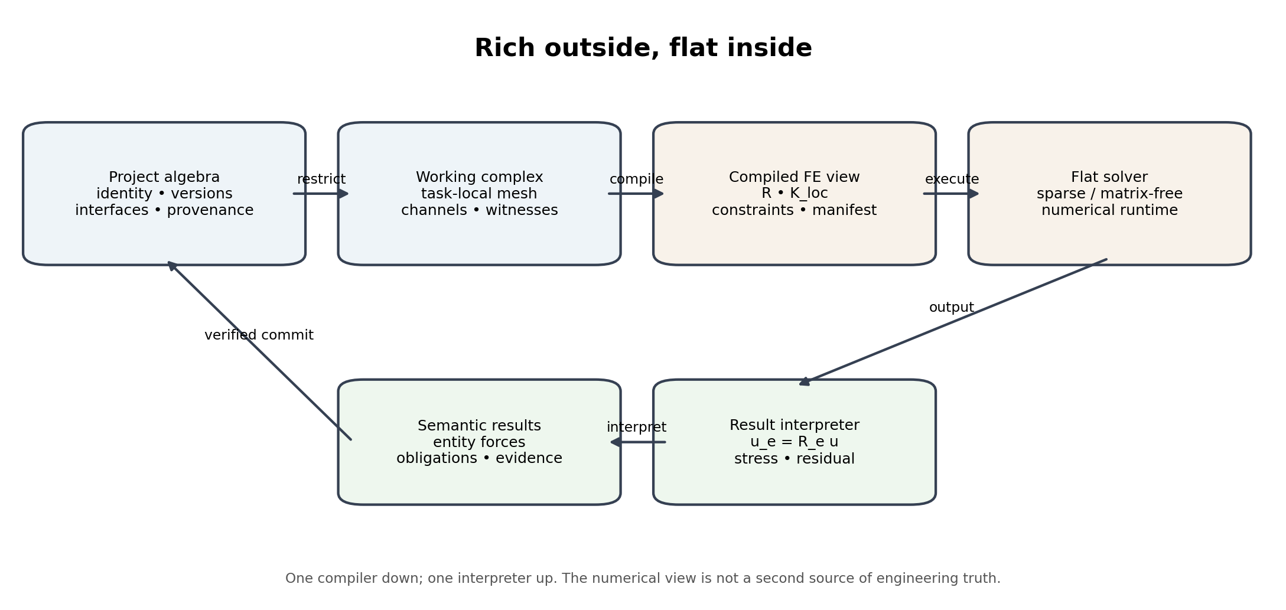
Figure 1. The project model compiles downward into a task-local numerical artifact; only interpreted and audited results return upward.
Let P be the persistent project algebra and θ an analysis context containing region, analysis type, mesh, load cases, constitutive assumptions, boundary conditions, code rules, and solver settings. A restriction operator extracts a task-local working complex W_θ. A numerical compiler C_θ then emits the execution package N_θ.
The compiler output should contain the degree-of-freedom map R, element and patch recipes, constraint operators, units and sign conventions, a versioned source manifest, and hashes of all analysis-defining inputs. The solver may reorder, partition, condense, or apply the resulting operators matrix-free. Those transformations belong to the execution layer and should not overwrite project identity.
The reverse operation is an interpreter, not C_θ^{-1}. It uses the retained manifest to associate displacements, forces, stresses, reactions, utilization ratios, modal data, and residuals with immutable engineering entities. Multiple rich project states can compile to numerically identical operators for a selected analysis; the flat result cannot reconstruct what compilation intentionally forgot.
P --restrict_θ--> W_θ --C_θ--> N_θ --solve--> y_θ --interpret_θ--> R_θ

6. Primal exactness collapse in conforming FEA
Suppose element fields are first allowed to exist independently in V_loc. An interface jump operator J: V_loc -> W_int compares the copies carried by adjacent elements. In a conforming discretization, every admissible primal field is constructed from a global vector u as s = R u. Consequently J R = 0.
Under suitable connectivity assumptions, im R = ker J. This is an exact compatibility statement: globally representable fields are precisely the locally compatible element fields. But an audit applied only after the compiler has restricted its input to im R cannot encounter a non-exact field. The audit returns zero for every admissible input because the candidate construction has already enforced the property being tested.
0 -> V_g --R--> V_loc --J--> W_int, J R = 0
s = R u => J s = J R u = 0
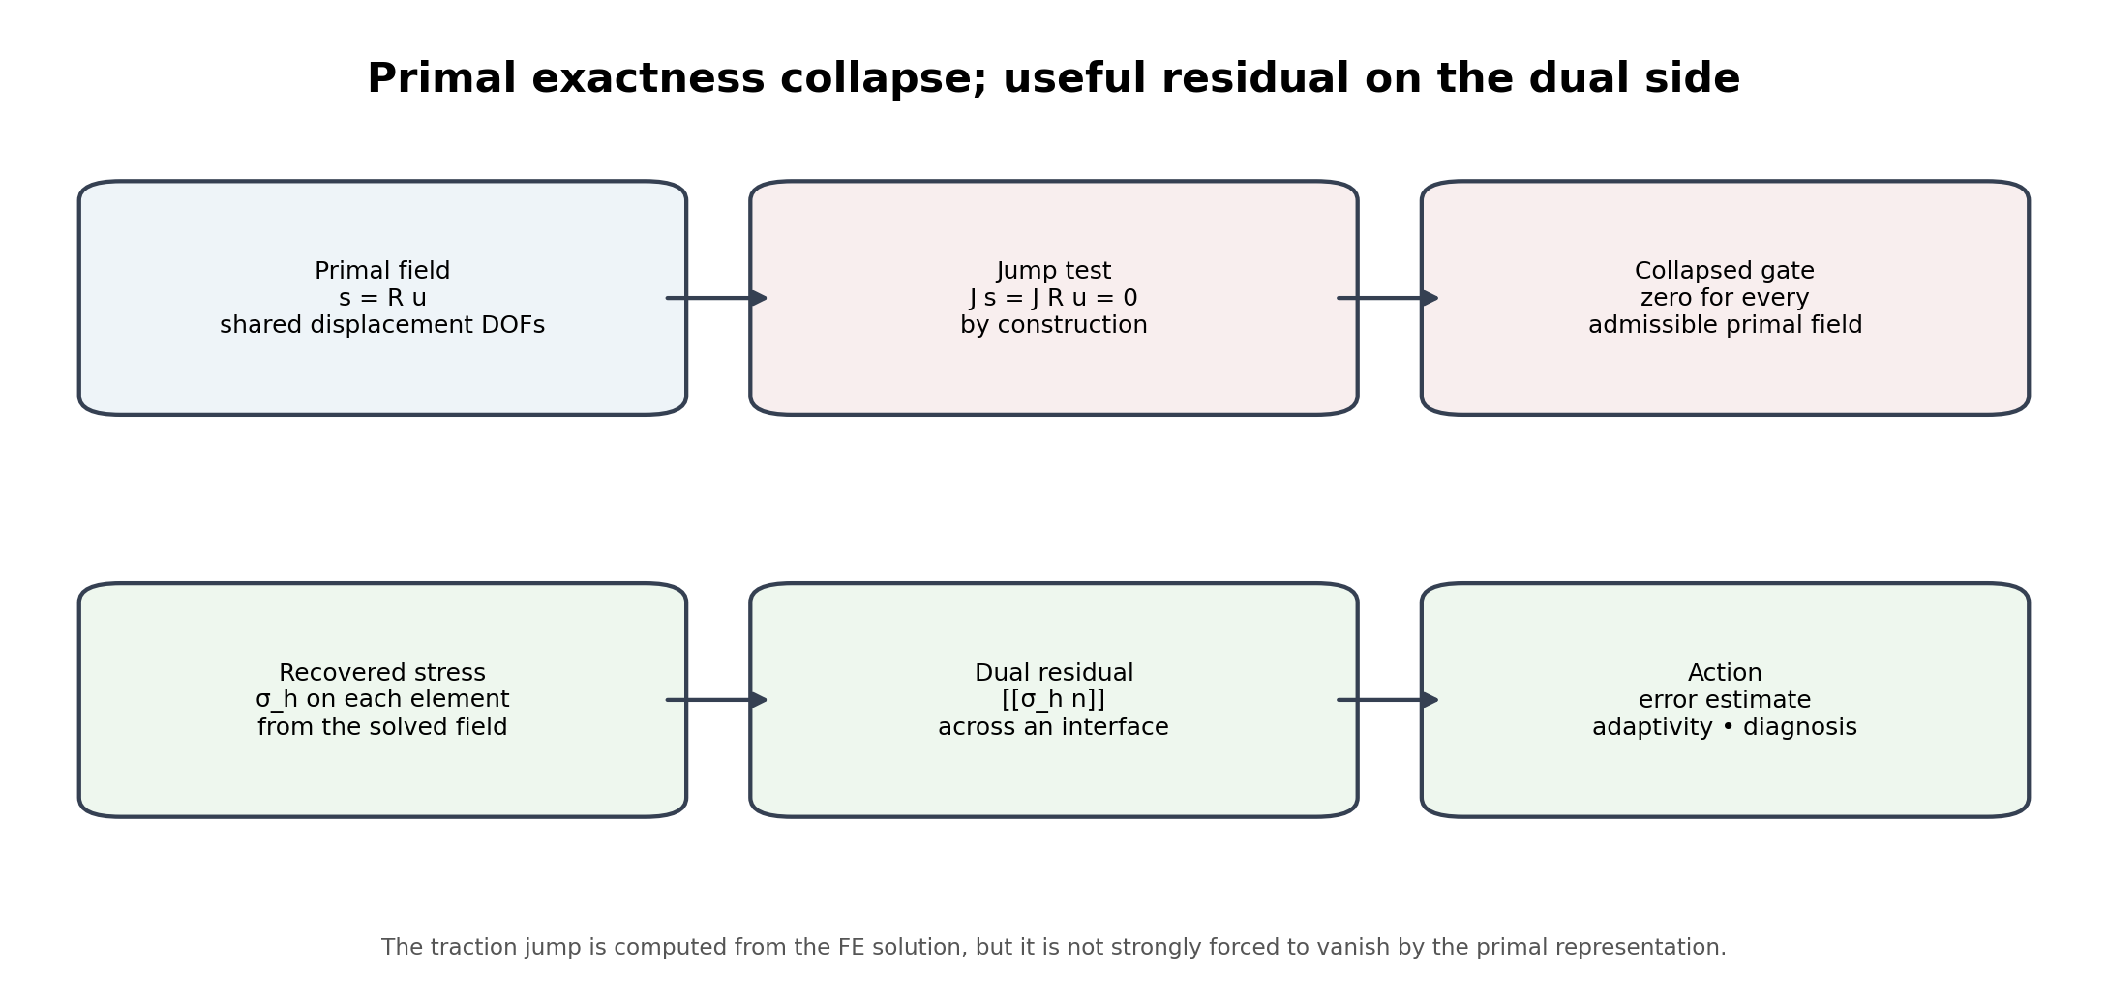
Figure 2. Strong primal continuity collapses the post-assembly compatibility gate; useful residual information survives on the dual side.
Table 3. The same zero verdict can demand opposite engineering responses.
Silent verdict | Mechanism | Correct action
No interface problem exists | The admissible domain genuinely contains no relevant incompatibility | Accept the silence and remove unnecessary audit cost
No admissible non-exact input exists | The same construction creates the candidate and guarantees a zero audit input | Repair the audit by obtaining evidence not forced to be exact
Measurement or decoder is insensitive | The phenomenon may exist outside the chosen coefficient channel or observation map | Change the measurement, coefficient system, or witness source

A right verdict without its mechanism is not operational. “Silent” must say whether the gate passed, collapsed, or lacked sensitivity.

7. The topology computation remains informative
The collapse of the primal compatibility gate does not make every sheaf computation trivial. For a rank-one constant sheaf on an appropriate graph nerve, dim H^1 equals the first Betti number β_1. A simply connected patch has no cycle class, an annular domain has one, and a domain with two holes has two.
That calculation answers a topology question: what cycles or holes are represented by the chosen nerve? It does not answer whether a conforming displacement field is incompatible. The two uses must not be placed under one undifferentiated label such as “the H^1 audit.” The coefficient system, cover, and engineering question must travel with the result.
Even the topology reading has jurisdiction. A mesh connectivity graph can contain graph cycles that do not correspond to holes in the physical domain, and witnessed higher cells can fill graph cycles. The nerve or cell complex must be constructed at the intended geometrical level before β_1 is interpreted as a domain invariant.

8. The useful residual lives on the dual side
Conforming displacement-based FEA enforces primal continuity strongly through shared degrees of freedom. Interelement traction or flux continuity is normally enforced only weakly through the variational statement. The recovered stress field is element-wise and its normal traction need not agree pointwise across an interior face.
For an interior face F shared by elements K+ and K-, the traction jump is formed from the two recovered element stresses.
[[σ_h n]]_F = σ_h|_{K+} n_+ + σ_h|_{K-} n_-
A standard residual-type estimator has the schematic form
η_K² = h_K² ||f + div σ_h||²_K + 1/2 Σ_{F subset ∂K} h_F ||[[σ_h n]]||²_F
This jump is not an independent physical measurement in the experimental sense; it is computed from the same finite-element solution. Its value is nevertheless not forced to vanish by the primal global representation. It is therefore algebraically informative where J R u is structurally zero.
The distinction matters for the claim mechanism. The dual residual is useful not because it comes from an unrelated sensor, but because the approximation space enforces a different continuity condition on the primal and dual variables. Residual-based a posteriori error estimation already exploits this asymmetry for mesh refinement and error control.
Table 4. Primal, dual, and semantic interfaces require different gates.
Channel | How continuity is imposed | Typical result | Use
Displacement / primary field | Strongly, by shared conforming DOFs | Jump is zero on compiled admissible fields | Kinematic conformity; not an independent post-assembly audit
Traction / flux | Weakly, through the variational form | Element-side values generally jump | A posteriori estimation, adaptivity, interface diagnosis
Semantic identification | Not guaranteed by numerical assembly | May be wrong even when displacement jump is zero | Pre-assembly witness gate for node merging and constraint creation

9. Nonconforming and mixed-dimensional interfaces
At a nonconforming interface the two submodels do not share one global set of primary degrees of freedom. Let V_A and V_B be the local trace spaces and W the selected interface quantity space. Coupling maps ρ_A: V_A -> W and ρ_B: V_B -> W define an interface operator δ^0 = [ρ_A, -ρ_B].
For a one-edge interface complex with no higher cell, the local cokernel measures interface modes outside the joint span.
H¹_interface = coker[ρ_A -ρ_B]
dim H¹_interface = dim W - rank[ρ_A -ρ_B]
The number is not a universal property of labels such as beam-to-solid or shell-to-solid. It depends on the interface space, interpolation order, kinematic assumptions, rotational treatment, mortar or tying formulation, stabilization, and coefficient system. A nonzero cokernel identifies modes the chosen coupling cannot express; engineering significance requires a separate approximation and sensitivity judgment.

10. Provenance should regenerate local evidence
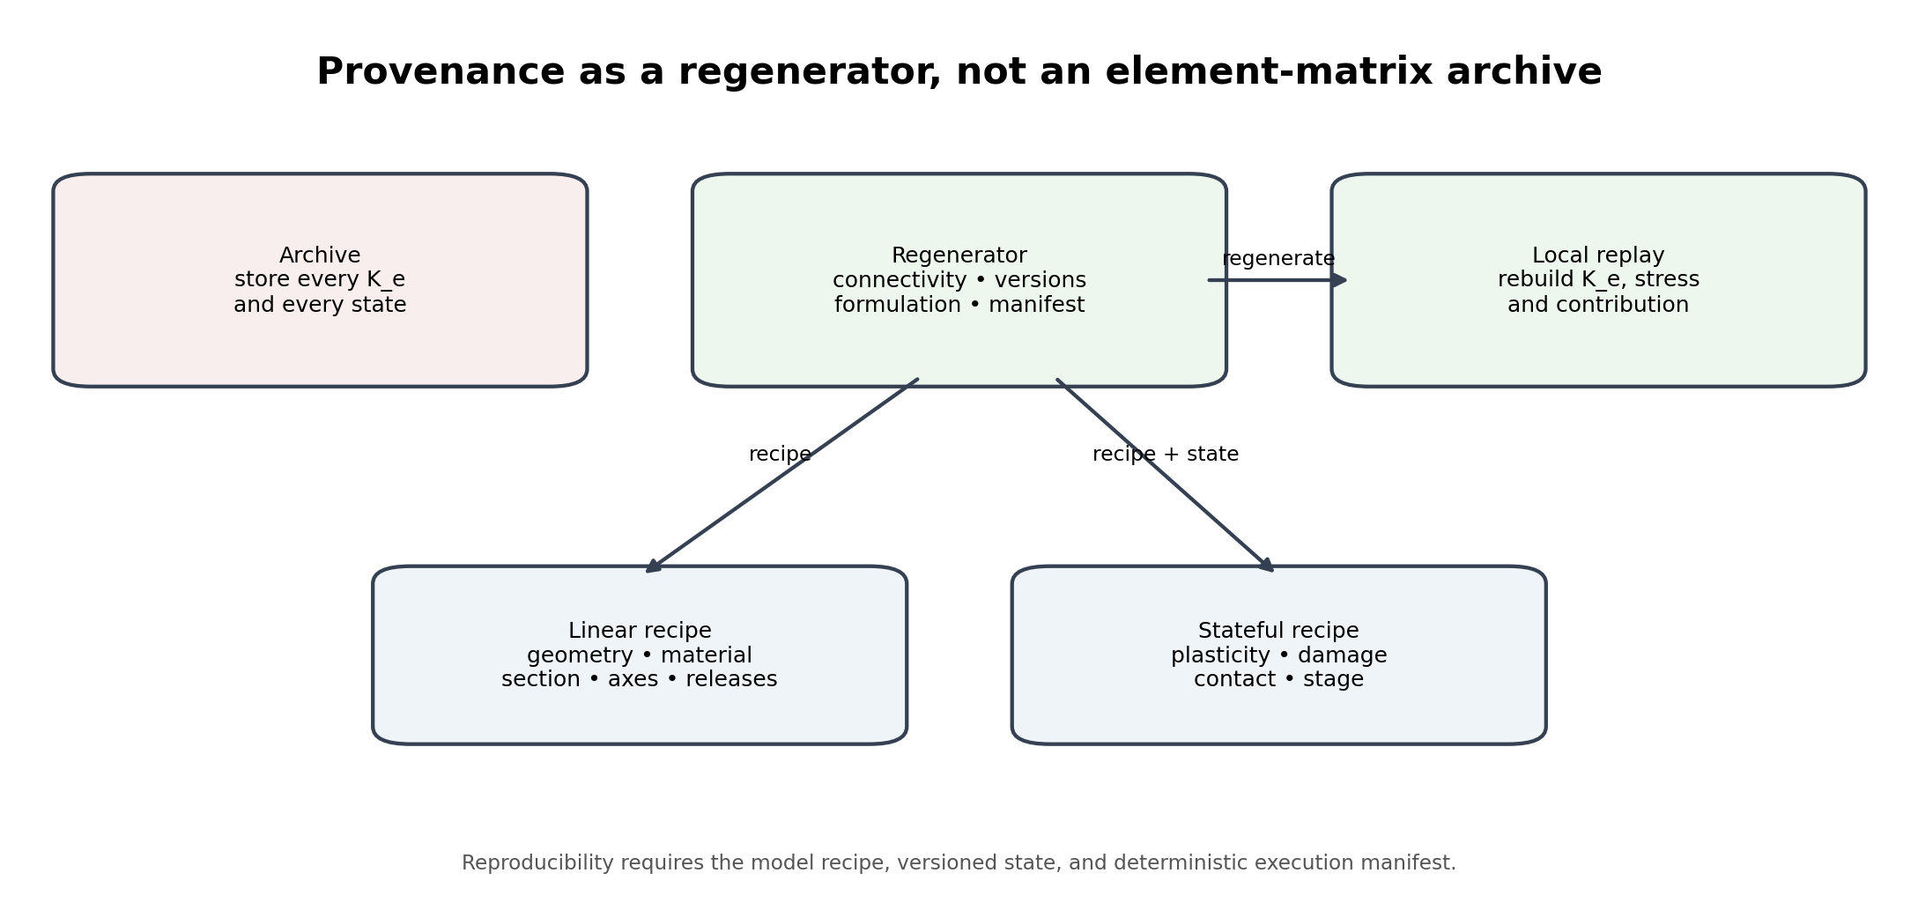
Figure 3. An affordable provenance architecture stores the recipe and state needed to replay a local contribution.
Assembly is many-to-one. Different collections of element contributions can produce the same assembled entry or global operator. The assembled matrix alone cannot determine its decomposition. The remedy is not necessarily to archive every K_e. It is to retain enough information to reproduce the element contribution under the original analysis conditions.
For a linear analysis the recipe typically includes geometry, connectivity, element formulation, material and section versions, local axes, integration rule, releases, offsets, units, and the compiler version. In nonlinear, contact, staged, or history-dependent analysis, the recipe must be augmented by versioned state: current configuration, plastic strains, hardening variables, damage, contact active sets, temperature, prestress, construction stage, adaptive quadrature state, and algorithmic tolerances.
The illustrative storage ratios in the exploration note—element-matrix archiving near 11.5 times the assembled sparse representation and recipe storage near 0.5 times—are benchmark-specific rather than universal constants. Their architectural lesson survives: a replayable recipe can be substantially cheaper than a complete element-operator archive, but reproducibility depends on the state ledger and execution manifest.

11. Three clocks for an efficient implementation
Table 5. Rich reasoning stays outside the innermost numerical loop.
Clock | Triggered by | Operations
Semantic clock | Drawing, discipline, responsibility, interface, or revision change | Update rich entities, restrictions, witnesses, versions, and claims
Compilation clock | Mesh, property, constraint, load, or analysis-context change | Invalidate affected recipes; rebuild maps, operators, partitions, and manifests
Solver clock | Newton/Krylov iteration, eigen extraction, time step, constitutive update | Operate on compact arrays and local kernels without traversing the semantic graph

The architecture should support dependency-aware incremental compilation. A changed support or opening should invalidate only the affected interface witnesses, elements, degrees of freedom, operator blocks, and result claims. Unchanged local matrices, symbolic factorizations, partitions, and semantic conclusions should remain reusable when their dependencies and hashes remain valid.

12. Relation to the 2023 Second Foundation paper
The 2023 paper Second Foundation: Knowledge Graph vs Sentence Embedding for Long-Term & Short-Term Memory argued against choosing one representation for every operation. It proposed retaining structured relational representations for compositional reasoning and compact vector representations for rapid retrieval and execution, connected through an explicit update process.
The finite-element correspondence is architectural, not literal. The persistent project graph or sheaf resembles the structured representation; the assembled numerical operator resembles a computation-optimized view; and the gather maps plus manifest preserve the relation between them. Unlike a learned sentence embedding, the FE operator is sparse, physically derived, and tied to a declared variational problem. The transferable principle is representation plurality with a named compilation relation.
Table 6. The correspondence is an architectural analogy, not a claim of object identity.
Second Foundation, 2023 | Finite-element continuation
Durable relational representation | Versioned semantic project algebra
Task-local structured workspace | Analysis-specific working complex
Compact execution representation | Sparse, condensed, or matrix-free FE operator
Retrieval and conversion relation | Restriction, compilation, gather map, and manifest
Consolidation | Audited semantic result commit and dependency update

13. Implementation blueprint
- Maintain a persistent project algebra with immutable entity identifiers, versioned discipline and interface objects, coefficient systems, and witness provenance.
- Build a task-local working complex for each requested analysis rather than materializing every semantic channel in the solver.
- Audit semantic identifications before node merging, rigid links, multi-point constraints, and interface couplings are committed.
- Compile the working complex into a numerical package containing R, local recipes, constraints, units, source hashes, and the execution manifest.
- Run the flat solver with sparse or matrix-free kernels and keep rich reasoning outside the innermost iterations.
- Recover local primal and dual quantities; compute residuals and jumps on patches where their mechanisms remain informative.
- Regenerate local contributions on demand for provenance queries, change attribution, and disputed results.
- Commit only typed, audited, entity-level results to the project model; discard partition-dependent and iteration-local state unless required for reproducibility.

14. Validation programme
Table 7. A minimum empirical programme for the engineering architecture.
Experiment | Question | Expected falsifiable output
Primal-collapse demonstrator | Does J R vanish for every conforming global vector? | Machine-precision zero; any nonzero result exposes a mapping or implementation defect
Pre-merge witness test | Can intentionally mismatched nodes be detected before shared DOF creation? | Independent geometric/semantic witness rejects incorrect merge
Dual residual benchmark | Do traction jumps correlate with discretization error and refinement benefit? | Estimator reduction and response convergence after targeted refinement
Nonconforming span test | Which interface modes are outside the coupling range? | Rank/cokernel basis tied to physical interface modes
Regeneration audit | Can a disputed K entry or element force be reproduced from the manifest? | Bitwise or tolerance-bounded replay under declared deterministic conditions
Incremental rebuild test | Does a local design change avoid project-wide recompilation? | Measured invalidation set agrees with dependency graph and yields identical unaffected results

15. The claim object gains a mechanism field
The recurring failure in this line was not only the omission of conditions. The conforming-audit example produced the correct zero verdict under two possible explanations that required opposite actions. A technical result intended for implementation should therefore be emitted as:
Claim = (statement, type, mechanism, conditions, coefficient system, jurisdiction, disabled regime, falsifier, guard)
Table 8. Mechanism distinguishes a justified silence from a defective silence.
Field | FEA example
Statement | The post-assembly primal jump is zero for a conforming field s = R u.
Type | Vacuity diagnosis and scope condition.
Mechanism | Exactness collapse: J R = 0 and the audit receives only fields in im R.
Conditions | Conforming displacement-based FE space with shared global DOFs.
Coefficient system | Declared displacement/rotation trace spaces and sign conventions.
Jurisdiction | Primal compatibility after compilation.
Disabled regime | Nonconforming interface or independently retained local copies.
Falsifier | A nonzero J R u for a correctly implemented conforming map.
Guard | Detect candidate-derived witnesses and move the audit before merging or to a non-collapsed residual channel.

16. Limitations and open debts
- The sheaf interpretation is exact only after a cover, stalks, restriction maps, and coefficient systems have been specified; the ordinary connectivity table alone is insufficient.
- Traction jumps are computed residuals, not independent experimental measurements. Their usefulness comes from weak rather than strong continuity enforcement.
- Residual estimators can be unreliable without the regularity, stability, and problem-specific assumptions required by their theory.
- Nonlinear regeneration may be expensive or non-deterministic unless state, solver versions, parallel reductions, tolerances, and constitutive update order are controlled.
- Matrix-free execution does not remove the need for provenance; it increases the importance of retaining the operator recipe and application path.
- The storage measurements in the exploration note must be reproduced on representative element families, precision choices, and project scales before being used for capacity planning.

17. Conclusion
The efficient interaction between rich algebraic engineering data and flat finite-element computation is not a repeated conversion between two complete databases. It is a compilation architecture. The project model retains semantic identity, provenance, versions, and interfaces. A task-local compiler emits the gather maps, element recipes, constraints, and numerical operators needed for one analysis. The solver executes on flat data. An interpreter then uses the retained maps and manifest to return selected results to engineering entities.
Finite-element assembly already contains the essential incidence-restriction backbone, but naming it correctly matters. R^T is the adjoint scatter on vectors; K = R^T K_loc R is a congruence on operators; connectivity is data for a nerve rather than a nerve by itself; and a conforming primal audit is silent because its admissible input has been made exact by construction. The useful discretization residual appears on the dual side as an element or interface imbalance not strongly forced to vanish.
The practical rule is therefore: reason richly, compile locally, solve flat, recover through retained maps, regenerate evidence from recipe and state, and attach the mechanism to every verdict.
Reason rich. Compile local. Solve flat. Recover dual evidence. Regenerate provenance. Commit only what has passed a mechanism-aware guard.

References
[1] Ghosh, D. P. (2023). Second Foundation: Knowledge Graph vs Sentence Embedding for Long-Term & Short-Term Memory. DOI: 10.13140/RG.2.2.16935.52645.
[2] Ghosh, D. P. (2026). From CAD Primitives to Structural Meaning: Cosheaf Ascent, Cohomological Audit, and Extension Lifting for Engineering Drawing Intelligence. Debias Parametric Guru working paper.
[3] Ghosh, D. P. (2026). Short at Every Step, Exact at Every Interface: A Short-Exact-Sequence Architecture for Completing Structural Drawings and Auditing Engineering AI. Debias Parametric Guru working paper.
[4] Ghosh, D. P. (2026). Iso Within, Exact Across: A Long-Exact-Sequence Architecture for Multidiscipline Engineering Integration and Project Revision Control. Debias Parametric Guru working paper.
[5] Hughes, T. J. R. (2000). The Finite Element Method: Linear Static and Dynamic Finite Element Analysis. Dover.
[6] Zienkiewicz, O. C., Taylor, R. L., & Zhu, J. Z. (2013). The Finite Element Method: Its Basis and Fundamentals, 7th ed. Butterworth-Heinemann.
[7] Brenner, S. C., & Scott, L. R. (2008). The Mathematical Theory of Finite Element Methods, 3rd ed. Springer.
[8] Arnold, D. N., Falk, R. S., & Winther, R. (2006). Finite element exterior calculus, homological techniques, and applications. Acta Numerica, 15, 1-155.
[9] Babuška, I., & Rheinboldt, W. C. (1978). Error estimates for adaptive finite element computations. SIAM Journal on Numerical Analysis, 15(4), 736-754.
[10] Ainsworth, M., & Oden, J. T. (2000). A Posteriori Error Estimation in Finite Element Analysis. Wiley.
[11] Verfürth, R. (2013). A Posteriori Error Estimation Techniques for Finite Element Methods. Oxford University Press.
[12] Bernardi, C., Maday, Y., & Patera, A. T. (1994). A new nonconforming approach to domain decomposition: the mortar element method. In Nonlinear Partial Differential Equations and Their Applications.
[13] Wohlmuth, B. I. (2001). Discretization Methods and Iterative Solvers Based on Domain Decomposition. Springer.
[14] Farhat, C., & Roux, F.-X. (1991). A method of finite element tearing and interconnecting and its parallel solution algorithm. International Journal for Numerical Methods in Engineering, 32, 1205-1227.
[15] Bangerth, W., Hartmann, R., & Kanschat, G. (2007). deal.II - a general-purpose object-oriented finite element library. ACM Transactions on Mathematical Software, 33(4), Article 24.
[16] Anderson, R. et al. (2021). MFEM: A modular finite element methods library. Computers & Mathematics with Applications, 81, 42-74.
[17] Knepley, M. G., Karpeev, D. A., & others (2013). Mesh algorithms for PDE with Sieve I: mesh distribution. Scientific Programming, 17, 215-230; see also PETSc DMPlex documentation.
[18] Curry, J. (2014). Sheaves, Cosheaves and Applications. Ph.D. thesis, University of Pennsylvania.
[19] Hansen, J., & Ghrist, R. (2020). Toward a spectral theory of cellular sheaves. Journal of Applied and Computational Topology, 3, 315-358.
[20] Robinson, M. (2017). Sheaves are the canonical data structure for sensor integration. Information Fusion, 36, 208-224.
[21] Ern, A., & Guermond, J.-L. (2021). Finite Elements I: Approximation and Interpolation. Springer.
[22] Becker, R., & Rannacher, R. (2001). An optimal control approach to a posteriori error estimation in finite element methods. Acta Numerica, 10, 1-102.

