The Neuro Markov Boundary of the Cerebellar Circuit
  - Numerical experiments on mediation release calibration and delayed credit assignment
Debi Prasad Ghosh
Founder and Principal Engineer
Debias Parametric Guru, Kolkata, India
Revised manuscript 10 October 2026
Original conceptual manuscript dated 11 May 2026

Abstract
The cerebellar circuit combines expanded sensory representations, inhibitory cortical output, nuclear integration and delayed teaching. We investigate whether this architecture can be interpreted as a local process interface between candidate trajectories and consequential output. Five synthetic numerical experiments examine distinct parts of the proposal. In a linear Gaussian structural model, conditioning on the active output and background state reduces estimated conditional mutual information to 0.000077 nats, while a direct candidate bypass of strength 0.5 raises it to 0.1423 nats. The full input-gate-output state supplies no essential additional endpoint screening in this model. A predictive release rule reduces harmful releases from 29.87% to 1.57% of opportunities while releasing 55.89%, but holding all candidates also prevents harm and incurs an opportunity cost. With feedback delayed by 20 trials, indexing updates to the released candidate yields excess prediction mean squared error of 0.000275, compared with 1.3415 for updates assigned to the current candidate. Correctly labelled observations of unreleased candidates improve estimation, demonstrating that commitment indexing is an attribution constraint rather than a universal requirement for learning or screening. Finally, a delayed endpoint is screened by the output trajectory, but not necessarily by its initial snapshot. These results support a computationally coherent local mediation hypothesis and a benefit of event-specific credit assignment. They do not establish a biological Markov boundary, universal default-closed cerebellar gating or a unique explanation of cerebellar pathology. The revised theory separates statistical screening, causal mediation, release quality and learning provenance, and specifies biological experiments that can distinguish them.
Keywords: cerebellum; Markov boundary; causal mediation; release calibration; Purkinje inhibition; delayed feedback; eligibility traces; numerical experiments.

1 Introduction
The original Neuro-Markov proposal interpreted forward prediction, timing, adaptation and inhibitory control as parts of a common boundary process [1]. Its central insight is that internally generated possibilities need not have the same status as outputs that influence the body. A circuit that shapes output and receives delayed feedback must preserve enough information to relate later consequences to earlier events. This problem is relevant to cerebellar control and to artificial agents that generate alternatives before acting.
Classical cerebellar learning and internal-model accounts provide the computational background [6-8]. Graphical-model terminology supplies the screening criterion [9]. The proposed process interpretation adds an explicit question about how output mediation and delayed teaching are organised, rather than changing the established computations by definition.
The new contribution is an executable examination of the formal claim. We ask four questions. Does an output interface screen candidate information from consequences? Does such screening establish that the interface is safe? Does learning from an unexecuted candidate necessarily violate screening? Is a single output snapshot sufficient for a delayed consequence? These questions expose distinctions that were present in the original appendix but were not consistently maintained in the main argument.
The experiments are deliberately small. They use known causal equations, independent random draws and simple learning rules so that failure has an interpretable cause. They are computational stress tests, not fits to neural recordings. A successful synthetic test establishes a property of the constructed system. It does not show that the cerebellum implements that system. Conversely, a counterexample can disprove an unrestricted mathematical implication even when the biological hypothesis remains plausible.

2 Biological motivation and the scope of the hypothesis
The anatomical interpretation retains an input side associated with pontine-mossy and related afferents, a representation and modulation side associated with granule-Purkinje circuitry, and an output side associated with cerebellar nuclear or relevant vestibular output. Mossy-fibre collaterals also reach the nuclei, so the forward circuit is not a strictly serial input-Purkinje-output chain. The abstract output equation must permit both afferent excitation and inhibitory modulation [1,2].
Inhibitory sign alone does not establish that consequential output is normally closed. Nuclear neurons have spontaneous activity, with Purkinje inhibition and afferent excitation changing that activity [2]. We therefore treat default-closed release as a possible task-dependent operating regime. Establishing it requires specifying a downstream consequence threshold and measuring how baseline excitation and inhibition place output relative to that threshold. Tonic inhibition cannot by itself identify the operating regime.
Climbing-fibre teaching is also richer than a released-action error label. Kimpo and colleagues showed that error-related activity can have different learning effects depending on the training condition [3]. Kostadinov and colleagues reported reward expectation, delivery and omission signals [4]; Larry and colleagues reported expected reward-size encoding [5]. These findings motivate contextual teaching and provenance, but they do not justify an absolute prohibition on learning before execution. We use commitment indexing specifically for attributing a realised outcome to the action that generated it.
The cerebellum is not proposed as the sole cortical route to the body. Any experiment must define a local loop, an observed endpoint and a prespecified set of non-cerebellar covariates. Expanding the background state after seeing residual dependence would make the hypothesis difficult to falsify. Likewise, defining the endpoint as whatever is screened by the cerebellum would make screening circular.

3 Revised mathematical framework

3 1 Statistical screening and the process interface
Let C denote candidate state, W prespecified background variables, S the input representation, G a modulation state, A the active output and E a measured consequence. The process interface is B = (S, G, A). Assume that the endpoint equation uses only A, W and an innovation independent of the candidate and upstream variables. Then the local screening relation follows.
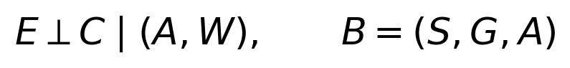
This is a model assumption with an observable implication. In the corresponding factorisation, the endpoint conditional density is p(E | A, W). Including upstream S and G does not change that density. Nevertheless, arbitrary enlargement of a conditioning set can introduce dependence in other graphs; the result here follows from the specific endpoint factorisation, not a general rule that more conditioning always preserves independence.
For the candidate-to-endpoint screening question, A may suffice. B should therefore be called a functional process interface, not automatically a minimal statistical Markov boundary. A formal Markov boundary of E relative to the measured variable universe must also account for W and test minimality among eligible subsets. Operational importance of S or G does not prove statistical minimality. Removing a circuit component by intervention is different from omitting its measurement from a regression.

3 2 Consequences over time
For delayed action, the relevant output may be a trajectory rather than an initial snapshot. If later output remains influenced by candidate information, conditioning on A at release need not screen that information from a later endpoint. A sufficient output record must cover all output events that affect the measured consequence; an adequate background record must cover other relevant influences.
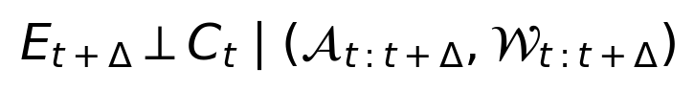
Here the calligraphic variables denote records over the stated interval. This trajectory formulation is a candidate test, not permission to condition on every downstream variable. In biological studies, measuring or intervening on an entire output record can be difficult, and post-treatment conditioning can bias causal interpretations. The timing and role of each covariate must be declared before analysis.

3 3 Learning provenance and structural persistence
A realised teaching event should identify the event whose outcome it reports. The required record can include context, chosen candidate, release status, parameter version and event time. A delayed eligibility trace is one possible implementation; an explicit stored event identifier is another. Our numerical learner uses the latter as an ideal reference and does not claim that neurons store literal identifiers.
If learning changes only upstream parameters and the endpoint equation remains fixed with an independent innovation, forward screening remains valid for many update functions U. This includes some functions that learn from observations of unreleased candidates. Commitment indexing is sufficient for a particular provenance restriction, but it is not necessary for this endpoint screening statement. The critical distinction is whether a label genuinely belongs to the candidate being updated.
A separate provenance hypothesis can require that changing irrelevant unchosen candidates while holding the chosen event, old parameters and teaching event fixed leaves the update unchanged. This is narrower than a universal conditional-independence law. It must include all stored traces and parameter state in the conditioning set. Learning from imagination is valid only to the extent that its simulated labels are valid; labelling every unchosen candidate with another action’s outcome is a credit-assignment error.

3 4 Identification through interventions
An ideal controlled test changes C while clamping A and W. Under the endpoint model this change has no effect on E. This is a joint intervention on the output interface and the candidate, rather than an ordinary candidate perturbation followed by conditioning on its downstream result. In vivo, a candidate perturbation typically changes the output and other pathways. Any claim of a direct bypass must distinguish those changes from a controlled direct effect.
The earlier intact-minus-inactivated contrast estimates an effect of a specified cerebellar perturbation under appropriate identification assumptions. It is not automatically a separable per-trial cerebellar component of an outcome. Interactions, altered background pathways and unobserved counterfactual outcomes complicate that interpretation. The synthetic experiments use explicitly generated endpoints rather than subtracting biological potential outcomes.

4 Numerical methods
All five experiments were executed for this revision. Experiment 1 and Experiment 5 use 100 independent seeds and 6,000 independent observations per seed. Experiment 2 uses 30 seeds and 20,000 opportunities per seed. Experiment 3 uses 30 seeds, 8,000 trials and three delays for each learning rule. Experiment 4 uses 100 seeds with 100 labelled candidates per seed. Seeds and coefficients are fixed in the accompanying script. Repeated conditions share underlying random draws within a seed wherever the comparison requires matched data.
We report the mean across seeds and a two-sided 95% Student t interval for that mean. These intervals quantify Monte Carlo uncertainty under the stated simulator; they are not biological population intervals and do not describe uncertainty over the model assumptions. No hyperparameter search or biological parameter fitting was performed. All quantities are dimensionless except for mutual information, measured in nats.
For Gaussian experiments, we regress both C and E on the conditioning variables, including an intercept, and compute the correlation of the residuals. Joint Gaussianity makes the resulting expression a conditional mutual-information estimator.
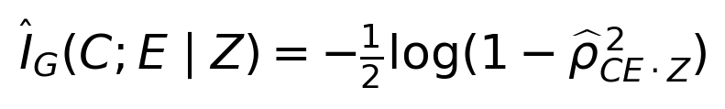
The estimator is nonnegative and has a positive finite-sample null floor. A positive interval for the mean estimator near zero is therefore not evidence against the exact model null. We report the intact model as an empirical null calibration. This estimator is not used to claim general nonlinear independence and would require replacement or supplementary tests for non-Gaussian neural data.

5 Experiment 1 Endpoint screening and failure controls
The forward simulator preserves a direct afferent-to-output contribution as well as an indirect modulation route. All C, W and epsilon variables are independent standard normal draws. The equations are as follows.
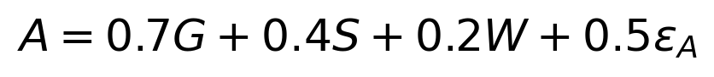
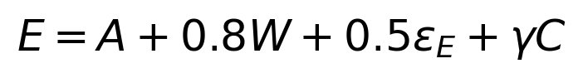
The intact model sets gamma to zero. Direct bypass controls set it to 0.25 or 0.5. Additional controls omit W, observe A with independent Gaussian measurement noise of standard deviation 0.5, or multiply the output contribution by two. In the gain control, the measured active output is also scaled by two. Thus the control changes downstream amplitude without introducing a candidate bypass.
Condition | Conditioning variables | Estimated CMI and 95% interval
Intact endpoint | A and W | 0.000077 [0.000060, 0.000094]
Full process measurements | S G A and W | 0.000080 [0.000062, 0.000098]
Bypass strength 0.25 | A and W | 0.0401 [0.0394, 0.0408]
Bypass strength 0.50 | A and W | 0.1423 [0.1411, 0.1435]
Background omitted | A | 0.1278 [0.1266, 0.1289]
Output measurement noise | Noisy A and W | 0.0609 [0.0600, 0.0617]
Output gain doubled | Scaled A and W | 0.000077 [0.000060, 0.000094]

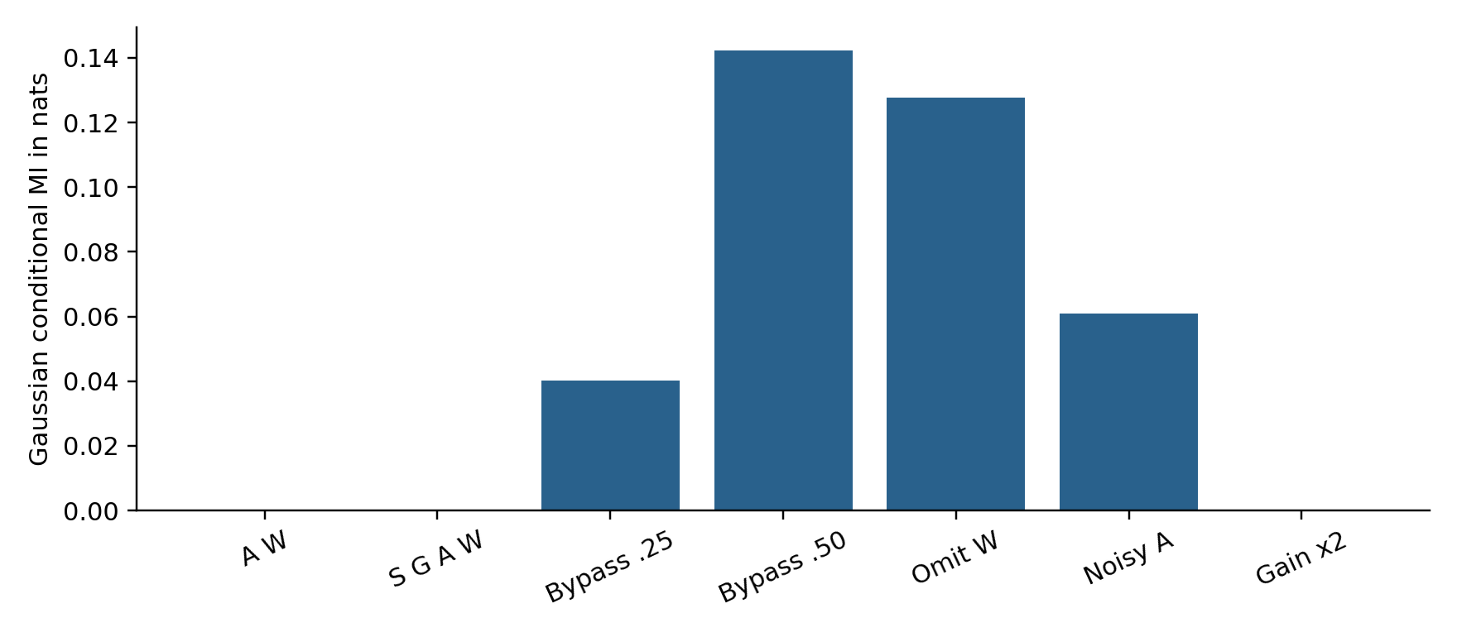
Figure 1. Gaussian screening estimates. Upstream measurements do not improve the essential endpoint screen in the intact model. Direct bypass, omitted background and output measurement noise all produce residual dependence. The gain control retains the intact estimate.
The intact A-W estimate is 0.000077 nats; the larger S-G-A-W set gives 0.000080 nats. A bypass of strength 0.5 raises the estimate to 0.1423 nats. Omitting W produces 0.1278 nats even though the simulator contains no direct candidate bypass. Measurement noise produces 0.0609 nats. Residual dependence therefore has multiple explanations. A biological observation of leakage must control for background omission and measurement error before interpreting it as a broken anatomical boundary.
The doubled-gain condition retains the screening estimate. It demonstrates that amplitude distortion does not necessarily violate the statistical relation. Conversely, low leakage cannot establish accurate amplitude, safe action or a normal phenotype. The intact screen is also not uniquely cerebellar: a conventional fully observed mediator would satisfy the same equation.

6 Experiment 2 Release calibration and opportunity cost
We next isolate the release decision. Candidate command u is uniform on [-1.5, 1.5] and load W is uniform on [0.6, 1.4]. The true consequence is their product; a noisy estimate adds independent normal error. Safe consequences have absolute magnitude at most one. The predictive policy releases when the estimated absolute magnitude is at most threshold h.
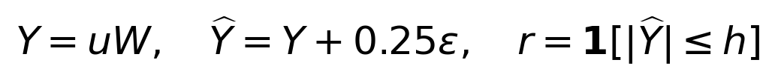
This estimate is supplied by the simulator and is not trained in this experiment. It represents a fixed predictor with specified accuracy, so the experiment tests the decision rule rather than the ability of a neural circuit to learn prediction. The main comparison uses h = 0.8. A sign-inverted rule releases when the same estimate exceeds 0.8. Always-release and always-hold policies provide two limiting controls.
Harm costs ten units and withholding a safe opportunity costs half a unit; withholding an unsafe opportunity has no cost in this toy task. These choices are explicit modelling assumptions. We also sweep 20 thresholds from 0.35 to 1.3 to display the release-harm tradeoff, without reporting the sample-minimising threshold as an independently validated optimum.
Policy | Release fraction | Harm per opportunity | Expected cost
Predictive | 0.5589 | 0.0157 | 0.2363 [0.2329, 0.2396]
Sign inverted | 0.4411 | 0.2830 | 3.1018 [3.0904, 3.1132]
Always release | 1.0000 | 0.2987 | 2.9874 [2.9765, 2.9983]
Always hold | 0.0000 | 0.0000 | 0.3506 [0.3501, 0.3512]

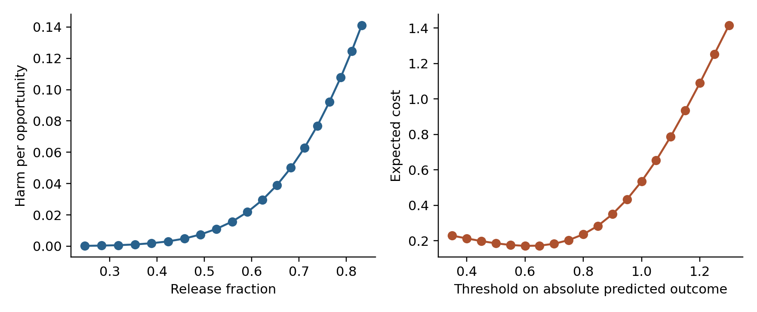
Figure 2. Threshold sweep for the fixed predictor. The left panel reports harmful releases against throughput. The right panel includes a penalty for holding safe opportunities. Curves show means over 30 seeds; raw curves are supplied in the supplement.
The predictive rule releases 55.89% of opportunities and causes harm on 1.57%, with expected cost 0.2363 [0.2329, 0.2396]. Always-release causes harm on 29.87%, with cost 2.9874. Always-hold has zero harm but cost 0.3506 because it loses every safe opportunity. The sign-inverted rule has cost 3.1018. Inhibition or a gate is therefore insufficient: the rule must be calibrated to a defined consequence and to the cost of withholding action.
Default-closed and default-open implementations of the same final release function would have identical static outcomes here. Their difference requires a fault or dynamics model, such as lost input, delayed inhibition or a stuck actuator. We do not simulate such faults and do not infer a biological default regime from this comparison. The endpoint would remain structurally mediated under every policy if it were generated only from the realised output and independent noise.

7 Experiment 3 Delayed outcome attribution
Each trial presents four independently drawn five-dimensional candidate vectors. A uniformly selected candidate is released with probability 0.6, independently of its features. The label for that candidate is its inner product with a fixed coefficient vector plus normal noise of standard deviation 0.1. A linear learner starts at zero. Its step size is 0.01, and labels arrive after 0, 5 or 20 trials.
At feedback arrival the learner performs an update only if the originating trial was released. All rules therefore already share a release mask. The experimental difference is which features receive the outcome, not whether release is required. The indexed rule retrieves the originating selected vector. The current rule uses the currently selected vector. The pooled rule uses the mean of all four candidates from the originating trial, including unchosen alternatives.
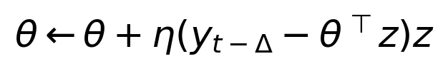
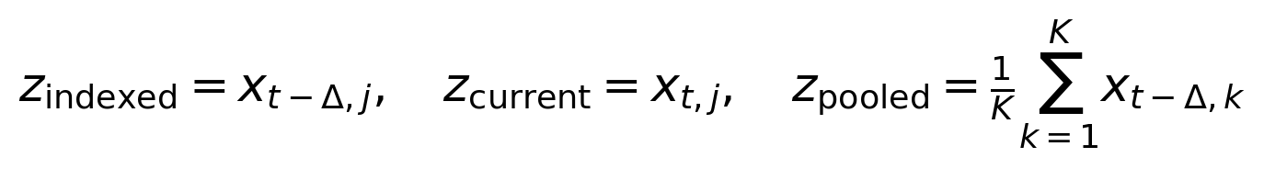
In the current rule, j denotes the candidate selected in the current trial; in the indexed rule it denotes the originating selection. Prediction is recomputed with the current parameters at arrival. Because test features are standard normal, squared coefficient error exactly equals noise-free expected excess prediction MSE. The irreducible observation-noise MSE of 0.01 is excluded. Every condition uses the same trial stream for a given seed.
Delay in trials | Indexed MSE | Current candidate MSE | Pooled candidates MSE
0 | 0.000257 [0.000193, 0.000321] | 0.000257 [0.000193, 0.000321] | 0.0221 [0.0163, 0.0279]
5 | 0.000256 [0.000197, 0.000315] | 1.2988 [1.2250, 1.3726] | 0.0227 [0.0166, 0.0288]
20 | 0.000275 [0.000211, 0.000340] | 1.3415 [1.2720, 1.4110] | 0.0238 [0.0172, 0.0303]

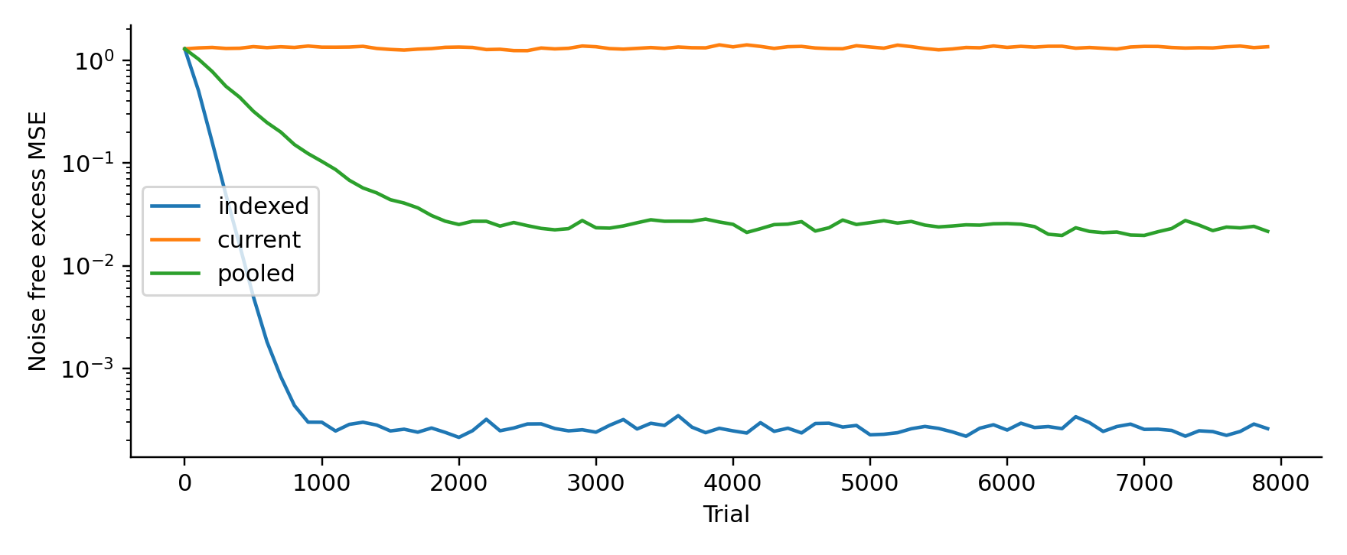
Figure 3. Mean noise-free excess MSE across 30 seeds at a delay of 20 trials. The indexed learner retains the originating chosen candidate. Pooling alternatives adds label uncertainty. Updating the unrelated current candidate fails to recover the true mapping.
At zero delay the indexed and current rules agree, as they should. At delay 20 the indexed error is 0.000275 [0.000211, 0.000340]; the current error is 1.3415 [1.2720, 1.4110]. The zero predictor has error 1.29, so the current rule is approximately nonlearning with additional update noise. The pooled error is 0.02376 [0.01723, 0.03028], about 86 times the indexed error, although much lower than the current-rule error.
Pooling is not constructed to be impossible. With exchangeable independent candidates and random selection, the conditional mean label given their average has the same coefficient vector. It remains learnable but has more residual label variance. This control prevents us from claiming that every update involving an unchosen candidate is necessarily biased. The evidence supports event-specific attribution under delay, not a general proof that commitment indexing is required for conditional independence.

8 Experiment 4 Valid observation of unreleased candidates
We test the strongest exclusion claim directly. Each seed generates 100 independent five-dimensional candidates and their own valid labels using the same coefficient vector, with noise standard deviation 0.2. Each candidate is marked released with probability 0.3. Ordinary least squares is fitted either to the released subset alone or to all valid labels, including labels for unreleased candidates. The second learner receives additional legitimate information. The comparison intentionally tests the value of that information, not sample-efficiency at equal label count.
Training information | Excess prediction MSE and 95% interval
Released subset only | 0.0086 [0.0073, 0.0100]
Released and valid observed candidates | 0.0020 [0.0017, 0.0023]

The error falls from 0.008618 to 0.002038, a reduction of approximately 76%. The labels for unexecuted candidates are externally provided in this simulator. Real biology would need a valid sensory, observational or simulated teaching source; this experiment does not show that such labels are always available. It does show that the unrestricted rule “no release implies no learning” is too strong.
Embedding either fitted predictor upstream of an endpoint equation E = f(A, W, independent noise) leaves that endpoint structurally screened by A and W. Thus observation-based learning does not inherently open a candidate-to-endpoint bypass. Whether a proposed biological observational-learning channel preserves the same structure is an empirical question. The revision replaces the universal exclusion with a provenance rule: an outcome may teach a candidate only when the teaching source legitimately identifies that candidate’s outcome or target.

9 Experiment 5 A snapshot is not always a delayed boundary
The final experiment gives one candidate two opportunities to affect output before the delayed endpoint. Independent standard normal innovations generate two output samples. Background and endpoint noise are also independent standard normals.
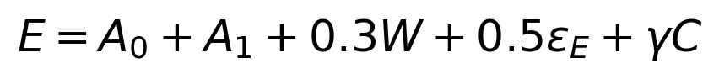
The intact trajectory model has gamma = 0. We compare conditioning on the first output and W with conditioning on both outputs and W. A positive control then adds a direct bypass of strength 0.5 while retaining both output samples.
Condition | Estimated CMI and 95% interval
Initial output snapshot | 0.2123 [0.2108, 0.2138]
Complete two-sample output trajectory | 0.000092 [0.000065, 0.000119]
Trajectory with direct bypass | 0.0683 [0.0673, 0.0692]

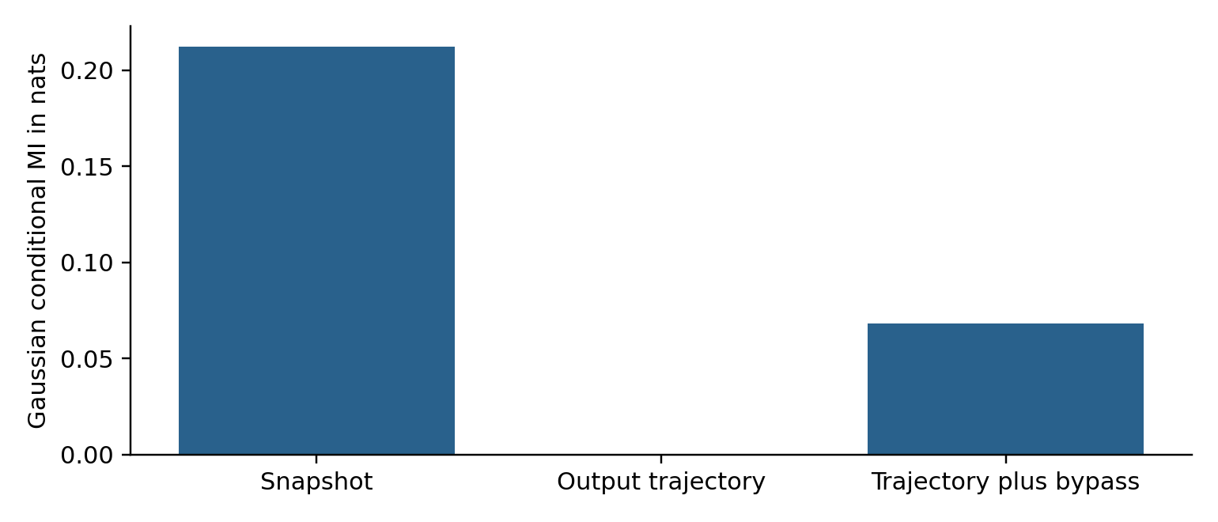
Figure 4. The delayed endpoint depends on both output samples. Observing the complete trajectory restores the model screen; observing only the initial output does not. A direct candidate bypass remains detectable after both outputs are included.
The snapshot estimate is 0.2123 nats. Including both output samples reduces it to 0.000092 nats, while the bypass control gives 0.06826 nats. The result does not refute a snapshot claim for a task whose initial output fully specifies its future effect. It identifies the additional sufficiency assumption required when later output carries further candidate influence. In an adaptive circuit, continuing feedback and updated control can make this issue especially important.

10 Interpretation and biological predictions

10 1 What the numerical evidence changes
The tested architecture can implement a local mediation screen, and correct event attribution improves delayed learning. Neither result alone identifies the cerebellum. The practical content of the hypothesis now lies in the joint organisation of contextual output modulation and teaching provenance. Existing forward-model accounts remain compatible with this organisation; this study does not demonstrate that the boundary account subsumes or outperforms them.
A biological study should first specify a loop and endpoint, record candidate-related and nuclear-output activity, and prespecify background variables. A nested prediction analysis can compare outcome prediction from output and background alone with prediction after adding candidate information. Held-out improvement is evidence of residual predictive dependence, with interpretation contingent on measurement accuracy, hidden state and model adequacy. A nonlinear analysis should not substitute Gaussian partial correlation without justification.
A stronger causal test would perturb candidate-related activity while experimentally matching or clamping the relevant output trajectory and relevant background pathways. Residual endpoint effects would challenge the specified mediation model. Merely finding that ordinary cortical perturbations change behaviour does not identify a bypass, because those perturbations can change the output interface itself.

10 2 Distinguishing teaching provenance from execution
A delayed teaching experiment should independently manipulate execution, label validity and label-event matching. Compare a released movement followed by its own outcome, a withheld movement with a valid externally supplied target, and either condition paired with another movement’s outcome. The revised model predicts that mismatched teaching should impair calibration more than correctly matched teaching at comparable information quality. The strict original exclusion predicts no durable learning for withheld movements even when their targets are valid. These are distinguishable claims.
To test inhibitory operating regimes, measure the effect of reducing Purkinje activity while keeping afferent drive and task demands controlled. A default-closed interpretation requires a consequential output threshold, low baseline crossing probability and an appropriate causal change with disinhibition. Alternative findings could favour graded timing or gain modulation. No result from the present binary gate alone decides that question.

10 3 Pathology and nonmotor extensions
The original pathology taxonomy remains useful for generating hypotheses, but it is no longer presented as a taxonomy of conditional-independence failures. Dysmetria can result from incorrect output gain while screening is intact, as Experiment 1 illustrates. Impaired switching, tremor or ataxia may reflect dynamics or calibration without an additional candidate bypass. Conversely, residual dependence can appear solely because an output measurement is noisy.
For each proposed syndrome, the next model must reproduce a concrete observable, such as endpoint amplitude error, alternating-movement phase error or a tremor spectrum, and compare a boundary account against conventional control explanations. The present experiments contain no limbs, spiking neurons, oscillatory loop or lesion-specific physiology. They do not simulate these clinical syndromes.
Cognitive, language and affective extensions retain the same status as hypotheses from the conceptual manuscript. An investigator must define a candidate, a measurable commitment, an output interface and a valid delayed teaching signal within the selected loop. Motor analogies alone cannot establish that cognitive trajectories use the same release rule. Nonmotor tests should follow a successful operationalisation rather than be inferred from the mathematical notation.

11 Implications for Construction AGI
The computational results suggest a useful design for engineering agents that draft alternatives before executing tools. The agent should record the selected proposal, applicable constraints, realised tool call, parameter or document version and outcome-event identity. A delayed solver result should update the proposal that produced it. Assigning that result to whichever alternative is currently in context resembles the failed current-candidate learner in Experiment 3.
Engineering release quality should be measured independently from provenance. An interface that perfectly records every tool call can still release an unsafe design. A conservative interface can avoid unsafe release by blocking useful work. Calibration therefore needs a task-specific tradeoff between harmful release and justified withholding, with the thresholds evaluated on realistic engineering cases rather than inherited from this toy simulator.
Valid evidence from an unexecuted option can still be valuable. A checked calculation or labelled simulation may legitimately teach an alternative that was not issued to procurement or construction. The provenance record should distinguish an executed outcome from an independently verified simulation. This is an architectural implication of the attribution experiments; it is not a neuroscience claim or a demonstrated Construction-AGI benchmark.

12 Limitations and conclusion
The results depend on intentionally simple simulators. Gaussian screening is analytically expected from the chosen graph and therefore serves as an implementation check and sensitivity study. The release experiment supplies a predictor rather than learning it, uses one-dimensional consequences and assigns arbitrary costs. The delayed learner uses independent candidates, a stationary linear target, random release and perfect storage of the chosen features. We did not test decaying biological eligibility traces, selective release, distribution shifts, spiking microcircuits or causal identification from real recordings.
The seed intervals quantify numerical sampling variability only. There is no evidence here about biological effect size, clinical sensitivity or anatomical uniqueness. A useful next computational study would replace random release with learned selective gating, introduce a finite eligibility memory and test attribution under feedback collisions. A useful biological study would independently vary execution, provenance and label validity within one defined cerebro-cerebellar loop.
The revised Neuro-Markov proposal is a local process-interface hypothesis with four separately testable properties: output mediation, sufficient temporal state, calibrated release and valid teaching attribution. The numerical experiments support mediation under the specified causal equations and the value of preserving event identity under delay. They also delimit the theory: process components need not form a minimal statistical boundary; inhibition alone does not establish default-closed release; valid observations can teach unexecuted candidates; and poor performance need not imply screening failure. These distinctions give the biological hypothesis a clearer target for falsification.

Data and code availability
The accompanying Neuro_Markov_Numerical_Supplement.zip contains the executed Python experiment script, summary.csv, results.json, run.log and the four generated figures. The JSON contains seed-level results for the Gaussian and delayed-learning experiments and all gate-sweep curves. The script regenerates the remaining summaries. Run OPENBLAS_NUM_THREADS=1 python neuro_markov_experiments.py with NumPy, SciPy and Matplotlib installed. All observations are synthetic. No animal, human or clinical data were collected for this revision.

References
1. Ghosh, D. P. (2026). The Neuro-Markov Boundary of the Cerebellar Circuit. Original conceptual manuscript dated 11 May 2026. Author-supplied PDF; revised in the present manuscript.
2. Zheng, N., and Raman, I. M. (2009). Ca currents activated by spontaneous firing and synaptic disinhibition in neurons of the cerebellar nuclei. Journal of Neuroscience, 29, 9826-9838. https://doi.org/10.1523/JNEUROSCI.2069-09.2009
3. Kimpo, R. R., Rinaldi, J. M., Kim, C. K., Payne, H. L., and Raymond, J. L. (2014). Gating of neural error signals during motor learning. eLife, 3, e02076. https://doi.org/10.7554/eLife.02076
4. Kostadinov, D., Beau, M., Blanco-Pozo, M., and Häusser, M. (2019). Predictive and reactive reward signals conveyed by climbing fiber inputs to cerebellar Purkinje cells. Nature Neuroscience, 22, 950-962. https://doi.org/10.1038/s41593-019-0381-8
5. Larry, N., Yarkoni, M., Lixenberg, A., and Joshua, M. (2019). Cerebellar climbing fibers encode expected reward size. eLife, 8, e46870. https://doi.org/10.7554/eLife.46870
6. Marr, D. (1969). A theory of cerebellar cortex. Journal of Physiology, 202, 437-470. Foundational context retained from the original manuscript.
7. Albus, J. S. (1971). A theory of cerebellar function. Mathematical Biosciences, 10, 25-61. Foundational context retained from the original manuscript.
8. Wolpert, D. M., Miall, R. C., and Kawato, M. (1998). Internal models in the cerebellum. Trends in Cognitive Sciences, 2, 338-347. Foundational context retained from the original manuscript.
9. Pearl, J. (1988). Probabilistic reasoning in intelligent systems. Morgan Kaufmann. Graphical-model context retained from the original manuscript.
https://github.com/debiprasadghosh/ResearchOverFlow/tree/main/October2026/NeuroMarkovBoundary

Appendix Revision record
Original proposition | Status in this revision
S G A is a minimal local Markov boundary | B is a functional process interface. Statistical minimality is a separate question; A with W suffices in the endpoint simulator.
Purkinje inhibition implies default closed release | Task-dependent operating regime requiring evidence about baseline output and a consequential threshold.
No release implies no learning | Replaced by label-event validity. Own outcomes require originating-action attribution; valid observational targets can support learning.
Learning from unchosen candidates collapses screening | Not generally true. Screening persists under upstream learning if the endpoint factorisation and independent innovations remain valid.
Pathology reflects conditional independence failure | Retained only as a set of functional hypotheses. Calibration failure can coexist with screening.
A release-time state screens a delayed endpoint | Requires temporal sufficiency. A complete relevant output record may be necessary.

