Vocabucapillary Text Diffusion
Coefficient resolution as the noise variable: exact likelihood, schedule geometry and the limits of coarse-to-fine parallel decoding
Debi Prasad Ghosh
Founder and Principal Engineer, Debias Parametric Guru, Kolkata, India
8 November 2026 · Preprint · Defensible Intelligence series

Abstract
Text diffusion generates a sequence by starting from an uninformative state and refining all positions in parallel over a fixed number of steps. Masked diffusion uses a mask symbol as that state. We replace the mask by the resolution of a Vocabucapillary code: each position carries a unit-mass coefficient vector over vocabulary addresses whose coarsest form is the vocabulary prior and whose finest form is a one-hot token, with intermediate forms given by the prior restricted to a group of a nested vocabulary hierarchy. The forward process lowers resolution; the reverse process refines it, one hierarchy level or several at a time, at chosen positions. We prove that intermediate codes decode exactly to prior-weighted group atoms, that masked diffusion is the endpoint case, and that every deterministic resolution schedule has an exact likelihood whose excess over the data entropy, for an optimal factorised denoiser, equals the summed conditional total correlation of the refinements made together. Resolution schedules contain masked schedules, so their optimal gap is never larger at equal step count, and a parity construction separates them strictly (2 bits versus 0 at two steps). The level-synchronous schedule, in which every position is refined by one level per step, has gap equal to the total correlation of the sequence minus a quantity we call cross-resolution information; when that quantity vanishes, level-synchronous decoding is no better than one-shot decoding. If each token is conditionally independent of the rest given its own coarse group, no resolution schedule beats the best masked schedule. Coefficient precision and support truncation in the reverse sampler obey an explicit total-variation bound that scales with branching width rather than vocabulary size. An exact numerical study in immutable C# over all 16^{L} sequences (L ≤ 5) confirms each identity to 2×10⁻¹¹ or better, finds no gain over masked scheduling on three structured toy languages, and finds that on random pairwise models resolution scheduling helps in 35–65% of models but, at two steps, by only 6–11% of the masked gap on average. All denoisers in the study are Bayes-optimal; no claim is made about trained models or natural text.
Keywords: Vocabucapillary; discrete diffusion; masked diffusion language models; coarse-to-fine generation; total correlation; parallel decoding; vocabulary hierarchy; coefficient precision

1 Motivation and scope
Autoregressive language models decide one token per network evaluation. Discrete diffusion models instead begin from a corrupted sequence and denoise all positions in parallel (Austin et al., 2021). The masked, or absorbing-state, variant has become the strongest discrete form: each corrupted position holds a mask symbol, and the model learns to recover tokens at masked positions (Sahoo et al., 2024; Shi et al., 2024; Lou et al., 2024). Scaled versions now compete with autoregressive models of similar size (Nie et al., 2025).
A masked position carries no information about its token, so every unmasking step makes a full vocabulary-wide decision. Vocabucapillary offers a finer language for partial knowledge. A contextual state is a sparse unit-mass coefficient vector over vocabulary-associated addresses, decoded through a dictionary (Ghosh, 2026b), and a resolution specifies the available atoms, support cap and numerical precision of such codes (Ghosh, 2026g). The present paper asks a narrow question: if the noise variable of text diffusion is coefficient resolution instead of a mask, what changes mathematically, what can be proved about parallel decoding, and what does an exact computation show?
The answer has three parts. First, the construction is clean: lowering resolution is a deterministic, information-monotone map with an explicit Vocabucapillary meaning, and it yields exact likelihoods rather than evidence lower bounds. Second, resolution enlarges the space of decoding schedules, and the enlargement provably helps exactly when the fine choices at one position depend on the coarse choices at others. Third, that condition is not automatic: on structured toy languages the semantically natural hierarchy makes it vanish, and the optimal resolution schedule then collapses to a masked one. We state these limits as plainly as the positive results.

1.1 Related work
Structured transition matrices for discrete diffusion, including absorbing and nearest-neighbour corruptions, were introduced by Austin et al. (2021). Masked diffusion language models simplify the absorbing objective to weighted cross-entropy (Sahoo et al., 2024; Shi et al., 2024), and score-entropy methods estimate ratios of the data distribution (Lou et al., 2024). Autoregressive diffusion models connect order-agnostic generation with absorbing diffusion (Hoogeboom et al., 2022). Liu et al. (2025) show that a fully factorised denoiser incurs an irreducible error equal, at least, to the summed total correlation of the forward posteriors; our Theorem 1 is the deterministic-schedule form of that statement, with equality and no variational slack.
Closest to the present work, hierarchical diffusion language models (HDLM) insert a semantic cluster level between word tokens and the mask, with clusters obtained by K-means on token embeddings and a continuous-time stochastic forward process trained through an evidence lower bound (Zhou et al., 2025). HDLM reports improved validation and generative perplexity on OpenWebText. The present paper differs in object and in claim. It uses a deterministic schedule over positions and levels, so likelihoods are exact. It identifies when coarse-to-fine refinement reduces parallel-decoding error and when it cannot. It treats intermediate states as Vocabucapillary codes with support, precision and memory guarantees. We make no empirical claim about trained models, and our results neither confirm nor refute HDLM’s measurements.
Vocabucapillary itself is developed in companion papers: bounded coefficient memory (Ghosh, 2026a; 2026b; 2026d), sparse quantisation (Ghosh, 2026c), interpretability (Ghosh, 2026e), sparse backpropagation and function-preserving refinement (Ghosh, 2026f), resolution-adaptive meta-learning (Ghosh, 2026g), probabilistic codes and hierarchical grouping (Ghosh, 2026h), and multimodal attribution (Ghosh, 2026i; 2026j). Class-based clustering of vocabularies goes back to Brown et al. (1992).

1.2 Contributions
- A definition of resolution codes over a nested vocabulary hierarchy, with exact decoding, total-variation and mixture identities (Proposition 1), and a proof that masked diffusion is the endpoint case (Proposition 2).
- Exact likelihood for every deterministic resolution schedule and an exact identity for the factorisation gap of an optimal factorised denoiser (Theorem 1).
- Schedule geometry: inclusion of masked schedules (Theorem 2), strict separation by a parity language (Proposition 3), the decomposition of the level-synchronous gap into total correlation minus cross-resolution information (Theorem 3), and a no-gain theorem under local refinement independence (Theorem 4).
- A total-variation bound for support truncation and coefficient precision in the reverse sampler, scaling with branching width (Theorem 5), and an exact histogram form for a uniform-level coefficient-memory read (Proposition 6).
- An exact study in immutable C# over all sequences of length up to five, a schedule search over every admissible schedule, a random-model study of when resolution helps, and falsification gates for natural text.

1.3 Structure
Section 2 defines resolution codes. Section 3 defines resolution diffusion and proves the likelihood identity. Section 4 analyses schedules. Section 5 treats support and precision, and Section 6 the denoiser read. Section 7 reports the numerical study. Sections 8 to 10 discuss consequences, hypotheses and limits. Appendix A lists the core C# routines.

2 Resolution codes
Let V = {1, …, N} be the vocabulary, let D = [d₁, …, d_{N}] be a dictionary of vocabulary atoms, and let b ∈ Δ^{N−1} be positive base weights, for example unigram frequencies. A Vocabucapillary code is a vector c ≥ 0 with 1^{T}c = 1 and bounded support, decoded as h = Dc (Ghosh, 2026b, Definition 1).
Definition 1 (Resolution hierarchy and resolution code). A resolution hierarchy is a chain of partitions P₀ ≼ P₁ ≼ … ≼ P_{K} of V in which P₀ consists of singletons, P_{K} = {V}, and every block of P_{k−1} lies inside a block of P_{k}. Write γ_{k}(j) for the block of P_{k} containing j, N_{k} = |P_{k}| and b(g) = Σ_{l∈g} b_{l}. The resolution-k code of token j is
R_{k}(j)_{l} = b_{l} / b(γ_{k}(j)) if l ∈ γ_{k}(j), R_{k}(j)_{l} = 0 otherwise. (1)
The coarse atom of a block g is the prior-weighted mean d̄_{g} = Σ_{l∈g} b_{l} d_{l} / b(g). The resolution of a code in the sense of Ghosh (2026g, Definition 1) has three components: the available atoms, here the N_{k} blocks of level k; the support cap s; and the precision J of stored coefficients. Diffusion uses the first as its noise variable; Section 5 uses the other two in the reverse sampler.
Proposition 1 (Identities of resolution codes). For every level k and token j, with g = γ_{k}(j): (i) R_{k}(j) is a unit-mass code with support |g|; (ii) DR_{k}(j) = d̄_{g}; (iii) TV(e_{j}, R_{k}(j)) = 1 − b_{j}/b(g); (iv) ‖d_{j} − DR_{k}(j)‖ ≤ (1 − b_{j}/b(g)) max_{l∈g} ‖d_{j} − d_{l}‖; (v) R_{k}(j) = Σ_{h} (b(h)/b(g)) R_{k−1}(h), summing over the level-(k−1) blocks h ⊆ g; (vi) R_{k}(j) = R_{k}(j′) if and only if γ_{k}(j) = γ_{k}(j′); (vii) R_{K}(j) = b for every j.
Proof. Items (i), (ii) and (vii) follow from the definition. For (iii), e_{j} and R_{k}(j) differ by 1 − b_{j}/b(g) at j and agree in total on the rest, so half the ℓ₁ distance is that amount. For (iv), write d_{j} − DR_{k}(j) = Σ_{l∈g} R_{k}(j)_{l} (d_{j} − d_{l}); the l = j term vanishes and the remaining weights sum to 1 − b_{j}/b(g). For (v), each child code is b restricted to h and normalised by b(h); reweighting by b(h)/b(g) and summing restores b restricted to g, normalised by b(g). For (vi), codes of distinct blocks have disjoint supports, and codes of the same block coincide by definition ∎
Item (v) is the precise sense in which lowering resolution is averaging: the coarse code is the prior mixture of the finer codes it contains, which is also the posterior over the token given only its block under prior b. Item (ii) is the equal-feature grouping of Ghosh (2026h, Theorem 11) applied to the decoder, so the decoded state at level k is an ordinary atom of a coarse dictionary with N_{k} columns. Item (vi) shows that a resolution code carries exactly the information of its block label, which is what the diffusion process stores.
The entropy of R_{k}(j) is the entropy of b inside the block. It is fixed by the prior and the hierarchy, not by any model, and it grows under duplicate refinement without changing behaviour (Ghosh, 2026h, Proposition 12; Ghosh, 2026b, Proposition 2). It must not be read as the denoiser’s uncertainty.

3 Resolution diffusion
A sequence x = (x₁, …, x_{L}) ∈ V^{L} is drawn from a data law p. A state assigns to each position i a level κ_{i} ∈ {0, …, K} and stores the block label z_{i} = γ_{κi}(x_{i}), equivalently the code c_{i} = R_{κi}(x_{i}). We write G_{k,i} = γ_{k}(x_{i}) and G_{k} = (G_{k,1}, …, G_{k,L}).
Definition 2 (Deterministic resolution schedule). A schedule with T generation steps assigns to each position i and each refinement r ∈ {1, …, K} a step σ(i, r) ∈ {1, …, T}, nondecreasing in r, at which position i is refined from level K − r + 1 to level K − r. The state after t steps is S_{t}, with κ_{i}(t) = K − #{r : σ(i, r) ≤ t}; S₀ is the all-root state and S_{T} = x. The forward process is S_{t−1} = coarsen(S_{t}), a deterministic function; the set of positions refined at step t is U_{t}, written U(t) inside subscripts. A schedule is masked if σ(i, ·) is constant for every i, and level-synchronous if T = K and σ(i, r) = r for every i.
Masked schedules use only levels 0 and K; level-synchronous schedules move every position by one level per step. Figure 1 shows both and a mixed schedule. Several refinements of one position may occur in a single step, so a masked step that reveals a token is a K-level refinement.
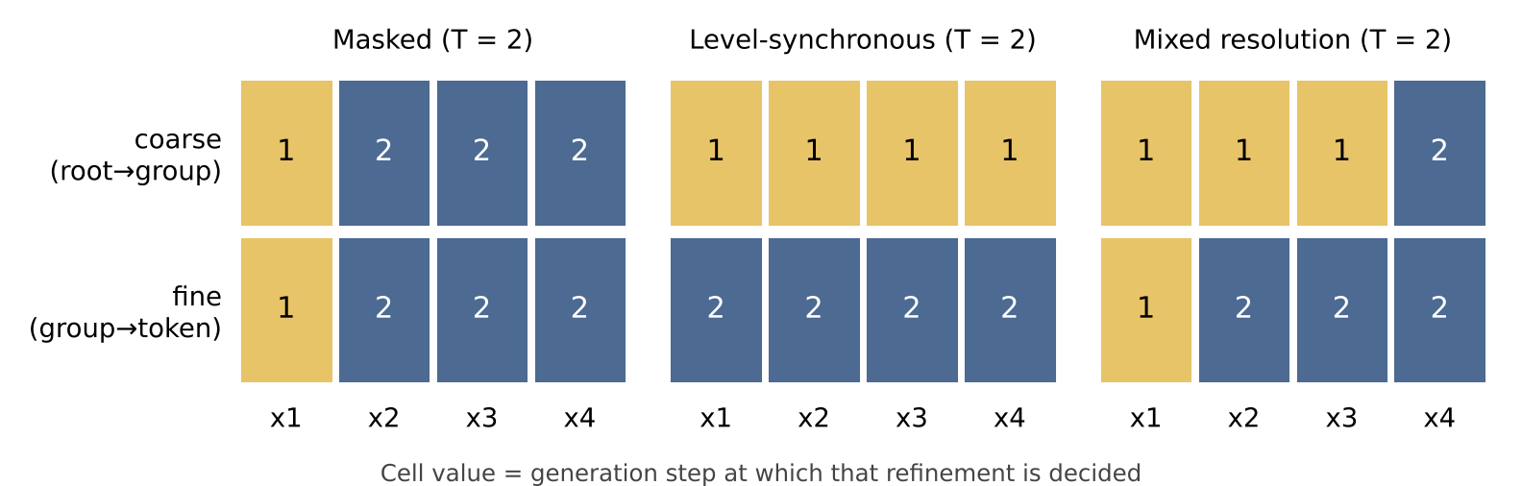
Figure 1. Three schedules for L = 4, K = 2 and T = 2. Each column is a position, the upper cell its root-to-group refinement and the lower cell its group-to-token refinement. The mixed schedule is the optimum found for the parity language in Section 7.
Definition 3 (Factorised reverse model). A reverse model gives, for each step t, a kernel q_{t}(S_{t} | S_{t−1}) that copies unrefined positions and draws refined positions independently: q_{t}(S_{t} | S_{t−1}) = Π_{i} q_{t,i}(S_{t,i} | S_{t−1}), the product taken over i ∈ U_{t}, where S_{t,i} ranges over the descendants of S_{t−1,i} at level κ_{i}(t). The generated law is q(x) = Π_{t} q_{t}(S_{t}(x) | S_{t−1}(x)).
Proposition 2 (Masked diffusion is the endpoint case). Under a masked schedule, every undecided position carries the code R_{K}(x_{i}) = b whatever its token, and every decided position carries the one-hot code of its token. The state therefore reveals exactly the set of decided positions and their tokens, as the absorbing state of masked diffusion does, and the reverse model of Definition 3 is a fixed-order masked denoiser. This holds for every hierarchy.
Proof. Proposition 1(vii) gives R_{K}(j) = b for all j, and level 0 gives one-hot codes. A masked schedule never visits intermediate levels, so states and kernels coincide with those of fixed-order absorbing diffusion with the mask replaced by the constant code b ∎
Stochastic masked diffusion randomises the order and the noise level and therefore optimises an evidence lower bound. A deterministic schedule has no such gap, as the next theorem shows. For single-position steps this is the order-fixed case of autoregressive diffusion (Hoogeboom et al., 2022).
Theorem 1 (Exact likelihood and the factorisation gap). For every deterministic schedule and every reverse model of Definition 3, q is a probability law on V^{L} and q(x) is computed exactly by one pass along the schedule. Moreover H(X) = Σ_{t} H(S_{t} | S_{t−1}), and
E_{p}[−log q(X)] = H(X) + KL(p ‖ q) ≥ H(X) + Γ(σ), Γ(σ) = Σ_{t} TC_{t}, (2)
TC_{t} = Σ_{i ∈ U(t)} H(S_{t,i} | S_{t−1}) − H(S_{t} | S_{t−1}) ≥ 0, (3)
with equality if and only if each q_{t,i} equals the conditional marginal p(S_{t,i} | S_{t−1}) on states reached by p. Hence the minimum of KL(p ‖ q) over factorised reverse models is exactly Γ(σ).
Proof. Each x determines its path S₀, …, S_{T}, and each path ends at a distinct x, so the generative path law and q coincide; summing the product of kernels over paths gives one. Because S_{t−1} is a function of S_{t} and S_{T} = X, the chain rule gives H(X) = Σ_{t} H(S_{t} | S_{t−1}) and log p(x) = Σ_{t} log p(S_{t} | S_{t−1}). For the cross-entropy, E_{p}[−log q(X)] = Σ_{t} Σ_{i} E_{p}[−log q_{t,i}(S_{t,i} | S_{t−1})], with i ranging over U_{t}, and Gibbs’ inequality bounds each term below by H(S_{t,i} | S_{t−1}), with equality exactly for the true conditional marginal. Subtracting H(X) gives the gap. Each TC_{t} is an average of conditional total correlations, hence nonnegative ∎
Γ(σ) is the irreducible error of parallel decoding along σ: it remains after perfect learning of every conditional marginal. It is zero if each step refines conditionally independent cells, in particular if each step refines one position. The question for this paper is how Γ depends on the schedule when T is small.

4 Schedule geometry
Let G★_{res}(T) and G★_{mask}(T) be the minima of Γ(σ) over all schedules and over masked schedules with at most T steps.
Theorem 2 (Inclusion). G★_{res}(T) ≤ G★_{mask}(T) for every T, and both are zero when T ≥ L.
Proof. Masked schedules are schedules. With T ≥ L, the masked schedule that decides one position per step has |U_{t}| ≤ 1, so every TC_{t} vanishes ∎
Inclusion alone does not say whether the larger family ever helps. The next construction shows that it can, by an amount that does not vanish.
Proposition 3 (Strict separation). Let K = 2 with N₁ = B blocks of B tokens each, write x_{i} = (a_{i}, f_{i}) for block and within-block index, and let L = 3. Draw a₁, a₂, a₃ independently and uniformly, and set f_{i} = Σ_{j≠i} a_{j} mod B. Then G★_{res}(2) = 0 while G★_{mask}(2) = log B.
Proof. Resolution. Refine all positions to their blocks at step 1 and all blocks to tokens at step 2. The blocks are independent, so TC₁ = 0; the tokens are determined by the blocks, so TC₂ = 0. Masked. A two-step masked schedule either decides all three tokens in one step or decides one or two at step 1. Each token has entropy 2 log B, and the triple has entropy 3 log B, so one-shot decoding costs 3 log B. If step 1 decides x_{i} alone, step 2 decides x_{j} and x_{k} given x_{i}: a_{j} is uniform and determines a_{k} = f_{i} − a_{j}, f_{j} and f_{k}, so the pair has conditional entropy log B while each member has conditional entropy log B, giving TC = log B. If step 1 decides x_{i} and x_{j}, the map (a_{i}, a_{j}, a_{k}) ↦ (x_{i}, x_{j}) is injective, so the pair has entropy 3 log B against 2 log B for each member, giving TC = log B, and step 2 decides one position at no cost. The minimum is log B ∎
The resolution schedule wins because the fine digit of each position is determined by the coarse digits of the others. The next result turns that observation into an identity for the level-synchronous schedule.
Definition 4 (Cross-resolution information). For a hierarchy h and data law p,
CRI(h) = Σ_{k=1}^{K} Σ_{i=1}^{L} I(G_{k−1,i} ; G_{k,−i} | G_{k,i}), (4)
the information that the level-k labels of the other positions carry about the next refinement of position i, beyond its own level-k label.
Theorem 3 (Level-synchronous decomposition). For the level-synchronous schedule σ_{LS},
Γ(σ_{LS}) = TC(X) − CRI(h), TC(X) = Σ_{i} H(X_{i}) − H(X). (5)
Consequently Γ(σ_{LS}) ≤ TC(X), the one-step gap, with equality if and only if CRI(h) = 0.
Proof. Along σ_{LS}, step t refines G_{K−t+1} to G_{K−t}, so Γ(σ_{LS}) = Σ_{k} [Σ_{i} H(G_{k−1,i} | G_{k}) − H(G_{k−1} | G_{k})]. The chain rule along the hierarchy gives H(X) = Σ_{k} H(G_{k−1} | G_{k}) and, for each position, H(X_{i}) = Σ_{k} H(G_{k−1,i} | G_{k,i}). Subtracting, TC(X) − Γ(σ_{LS}) = Σ_{k} Σ_{i} [H(G_{k−1,i} | G_{k,i}) − H(G_{k−1,i} | G_{k})], and each bracket is the conditional mutual information in Definition 4 ∎
Theorem 3 makes two cautions exact. Level-synchronous refinement is not a substitute for spreading decisions over positions: a language in which every position copies the first has CRI = 0 under every hierarchy, so its level-synchronous gap equals its one-shot gap, while a two-step masked schedule has zero gap. And CRI depends on the hierarchy, not only on the language, so the same text can make level-synchronous decoding useful or useless.
Theorem 4 (No gain under local refinement independence). Fix a level m. Suppose that for every position i the token X_{i} is conditionally independent of X_{−i} given G_{m,i}. Then every schedule σ has a schedule σ′ with no more steps and Γ(σ′) = Γ(σ), in which each position is refined from level m to level 0 in the same step at which it reaches level m. In particular, if K = 2 and m = 1, then G★_{res}(T) = G★_{mask}(T) for every T.
Proof. Fix position i and let F be one part of its refinement below level m, decided at some step t, with F′ the parts of that refinement decided earlier. When F is decided, G_{m,i} is already in the state or is decided in the same step. The hypothesis gives (F, F′) ⊥ X_{−i} | G_{m,i}, so for any W that is a function of X_{−i}, H(F | G_{m,i}, F′, W) = H(F | G_{m,i}, F′). Hence F adds the same term H(F | G_{m,i}, F′) to the joint entropy H(S_{t} | S_{t−1}) and to the marginal entropy of position i at step t, and these cancel in TC_{t}. For the same reason, whether F is in a conditioning state changes no conditional entropy of another position. Moving every part of the refinement of i below level m to the step at which i reaches level m therefore leaves every TC_{t} unchanged; steps can only become empty. For K = 2 and m = 1, the resulting schedule decides each token in one step, so it is masked ∎
Theorem 4 is the formal content of an uncomfortable observation from Section 7. When a coarse class is a sufficient summary of a token for everything else in the sequence, as for the topic of a hidden-Markov emission, splitting the token into coarse and fine decisions gives the parallel decoder nothing to exploit. Resolution helps only when the fine choice at one position is evidence about, or is evidenced by, the coarse choices elsewhere. The hypothesis is sufficient but not necessary; Section 7 reports languages that violate it and still show no gain.

5 Support and precision in the reverse sampler
The reverse model outputs, for each refined cell, a distribution over its children. Vocabucapillary keeps such distributions sparse and stores them at finite precision (Ghosh, 2026c). Let q̃ be the reverse model obtained from q by keeping the s largest child probabilities of each refined cell, renormalising, and rounding to integer counts summing to J by the largest-remainder rule. Let η_{t,i}(S) be the probability mass discarded by truncation in cell i at state S.
Theorem 5 (Sampler error from support and precision). For every deterministic schedule,
TV(q, q̃) ≤ Σ_{t} E_{q} Σ_{i ∈ U(t)} TV(q_{t,i}, q̃_{t,i}) ≤ Σ_{t} E_{q} Σ_{i ∈ U(t)} min{1, η_{t,i} + s_{t,i} / (2J)}, (6)
where E_{q} averages over S_{t−1} drawn from q, both kernels are evaluated at that state, and s_{t,i} is the number of children retained. Without truncation the bound is Σ_{t} E_{q} Σ_{i} min{1, w_{t,i} / (2J)}, with w_{t,i} the number of children.
Proof. Let R_{t} be the hybrid chain that uses q for the first t transitions and q̃ afterwards. R_{t} and R_{t−1} share the first t − 1 transitions and the transitions after step t, so by data processing TV(R_{t}, R_{t−1}) is at most the expected kernel distance at step t under q. Telescoping from R_{T} = q to R₀ = q̃ gives the first inequality, because the generated law and the path law coincide (Theorem 1). Total variation of a product is at most the sum over factors, and each factor obeys the joint support-and-precision bound of Ghosh (2026c, Theorem 2) ∎
Corollary 5.1 (Branching width replaces vocabulary size). With b-bit counts (J = 2^{b} − 1) and no truncation, a masked step that reveals a position contributes up to min{1, N/(2J)}, whereas a hierarchy with branching B and N = B^{K} refines the same position through K cells contributing at most min{K, KB/(2J)} in total. For N = 32768, B = 32, K = 3 and b = 8, the masked term saturates at 1 (raw value 64.3) while the resolution total is 0.188.
This is a worst-case bound on the effect of stored precision, not a statement about learned distributions, and truncation can make a sampler assign zero probability to data sequences, which makes likelihood infinite while total variation stays bounded. The practical reading is narrower: a reverse step that chooses among B children can be stored and sampled at much lower precision than one that chooses among N tokens.

6 The denoiser read in coefficient memory
A Vocabucapillary denoiser can read the current state through bounded coefficient memory rather than attention over all positions (Ghosh, 2026a; 2026b). At a uniform level k every position carries a coarse atom, so the memory has few occupied rows.
Proposition 6 (Histogram sufficiency of a uniform-level read). Suppose every position is at level k, and the key response φ_{g}(q) and value u_{g} of position i depend only on its block g(i) = z_{i}. Let n_{g} be the number of positions in block g. Then
o(q) = Σ_{i} φ_{g(i)}(q) u_{g(i)} / Σ_{i} φ_{g(i)}(q) = Σ_{g} n_{g} φ_{g}(q) u_{g} / Σ_{g} n_{g} φ_{g}(q), (7)
so the read uses at most min(L, N_{k}) occupied rows and is invariant to permutations of the positions.
Proof. Group the terms of numerator and denominator by block ∎
Invariance is a limitation as much as a saving: a code-determined read cannot tell where a block occurs. A denoiser therefore needs a positional channel, for instance local windows or position-dependent values, whose compatibility with aggregation is discussed in Ghosh (2026b). Proposition 6 is offered as the coarse global summary inside such a block, not as a complete denoiser.
Algorithm 1 (Vocabucapillary text-diffusion sampler). Inputs: hierarchy h, schedule σ, reverse model q, support cap s and precision J.
- Set every position to the root state; its code is the prior b and its decoded state is d̄_{V}.
- For t = 1, …, T: form the decoded state of every position, the coarse atom of its current block; read context through local windows and the coefficient memory of Proposition 6; for each i ∈ U_{t}, compute the child distribution, keep its s largest entries, round to J counts and sample.
- Replace each refined label by its sampled child, advancing κ_{i} by the number of refinements scheduled at step t.
- After step T every position is at level 0; return the tokens. Report Γ(σ) estimates, and the bound of Theorem 5 for the chosen s and J.

7 Numerical study

7.1 Setting
All computations were performed in immutable C# on .NET 10 (records, ImmutableArray, pure static functions; arrays appear only as accumulators local to a pure function). The vocabulary has N = 16 tokens with either a quaternary hierarchy (root, 4 blocks of 4 tokens, K = 2) or a binary hierarchy (K = 4). For each language, the exact law over all 16^{L} sequences is enumerated for L ≤ 5. Entropies of every view (a per-position level vector) are tabulated once, which makes Γ(σ) exact and cheap for every schedule. Optimal gaps are found by exhaustive search over all admissible schedules with at most T steps. Reverse models are Bayes-optimal conditional marginals, so every reported gap is the irreducible parallel-decoding error, not learning error. Figures were drawn in Python from the C# output files.
Five languages were used. Copy: every token repeats the first. Parity: the construction of Proposition 3 with B = 4, extended to L positions. TopicHMM: a sticky hidden chain over four topics (stay probability 0.85), with the token’s block equal to the topic and its within-block index drawn from a topic-specific law; it satisfies Theorem 4 with m = 1 under the true hierarchy. Agreement: independent blocks, and a within-block index tied to a shared latent feature with probability 0.85. TwoLevelChain: a Markov chain in which block and within-block index each persist with probability 0.7.

7.2 Identities
With a random 8 × 16 dictionary and the TopicHMM unigram prior, the decoding identity of Proposition 1(ii) held to 1.1 × 10⁻¹⁶, the total-variation identity (iii) to 2.2 × 10⁻¹⁶ and the mixture identity (v) to 2.8 × 10⁻¹⁷. The decoded-error bound (iv) had no violations, the number of distinct codes per level equalled the number of blocks (16, 4, 1), and the root code equalled the prior for every token to 2.0 × 10⁻¹⁴. For Theorem 1, the exact law of the Bayes factorised sampler was computed over all 16⁴ sequences. KL(p ‖ q) matched Γ(σ) to 2.1 × 10⁻¹² (TopicHMM, level-synchronous, Γ = 3.457 bits), 1.2 × 10⁻¹¹ and 1.4 × 10⁻¹¹ (TwoLevelChain, quaternary and binary hierarchies, Γ = 3.859 bits), and exactly (Parity, a masked two-step schedule, Γ = 4 bits). The sampler’s mass summed to one within 10⁻¹² in every case.

7.3 Schedules at equal step count
Table 1. Exact optimal factorisation gap (bits) with T steps, quaternary hierarchy (K = 2). Level-synchronous decoding has T = K = 2. Gain is masked optimum minus resolution optimum.
Language | L | H(X) | T | Masked optimum | Level-sync | Resolution optimum | Gain
Copy | 4 | 3.692 | 2 | 0.0000 | 11.0786 | 0.0000 | 0
Copy | 4 | 3.692 | 3 | 0.0000 | – | 0.0000 | 0
Parity | 3 | 6.000 | 2 | 2.0000 | 0.0000 | 0.0000 | 2.0000
Parity | 3 | 6.000 | 3 | 0.0000 | – | 0.0000 | 0
Parity | 4 | 8.000 | 2 | 2.0000 | 0.0000 | 0.0000 | 2.0000
Parity | 4 | 8.000 | 3 | 0.0000 | – | 0.0000 | 0
Parity | 5 | 10.000 | 2 | 2.0000 | 0.0000 | 0.0000 | 2.0000
Parity | 5 | 10.000 | 3 | 0.0000 | – | 0.0000 | 0
TopicHMM | 4 | 10.946 | 2 | 0.4218 | 3.4572 | 0.4218 | 0
TopicHMM | 4 | 10.946 | 3 | 0.0000 | – | 0.0000 | 0
TopicHMM | 5 | 13.395 | 2 | 0.6359 | 4.6097 | 0.6359 | 0
TopicHMM | 5 | 13.395 | 3 | 0.0000 | – | 0.0000 | 0
Agreement | 4 | 12.078 | 2 | 0.5110 | 3.3077 | 0.5110 | 0
Agreement | 4 | 12.078 | 3 | 0.1176 | – | 0.1176 | 0
Agreement | 5 | 14.639 | 2 | 0.8633 | 4.5923 | 0.8633 | 0
Agreement | 5 | 14.639 | 3 | 0.2348 | – | 0.2348 | 0
TwoLevelChain | 4 | 12.140 | 2 | 0.4807 | 3.8593 | 0.4807 | 0
TwoLevelChain | 4 | 12.140 | 3 | 0.0000 | – | 0.0000 | 0
TwoLevelChain | 5 | 14.854 | 2 | 0.4807 | 5.1458 | 0.4807 | 0
TwoLevelChain | 5 | 14.854 | 3 | 0.0000 | – | 0.0000 | 0

Table 1 and Figure 2 show three regimes. Parity separates the families strictly: the masked optimum at T = 2 is 2 bits (log₂ 4) for L = 3, 4 and 5, and the resolution optimum is zero; the L = 3 case is Proposition 3, while L = 4 and 5 are computed rather than proved. Copy shows the reverse risk: level-synchronous decoding costs 11.08 bits, equal to the one-shot gap, while two masked steps cost nothing. On TopicHMM, Agreement and TwoLevelChain the resolution optimum equals the masked optimum at every T and L tested; the optimal schedules returned by the search are masked. TopicHMM is covered by Theorem 4. Agreement and TwoLevelChain violate its hypothesis yet show no gain, so the hypothesis is not necessary. The binary hierarchy on TwoLevelChain (K = 4) gave the same optima as the quaternary one at T = 1 to 4.
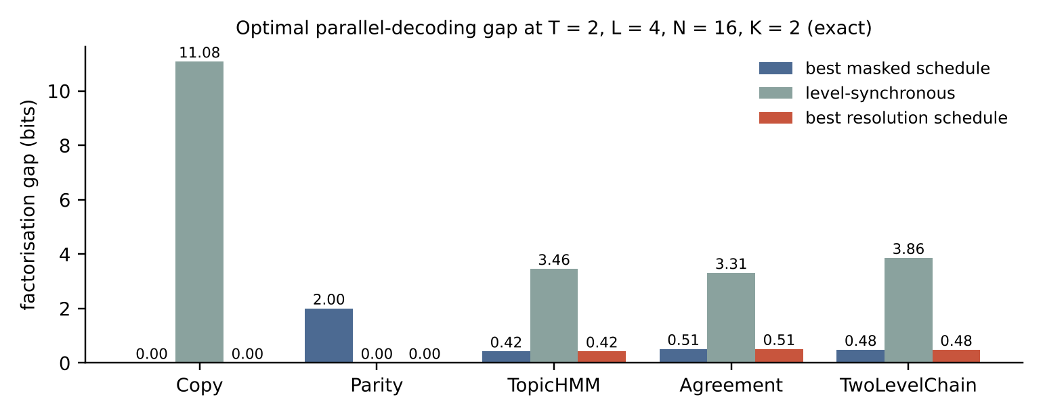
Figure 2. Exact optimal gaps at two steps for L = 4. The red and blue bars coincide on the three structured languages.

7.4 Cross-resolution information and the choice of hierarchy
Table 2. Theorem 3 across hierarchies (L = 4, K = 2, bits). “Brown” is exact agglomerative clustering maximising adjacent class mutual information; “random” are uniformly random partitions into four blocks of four. The identity TC − CRI = level-sync held to 2 × 10⁻¹² in every row.
Language | Hierarchy | TC(X) | Level-sync | CRI | Resolution opt. T=2 | Masked opt. T=2
TopicHMM | true | 3.4572 | 3.4572 | 0.0000 | 0.4218 | 0.4218
TopicHMM | brown | 3.4572 | 3.4572 | 0.0000 | 0.4218 | 0.4218
TopicHMM | random0 | 3.4572 | 1.6002 | 1.8570 | 0.4218 | 0.4218
TopicHMM | random1 | 3.4572 | 2.4191 | 1.0382 | 0.4218 | 0.4218
Agreement | true | 3.3077 | 3.3077 | 0.0000 | 0.5110 | 0.5110
Agreement | brown | 3.3077 | 3.3077 | 0.0000 | 0.5110 | 0.5110
Agreement | random0 | 3.3077 | 2.2669 | 1.0408 | 0.5110 | 0.5110
Agreement | random1 | 3.3077 | 1.9740 | 1.3337 | 0.5110 | 0.5110
TwoLevelChain | true | 3.8593 | 3.8593 | 0.0000 | 0.4807 | 0.4807
TwoLevelChain | brown | 3.8593 | 3.6624 | 0.1969 | 0.4807 | 0.4807
TwoLevelChain | random0 | 3.8593 | 3.5645 | 0.2948 | 0.4807 | 0.4807
TwoLevelChain | random1 | 3.8593 | 3.5579 | 0.3015 | 0.4807 | 0.4807
Parity | true | 8.0000 | 0.0000 | 8.0000 | 0.0000 | 2.0000
Parity | brown | 8.0000 | 8.0000 | 0.0000 | 2.0000 | 2.0000
Parity | random0 | 8.0000 | 3.3835 | 4.6165 | 2.0000 | 2.0000
Parity | random1 | 8.0000 | 3.9195 | 4.0805 | 1.8750 | 2.0000
Copy | true | 11.0786 | 11.0786 | 0.0000 | 0.0000 | 0.0000
Copy | brown | 11.0786 | 11.0786 | 0.0000 | 0.0000 | 0.0000
Copy | random0 | 11.0786 | 11.0786 | 0.0000 | 0.0000 | 0.0000
Copy | random1 | 11.0786 | 11.0786 | 0.0000 | 0.0000 | 0.0000

The hierarchy that looks natural is the worst for level-synchronous decoding. Brown-style clustering recovered the four topics of TopicHMM and the four persistence classes of TwoLevelChain exactly, and for Agreement it grouped tokens by the shared feature rather than by block. In each case CRI was zero and the level-synchronous gap equalled TC(X). Random partitions leak topic information into the fine level and have positive CRI, which lowers the level-synchronous gap: for TopicHMM from 3.457 to between 1.600 and 2.419 bits. For Parity, the true hierarchy has CRI = 8 bits and zero level-synchronous gap, whereas Brown clustering chose a hierarchy with CRI = 0. The optimal schedule gap at T = 2 did not depend on the hierarchy for the three structured languages, since their optima are masked; for Parity under one random hierarchy it fell slightly below the masked optimum (1.875 versus 2 bits).
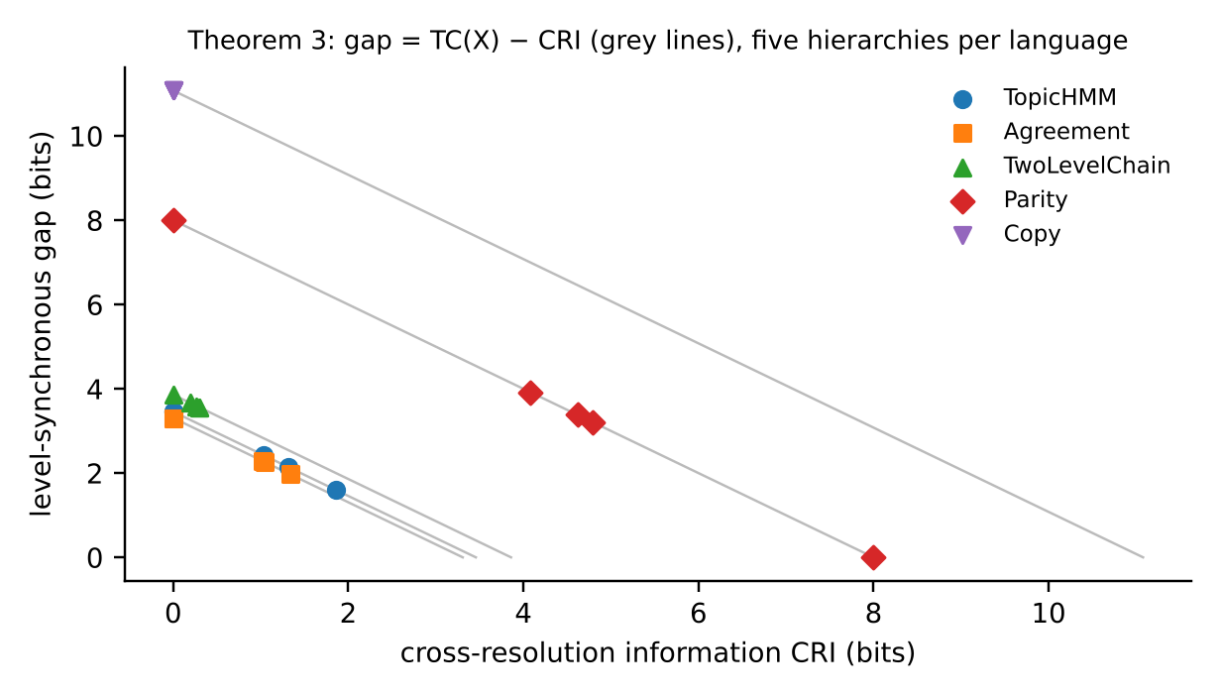
Figure 3. Level-synchronous gap against CRI. Every point lies on the line TC(X) − CRI of its language (Theorem 3).

7.5 How often does resolution help?
To test generality beyond hand-built languages, we drew random pairwise models over the block and within-block digits of L = 4 positions, with Gaussian unary terms on each token, block–block and index–index couplings of scale 1, and cross couplings between the block of one position and the index of another at scale λ_{cross}. Forty models were drawn per setting.
Table 3. Gain of the optimal resolution schedule over the optimal masked schedule (bits) on random pairwise models, 40 models per row.
λ_{cross} | T | Mean gain | Fraction with gain | Max gain | Mean masked opt. | Mean gain / masked | Mean CRI | corr(gain, CRI)
0 | 2 | 0.0296 | 0.425 | 0.1998 | 0.5167 | 5.7% | 0.0898 | 0.44
0 | 3 | 0.0188 | 0.650 | 0.0984 | 0.1208 | 15.5% | 0.0898 | 0.28
0.5 | 2 | 0.0345 | 0.425 | 0.3753 | 0.5598 | 6.2% | 0.6463 | 0.56
0.5 | 3 | 0.0105 | 0.475 | 0.0483 | 0.1199 | 8.8% | 0.6463 | 0.09
1 | 2 | 0.0357 | 0.500 | 0.2225 | 0.5720 | 6.2% | 1.3353 | 0.23
1 | 3 | 0.0067 | 0.400 | 0.0526 | 0.1018 | 6.6% | 1.3353 | 0.03
2 | 2 | 0.0388 | 0.450 | 0.3148 | 0.3599 | 10.8% | 1.6092 | 0.23
2 | 3 | 0.0055 | 0.425 | 0.0718 | 0.0407 | 13.4% | 1.6092 | 0.17
4 | 2 | 0.0055 | 0.350 | 0.1013 | 0.0812 | 6.7% | 0.7860 | 0.14
4 | 3 | 0.0011 | 0.525 | 0.0192 | 0.0034 | 31.7% | 0.7860 | 0.16

Resolution scheduling helped in 35% to 65% of models, but the mean gain at T = 2 stayed between 5.7% and 10.8% of the masked gap, and the largest single gain was 0.375 bits. Even without explicit cross couplings, gains occurred, because the unary term on each token couples its own block and index, so the two digit processes are not independent. CRI correlated only weakly or moderately with the gain (0.03 to 0.56). Theorem 3 makes CRI an exact predictor of the level-synchronous gap, but it is not a good predictor of what an optimised schedule can achieve.

7.6 Support and precision
Table 4. Exact sequence-level total variation between the Bayes sampler and its compressed version, with the two bounds of Theorem 5 (TopicHMM, L = 4). Width is the number of children per decision; s = width means no truncation.
Schedule | Width | s | J | TV exact | Hybrid bound | Closed bound
masked T=2 | 16 | 16 | 255 | 0.0201 | 0.0276 | 0.1255
masked T=2 | 16 | 16 | 15 | 0.3519 | 0.4438 | 2.1333
masked T=2 | 16 | 16 | 3 | 0.8677 | 1.6022 | 4.0000
masked T=2 | 16 | 8 | 255 | 0.3563 | 0.4106 | 0.4717
masked T=2 | 16 | 8 | 15 | 0.4484 | 0.5788 | 1.4757
masked T=2 | 16 | 1 | 255 | 0.9879 | 2.5260 | 2.5338
masked T=2 | 16 | 1 | 15 | 0.9879 | 2.5260 | 2.6593
levelsync K=2 | 4 | 4 | 255 | 0.0070 | 0.0196 | 0.0627
levelsync K=2 | 4 | 4 | 15 | 0.1204 | 0.3333 | 1.0667
levelsync K=2 | 4 | 4 | 3 | 0.8704 | 1.8000 | 5.3333
levelsync K=2 | 4 | 2 | 255 | 0.9744 | 2.8000 | 2.8314
levelsync K=2 | 4 | 2 | 15 | 0.9744 | 2.8000 | 3.3333
levelsync K=2 | 4 | 1 | 255 | 0.9996 | 4.8000 | 4.8157
levelsync K=2 | 4 | 1 | 15 | 0.9996 | 4.8000 | 5.0667
levelsync K=4 | 2 | 2 | 255 | 0.0050 | 0.0204 | 0.0627
levelsync K=4 | 2 | 2 | 15 | 0.0858 | 0.3467 | 1.0667
levelsync K=4 | 2 | 2 | 3 | 0.4458 | 1.9333 | 5.3333
levelsync K=4 | 2 | 1 | 255 | 0.9996 | 6.2000 | 6.2314
levelsync K=4 | 2 | 1 | 15 | 0.9996 | 6.2000 | 6.7333

The ordering exact ≤ hybrid ≤ closed held in all 24 configurations. Without truncation, narrower decisions tolerated lower precision: at 8-bit counts the sequence-level error was 0.0201 for the 16-way masked decoder, 0.0070 for the 4-way level-synchronous decoder and 0.0051 for the 2-way binary decoder, and at 4-bit counts 0.352, 0.120 and 0.086. These three decoders have different factorisation gaps, so the comparison isolates the precision effect only. Truncation was costly at every width, because the Bayes child distributions of this language are not sparse; halving the support pushed the error above 0.35 in every schedule.
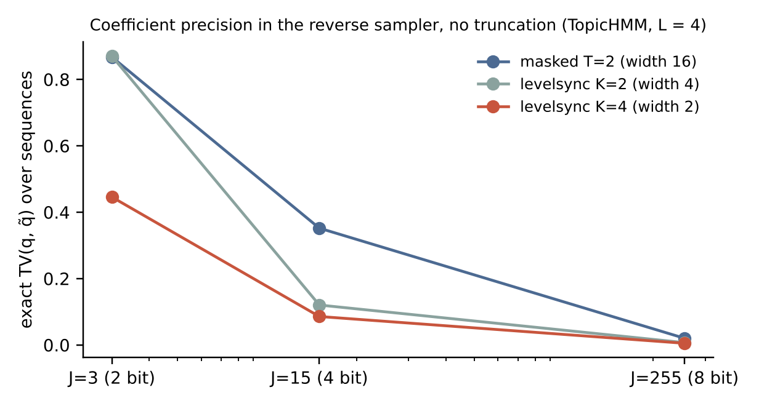
Figure 4. Exact error from coefficient precision alone, by branching width.

7.7 Coefficient-memory read
For 1 000 positions at level 1 with four blocks, the histogram read of Proposition 6 matched the full positional sum to 6.9 × 10⁻¹⁵ with 4 occupied rows, and permuting the sequence changed the read by 3.0 × 10⁻¹⁵, confirming both the saving and the positional blindness.

8 What resolution buys and what it does not
Replacing the mask by coefficient resolution changes three things, with different strengths of evidence.
Exactness. A deterministic resolution schedule has an exact likelihood and an exact decomposition of its parallel-decoding error (Theorem 1). This is a property of determinism, shared with fixed-order masked schedules, but the resolution family makes it available for coarse-to-fine generation, where stochastic constructions such as HDLM rely on bounds.
Schedule space. Resolution adds a second axis, levels, to the positions that masked diffusion schedules. Theorem 2 guarantees no loss at the optimum, and Proposition 3 shows real gains are possible. The study, however, found no gain on three structured languages and small average gains on random models. Theorem 3 identifies why level-synchronous decoding, the most obvious coarse-to-fine schedule, is often poor: its improvement over one-shot decoding is exactly CRI, and semantically natural hierarchies tend to drive CRI to zero by placing whatever carries dependence entirely at the coarse level. Two design rules follow. Coarse-to-fine schedules should still spread decisions over positions, as masked schedules do. And a hierarchy chosen for level-synchronous decoding should maximise CRI, not class coherence.
Decision width. Every reverse decision chooses among B children rather than N tokens. Theorem 5 and Table 4 show that this lowers the precision needed for stored coefficients. It also narrows each output head, which plausibly eases learning and lowers the cost of a softmax; neither effect was measured here.
Vocabucapillary contributes the semantics of the intermediate state. A partially resolved position is not a blank: it is a unit-mass code whose decoded state is the prior-weighted atom of its block (Proposition 1). The same object serves as denoiser input, as a coefficient-memory row (Proposition 6), and as the substrate for the support and precision guarantees of companion work.

9 Hypotheses and falsification gates
The study is exact but small and synthetic. The following hypotheses state what would have to hold for resolution diffusion to matter on natural text, each with a test that could refute it.
- H1 Cross-resolution information on text. With a vocabulary hierarchy learned from a corpus, plug-in estimates of CRI over local windows are positive and comparable to TC. Falsifier: estimated CRI is near zero for Brown or embedding hierarchies, as Section 7.4 suggests natural hierarchies may make it. Estimates must be corrected for the upward bias of plug-in mutual information on sparse counts.
- H2 Schedule gain at equal evaluations. A learned denoiser with a searched mixed schedule reaches lower validation negative log-likelihood than a masked schedule with the same number of network evaluations and parameters. Falsifier: the gain is within seed variation, consistent with the small gains of Table 3.
- H3 Width and learning. At fixed parameter count, B-way reverse heads have lower estimation error per refinement than N-way heads. Falsifier: the total cross-entropy over the K refinements of a position is no lower than one N-way decision.
- H4 Precision. Reverse samplers with B-way decisions retain generation quality at fewer coefficient bits than masked samplers, as Theorem 5 permits. Falsifier: measured quality degrades at the same bit width for both.
A negative result on H1 would not invalidate the theory; it would show, through Theorems 3 and 4, that coarse-to-fine refinement on that hierarchy cannot reduce parallel-decoding error, whatever else it offers.

10 Limitations
- All denoisers are Bayes-optimal conditional marginals computed from known laws. The study measures irreducible factorisation error and nothing about learnability, optimisation or generalisation.
- Vocabulary size 16 and length up to 5 permit exact enumeration and exhaustive schedule search; neither scales. Real vocabularies require estimated gaps and heuristic schedule search.
- The languages are synthetic. Natural text was not used, and no perplexity, generation-quality or speed claim is made.
- Schedules are deterministic. Randomised schedules, as in standard masked diffusion training, optimise a bound rather than the exact likelihood studied here.
- Theorem 4 is sufficient, not necessary. Proposition 3 is proved for L = 3; its extension to L = 4 and 5 is computed only.
- The memory read of Proposition 6 is positionally blind and is not a complete denoiser.

11 Conclusion
Coefficient resolution is a coherent replacement for the mask in text diffusion. It turns the noise variable into a Vocabucapillary code with an exact decoded meaning, gives deterministic schedules an exact likelihood, and exposes the parallel-decoding error as a sum of conditional total correlations over refinements made together. Resolution schedules contain masked ones and can beat them strictly, but only when fine choices at one position are tied to coarse choices at another. The level-synchronous form improves on one-shot decoding by exactly the cross-resolution information, and the natural hierarchies of our toy languages set that quantity to zero. Whether natural text carries enough cross-resolution information to reward coarse-to-fine diffusion is an empirical question that the gates of Section 9 can settle.

Appendix A Core C# routines
The complete program (Program.cs) accompanies this paper. The routines below compute the factorisation gap of Theorem 1 from the view-entropy table, the cross-resolution information of Definition 4 and the compressed child distribution of Theorem 5.
/// A deterministic schedule: Step[i][r] = step at which position i refines from level K-r to K-r-1.
public sealed record Schedule(ImmutableArray<ImmutableArray<int>> Step, int T)
{
public int Level(int i, int t, int K) => K - Step[i].Count(s => s <= t);
public ImmutableArray<int> Levels(int t, int K) =>
Enumerable.Range(0, Step.Length).Select(i => Level(i, t, K)).ToImmutableArray();
}

/// Theorem 1: Gamma(sigma) = sum_t [ sum_{i in U_t} H(S_t,i | S_t-1) - H(S_t | S_t-1) ].
public static GapResult Gap(EntTable e, Schedule s, int K)
{
var per = Enumerable.Range(1, s.T).Select(t =>
{
var prev = s.Levels(t - 1, K); var cur = s.Levels(t, K);
double hPrev = e.H[ViewCode(prev, K)];
double joint = e.H[ViewCode(cur, K)] - hPrev;
double marg = Enumerable.Range(0, e.L).Where(i => cur[i] < prev[i])
.Sum(i => e.H[ViewCode(prev.SetItem(i, cur[i]), K)] - hPrev);
return marg - joint;
}).ToImmutableArray();
return new GapResult(per.Sum(), per);
}

/// Definition 4: CRI = sum_k sum_i I(G_{k-1,i}; G_{k,-i} | G_{k,i}).
public static double Cri(EntTable e, int L, int K) =>
(from k in Enumerable.Range(1, K) from i in Enumerable.Range(0, L)
let own = e.H[ViewCode(Enumerable.Range(0, L).Select(j => j == i ? k - 1 : K), K)]
- e.H[ViewCode(Enumerable.Range(0, L).Select(j => j == i ? k : K), K)]
let all = e.H[ViewCode(Enumerable.Range(0, L).Select(j => j == i ? k - 1 : k), K)]
- e.H[ViewCode(Enumerable.Repeat(k, L), K)]
select own - all).Sum();

/// Theorem 5: top-s truncation, renormalisation, largest-remainder rounding to J counts.
public static ImmutableDictionary<int, double> Compress(
ImmutableArray<int> children, ImmutableDictionary<int, double> p, int s, int J)
{
var kept = children.Select(c => (c, v: p.GetValueOrDefault(c)))
.OrderByDescending(z => z.v).ThenBy(z => z.c).Take(s).ToImmutableArray();
double mass = kept.Sum(z => z.v);
var cond = kept.Select(z => (z.c, v: mass > 0 ? z.v / mass : 1.0 / kept.Length));
var floor = cond.Select(z => (z.c, n: (int)Math.Floor(J * z.v), fr: J * z.v - Math.Floor(J * z.v)))
.ToImmutableArray();
var bonus = floor.OrderByDescending(z => z.fr).ThenBy(z => z.c)
.Take(J - floor.Sum(z => z.n)).Select(z => z.c).ToImmutableHashSet();
return floor.ToImmutableDictionary(z => z.c, z => (z.n + (bonus.Contains(z.c) ? 1 : 0)) / (double)J);
}

Entropies of all (K + 1)^{L} views are computed once per language and hierarchy by grouping the exact law by view labels; every schedule evaluation thereafter is a table lookup, which makes exhaustive search over all schedules feasible for the sizes used.

References
Austin, J., Johnson, D. D., Ho, J., Tarlow, D., & van den Berg, R. (2021). Structured denoising diffusion models in discrete state-spaces. Advances in Neural Information Processing Systems, 34. https://arxiv.org/abs/2107.03006
Brown, P. F., Della Pietra, V. J., deSouza, P. V., Lai, J. C., & Mercer, R. L. (1992). Class-based n-gram models of natural language. Computational Linguistics, 18(4), 467–479.
Ghosh, D. P. (2026a). KV Coefficient Memory for Attentionlet [Preprint]. ResearchGate. https://doi.org/10.13140/RG.2.2.31586.70088
Ghosh, D. P. (2026b). Vocabucapillary for Cacheless Transformer [Preprint]. ResearchGate. https://doi.org/10.13140/RG.2.2.36209.44648
Ghosh, D. P. (2026c). Vocabuquantization for memory efficient Vocabucapillary language models [Preprint]. ResearchGate. https://doi.org/10.13140/RG.2.2.21571.98085
Ghosh, D. P. (2026d). Vocabucapillary memory for cacheless transformers and evidence guided AI [Preprint]. ResearchGate. https://doi.org/10.13140/RG.2.2.20759.33449
Ghosh, D. P. (2026e). Interpreting large language models through Vocabucapillary coefficient trajectories [Preprint]. ResearchGate. https://doi.org/10.13140/RG.2.2.27994.50884
Ghosh, D. P. (2026f). Sparse backpropagation and progressive capacity in Vocabucapillary language models [Preprint]. ResearchGate. https://doi.org/10.13140/RG.2.2.17692.24960
Ghosh, D. P. (2026g). Resolution adaptive MAML with Vocabucapillary memory [Preprint]. ResearchGate. https://doi.org/10.13140/RG.2.2.20418.54723
Ghosh, D. P. (2026h). Probabilistic Vocabucapillary for efficient meta learning [Preprint]. ResearchGate. https://doi.org/10.13140/RG.2.2.27011.46889
Ghosh, D. P. (2026i). Multimodal explainability through Vocabucapillary [Preprint]. ResearchGate. https://doi.org/10.13140/RG.2.2.34561.21608
Ghosh, D. P. (2026j). Efficient Shapley explanations for multimodal Vocabucapillary [Preprint]. ResearchGate. https://doi.org/10.13140/RG.2.2.16106.27841
Hoogeboom, E., Gritsenko, A. A., Bastings, J., Poole, B., van den Berg, R., & Salimans, T. (2022). Autoregressive diffusion models. International Conference on Learning Representations. https://arxiv.org/abs/2110.02037
Liu, A., Broadrick, O., Niepert, M., & Van den Broeck, G. (2025). Discrete copula diffusion. International Conference on Learning Representations. https://arxiv.org/abs/2410.01949
Lou, A., Meng, C., & Ermon, S. (2024). Discrete diffusion modeling by estimating the ratios of the data distribution. Proceedings of the 41st International Conference on Machine Learning. https://arxiv.org/abs/2310.16834
Nie, S., Zhu, F., You, Z., Zhang, X., Ou, J., Hu, J., Zhou, J., Lin, Y., Wen, J.-R., & Li, C. (2025). Large language diffusion models. Advances in Neural Information Processing Systems, 38. https://arxiv.org/abs/2502.09992
Sahoo, S. S., Arriola, M., Schiff, Y., Gokaslan, A., Marroquin, E., Chiu, J. T., Rush, A., & Kuleshov, V. (2024). Simple and effective masked diffusion language models. Advances in Neural Information Processing Systems, 37. https://arxiv.org/abs/2406.07524
Shi, J., Han, K., Wang, Z., Doucet, A., & Titsias, M. K. (2024). Simplified and generalized masked diffusion for discrete data. Advances in Neural Information Processing Systems, 37. https://arxiv.org/abs/2406.04329
Zhou, C., Wang, C., Zhang, D., Tong, S., Wang, Y., Bates, S., & Jaakkola, T. (2025). Next semantic scale prediction via hierarchical diffusion language models. Advances in Neural Information Processing Systems, 38. https://arxiv.org/abs/2510.08632

