Caches, Temperature and Reuse
Improving Autoregressive Diffusion Evolution: Z as a Density Cache, the Noise Term σₜw as a Mutation Temperature, and Evaluation-Efficient Reuse of f(x)
Debi Prasad Ghosh
Founder and Principal Engineer, Debias Parametric Guru, Kolkata, India
12 October 2026 · Mathematical research manuscript

Abstract
Autoregressive Diffusion Evolution (AR-DE; Ghosh, 2026f) generates candidate solutions one token at a time; each token descends through the diffusion steps as through the layers of a decoder, attending at each layer to a per-layer cache of earlier states and evaluating the fitness f once per layer. This conceptual paper asks three questions about improving it, and answers each with a definition, a proposition and a controlled test on the Himmelblau landscape (ten seeds).
Can Z be a cache, like f(x)? Not for the query being generated — its normaliser depends on the query — but yes for every state already in the cache. Each entry can carry U_j = Σₖ N(c_j; √αₜ c_k, 1 − αₜ), the unweighted Z evaluated at that entry, and U_j can be maintained exactly by a running sum because its query point is fixed. The incremental and batch values agree to 1.2 × 10⁻¹⁵ (Python) and exactly (C#). This Z-cache costs one extra number per entry and gives the population density at every cached point. As a density correction of the weights its effect here is within noise; as a novelty signal it is what makes fitness reuse work.
Is σₜw a temperature for diversity? Yes, but not monotonically. With η = 0 (no fresh noise) consecutive tokens become a deterministic orbit and the run collapses (spread 0.012, no token near an optimum). Between η = 0.5 and 1.4 performance is similar; diversity peaks at η = 1. The DDIM step conserves the total spread and η only chooses its source — a token’s own inherited direction or fresh noise — so the noise term is above all the source of independence between successive tokens.
If f is costly, how can f(x) be reused? By separating the two roles of an intermediate state: its position is needed in the cache for exploration, its fitness is not needed exactly. Giving intermediate states a surrogate fitness read from the archive of true evaluations, and evaluating truly only when the Z-cache says the state is in a sparsely sampled region, matches every-state evaluation at half the evaluations (794 vs 1,600) and gives a better best point at every budget when the saved evaluations are spent on more tokens: at 400 evaluations the regret of the best point is 0.044 with surrogates against 0.260 with every state evaluated.

Keywords: Diffusion Evolution; autoregression; KV cache; density estimation; surrogate-assisted evolution; mutation temperature; evaluation efficiency.

1. Introduction
The previous paper in this series (Ghosh, 2026f) interchanged the two loops of Algorithm 1 of Diffusion Evolution (Zhang, Hartl, Hazan & Levin, 2025) to obtain AR-DE: a prompt of N₀ evaluated candidates fills a per-layer cache; each new token passes down through layers t = T, …, 1, at each layer estimating its denoising target x̂₀ by attention over that layer’s cache, evaluating f at the state that entered the layer, and appending that state to the cache. Three findings from that paper set up this one: Z cannot be maintained as a running sum for the query; tokens improve only if the selection strength β rises over tokens; and the T evaluations per token are expensive but cannot simply be dropped, because the evaluated intermediate states are the algorithm’s exploration.
This paper explores three improvements suggested by those findings:
- Q1. Z as a second cache, alongside f(x) (Section 3).
- Q2. The noise term σₜw as a temperature that controls the diversity of the next token (Section 4).
- Q3. Reuse of f(x) when each evaluation is costly (Section 5).
It is a conceptual paper: each answer is a definition and a proposition, checked by a small controlled experiment rather than a benchmark campaign. The improved algorithm is assembled in Section 6, its cache requirements in Section 7, and the tests and open requirements in Section 8.

2. AR-DE in brief
At layer t the cache is C_t = {(c_j, F_j)}. Token k, currently at state x, computes
x̂₀ = Σⱼ softmaxⱼ( β_k F_j − ‖x − √αₜ c_j‖² / (2(1 − αₜ)) ) · c_j (1)
evaluates f(x), appends (x, f(x)) to C_t, and moves by the DDIM rule
x ← √αₜ₋₁ x̂₀ + √(1 − αₜ₋₁ − σₜ²) · ε̂ + σₜ w, ε̂ = (x − √αₜ x̂₀)/√(1 − αₜ), σₜ = η · σₜ^DDPM (2)
where η = 1 is the DDPM noise level used by Zhang et al. and η = 0 is deterministic DDIM. The normaliser of the softmax is the Z of line 5 of Algorithm 1.

3. Z as a cache

3.1 What Z is
Zhang et al. write Z = p(xₜ): the normaliser of x̂₀ is the estimated density of the noised population at the query, under the fitness-weighted prior. It therefore has a meaning of its own, beyond normalising. It is also, as shown in Ghosh (2026f, Proposition 1), a function of the query: no running sum can supply it for a new query except at the first layer, where the kernel stops depending on the key.

3.2 What can be cached
The obstacle is the moving query. For points that do not move — the states already in the cache — the density is a sum over cache entries with a fixed argument, and fixed-argument sums can be maintained incrementally. Define, for each entry j of layer t,
U_j = Σ_{k ∈ C_t} N(c_j; √αₜ c_k, 1 − αₜ) (unweighted, unnormalised Z at c_j) (3)
Proposition 1 (exact incremental Z-cache).
When a state x is appended to C_t, set U_j ← U_j + N(c_j; √αₜ x, 1 − αₜ) for every existing entry and U_x = Σ_{k ∈ C_t ∪ {x}} N(x; √αₜ c_k, 1 − αₜ) for the new one. After any sequence of appends, every U_j equals the batch sum over the current cache.
Proof. Each U_j is a sum of one term per cache entry; an append adds exactly one term to each existing sum and creates the new sum in full. ∎
Cost. The new entry’s U_x uses the same distances as the attention that produced x̂₀; the update of the others is one more pass over the layer, O(|C_t|·D). Memory: one number per entry, plus the layer’s count n_t, so that q̂_j = U_j/n_t is a density estimate.

Two forms of Z are deliberately not cached. The fitness-weighted form Σₖ e^{βF_k} N(·) depends on β, which rises over tokens, so it would have to be recomputed at every token. The query’s own Z is computed fresh at every layer anyway. The unweighted U is independent of β and of the query, which is what makes it cacheable. Numerically, after 250 appends the incremental and batch values differ by at most 1.2 × 10⁻¹⁵ relative (Python), and by exactly zero in the C# implementation of Appendix A.

3.3 What the Z-cache is for
- Density correction. Subtracting λ log q̂_j from the logits divides each entry’s weight by its local density. This is the proposal correction that, in parallel DE, restored the target mode masses (Ghosh, 2026a). Here it costs nothing beyond the cache.
- Novelty signal. The unweighted density of the cache around a query, ū(x) = (1/n_t) Σₖ N(x; √αₜ c_k, 1 − αₜ), comes out of the same distance computation as x̂₀. A small ū(x) means the query is in a region that the cache has sampled sparsely. Section 5 uses this to decide when an evaluation is worth paying for.
- Diversity monitor. The distribution of U over the final-layer cache shows whether new tokens are piling onto existing ones, which is the signal a diversity controller needs (Section 4.3).

3.4 Test: density correction
Table 1. Density correction from the Z-cache (AR-DE with rising β, η = 1, 96 tokens, 1,600 evaluations; mean ± standard error over 10 seeds).
λ | Best f | Last 64 tokens near an optimum | Spread of last 64 tokens | Share entropy (bits)
0 (no correction) | -0.030 ± 0.017 | 0.38 ± 0.06 | 0.66 ± 0.08 | 0.72 ± 0.11
0.5 | -0.024 | 0.42 | 0.71 | 0.73
1.0 | -0.013 ± 0.005 | 0.42 ± 0.04 | 0.74 ± 0.09 | 0.68 ± 0.12

The correction moves best fitness and spread in the expected direction, but every difference is within about one standard error. Unlike parallel DE, AR-DE’s cache is dominated by intermediate states spread across the space, so the over-concentration that the correction targets is weaker to begin with. The density correction is therefore kept as an option, not a default. The Z-cache earns its place through the novelty signal.

4. σₜw as a temperature

4.1 Three temperatures
AR-DE has three quantities that behave like temperatures, and they control different things:
Quantity | Acts on | Low value | High value
1/β (selection temperature) | softmax over fitness | strong selection: copy the fittest | weak selection: fitness ignored
1 − αₜ (kernel temperature) | softmax over distance, set by the layer | local: each token sees its neighbours | global: one universal target
η (mutation temperature) | fresh noise σₜ = η σₜ^DDPM | deterministic DDIM | maximal fresh noise (capped)

4.2 What η actually changes
Proposition 2 (η changes the source of spread, not its amount).
In the DDIM step, the displacement around √αₜ₋₁ x̂₀ is √(1 − αₜ₋₁ − σₜ²) ε̂ + σₜ w. If ε̂ has unit variance per coordinate, the variance of the displacement is (1 − αₜ₋₁ − σₜ²) + σₜ² = 1 − αₜ₋₁ for every η. The noise temperature η therefore does not change how far a token spreads on average; it changes how much of the spread is the token’s own inherited direction ε̂ and how much is independent noise.
Corollary. With η = 0 the map from a token’s starting state to its output is deterministic given the cache. In AR-DE each token starts from the previous output, so the whole sequence of tokens becomes a deterministic orbit, and nothing but the growth of the cache can make one token differ from the next.

4.3 Test
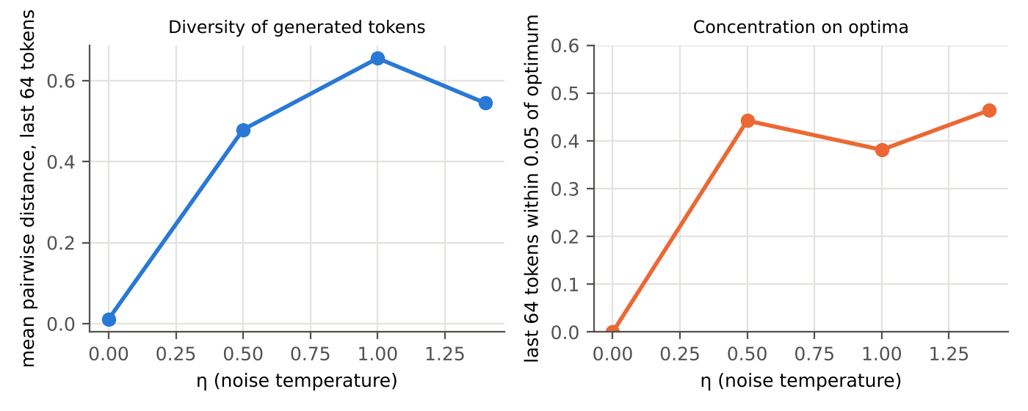
Figure 1. Effect of the noise temperature η (AR-DE with rising β, 96 tokens, 1,600 evaluations, mean of 10 seeds). Left: spread of the last 64 tokens. Right: fraction of the last 64 tokens within 0.05 of an optimum.
Table 2. Noise temperature.
η | Best f | Near an optimum | Optima among last 64 | Share entropy (bits) | Spread
0.0 | -4.687 | 0% | 0.0 | 0.00 | 0.012
0.5 | -0.022 | 44% | 1.7 | 0.59 | 0.479
1.0 | -0.030 | 38% | 1.9 | 0.72 | 0.655
1.4 | -0.010 | 46% | 1.6 | 0.46 | 0.545

The corollary is confirmed: at η = 0 the tokens collapse onto a single orbit (spread 0.012) that reaches no optimum. Between 0.5 and 1.4 the algorithm works, with a plateau rather than a trend: η = 1 gives the most diverse tokens (entropy 0.72 bits, spread 0.66), η = 1.4 the best fitness but less diversity. Above 1 the noise hits the cap √(1 − αₜ₋₁) at the late layers, which is why it does not keep buying diversity. The answer to Q2 is therefore: yes, σₜw is the diversity temperature, but its real job is to make successive tokens independent; beyond η ≈ 1 it is saturated.
A natural refinement, not tested here, is a per-token η controlled by the Z-cache: raise η for the next token when the last output’s density ū in the final-layer cache is high (it landed on top of existing tokens), and lower it when ū is low. That turns the noise temperature into a feedback controller for diversity, the counterpart of the rising β that controls selection.

5. Reusing f(x)

5.1 Where the evaluations go
AR-DE spends T evaluations per token: one per intermediate state, plus the output. With T = 16, fifteen of every sixteen evaluations are spent on noisy intermediate states. The previous paper showed that dropping those states from the cache is harmful: they supply the cache with samples outside the region already explored, and since x̂₀ is a convex combination of cached states, a cache without them cannot explore. The improvement rests on noticing that an intermediate state plays two roles that can be separated.
Principle (separate position from fitness).
An intermediate state contributes its position to the cache — the geometry that lets later tokens reach new regions — and its fitness — which weights it as a target. The position is needed exactly; the fitness is needed only well enough to weight it, and only where the cache cannot already predict it.

5.2 Three mechanisms
- Surrogate fitness from the true archive. Keep every true evaluation in an archive A = {(x_i, f_i)}. Give an intermediate state the Nadaraya–Watson estimate f̂(x) = Σᵢ K_h(x − x_i) f_i / Σᵢ K_h(x − x_i). Surrogates are built only from true values, never from other surrogates, so errors do not compound; each cache entry carries a flag saying which kind of fitness it holds.
- Novelty-triggered evaluation. Evaluate f(x) truly only when the Z-cache says the state is novel, ū(x) < u∗, and use the surrogate otherwise. The trigger costs nothing extra, because ū(x) uses the distances already computed for x̂₀. This is the Z-cache of Section 3 doing its main job.
- Always evaluate the output token. The output is the candidate that is reported and the next token’s starting state, so it is always evaluated truly; the archive grows by at least one true value per token.
Further mechanisms belong to the same family and need no new machinery: exact memoisation of repeated states; reuse of a cached value for a near-duplicate state within a tolerance; multi-fidelity evaluation, with a cheap proxy at early layers where the kernel is wide and a precise f only at late layers; fitness inheritance from the parents that dominate x̂₀ (Smith, Dike & Stegmann, 1995); and a Gaussian-process surrogate with an explicit variance in place of the Nadaraya–Watson estimate (Jones, Schonlau & Welch, 1998; Jin, 2011). Re-scoring after a change of critic is already free, because the cache stores raw F and β enters only at use (Ghosh, 2026f, Proposition 3).

5.3 Test
Table 3. Fitness reuse for a fixed run of 96 tokens (surrogate bandwidth h = 0.15; mean of 10 seeds).
Evaluation policy | True evaluations | Best f | Near an optimum | Optima among last 64
Every state evaluated (AR-DE) | 1,600 | -0.030 | 38% | 1.9
Novelty-triggered, u∗ = 0.2 | 794 | -0.034 | 44% | 1.6
Novelty-triggered, u∗ = 0.05 | 296 | -0.035 | 33% | 1.4
Surrogate for all intermediate states | 160 | -0.304 | 13% | 1.2

With the trigger at u∗ = 0.2, half the evaluations give the same quality as evaluating every state (best -0.034 vs -0.030; near an optimum 44% vs 38%; all differences within one standard error). At u∗ = 0.05, 18% of the evaluations still give a best point of -0.035. Surrogates for every intermediate state cut evaluations tenfold (160) at a visible cost in quality.
The fairer comparison spends the same evaluation budget and lets the cheaper policies generate more tokens.
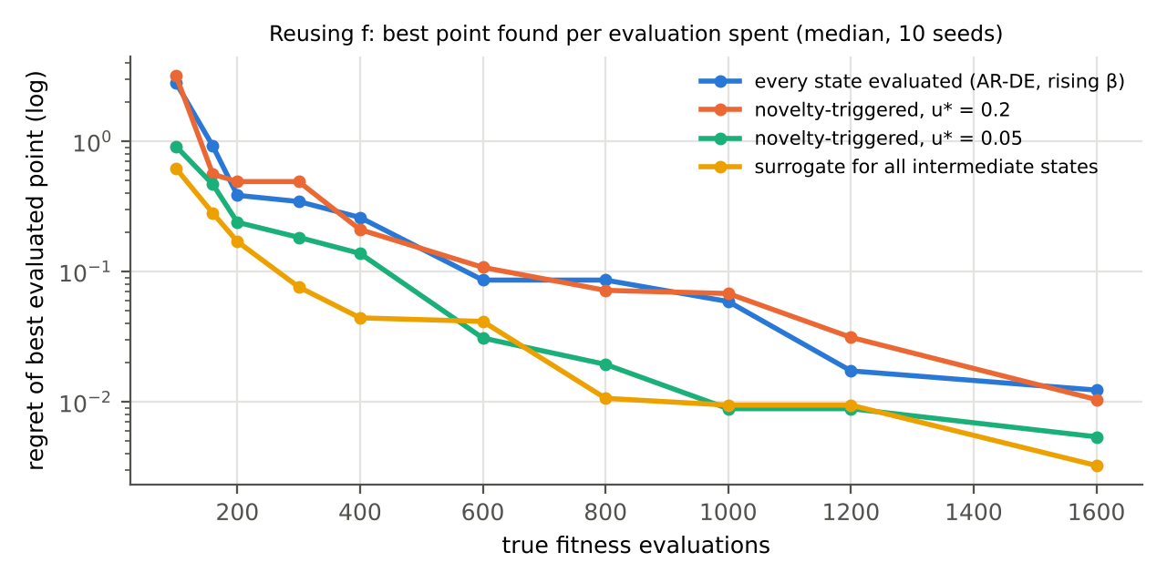
Figure 2. Regret of the best truly evaluated point against the number of true evaluations spent (median of 10 seeds, log scale). The reuse policies spend their saved evaluations on more tokens.
At every budget from 100 to 1,600 evaluations the surrogate policy finds a better point than evaluating every state; at 400 evaluations the regret is 0.044 against 0.260, and at 1,600 it is 0.003 against 0.012. The novelty trigger at u∗ = 0.05 lies between the two for most budgets and matches the surrogate policy from 1,000 evaluations on. The price is concentration: with the budget spread over 1,536 tokens and β rising over all of them, only 18% of the last 64 tokens lie within 0.05 of an optimum. The choice between policies is therefore a choice of goal: the best single point per evaluation favours surrogates; a population concentrated on several optima favours the trigger.

6. The improved algorithm
Algorithm 3: AR-DE with Z-cache, noise temperature and fitness reuse
Input: prompt size N₀, layers T, schedules α, σ^DDPM, tokens M, selection schedule β₁ ≤ … ≤ β_M, noise temperature η (default 1), trigger threshold u∗, surrogate bandwidth h, density-correction weight λ (default 0).
1: evaluate prompt P; archive A ← {(p, f(p))}; for every t: C_t ← {(p, f(p), true, U)} with U from Prop. 1
2: x_prev ← last prompt state
3: for k = 1 … M do
4: x ← x_prev
5: for t = T … 1 do
6: d_j ← ‖x − √αₜ c_j‖² / (2(1 − αₜ)) for all j ∈ C_t ▷ one distance pass
7: x̂₀ ← Σ_j softmax(β_k F_j − λ log(U_j / n_t) − d_j) · c_j ▷ Z exact for the query
8: ū ← (1/n_t) Σ_j e^{−d_j} ▷ novelty, from the same pass
9: if t < T:
10: if ū < u∗: F_x ← f(x); A ← A ∪ {(x, F_x)}; flag ← true ▷ pay only where novel
11: else: F_x ← f̂_h(x) from A; flag ← surrogate ▷ reuse
12: append (x, F_x, flag) to C_t; update every U_j (Prop. 1)
13: σ ← min(η σₜ^DDPM, 0.999 √(1 − αₜ₋₁))
14: x ← √αₜ₋₁ x̂₀ + √(1 − αₜ₋₁ − σ²) · (x − √αₜ x̂₀)/√(1 − αₜ) + σ w
15: F ← f(x); A ← A ∪ {(x, F)}; emit x; x_prev ← x ▷ outputs always evaluated

Setting u∗ = ∞ recovers AR-DE with every state evaluated; setting u∗ = 0 gives surrogates for every intermediate state; λ = 0 switches the density correction off; η = 1 is the default noise. The algorithm therefore contains the previous one as a special case, and the three improvements are independent switches.

7. Cache requirements
With E = T·N₀ + T·M − 1 layer-cache entries (Ghosh, 2026f) and E_A true evaluations in the archive:
Memory = E · (D + 2) · b + E/8 + E_A · (D + 1) · b bytes (4)
Each cache entry now holds its state (D numbers), its fitness and its Z-cache value U (two numbers) and a one-bit flag; the archive holds the true evaluations, needed for the surrogate. For the test of this paper (D = 2, T = 16, N₀ = 64, M = 96, b = 8): E = 2,559 entries take 81.9 kB, the flags 0.3 kB, and the archive of 1,600 true evaluations 38.4 kB, or 19.1 kB under the u∗ = 0.2 trigger (about 794 true evaluations). The Z-cache adds one number per entry (+33% at D = 2, +1% at D = 100).
Compute per token rises by one extra pass over each layer cache for the U update, plus a surrogate query against the archive, O(|A|·D), for each non-evaluated state. Both are of the same order as the attention itself. When f is costly — the setting that motivates Section 5 — this overhead is negligible next to the evaluations it saves.

8. Tests and open requirements
Table 4. New tests, extending T1–T11 of Ghosh (2026f).
ID | Test | Pass criterion
T12 | Incremental Z-cache equals the batch sum after any sequence of appends | max relative difference < 10⁻¹²
T13 | Surrogates are built only from true evaluations | no flagged-surrogate value ever enters the archive A
T14 | Evaluation count | exactly N₀ + M + (number of triggered intermediate evaluations)
T15 | Noise regression guard | η = 0 must reproduce the collapse (spread < 0.05 on Himmelblau)
T16 | Reuse acceptance | trigger policy matches every-state AR-DE within one standard error at ≤ 50% of its evaluations
T17 | Anytime acceptance | surrogate policy’s best-point regret ≤ every-state AR-DE’s at every budget on the test suite

Open requirements, in order of expected value:
- R1. Z-cache-controlled η. Raise or lower the next token’s noise temperature from the density of the last output in the final-layer cache (Section 4.3). Acceptance: share entropy across equal optima ≥ that of η = 1, with no loss in best fitness.
- R2. Surrogate with uncertainty. Replace the Nadaraya–Watson estimate by one with a variance, and trigger on expected improvement rather than density alone. Acceptance: T17 with fewer evaluations than the density trigger.
- R3. Layer-dependent fidelity. Cheap proxies at early layers and the true f only at late layers. Acceptance: T16 at ≤ 25% of the evaluations on a problem with a natural cheap proxy.
- R4. Adaptive bandwidth h. Leave-one-out choice of h from the archive as it grows. Acceptance: no tuning needed across the benchmark suite.
- R5. Noisy f. With a noisy critic, the surrogate is also a smoother; test whether it removes the variance bonus identified in Ghosh (2026a).

9. Limitations
- One landscape in two dimensions with ten seeds. Nadaraya–Watson surrogates degrade quickly with dimension, so high-dimensional problems will need a latent kernel or a different surrogate.
- The trigger threshold u∗ and bandwidth h were set by hand; the anytime comparison uses medians, not a full statistical test.
- The density correction was tested only with the rising-β schedule; its effect may differ under a fixed β.

10. Conclusion
Z can be cached — not for the query, whose density moves with it, but for every state already in the cache, where a running sum with a counter is exact. That Z-cache is one number per entry, and it supplies the density of the population wherever it is needed. The noise term σₜw is the diversity temperature, but what it mainly provides is independence between successive tokens: without it the autoregression collapses into a deterministic orbit, and above η ≈ 1 it saturates. And f(x) can be reused by separating the position of an intermediate state, which the cache needs, from its fitness, which it can borrow from earlier true evaluations unless the Z-cache says the state is novel. With that separation AR-DE reaches the same quality at half the evaluations, or a better best point at every budget when the saved evaluations are spent on more tokens.

References
Ghosh, D. P. (2026a). Specification as Density: Spec-driven development through Diffusion Evolution with an LLM critic.
Ghosh, D. P. (2026f). Autoregressive Diffusion Evolution: Interchanging the loops of Algorithm 1 to obtain a cached, token-by-token optimiser. https://github.com/debiprasadghosh/ResearchOverFlow/tree/main/October2026/AutoregressiveDiffusionEvolution
Jin, Y. (2011). Surrogate-assisted evolutionary computation: Recent advances and future challenges. Swarm and Evolutionary Computation, 1(2), 61–70.
Jones, D. R., Schonlau, M., & Welch, W. J. (1998). Efficient global optimization of expensive black-box functions. Journal of Global Optimization, 13, 455–492.
Nadaraya, E. A. (1964). On estimating regression. Theory of Probability and Its Applications, 9(1), 141–142.
Smith, R. E., Dike, B. A., & Stegmann, S. A. (1995). Fitness inheritance in genetic algorithms. Proceedings of the ACM Symposium on Applied Computing, 345–350.
Song, J., Meng, C., & Ermon, S. (2021). Denoising diffusion implicit models. ICLR 2021.
Watson, G. S. (1964). Smooth regression analysis. Sankhyā: The Indian Journal of Statistics, Series A, 26(4), 359–372.
Zhang, Y., Hartl, B., Hazan, H., & Levin, M. (2025). Diffusion models are evolutionary algorithms. ICLR 2025. arXiv:2410.02543.

Appendix A. C# Z-cache layer
Immutable-style C# for one layer of the Z-cache; compiled with .NET 8. After 200 appends the incremental U values equal the batch sums exactly.
using System;
using System.Collections.Generic;
using System.Collections.Immutable;
using System.Linq;

namespace SddDe;

/// <summary>A cached state at one layer: position, fitness (true or surrogate), its flag, and its Z-cache value U.</summary>
public sealed record ZEntry(IReadOnlyList<double> X, double F, bool IsTrue, double U);

/// <summary>Per-layer cache with an exactly maintained density sum U_j = Σ_k N(c_j; √α c_k, 1 − α) (unnormalised).</summary>
public sealed record ZLayer(double Alpha, ImmutableList<ZEntry> Entries)
{
static double K(IReadOnlyList<double> at, IReadOnlyList<double> centre, double alpha) =>
Math.Exp(-at.Select((v, d) => (v - Math.Sqrt(alpha) * centre[d]) * (v - Math.Sqrt(alpha) * centre[d])).Sum() / (2 * (1 - alpha)));

/// <summary>Unweighted density of the cache around a query: the quantity the novelty trigger reads.</summary>
public double DensityAt(IReadOnlyList<double> x) => Entries.IsEmpty ? 0 : Entries.Sum(e => K(x, e.X, Alpha)) / Entries.Count;

/// <summary>Append a state; every existing U_j gains the new entry's contribution, and the new entry's U is its own sum.</summary>
public ZLayer Add(IReadOnlyList<double> x, double f, bool isTrue)
{
var updated = Entries.Select(e => e with { U = e.U + K(e.X, x, Alpha) }).ToImmutableList();
double own = Entries.Sum(e => K(x, e.X, Alpha)) + K(x, x, Alpha);
return this with { Entries = updated.Add(new ZEntry(x, f, isTrue, own)) };
}
}

