Fitness as Attention
Segment-Level Fitness Bias for Language-Model Program Search: Selection Inside the Decoder, Why the Naive Form Breaks Generation, and a Mass-Preserving Repair
Debi Prasad Ghosh
Founder and Principal Engineer, Debias Parametric Guru, Kolkata, India
12 October 2026 · Mathematical research manuscript

Abstract
Language-model program search — FunSearch, AlphaEvolve, OPRO and their relatives — puts earlier programs into the prompt and asks the model for a better one. Fitness reaches the model in one of two ways: by choosing which programs enter the prompt, or by writing their scores into it as text. A companion paper (Ghosh, 2026d) proposed a third way, motivated by the identity between Diffusion Evolution and attention: add γ·ĝⱼ, a preprocessed fitness of program j, to the attention logits of every edge from the tokens being generated into the tokens of program j. For a single attention head this multiplies the attention mass on program j by exp(γĝⱼ) exactly, so it is the stochastic-parent selection of Diffusion Evolution performed inside the decoder.
We test the proposal on a decoder-only language model (0.63 M parameters, character-level) trained only to edit programs shown in its context, with no notion of fitness; the bias is applied zero-shot. Three results. (i) The naive bias selects, but it breaks generation: at γ = 3 the fraction of syntactically valid programs falls from 0.91 to 0.74, at γ = 6 to 0.42, and search success falls below that of no fitness at all (0.29 vs 0.46). The cause is that a z-scored bias raises the total attention mass on program tokens relative to structural tokens by the factor mean exp(γĝ), whose median over eight-program contexts is 18 at γ = 3. (ii) Subtracting log mean exp(γĝ) — a mass-preserving bias — restores validity (0.87 at γ = 6) while strengthening selection (the copied parent is the context’s fittest program in 49% of generations against 12.5% by chance). With it, search from random contexts solves 0.67 of runs against 0.46 without fitness, comparable to prompt-level selection (top-K 0.71, fitness-proportional 0.77; confidence intervals overlap). (iii) Applying the bias only in the last layer has no selective effect at all: parent choice is made in earlier layers.
Two structural properties hold regardless of these numbers. Because the bias is restricted to edges from generated positions, the context’s keys and values are independent of fitness (measured difference: exactly 0), so re-scoring the archive requires no re-encoding; and in-context selection can never select a program that is not in the context, so it complements rather than replaces prompt-level selection. Our attempt to train a comparison model that reads scores written as text failed to learn to use them; that comparison remains open.

Keywords: language-model program search; attention bias; attention steering; evolutionary search; Diffusion Evolution; in-context selection; KV cache.

1. Introduction
The previous papers in this series moved from Diffusion Evolution (DE; Zhang et al., 2025) to attention. DE’s denoising target is exactly softmax self-attention with the fitness as a key bias (Ghosh, 2026c), and a decoder that receives fitness as an attention bias optimises better than one that receives it as an input feature (Ghosh, 2026d). The natural next step is the setting where these ideas would matter most: search over programs with a language model.
In current language-model program search, a model is shown several earlier programs and generates a new one; the new program is executed and scored; the process repeats. ELM (Lehman et al., 2022) and Language Model Crossover (Meyerson et al., 2024) use the model as a mutation or recombination operator. FunSearch (Romera-Paredes et al., 2024) and AlphaEvolve (Novikov et al., 2025) select which high-scoring programs enter the prompt. OPRO (Yang et al., 2024) writes the scores into the prompt as text. In every case the model itself has no channel for fitness other than its input.
This paper tests a different channel. Fitness enters as an additive bias on the attention logits from the tokens being generated to the tokens of each earlier program — a segment-level bias. The idea is close in mechanism to post-hoc attention steering, which emphasises user-marked spans by rescaling attention in selected heads (PASTA; Zhang et al., 2024), but its purpose is selection: making the model copy and edit good programs more than bad ones. The questions are whether it selects, whether it harms generation, and whether it helps search.
A constraint shaped the study and should be stated at the outset. The intended experiment used a pretrained code model; model downloads were not reachable from the environment in which this work was done. We therefore trained a small decoder-only model on program edits. This is a weaker test of ‘plugging a bias into an existing large model’, but a cleaner one in one respect: the model never saw a fitness value during training, so any selective effect comes from the bias alone.

2. Segment-level fitness bias

2.1 Definition
A context holds K programs p₁, …, p_K separated by delimiter tokens, followed by a generation marker. Let seg(k) = j if key position k is a token of program j, and undefined for delimiters and other structural tokens. With ĝⱼ a preprocessed fitness of program j (here z-scored within the context), the biased attention logit from query position q to key position k is
s′(q, k) = s(q, k) + γ · ĝ_seg(k) · 1[q ≥ q₀] · 1[k is a program token] (1)
where q₀ is the position of the generation marker. The bias is added in every layer and every head unless stated otherwise.
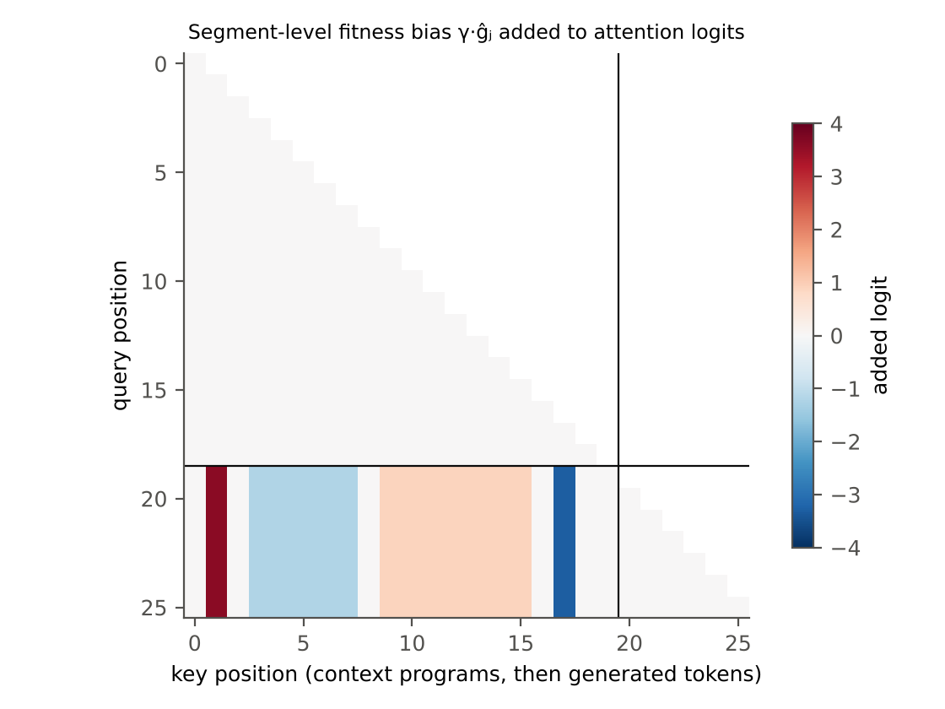
Figure 1. The bias matrix for a four-program context. Rows above the horizontal line are context positions and receive no bias, so their keys and values are unaffected by fitness. Rows from the generation marker onward add γ·ĝⱼ to every key in program j (red: fitter, blue: less fit); delimiters and generated tokens receive nothing.

2.2 What the bias does to one head
Proposition 1 (exact segment reweighting).
For a single head and a single query position q ≥ q₀, let mⱼ be the attention mass on the tokens of program j and m₀ the mass on all other tokens, before the bias. After the bias the masses are m′ⱼ = mⱼ e^{γĝⱼ} / Z and m′₀ = m₀ / Z, with Z = m₀ + Σₖ mₖ e^{γĝₖ}.
Proof. Every key in program j receives the same additive term, so each of its exponentiated scores is multiplied by e^{γĝⱼ}; summing within the segment multiplies mⱼ by the same factor. Normalisation gives Z. ∎

Among program tokens this is exactly the parent-posterior reweighting of stochastic-parent Diffusion Evolution (Ghosh, 2026a, Proposition 3) with g = exp(γĝ): if a head’s mass on a program determines which program is copied, the bias multiplies the odds of copying program j by g(fⱼ)^γ. Two qualifications follow from the same formula and organise the experiments.

2.3 The mass problem
Proposition 2 (mass inflation).
The ratio of total mass on program tokens to mass on all other tokens is multiplied by Σⱼ mⱼ e^{γĝⱼ} / Σⱼ mⱼ. If the pre-bias masses are equal across programs this is the mean of e^{γĝⱼ}, which by Jensen’s inequality is at least e^{γ·mean ĝ} = 1 for z-scored ĝ, with equality only if all ĝⱼ are equal. For standard-normal ĝ its expectation is e^{γ²/2}.

Heads that track structure — delimiters, the generation marker, the program being written — lose mass to program tokens. For z-scored fitness over eight programs, the median inflation factor is 1.6 at γ = 1, 18 at γ = 3 and about 1,600 at γ = 6. A bias meant to change which program is attended to also changes whether structural tokens are attended to, and Section 4 shows that this breaks generation.
Mass-preserving bias.
Replace γĝⱼ by γĝⱼ − log( (1/K) Σₖ e^{γĝₖ} ). Under equal pre-bias masses the total mass on program tokens is then unchanged, and the relative reweighting among programs of Proposition 1 is untouched, since a constant shift cancels within the program set.

The correction assumes equal pre-bias masses across programs; heads that already concentrate on one program will still see some inflation or deflation. It is the simplest correction that removes the expected effect.

2.4 Two structural properties
Proposition 3 (re-scoring without re-encoding).
Because the bias is applied only to query positions q ≥ q₀, the hidden states, keys and values of all context positions before the generation marker are independent of ĝ. Changing any or all fitness values — a new critic, a corrected test — requires recomputing only the generation marker’s row. If instead the scores are written into the context as text, changing the score of program j invalidates the cache from that score’s position onward, and changing all scores invalidates nearly the whole context.

Proposition 4 (context-limited selection).
In-context selection can only redistribute attention among programs that are in the context. If the context is a uniform random K-subset of an archive of n programs, the archive’s best program is in context with probability K/n, which bounds the probability that it is used as a parent, whatever γ is. Prompt-level selection (choosing the context by fitness) is not bounded in this way.

Proposition 4 means the bias is not a substitute for prompt-level selection unless the context holds the archive. It can complement it — by selecting within a context chosen for other reasons, such as diversity or recency, or by steering a long context whose cache is expensive to rebuild.

3. Testbed
- Programs. Integer expressions over x in prefix notation with operators +, −, × and leaves x, 1, 2, 3, at most 15 nodes; each symbol is one token.
- Edit model. A decoder-only Transformer (3 layers, 4 heads, width 128, learned positions; 0.63 M parameters) trained for 3,000 steps (batch 32) on synthetic edit tasks: eight context programs, most of them variants of a common ancestor, followed by a target that is a mutation, crossover or copy of a uniformly chosen context program. The model has never seen a fitness value. At γ = 0, 91% of its generations are valid programs and 20% are exact copies of a context program.
- Text-score model. The same architecture trained on the same edits, but each context program is followed by its score written as a decile digit, and the target’s parent is drawn with probability ∝ exp(4·score). This is the comparison channel for scores written as text.
- Search. 24 target functions (5–13 nodes, nontrivial behaviour), 2 seeds each. Fitness of a program is the mean over x ∈ {−5, …, 5} of exp(−|ŷ − y|/(1 + |y|)); a target is solved when all 11 outputs match. 32 random programs seed the archive; each iteration builds an eight-program context, samples 16 programs at temperature 1 and evaluates them; invalid programs and duplicates also cost an evaluation; the budget is 800 evaluations.
- Context policies. random (uniform from the archive); top-K (the eight fittest); fitness-proportional (sampled ∝ exp(8(f − max f))).
- Parent attribution. Each generated program is assigned the context program at smallest normalised edit distance. The effective selection strength γ_eff is the maximum-likelihood γ in P(parent = j) ∝ exp(γ ĝⱼ).

4. Results

4.1 Does the bias select, and what does it cost?
Forty eight-program contexts with random standard-normal fitness, 32 generations each, for every setting.
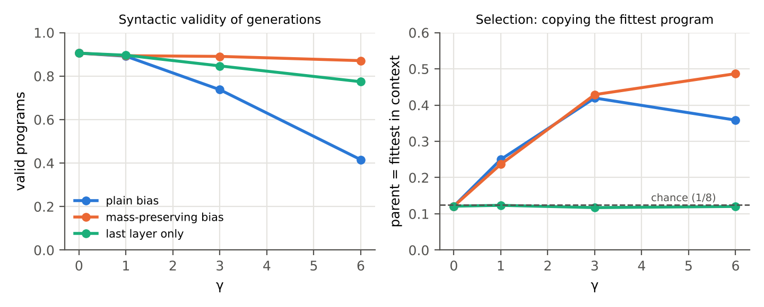
Figure 2. Left: fraction of syntactically valid generations. Right: fraction of generations whose parent is the context’s fittest program (chance 1/8).
Table 1. Selection and validity of the edit model under each form of the bias.
Bias | γ | Valid | Novel and valid | Parent = fittest | γ_eff
no bias | 0 | 0.91 | 0.70 | 0.12 | 0.00
plain | 1 | 0.89 | 0.67 | 0.25 | 0.50
plain | 3 | 0.74 | 0.52 | 0.42 | 0.85
plain | 6 | 0.42 | 0.28 | 0.36 | 0.55
mass-preserving | 1 | 0.89 | 0.67 | 0.24 | 0.45
mass-preserving | 3 | 0.89 | 0.63 | 0.43 | 0.85
mass-preserving | 6 | 0.87 | 0.61 | 0.49 | 0.95
last layer only | 3 | 0.85 | 0.66 | 0.12 | -0.05
last layer only | 6 | 0.77 | 0.57 | 0.12 | 0.00

The plain bias selects: at γ = 3 the fittest program is the parent 42% of the time, more than three times chance. But validity falls as γ grows, to 42% at γ = 6, and selection itself weakens again at γ = 6, because many generations are no longer recognisable edits of any parent. The mass-preserving bias keeps validity within a few points of the unbiased model at every γ while its selection keeps rising, to 49% at γ = 6. Restricting the bias to the last layer has no selective effect at all (γ_eff ≈ 0): by the last layer the decision of what to copy has already been made.
The text-score model did not learn to use the scores: its γ_eff is 0.00 and its fittest-parent rate 0.11, indistinguishable from chance. This is a failure of our training at this scale and budget, not evidence about scores written as text in large pretrained models, where OPRO-style prompting is known to work. The comparison between the two channels is therefore left open.

4.2 Search
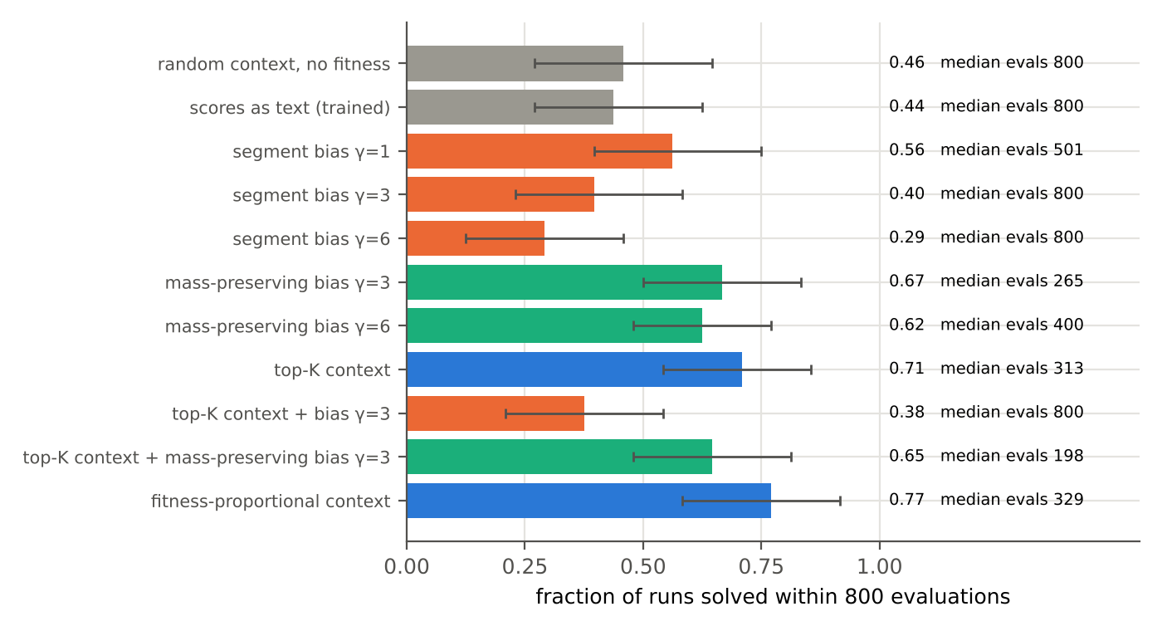
Figure 3. Fraction of the 48 (target, seed) runs solved within 800 evaluations, with 95% bootstrap confidence intervals over targets, and median evaluations to solve (800 when the median run fails). Grey: no fitness signal reaches the model; orange: plain bias; green: mass-preserving bias; blue: prompt-level selection.
Table 2. Search results (24 targets × 2 seeds, budget 800).
Method | Solved | 95% CI | Median evals | Mean best fitness | γ_eff in search
random context, no fitness | 0.46 | [0.27, 0.65] | 800 | 0.885 | 0.00
scores as text (trained) | 0.44 | [0.27, 0.63] | 800 | 0.871 | 0.05
segment bias γ=1 | 0.56 | [0.40, 0.75] | 501 | 0.907 | 0.80
segment bias γ=3 | 0.40 | [0.23, 0.58] | 800 | 0.849 | 0.80
segment bias γ=6 | 0.29 | [0.13, 0.46] | 800 | 0.774 | 0.70
mass-preserving bias γ=3 | 0.67 | [0.50, 0.83] | 265 | 0.922 | 1.20
mass-preserving bias γ=6 | 0.63 | [0.48, 0.77] | 401 | 0.932 | 1.30
top-K context | 0.71 | [0.54, 0.85] | 313 | 0.953 | 0.20
top-K context + bias γ=3 | 0.38 | [0.21, 0.54] | 800 | 0.850 | 0.75
top-K context + mass-preserving bias γ=3 | 0.65 | [0.48, 0.81] | 198 | 0.923 | 0.70
fitness-proportional context | 0.77 | [0.58, 0.92] | 329 | 0.950 | 0.05

Four findings.
- The plain bias hurts search. At γ = 3 and 6 it solves fewer runs than giving the model no fitness at all, and adding it to top-K contexts drops top-K from 0.71 to 0.38. Only γ = 1, where the mass inflation is small, is mildly positive (0.56).
- The mass-preserving bias makes in-context selection work. From random contexts it solves 0.67 of runs (γ = 3), against 0.46 without fitness; on paired runs it is faster than the no-fitness baseline in 48% of pairs and slower in 21%. Its median evaluations to solve (265) are the lowest of any random-context method.
- It does not beat prompt-level selection. Top-K (0.71) and fitness-proportional contexts (0.77) solve at least as many runs; confidence intervals overlap with the mass-preserving bias, and paired comparisons are close to even (40% faster, 44% slower against top-K). This is what Proposition 4 predicts: a random eight-program context usually does not contain the archive’s best programs, and no bias can select what is absent.
- Combined with top-K it is faster but not more successful. Top-K plus the mass-preserving bias has the lowest median evaluations of all methods (198 against 313 for top-K alone) but solves 0.65 of runs against 0.71. Within an already-selected context, sharper selection speeds up the runs that succeed and costs diversity in the rest; the difference in success is within noise.

4.3 Re-scoring and the cache
For a context of 72 tokens, the attention patterns of all context positions under two independent random fitness vectors (γ = 3) differ by exactly 0.0 in every layer, as Proposition 3 requires. With scores as text, changing one program’s score invalidates the cache from that program onward, on average half the context for a uniformly chosen program; changing every score — the case of a revised critic — invalidates almost all of it. The saving matters little at this scale and a great deal for long contexts in large models, where re-encoding the archive is the dominant cost.

5. Discussion

5.1 What the experiment shows about the proposal
The segment-level bias is a real selection channel: applied zero-shot to a model that never saw fitness, it makes the model copy and edit fitter programs, by a factor that γ controls. The naive form, however, is self-defeating at useful strengths, for a reason that is entirely predictable from the softmax: a bias that is not mean-zero in the exponential domain moves mass between the programs and everything else. The repair is one line, and with it in-context selection becomes competitive with — though not better than — the prompt-level selection used by current systems.

5.2 Where the bias should matter
Proposition 4 says that in-context selection competes with prompt-level selection only when the context holds most of the archive. That is the long-context regime, and it is exactly where Proposition 3 matters: the archive is large, its cache is expensive, and critics and tests are revised. A system could keep a long, stable context of programs chosen for diversity, never re-encode it, and steer the model’s choice of parents by changing one scalar per program. The experiment here, with eight programs in context, is the regime least favourable to the bias.

5.3 Connections
The mass-preservation result connects to attention steering (Zhang et al., 2024), which also found that steering must be confined to suitable heads to avoid damaging generation; our finding that the last layer carries no parent choice is a coarse version of the same head-selection question. The weighting exp(γĝ) inherits the critic-noise problem of the first paper in the series: with a noisy LLM critic, ĝ should be computed from debiased or interval-lower scores (Ghosh, 2026a). And the context-limited selection of Proposition 4 is the language-model form of the convex-hull limitation of Diffusion Evolution (Ghosh, 2026b): attention can only recombine what is present.

6. Limitations
- No pretrained language model was used; the edit model has 0.63 M parameters and a seven-symbol program language. Effects of the bias on a large pretrained model, whose heads serve many functions, may differ in size and even sign.
- The text-score comparison model failed to learn to use scores, so the central comparison with OPRO-style prompting is not made.
- Forty-eight runs per method give wide confidence intervals; differences among the better methods are within noise.
- The mass-preserving correction assumes equal pre-bias masses across programs; a head-aware correction was not tried.
- Fitness here is exact. With a noisy critic the variance-bonus effect of the companion paper applies to the bias unchanged.

7. Conclusion
Fitness can be given to a language model as attention rather than as input. For each head the segment-level bias is exactly Diffusion Evolution’s parent reweighting, and applied zero-shot it makes a model that has never seen a fitness value select fitter parents. Applied naively it inflates the attention mass on all programs relative to the structure of the output and breaks generation, which makes search worse than no fitness at all. Made mass-preserving, it turns in-context selection into a working search operator, competitive with prompt-level selection from contexts that were not selected by fitness, and it leaves the context’s cache untouched when fitness changes. It cannot select what is not in the context, so its natural place is the long-context regime, alongside prompt-level selection rather than instead of it.

References
Ghosh, D. P. (2026a). Specification as Density: Spec-driven development through Diffusion Evolution with an LLM critic. https://github.com/debiprasadghosh/ResearchOverFlow/tree/main/October2026/SpecificationAsDensity
Ghosh, D. P. (2026b). Sambhavāmi Yuge Yuge: The denoising target x̂₀ as an algorithmic avatar in Diffusion Evolution. https://github.com/debiprasadghosh/ResearchOverFlow/tree/main/October2026/AVATAR
Ghosh, D. P. (2026c). The hidden Transformer in Diffusion Evolution. https://github.com/debiprasadghosh/ResearchOverFlow/tree/main/October2026/AutoregressiveDiffusionEvolution
Ghosh, D. P. (2026d). Optimisation-Attention: A fitness-biased decoder that turns the GPT backbone into an optimiser. https://github.com/debiprasadghosh/ResearchOverFlow/tree/main/October2026/AutoregressiveDiffusionEvolution
Lehman, J., Gordon, J., Jain, S., Ndousse, K., Yeh, C., & Stanley, K. O. (2022). Evolution through large models. arXiv:2206.08896.
Meyerson, E., Nelson, M. J., Bradley, H., Gaier, A., Moradi, A., Hoover, A. K., & Lehman, J. (2024). Language model crossover: Variation through few-shot prompting. ACM Transactions on Evolutionary Learning and Optimization. arXiv:2302.12170.
Novikov, A., et al. (2025). AlphaEvolve: A coding agent for scientific and algorithmic discovery. arXiv:2506.13131.
Press, O., Smith, N. A., & Lewis, M. (2022). Train short, test long: Attention with linear biases enables input length extrapolation. ICLR 2022.
Romera-Paredes, B., et al. (2024). Mathematical discoveries from program search with large language models. Nature, 625, 468–475.
Yang, C., Wang, X., Lu, Y., Liu, H., Le, Q. V., Zhou, D., & Chen, X. (2024). Large language models as optimizers. ICLR 2024.
Zhang, Q., Singh, C., Liu, L., Liu, X., Yu, B., Gao, J., & Zhao, T. (2024). Tell your model where to attend: Post-hoc attention steering for LLMs. ICLR 2024. arXiv:2311.02262.
Zhang, Y., Hartl, B., Hazan, H., & Levin, M. (2025). Diffusion models are evolutionary algorithms. ICLR 2025. arXiv:2410.02543.

Appendix A. Implementation of the bias
The bias is built once per generation step and added to the attention scores of every layer before the causal mask and the softmax. The mass-preserving variant changes only how ĝ is shifted.
gh = np.asarray(ghat) # z-scored fitness of the K context programs
if mode == 'lse': # mass-preserving shift
gh = gh - np.log(np.mean(np.exp(gamma * gh))) / gamma
gvec[:n0] = gh[seg[:n0]] where seg >= 0 else 0 # per-key value; 0 on delimiters and markers
bias = zeros(n, n)
bias[n0 - 1:, :n0] = gamma * gvec[:n0][None] # only rows from the generation marker onward
...
a = q @ k.T / sqrt(dh) + bias # in every layer (mode 'last': final layer only)
a = a.masked_fill(~causal, -inf).softmax(-1)

Appendix B. Reproducibility
- Edit-model training data: base program from a random grammar of depth ≤ 3; seven further context programs, each a double mutation of the base with probability 0.6 and otherwise random; target a mutation (0.6), crossover with another context program (0.2) or copy (0.2) of the chosen parent.
- Search: targets seeded 2026; search seeds 0 and 1; all methods face the same targets and seeds. Calibration: contexts seeded 0, fitness vectors seeded by context index.
- Compute: about 1.5 hours on two CPU cores, including the training of both models.

