Optimisation-Attention
A Fitness-Biased Decoder That Turns the GPT Backbone into an Optimiser: Diffusion Evolution as Block-Causal Attention, Fitness as an Attention Bias, and What Learning Adds
Debi Prasad Ghosh
Founder and Principal Engineer, Debias Parametric Guru, Kolkata, India
12 October 2026 · Mathematical research manuscript

Abstract
Can an optimiser be built on the backbone of a Transformer decoder, with the fitness g[f(x)] multiplied into attention and new candidates produced autoregressively and fed back? We show that the answer is yes, and that the construction is already latent in Diffusion Evolution (DE; Zhang et al., ICLR 2025). Multiplying attention weights by g[f(xⱼ)] is identical to adding γ·log g[f(xⱼ)] to the logits, so the proposal is an attention bias, implementable in any attention kernel that accepts one. With identity weights, DE is exactly a block-causal decoder whose attention window is one block; widening the window to the whole KV cache turns the cache into an archive of every evaluated candidate and, on the Himmelblau function, recovers all four optima on every seed (DE: 3.5). Token-by-token autoregression, by contrast, fails: a single lineage has no population to select within, and its final candidates reach none of the optima. Generation must be block-wise — one block of candidates per generation.
We then train small decoders (two layers, four heads) to predict the denoising target x̂₀ across a family of random multi-modal landscapes, so that the x₀ examples that a diffusion model needs are supplied by a prior over tasks rather than by the task being solved. Four ways of giving the decoder its fitness are compared at equal evaluation budget: none, as an input feature of each key, as an attention bias, and both. With z-scored fitness, the bias form solves 97% of held-out tasks and covers 98% of the top modes, against 87% and 78% for the feature form, 95% and 94% for untrained DE with an archive, and 32% and 7% with no fitness. Giving both forms is no better than the feature alone. On an out-of-family landscape the bias decoder finds 3.8 of 4 Himmelblau optima against 2.0 for the feature decoder.
A prediction made before the experiment failed: that the bias form would be more robust than the feature form when the fitness is monotonically transformed at test time. It is not; both lose coverage under a flattening transform, and the bias form loses more, though it stays ahead in absolute terms. Invariance comes from rank-transforming the fitness, not from where it enters; with ranks, both forms are invariant and the advantage of the bias form disappears. The bias form has one structural property that does not depend on these numbers: when the fitness or the critic changes, keys and values need not be recomputed.

Keywords: Diffusion Evolution; Transformer decoder; attention bias; learned optimisers; in-context optimisation; KV cache; amortised optimisation; meta-learning.

1. Introduction
A companion paper (Ghosh, 2026c) showed that the denoising target of Diffusion Evolution is exactly softmax self-attention over the population, with query xᵢ, key √αₜ xⱼ, value xⱼ, temperature 1 − αₜ and a per-key bias that carries the fitness. That identity invites a constructive question: instead of finding a Transformer hidden inside an optimiser, can we build an optimiser on the backbone of a Transformer — specifically a decoder of the GPT kind, which generates autoregressively and feeds its own outputs back as input?
The proposal studied here is the natural one. Candidates are tokens. Each token carries its evaluated fitness f(xⱼ). A new candidate is produced by attending over the evaluated ones, with the attention weight of each multiplied by g[f(xⱼ)]; it is evaluated and appended; the process repeats. We answer four questions about it.
- Q1. What is the exact form of ‘multiply by g in the attention’? An additive logit bias γ·log g (Section 3.1).
- Q2. Is DE already such a decoder, and what does the autoregressive form change? DE is a block-causal decoder with a one-block window; a full window adds an archive; token-by-token generation fails (Sections 3.2–3.3, 5.1).
- Q3. Does learning help, and where should the fitness enter? Trained decoders improve on untrained DE only when the fitness enters as an attention bias; as an input feature they are worse than DE (Section 5.2).
- Q4. Is the bias form more robust to rescaled fitness? No — invariance comes from rank preprocessing, not from where the fitness enters (Section 5.3).

2. Background

2.1 Diffusion Evolution and its attention form
DE (Zhang, Hartl, Hazan & Levin, 2025) maps a fitness f to a target density ∝ g[f], and at each step estimates for every individual a denoising target x̂₀ by a fitness- and kernel-weighted average of the population, then takes a DDIM step toward it with added noise. By Theorem 1 of Ghosh (2026c),
x̂₀(xᵢ) = Σⱼ softmaxⱼ( √αₜ xᵢ·xⱼ / (1 − αₜ) + log g[f(xⱼ)] − αₜ‖xⱼ‖² / (2(1 − αₜ)) ) · xⱼ (1)
so a DE step is attention with fixed (identity) projections, a temperature schedule, and a fitness-carrying key bias.

2.2 Transformers as optimisers
Several lines of work use Transformers to propose new candidates from a history of evaluated ones. OptFormer (Chen et al., 2022) trains a Transformer on hyperparameter-tuning trajectories serialised as text. OPRO (Yang et al., 2024) prompts a large language model with past solutions and their scores written as text. PFNs4BO (Müller et al., 2023) trains a Transformer on samples from a prior over functions to act as a Bayesian-optimisation surrogate. Algorithm Distillation (Laskin et al., 2023) trains a Transformer on learning histories so that it improves in context. The Decision Transformer (Chen et al., 2021) conditions generation on a desired return. In all of these, the quality signal enters as an input — a token, a feature, or text. ALiBi (Press et al., 2022) is the standard precedent for putting information into attention as an additive bias instead. The present paper puts the quality signal there.

3. Optimisation-attention

3.1 Multiplying by g is adding log g
Proposition 1.
For any scores sⱼ and positive weights gⱼ, the normalised product gⱼ exp(sⱼ) / Σₖ gₖ exp(sₖ) equals softmaxⱼ(sⱼ + log gⱼ). Raising gⱼ to a power γ corresponds to scaling the bias, softmaxⱼ(sⱼ + γ log gⱼ).
Proof. gⱼ exp(sⱼ) = exp(sⱼ + log gⱼ); the normalisation is unchanged. ∎

Two consequences are practical. First, the multiplicative proposal needs no new kernel: every attention implementation that accepts an additive bias or mask (as used for ALiBi or for padding) can carry it. Second, with g = exp(βf), the bias is simply βf, so ‘multiplying by g’ and ‘adding the fitness to the logits’ are the same operation; the choice of g is the choice of how fitness is scaled before it enters. We write the optimisation-attention of a query qᵢ over evaluated tokens j as
hᵢ = Σ_{j ∈ archive} softmaxⱼ( (W_Q qᵢ)·(W_K e(xⱼ)) / √d + γ_{l,h} · ĝⱼ ) · W_V e(xⱼ), ĝⱼ = β · P(f)ⱼ (2)
where e is a token-wise encoder of the candidate, P is a preprocessing of the archive’s fitness values (z-score or rank) and γ_{l,h} is a learned scale per layer and head.

3.2 DE is a block-causal decoder
Arrange the evaluated candidates as a sequence of blocks, one block of B tokens per generation. Let each token of block K+1 be generated from the token in the same position of block K (its parent, used as the query) attending over a window of earlier blocks.
Proposition 2 (DE as a decoder).
With identity projections, no MLP, the bias of Theorem 1 and a window of exactly one block, the block-causal decoder reproduces Diffusion Evolution step for step.
Proof. In DE the population at step t is the previous block; each individual is its own query; x̂₀ attends over the current population only. That is attention over a one-block window with the given query, key, value and bias. The DDIM move is the same in both. ∎

This makes the two time axes of the construction explicit. In DE as published, the diffusion steps are the generations, so in the decoder they lie along the sequence, not the depth: each new block is one denoising step. Depth — the number of layers inside one decoding step — is a separate resource that DE does not use and a trained decoder can.

3.3 What autoregression changes
Two departures from DE come with the decoder form. The KV cache becomes an archive. A full causal window lets each new block attend to every candidate ever evaluated, not only to the last population. Token-by-token generation removes the population. If each token is produced from the previous token alone, there is one query per step and one lineage; DE’s selection, which happens across the N parallel individuals of a step, has nothing to act on. The decoder must therefore emit a block of candidates per generation. Both effects are tested in Section 5.1.

3.4 Learning the denoiser from a task prior
A trained diffusion model learns x̂₀ from examples of x₀; DE avoids that by computing x̂₀ from fitness alone. A trained decoder sits between the two. Its x₀ examples come not from the task being solved but from a prior over tasks: synthetic problems whose optima are known at training time and never seen at test time. This is the same move that prior-fitted networks make for Bayesian inference (Müller et al., 2022, 2023). The training target for a query q in a task with known local optima {c} is the attractor of q — the optimum whose basin dominates at q — and the decoder must infer it from the archive’s (x, f) pairs alone.
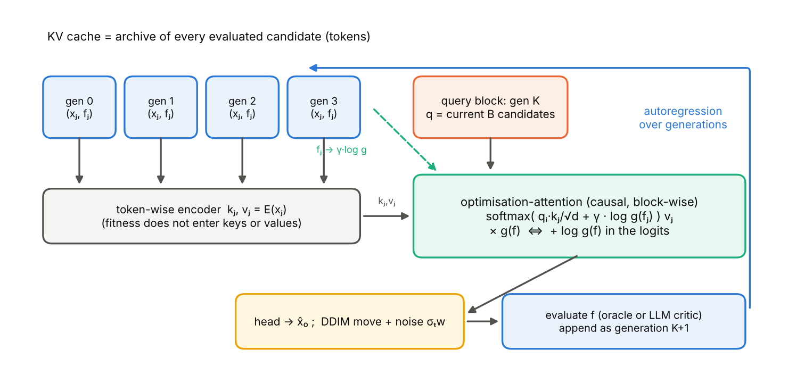
Figure 1. The fitness-biased decoder. Evaluated candidates are tokens in the KV cache; a block of queries attends over them with the fitness entering only as an additive logit bias; the head predicts x̂₀, a DDIM move adds noise, the new block is evaluated and appended.

3.5 A structural property of the bias form
Proposition 3 (re-scoring without re-encoding).
If archive tokens are encoded token-wise (no attention among archive tokens) and the fitness enters only as the bias ĝ, then changing the fitness of any or all archived candidates — a new critic, a revised specification, a corrected measurement — changes only the vector ĝ. No key or value need be recomputed. In the feature form, every changed token’s key and value must be recomputed.
Proof. Keys and values are functions of e(xⱼ) alone in the bias form and of (xⱼ, ĝⱼ) in the feature form. ∎
Scope. In a full GPT stack where archive tokens attend to one another, the property holds for the first layer’s keys and values only, unless the fitness bias is also withheld from archive-to-archive attention.

This matters for the two settings that motivated the series: an LLM critic whose scores are revised (Ghosh, 2026a), and a fitness landscape that moves, where re-scoring the archive is the response to decline (Ghosh, 2026b).

4. Experimental setup
- Task family. f(x) = maxₖ hₖ exp(−‖x − cₖ‖²/(2wₖ²)) in two dimensions, with K ∈ {1, …, 4} bumps, centres uniform on [−1.5, 1.5]², widths in [0.15, 0.4], heights in [0.5, 1] and one height fixed at 1. The global maximum is 1.
- Protocol. Blocks of B = 64 candidates, 15 generations (one cosine-scheduled DDIM step per generation), so 1,024 evaluations per run; the first block is drawn from N(0, I).
- Decoder. Token-wise MLP encoder of archive candidates; query MLP of (q, αₜ, √(1 − αₜ)); two cross-attention layers of four heads (width 64) with residuals and MLPs; output x̂₀ = q + head(h). About 76 thousand parameters.
- Fitness entry. none: the decoder sees only positions; feature: ĝⱼ is concatenated to the encoder input; bias: ĝⱼ is added to every logit with a learned scale γ_{l,h} (initialised to 1); both. Preprocessing P: z-score within the archive (β = 3) or normalised rank (β = 6).
- Training. 22,500 contexts from 1,500 tasks rolled out by untrained DE with an archive; mean-squared error to the attractor; 2,500 AdamW steps, then one round of data aggregation (600 tasks rolled out by the trained decoder) and 1,200 further steps. The feature and bias decoders were trained with three seeds each; the other variants with one.
- Evaluation. 150 held-out tasks from the family. A task is solved if the best evaluated candidate is within 0.01 of the global maximum; coverage is the fraction of bumps of height ≥ 0.9 that have a final-block candidate within 0.1. Out of family: the Himmelblau function scaled into the unit region, g ∝ exp(−h/30), 30 runs, optima found within 0.1. Robustness: at test time the decoder sees f, f⁴ or log(f + 10⁻³) in place of f, while success is measured on f.

5. Results

5.1 Untrained decoders
Table 1. Untrained (identity-weight) decoders on Himmelblau, equal budget of 512 × 26 evaluations. Final-block candidates within 0.05 of an optimum; best fitness found (maximum 0).
Variant | Optima found (of 4) | Final block near an optimum | Best f | Seeds
Diffusion Evolution (published form) | 3.5 | 18% | -0.0051 | 10
block-causal decoder, window = 1 block | 3.5 | 18% | -0.0051 | 10
block-causal decoder, full KV archive | 4.0 | 16% | -0.0031 | 10
single autoregressive chain | 0.0 | 0% | -0.0140 | 3

The one-block decoder reproduces DE to every printed digit, as Proposition 2 requires. The full-window decoder finds all four optima on every seed and a slightly better best value, at the cost of a slightly less concentrated final block. The token-by-token chain finds a good point at some stage (best f = -0.014) but its last 512 candidates are near no optimum: with one query per step there is no population for selection to act on.

5.2 Trained decoders: where should the fitness enter?
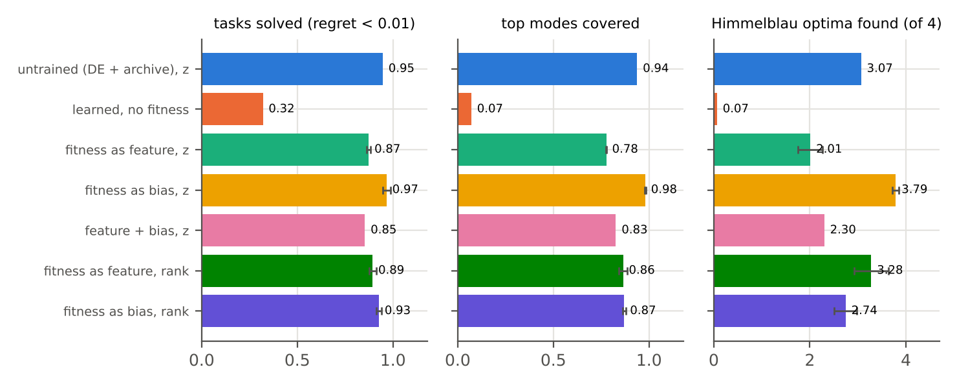
Figure 2. Held-out tasks from the training family (left, centre) and the out-of-family Himmelblau function (right). Error bars: ± s.d. over three training seeds, for the feature and bias decoders.
Table 2. Trained and untrained decoders at equal budget (1,024 evaluations per run). Mean ± s.d. over training seeds where three were run.
Decoder | Solved | Top modes covered | Himmelblau optima (of 4)
Untrained (DE + archive), z-score | 0.95 | 0.94 | 3.1
Untrained (DE + archive), rank | 0.63 | 0.82 | 2.9
Learned, no fitness | 0.32 | 0.07 | 0.1
Fitness as input feature, z-score | 0.87 ± 0.01 | 0.78 ± 0.00 | 2.0 ± 0.3
Fitness as attention bias, z-score | 0.97 ± 0.02 | 0.98 ± 0.00 | 3.8 ± 0.1
Feature + bias, z-score | 0.85 | 0.83 | 2.3
Fitness as input feature, rank | 0.89 ± 0.02 | 0.86 ± 0.02 | 3.3 ± 0.4
Fitness as attention bias, rank | 0.93 ± 0.01 | 0.87 ± 0.01 | 2.7 ± 0.2

Four findings.
- The decoder uses the fitness. Without it, a trained decoder solves 32% of tasks and covers 7% of top modes: knowing the task prior is not enough.
- With z-scored fitness, only the bias form improves on untrained DE. The bias decoder solves 0.97 ± 0.02 and covers 0.98 ± 0.00; untrained DE 0.95 and 0.94; the feature decoder 0.87 ± 0.01 and 0.78 ± 0.00. Against the feature decoder the gap is many times the training-seed spread; against untrained DE it is clear in coverage but within noise for tasks solved. The difference is largest out of family: 3.8 ± 0.1 Himmelblau optima for the bias decoder against 2.0 ± 0.3 for the feature decoder.
- Both is not better than one. Adding the feature to the bias decoder brings it down to the feature decoder’s level (0.85 solved, 0.83 covered, 2.3 Himmelblau optima). Once the fitness is available as a feature, the network appears to route its use through the encoder rather than through the bias. The feature decoders also reach a lower training loss than the bias decoder (0.089 vs 0.122), so the better optimiser is the worse regressor: fitting the attractor more closely on training contexts does not translate into better search.
- With rank preprocessing the forms converge. On held-out tasks the bias decoder solves slightly more (0.93 ± 0.01 against 0.89 ± 0.02) and coverage is equal; out of family the feature decoder finds 3.3 ± 0.4 Himmelblau optima and the bias decoder 2.7 ± 0.2. Neither rank decoder matches the z-score bias decoder on held-out tasks.
The learned bias scales γ_{l,h} remain close to their initial value with z-scored fitness (between 0.79 and 1.01) and grow with ranks (between 1.61 and 2.16), i.e. the network sharpens selection when the fitness signal is compressed into [0, 1].

5.3 A failed prediction: robustness to rescaled fitness
Before the experiment we predicted that the bias form would be more robust than the feature form when the fitness is monotonically transformed at test time, provided g is rank-based. The prediction was badly posed and, in the form that can be tested, false.
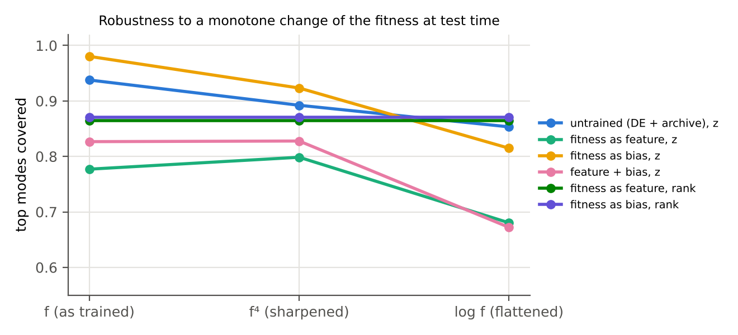
Figure 3. Coverage of top modes when the decoder sees a monotone transform of the fitness it was trained on. Rank-preprocessed decoders are flat by construction. Untrained DE with z-scores also degrades under the flattening transform.
Table 3. Top-mode coverage under test-time transforms of the fitness.
Decoder | f | f⁴ | log f | Change f → log f
Untrained, z | 0.94 | 0.89 | 0.85 | -0.08
Feature, z | 0.78 | 0.80 | 0.68 | -0.10
Bias, z | 0.98 | 0.92 | 0.81 | -0.17
Feature + bias, z | 0.83 | 0.83 | 0.67 | -0.15
Feature, rank | 0.86 | 0.86 | 0.86 | 0.00
Bias, rank | 0.87 | 0.87 | 0.87 | 0.00

Rank preprocessing makes any decoder invariant by construction (up to ties created when floating-point rounding merges very small fitness values), whichever way the fitness enters, so the condition in the prediction made it trivially true for both forms and therefore uninformative. With z-score preprocessing — the case in which the two forms can differ — the bias decoder loses more coverage under the flattening transform than the feature decoder (-0.17 against -0.10), although it remains ahead in absolute terms. The relative-robustness claim is withdrawn. What survives is narrower: robustness to the scale of the fitness should be bought by preprocessing, and among preprocessings, z-scores gave the best search on in-distribution fitness and ranks the most robust search.

6. Discussion

6.1 Why might the bias form search better?
We offer a hypothesis, not a result. In the bias form, the fitness can only change how much each archived candidate is attended to, never what it contributes; selection and representation are kept apart, as they are in DE. In the feature form the network can blend fitness into the value it copies, which helps it regress the training target but appears to cost it the clean selective behaviour that search needs, and that DE has by construction. A direct test is to probe the feature decoder’s attention weights for how strongly they correlate with fitness compared with the bias decoder’s.

6.2 Scaling up: a language model as the decoder
For program search, the decoder can be an existing language model, and each earlier solution a segment of the context. Optimisation-attention then adds γ·log g(fⱼ) to the logits of every attention edge from new tokens into the tokens of solution j — a segment-level bias. This is a concrete alternative to OPRO-style prompting, in which the score is written into the context as text. Proposition 3 says that under the bias form a revised critic changes only one scalar per solution. The prediction to test is that segment-level bias is at least as effective as textual scores and is cheaper to update.

6.3 Costs and connections
The archive grows linearly, so each new block costs O(nB) attention against n archived tokens. The prototype compression of the KV cache developed elsewhere in this research programme is the natural way to bound n. Two results of the companion papers carry over directly: under a noisy critic, γ·log g must use debiased or interval-lower scores (Ghosh, 2026a); and the density correction −log q̂(xⱼ) is one more additive bias in the same logits (Ghosh, 2026c).

7. Limitations
- All learned results are in two dimensions with a 76-thousand-parameter decoder and one synthetic task family; the out-of-family test is a single function.
- Training uses privileged knowledge of each training task’s optima. That is legitimate for amortised optimisation — the test task’s optima are never seen — but it means the decoder can only be as good as its task prior.
- Three training seeds for the two main decoders and one for the others; one round of data aggregation.
- The bump family is easy for DE (95% solved), so the head-room for learning is small; harder families may change the ranking.
- No language-model experiment was run; Section 6.2 is a proposal.

8. Conclusion
An optimiser can be built on the GPT backbone, and Diffusion Evolution already is one in its simplest form: a block-causal decoder with identity weights, a one-block window and the fitness as an additive attention bias. Multiplying the attention by g[f(x)] is that bias. Generation must be block-wise rather than token-wise, because selection needs a population. Widening the window makes the KV cache an archive. Training the decoder on a prior over tasks — so that the x₀ examples come from the prior rather than from the task — improves on DE when the fitness enters as an attention bias, and does not when it enters as an input feature. We expected the bias form to be more robust to rescaled fitness; it is not, and that robustness belongs to the preprocessing. The property of the bias form that holds regardless is that a change of critic re-weights the archive without re-encoding it.

References
Chen, L., Lu, K., Rajeswaran, A., Lee, K., Grover, A., Laskin, M., Abbeel, P., Srinivas, A., & Mordatch, I. (2021). Decision Transformer: Reinforcement learning via sequence modeling. NeurIPS 34.
Chen, Y., Song, X., Lee, C., Wang, Z., Zhang, Q., Dohan, D., Kawakami, K., Kochanski, G., Doucet, A., Ranzato, M., Perel, S., & de Freitas, N. (2022). Towards learning universal hyperparameter optimizers with transformers. NeurIPS 35.
Ghosh, D. P. (2026a). Specification as Density: Spec-driven development through Diffusion Evolution with an LLM critic. https://github.com/debiprasadghosh/ResearchOverFlow/tree/main/October2026/SpecificationAsDensity
Ghosh, D. P. (2026b). Sambhavāmi Yuge Yuge: The denoising target x̂₀ as an algorithmic avatar in Diffusion Evolution. https://github.com/debiprasadghosh/ResearchOverFlow/tree/main/October2026/AVATAR
Ghosh, D. P. (2026c). The hidden Transformer in Diffusion Evolution. https://github.com/debiprasadghosh/ResearchOverFlow/tree/main/October2026/AutoregressiveDiffusionEvolution
Laskin, M., et al. (2023). In-context reinforcement learning with algorithm distillation. ICLR 2023.
Müller, S., Hollmann, N., Pineda Arango, S., Grabocka, J., & Hutter, F. (2022). Transformers can do Bayesian inference. ICLR 2022.
Müller, S., Feurer, M., Hollmann, N., & Hutter, F. (2023). PFNs4BO: In-context learning for Bayesian optimization. ICML 2023.
Press, O., Smith, N. A., & Lewis, M. (2022). Train short, test long: Attention with linear biases enables input length extrapolation. ICLR 2022.
Ross, S., Gordon, G., & Bagnell, D. (2011). A reduction of imitation learning and structured prediction to no-regret online learning. AISTATS 2011.
Song, J., Meng, C., & Ermon, S. (2021). Denoising diffusion implicit models. ICLR 2021.
Vaswani, A., et al. (2017). Attention is all you need. NeurIPS 30.
Yang, C., Wang, X., Lu, Y., Liu, H., Le, Q. V., Zhou, D., & Chen, X. (2024). Large language models as optimizers. ICLR 2024.
Zhang, Y., Hartl, B., Hazan, H., & Levin, M. (2025). Diffusion models are evolutionary algorithms. ICLR 2025. arXiv:2410.02543.

Appendix A. Decoder forward pass
The core of the PyTorch implementation used in Section 5 (data aggregation follows Ross et al., 2011). The single line that distinguishes the bias form is marked.
def forward(self, xs, gv, mask, Q, a):
# xs: [b,n,2] archive, gv: [b,n] preprocessed fitness, Q: [b,m,2] queries, a: [b] alpha_t
e = self.kin(torch.cat([xs, gv[..., None]], -1) if self.feat else xs) # token-wise encoder
av = a[:, None, None].expand(-1, Q.shape[1], 1)
h = self.qin(torch.cat([Q, av, torch.sqrt(1 - av)], -1))
for l in range(self.L):
q = self.Wq[l](self.ln[l](h)).view(b, m, H, dh).transpose(1, 2)
k = self.Wk[l](e).view(b, n, H, dh).transpose(1, 2)
v = self.Wv[l](e).view(b, n, H, dh).transpose(1, 2)
s = q @ k.transpose(-1, -2) / math.sqrt(dh)
if self.bias: s = s + self.gamma[l][None, :, None, None] * gv[:, None, None, :] # <- optimisation-attention
s = s.masked_fill(~mask[:, None, None, :], -1e9)
h = h + self.Wo[l]((s.softmax(-1) @ v).transpose(1, 2).reshape(b, m, d))
h = h + self.mlp[l](h)
return Q + self.out(h) # x0-hat

Appendix B. Reproducibility
- Untrained comparison (Section 5.1): Himmelblau scaled by 4, g = exp(f/10), N = B = 512, 25 steps (26 blocks), seeds 0–9 (chain: 0–2).
- Training tasks seeded 1 (base) and 2, 11, 21 (aggregation); evaluation tasks seeded 12345 for every decoder, so all decoders face the same 150 tasks.
- Total compute: about 70 minutes on two CPU cores.

