Mail Module Functional Specification V1.0

Disclaimers

The information contained in this document is the proprietary and exclusive property of IDEAL INVENT Technologies Pvt. Ltd. except as otherwise indicated. No part of this document, in whole or in part, may be reproduced, stored, transmitted, or used for design purposes without the prior written permission of IDEAL INVENT Technologies Pvt. Ltd. The information contained in this document is subject to change without notice. The information in this document is provided for informational purposes only. IDEAL INVENT Technologies Pvt. Ltd. specifically disclaims all warranties, express or limited, including, but not limited, to the implied warranties of merchantability and fitness for a particular purpose, except as provided for in a separate software license agreement.

Privacy Information

This document may contain information of a sensitive nature. This information should not be given to persons other than those who are involved in the ProcessMate project or who will become involved during the lifecycle.

TABLE OF CONTENTS
1 Introduction 4
1.1 Purpose 4
1.2 Audience 4
1.3 Acronyms and definitions 4
1.4 Project Scope 4
2 Overall Description 4
2.1 Product Perspective 4
2.2 User classes and characteristics 5
3 System Features 5
3.1 Event Configuration 5
3.2 Input Interface 7
3.3 Sample - Steps for EOD alert in DM 8
4 Other requirements 9

Document Control

Document Name: Mail-SMS Module
Document Version: 1.0
Created by Preeti
Created on Sep18, 2007
Last saved by Preeti
Reviewed by: Preeti
Reviewed on:
Comments

Change History:

Version Number | Change
1.0 | Initial Draft

Introduction

Purpose

The purpose of this document is to outline the vision as well as the functional specifications of the automated Mail-SMS module.

Audience
The target audience for this document is

- Business Team
- Product development and architecture team
- Integration and implementation team

Acronyms and definitions
Abbreviation | Explanation
SMS | Short Message Service
PM | ProcessMate
DM | DataMatrice

Project Scope

The Mail module is an independent module to handle auto email and SMS.
Events which can take place in one or more external systems can trigger an alert message which can be emailed or messaged to a specified set of people.

This can be installed separately and is integrated with the either PM/DM. It could integrate with a third party software with some changes on the 3rd party software.

Overall Description

Product Perspective

The Mail/SMS module is envisioned as a generic pluggable product for sending automated mails and SMS on generation of events. The events in itself are customizable and can be generated out of any external system.

The input interface layer of the product exposes interfaces to trigger the alerts and the Mail/SMS product would send out the alert in compliance with the event configuration

The functional architecture of the product is represented in the below diagram
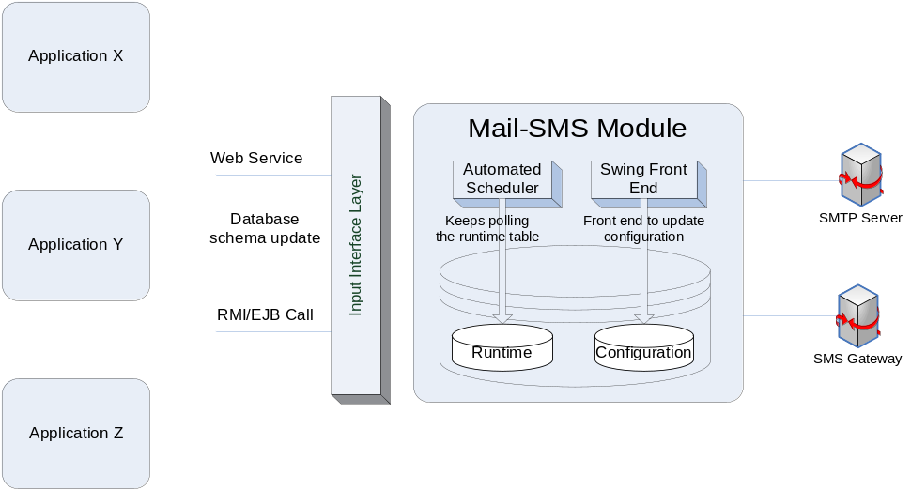

User classes and characteristics
This product is intended for use by the administrators and IT maintenance staff of the Mail/SMS product.

The administrators would typically take care of the configuration aspects of the application like
- Creation of events and configuration of characteristics of the events

System Features

Event Configuration

Each alert is based on an event in the system with which this module is integrated.
This product has an independent setup but if installed with DM, the user interface for the Mail Module is integrated in DM.

This front end allows the user to configure the alerts by specifying the following.

Column Name | Size | Example | Comments
Event_Id | 10 | 1 | Auto generated code
Event_Code | 20 | Eg. EODERROR, EODSTART, LIWFASSIGN | This is a user understandable unique code for an alert.
Version |  |  | Auto generated
External system | 50 | DM/FC/PM | Name of the external system from which it is generating a message
Description | 255 | ..... | Description
Function_Name | 255 | Schema.ProcedureName/com.pm.Inoker | This is the name of the function which gets called to fetch information to send the message.
Function_Type | 8 | DB/Java | It can be either database or java specific
Message_Type | 1 | Sms/email/both | It can be sms or email or both. (S,E,B)
Template_Name | 255 | .vm | It is the file name of the velocity template. The template is used to format the message. This will be customized for each requirement.
Template_Path | 255 | C:/processmate/template | It is the path specific to Os. In windows it may be C:/processmate/template, in Unix it may be /usr/processmate/template
File_Attachment | 1 | Y/N | Y indicates that the entire massage is in the form of a file and that will be mailed as an attachment.
Attachment Type | 10 |  | Can be used for the future
Attachment_Path | 255 | C:/processmate/attachment | It is the location where files for attachment will be stored and is specified only when file_attachment is Y
Delivery Frequency | 1 | D/M/W  Daily/Monthly/Weekly/Runtime | Specify the schedule of the email/sms.
Db_Server_Port | 4 | 1521 | The following fields are populated only when a connection needs to be made to an external database and the function_type is DB
DB_Server_IP | 50 | Idealdb01/123.34.55.23 | It can be the IP address or system name of the database server
DB_Name | 50 | Oracle | Database name
DB_User_Name | 50 | Basepmdev | User name of the database schema
DB_User_Pwd | 50 | Basepmdev | Password for the database schema
DB_SID | 50 | Ideal | It is the name of the schema of the database

The user can also specify the details of the email addresses and message details for each event which has been configured.

Column Name | Example | Comments
To Name | Harish.K | It is the name of the person who has an email Id.
From Name | Datamatice_Bank/datamatirce@dm.com | It is the source address from which message will be sent.
To_Id | Deba@gmail.com | It is the destination email address
To | Y/N | If it is Y, address will be in the To field. If nothing is there, mail will not be sent or if sent , it will be in the To field.
Cc | Y/N | If it is Y, address will be in the Cc field.
Bcc | Y/N | If it is Y, address will be in the Bcc field.
Subject | WF / EOD status | Subject of the message
Priority | High/Normal | If high, it will be flagged mail, else it will be as normal.

For SMS – user needs to specify only the To, From and Cell number.

This module has a runtime table which should be populated by the external system to indicate that the event has been triggered.
The scheduler keeps polling on this runtime table to check for new messages. Once found, the configuration table is checked to call the appropriate function to populate the message content and the list of people to whom the message needs to be sent.
Once the message is successfully delivered, it updates the status so that message is not re-picked.

Input Interface

The population of the Runtime table is the responsibility of the external system and should be done when the event occurs – for example completion of EOD or failure during EOD, completion of a workflow etc.
There are many ways the runtime table can be populated. The business logic could be in the front-end java layer which evaluates the event and populates the table or the entire logic could be at the database layer in which case it populates the runtime table directly.

The external systems and mail module need not share the same database btu it would speed up performance if they did.

Sample - Steps for EOD alert in DM

- Install DM , Install the Mail Module
- Click on the Mail Module exe to setup the configuration parameters for DM EOD as
Column Name | Value
Event_Id | Auto generated code
Event_Code | DMEOD
Version | 1
External system | DM
Description | Auto End of day
Function_Name | Dmpk_eod.Fn_Eod_Batch_Status
Function_Type | DB
Message_Type | E
Template_Name | Eod.vm
Template_Path | C:/temp/TEMPLATE/VM
File_Attachment | N
Attachment Type
Attachment_Path
Delivery Frequency | D
Db_Server_Port | 1521
DB_Server_IP | As applicable
DB_Name | As applicable
DB_User_Name | As applicable
DB_User_Pwd | As applicable
DB_SID | As applicable

- Specify the to, from, email ids etc as part of the configuration setup.
- As of now a standard template has been used to generate the EOD message.
- In DM, a trigger written to populate the runtime table when the EOD completes successfully or when the EOD fails.

Note :- In the next release for DM, the tool will have the configuration screen integrated with the tool. It will also have an additional screen for associating branches, batches which need to be reported for alerts.

Other requirements

The product must be localized and should be able to handle multiple languages

