DAO – Service – Layer (Service – Repository –Entity) Layer Architecture

# UML Architecture Diagram

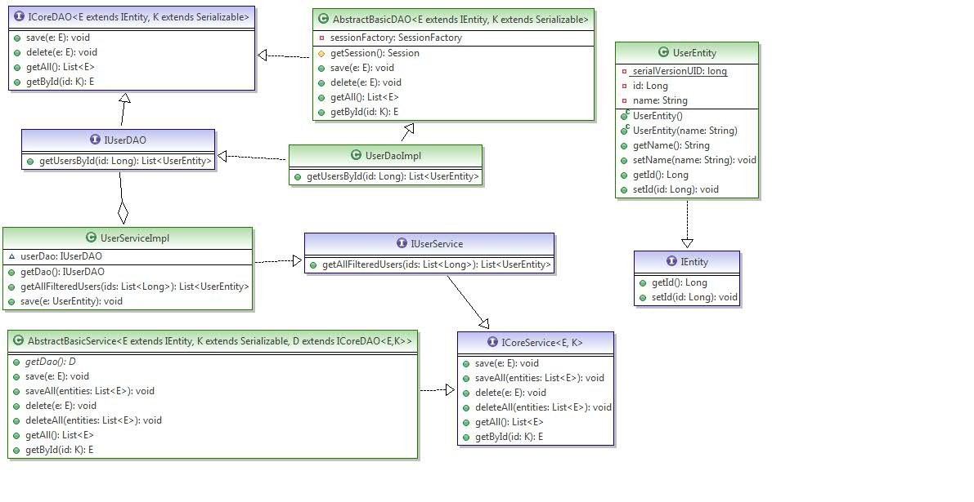

# Maven Configuration(pom.xml)

<project xmlns=*"http://maven.apache.org/POM/4.0.0"* xmlns:xsi=*"http://www.w3.org/2001/XMLSchema-instance"*

xsi:schemaLocation=*"http://maven.apache.org/POM/4.0.0 http://maven.apache.org/xsd/maven-4.0.0.xsd"*>

<modelVersion>4.0.0</modelVersion>

<groupId>dao-service-layer</groupId>

<artifactId>dao-service-layer</artifactId>

<version>0.0.1-SNAPSHOT</version>

<packaging>jar</packaging>

<name>many-to-many</name>

<url>http://maven.apache.org</url>

<properties>

<project.build.sourceEncoding>UTF-8</project.build.sourceEncoding>

<spring.version>4.1.2.RELEASE</spring.version>

<spring.security.version>3.2.3.RELEASE</spring.security.version>

</properties>

<dependencies>

<dependency>

<groupId>junit</groupId>

<artifactId>junit</artifactId>

<version>4.0</version>

<scope>test</scope>

</dependency>

<dependency>

<groupId>org.springframework</groupId>

<artifactId>spring-core</artifactId>

<version>${spring.version}</version>

</dependency>

<dependency>

<groupId>org.springframework</groupId>

<artifactId>spring-web</artifactId>

<version>${spring.version}</version>

</dependency>

<dependency>

<groupId>org.springframework</groupId>

<artifactId>spring-orm</artifactId>

<version>${spring.version}</version>

</dependency>

<dependency>

<groupId>org.springframework</groupId>

<artifactId>spring-jdbc</artifactId>

<version>${spring.version}</version>

</dependency>

<dependency>

<groupId>mysql</groupId>

<artifactId>mysql-connector-java</artifactId>

<version>5.1.30</version>

</dependency>

<!-- C3P0 library -->

<dependency>

<groupId>com.mchange</groupId>

<artifactId>c3p0</artifactId>

<version>0.9.5</version>

</dependency>

<dependency>

<groupId>org.hibernate</groupId>

<artifactId>hibernate-core</artifactId>

<version>4.3.7.Final</version>

</dependency>

</dependencies>

</project>

# SQL Configuration

**drop** **table** IF **EXISTS** **user**;

**CREATE** **TABLE** IF **NOT** **EXISTS** **user** (

id **int**(11) **NOT** **NULL** AUTO_INCREMENT,

name **varchar**(255) **DEFAULT** **NULL**,

**PRIMARY** **KEY** (id)

) ;

**select** * **from** **user**;

# Spring-Hibernate Configuration (app-context.xml)

<beans xmlns=*"http://www.springframework.org/schema/beans"*

xmlns:xsi=*"http://www.w3.org/2001/XMLSchema-instance"* xmlns:context=*"http://www.springframework.org/schema/context"*

xmlns:aop=*"http://www.springframework.org/schema/aop"* xmlns:jee=*"http://www.springframework.org/schema/jee"*

xmlns:tx=*"http://www.springframework.org/schema/tx"* xmlns:jdbc=*"http://www.springframework.org/schema/jdbc"*

xmlns:osgi=*"http://www.springframework.org/schema/osgi"* xmlns:security=*"http://www.springframework.org/schema/security"*

xsi:schemaLocation=*"http://www.springframework.org/schema/aop http://www.springframework.org/schema/aop/spring-aop-3.0.xsd*

*http://www.springframework.org/schema/beans http://www.springframework.org/schema/beans/spring-beans-3.0.xsd*

*http://www.springframework.org/schema/context http://www.springframework.org/schema/context/spring-context-3.0.xsd*

*http://www.springframework.org/schema/jee http://www.springframework.org/schema/jee/spring-jee-3.0.xsd*

*http://www.springframework.org/schema/tx http://www.springframework.org/schema/tx/spring-tx-3.0.xsd*

*http://www.springframework.org/schema/jdbc http://www.springframework.org/schema/jdbc/spring-jdbc-3.0.xsd*

*http://www.springframework.org/schema/osgi http://www.springframework.org/schema/osgi/spring-osgi.xsd*

*http://www.springframework.org/schema/security http://www.springframework.org/schema/security/spring-security-3.0.3.xsd"*>

**<tx:annotation-driven transaction-manager=*"transactionManager"* />**

**<context:annotation-config/>**

**<context:component-scan base-package=*"com.ddlab.rnd"*/>**

<bean id=*"dataSourceInternal"* class=*"com.mchange.v2.c3p0.ComboPooledDataSource"*

destroy-method=*"close"*>

<property name=*"driverClass"* value=*"com.mysql.jdbc.Driver"* />

<property name=*"jdbcUrl"* value=*"jdbc:mysql://localhost/test"* />

<property name=*"user"* value=*"deba"* />

<property name=*"password"* value=*"deba"* />

<!-- these are C3P0 properties -->

<property name=*"acquireIncrement"* value=*"5"* />

<property name=*"initialPoolSize"* value=*"5"* />

<property name=*"minPoolSize"* value=*"5"* />

<property name=*"maxPoolSize"* value=*"20"* />

</bean>

<!-- This is the lazy DataSource proxy that interacts with the target DataSource once a real statement is sent to the database. Users use this DataSource to set up their Hibernate session factory, which in turn forces the Hibernate second-level cache and also everything that interacts with that Hibernate session factory to use it. -->

<bean id=*"dataSource"* class=*"org.springframework.jdbc.datasource.LazyConnectionDataSourceProxy"*>

<property name=*"targetDataSource"*><ref bean=*"dataSourceInternal"* /></property>

</bean>

<bean id=*"sessionFactory"* class=*"org.springframework.orm.hibernate4.LocalSessionFactoryBean"*>

<property name=*"dataSource"* ref=*"dataSource"* />

<property name=*"hibernateProperties"*>

<value>

hibernate.id.new_generator_mappings=true,

hibernate.show_sql=true

<!-- hibernate.hbm2ddl.auto=update -->

<!-- hibernate.current_session_context_class=thread -->

</value>

</property>

<property name=*"annotatedClasses"*>

<list>

<value>com.ddlab.rnd.entity.UserEntity</value>

</list>

</property>

</bean>

<bean id=*"userService"* class=*"com.ddlab.rnd.service.impl.UserServiceImpl"*/>

<bean id=*"transactionManager"*

class=*"org.springframework.orm.hibernate4.HibernateTransactionManager"*>

<property name=*"sessionFactory"* ref=*"sessionFactory"* />

</bean>

</beans>

# Java Source Code

## Entity Layer

### IEntity.java

**package** com.ddlab.rnd.entity;

**import** java.io.Serializable;

**public** **interface** IEntity **extends** Serializable {

**public** Long getId();

**public** **void** setId(Long id);

}

### UserEntity.java

**package** com.ddlab.rnd.entity;

**import** javax.persistence.Column;

**import** javax.persistence.Entity;

**import** javax.persistence.GeneratedValue;

**import** javax.persistence.GenerationType;

**import** javax.persistence.Id;

**import** javax.persistence.Table;

@Entity

@Table(name = "user")

**public** **class** UserEntity **implements** IEntity {

**private** **static** **final** **long** ***serialVersionUID*** = 5921262165555614502L;

@Id

@GeneratedValue(strategy = GenerationType.***IDENTITY***)

@Column(name = "id")

**private** Long id;

@Column(name = "name")

**private** String name;

**public** UserEntity() {

}

**public** UserEntity(String name) {

**this**.name = name;

}

**public** String getName() {

**return** name;

}

**public** **void** setName(String name) {

**this**.name = name;

}

**public** Long getId() {

**return** id;

}

**public** **void** setId(Long id) {

**this**.id = id;

}

}

## DAO Layer

### ICoreDAO.java

**package** com.ddlab.rnd.dao;

**import** java.io.Serializable;

**import** java.util.List;

**import** com.ddlab.rnd.entity.IEntity;

**public** **interface** ICoreDAO<E **extends** IEntity , K **extends** Serializable> {

**public** **void** save(E e);

**public** **void** delete(E e);

**public** List<E> getAll();

**public** E getById(K id);

}

### IUserDAO.java

**package** com.ddlab.rnd.dao;

**import** java.util.List;

**import** com.ddlab.rnd.entity.UserEntity;

**public** **interface** IUserDAO **extends** ICoreDAO<UserEntity, Long> {

**public** List<UserEntity> getUsersById(Long id);

}

### AbstractBasicDAO.java

**package** com.ddlab.rnd.dao;

**import** java.io.Serializable;

**import** java.util.List;

**import** org.hibernate.Query;

**import** org.hibernate.Session;

**import** org.hibernate.SessionFactory;

**import** org.springframework.beans.factory.annotation.Autowired;

**import** org.springframework.beans.factory.annotation.Qualifier;

**import** com.ddlab.rnd.entity.IEntity;

**public** **abstract** **class** AbstractBasicDAO<E **extends** IEntity, K **extends** Serializable> **implements** ICoreDAO<E, K> {

@Autowired

@Qualifier("sessionFactory")

**private** SessionFactory sessionFactory;

**protected** Session getSession() {

**return** sessionFactory.getCurrentSession();

}

**public** **void** save(E e) {

System.***out***.println("Going to save--->"+e);

getSession().save(e);

}

**public** **void** delete(E e) {

System.***out***.println("Going to delete--->"+e);

}

**public** List<E> getAll() {

String hql = "FROM UserEntity";

**return** getSession().createQuery(hql).list();

}

**public** E getById(K id) {

String hql = "FROM UserEntity u where u.id =:id";

Query query = getSession().createQuery(hql);

query.setParameter("id", id);

**return** (E) query.list().get(0);

}

}

### UserDAOImpl.java

**package** com.ddlab.rnd.dao.impl;

**import** java.util.List;

**import** org.springframework.stereotype.Repository;

**import** com.ddlab.rnd.dao.AbstractBasicDAO;

**import** com.ddlab.rnd.dao.IUserDAO;

**import** com.ddlab.rnd.entity.UserEntity;

**@Repository(value = "userDao")**

**public** **class** UserDaoImpl **extends** AbstractBasicDAO<UserEntity,Long> **implements** IUserDAO {

**public** List<UserEntity> getUsersById(Long id) {

System.***out***.println("UserDaoImpl : getUsersById");

**return** **null**;

}

}

## Service Layer

### ICoreService.java

**package** com.ddlab.rnd.service;

**import** java.util.List;

**public** **interface** ICoreService<E,K> {

**public** **void** save(E e);

**public** **void** saveAll(List<E> entities);

**public** **void** delete(E e);

**public** **void** deleteAll(List<E> entities);

**public** List<E> getAll();

**public** E getById(K id);

}

### IUserService.java

**package** com.ddlab.rnd.service;

**import** java.util.List;

**import** com.ddlab.rnd.entity.UserEntity;

**public** **interface** IUserService **extends** ICoreService<UserEntity, Long> {

**public** List<UserEntity> getAllFilteredUsers(List<Long> ids);

}

### AbstractBasicService.java

**package** com.ddlab.rnd.service;

**import** java.io.Serializable;

**import** java.util.List;

**import** org.springframework.transaction.annotation.Transactional;

**import** com.ddlab.rnd.dao.ICoreDAO;

**import** com.ddlab.rnd.entity.IEntity;

**@Transactional**

**public** **abstract** **class** AbstractBasicService<E **extends** IEntity, K **extends** Serializable, D **extends** ICoreDAO<E, K>> **implements** ICoreService<E, K> {

**public** **abstract** D getDao();

**public** **void** save(E e) {

getDao().save(e);

}

**public** **void** saveAll(List<E> entities) {

}

**public** **void** delete(E e) {

getDao().delete(e);

}

**public** **void** deleteAll(List<E> entities) {

}

**public** List<E> getAll() {

**return** getDao().getAll();

}

**public** E getById(K id) {

**return** getDao().getById(id);

}

}

### UserService.java

**package** com.ddlab.rnd.service.impl;

**import** java.util.List;

**import** org.springframework.beans.factory.annotation.Autowired;

**import** org.springframework.beans.factory.annotation.Qualifier;

**import** org.springframework.stereotype.Service;

**import** com.ddlab.rnd.dao.IUserDAO;

**import** com.ddlab.rnd.entity.UserEntity;

**import** com.ddlab.rnd.service.AbstractBasicService;

**import** com.ddlab.rnd.service.IUserService;

@Service(value = "userService")

**public** **class** UserServiceImpl **extends** AbstractBasicService<UserEntity, Long, IUserDAO> **implements** IUserService {

@Autowired

@Qualifier("userDao")

IUserDAO userDao;

@Override

**public** IUserDAO getDao() {

**return** userDao;

}

**public** List<UserEntity> getAllFilteredUsers(List<Long> ids) {

**return** **null**;

}

@Override

**public** **void** save(UserEntity e) {

**super**.save(e);

}

}

### Test.java (Test Program)

**package** com.ddlab.rnd.test;

**import** java.util.List;

**import** org.springframework.context.ApplicationContext;

**import** org.springframework.context.support.ClassPathXmlApplicationContext;

**import** com.ddlab.rnd.entity.UserEntity;

**import** com.ddlab.rnd.service.IUserService;

**public** **class** Test {

**public** **static** **void** main(String[] args) {

ApplicationContext context = **new** ClassPathXmlApplicationContext("app-context.xml");

IUserService userService = (IUserService) context.getBean("userService");

UserEntity userEntity = **new** UserEntity("Deba1");

userService.save(userEntity);

List<UserEntity> usersList = (List<UserEntity>) userService.getAll();

**for**(UserEntity user : usersList) {

System.***out***.println(user.getId()+"---->"+user.getName());

}

UserEntity user1 = userService.getById(1L);

System.***out***.println("User Name :::"+user1.getName());

}

}