URI, URL, URN

A Uniform Resource Identifier (URI) is a compact sequence of characters that identifies an abstract or physical resource.

A URI can be further classified as a locator, a name, or both. The term “Uniform Resource Locator” (URL) refers to the subset of URIs that, in addition to identifying a resource, provide a means of locating the resource by describing its primary access mechanism (e.g., its network “location”).

URL is **a type of URI**.

1. First of all (as we see in the diagram as well) a URL is **a type of URI**. So if someone tells you that a URL is not a URI, he’s wrong. But that doesn’t mean all URIs are URLs. All butterflies fly, but not everything that flies is a butterfly.
2. The part that makes a URI a URL is the inclusion of the “access mechanism”, or “network location”, e.g. http:// or ftp://.
3. The URN is the “globally unique” part of the identification; it’s a unique name.

So let’s look at some examples of URIs–again from the RFC:

* ftp://ftp.is.co.za/rfc/rfc1808.txt (also a URL because of the protocol)
* http://www.ietf.org/rfc/rfc2396.txt (also a URL because of the

So, if you use **URI** you’ll always be technically correct, and if you use**URL** you might not be.

<http://stackoverflow.com/questions/176264/what-is-the-difference-between-a-uri-a-url-and-a-urn>

A URI can be further classified as a locator, a name, or both. The term "Uniform Resource Locator" (URL) refers to the subset of URIs that, in addition to identifying a resource, provide a means of locating the resource by describing its primary access mechanism (e.g., its network "location"). The term "Uniform Resource Name" (URN) has been used historically to refer to both URIs under the "urn" scheme [RFC2141], which are required to remain globally unique and persistent even when the resource ceases to exist or becomes unavailable, and to any other URI with the properties of a name.

So all URLs are URIs

[**URI**](http://en.wikipedia.org/wiki/Uniform_Resource_Identifier)**s identify** and [**URL**](http://en.wikipedia.org/wiki/Uniform_Resource_Locator)**s locate**; however, **locators are also identifiers**, so every URL is also a URI, but there are URIs which are not URLs.

### **Examples**

* Roger Pate

This is my name, which is an identifier. It is like a URI, but cannot be a URL, as it tells you nothing about my location or how to contact me. In this case it also happens to identify at least 5 other people in the USA alone.

* 4914 West Bay Street, Nassau, Bahamas

This is a locator, which is an identifier for that physical location. It is like both a URL and URI (since all URLs are URIs), and also identifies me [indirectly](http://www.w3.org/TR/webarch/#indirect-identification) as "resident of..". In this case it uniquely identifies me, but that would change if I get a roommate.

I say "like" because these examples do not follow the required syntax.

Popular confusion

From [Wikipedia](http://en.wikipedia.org/wiki/Uniform_Resource_Locator):

In computing, a Uniform Resource Locator (URL) is a subset of the Uniform Resource Identifier (URI) that specifies where an identified resource is available and the mechanism for retrieving it. **In popular usage and in many technical documents and verbal discussions it is often incorrectly used as a synonym for URI**, ... [emphasis mine]

Because of this common confusion, many products and documentation incorrectly use one term instead of the other, assign their own distinction, or use them synonymously.

### **URNs**

My name, Roger Pate, could be like a [URN](http://en.wikipedia.org/wiki/Uniform_Resource_Name) (Uniform Resource Name), except those are [much more regulated](http://stackoverflow.com/questions/2135450/why-is-urn-one-of-more-popular-formats-used-to-uniquely-identify-the-resource/3083561#3083561) and intended to be unique across both space and time.

Because I currently share this name with other people, it's not globally unique and would not be appropriate as a URN. However, even if no other family used this name, I'm named after my paternal grandfather, so it still wouldn't be unique across time. And even if that wasn't the case, the possibility of naming my descendants after me make this unsuitable as a URN.

URNs are different from URLs in this rigid uniqueness constraint, even though they both share the syntax of URIs.

In summary: **a URI identifies, a URL identifies and locates.**

Consider a specific edition of Shakespeare's play Romeo and Juliet, of which you have a digital copy on your home network.

You could identify the text as urn:isbn:0-486-27557-4.  
That would be a URI, but more specifically a [**URN**](http://en.wikipedia.org/wiki/Uniform_Resource_Name) because it **names the text**.

You could also identify the text as file://hostname/sharename/RomeoAndJuliet.pdf.  
That would also be a URI, but more specifically a **URL** because it **locates the text**.

These are some very well-written but long-winded answers. Here is the difference **as far as CodeIgniter is concerned**:

**URL** - <http://example.com/some/page.html>

**URI** - /some/page.html

Put simply, URL is the full way to indentify any resource anywhere and can have different protocols like FTP, HTTP, SCP, etc.

URI is a resource on the current domain, so it needs less information to be found.

# URL -- [Uniform Resource Locator](https://en.wikipedia.org/wiki/Uniform_resource_locator)

Contains information about how to fetch a resource from its location. For example:

* http://example.com/mypage.html
* ftp://example.com/download.zip
* mailto:user@example.com
* file:///home/user/file.txt
* tel:1-888-555-5555
* http://example.com/resource?foo=bar#fragment
* /other/link.html (A relative URL, only useful in the context of another URL)

URLs always start with a protocol (http) and usually contain information such as the network host name (example.com) and often a document path (/foo/mypage.html). URLs may have query parameters and fragment identifiers.

# URN -- [Uniform Resource Name](https://en.wikipedia.org/wiki/Uniform_resource_name)

Identifies a resource by a unique and persistent name. It usually starts with the prefix urn: For example:

* urn:isbn:0451450523 to identify a book by its ISBN number.
* urn:uuid:6e8bc430-9c3a-11d9-9669-0800200c9a66 a globally unique identifier
* urn:publishing:book - An XML namespace that identifies the document as a type of book.

URNs can identify ideas and concepts. They are not restricted to identifying documents. When a URN does represent a document, it can be translated into a URL by a "resolver". The document can then be downloaded from the URL.

# URI -- [Uniform Resource Identifier](https://en.wikipedia.org/wiki/Uniform_resource_identifier)

URIs encompass URLs, URNs, and other ways to identify a resource.

An example of a URI that is neither a URL nor a URN would be a [data URI](https://en.wikipedia.org/wiki/Data_URI_scheme) such as data:,Hello%20World. It is not a URL nor a URN because the URI contains the data. It neither names it, nor tells you how to locate it over the network.

There are also uniform resource citations (URCs) that point to meta data about a document rather than to the document itself. An example of a URC would be an identifier for viewing the source code of a web page: view-source:http://example.com/. A URC is another type of URI that is neither URL nor URN.

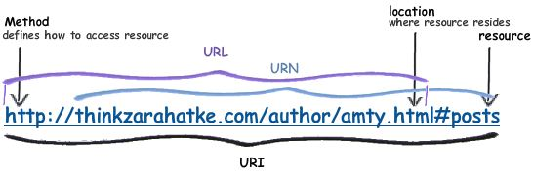

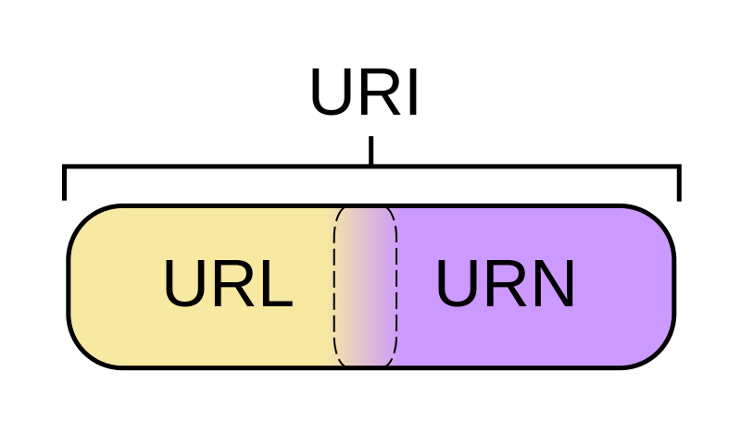

All the URL's are URI; All the URN's are URI; but all the URI's are not URL