**UML**

**Dependency** is often confused as Association. Dependency is normally created when you receive a reference to a class as part of a particular operation / method. Dependency indicates that you may invoke one of the APIs of the received class reference and any modification to that class may break your class as well. Dependency is represented by a dashed arrow starting from the dependent class to its dependency.

Symbol :

Dependency is a relationship that shows that a class is dependent on another class for its existence or implementation. Dependency relationship is shown as a dotted line with an arrow from source class to the dependent class.  
In Java we can consider the dependency relationship if the source class has a reference to the dependent class directly or source class has methods through which the dependent objects are passed as a parameter or refers to the static operation’s of the dependent class or source class has a local variable referring to the dependent class etc.

[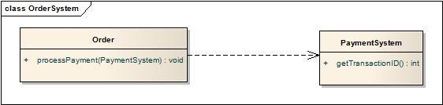](http://i0.wp.com/idiotechie.com/wp-content/uploads/2012/12/Dependency.jpg)

The above diagram satisfies dependency relationship as the source class Order passes the PaymentSystem reference through the processPayment().

public class Order {

public void processPayment(PaymentSystem ps) {

}

}

public class PaymentSystem {

}

The dependency is a relationship of use, and typically it is not in the diagrams.

If A---->B that means that a method in A has a parameter of type B, or that a method of A creates an instance of B to do some task and then destroy it. There is just a relation of use, there is not permanent relation between A and B. Of course, there are other kind of dependencies, but these are the most common.

public class MyActionListener implements ActionListener {

public void actionPerformed(ActionEvent event){

}

}

Dependency is a loose form of Association. It is "optional" to show dependency in class diagrams. The best example will be a **Teacher teaches a subject of Physics**. The java code is given below.

public class Subject {

private String subjectName = "Physics";

public String getSubjectName() {

return subjectName;

}

}

public class Teacher {

public String teaches( Subject subject ) {

return subject.getSubjectName();

}

}

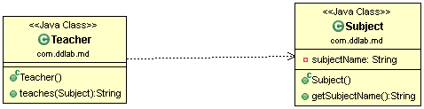

**Association:**  
The association represents the static relationship between two classes along with the multiplicity. E.g. an employee can have one primary address associated with it but can have multiple mobile numbers. Association are represented as thin line connecting two classes. Association can be unidirectional (shown by arrow at one end) or bidirectional (shown by arrow at both end).  
Multiplicity defines how many instances can be associated at any given moment.

Symbol :

|  |  |  |
| --- | --- | --- |
| 0..1 | No instances or one instance | A flight seat can have no or one passenger only |
| 1 | Exactly one instance | An order can have only one customer |
| 0..* or * | Zero or more instances | A class can have zero or more students. |
| 1..* | One or more instances (at least one) | A flight can have one or more passenger |

The unidirectional relationship shows that the source object can invoke methods of the destination class. In Java a possible example can be the instance variable of source class referencing the destination class.Association Example

public class Customer {

private String name;

private String address;

private String contactNumber;

}

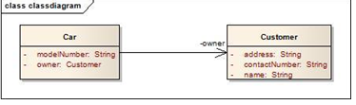

public class Car {

private String modelNumber;

private Customer owner;

}

Let’s look at an example of bidirectional association: Bidirectional association

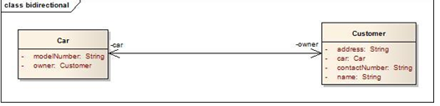

public class Car {

private String modelNumber;

private Customer owner;

}

public class Customer {

private String name;

private String address;

private String contactNumber;

private Car car;

}

In the bidirectional association each of the class in this relationship refers to each other by calling each others method. In the above Java example it is depicted as instance variable of Car class in called inside the Customer class and vice versa. In the above example the car and owner refers to the roles and is depicted by the name of instance variable in the code.  
**Multiplicity:** Assume a scenario where a customer has multiple cars. How do we represent this situation in Java and UML?

[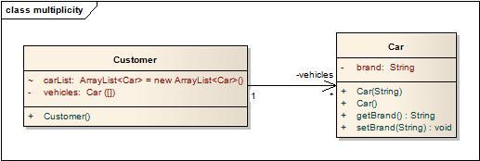](http://i2.wp.com/idiotechie.com/wp-content/uploads/2012/12/multiplicity-in-association.jpg)

Multiplicity in association

The above diagram explains a unidirectional association with a one to may relationship. Both use of ArrayList and Array is for illustration purposes only.

public class Customer {

private Car[] vehicles;

ArrayList<Car> carList = new ArrayList<Car>();

public Customer(){

vehicles = new Car[2];

vehicles[0] = new Car("Audi");

vehicles[1] = new Car("Mercedes");

carList.add(new Car("BMW"));

carList.add(new Car("Chevy"));

}

}

public class Car {

private String brand;

public Car(String brands){

this.brand = brands;

}

public Car() {

}

public String getBrand() {

return brand;

}

public void setBrand(String brand) {

this.brand = brand;

}

}

An association is a "has a" relationship. It implies that one class retains a long lasting relationship to another object. Most of the times this implies that a class has an attribute ( a field member) which is the type of the second class, then A has a B. Example will be Class Man uses a Class Pen for writing.

Class Client{

protected String name;

}

An association is **used when** one object wants another object to perform a service for it. Examples are given.

* Employee uses BusService for transportation.
* Client-Server model.
* Computer uses keyboard as input device.

Java code Example is given below.

public class KeyBoard {

public String getCharacters() {

return "abcd";

}

}

public class Computer {

private KeyBoard keyBoard;

public Computer() {

keyBoard = new KeyBoard();

}

public void manipulateChars() {

String chars = keyBoard.getCharacters();

}

}

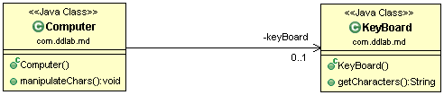

**Aggregation**: has a relationship. Example will be a Class Man has a Class Car ( Car is still there when Man dies ) . This shows “has a” relationship. It is a form of association relationship. This relationship highlights that a whole is made of its parts. So if a whole is destroyed the part still remains. In UML this is represented through a hollow diamond with the diamond symbol pointing towards the whole.  
In case of Java the aggregation follows the same structure as association. It is represented through the instance variables of a class.

http://javapapers.com/wp-content/uploads/2010/06/aggregation.jpg  
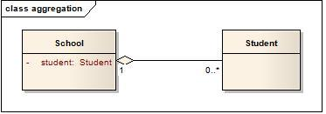

public class School {

private Student student;

}

public class Student {

}

In this case a student is a part of the School. However during design it is preferred to use association instead of aggregation as it is not a recommended option. Complete java code is given below.

public class Student {

private String name;

private String subject;

public String getSubject() {

return subject;

}

public void setSubject(String subject) {

this.subject = subject;

}

public Student( String name ) {

this.name = name;

}

public String getName() {

return name;

}

}

import java.util.List;

public class School {

private List<Student> studentsList;

public School( List<Student> studentsList ) {

this.studentsList = studentsList;

}

public void provides(String subject) {

for(Student student : studentsList ) {

student.setSubject(subject);

}

}

}

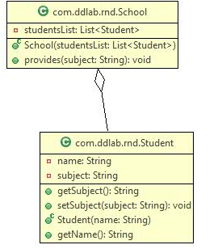

**Composition** : Composition: owns a

Ex:a Class Man owns a Class Heart ( When Man die, Heart die )

http://javapapers.com/wp-content/uploads/2010/06/composition.jpg

Composite aggregation is depicted as a binary association decorated with a **filled black diamond** at the aggregate (whole) end.

Composite aggregation is depicted as binary associations with filled black diamond

Folder could contain many files, while each File has exactly one Folder parent. If Folder is deleted, all contained Files are deleted as well. In cases where in addition to the part-of relationship between ClassA and ClassB - there’s a strong life cycle dependency between the two, meaning that when ClassA is deleted then ClassB is also deleted as a result, we should be more specific and use the composition link instead of the aggregation link or the association link. The composition link shows that a class (container, whole) has exclusive ownership over other class/s (parts), meaning that the container object and its parts constitute a parent-child/s relationship. Java code for Composition is given below.

public class Heart {

private String condition;

public String getCondition() {

return condition;

}

}

public class Head {

private String condition;

public String getCondition() {

return condition;

}

}

[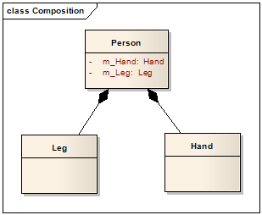](http://lh5.ggpht.com/_aUOgqE3fGXc/Sh35YNKDw9I/AAAAAAAAAao/E4v4uDJcD5w/s1600-h/image%5b5%5d.png)

public class Person {

private Heart heart;

private Head head;

private Leg[] legs;

public Person() {

heart = new Heart();

head = new Head();

legs = new Leg[2];

}

}

public class Leg {

private String leftLegName;

private String rightLegName;

public String getLeftLegName() {

return leftLegName;

}

public String getRightLegName() {

return rightLegName;

}

}

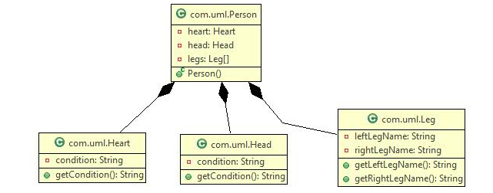

**Generalization : IS-A** example will be a Class Man is a Class Human ( Man is a Human ) , Crow is a Bird. This property represents the inheritance feature of the object oriented concept. In Java this can relate to the “extends” keyword. The inheritance should ideally follow the Liskov Substitution Principle i.e. the subtype should be able to substitute for its supertype. It helps to make the code implicitly follow the Open Close Principle i.e. Open for extension but closed for modification.

http://javapapers.com/wp-content/uploads/2010/06/generalization.jpg

Java code for Generalization is given below.

**public** **class** Bird {

**public** **void** eat() {

}

}

**public** **class** Crow **extends** Bird {

}

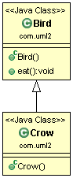

**Realization**

This is related to the relationship between the class and the interface. The realization is equivalent to the “*implements*” keyword in Java.

http://javapapers.com/wp-content/uploads/2010/06/realization.jpg

Java code for Realization

**public** **class** **AccountValidatorImpl** **implements** Validator {

@Override

**public** **boolean** isValid() {

**return** **false**;

}

}

**public** **interface** **Validator** {

**public** **boolean** isValid();

}

**public** **class** LoanValidatorImpl **implements** Validator {

@Override

**public** **boolean** isValid() {

**return** **false**;

}

}

