Zuul – API Gateway for Microservices

Zuul is an edge service that provides dynamic routing, monitoring, resiliency, security, and more.

# **What is Zuul?**

Zuul is the front door for all requests from devices and web sites to the backend of the Netflix streaming application. As an edge service application, Zuul is built to enable dynamic routing, monitoring, resiliency and security. It also has the ability to route requests to multiple Amazon Auto Scaling Groups as appropriate.

# **Why did we build Zuul?**

The volume and diversity of Netflix API traffic sometimes results in production issues arising quickly and without warning. We need a system that allows us to rapidly change behavior in order to react to these situations.

Zuul uses a range of different types of filters that enables us to quickly and nimbly apply functionality to our edge service. These filters help us perform the following functions:

* Authentication and Security - identifying authentication requirements for each resource and rejecting requests that do not satisfy them.
* Insights and Monitoring - tracking meaningful data and statistics at the edge in order to give us an accurate view of production.
* Dynamic Routing - dynamically routing requests to different backend clusters as needed.
* Stress Testing - gradually increasing the traffic to a cluster in order to gauge performance.
* Load Shedding - allocating capacity for each type of request and dropping requests that go over the limit.
* Static Response handling - building some responses directly at the edge instead of forwarding them to an internal cluster
* Multiregion Resiliency - routing requests across AWS regions in order to diversify our ELB usage and move our edge closer to our members

**Edge Service:**Zuul acts as an **API gateway** or **Edge service**. It receives all the request comes from UI and then delegates the request to internal Microservices. So we have to create a brand new Microservice which is Zuul enabled and this service sits on top of all other Microservices. It acts as an Edge service or Client facing service. Its Service API should be exposed to client/UI, Client calls this service as a proxy for Internal Microservice then this service delegates the request to appropriate service.

The advantage of this type of design is common aspects like CORS, Authentication, Security can be put into a centralized service, so all common aspects will be applied on each request, and if any changes occur in the future we just have to update the business logic of this Edge Service.

Also, we can implement any Routing rules or any Filter implementation says we want to append a special tag into the request header before it reaches to internal Microservices we can do it in the Edge service. As Edge service itself is a Microservice so it can be independently scalable, deployable. So we can perform some load testing also.

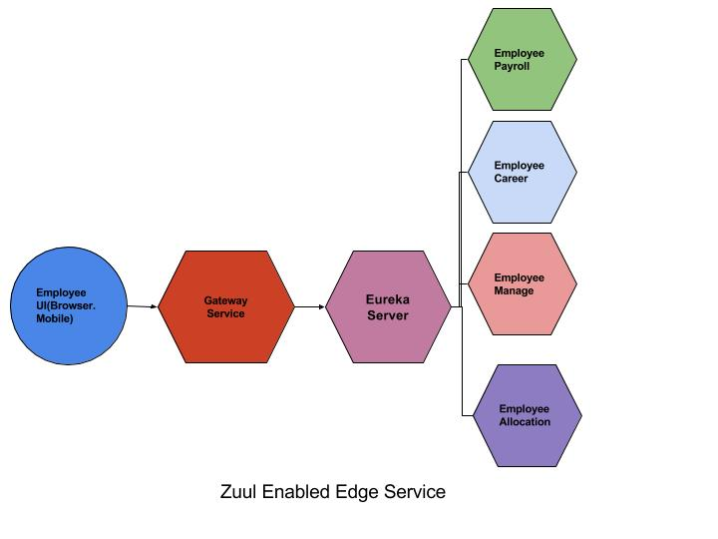

Let us consider a practical example. There are two microservices like **Organisation** and **Employee**. Both the microservices provide REST end points and provide data and these microservices can accessed directly without using Zuul. In case the microservices move to different location or different port, we have to change our application with REST end point URI. In case of Zuul, we configure all the microservices and access the rest end points through Zuul API gate way.

Source code for Organisation – A simple Microservice

# **Project Structure**

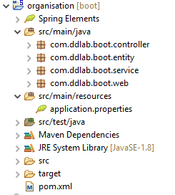

# **Maven (pom.xml)**

<project xmlns=*"http://maven.apache.org/POM/4.0.0"*

xmlns:xsi=*"http://www.w3.org/2001/XMLSchema-instance"*

xsi:schemaLocation=*"http://maven.apache.org/POM/4.0.0 http://maven.apache.org/xsd/maven-4.0.0.xsd"*>

<modelVersion>4.0.0</modelVersion>

<groupId>organisation</groupId>

<artifactId>organisation</artifactId>

<version>0.0.1-SNAPSHOT</version>

<packaging>jar</packaging>

<name>organisation</name>

<url>http://maven.apache.org</url>

**<parent>**

**<groupId>org.springframework.boot</groupId>**

**<artifactId>spring-boot-starter-parent</artifactId>**

**<version>2.0.0.RELEASE</version>**

**</parent>**

<properties>

<project.build.sourceEncoding>UTF-8</project.build.sourceEncoding>

</properties>

<dependencies>

**<dependency>**

**<groupId>org.springframework.boot</groupId>**

**<artifactId>spring-boot-starter-web</artifactId>**

**</dependency>**

**<dependency>**

**<groupId>org.projectlombok</groupId>**

**<artifactId>lombok</artifactId>**

**<scope>provided</scope>**

**</dependency>**

<dependency>

<groupId>junit</groupId>

<artifactId>junit</artifactId>

<scope>test</scope>

</dependency>

</dependencies>

<build>

<plugins>

<plugin>

<groupId>org.apache.maven.plugins</groupId>

<artifactId>maven-compiler-plugin</artifactId>

<configuration>

<source>1.8</source>

<target>1.8</target>

</configuration>

</plugin>

**<plugin>**

**<groupId>org.springframework.boot</groupId>**

**<artifactId>spring-boot-maven-plugin</artifactId>**

**</plugin>**

</plugins>

</build>

</project>

## **SpringBoot Main Application – Web Layer**

**OrganisationBootApplication.java**

**package** com.ddlab.boot.web;

**import** org.springframework.boot.SpringApplication;

**import** org.springframework.boot.autoconfigure.SpringBootApplication;

@SpringBootApplication

**public** **class** OrganisationBootApplication {

**public** **static** **void** main(String[] args) {

SpringApplication.*run*(OrganisationBootApplication.**class**, args);

}

}

**BootConfig.java**

**package** com.ddlab.boot.web;

**import** org.springframework.context.annotation.ComponentScan;

**import** org.springframework.context.annotation.Configuration;

@ComponentScan(basePackages= {"com.ddlab.boot.*"})

@Configuration

**public** **class** BootConfig {

}

## **Entity Layer**

**Location.java**

**package** com.ddlab.boot.entity;

**import** com.fasterxml.jackson.annotation.JsonProperty;

**import** com.fasterxml.jackson.annotation.JsonPropertyOrder;

**import** lombok.Data;

**import** lombok.NoArgsConstructor;

@Data

@NoArgsConstructor

@JsonPropertyOrder({"officeName", "streetName", "city", "pincode"})

**public** **class** Location {

@JsonProperty **private** String officeName;

@JsonProperty **private** String streetName;

@JsonProperty **private** String city;

@JsonProperty **private** String pincode;

}

## **Service Layer**

**OrgService.java**

**package** com.ddlab.boot.service;

**import** com.ddlab.boot.entity.Location;

**public** **interface** OrgService {

Location getLocationByPincode(String pincode);

}

**OrgServiceImpl.java**

**package** com.ddlab.boot.service;

**import** org.springframework.stereotype.Service;

**import** com.ddlab.boot.entity.Location;

@Service

**public** **class** OrgServiceImpl **implements** OrgService {

@Override

**public** Location getLocationByPincode(String pincode) {

Location location = **new** Location();

location.setOfficeName("DDLAB INC");

location.setCity("Bangalore, Karnataka");

location.setPincode(pincode);

location.setStreetName("13th main road, 5th block");

**return** location;

}

}

## **Resource or Controller Layer**

**OrgController.java**

**package** com.ddlab.boot.controller;

**import** org.springframework.beans.factory.annotation.Autowired;

**import** org.springframework.http.HttpStatus;

**import** org.springframework.http.MediaType;

**import** org.springframework.http.ResponseEntity;

**import** org.springframework.web.bind.annotation.CrossOrigin;

**import** org.springframework.web.bind.annotation.GetMapping;

**import** org.springframework.web.bind.annotation.PathVariable;

**import** org.springframework.web.bind.annotation.RequestMapping;

**import** org.springframework.web.bind.annotation.RestController;

**import** com.ddlab.boot.entity.Location;

**import** com.ddlab.boot.service.OrgService;

**@RestController**

**@RequestMapping("/home")**

**@CrossOrigin**

**public** **class** OrgController {

@Autowired **private** OrgService orgService;

//http://localhost:8081/org/home/location/12345

@GetMapping(path = "/location/{pincode}", produces = MediaType.***APPLICATION_JSON_VALUE***)

**public** ResponseEntity<Location> getLocationByPincode(@PathVariable("pincode") String pincode) {

System.***out***.println("Org Service :::" + orgService);

**return** **new** ResponseEntity<Location>(orgService.getLocationByPincode(pincode), HttpStatus.***OK***);

}

}

# **Spring Boot Configuration**

**Application.properties**

**spring.application.name=org**

**server.servlet.context-path=/org**

**server.port=8081**

server.error.whitelabel.enabled=false

# **How to use**

Start the server and access the following URL in browser

http://localhost:8081/org/home/location/12345.

Now accordingly develop employee service, it is just similar to Organisation service, the only difference is port number which 8082.

# **Zuul API Gateway**

It is also a SpringBoot microservice with Netflix specific libraries.

# **Project Structure**

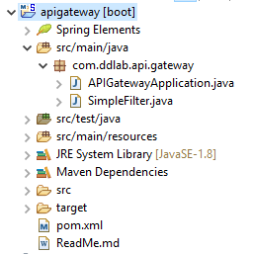

# **Maven Configuration (pom.xml)**

<project xmlns=*"http://maven.apache.org/POM/4.0.0"*

xmlns:xsi=*"http://www.w3.org/2001/XMLSchema-instance"*

xsi:schemaLocation=*"http://maven.apache.org/POM/4.0.0 http://maven.apache.org/xsd/maven-4.0.0.xsd"*>

<modelVersion>4.0.0</modelVersion>

<groupId>apigateway</groupId>

<artifactId>apigateway</artifactId>

<version>0.0.1-SNAPSHOT</version>

<packaging>jar</packaging>

<name>apigateway</name>

<url>http://maven.apache.org</url>

<parent>

<groupId>org.springframework.boot</groupId>

<artifactId>spring-boot-starter-parent</artifactId>

<version>2.0.0.RELEASE</version>

</parent>

<properties>

<project.build.sourceEncoding>UTF-8</project.build.sourceEncoding>

</properties>

**<dependencyManagement>**

**<dependencies>**

**<dependency>**

**<groupId>org.springframework.cloud</groupId>**

**<artifactId>spring-cloud-dependencies</artifactId>**

**<version>Finchley.RELEASE</version>**

**<type>pom</type>**

**<scope>import</scope>**

**</dependency>**

**</dependencies>**

**</dependencyManagement>**

<dependencies>

**<dependency>**

**<groupId>org.springframework.boot</groupId>**

**<artifactId>spring-boot-starter-web</artifactId>**

**</dependency>**

**<dependency>**

**<groupId>org.springframework.cloud</groupId>**

**<artifactId>spring-cloud-starter-config</artifactId>**

**</dependency>**

**<dependency>**

**<groupId>org.springframework.cloud</groupId>**

**<artifactId>spring-cloud-starter-netflix-zuul</artifactId>**

**</dependency>**

<dependency>

<groupId>junit</groupId>

<artifactId>junit</artifactId>

<scope>test</scope>

</dependency>

</dependencies>

<build>

<plugins>

<plugin>

<groupId>org.apache.maven.plugins</groupId>

<artifactId>maven-compiler-plugin</artifactId>

<configuration>

<source>1.8</source>

<target>1.8</target>

</configuration>

</plugin>

**<plugin>**

**<groupId>org.springframework.boot</groupId>**

**<artifactId>spring-boot-maven-plugin</artifactId>**

**</plugin>**

</plugins>

</build>

</project>

# **SpringBoot Main Application**

**APIGatewayApplication.java**

**package** com.ddlab.api.gateway;

**import** org.springframework.boot.SpringApplication;

**import** org.springframework.boot.autoconfigure.SpringBootApplication;

**import** org.springframework.cloud.netflix.zuul.EnableZuulProxy;

**import** org.springframework.context.annotation.Bean;

**@EnableZuulProxy**

**@SpringBootApplication**

**public** **class** APIGatewayApplication {

**public** **static** **void** main(String[] args) {

SpringApplication.*run*(APIGatewayApplication.**class**, args);

}

@Bean

**public** SimpleFilter simpleFilter() {

**return** **new** SimpleFilter();

}

}

**SimpleFilter.java**

**package** com.ddlab.api.gateway;

**import** javax.servlet.http.HttpServletRequest;

**import** com.netflix.zuul.context.RequestContext;

**import** com.netflix.zuul.ZuulFilter;

**import** org.slf4j.Logger;

**import** org.slf4j.LoggerFactory;

**public** **class** SimpleFilter **extends** ZuulFilter {

**private** **static** Logger *log* = LoggerFactory.*getLogger*(SimpleFilter.**class**);

**public** String filterType() {

**return** "pre";

}

**public** **int** filterOrder() {

**return** 1;

}

**public** **boolean** shouldFilter() {

**return** **true**;

}

**public** Object run() {

**RequestContext ctx = RequestContext.*getCurrentContext*();**

**HttpServletRequest request = ctx.getRequest();**

***log*.info( String.*format*("%s request to %s", request.getMethod(), request.getRequestURL().toString()));**

**return** **null**;

}

}

# **Zuul API Gateway Configuration**

**Application.properties**

#API Getway Configuration for Organization service

**zuul.routes.org.url=http://localhost:8081**

**zuul.routes.org.path=/org/\*\***

**zuul.routes.org.serviceId=org**

**zuul.routes.org.stripPrefix=false**

#API Getway Configuration for Employee service

**zuul.routes.emp.url=http://localhost:8082**

**zuul.routes.emp.path=/emp/\*\***

**zuul.routes.emp.serviceId=emp**

**zuul.routes.emp.stripPrefix=false**

**zuul.prefix=/api**

**server.port=8085**

server.error.whitelabel.enabled=false

# **How to use**

1. Start organization service in port 8081
2. Start employee service in port 8082
3. Finally start apigateway service in port 8085.

Now access the following URIs

<http://localhost:8085/api/org/home/location/12345>

<http://localhost:8085/api/emp/home/id/11>