URI, URL, URN - 2022

# URL -- [Uniform Resource Locator](https://en.wikipedia.org/wiki/Uniform_resource_locator)

Contains information about how to fetch a resource from its location. For example:

* http://example.com/mypage.html
* ftp://example.com/download.zip
* mailto:user@example.com
* file:///home/user/file.txt
* tel:1-888-555-5555
* http://example.com/resource?foo=bar#fragment

URLs always start with a protocol (http) and usually contain information such as the network host name (example.com) and often a document path (/foo/mypage.html). URLs may have query parameters and fragment identifiers.

# URN -- [Uniform Resource Name](https://en.wikipedia.org/wiki/Uniform_resource_name)

Identifies a resource by a unique and persistent name. It usually starts with the prefix urn: For example:

* urn:isbn:0451450523 to identify a book by its ISBN number.
* urn:uuid:6e8bc430-9c3a-11d9-9669-0800200c9a66 a globally unique identifier
* urn:publishing:book - An XML namespace that identifies the document as a type of book.

When a URN does represent a document, it can be translated into a URL by a "resolver". The document can then be downloaded from the URL.

# URI -- [Uniform Resource Identifier](https://en.wikipedia.org/wiki/Uniform_resource_identifier)

URIs encompass URLs, URNs, and other ways to identify a resource.

An example of a URI that is neither a URL nor a URN would be a [data URI](https://en.wikipedia.org/wiki/Data_URI_scheme) such as data:,Hello%20World. It is not a URL nor a URN because the URI contains the data. It neither names it, nor tells you how to locate it over the network.

A URC is another type of URI that is neither URL nor URN.

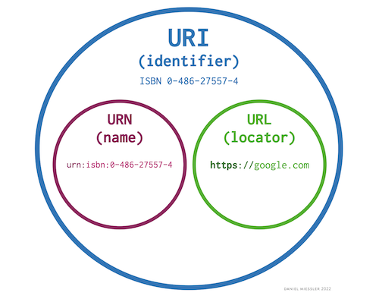 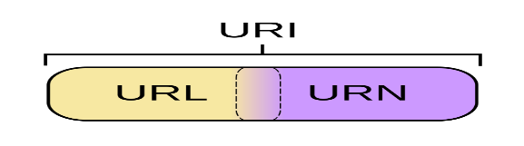

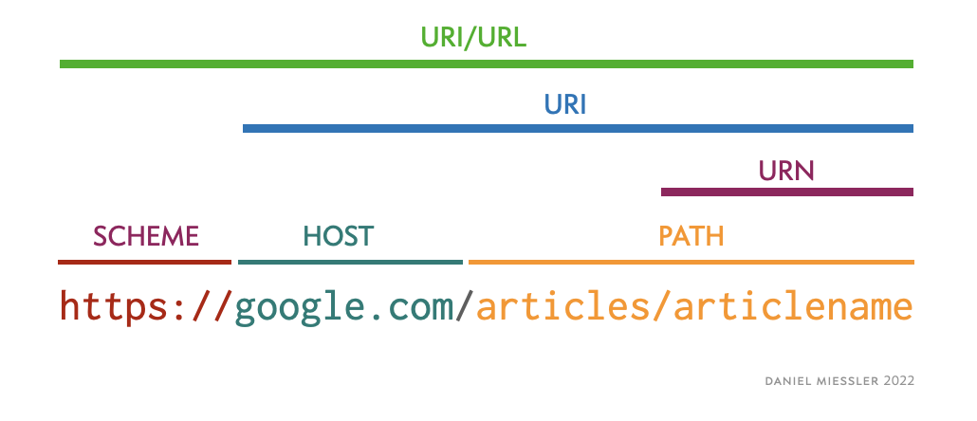

**All the URL's are URI; All the URN's are URI; but all the URI's are not URL**